Experiment

This experiment will take 15-30 minutes. Thanks.

1. Please open nodule\_me.
2. Please input l10.dcm in S40.
3. Please label 6 nodules in order by hand and save “a\_yourname.json”.

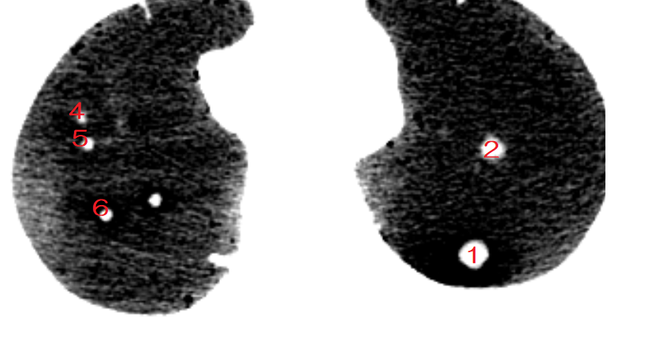

z-index is 128-133

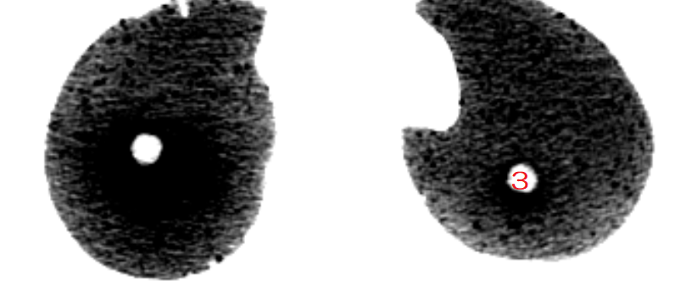

z-index is 147-153

1. Please label 6 nodules by snake and save “b\_yourname.json”.

If snake miss labeling, please retry.

|  |  |  |
| --- | --- | --- |
| OK | NG (Please retry) | NG (Please retry) |
| C:\Users\VILAB1\AppData\Local\Microsoft\Windows\INetCache\Content.Word\snake_ok.png | C:\Users\VILAB1\AppData\Local\Microsoft\Windows\INetCache\Content.Word\snake_ng1.png | C:\Users\VILAB1\AppData\Local\Microsoft\Windows\INetCache\Content.Word\snake_ng2.png |

Don’t edit labels by PINSET tool now.

1. Please edit 6 nodules of b\_yourname.json by hand and save “c\_yourname.json”
2. Please send me a\_yourname.json b\_yourname.json and c\_yourname.json. (you don’t have to send .npy files.)