Nodule_me.exe

uSER guide

version 1.0

2019

**1. Install**

**1.1 download nodule me and unzip file.**

Please download nodule_me.zip at website.

Then you must unzip nodule_me.zip by unzip tools. (7-ZIP etc.)

**1.2 open unzipped folder and find nodule_me.exe.**

Find nodule_me.exe in unzipped nodule_me.zip file.

Double click to start Nodule me.

Please wait in a second to open the interface.

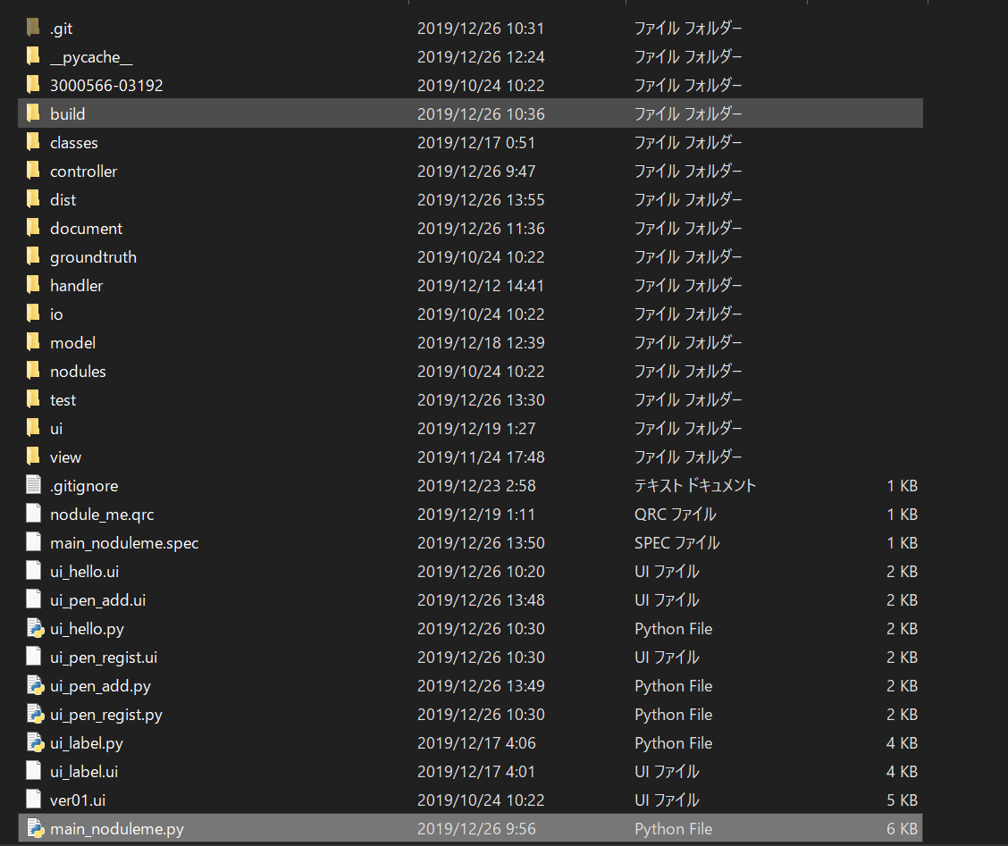

**2. Start up**

**2.1 select current user.**

Nodule me can use multi user. Please select your name in combo box.

(You can also change user later.)

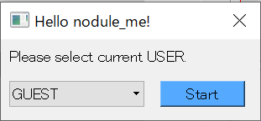

**2.2 open main interface**

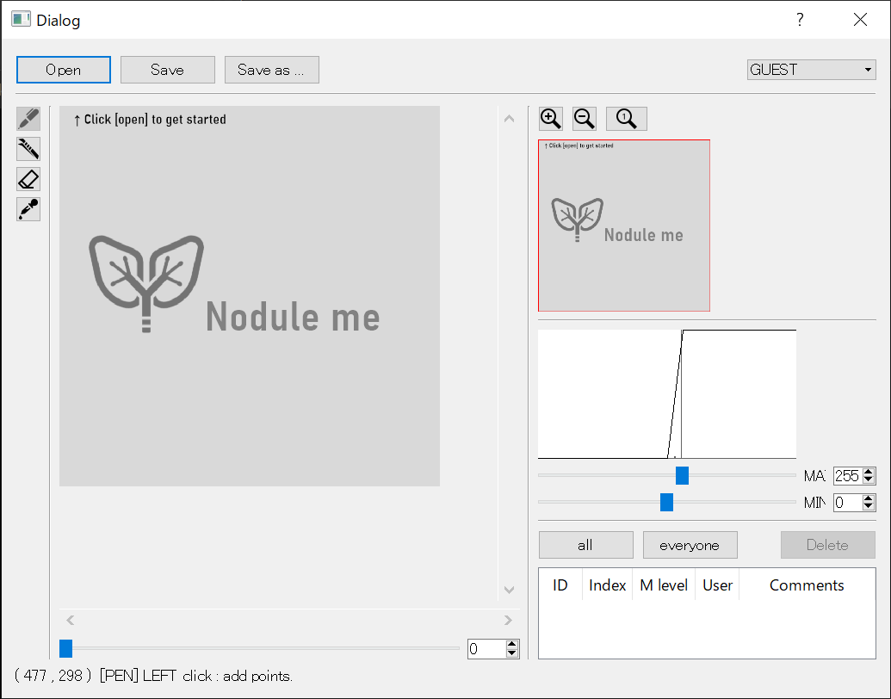

**3. Open DICOM data**

**3.1 click [Open] button**

There is [Open] button at top left diagonal.

Please wait just a moment until new dialog will open.

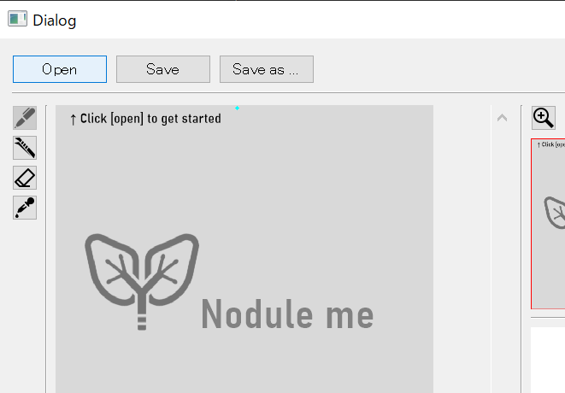

**3.2 choose one of DICOM file.**

You select .dcm (DICOM) file.

→ Demo file is in nodule_me/3000566-03192.

Please try if you don’t have any .dcm data.

*Usually, one slice of CT scan images is associated with one .dcm file.

Whichever you choose .dcm file, you will have chosen all .dcm file in the folder.

(You can also choose .png and .json file.)

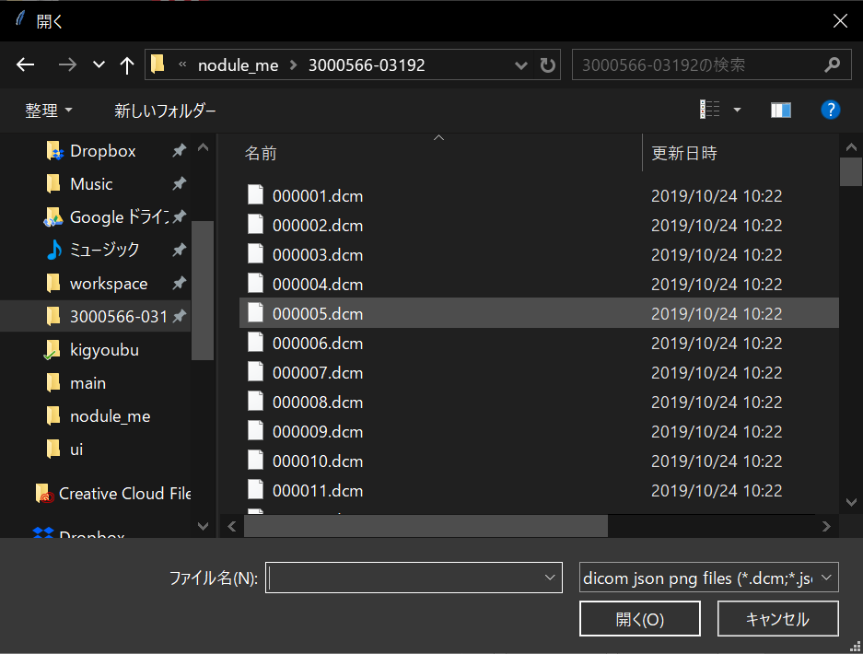

**3.3 open DICOM data.**

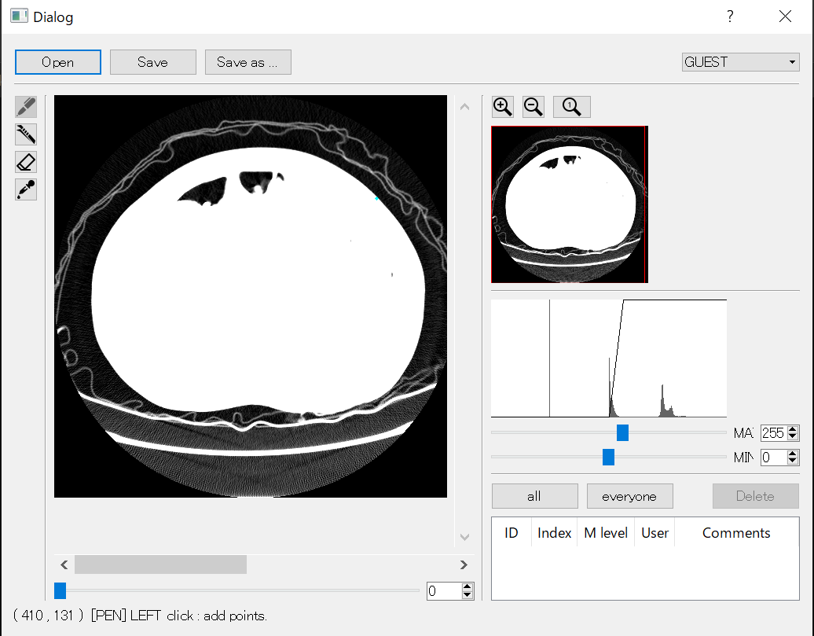

**4. Contrast, Zoom and z-index.**

* **Contrast Adjustment function**

Usually, DICOM data is 16bit but most display can only show 8bit.

Horizontal length is [-2024 2024] (max and min of DICOM pixel array).

Vertical length is [0 255] (max and min of display luminance).

Histogram show value of DICOM pixel array.

Please adjust contrast to your liking by moving below MAX/MIN slide bar.

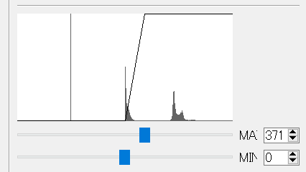

* **Zoom and Map function**

You can zoom up/down by pushing button or mouse rotate mouse wheel.

Also you can change area by dragging red square or scroll bar around canvas.

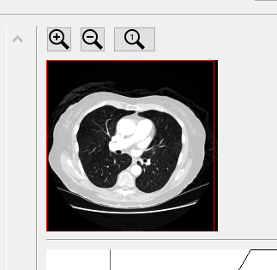

* **Z-index function**

Usually, CT-images is 3D volume data.

You can change z-index by index slide bar or spin box.

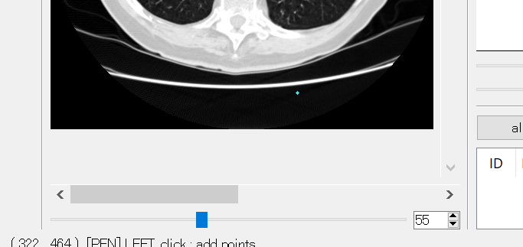

**5. Labeling**

**5.1 set [PEN] tool**

If you don’t close PEN, please select PEN tool.

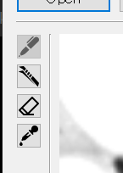

**5.2 click canvas and add points of label.**

When you find nodule, please start to label by click in canvas.

(After first pointing, pen dialog (step1/2) will be opened automatically.

Please ignore until complete labeling in the slice. )

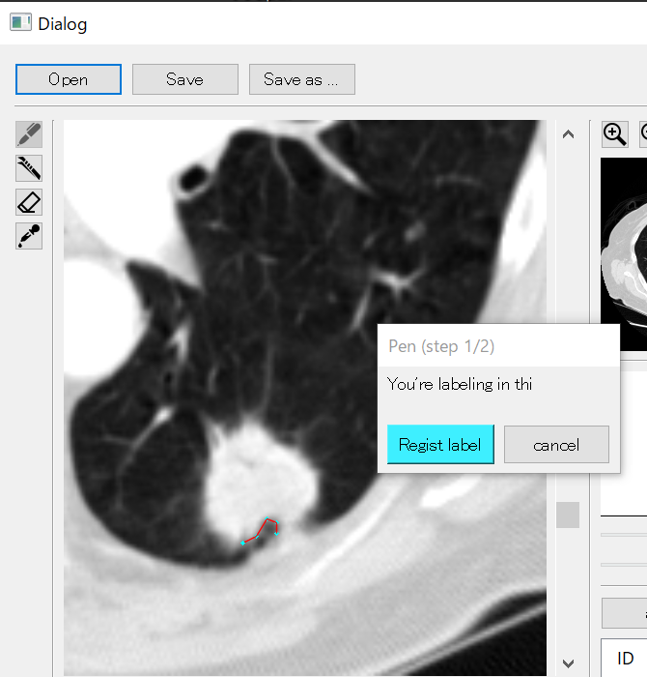

**5.2 finish pointing of the slide.**

When you finish labeling in one slide, click [Regist label] or right ckick.

The start and end of your points will be connected automatically

Temporarily, the label is saved but labeling has NOT completed yet.

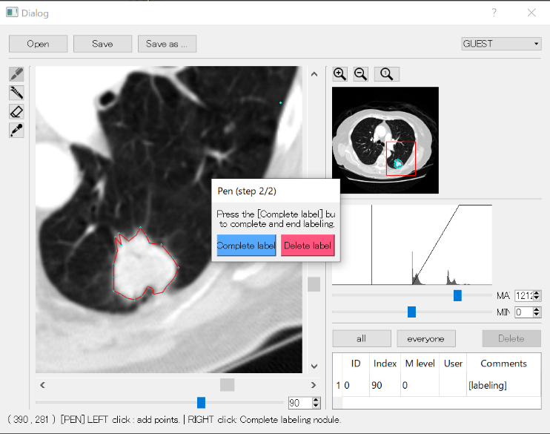

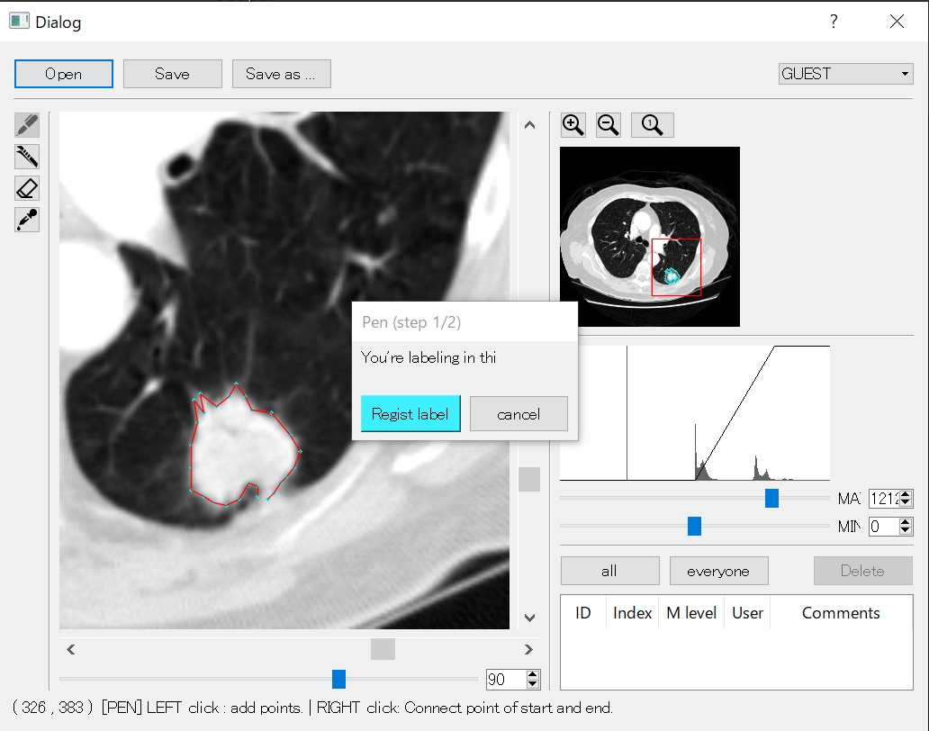

You can continue to label in other slices by click canvas.

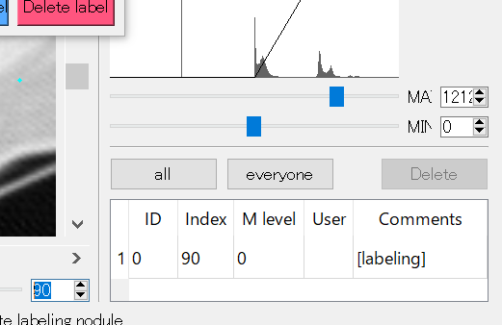

Temporary label is listed and saved.

**5.3 labeling some slices and finish labeling**

When you finish labeling all slices contain one nodule, please click [Complete label].

And fill out form about the nodule.

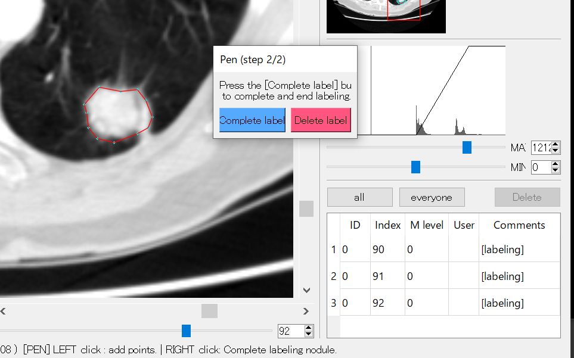

(Upper figure: There is 3 labels, you can set information at once by [Complete label])

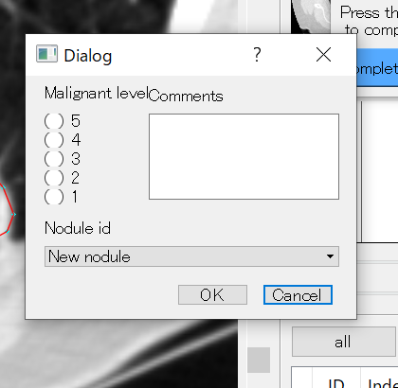

Please fill out [Malignant level].

