**Usability evaluation for Nodule_me 1.2**

**Q1. Are you doctor or radiologist?**

____NO_____

**Q2. Which tool do you use when you annotate nodule now?**

**Please answer name of the tool.**

ImageJ LabelMe Paint(Win) Labelbox VoTT ……

or No use

____ No use ____

If you choose “No use” at Q2.

Please try to use ImageJ and compare ImageJ to Nodule_me.

Please answer below question by from 1 to 5.

1: Strong Disagree

2: Disagree

3: Neither agree nor disagree

4: Agree

5: Strong Agree

**Q3. Nodule_me is easier to open DICOM data than Q2 tool.**

__3___

**Q4. Nodule_me is easier to** **adjust contrast of CT image than Q2 tool**

__4___

**Q5. Nodule_me is more helpful to take a close look at CT image than Q2 tool**

___4__

**Q6. Nodule_me is easier and more useful to annotate nodule in CT image than Q2 tool.**

___4__

**Q7. Nodule_me is easier to fix and edit annotate data than Q2 tool.**

___4__

**Q8. Nodule_me is easier to understand how to use than Q2 tool.**

___4___

**Q9. Please tell me where nodule_me is good.**

1. **调整对比度**
2. **能够放大某一部分区域**
3. **能够标注结节的恶性程度**

**1.adjust contrast**

**2. Ability to zoom in on an area**

**3. It can mark the malignancy of nodules**

**Q10. Please tell me where nodule_me is NOT good.**

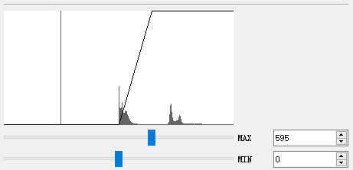

**1. 图中没有标明数值**

**Values are not shown in the figure**

I appreciate your cooperation for study. Thank you very much.