**Usability evaluation for Nodule_me 1.2**

**Q1. Are you doctor or radiologist?**

___No______

**Q2. Which tool do you use when you annotate nodule now?**

**Please answer name of the tool.**

ImageJ LabelMe Paint(Win) Labelbox VoTT ……

or No use

_ No use _______

If you choose “No use” at Q2.

Please try to use ImageJ and compare ImageJ to Nodule_me.

Please answer below question by from 1 to 5.

1: Strong Disagree

2: Disagree

3: Neither agree nor disagree

4: Agree

5: Strong Agree

**Q3. Nodule_me is easier to open DICOM data than Q2 tool.**

__3___

**Q4. Nodule_me is easier to adjust contrast of CT image than Q2 tool**

__5___

**Q5. Nodule_me is more helpful to take a close look at CT image than Q2 tool**

__4___

**Q6. Nodule_me is easier and more useful to annotate nodule in CT image than Q2 tool.**

__4___

**Q7. Nodule_me is easier to fix and edit annotate data than Q2 tool.**

__3___

**Q8. Nodule_me is easier to understand how to use than Q2 tool.**

___3___

**Q9. Please tell me where nodule_me is good.**

1. **调节对比度**
2. **能同时标注多个结节**
3. **Adjust the contrast**

**2. Mark multiple nodules at the same slice**

**Q10. Please tell me where nodule_me is NOT good.**

1. 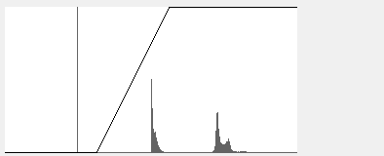

**这个框感觉没有任何意义**

1. 

**一下子不能理解这个滑动框的作用，希望能进行一个简单的注释**

**I can't understand the function of this sliding box at once, I hope to make a simple comment**

I appreciate your cooperation for study. Thank you very much.