Web Services

Table of Contents

1.1Characteristics 2
1.2Types of Web services (Technically) 2
2.1Architecture 3
2.2Roles in Web Services Architecture 4
2.3Artifacts in Web Services Architecture 4
2.4Operations in Web Services Architecture 4
2.5Components of XML web services 6
2.6Asynchronous Web service requests (jaxws:enableAsyncMapping) 8
2.7Top-down / bottom-up Development 11
2.8Some of the JAX-WS implementations 11
3.1REST Web service design structure 13
3.2REST Constraints 13
3.3AJAX and REST 14
3.4Some of the JAX-RS implementations 14
3.5Some of the RESTful web service providers 14
4.1Terminology 17
4.2Server/Service components 18
4.3Client components 20
4.4Wink Runtime 20
4.5JAX-RS Parameters 23
4.6JAX-RS Request and Response Entities 23
4.7JAX-RS Content Negotiation 23
4.8JAX-RS Context Information 23
4.9JAX-RS Resource Representations 24
5.1Example 25
6.1Example 25
7.1Example 25
8.1Java Specification Requirement 25
8.2Supporting Documents 25

Introduction

Web service is a method of communication between two software systems distributed over the web.
A Web service is a software system designed to support interoperable machine-to-machine interaction over a network. It has an interface described in a machine-processable format (specifically WSDL). Other systems interact with the Web service in a manner prescribed by its description using SOAP messages, typically conveyed using HTTP with an XML serialization in conjunction with other Web-related standards.
Web services are client and server applications that communicate over the WWW’s HTTP, provide a standard means of interoperating between software applications running on a variety of platforms and frameworks.

Characteristics
- Platform and language independent
- Provides great interoperability and extensibility
- XML based (only xml web services)
- Loosely coupled
- Coarse-grained
- Ability to be synchronous or asynchronous

Types of Web services (Technically)
- Big/ XML Web services (JAX-WS)
- Big web services use XML messages that follow the Simple Object Access Protocol (SOAP) standard.
- SOAP is a protocol.
- Useful in enterprise application integration scenarios those have advanced Quality of Service (QoS) and support for WS-* set of protocols requirements.
- RESTful Web services (JAX-RS)
- A new approach to systems architecture and a lightweight alternative to XML web services.
- JAX-RS provides the functionality for REpresentational State Transfer (RESTful) web services.
- REST is an architectural style of client-server application centred around the transfer of representations of resources through requests and responses.
- Useful for integration over the web (web application integration) because it’s easier for many types of clients to consume RESTful web services while enabling server side to evolve and scale.

Big/XML Web service (JAX-WS)

Architecture

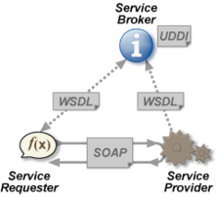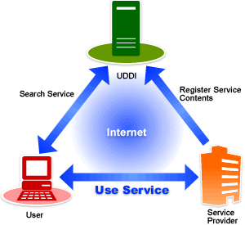
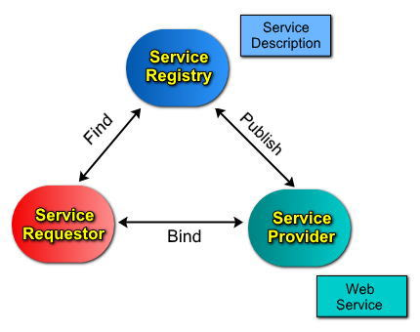

Roles in Web Services Architecture
- Service Provider (Provider of the web service)
The service provider implements the service and makes it available on the internet.
They (providers) publish WSDL on service registry/UDDI.
- Service Requester (Consumer of the web service)
The service requester finds the existing web services at registry/UDDI and binds with service provide by sending an XML request.
They (consumers) find WSDLs at UDDI and bind with provider by sending SOAP/ XML-RPC.
- Service Registry (Centralized directory of services)
The registry provides the central place where developers can publish new services or find existing ones.
They (UDDIs) maintain WSDLs.

Artifacts in Web Services Architecture
- Service
A service is a software component deployed on network-accessible platforms provided by service provider.
- Service Description
A service description contains the details of interface and implementation of the service. This includes its data types, operations, binding information and network location.

Operations in Web Services Architecture
- Publish
Publication of service descriptions.
- Find
Lookup or finding of service descriptions.
- Bind
Binding or invoking of services based on service description.

Components of XML web services

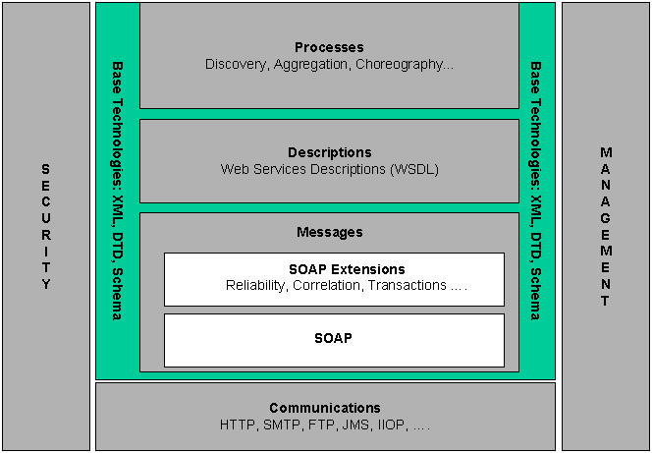
- SOAP
- Stands for Simple Object Access Protocol
- XML language defining message architecture and message formats
- Platform and language independent
- XML based communication protocol
- W3C standard

SOAP is a protocol specification for exchanging structured information and relies on other application layer protocols (e.g.: HTTP, FTP, SMTP, etc.) for message transmission.

A SOAP message is an ordinary XML document containing the following elements/parts:
Element | Description | Required
Envelope | Identifies the XML document as a SOAP message. | Yes
Header | Contains header information. | No
Body | Contains call and response information. | Yes
Fault | Provides information about errors that occurred while processing the msg. | No

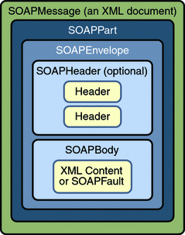

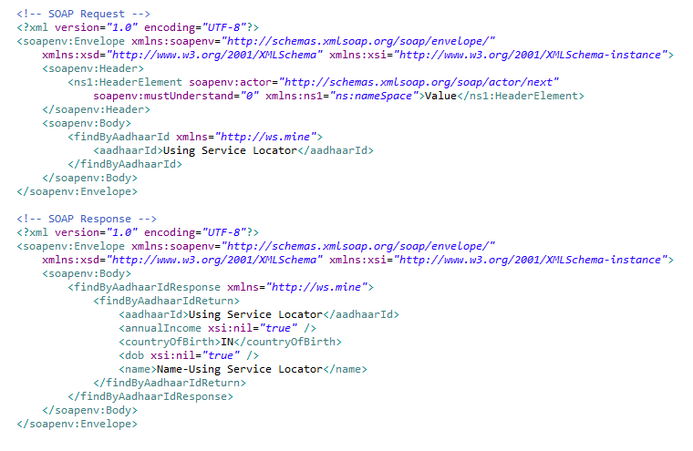

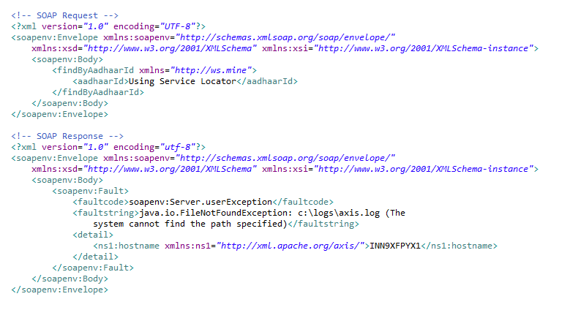

- UDDI
- Stands for Universal Description, Discovery and Integration
- XML based standard for describing, publishing, and finding web services
- Specification for a distributed registry of Web services
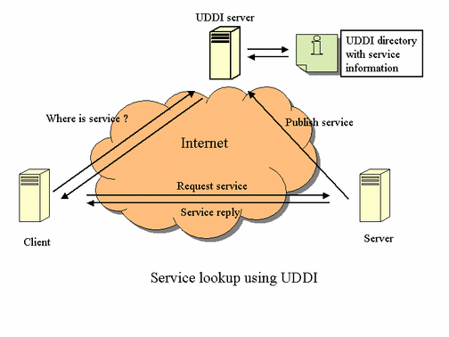

- WSDL
- Stands for Web Services Description Language
- XML based language for describing web services and how to access them
- XML for defining interfaces syntactically. It can be used to describe the details of the contract, which may include messages, operations, bindings, and the location of the web service.
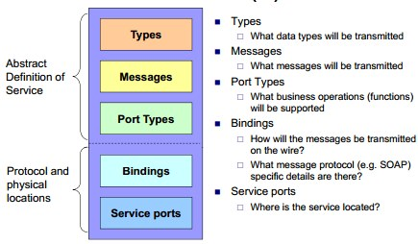

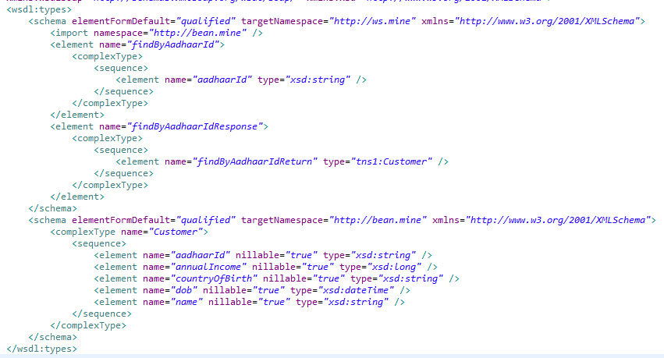

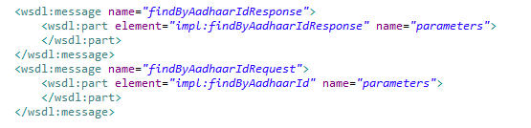
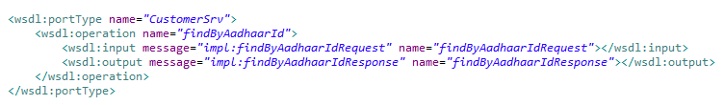

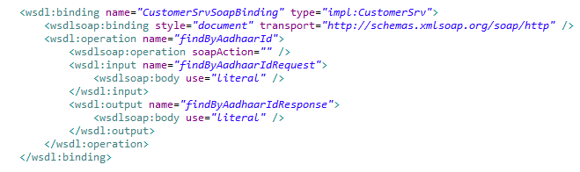

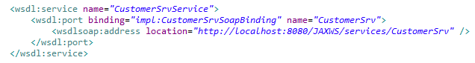

Web service specifications: “WS-“is a prefix used to indicate specifications associated with Web Services and there exist many WS* standards including WS-Addressing, WS-Discovery, WS-Federation, WS-Policy, WS-Security, and WS-Trust.[2] This page includes many of the specifications that might be considered a part of "WS-*".

Asynchronous Web service requests (jaxws:enableAsyncMapping)

An asynchronous invocation of a Web service sends a request to the service endpoint and then immediately returns control to the client program without waiting for the response to return from the service.

JAX-WS API provides support for invoking Web services using an asynchronous client invocation using either the callback model or the polling model.

Using a polling model, a client can issue a request and receive a response object that is polled to determine if the server has responded. When the server responds, the actual response is retrieved.

Using the callback model, the client provides a callback handler to accept and process the inbound response object. The handleResponse() method of the handler is called when the result is available.

Both the polling and callback models enable the client to focus on continuing to process work without waiting for a response to return.

We can enable or disable asynchronous support by adding an element jaxws:enableAsyncMapping in WSDL.
Embedded binding declaration:
<jaxws:bindings xmlns:jaxws="http://java.sun.com/xml/ns/jaxws">
<jaxws:enableAsyncMapping>true</jaxws:enableAsyncMapping>
</jaxws:bindings>
Contexts of jaxws:enableAsyncMapping:
- wsdl:definitions
If present with a Boolean value of true, asynchronous mappings are enabled else disabled by default (false) for all operations.
< wsdl:definitions>
// Embed jaxws bindings
</wsdl:definitions>
- wsdl:portType
If present with a Boolean value of true, asynchronous mappings are enabled else disabled by default (false) for all operations in this wsdl:portType.
< wsdl:portType>
// Embed jaxws bindings
</wsdl:portType>
- wsdl:portType>>wsdl:operation
If present with a boolean value of true, asynchronous mappings are enabled by default for this wsdl:operation.
<wsdl:operation>
// Embed jaxws bindings
</wsdl: operation>
Polling Model (javax.xml.ws.Response)
A polling method returns a typed Response<ResponseBean> that may be polled using methods inherited from Future<T> to determine when the operation has completed and to retrieve the results.
javax.xml.ws.Response – An interface provides methods used to obtain the payload and context of a message sent in response to an operation invocation. Response extends Future<T> to provide asynchronous result polling capabilities.
SEI (Service Endpoint Interface) extract without Async Support:
public MyResponseBean operationName(java.lang.String reqParam);
SEI extract with Async Support:
public Response<MyResponseBean> operationNameAsync(java.lang.String reqParam);
Callback Model (javax.xml.ws.AsyncHandler)
A callback method takes an additional final parameter that is an instance of a typed AsyncHandler<ResponseBean> and returns a wildcard Future<?> that may be polled to determine when the operation has completed.
javax.xml.ws.AsyncHandler – An interface is implemented by clients that wish to receive callback notification of the completion of service endpoint operations invoked asynchronously.
SEI extract with Async Support:
public Future<?> operationNameAsync(java.lang.String reqParam, AsyncHandler<MyResponseBean> myAsyncHandler);
SEI generated without asynchronous support (using Axis):
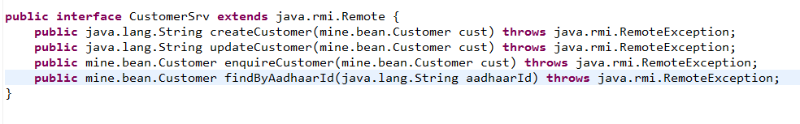
SEI generated with asynchronous support (using CFX):
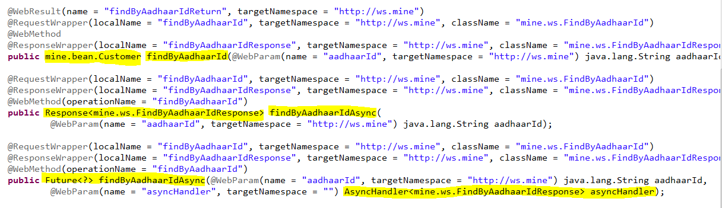
AsyncHandler Implementation:
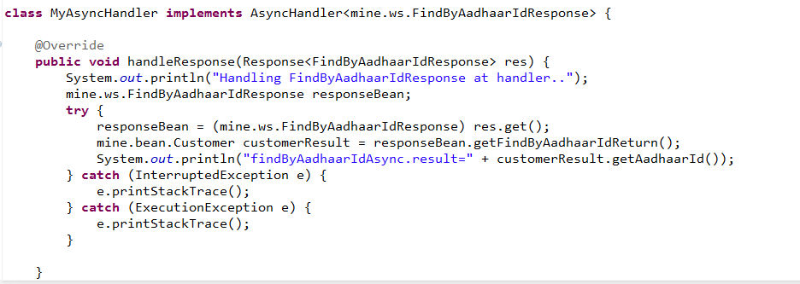

Top-down / bottom-up Development
Top-down development involves creating a Web service from a WSDL file.
Bottom-up development involves creating a Web service from a Java Bean or enterprise bean.
Although bottom-up development is faster and easier, the top-down approach is the recommended way of creating Web services.
By creating the WSDL file first you will ultimately have more control over the Web service and can eliminate interoperability issues arise when using bottom-up approach.

Some of the JAX-WS implementations
- Apache CXF (Celtix and XFire), an open source Web service framework.
- Apache Axis2, an open source Web service framework.
- Metro Project (Reference Implementation), in GlassFish.
- JBossWS, in JBossAS.

Representational State Transfer (REST)

Representational State Transfer (REST) is an architectural style of client-server application centred on the transfer of representations of resources through requests and responses.
REST web services are "Resources" that are identified by unique URIs. These resources are accessed and manipulated using a set of "Uniform methods". Each resource has one or more "Representations" that are transferred between the client and the service during a web service invocation.
The REST style is an abstraction of the architectural elements within a distributed hypermedia system.
REST is a hybrid style derived from several of the network-based architectural styles.
REST ignores the details of component implementation and protocol syntax in order to focus on the roles of components, the constraints upon their interaction with other components, and their interpretation of significant data elements.
RESTful web services are loosely coupled, lightweight web services that are particularly well suited for creating APIs for clients spread out across the internet.
The REST architectural style is designed to use a stateless communication protocol, typically HTTP. In the REST architecture style, clients and servers exchange representations of resources by using a standardized interface and protocol.
In the REST architectural style,
- Data and functionality are considered resources and are accessed using Uniform Resource Identifiers (URIs), typically links on the Web.
- The resources are represented by documents, and are acted upon by using a set of simple, well-defined operations.

For example, a REST resource might be the current weather conditions for a city. The representation of that resource might be an XML document, or an image file, or an HTML page. A client might retrieve a particular representation, modify the resource by updating its data, or delete the resource entirely.

REST Web service design structure

REST architecture components
- Resources, which are identified by logical URLs. Both state and functionality are represented using resources.
- A web of resources, meaning that a single resource should not be overwhelmingly large and contain too fine-grained details. Whenever relevant, a resource should contain links to additional information -- just as in web pages.
- The system has a client-server, but of course one component's server can be another component's client.
- There is no connection state; interaction is stateless (although the servers and resources can of course be stateful). Each new request should carry all the information required to complete it, and must not rely on previous interactions with the same client.
- Resources should be cacheable whenever possible (with an expiration date/time). The protocol must allow the server to explicitly specify which resources may be cached, and for how long.
- Proxy servers can be used as part of the architecture, to improve performance and scalability.

REST Constraints
The REST architectural style describes the following six constraints applied to the architecture, while leaving the implementation of the individual components free to design.
- Client-Server
A uniform interface separates clients from servers, this separation of concern means that clients are not concerned with data storage.
- Stateless
No client context being stored on the server between requests.
- Cacheable
Clients can cache responses to improve client-server interactions.
- Layered system
A client cannot tell whether it is connected directly to server or to an intermediary on the way.
- Code on demand (optional)
Transfer an executable code to client to extent or customize functionality.
- Uniform interface
The uniform interface between clients and servers simplifies and decouples the architecture, which enables each part to evolve independently.

AJAX and REST
Ajax is web development technique that makes web pages interactive using JavaScript. In many ways, AJAX applications follow the REST design principles. Each XMLHttpRequest can be viewed as a REST service request, sent using GET.

Some of the JAX-RS implementations
- Apache CXF (Celtix and XFire), an open source Web service framework.
- Jersey, the reference implementation from Sun (now Oracle).
- RESTeasy, JBoss's implementation.
- Restlet, created by Jerome Louvel.
- Apache Wink, Apache Software Foundation Incubator project.

Some of the RESTful web service providers
- The Google Glass API, known as "Mirror API", is a pure REST API.
- Twitter has a REST API.
- Flickr.
- Amazon.com offer several REST services (S3 storage solution)
- Atom is a RESTful alternative to RSS.

RESTful Web Service (JAX-RS) By Apache Wink
Apache Wink is a framework for implementing and consuming REST based Web Services.
- Wink consists of a server module for developing REST services, and of a client module for consuming REST services.
- Wink separates the low-level protocol aspects from application aspects.
- Wink provides the features in addition to JAX-RS (JSR 311).
JAX-RS (Java API for RESTful Web services) is a Java programming API that provides support in creating web services compliance to the REST architectural style. JAX-RS uses annotations to simplify the development and deployment of web service clients and endpoints.
Figure 4.1: REST Web service design structure

Figure 4.2: Resource Representations

Figure 4.3: Apache Wink Logic Flow

Terminology

Resource class
A resource class is a Java class (POJO) that uses JAX-RS annotations to implement a corresponding Web resource. Resource classes are POJOs that have at least one method annotated with @Path or a request method designator (@GET, @POST,..).
Root resource class
A resource class annotated with @Path. Root resource classes provide the roots of the resource class tree and provide access to sub-resources.
Root resources Java class instances are created per request to that resource by default. First the constructor is called, then any requested dependencies are injected, then the appropriate method is invoked and finally the object is made available to the garbage collection.
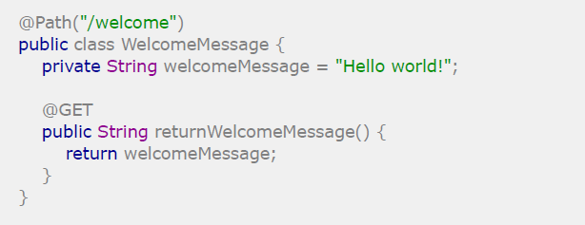
Resource method
Resource methods are public methods of a resource class annotated with a request method designator (@GET, @POST,.) that is used to handle requests on the corresponding resource.
Resource classes have methods that are invoked when specific HTTP method requests are made, referred to as resource methods. In order to create Java methods that will be invoked with specific HTTP methods, a regular Java method must be implemented and annotated with one of the JAX-RS @HttpMethod annotated annotations (namely, @GET, @POST, @PUT, and @DELETE).
Sub-resource method
Sub-resource methods are Java methods with a @Path annotation and a @HttpMethod annotated annotation (@GET, @POST, @PUT, @DELETE). They are used to handle requests on a sub-resource of the corresponding resource.
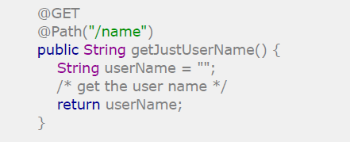
Sub-resource locator
Sub-resource locators are Java methods which have only @Path annotation. They are different than sub-resource methods because they do not have any HTTP method annotation.
They are used to locate sub-resource of the corresponding resource, particularly useful when requests must be further resolved by other objects.
A sub-resource locator returns an object that has JAX-RS annotations on its methods (or inherits them). The object is used to further resolve the incoming requests by dynamically inspecting the object for JAXRS annotations.
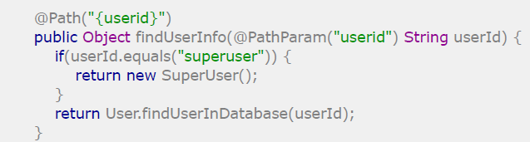
Request method designator
Request method designator is a runtime annotation annotated with @HttpMethod. It is used to identify the HTTP request method to be handled by a resource method.
The built-in annotations annotated with @HttpMethod are @GET, @POST, @PUT, and @DELETE.
JAX-RS Application
JAX-RS Application is a Java class extends javax.ws.rs.core.Application, used for obtaining user defined resources and providers.
Provider
A provider is a class that is annotated with the @Provider annotation and implements one or more interfaces defined by the JAX-RS specification.
Provider is an implementation of a JAX-RS extension interface. Provider extends the capabilities of a JAX-RS runtime.
Providers convert data into a specific format, supply contexts to resource classes, or map exceptions into an instance of Response class.
There are three types of providers defined by the JAX-RS specification:
• Entity Providers
• Context Providers
• Exception Mapping Provider

Server/Service components

Resource
A resource represents a serviceable component for the retrieval and manipulation of data.
A resource class implements a resource by defining the resource methods that handle requests by implementing the business logic.
A resource is bound or anchored to a URI space by annotating the resource class with the @Path (/resourcePath) annotation.
The resource methods are public methods of a resource class (and bound to a HTTP request method) annotated with a request method designator (@GET, @POST,.) that is used to handle requests on the corresponding resource.
Resource Method Return Type
Resource methods may return void, Response, GenericEntity, or another Java type, these return types are mapped to a response entity body.
- void – Results in an empty entity body with a status code 204 (No Content)
- Response – Results in an entity body mapped from the property of the Response (with status code 204, if not given).
- GenericEntity - Results in an entity body mapped from the property of the Entity.
- Other - Results in an entity body mapped from the property of the returned instance.
In all of the last 3 cases, server returns status code as 204 (No Content), if not set.
Providers
A provider is a class that is annotated with the @Provider annotation and implements one or more interfaces defined by the JAX-RS specification.
Provider is an implementation of a JAX-RS extension interface. Provider extends the capabilities of a JAX-RS runtime.
Providers convert data into a specific format, supply contexts to resource classes, or map exceptions into an instance of Response class.
There are three types of providers defined by the JAX-RS specification:
- Entity Providers
- Context Providers
- Exception Mapping Providers
Entity Provider
A class, implements javax.ws.rs.ext.MessageBodyWriter and/or javax.ws.rs.ext.MessageBodyReader, converts server data into a specific format specified by client and/or converts a client request data into server data.
E.g.: A string entity provider can convert message body into a Java type (java.lang.String) vice versa.

Context Provider
A class, implements javax.ws.rs.ext.ContextResolver, supplies contexts to resource classes and other providers.
E.g.: A JAXPContext is required to serialize or deserialize JAXB objects.
Exception Mapping Provider
A class, implements javax.ws.rs.ext.ExceptionMapper, maps exceptions into an instance of a javax.ws.rs.core.Response.
The response object can contain response information such as status codes, HTTP headers, and message body.

URI Dispatching
RESTful resources are identified by URIs in most cases related resources have URIs that share common path elements.
The REST servlet uses the “Request processor” and the request URI in order to find, match and invoke the correct resource method.
The HTTP request is match to the Resource method based on the HTTP request parameters, the Resource method definitions and the MIME type.
Figure 4.4: URL Request Handling

Client components

Figure 4.5: Apache Wink Client Flow

Wink Runtime
The Apache Wink runtime is deployed on JEE environment and configured by defining the RestServlet in the web.xml. This RestServlet is the entry point of all the HTTP requests targeted for web services, and passes the request to Wink engine and sends back the response to clients.
Figure 4.6: Apache Wink Request Processor Architecture
Request Processor
The request processor is the Apache Wink engine, that is initialized by RestServlet and is populated with an instance of DeploymentConfiguration.
When a request is passed to the HandleRequest() method of the RequestProcessor, a new instance of a MessageContext is created.
The MessageContext contains all of the information that is required for the Wink runtime to handle the request.
The RequestProcessor first invokes the Requester Handler Chain and then Response Handler Chain. If an exception occurs during any stage of request processing, the RequestProcessor invokes the Error Handler Chain for processing the exception.
Deployment Configuration
The deployment configuration holds the runtime configuration, including the handler chains, registries, configuration properties.
It is initialized with an instance of a JAX-RS Application used for obtaining user resources and providers
Handler Chains
The handler chain pattern is used for implementing core functionalities of Wink engine.
There are three handler chains used by Wink engine:
- RequestHandlersChain
- ResponseHandlersChain
- ErrorHandlersChain
Registries
The registries are used to maintain resources and providers in a sorted state according to JAX-RS.
Resource Registry
The resources registry maintains all of the root resources in the form of Resource Records.
A Resource Record holds the following,
  - URI template processor – Associated with a resource for matching resource.
  - Resource meta-data – meta-data collected from the resource annotations.
  - Sub-resource records – records of all the sub-resources (methods and locators) collected from sub-resource annotations.
  - Resource factory – retrieves an instance of the resource.

JAX-RS Parameters
Parameters are used to pass and add additional information to a request.
Query Parameters (@QueryParam)
Extracts the value of a URI query parameter.
Path Parameters (@PathParam)
Extracts the value of a URI template parameter.
Matrix Parameters (@MatrixParam)
Extracts the value of a URI matrix parameter
Header Parameters (@HeaderParam)
Extracts the value of a header.
Cookie Parameters (@CookieParam)
Extracts the value of a cookie.

JAX-RS Request and Response Entities

JAX-RS Content Negotiation
Using URIs to identify content type
Using parameters to identify content type
Using Accept headers

JAX-RS Context Information

JAX-RS provides facilities for obtaining and processing information about the application deployment context and the context of individual requests through @Context annotation. Such information is available to Application subclasses, root resource classes, and providers.

An annotation @Context injects an instance of a supported resource.

In addition to request parameters and entities, there is more request information that can be accessed via request @Context injected variables. When a resource method is invoked, the runtime injects the @Context variables.

HTTP Headers
URI Information
Security Information
Request
Providers

JAX-RS Resource Representations
Json (JavaScript Object Notation)
Atom
APP (Atom Publishing Protocol)
RSS (Really Simple Syndication)
HTML
CSV
OpenSearch
MultiPart

Building Web Services with JAX-WS

Example

Building Web Services with JAX-RS

Example

Web services in Java SE 6+ platform

Example

Appendix

Java Specification Requirement

Supporting Documents

