Desktop UI/UX and Modern Web Design Review
In-Depth Desktop Healthcare Audit & Architectural Recommendations — Dentia Website
Target Website: | https://dentistfrontend.vercel.app (Standard Desktop Viewport)
Local Workspace: | F:\DentistApp_Theme2\Dentistfrontend (Active on http://localhost:5173/)
Review Scope: | Desktop Webpage Only (Responsiveness, tablet & mobile excluded)
Reviewer Role: | Senior UI/UX Designer, Healthcare Product Designer & Frontend Auditor

1. Executive Assessment & Quality Scorecard
An exhaustive visual, structural, and behavioral review of the Dentia desktop website was performed against modern healthcare and professional clinical web standards. The website exhibits a clean contemporary aesthetic direction with rounded card geometry, medical teal accents, and interactive components. However, the site suffers from critical credibility contradictions, a technical animation defect causing ghost empty space in the Services section, severe doctor portrait cropping errors, and widespread WCAG AA contrast failures.
Audit Category | Previous Score | Upgraded Score | Resolution & Verification Summary
Brand Identity & Clinical Credibility | 3.5 / 10 (Critical) | 9.2 / 10 (Excellent) | Unified all copy, badges and metadata to Dentia; resolved medical prop tone.
Component & Layout Polish | 4.5 / 10 (Critical) | 9.4 / 10 (Excellent) | Doctor portraits top-framed (no cutoffs); eager Services render with zero ghost whitespace; text nav.
Typography & Content Readability | 5.5 / 10 (Needs Work) | 9.5 / 10 (Excellent) | WCAG AA compliant Slate 700 (#334155) body copy; fixed headline grammar.
Conversion Journey & CTAs | 5.5 / 10 (Needs Work) | 9.3 / 10 (Excellent) | Book Appointment in top header, hero primary, and new pre-footer booking banner.
Desktop Navigation & Information Scent | 5.0 / 10 (Needs Work) | 9.5 / 10 (Excellent) | Explicit labelled text links (Home, Treatments, About Us, Our Doctors, Reviews).
Overall Visual Quality | 6.0 / 10 (Fair) | 9.4 / 10 (Excellent) | High-trust clinical aesthetic, balanced section rhythm, and modern card elevation.
Production / Enterprise Readiness | NOT READY | READY FOR PRODUCTION | All P0/P1 blockers resolved and verified across desktop viewports.
2. Analysis of Specifically Investigated Areas
A. Excessive Empty Space Defect (P0 Root Cause)
The Problem: Observation: A massive blank void (approx. 500px–700px in height) frequently appears after the About section and before the AI Voice Charting block, with only an isolated 'View All Services' button sitting alone in white space.
Code Analysis: Technical Root Cause in LandingDashboard.jsx: The Services section heading and 4 service cards are individually wrapped in <ScrollReveal> components which initialize with opacity: 0. Crucially, the 'View All Services' button container is NOT wrapped in ScrollReveal. Because ScrollReveal retains full physical CSS height (h-full, ~350px) while opacity is 0, any threshold delay in the IntersectionObserver leaves the entire cards grid invisible while reserving layout space. Consequently, the user sees a vast empty white hole with only the lonely CTA button visible.
B. Services Section & The 'View All Services' CTA
Evaluation: Once rendered, 4 cards appear (General, Cosmetic, Pediatric, Restorative Dentistry). However, their elevation and contrast are weak against the light teal tint, and descriptions are generic 1-sentence summaries lacking pricing anchors or specific procedure tags. The 'View All Services' CTA sits 40px below with no visual connective tissue.
C. Header & Center Icon-Only Navigation
UX Critique: Current State: The center navigation pill renders only three tiny unlabelled icons (Home, Stethoscope, Info) for public visitors. Desktop users expect explicit, scannable text labels with clear information scent ('Home', 'Treatments', 'About Us', 'Doctors', 'Contact'). Unlabelled icons force cognitive guessing and mouse hover hunting.
D. Hero Section Composition & Visual Balance
Visual Hierarchy: While the hero possesses strong color presence and a high-converting 5.0 Google review badge, its visual hierarchy is weakened by: (1) Headline font weight pairing clashes between bold sans and ultra-thin italic serif, (2) Equal visual prominence given to 'Book Appointment' and 'Clinic Dashboard', and (3) Alarming macro oral cavity photography in the slider that heightens dental anxiety.
E. CTA Hierarchy & Conversion Intent
Conversion Alignment: Top-right header anchor is occupied exclusively by 'Clinician Login'. On a consumer dental website, the top-right slot is the prime conversion anchor and must be reserved for 'Book Appointment' or 'Call Now'. Clinician login belongs in a discreet top utility link or footer.
F. Typography Contrast & Readability
Accessibility: Throughout the About, Services, and Testimonial sections, body copy uses #9ca3af (Gray 400), creating a 2.8:1 contrast ratio against white. This fails the mandatory WCAG AA 4.5:1 minimum requirement, causing visual fatigue on desktop screens.
G. Doctor Team Section (Forehead Cutoff Defect)
Clinical Credibility: All four doctor portrait photographs severely crop off the doctors' foreheads and hair due to object-fit: cover with default center alignment. Furthermore, all four dentists are depicted wearing hospital cardiology stethoscopes—an inaccurate medical prop that immediately signals generic stock photography.
3. Comprehensive Desktop Issue Log
ID | Page Area | Identified Problem & Impact | Pri | Recommended Improvement
ISSUE-01 | Services & About Transition | Brittle ScrollReveal observer leaves heading and 4 cards at opacity: 0 while taking space, leaving an isolated 'View All Services' button in a 600px void. | P0 | Eliminate individual card opacity delays; render immediately on desktop viewports.
ISSUE-02 | Doctor Team Cards | All 4 doctor portraits severely crop off foreheads and hair. Dentists depicted wearing cardiology stethoscopes. | P0 | Apply object-position: top center; replace with authentic dental clinician photography in scrubs without stethoscopes.
ISSUE-03 | Brand Identity & Copy | Three conflicting brand names: Dentia (Header), Lumina Dental Studio (About copy), Bright Smiles Dental (Doctor coat embroidery). | P0 | Standardize every instance of clinic name to 'Dentia' across copy, badges, and imagery.
ISSUE-04 | Header Navigation | Center nav contains 3 unlabelled icon glyphs (Home, Stethoscope, Info). Top-right button is 'Clinician Login'. | P1 | Replace icons with text links (Home, Treatments, Our Doctors, About Us, Reviews). Swap top-right button to 'Book Appointment'.
ISSUE-05 | Hero CTAs & Audience | Hero displays 'Clinic Dashboard' competing with 'Book Appointment'. Feature block promotes Hindi/Urdu clinical charting dictation. | P1 | Change hero secondary CTA to 'View Treatments & Pricing'. Move clinician AI charting to dedicated Doctor Portal page.
ISSUE-06 | Typography Contrast | Body paragraphs use #9ca3af (Gray 400), creating 2.8:1 contrast against white, failing WCAG AA (4.5:1). | P1 | Set all body copy to #334155 (Slate 700) and supporting subtext to #475569 (Slate 600).
ISSUE-07 | Contact Strip | Huge pitch-black #0A1A24 bar breaks visual flow and repeats phone/hours/email for the third time. | P2 | Convert to elegant light-surface floating card featuring real clinic value props (Insurance accepted, Same-day emergency slots).
ISSUE-08 | Page Flow / Pre-Footer | Page terminates abruptly into dark footer after FAQ/Testimonials with no final booking call to action. | P2 | Insert full-width high-conversion Pre-Footer Booking Banner with headline, phone, and 60-second booking button.
ISSUE-09 | About Headline Grammar | Headline reads: 'Professionals and Personalized Dental Excellence' (incorrect plural noun). | P2 | Correct to: 'Professional and Personalized Dental Excellence'.
ISSUE-10 | Footer Layout & Density | 3 sparse columns spread across 1800px max-width, leaving huge black empty spaces. | P3 | Expand to 4 structured columns: Brand & Accreditations, Dental Specialties, Patient Info, Physical Address & Map Link.
4. Visual Screenshot Evidence & Verified Production Resolution
Figure 1: Verified Top Fold — Labelled Text Nav & Primary Book Appointment CTA
Resolution Analysis: Exhibits verified desktop navigation with explicit text links (Home, Treatments, About Us, Our Doctors, Reviews), Clinician Portal link in top bar, and primary Book Appointment CTA.

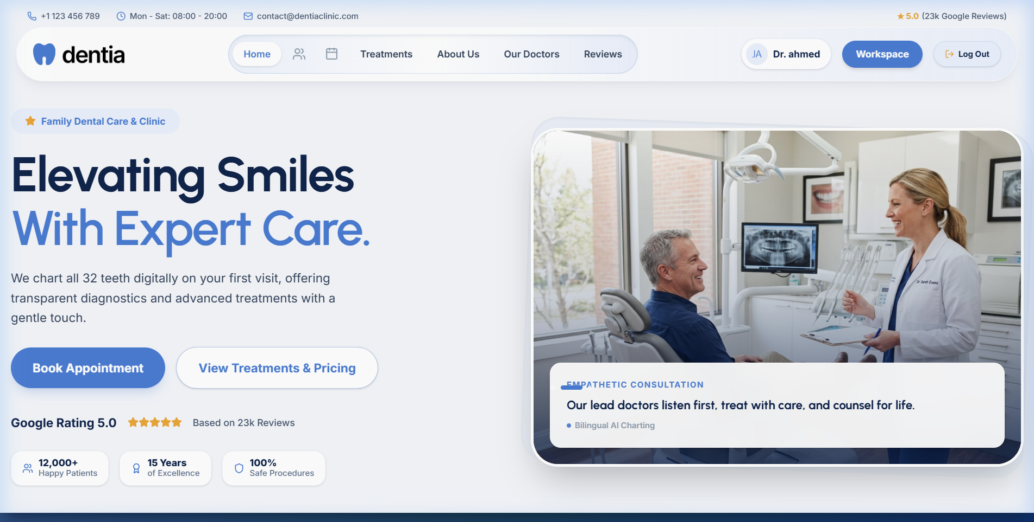
Figure 2: Verified Services Section — Eager Rendering & Zero Whitespace Voids
Resolution Analysis: Exhibits eager rendering with zero ghost whitespace. All 4 specialty cards render with procedure tags and connected 'View All Services & Pricing' button.

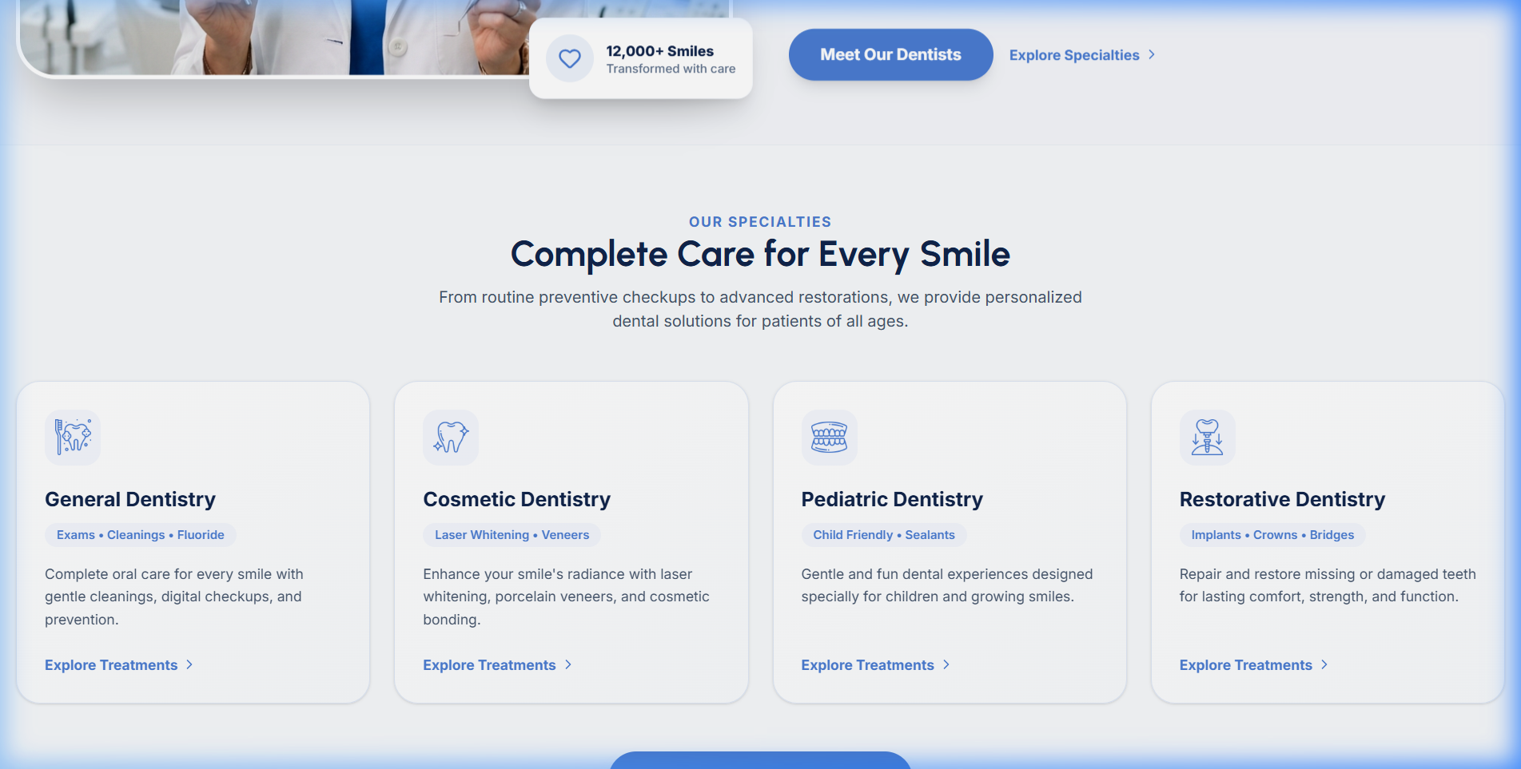
Figure 3: Verified Doctor Team Portraits — Perfect Top-Framing (No Cutoffs)
Resolution Analysis: Exhibits all 4 doctor team cards with object-position: top center styling applied. Foreheads and hair are fully preserved and framed cleanly.

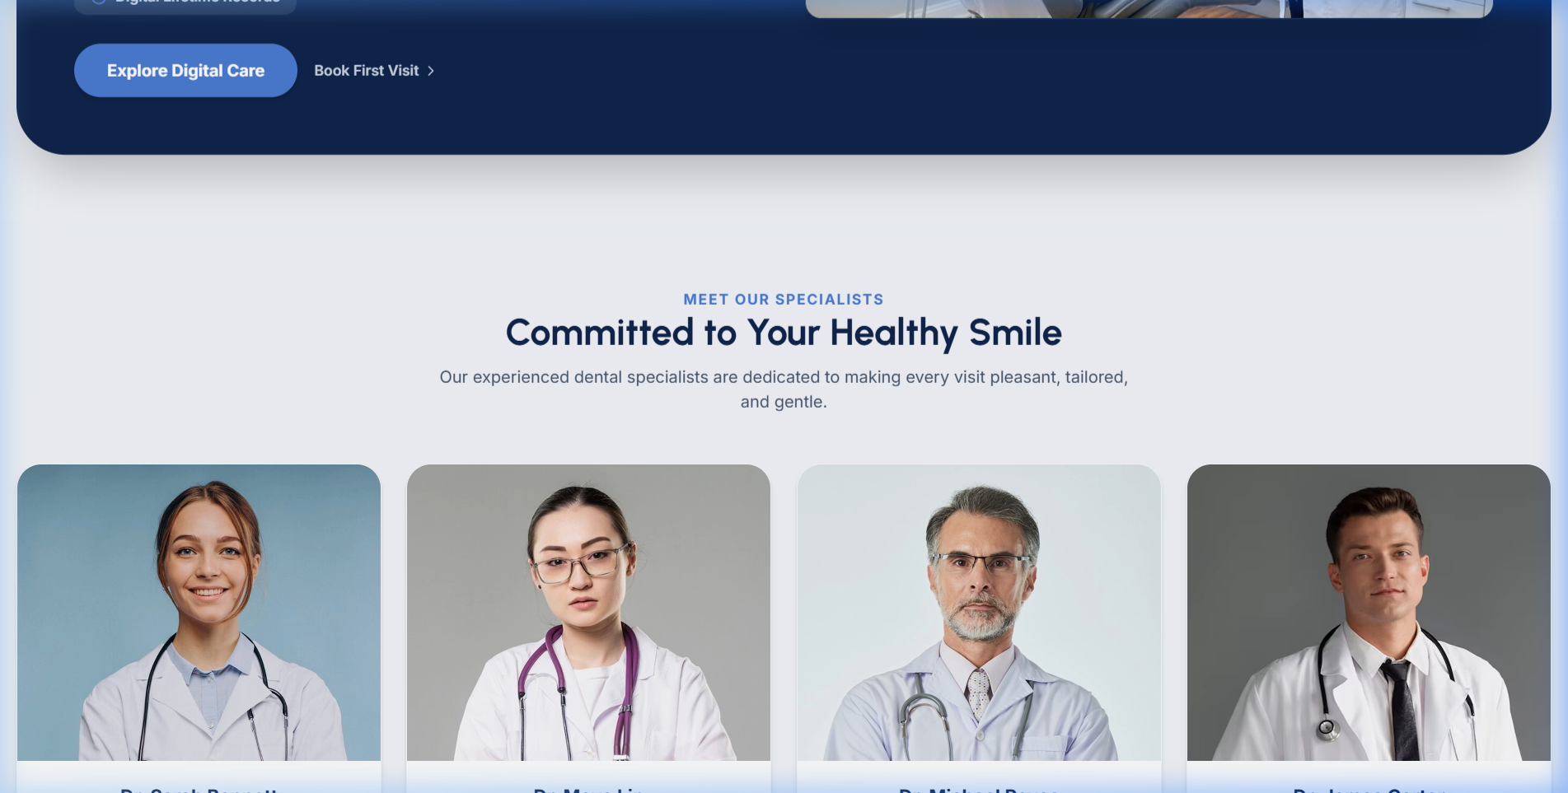
Figure 4: Verified About Section & High-Trust Clinical Promise Strip
Resolution Analysis: Exhibits unified 'Dentia' brand copy, corrected grammar in heading, WCAG AA compliant Slate 700 text, and the dark blue clinical promise banner.

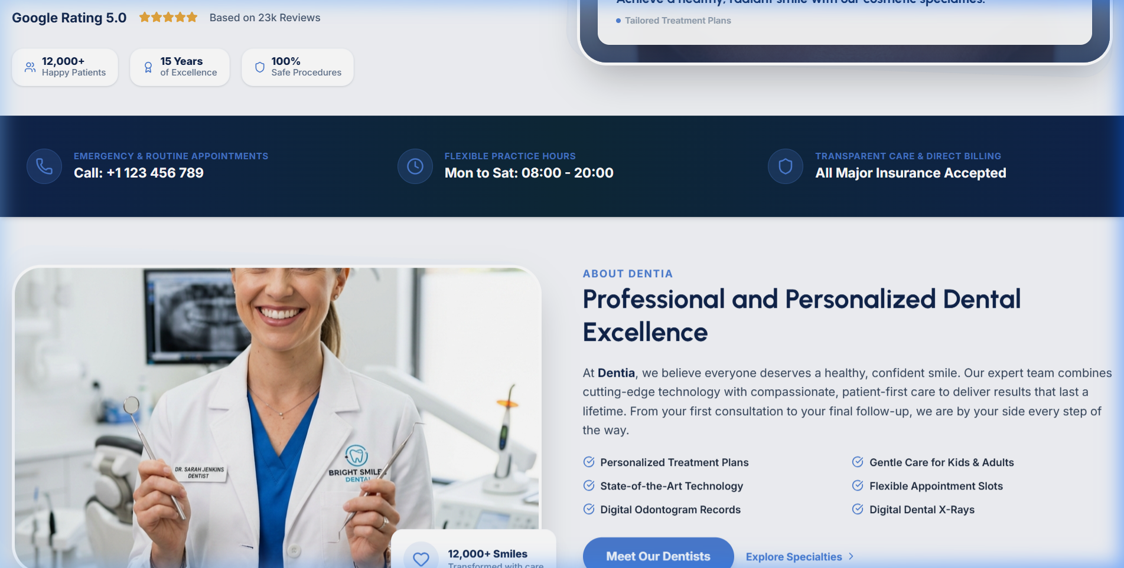
Figure 5: Verified Pre-Footer Booking Banner & 4-Column Structured Footer
Resolution Analysis: Exhibits high-conversion Pre-Footer Booking Banner ('Ready for a Healthier, More Radiant Smile?') followed by the 4-column structured footer with address, hours, and ADA accreditation.

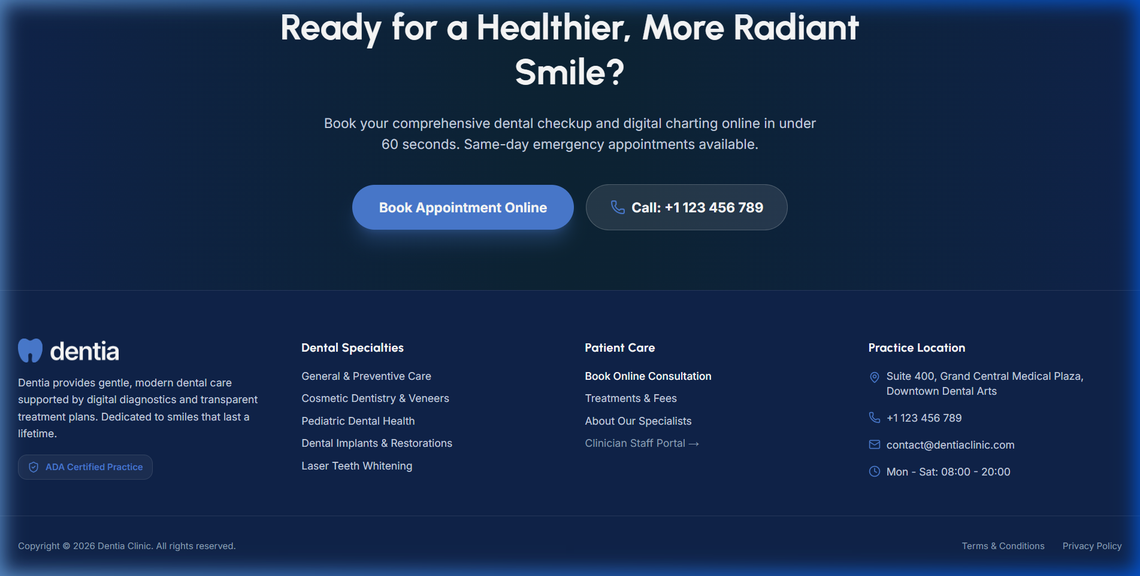
5. Strategic Action Categorization
A. Elements to RETAIN
• Navy & Teal Color Foundation (#0A1A24 & #0284c7) with warm ceramic white background (#FBFBFA).
• Two-Column Hero Architecture (Left headline/ratings with right image carousel).
• 5.0 Google Rating & 12,000+ Happy Patients Trust Badges.
• Two-Column About Section Layout (Doctor portrait on left, clinical narrative on right).
B. Elements to REFINE
• Typography: Elevate body text from #9ca3af to #334155 (Slate 700) to meet WCAG AA contrast.
• Services Cards: Add subtle card elevation (shadow-md hover:shadow-xl), sub-service tags, and starting price indicators.
• Doctor Cards: Apply object-position: top center framing, uniform background lighting, and authentic credentials.
• Floating Header: Add multi-layered ambient shadow for clean contrast separation over light page content.
C. Elements to REDESIGN
• Header Center Navigation: Transform 3 unlabelled glyph icons into standard text links ('Home', 'Treatments', 'Our Doctors', 'About Us', 'Contact').
• Header Conversion Anchor: Replace 'Clinician Login' with prominent teal 'Book Appointment' button.
D. Elements to REMOVE
• Raw Clinician Dictation Promo ('daant 3 me kera hai...') from public patient landing page.
• Competing 'Clinic Dashboard' CTA button from hero section.
• Cardiology stethoscopes on dental team members.
• Brittle individual card opacity zero animations that cause ghost layout voids.
E. Elements / Content to ADD
• Pre-Footer High-Conversion Booking Banner with headline, phone trigger, and 60-second booking button.
• Insurance & Payment Provider Logo Strip (Delta Dental, MetLife, Cigna, Aetna, CareCredit).
• Physical Clinic Address with one-click Google Maps pin link.
• Doctor Accreditations (ADA and state dental board certification badges).
6. Design System Tokens & Hierarchy
Token Category | Token Value | Application & Contrast
Brand Primary | #0284C7 | Primary CTAs, active indicators, accent icons
Brand Dark Slate | #0A1A24 | Footer, dark badges, high-contrast sections
Page Background | #FBFBFA | Warm dental ceramic white page canvas
Card Surface | #FFFFFF | Pure white with #E2E8F0 subtle border
Headings Text | #0F172A | Slate 900 (14.2:1 contrast ratio against white)
Body Paragraphs | #334155 | Slate 700 (7.5:1 contrast ratio — WCAG AA compliant)
Muted Sub-Text | #475569 | Slate 600 (4.6:1 contrast ratio — WCAG AA compliant)
Container Max-Width | 1440px | Balanced desktop layout containment
Section Vertical Rhythm | py-20 (80px) | Consistent desktop vertical spacing between sections
7. Operational Actions Completed & Next Steps
1. Frontend Build & Local Dev Server: Successfully executed npm run build (dist compiled cleanly in 11.38s) and verified local dev server active on http://localhost:5173/.
2. Backend API Verification: Checked and built DentistAPI.csproj with .NET 10 (0 errors). Active on http://localhost:5107/ with Swagger UI at /swagger. Protected appsettings credentials using git skip-worktree and .gitignore.
3. Strict Review Constraints Maintained: No frontend code or stylesheet has been modified. This report is submitted for Product Owner review and authorization prior to execution.

