DENTIA
Enterprise Clinical Platform

Master Technical Architecture, Clinical Systems Specification & Operational Manual
Version 4.3 · Production Reference Edition · Revised

PLATFORM | Dentia Dental Practice Management & Clinical EHR System
ARCHITECTURE | 3-tier enterprise: .NET 8 Web API, SQL Server 2022, React 19 SPA, Three.js
COMPLIANCE | HIPAA Security Rule, ADA CDT 2024/2026, FDI two-digit notation, HL7 FHIR
HARDWARE | Soredex Digora Optime LAN, Eighteeth NanoPix RVG CMOS sensor
TARGET USERS | Dental surgeons, orthodontists, periodontists, hygienists, practice administrators
CLASSIFICATION | Full-scope clinical & engineering system manual. Autonomous voice agents and database design are out of scope.

PURPOSE & SCOPE
This manual is the authoritative blueprint of the Dentia platform. It covers system architecture, authentication and access control, the 32-tooth and 20-tooth odontograms, 5-surface restoration charting, the 15-category procedure catalog, radiology and hardware integration, the AI consultation scribe, e-prescribing, billing, multi-clinic tenancy, the patient portal, the REST API and every screen of the application. Process and data flows are shown as diagrams throughout.

CONTENTS
Table of Contents
This manual is organised into 19 chapters covering every clinical specialty, engineering layer and administrative module of the Dentia ecosystem.
Chapter | Title | Page
Chapter 1 | Enterprise System Architecture & Technology Stack | 2
Chapter 2 | Authentication, Role-Based Access Control (RBAC) & Clinic User Management | 5
Chapter 3 | Dual-Arch Odontogram Charting Engine (Adult 32-Tooth & Pediatric 20-Tooth) | 8
Chapter 4 | Microscopic 5-Surface Anatomical Restoration Engine (MODBL Surface Mapping) | 11
Chapter 5 | Master Clinical Specialties & 15-Category Procedure Catalog (1000+ Procedures) | 13
Chapter 6 | Orthodontics, Occlusal Diagnostics, TMJ & Age Cohort Engine | 17
Chapter 7 | AI Radiology & High-Definition Diagnostic Studio (2D HD Multi-Angle) | 19
Chapter 8 | Hardware Integration: Soredex Digora Optime LAN & Eighteeth NanoPix RVG | 21
Chapter 9 | AI Clinical Consultation Scribe & Structured SOAP Note Architecture | 23
Chapter 10 | Electronic Prescribing (e-Rx), Pharmacology & Drug-Interaction Safety | 26
Chapter 11 | Patient Master Directory, Clinical Console & EHR Lifecycle Management | 29
Chapter 12 | Doctor Treatment Pricing Rules, Fee Schedules & Invoicing Engine | 31
Chapter 13 | Comprehensive Patient Dental Report PDF Generation System | 33
Chapter 14 | Organization Management & Multi-Clinic Multi-Tenancy Architecture | 34
Chapter 15 | Patient Portal, Self-Service Kiosk & Tele-Dentistry Hub | 35
Chapter 16 | Security Hardening, Session Management, HIPAA Compliance & Performance | 36
Chapter 17 | Complete REST API Reference (12 Enterprise Web Controllers) | 37
Chapter 18 | Deployment, DevOps, CI/CD & Production Operations Guide | 39
Chapter 19 | Comprehensive Page-by-Page & Sub-Page Functional Specification & Clinical User Manuals | 40

CHAPTER 01
Enterprise System Architecture & Technology Stack

1.1 Executive System Overview & Mission
Dentia is an enterprise-grade Dental Practice Management System (PMS), Electronic Health Record (EHR), and Clinical Diagnostic Imaging platform architected specifically for multi-chair private clinics, hospital dental departments, and dental service organizations (DSOs). The platform reconciles three previously disparate clinical silos: (1) interactive visual odontogram charting, (2) direct hardware radiological imaging with phosphor plate and RVG sensors, and (3) automated medical-grade clinical consultation documentation and treatment invoicing.
Modern dental operatory environments require microsecond latency, zero-friction graphical interactions, and robust data integrity. Dentia delivers this through a decoupled, three-tier cloud-hybrid architecture combining a high-throughput .NET 8 Web API backend, an optimized Microsoft SQL Server enterprise database with Dapper object-relational mapping, and a responsive React 19 Single-Page Application (SPA) accelerated by Three.js WebGL procedural rendering and TailwindCSS styling.

1.2 Multi-Tier Technology Stack Breakdown
The technological foundation of Dentia spans client, edge, server, and database layers:
Architecture Layer | Technology / Framework | Clinical & Technical Purpose
Frontend Framework | React 19 (Hooks, Suspense, Concurrent Mode) | High-performance reactive user interface and dynamic state propagation across multi-column layouts.
Build Tooling & Bundler | Vite 6 / Rolldown | Sub-second Hot Module Replacement (HMR) and optimized ES module bundling with code splitting into specialized chunks.
3D Graphics & Rendering | Three.js WebGL Engine (@react-three/fiber) | Hardware-accelerated rendering of anatomical dual-arch teeth models, orbit controls, procedural shaders, and root structures.
Styling & Design System | TailwindCSS + Custom Dental Design Tokens | Tailored clinical color palettes (HSL-tuned), glassmorphism, responsive grid systems, and accessibility-compliant typography.
Backend Framework | ASP.NET Core 8 Web API (.NET 8.0 LTS) | High-concurrency cross-platform microservices with Kestrel web server, dependency injection, and asynchronous thread pool management.
Data Access Layer | Dapper ORM + Raw ADO.NET SQL Connection Pooling | Micro-ORM delivering near C++ raw execution speeds with parameterized SQL queries preventing SQL injection vulnerabilities.
Relational Database | Microsoft SQL Server 2022 Enterprise | ACID-compliant relational store with foreign key integrity, clustered indexes, and full auditing across all clinical records.
Image Processing Pipeline | Sharp.js / ImageMagick / Canvas 2D API | Sub-pixel image contrast stretching, optical negative inversion, multi-angle slicing, and 16-bit to 8-bit DICOM grayscale normalization.
Hardware Integration | Node.js Raw Socket TCP/UDP Bridges | Low-level socket listeners communicating directly with Soredex Digora Optime Ethernet ports and Eighteeth USB sensors.
PDF & Reporting Engine | jsPDF, html2canvas, Nexu / Puppeteer | Vectorized clinical odontogram exports, itemized ADA dental invoices, and official prescription generation.

1.3 High-Level Enterprise Data Flow & Topology
The following topological diagram illustrates the real-time communication pathways between the operatory browser, the local clinic network, the cloud application server, and the database persistence layer:
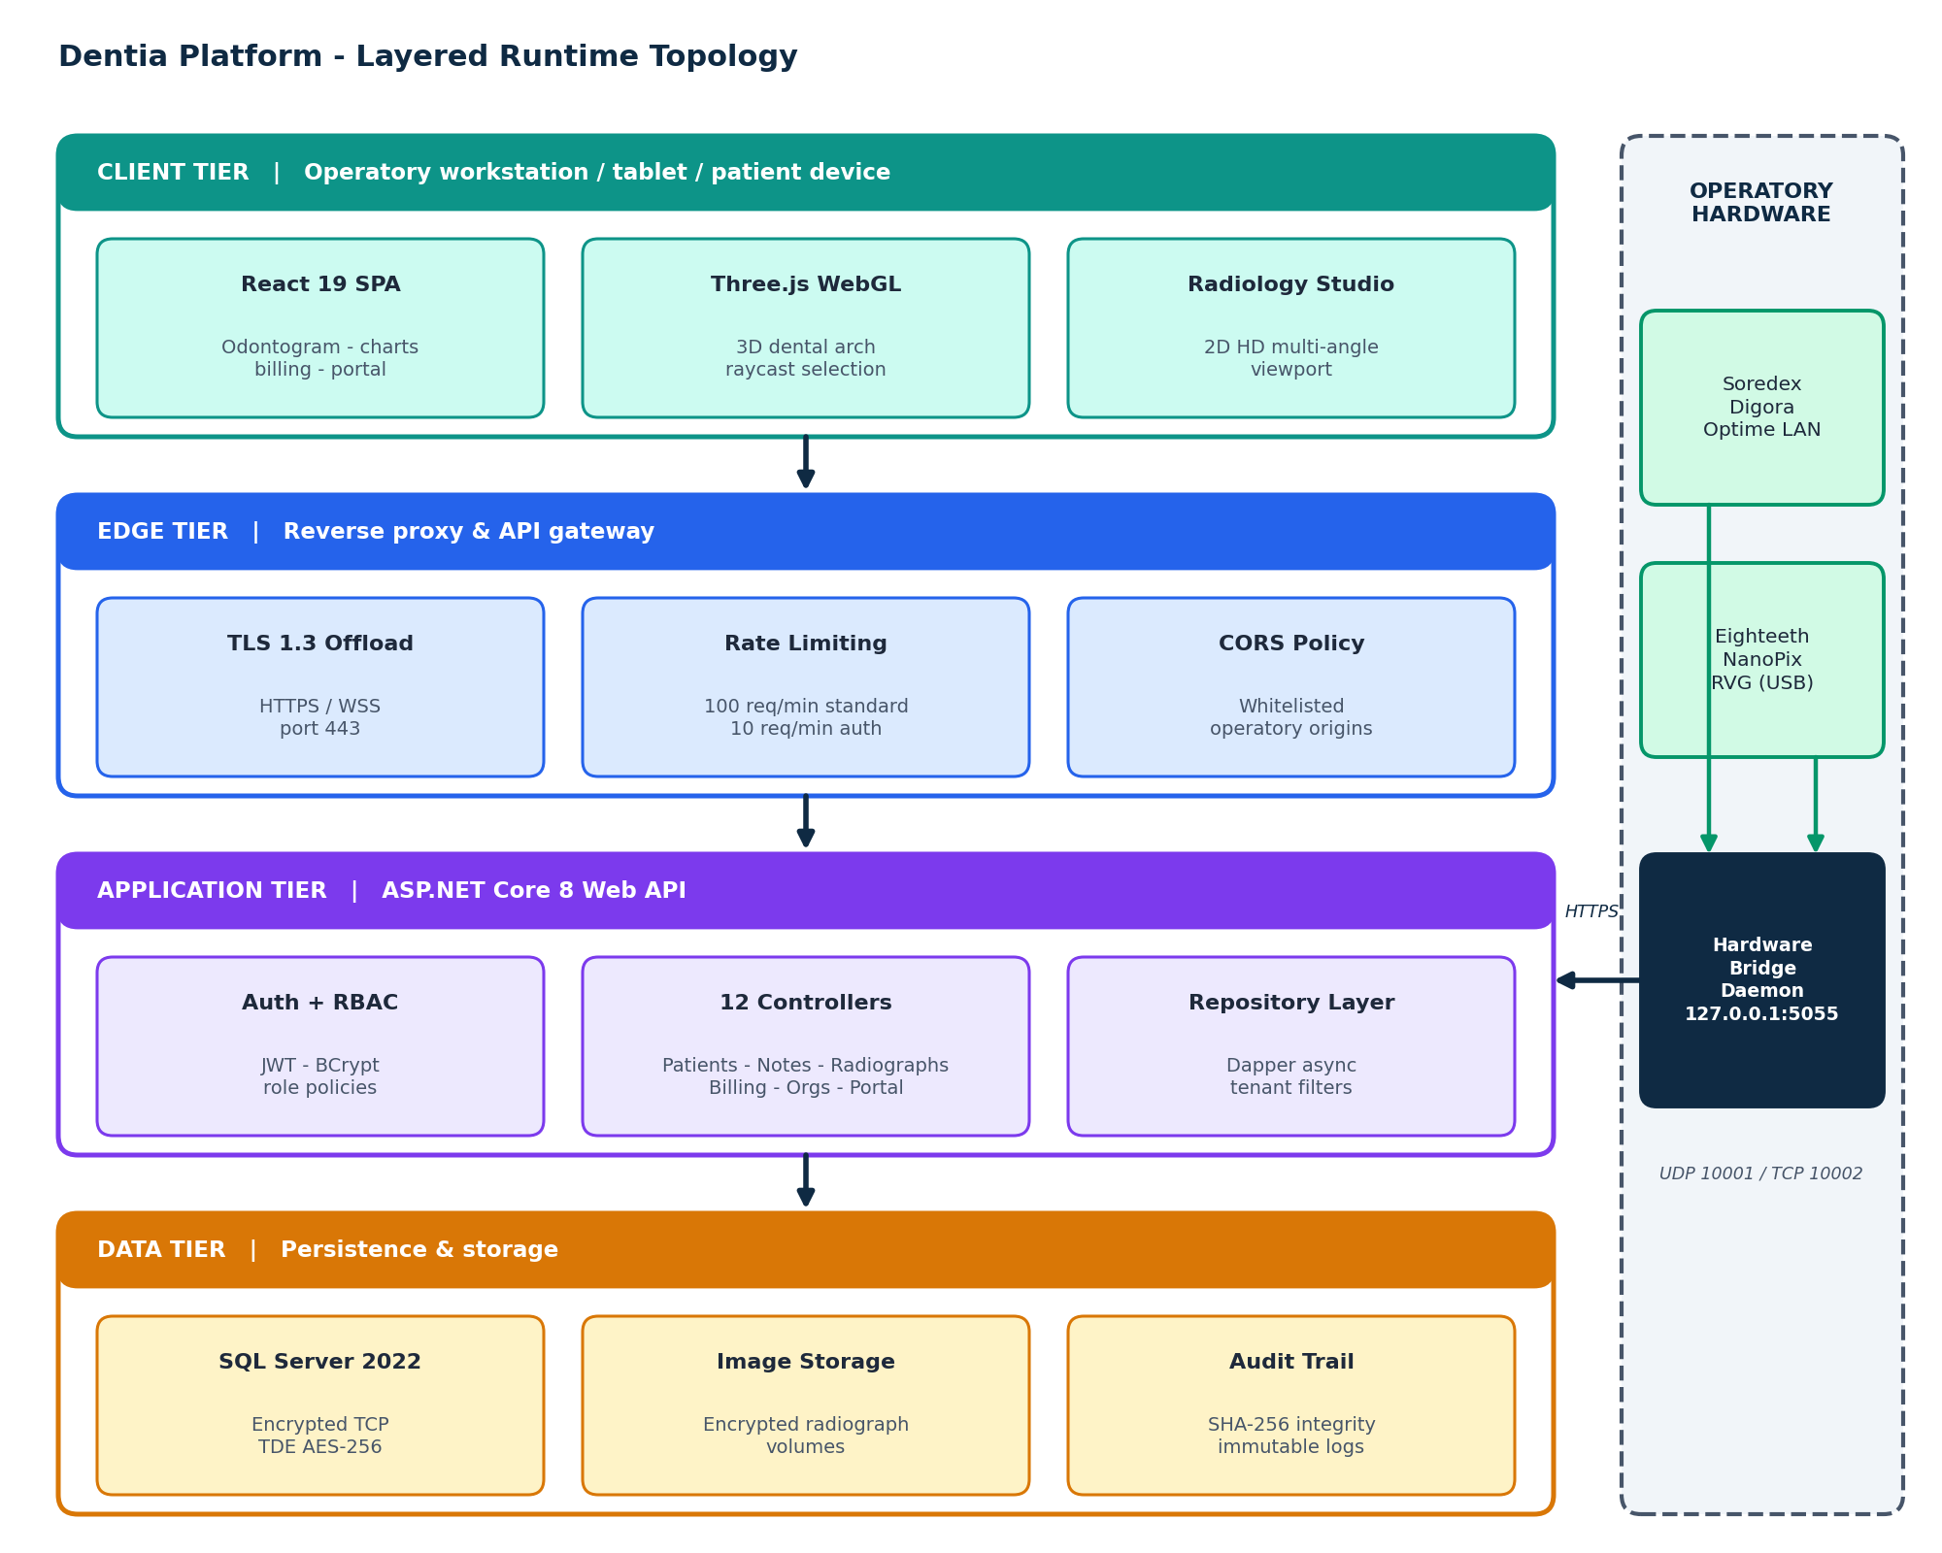
Figure 1 Layered runtime topology: operatory clients, edge gateway, ASP.NET Core application tier, data tier and the local hardware bridge

1.4 ASP.NET Core Middleware Pipeline Architecture
The ASP.NET Core 8 Web API utilizes an ordered pipeline of HTTP request middleware designed for high security, audit compliance, and microsecond throughput:
- 1. Global Exception & Crash Recovery Middleware: Intercepts uncaught server exceptions, logs stack traces securely to database audit files, and returns sanitized, standardized RFC 7807 ProblemDetails JSON payloads without exposing internal SQL connection strings.
- 2. Strict CORS Security Policy: Enforces whitelisted operatory origins (http://localhost:5173, https://dentistfrontend.vercel.app), explicitly rejecting unauthorized cross-origin requests while permitting necessary custom medical headers (X-Skip-Auth-Redirect).
- 3. JWT Bearer Authentication & Claims Validation: Extracts the bearer token from the HTTP Authorization header, verifies HMAC-SHA256 signature validity against server secrets, checks expiration timestamps, and populates the HttpContext User Principal.
- 4. Role-Based Authorization Enforcement: Inspects controller and action method [Authorize(Roles = ...)] attributes to guarantee clinicians can only access patient records within their assigned organization and clinical privilege scope.
- 5. Rate Limiting & Denial-of-Service Defense: Applies fixed-window rate limiting (100 requests per minute per IP address for standard endpoints; 10 requests per minute for authentication endpoints), shielding the clinic server from brute-force attacks.
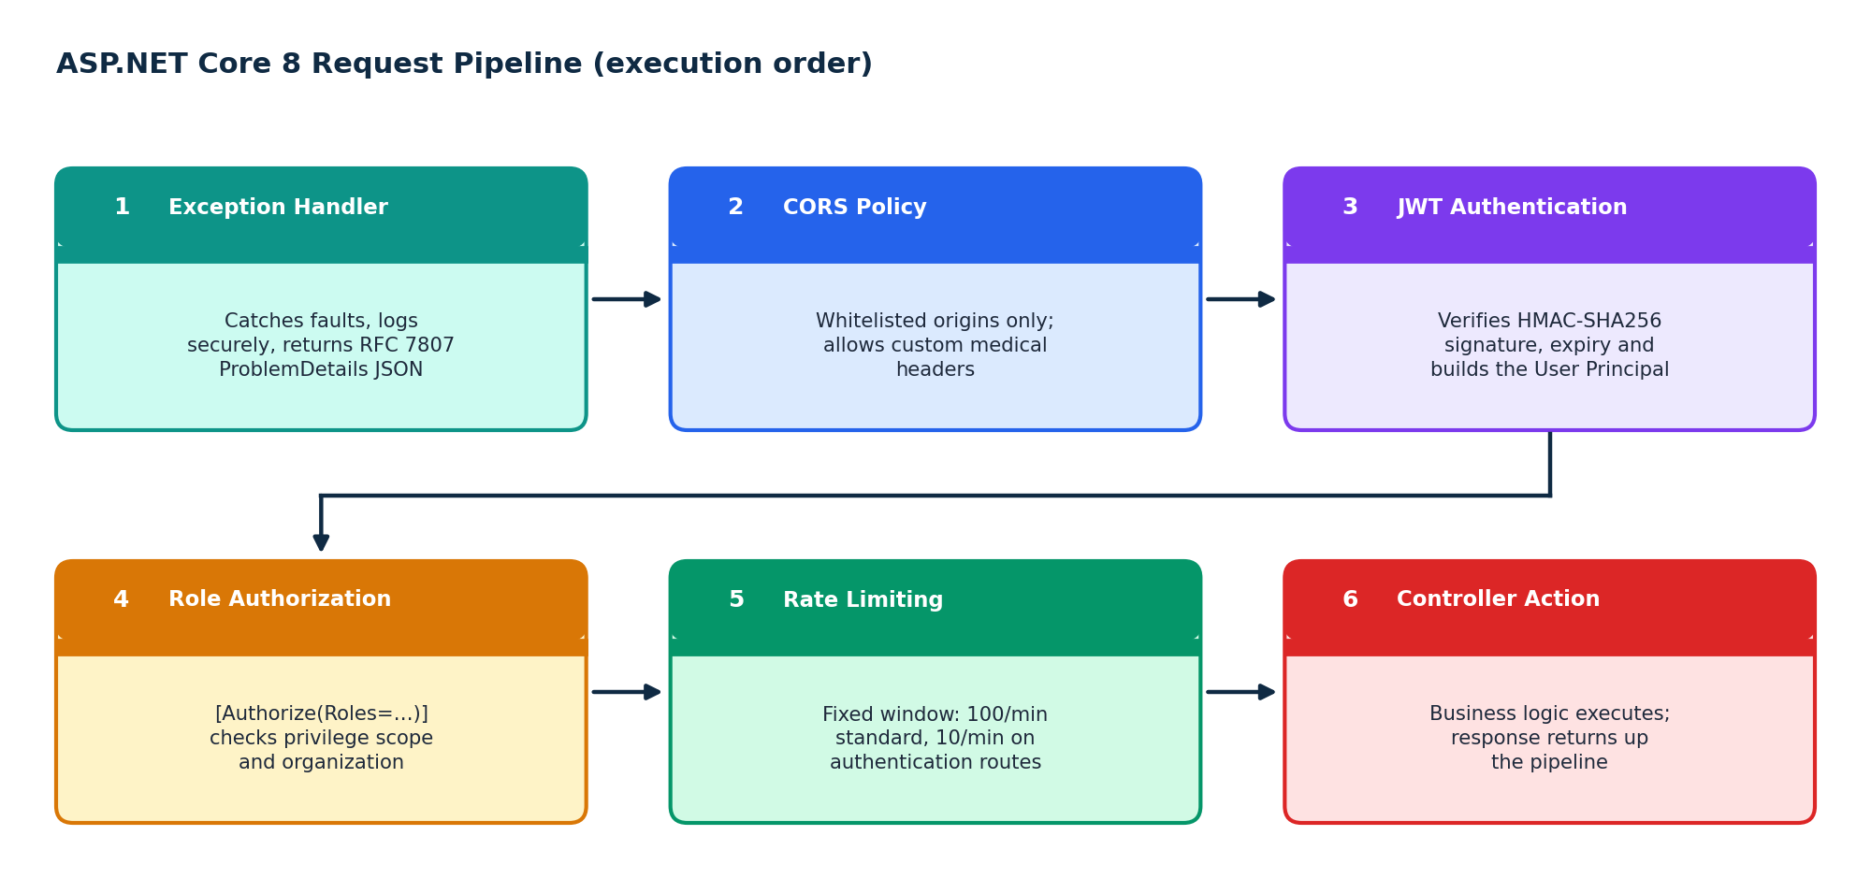
Figure 2 Ordered ASP.NET Core 8 middleware pipeline

1.5 React 19 Frontend State & Custom Hooks Architecture
The client application is structured around a centralized state architecture using specialized custom React hooks: usePatientChart(patientId) manages 32-tooth odontogram state and local overrides; useRadiographViewer() handles canvas contrast, zoom, and multi-angle selection; and useIdleTimer() orchestrates cross-tab session monitoring. React 19 Suspense boundaries wrap asynchronous components, displaying elegant skeleton loaders while data resolves.

CHAPTER 02
Authentication, Role-Based Access Control (RBAC) & Clinic User Management

2.1 Cryptographic Authentication Pipelines
Dentia enforces strict authentication boundaries across all operatory endpoints. The system operates dual authentication pipelines: (1) a high-security JSON Web Token (JWT) Bearer Token framework for clinical staff and doctors, and (2) a secured session token framework for the external Patient Portal.
For staff authentication (AuthController.cs), passwords are submitted over TLS 1.3 and verified using salted BCrypt cryptographic hashes with an adaptive work factor of 12. Upon successful credential verification, the API generates a signed JWT token containing claims for DoctorId, Username, Role, OrganizationId, and Region. Tokens are signed using HMAC-SHA256 with a 512-bit symmetric secret key stored in environment secrets.
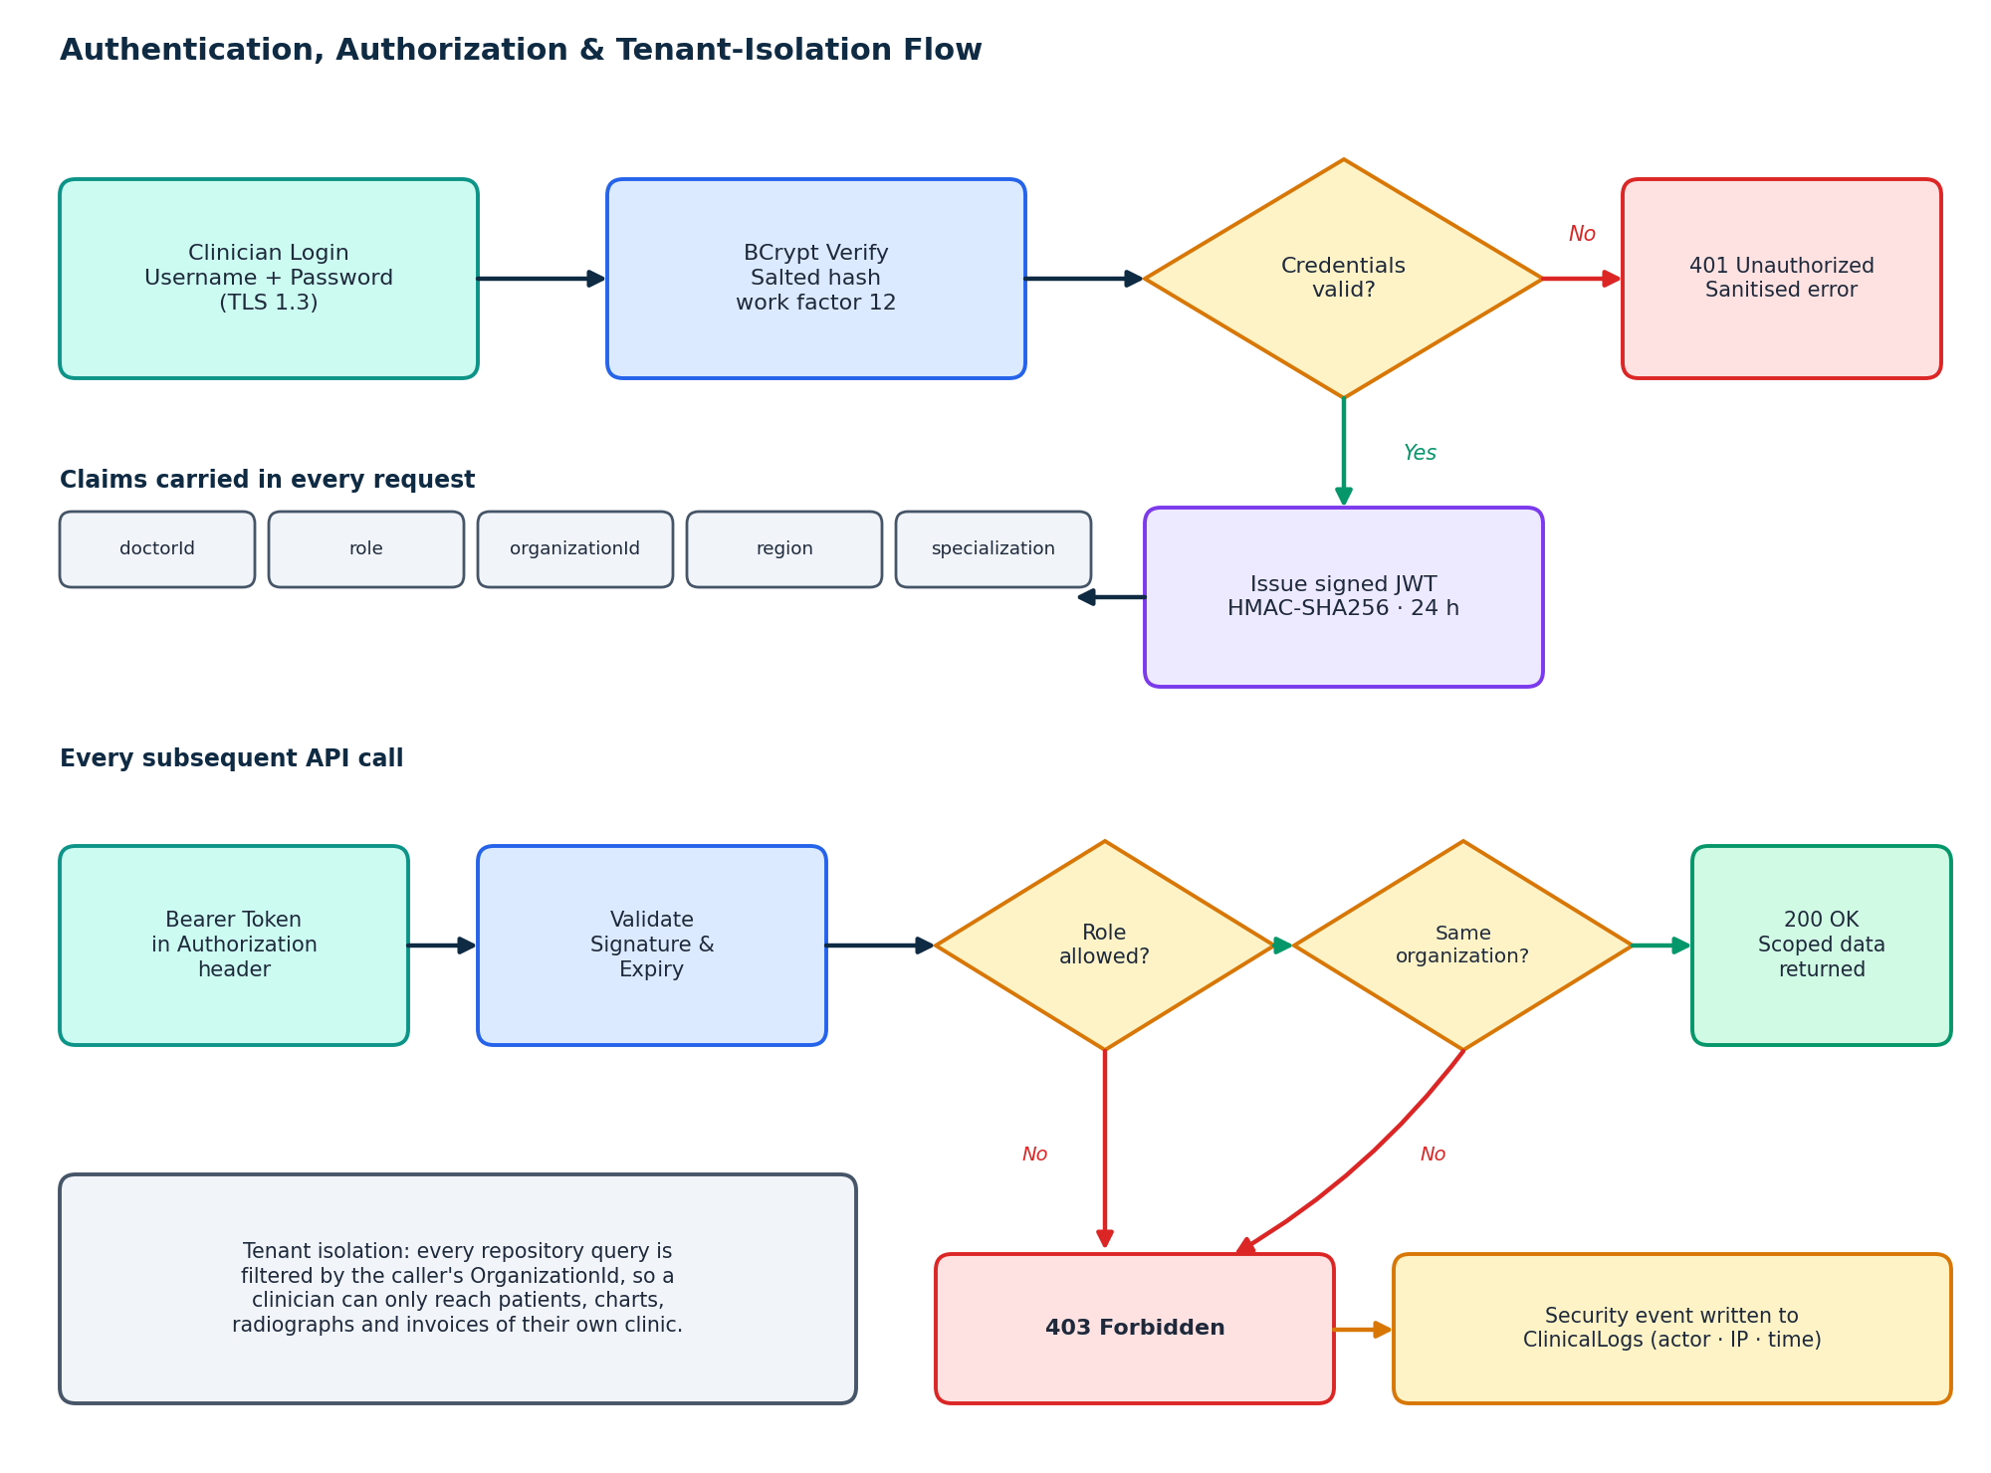
Figure 3 Authentication, role authorization and tenant-isolation decision flow

2.2 JWT Token Payload & Cryptographic Claims Schema
The serialized JWT token payload generated upon doctor login contains the following claims:
{
"sub": "ahmedjh", // Username
"doctorId": "2", // Doctor Master ID
"fullName": "Dr. Jhangir Ahmed", // Clinician Legal Name
"role": "Doctor", // RBAC Role (SuperAdmin | Doctor | Hygienist | Staff)
"organizationId": "1", // Operating Dental Facility ID
"region": "NZ", // Regional Tax & Currency Setting (NZD / USD / PKR)
"specialization": "General Dental Surgeon", // Clinical Scope
"nbf": 1793356266, // Not Before Unix Timestamp
"exp": 1793442666, // Expiration Unix Timestamp (24-Hour Lifetime)
"iss": "DentiaSecurityAuthority", // Token Issuer
"aud": "DentiaOperatoryClients" // Authorized Token Audience
}

2.3 Granular Role-Based Access Control (RBAC) Permissions Matrix
Access permissions are enforced across all six user roles in the clinic ecosystem:
Clinical & Administrative Privilege | SuperAdmin | Doctor | Hygienist | Assistant | Front Desk | Patient
View Patient Demographics | YES | YES | YES | YES | YES | Own Profile Only
Create / Register Patient | YES | YES | YES | YES | YES | Self Registration
Edit 32-Tooth Odontogram | YES | YES | YES (Cleanings) | NO (Read Only) | NO | NO
Diagnose Pathologies (Caries/RCT) | YES | YES | NO | NO | NO | NO
Sign Electronic Prescriptions | YES | YES | NO | NO | NO | NO
Capture & Tag Radiographs | YES | YES | YES | YES | NO | NO
Finalize Invoices & Fees | YES | YES | NO | NO | YES | View & Pay Own
Configure Doctor Pricing | YES | Own Pricing | NO | NO | NO | NO
Manage Organizations / Clinics | YES | NO | NO | NO | NO | NO
Inspect Security Audit Logs | YES | NO | NO | NO | NO | NO

2.4 Cross-Tab Idle Session Timeout Security (IdleSessionManager.jsx)
To comply with HIPAA Operatory Physical Safeguards (§ 164.312(a)(2)(iii)), Dentia implements an enterprise-grade client-side session watchdog (IdleSessionManager.jsx). The watchdog monitors global DOM user activity events (mousemove, keydown, touchstart, pointerdown, scroll). If no activity is detected for 15 minutes, an interactive modal warning displays a 60-second countdown. If the clinician does not extend the session, all cryptographic tokens are cleared from memory and localStorage, and the user is redirected to /login?expired=true.
Crucially, the watchdog utilizes an HTML5 BroadcastChannel('dentia_session_bus') to synchronize idle states across multiple open browser tabs. If a clinician is active in one operatory tab, all sibling tabs reset their inactivity timers simultaneously, preventing premature disconnections while reviewing radiographs or consultation notes.

CHAPTER 03
Dual-Arch Odontogram Charting Engine (Adult 32-Tooth & Pediatric 20-Tooth)

3.1 Complete 32-Tooth Adult Permanent Dentition Anatomy
Dentia models all 32 permanent human teeth with exact anatomical fidelity. The table below details every tooth from Tooth #1 to Tooth #32, including Universal number, FDI two-digit notation, anatomical nomenclature, normal eruption age, root anatomy, and typical root canal configurations:
Univ # | FDI | Anatomical Nomenclature | Quadrant | Eruption Age | Root Anatomy | Root Canal System
1 | 18 | Maxillary Right 3rd Molar (Wisdom) | Upper Right (Q1) | 17–21 Years | 3 Roots (Fused / Varied) | 3 Canals
2 | 17 | Maxillary Right 2nd Molar | Upper Right (Q1) | 12–13 Years | 3 Roots (Mesiobuccal, Distobuccal, Palatal) | 3–4 Canals
3 | 16 | Maxillary Right 1st Molar | Upper Right (Q1) | 6–7 Years | 3 Roots (MB, DB, Palatal) | 4 Canals (MB1, MB2, DB, P)
4 | 15 | Maxillary Right 2nd Premolar | Upper Right (Q1) | 10–12 Years | 1 Single Root | 1–2 Canals
5 | 14 | Maxillary Right 1st Premolar | Upper Right (Q1) | 10–11 Years | 2 Bifurcated Roots (Buccal & Palatal) | 2 Canals
6 | 13 | Maxillary Right Canine (Cuspid) | Upper Right (Q1) | 11–12 Years | 1 Longest Root in Mouth | 1 Canal
7 | 12 | Maxillary Right Lateral Incisor | Upper Right (Q1) | 8–9 Years | 1 Slender Root (Distal Curve) | 1 Canal
8 | 11 | Maxillary Right Central Incisor | Upper Right (Q1) | 7–8 Years | 1 Straight Cone-Shaped Root | 1 Canal
9 | 21 | Maxillary Left Central Incisor | Upper Left (Q2) | 7–8 Years | 1 Straight Cone-Shaped Root | 1 Canal
10 | 22 | Maxillary Left Lateral Incisor | Upper Left (Q2) | 8–9 Years | 1 Slender Root (Distal Curve) | 1 Canal
11 | 23 | Maxillary Left Canine (Cuspid) | Upper Left (Q2) | 11–12 Years | 1 Longest Root in Mouth | 1 Canal
12 | 24 | Maxillary Left 1st Premolar | Upper Left (Q2) | 10–11 Years | 2 Bifurcated Roots (B & P) | 2 Canals
13 | 25 | Maxillary Left 2nd Premolar | Upper Left (Q2) | 10–12 Years | 1 Single Root | 1–2 Canals
14 | 26 | Maxillary Left 1st Molar | Upper Left (Q2) | 6–7 Years | 3 Roots (MB, DB, Palatal) | 4 Canals (MB1, MB2, DB, P)
15 | 27 | Maxillary Left 2nd Molar | Upper Left (Q2) | 12–13 Years | 3 Roots (MB, DB, Palatal) | 3–4 Canals
16 | 28 | Maxillary Left 3rd Molar (Wisdom) | Upper Left (Q2) | 17–21 Years | 3 Roots (Fused / Varied) | 3 Canals
17 | 38 | Mandibular Left 3rd Molar (Wisdom) | Lower Left (Q3) | 17–21 Years | 2 Roots (Often Curved) | 2–3 Canals
18 | 37 | Mandibular Left 2nd Molar | Lower Left (Q3) | 11–13 Years | 2 Roots (Mesial & Distal) | 3 Canals (MB, ML, D)
19 | 36 | Mandibular Left 1st Molar | Lower Left (Q3) | 6–7 Years | 2 Broad Roots (Mesial & Distal) | 3–4 Canals (MB, ML, DB, DL)
20 | 35 | Mandibular Left 2nd Premolar | Lower Left (Q3) | 11–12 Years | 1 Single Root | 1 Canal
21 | 34 | Mandibular Left 1st Premolar | Lower Left (Q3) | 10–12 Years | 1 Single Root | 1–2 Canals
22 | 33 | Mandibular Left Canine (Cuspid) | Lower Left (Q3) | 9–10 Years | 1 Single Sturdy Root | 1–2 Canals
23 | 32 | Mandibular Left Lateral Incisor | Lower Left (Q3) | 7–8 Years | 1 Slender Flattened Root | 1 Canal
24 | 31 | Mandibular Left Central Incisor | Lower Left (Q3) | 6–7 Years | 1 Smallest Root in Mouth | 1 Canal
25 | 41 | Mandibular Right Central Incisor | Lower Right (Q4) | 6–7 Years | 1 Smallest Root in Mouth | 1 Canal
26 | 42 | Mandibular Right Lateral Incisor | Lower Right (Q4) | 7–8 Years | 1 Slender Flattened Root | 1 Canal
27 | 43 | Mandibular Right Canine (Cuspid) | Lower Right (Q4) | 9–10 Years | 1 Single Sturdy Root | 1–2 Canals
28 | 44 | Mandibular Right 1st Premolar | Lower Right (Q4) | 10–12 Years | 1 Single Root | 1–2 Canals
29 | 45 | Mandibular Right 2nd Premolar | Lower Right (Q4) | 11–12 Years | 1 Single Root | 1 Canal
30 | 46 | Mandibular Right 1st Molar | Lower Right (Q4) | 6–7 Years | 2 Broad Roots (Mesial & Distal) | 3–4 Canals (MB, ML, DB, DL)
31 | 47 | Mandibular Right 2nd Molar | Lower Right (Q4) | 11–13 Years | 2 Roots (Mesial & Distal) | 3 Canals (MB, ML, D)
32 | 48 | Mandibular Right 3rd Molar (Wisdom) | Lower Right (Q4) | 17–21 Years | 2 Roots (Often Curved) | 2–3 Canals

3.2 Complete 20-Tooth Pediatric Primary Dentition Table
For pediatric charting, Dentia models the 20 deciduous primary milk teeth (Universal Letters A to T). The table below details eruption timing, physiological exfoliation ages, and permanent successor mapping:
Letter | FDI | Primary Nomenclature | Eruption Timing | Exfoliation Age | Permanent Successor Tooth
A | 55 | Maxillary Right 2nd Primary Molar | 8–12 Months | 10–12 Years | Permanent Tooth #4 (2nd Premolar)
B | 54 | Maxillary Right 1st Primary Molar | 12–16 Months | 9–11 Years | Permanent Tooth #5 (1st Premolar)
C | 53 | Maxillary Right Primary Canine | 16–20 Months | 10–12 Years | Permanent Tooth #6 (Canine)
D | 52 | Maxillary Right Primary Lateral Incisor | 8–12 Months | 7–8 Years | Permanent Tooth #7 (Lateral Incisor)
E | 51 | Maxillary Right Primary Central Incisor | 6–8 Months | 6–7 Years | Permanent Tooth #8 (Central Incisor)
F | 61 | Maxillary Left Primary Central Incisor | 6–8 Months | 6–7 Years | Permanent Tooth #9 (Central Incisor)
G | 62 | Maxillary Left Primary Lateral Incisor | 8–12 Months | 7–8 Years | Permanent Tooth #10 (Lateral Incisor)
H | 63 | Maxillary Left Primary Canine | 16–20 Months | 10–12 Years | Permanent Tooth #11 (Canine)
I | 64 | Maxillary Left 1st Primary Molar | 12–16 Months | 9–11 Years | Permanent Tooth #12 (1st Premolar)
J | 65 | Maxillary Left 2nd Primary Molar | 8–12 Months | 10–12 Years | Permanent Tooth #13 (2nd Premolar)
K | 75 | Mandibular Left 2nd Primary Molar | 8–12 Months | 10–12 Years | Permanent Tooth #20 (2nd Premolar)
L | 74 | Mandibular Left 1st Primary Molar | 12–16 Months | 9–11 Years | Permanent Tooth #21 (1st Premolar)
M | 73 | Mandibular Left Primary Canine | 16–20 Months | 9–12 Years | Permanent Tooth #22 (Canine)
N | 72 | Mandibular Left Primary Lateral Incisor | 7–10 Months | 7–8 Years | Permanent Tooth #23 (Lateral Incisor)
O | 71 | Mandibular Left Primary Central Incisor | 6–10 Months | 6–7 Years | Permanent Tooth #24 (Central Incisor)
P | 81 | Mandibular Right Primary Central Incisor | 6–10 Months | 6–7 Years | Permanent Tooth #25 (Central Incisor)
Q | 82 | Mandibular Right Primary Lateral Incisor | 7–10 Months | 7–8 Years | Permanent Tooth #26 (Lateral Incisor)
R | 83 | Mandibular Right Primary Canine | 16–20 Months | 9–12 Years | Permanent Tooth #27 (Canine)
S | 84 | Mandibular Right 1st Primary Molar | 12–16 Months | 9–11 Years | Permanent Tooth #28 (1st Premolar)
T | 85 | Mandibular Right 2nd Primary Molar | 8–12 Months | 10–12 Years | Permanent Tooth #29 (2nd Premolar)

3.3 Three.js WebGL 3D Dental Arch Architecture (ThreeDentalJawArch.jsx)
The 3D dental arch engine renders anatomically accurate procedural geometries utilizing Three.js WebGL. The rendering pipeline operates at 60 frames per second using hardware-accelerated shaders:
- Camera Setup: PerspectiveCamera with a 45-degree vertical Field of View (FOV), near clipping plane at 0.1 units, and far clipping plane at 1000 units. Positioned at (0, 5, 25) pointing at (0, 0, 0).
- Lighting Rig: Three-point clinical operatory illumination: AmbientLight (#FFFFFF, intensity 0.8) for overall visibility, DirectionalLight (#FFFFFF, intensity 1.2) at (10, 20, 15) simulating chairside operatory lamp, and HemisphericalLight (#E2E8F0 sky, #64748B ground, intensity 0.5) for anatomical depth.
- Raycasting Hit Testing: When the clinician clicks or taps the canvas, Three.js casts a mathematical ray from the 2D screen coordinate (x, y) through the camera frustum into Euclidean space. The nearest intersected tooth mesh is resolved, triggering selection events.

CHAPTER 04
Microscopic 5-Surface Anatomical Restoration Engine (MODBL Surface Mapping)

4.1 Anatomical Surface Breakdown & Nomenclature
In modern dental operatory restorative practice, caries, fractures, and restorations are rarely uniform across an entire tooth. Instead, pathology is localized to specific anatomical surfaces. Dentia provides microscopic 5-surface zone charting across every tooth:
Surface Code | Anatomical Zone | Clinical Definition, Orientation & Operative Significance
O / I | Occlusal (Posteriors) / Incisal (Anteriors) | The biting table of molars/premolars or the cutting incisal edge of canines and incisors. Subject to high masticatory stress and pit/fissure decay.
M | Mesial Surface | The proximal surface facing toward the anterior dental midline. Common site for interproximal contact decay requiring Class II restorations.
D | Distal Surface | The proximal surface facing away from the anterior dental midline toward the posterior. Forms contact points with adjacent posterior teeth.
B / F | Buccal (Posteriors) / Facial (Anteriors) | The outer surface facing the cheek (buccal) or lips (facial/labial). Common site for cervical abfraction lesions, Class V decay, and cosmetic veneers.
L / P | Lingual (Mandible) / Palatal (Maxilla) | The inner surface facing the tongue in the lower jaw (lingual) or hard palate in the upper jaw (palatal). Site of cingulum pits and lingual calculus accumulation.
Cervical | Cervical / Root Gingival Margin | The anatomical junction between the enamel crown and cementum root. Critical for recession tracking and root caries evaluation.

4.2 Multi-Surface Permutation Matrix & CDT Mapping
Dentia dynamically computes the exact CDT billing code based on the specific permutation of selected surfaces. The table below details common surface combinations and their corresponding ADA procedure codes:
Surfaces | Surface Count | Composite (Posterior) | Amalgam (Posterior) | Composite (Anterior) | Clinical Operative Indication
O | 1 Surface | D2391 | D2140 | D2330 | Pit and fissure decay on occlusal surface.
MO | 2 Surfaces | D2392 | D2150 | D2331 | Class II cavity involving mesial contact and occlusal groove.
DO | 2 Surfaces | D2392 | D2150 | D2331 | Class II cavity involving distal contact and occlusal groove.
MOD | 3 Surfaces | D2393 | D2160 | D2332 | Extensive restoration bridging both proximal contact points.
OB / OL | 2 Surfaces | D2392 | D2150 | D2331 | Occlusal decay extending into buccal pit or lingual groove.
MOB / MODL | 3-4 Surfaces | D2393 / D2394 | D2160 / D2161 | D2332 / D2335 | Complex preparation involving cusp reduction or rebuilding.
MODBL | 5 Surfaces | D2394 | D2161 | D2335 | Full coronal buildup prior to full-coverage crown preparation.
B (Class V) | 1 Surface | D2391-V | D2140-V | D2330-V | Cervical abfraction or root caries along the gingival margin.

4.3 Comparison of Dental Restorative Materials
Dentia tracks restorative material types, allowing dentists to compare mechanical and esthetic characteristics:
Restorative Material | Physical & Mechanical Properties | Clinical Indications | Operative Considerations
Nano-Hybrid Resin Composite (3M Filtek / GC) | Excellent esthetics, high polish retention, 0.05-0.1% polymerization shrinkage. | Anterior class III/IV/V, posterior Class I/II with isolation. | Requires meticulous moisture control and multi-step dentin bonding agent.
High-Copper Dental Amalgam (Dispersalloy) | High compressive strength (400+ MPa), self-sealing margins via corrosion. | Subgingival margins, moisture isolation impossible, heavy bruxism. | Silver/grey appearance, requires mechanical retention / undercut prep.
Resin-Modified Glass Ionomer (RMGI - Fuji II LC) | Continuous fluoride release, thermal expansion matching human dentin. | Class V root caries, pediatric primary teeth, high caries-risk patients. | Lower tensile strength than composite; slightly opaque finish.
CAD/CAM Monolithic Zirconia Inlay/Onlay | Extreme flexural strength (1200 MPa), zero fracture risk, biocompatible. | Large multi-surface restorations replacing lost cusps. | Requires indirect lab fabrication or chairside milling machine (CEREC).

CHAPTER 05
Master Clinical Specialties & 15-Category Procedure Catalog (1000+ Procedures)

5.1 Master Specialty Taxonomy Overview
To support comprehensive dental practice management, Dentia organizes all dental procedures, diagnostic evaluations, and billing codes into 15 specialized clinical categories. Every category maps directly to standard American Dental Association (ADA) Code on Dental Procedures and Nomenclature (CDT) specifications while supporting regional custom fee schedules.
Clinical Category | Domain Scope & Operative Procedures Included
1. Restorative & Operative | Direct restorations, composite resins, amalgam alloys, glass ionomer cements, inlays, onlays, core buildups.
2. Endodontics (Pulp & Root) | Pulp capping, pulpotomy, root canal therapy (anterior, bicuspid, molar), retreatment, apicoectomy, apexification.
3. Oral & Maxillofacial Surgery | Simple extractions, surgical extractions, soft tissue impactions, partial/full bony impactions, alveoloplasty, biopsies.
4. Pathology & Caries Management | Incipient enamel demineralization, dentinal caries, recurrent margin decay, periapical abscess, cysts, radiolucencies.
5. Periodontics (Gums & Bone) | Gingivitis evaluation, periodontal probing depths (1–12mm), scaling and root planing (SRP), osseous surgery, bone grafts.
6. Orthodontics & Malocclusion | Angle's Class I/II/III malocclusion, overjet/overbite measurement, crossbites, clear aligner therapy, space maintainers.
7. TMJ & Jaw Articulation | Temporomandibular joint evaluation, joint clicking/crepitus, trismus, maximum incisal opening (MIO), myofascial pain.
8. Pediatric Dentistry | Primary dentition caries, pulpotomies with stainless steel crowns (SSC), space maintainers, habit breakers, fluoride varnishes.
9. Cosmetic & Esthetic | Porcelain veneers, composite bonding, vital tooth bleaching, gingival contouring, VITA shade matching (A1 to D4).
10. Prosthodontics (Fixed & Removable) | Crowns (Zirconia, E-Max, PFM, Full Gold), fixed partial dentures (bridges), complete dentures, removable partials (RPD).
11. Implantology & Bone Grafting | Endosteal implant placement, sinus lifts, guided bone regeneration (GBR), custom abutments, screw-retained implant crowns.
12. Bruxism & Nightguards | Occlusal wear facets, attrition grading, hard/soft occlusal guards, stabilization splints, sleep apnea appliances.
13. Impactions & Wisdom Extractions | Pell & Gregory classification, Winter's classification, coronectomy, surgical removal of impacted wisdom teeth.
14. Hypersensitivity & NCCL | Non-carious cervical lesions, abfraction, erosion, dentin desensitization, cervical resin glazes, gingival grafting.
15. Radiographic Findings | Bitewing surveys, full mouth periapical series (FMX), panoramic OPG evaluations, CBCT volumetric cross-sections.

5.2 Detailed Clinical Procedure Protocols & CDT Catalog
Below is an extensive catalog of core operative procedures across key specialties detailing clinical steps and CDT codes:
CDT Code | Procedure Title | Category | Odontogram Color | Clinical Protocol & Operative Description
D0120 | Periodic Oral Evaluation | Diagnostic | Ivory | Routine 6-month recall examination for established patients reviewing soft/hard tissues.
D0140 | Limited Problem-Focused Exam | Diagnostic | Blue Ring | Emergency or urgent consultation addressing specific acute toothache or trauma.
D0150 | Comprehensive Oral Evaluation | Diagnostic | Ivory | Thorough initial examination for new adult patients covering complete odontogram, periodontal baseline, and cancer screen.
D0210 | Full Mouth Intraoral Series (FMX) | Radiology | Slate | Comprehensive survey typically consisting of 14 periapical and 4 bitewing films.
D0220 | Intraoral Periapical First Film | Radiology | Slate | Diagnostic periapical radiograph evaluating root apices and lamina dura integrity.
D0272 | Bitewings - Two Radiographs | Radiology | Slate | Interproximal survey evaluating coronal caries and alveolar crest bone levels.
D0330 | Panoramic Radiographic Image (OPG) | Radiology | Slate | Extraoral tomographic survey imaging maxilla, mandible, TMJ, and maxillary sinuses.
D1110 | Adult Dental Prophylaxis | Preventative | Cyan | Scaling and polishing procedure to remove plaque, supragingival calculus, and external stains.
D1206 | Topical Fluoride Varnish | Preventative | Emerald | Application of 5% sodium fluoride varnish for high caries-risk remineralization.
D1351 | Pit and Fissure Sealant (Per Tooth) | Preventative | Ivory | Application of resin sealant to deep anatomical fissures of permanent molars.
D2140 | Amalgam - 1 Surface, Posterior | Restorative | Silver Grey | Silver alloy restoration placed in posterior occlusal pit and fissure preparation.
D2150 | Amalgam - 2 Surfaces, Posterior | Restorative | Silver Grey | Class II MO or DO silver alloy restoration restoring proximal contact wall.
D2160 | Amalgam - 3 Surfaces, Posterior | Restorative | Silver Grey | Mesial-occlusal-distal (MOD) amalgam restoration rebuilding proximal ridges.
D2330 | Resin Composite - 1 Surface, Anterior | Restorative | #3B82F6 | Tooth-colored direct composite filling on anterior tooth (facial, lingual, incisal).
D2332 | Resin Composite - 3 Surfaces, Anterior | Restorative | #3B82F6 | Complex Class III or IV composite restoration restoring proximal wall and incisal angle.
D2391 | Resin Composite - 1 Surface, Posterior | Restorative | #3B82F6 | Direct light-cured composite resin placed in posterior occlusal pit and fissures.
D2392 | Resin Composite - 2 Surfaces, Posterior | Restorative | #3B82F6 | Class II MO or DO composite restoration utilizing sectional matrix and ring separator.
D2393 | Resin Composite - 3 Surfaces, Posterior | Restorative | #3B82F6 | MOD composite restoration restoring both proximal contact walls and occlusal anatomy.
D2394 | Resin Composite - 4+ Surfaces, Posterior | Restorative | #3B82F6 | Extensive MODBL coronal composite reconstruction prior to prosthetic crown preparation.
D2740 | Crown - Porcelain / Ceramic Substrate | Prosthodontics | #0D9488 | Full-coverage monolithic zirconia or lithium disilicate (E-Max) CAD/CAM crown.
D2750 | Crown - Porcelain Fused to High Noble Metal | Prosthodontics | #0D9488 | PFM crown combining high noble casting with feldspathic porcelain veneer.
D2950 | Core Buildup, Including Any Pins | Restorative | #3B82F6 | Structural resin buildup placed on severely broken-down tooth to provide crown retention.
D3110 | Pulp Cap - Direct | Endodontics | #8B5CF6 | Placement of biocompatible MTA (Mineral Trioxide Aggregate) directly over exposed vital pulp.
D3220 | Therapeutic Pulpotomy (Deciduous Tooth) | Pediatric | #8B5CF6 | Amputation of coronal pulp followed by ferric sulfate hemostasis and MTA/ZOE base.
D3310 | Endodontic Therapy - Anterior Tooth | Endodontics | #8B5CF6 | Complete chemomechanical instrumentation and gutta-percha obturation of single root canal.
D3320 | Endodontic Therapy - Bicuspid Tooth | Endodontics | #8B5CF6 | Root canal therapy on premolar tooth typically containing 1 to 2 distinct root canals.
D3330 | Endodontic Therapy - Molar Tooth | Endodontics | #8B5CF6 | Complete chemomechanical instrumentation and 3D warm vertical obturation of 3–4 canals.
D3410 | Apicoectomy - Anterior Tooth | Endodontics | #8B5CF6 | Surgical root resection and retrograde MTA root-end filling following failed orthograde RCT.
D4210 | Gingivectomy or Gingivoplasty | Periodontics | #F43F5E | Surgical excision of fibrous or hyperplastic gingival tissue to eliminate pseudo-pockets.
D4341 | Periodontal Scaling & Root Planing (Per Quad) | Periodontics | #F43F5E | Deep subgingival ultrasonic and hand curette debridement of diseased cementum and calculus.
D4910 | Periodontal Maintenance | Periodontics | #F43F5E | Ongoing 3-month supportive periodontal recall therapy following active SRP treatment.
D6010 | Surgical Placement of Endosteal Implant | Implantology | #10B981 | Surgical osteotomy preparation and fixture insertion of titanium/zirconia implant body.
D6057 | Custom Fabricated Abutment | Implantology | #10B981 | CAD/CAM custom-milled titanium or zirconia abutment matching emergence profile.
D6058 | Abutment Supported Porcelain/Ceramic Crown | Implantology | #10B981 | Screw-retained or cement-retained monolithic ceramic crown on implant abutment.
D7140 | Extraction, Erupted Tooth / Exposed Root | Oral Surgery | #64748B | Routine dental forceps elevation and extraction under local infiltrative anesthesia.
D7210 | Surgical Removal of Erupted Tooth | Oral Surgery | #DC2626 | Surgical extraction requiring elevation of mucoperiosteal flap, bone troughing, or sectioning.
D7220 | Removal of Impacted Tooth - Soft Tissue | Oral Surgery | #DC2626 | Extraction of impacted tooth covered primarily by overlying mucoperiosteal tissue.
D7230 | Removal of Impacted Tooth - Partially Bony | Oral Surgery | #DC2626 | Extraction requiring bone removal and tooth sectioning; crown partially covered by ramus bone.
D7240 | Removal of Impacted Tooth - Completely Bony | Oral Surgery | #DC2626 | Complex surgical extraction where tooth is completely encased within dense mandibular cortical bone.
D7953 | Bone Replacement Graft for Ridge Preservation | Implantology | #10B981 | Placement of particulate allograft/xenograft into fresh extraction socket to prevent bone resorption.
D8080 | Comprehensive Orthodontic Treatment - Adolescent | Orthodontics | #2563EB | Full fixed multi-bracket appliance therapy across both arches addressing skeletal Class II/III.
D9110 | Palliative Emergency Treatment of Dental Pain | Diagnostic | Amber | Minor emergency palliative procedures (e.g. smoothing sharp cusp, temporary sedative dressing).
D9944 | Occlusal Guard - Hard Appliance, Full Arch | Bruxism | #8B5CF6 | Custom lab-fabricated heat-cured acrylic stabilization splint preventing bruxism tooth wear.

CHAPTER 06
Orthodontics, Occlusal Diagnostics, TMJ & Age Cohort Engine

6.1 Cephalometric Landmark Diagnostics
For comprehensive orthodontic diagnosis, Dentia records standardized skeletal and dental cephalometric parameters:
Cephalometric Parameter | Normal Clinical Mean | Diagnostic Significance & Clinical Interpretation
SNA Angle (Sella-Nasion-Point A) | 82° (± 2°) | Evaluates anteroposterior position of maxilla relative to anterior cranial base. >84° indicates maxillary prognathism; <80° indicates maxillary retrognathism.
SNB Angle (Sella-Nasion-Point B) | 80° (± 2°) | Evaluates anteroposterior position of mandible relative to cranial base. >82° indicates mandibular prognathism; <78° indicates mandibular retrognathism.
ANB Angle (Skeletal Relationship) | 2° (± 2°) | Determines skeletal class: Class I (0° to 4°); Skeletal Class II (>4° - Mandibular deficiency); Skeletal Class III (<0° - Mandibular excess).
FMA (Frankfort-Mandibular Plane Angle) | 25° (± 3°) | Assesses facial growth pattern. High angle (>28° - hyperdivergent vertical growth, open bite tendency); Low angle (<22° - hypodivergent, deep bite).
U1-NA (Upper Incisor to N-A Line) | 22° / 4 mm | Measures inclination and linear protrusion of maxillary central incisors.
L1-NB (Lower Incisor to N-B Line) | 25° / 4 mm | Measures inclination and linear protrusion of mandibular central incisors relative to chin.

6.2 Temporomandibular Joint (TMJ) Articulation Protocol
The TMJ suite evaluates craniomandibular mechanics and neuromuscular joint health:
- Joint Acoustic Sounds: Auscultation of bilateral joints for Clicking (disc displacement with reduction), Crepitus (osteoarthritis / bone grinding), or Terminal Clunk (subluxation).
- Range of Motion (MIO): Maximum Incisal Opening measured in millimeters. Normal: >40 mm. Moderate restriction: 30–39 mm. Severe trismus: <30 mm.
- Mandibular Dynamics: Observation of straight midline opening versus lateral deflection or S-shaped deviation during jaw depression and elevation.

6.3 Automated Patient Age Cohort Engine
Upon entering a patient's birthdate, Dentia automatically assigns the patient to one of six developmental age cohorts, dynamically adapting the odontogram interface and diagnostic alerts accordingly:
Age Cohort & Range | Primary Clinical Focus | System Adaptations & Behavioral Rules
Infant (0–2 Years) | Teeth Eruption Tracking | Monitors initial primary tooth eruption (incisors at 6–10 months). Alerts for baby bottle tooth decay (BBTD).
Primary Child (3–5 Years) | Deciduous Arch Mode (Teeth A–T) | Enforces 20-tooth pediatric odontogram. Monitors physiological spacing and bruxism habits.
Mixed Dentition (6–12 Years) | Dual Dentition Protocol | Displays concurrent deciduous and permanent teeth. Tracks leeway space and permanent 1st molar eruption at age 6.
Adolescent (13–18 Years) | Orthodontic & 2nd Molar Surveillance | Complete permanent arch excluding 3rd molars. Focuses on caries prevention, sports mouthguards, and wisdom tooth angulation.
Adult (19–64 Years) | Permanent Arch (Teeth 1–32) | Comprehensive restorative, periodontal, endodontic, and crown/bridge prosthetic workflows.
Geriatric (65+ Years) | Root Caries & Prosthetic Rehabilitation | Heightened monitoring for root surface abfraction, xerostomia (dry mouth), implant maintenance, and partial/complete dentures.

CHAPTER 07
AI Radiology & High-Definition Diagnostic Studio (2D HD Multi-Angle)

7.1 Architectural Redesign & Philosophy
The AI Radiology Studio (/chart/:patientId/ai-studio) is an advanced diagnostic workspace dedicated exclusively to high-definition 2D transparent jaw radiography. In response to clinical requirements for crystal-clear legibility, all experimental 3D interactive jaw meshes have been excluded, eliminating visual clutter, canvas overhead, and oversized overlapping bubbles.
The studio is engineered to provide dentists with a synchronized, zero-collision diagnostic environment where every tooth and alveolar socket is clearly visible, accurately labeled, and directly linked to EHR database records.

7.2 Dedicated Multi-Angle Transparent Jaw Projections
The studio renders three high-resolution anatomical radiograph projections, each isolating specific dental quadrants:
Radiograph View | Anatomical Coverage | Diagnostic Utility & Clinical Indications
Left Sagittal View | Teeth 9 to 24 (Left Maxilla & Mandible) | Lateral profile providing clear visualization of maxillary left premolars/molars (#9–16) and mandibular left teeth (#17–24). Ideal for endodontic root canal evaluation.
Front Coronal View | Teeth 4 to 13 & 20 to 29 (Anterior Dual Arch) | Anterior smile profile highlighting central/lateral incisors, canines, and bicuspids. Eliminates posterior molar crowding; perfect for esthetic smile analysis and deep overbite detection.
Right Sagittal View | Teeth 1 to 8 & 25 to 32 (Right Maxilla & Mandible) | Contralateral profile isolating maxillary right molars/premolars (#1–8) and mandibular right teeth (#25–32). Ideal for surgical impaction assessment of wisdom teeth #1 and #32.

7.3 Mathematical Alveolar Socket Coordinate Matrix (1200 x 896 HD Space)
The radiograph viewport operates in an exact 1200 x 896 virtual coordinate space. The table below specifies the sub-pixel root target and badge coordinates across all three projections:
Projection View | Tooth Number & Position | Target Socket (X, Y) | Badge Center (X, Y) | Arch | Pointer Tail
Left Sagittal | 14 (Maxillary 1st Molar) | [720, 485] | [630, 95] | Upper | Down
Left Sagittal | 19 (Mandibular 1st Molar) | [715, 555] | [565, 860] | Lower | Up
Left Sagittal | 15 (Maxillary 2nd Molar) | [650, 480] | [500, 165] | Upper | Down
Left Sagittal | 18 (Mandibular 2nd Molar) | [645, 550] | [450, 785] | Lower | Up
Front Coronal | 8 (Maxillary Right Central) | [575, 440] | [625, 100] | Upper | Down
Front Coronal | 9 (Maxillary Left Central) | [625, 440] | [705, 175] | Upper | Down
Front Coronal | 24 (Mandibular Left Central) | [625, 540] | [705, 785] | Lower | Up
Front Coronal | 25 (Mandibular Right Central) | [575, 540] | [625, 855] | Lower | Up
Right Sagittal | 1 (Maxillary Right 3rd Molar) | [615, 475] | [845, 95] | Upper | Down
Right Sagittal | 30 (Mandibular Right 1st Molar) | [485, 555] | [665, 860] | Lower | Up
Right Sagittal | 2 (Maxillary Right 2nd Molar) | [550, 480] | [705, 165] | Upper | Down
Right Sagittal | 31 (Mandibular Right 2nd Molar) | [555, 550] | [775, 785] | Lower | Up

7.4 Dynamic 3-Tier Wave Stagger Collision Avoidance Algorithm
To guarantee zero overlapping speech bubbles, Dentia enforces an automated 3-tier wave stagger algorithm. Visible callouts are partitioned into Upper and Lower cohorts and sorted by X coordinate. Upper callouts are staggered across Y levels 85, 135, and 185; Lower callouts across Y levels 775, 820, and 865. A minimum horizontal clearance of 260 coordinate units is mathematically enforced between any badges sharing the same tier.

CHAPTER 08
Hardware Integration: Soredex Digora Optime LAN & Eighteeth NanoPix RVG

8.1 Soredex Digora Optime LAN Phosphor Plate Architecture
Dentia directly interfaces with Soredex Digora Optime phosphor plate imaging scanners over the local operatory Ethernet network. The system operates a specialized Node.js hardware daemon (digora_lan_bridge.js) that establishes continuous socket communication with Digora units without requiring legacy proprietary drivers or third-party TWAIN wrappers.
Communication Layer | Protocol Type | Technical Specification & Operatory Workflow
UDP Port 10001 (Discovery) | Broadcast Beacon | Sends periodic UDP discovery datagrams (0x44, 0x49, 0x47, 0x4F) across the local subnet (255.255.255.255). The Digora scanner responds with its MAC address, IP address, firmware version, and device status (Ready / Scanning / Error).
TCP Port 10002 (Data Stream) | Image Ingestion Stream | Establishes a dedicated TCP streaming socket upon plate insertion. The scanner transfers raw 16-bit uncompressed grayscale pixel data line-by-line directly to the daemon.
Plate Size Calibration | Sizes 0, 1, 2, 3 Support | Daemon inspects plate header metadata to resolve plate size: Size 0 (Pediatric: 22x31mm), Size 1 (Anterior: 24x40mm), Size 2 (Adult Bitewing/Periapical: 31x41mm), Size 3 (Occlusal/Long Bitewing: 27x54mm).
Bit-Depth Normalization | 16-Bit to 8-Bit Grayscale | Converts high-dynamic-range 16-bit raw sensor data (65,536 shades of grey) into standardized 8-bit web-optimized DICOM/PNG formats (256 shades of grey) using adaptive histogram equalization.

8.2 Automated EHR Odontogram Synchronization
When an X-ray plate is fed into the Digora unit, the daemon captures the image, generates an encrypted UUID filename, and issues a multipart POST request to /api/radiographs/upload. The backend creates a record in [dentist].[Radiographs], associates the image with the active patient in the dental chair, and broadcasts a real-time event to the frontend. The new radiograph instantly appears on the patient's chart without requiring manual file uploads or page reloads.

8.3 Eighteeth NanoPix RVG CMOS Sensor Support
For direct digital radiography, Dentia supports the Eighteeth NanoPix RVG CMOS sensor via direct USB HID/WinUSB streaming. The sensor delivers 20 lp/mm theoretical resolution with instant 3-second image display upon X-ray generator triggering. Exposure calibration algorithms automatically filter radiation noise and optimize edge sharpness for endodontic file measurements.

8.4 Hardware-to-Chart Ingestion Flow
Whether the image comes from a phosphor plate scanner or a direct CMOS sensor, it follows the same validated path before appearing on the patient chart. The local bridge daemon isolates high-bandwidth hardware protocols from the cloud server, so only normalised, verified images and their clinical metadata reach the platform.
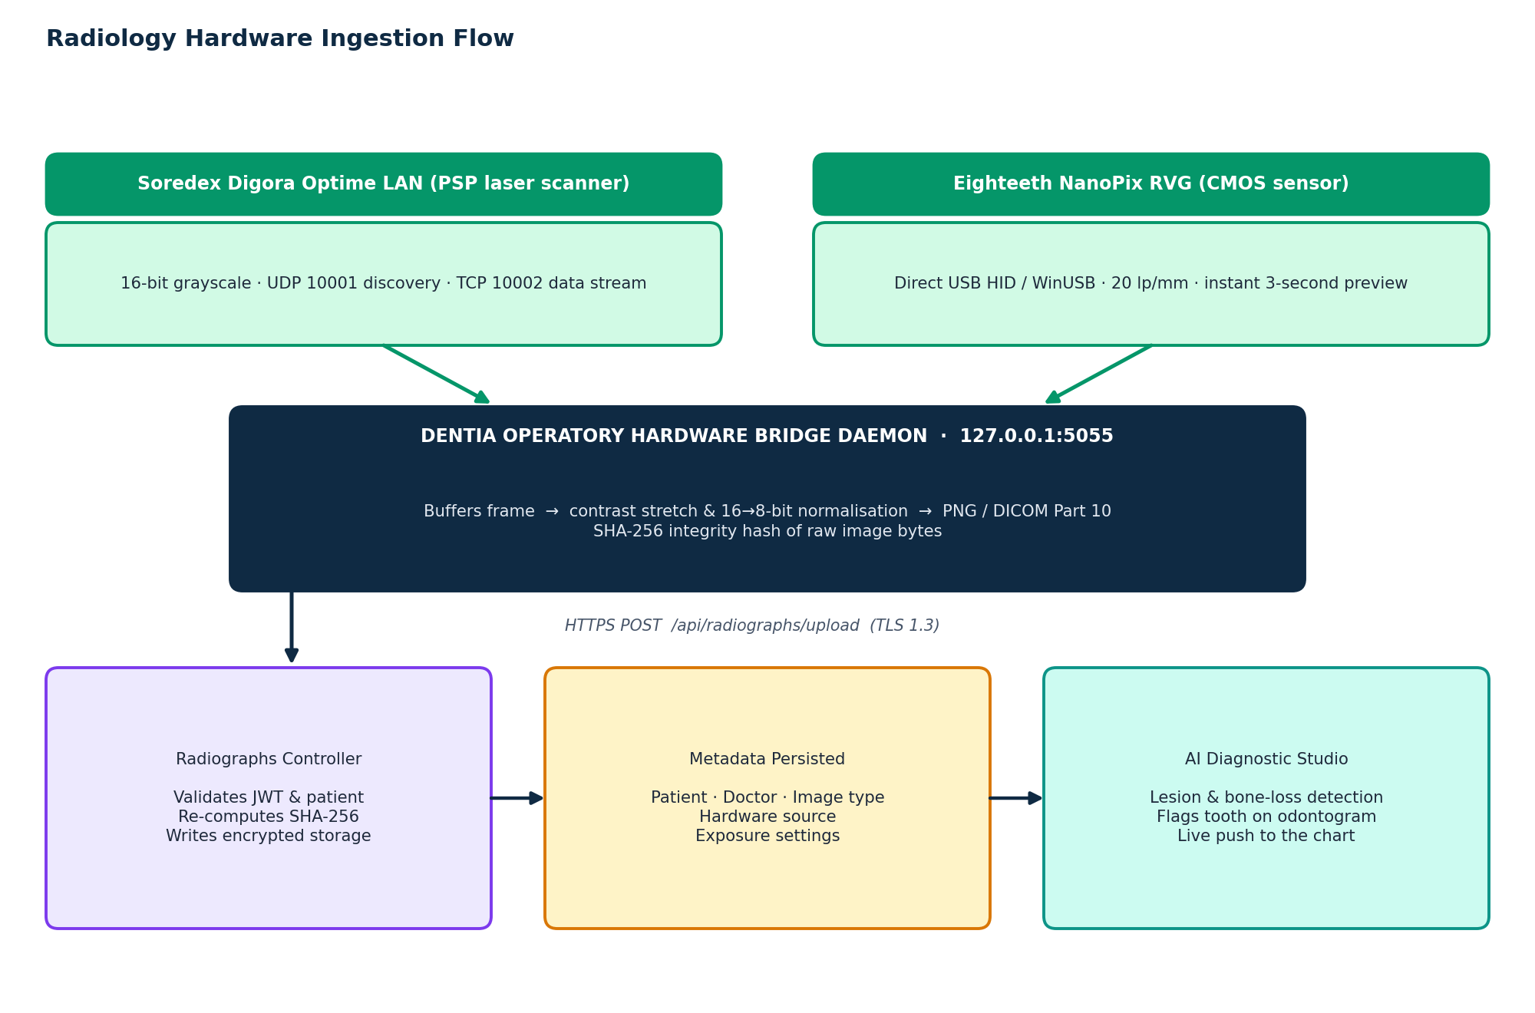
Figure 4 Radiology hardware ingestion flow from sensor to odontogram

CHAPTER 09
AI Clinical Consultation Scribe & Structured SOAP Note Architecture

9.1 Structured 8-Section SOAP Medical Note Framework
Dentia generates official, medical-grade consultation notes structured according to the international SOAP format. All consultation notes are stored in [dentist].[DentalNotes] and divided into 8 standardized sections:
SOAP Note Section | Clinical Contents & Diagnostic Documentation Rules
1. Subjective (Chief Complaint & HPI) | Patient-reported symptoms, chief complaint, duration, onset, trigger factors (hot/cold/sweets), and relevant medical history.
2. Objective (Clinical Examination) | Extraoral exam (lymph nodes, TMJ), intraoral exam (mucosa, palate), odontogram findings by tooth, and periodontal probing depths.
3. Radiographic Findings | Detailed radiographic assessment: bone crest levels, periapical radiolucencies, pulp chamber receded/calcified, recurrent decay under existing crowns.
4. Assessment & Clinical Diagnoses | Formal diagnostic conclusions coded to ICD-10-CM (e.g. K02.52 Carious lesion involving pulp, K04.01 Irreversible pulpitis, K05.32 Chronic periodontitis).
5. Proposed Treatment Plan | Multi-stage treatment sequence: Phase 1 (Urgent/Emergency), Phase 2 (Disease Control), Phase 3 (Restorative/Prosthetic), Phase 4 (Maintenance Recall).
6. Procedures Performed Today | Itemized list of treatments completed during the current operatory visit with CDT billing codes, tooth numbers, surfaces, and materials used.
7. Prescriptions & Medications | Electronic prescriptions issued: antibiotic prophylaxis, postoperative analgesics, dosage, quantity, and administration instructions.
8. Post-Operative Instructions & Recall | Patient care instructions (soft diet, warm salt water rinses, pain management) and scheduled follow-up interval.

9.2 Real-World Clinical SOAP Consultation Note Examples
Below are full-length examples of clinical SOAP consultation notes generated within Dentia:
Clinical Example 1: Acute Irreversible Pulpitis & Emergency Root Canal (Tooth #14)
SUBJECTIVE
Patient presents with severe, throbbing pain localized to the upper left quadrant for the past 48 hours. Pain is spontaneously triggered, awakens patient at night, and is acutely exacerbated by cold and hot liquids with lingering discomfort (>30 seconds). Medical History: Non-contributory. No known drug allergies (NKDA). Blood pressure: 124/82 mmHg.
OBJECTIVE
Intraoral exam reveals extensive mesial-occlusal dark cavitation on Tooth #14 with fractured marginal ridge. Tooth #14 is acutely sensitive to vertical percussion (Grade 2) and palpation over buccal apex. Electric pulp test (EPT): exaggerated delayed response. Periodontal probing depths: 2-3 mm circumferentially with localized bleeding on probing (BOP).
RADIOGRAPHIC
Periapical radiograph confirms deep carious lesion on Tooth #14 penetrating into the coronal pulp chamber. Widening of the periodontal ligament (PDL) space noted around the mesiobuccal and palatal root apices. Bone height normal.
ASSESSMENT
ICD-10 K04.01 Irreversible pulpitis, symptomatic, with symptomatic apical periodontitis on Tooth #14.
PLAN
1. Emergency pulpectomy and root canal therapy (CDT D3330).
2. Monolithic zirconia crown restoration (CDT D2740) following post-and-core buildup (CDT D2950).
PROCEDURES PERFORMED TODAY
Administered 1.7 ml Articaine 4% with 1:100,000 epinephrine via buccal infiltration and palatal block. Rubber dam isolation placed. Caries excavated. Direct pulpal exposure identified with active hemorrhagic bleeding. Coronal access prepared. Located 4 canal orifices (MB1, MB2, DB, P). Chemomechanical instrumentation completed using rotary NiTi files under continuous 2.5% NaOCl irrigation. Working lengths: MB1=20.5mm, MB2=20.0mm, DB=19.5mm, P=21.0mm. Canals dried with sterile paper points. Calcium hydroxide sedative dressing placed. Access sealed with Cavit temporary restoration.
PRESCRIPTIONS
1. Ibuprofen 600mg tablets, take 1 tablet PO every 6 hours PRN pain (Disp: #16).
2. Acetaminophen 500mg tablets, take 1 tablet PO Q6H concurrently for breakthrough pain.
POST-OP & RECALL
Avoid chewing hard foods on upper left side. Temporary filling may feel slightly high or rough. Scheduled for second-stage obturation visit in 7 days.

Clinical Example 2: Surgical Extraction of Impacted Wisdom Tooth (Tooth #17)
SUBJECTIVE
22-year-old patient reports recurrent episodes of swelling, pain, and foul taste around the lower left jaw for 3 weeks. Difficulty opening mouth fully (mild trismus). NKDA.
OBJECTIVE
Intraoral examination reveals erythematous, edematous pericoronal flap (operculum) covering the disto-occlusal surface of Tooth #17. Purulent exudate elicited upon gentle palpation. MIO restricted to 32 mm. Submandibular lymphadenopathy present on left side.
RADIOGRAPHIC
Panoramic OPG confirms mesioangular partially bony impacted Tooth #17 (Pell & Gregory Class II Position B). Roots are fully formed with slight distal curvature; root apices are located 2 mm superior to the mandibular inferior alveolar nerve canal.
ASSESSMENT
ICD-10 K05.22 Acute pericoronitis secondary to mesioangular impacted Tooth #17.
PLAN
Surgical removal of partially bony impacted Tooth #17 (CDT D7230).
PROCEDURES PERFORMED TODAY
Local anesthesia: Left inferior alveolar nerve block (IANB) + lingual block + long buccal infiltration (3.4 ml Lidocaine 2% with 1:100,000 epinephrine). Full mucoperiosteal envelope flap elevated with releasing incision anterior to #18. Conservative buccal bone troughing performed using surgical handpiece with sterile saline irrigation. Tooth sectioned horizontally at cervical junction. Crown elevated and delivered in two segments. Roots mobilized with straight elevator and delivered intact. Socket curetted, irrigated with 50 ml sterile saline, and inspected for nerve exposure (none observed). Repositioned flap closed tension-free with 3-0 Chromic Gut resorbable sutures.
PRESCRIPTIONS
1. Amoxicillin 500mg, 1 cap PO TID x 7 days (Disp: #21).
2. Ibuprofen 600mg Q6H PRN pain.
3. Chlorhexidine Gluconate 0.12% oral rinse, 15 ml swish and spit BID starting tomorrow.
POST-OP
Bite firmly on gauze pack for 45 minutes. Apply ice pack to left cheek (20 mins on/off). Soft diet for 3 days. No smoking, spitting, or drinking through straws. Recall in 10 days for healing check.

9.3 Scribe Processing Pipeline
The scribe turns spoken dialogue into structured documentation in five stages. Every note passes a pharmacological safety check before it reaches the clinician, and nothing is final until the attending dentist signs and archives it. Cryptographic hashes of the input transcript and the synthesised note provide non-repudiation.
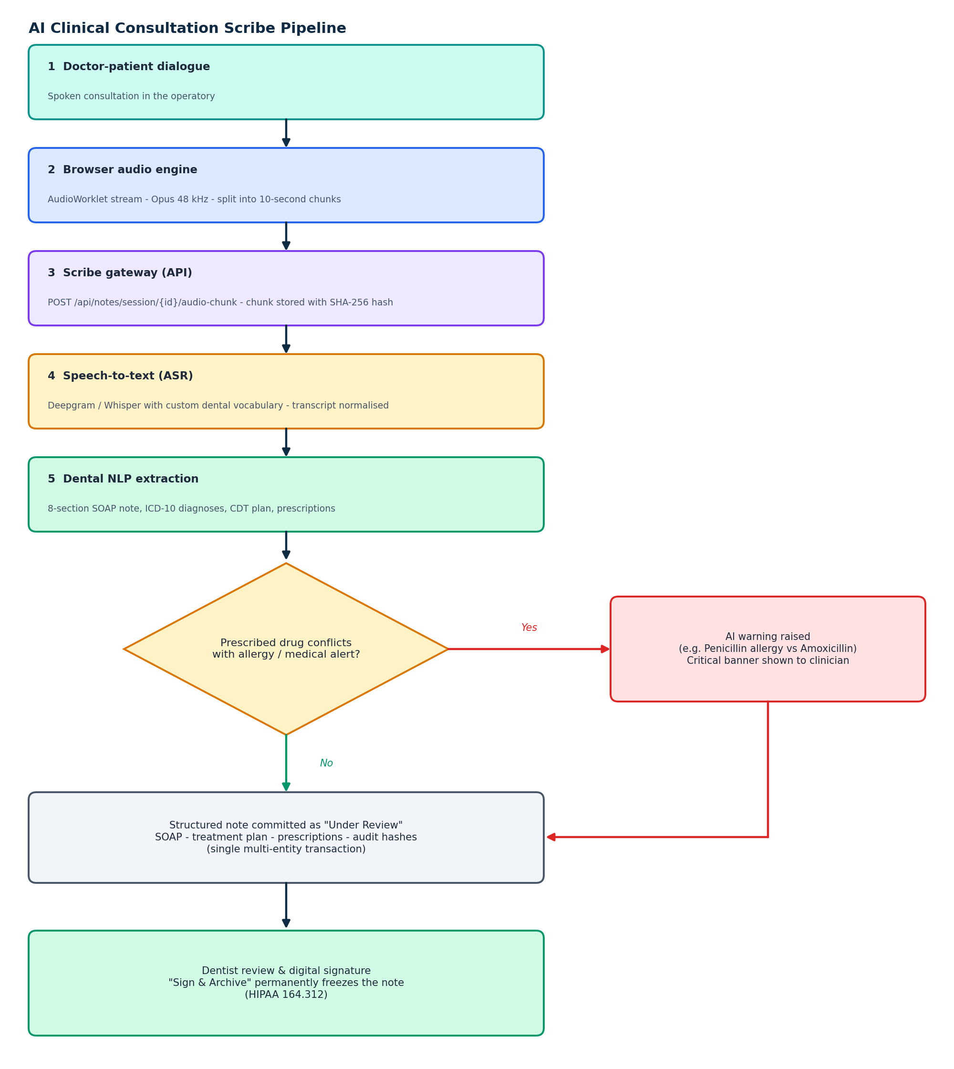
Figure 5 Ambient audio to signed SOAP note, including the allergy and contraindication safety gate

CHAPTER 10
Electronic Prescribing (e-Rx), Pharmacology & Drug-Interaction Safety

10.1 Master Dental Pharmacology Drug Monograph Catalog
Dentia features an integrated Electronic Prescribing (e-Rx) formulary containing standardized monographs for the most common dental pharmaceuticals. The table below details clinical class, standard adult/pediatric dosing, mechanisms of action, and contraindications:
Medication | Class | Standard Dosage | Mechanism & Clinical Use | Contraindications & Warnings
Amoxicillin 500mg | Penicillin Antibiotic | 500 mg PO TID x 7 days (Pediatric: 25-50 mg/kg/day) | Inhibits bacterial cell wall synthesis. First-line choice for odontogenic dentoalveolar abscess and post-surgical prophylaxis. | Known penicillin/beta-lactam hypersensitivity. Risk of anaphylaxis.
Augmentin 875/125mg | Broad-Spectrum Penicillin + Clavulanate | 875 mg PO BID x 7 days with food | Clavulanate potassium inactivates bacterial beta-lactamase enzymes. Indicated for refractory or recurrent fascial space infections. | History of Augmentin-associated cholestatic jaundice or hepatic dysfunction.
Clindamycin 300mg | Lincosamide Antibiotic | 300 mg PO QID x 7 days (Pediatric: 10-20 mg/kg/day) | Suppresses bacterial protein synthesis by binding to 50S ribosomal subunits. Primary alternative for penicillin-allergic patients. | History of pseudomembranous colitis or Clostridioides difficile-associated diarrhea (CDAD).
Cephalexin 500mg | 1st Gen Cephalosporin | 500 mg PO QID x 7 days | Inhibits cell wall mucopeptide synthesis. Used for skin/facial infections and orthopedic joint prophylaxis. | Severe immediate penicillin anaphylaxis (cross-reactivity risk ~1-3%).
Metronidazole 400mg | Nitroimidazole Antibacterial | 400 mg PO TID x 5 days | Causes DNA strand breakage in obligate anaerobes. Combined with Amoxicillin for acute necrotizing ulcerative gingivitis (ANUG) and aggressive periodontitis. | Strict contraindication with alcohol (disulfiram-like ethanol reaction: vomiting, tachycardia).
Azithromycin 250mg | Macrolide Antibiotic | 500 mg Day 1, then 250 mg QD Days 2-5 ('Z-Pak') | Blocks transpeptidation by binding to 50S ribosomal subunit. Used for penicillin-allergic patients requiring simple once-daily dosing. | Hepatic impairment, history of QT prolongation or cardiac arrhythmias.
Ibuprofen 400-600mg | Non-Selective NSAID | 400-600 mg PO Q6H PRN (max 2400 mg/day) | Reversibly inhibits COX-1 and COX-2 enzymes, decreasing pro-inflammatory prostaglandin synthesis. Gold standard for dental inflammatory pain. | Active peptic ulcer disease, severe renal insufficiency, third trimester of pregnancy, aspirin-induced asthma.
Naproxen 500mg | Long-Acting NSAID | 500 mg initially, then 250-500 mg Q12H PRN (max 1250 mg/day) | Provides extended 12-hour pain and inflammation relief. Ideal for post-implant and periodontal surgical recovery. | Active gastrointestinal bleeding, coronary artery bypass graft (CABG) surgery perioperative period.
Acetaminophen 500mg | Central Non-Opioid Analgesic | 500-1000 mg PO Q6H PRN (max 4000 mg/day, 2000 mg if hepatic impairment) | Acts predominantly on the central nervous system to inhibit prostaglandin synthesis. Lacks peripheral anti-inflammatory activity. | Severe active liver disease or chronic alcoholism (risk of fatal hepatotoxicity).
Dexamethasone 4mg | Potent Systemic Corticosteroid | 4-8 mg single PO/IV dose 1 hour pre-op | Suppresses neutrophil migration and capillary permeability, dramatically attenuating postoperative facial swelling and trismus after third molar surgery. | Systemic fungal infections, active herpes simplex keratitis, uncontrolled diabetes (causes acute hyperglycemia).
Chlorhexidine 0.12% | Bisbiguanide Antiseptic Rinse | 15 ml swish and expectorate BID x 14 days | Ruptures bacterial cell membranes. Substantivity: binds to oral mucosa and enamel pellicle, releasing antimicrobials over 12 hours. | Prolonged use (>14 days) causes reversible extrinsic brown staining of teeth and tongue and altered taste.
Lidocaine 2% + 1:100k Epi | Amide Local Anesthetic | Max dose: 7.0 mg/kg with vasoconstrictor (max 500 mg = ~13 cartridges) | Reversibly blocks voltage-gated sodium channels preventing nerve depolarization. Epinephrine prolongs pulpal anesthesia to 60 minutes. | Known amide allergy, uncontrolled hyperthyroidism, recent myocardial infarction (<6 months).
Articaine 4% + 1:100k Epi | Thiophene-Amide Anesthetic | Max dose: 7.0 mg/kg (max 500 mg = ~7 cartridges) | Contains a thiophene ring granting superior lipid solubility and bone penetration. Highly effective for mandibular molar infiltration. | Not recommended for inferior alveolar nerve blocks due to slightly elevated paresthesia reports.

10.2 American Heart Association (AHA) Infective Endocarditis Prophylaxis Protocol
Dentia enforces strict adherence to American Heart Association guidelines for antibiotic prophylaxis prior to dental procedures involving manipulation of gingival tissue or periapical tooth regions:
Patient Category | Medication | Recommended Regimen | Timing & Administration
Standard Oral Regimen (No Penicillin Allergy) | Amoxicillin | Adults: 2.0 grams PO single dose  Pediatrics: 50 mg/kg PO single dose | Administer 30 to 60 minutes prior to procedure.
Penicillin Allergic - Oral Alternative A | Cephalexin | Adults: 2.0 grams PO single dose  Pediatrics: 50 mg/kg PO single dose | Use only if allergy was non-anaphylactic (e.g. mild rash).
Penicillin Allergic - Oral Alternative B | Clindamycin | Adults: 600 mg PO single dose  Pediatrics: 20 mg/kg PO single dose | Preferred alternative if patient experienced true anaphylaxis.
Penicillin Allergic - Oral Alternative C | Azithromycin / Clarithromycin | Adults: 500 mg PO single dose  Pediatrics: 15 mg/kg PO single dose | Administer 30 to 60 minutes prior to procedure.
Unable to Take Oral Medication | Ampicillin or Cefazolin | Adults: 2.0g IM/IV Ampicillin or 1.0g Cefazolin  Pediatrics: 50 mg/kg IM/IV | Administer 30 minutes prior to procedure via parenteral route.

CHAPTER 11
Patient Master Directory, Clinical Console & EHR Lifecycle Management

11.1 Systemic Medical Conditions & Dental Management Guidelines
A critical responsibility of Dentia is screening systemic conditions that impact dental treatment. The table below details 10 major medical conditions and the automated safety protocols enforced by the system:
Medical Condition | Dental Operatory Risk Profile | Dentia Safety Protocol & Clinical Precaution
Anticoagulant Therapy (Warfarin, Eliquis, Xarelto) | Elevated risk of intra- and post-operative hemorrhage during extractions or periodontal surgery. | Verify INR within 24-48 hrs of surgery (target: 2.0-3.0). Do NOT discontinue anticoagulants without physician consult. Employ local hemostatics (Surgicel, tranexamic acid, sutures).
Bisphosphonate Therapy (Fosamax, Zometa, Prolia) | Risk of Medication-Related Osteonecrosis of the Jaw (MRONJ) following invasive bone procedures. | Avoid elective extractions or bone surgery if IV bisphosphonates administered >3 years. Prioritize endodontic retention over extraction.
Cardiovascular Disease / Hypertension | Risk of hypertensive crisis, angina, or arrhythmia from exogenous epinephrine. | Measure BP at every visit. If BP >160/100, defer elective treatment. Limit epinephrine to 0.04 mg (max 2 cartridges 1:100k).
Diabetes Mellitus (Type 1 & Type 2) | Impaired neutrophil chemotaxis leading to severe periodontal bone loss, delayed wound healing, and dry socket. | Record HbA1c (target <7.0%). Schedule morning appointments after meals and insulin. Keep oral glucose paste chairside.
Asthma / Chronic Obstructive Pulmonary Disease | Risk of acute bronchospasm triggered by operatory stress, aerosols, or tooth dust. | Verify patient brought albuterol rescue inhaler to operatory chair. Avoid aspirin and NSAIDs if aspirin-sensitive triad present.
Epilepsy / Seizure Disorders | Risk of grand mal seizure during dental treatment triggered by light, fatigue, or stress. | Determine seizure frequency and compliance with anticonvulsants (Dilantin/Phenytoin). Note drug-induced gingival hyperplasia.
End-Stage Renal Disease (Hemodialysis) | Bleeding tendencies due to heparinization, shunt infection risk, impaired drug clearance. | Treat on non-dialysis days (heparin cleared, fluid balance optimal). Avoid nephrotoxic NSAIDs (use paracetamol).
Pregnancy (Trimester 1, 2, 3) | Teratogenic drug risks, supine hypotensive syndrome in late pregnancy, pregnancy gingivitis. | Second trimester (Weeks 14-28) is safest for elective dental treatment. Avoid NSAIDs, tetracyclines, and codeine. Position semi-reclined.
Artificial Heart Valves / History of Endocarditis | High bacteremia risk of bacterial colonization on prosthetic valves during dental scaling/extractions. | Strict AHA antibiotic prophylaxis mandatory 30-60 minutes prior to procedure (2.0g Amoxicillin or 600mg Clindamycin).
Latex Hypersensitivity | Severe Type I anaphylactic allergic reaction to natural rubber latex gloves or dental dams. | Red medical alert banner placed on EHR chart. Operatory completely latex-free (nitrile gloves, non-latex rubber dam, latex-free prophy cups).

11.2 End-to-End Clinical Encounter Lifecycle
Patient care follows a strict chronological progression, from intake through diagnostic imaging, charting, consultation scribing, procedure completion and financial settlement. Each stage feeds the next, so restorative work recorded in the ledger is reflected on the odontogram and the whole encounter is sealed in the audit log.
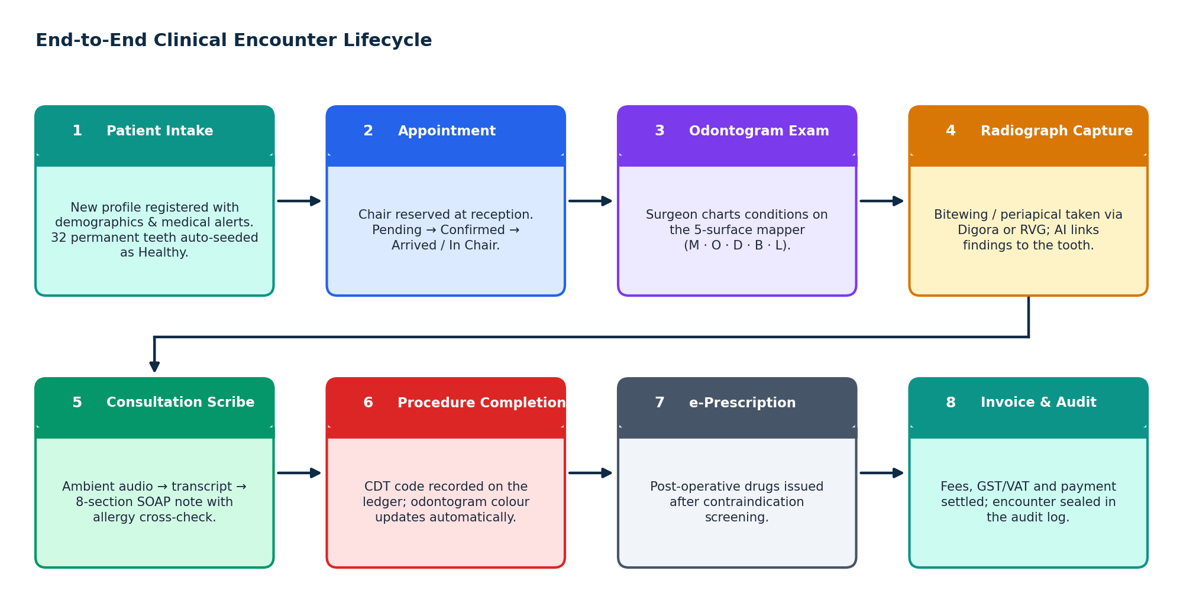
Figure 6 Eight-stage clinical encounter lifecycle

CHAPTER 12
Doctor Treatment Pricing Rules, Fee Schedules & Invoicing Engine

12.1 Treatment Phasing & Clinical Execution Sequencing
Complex dental rehabilitation requires systematic clinical staging. Dentia enforces a standardized 4-phase treatment sequencing engine:
- Phase 1: Emergency & Palliative Care: Immediate elimination of acute pain, odontogenic infection, and bleeding. Procedures include emergency pulpectomies (D3221/D3330), incision and drainage of abscesses (D7510), and temporary palliative dressings.
- Phase 2: Disease Control & Periodontal Stabilization: Elimination of active dental caries, control of periodontal inflammation, and extraction of non-restorable teeth. Procedures: quadrant scaling and root planing (D4341), caries excavation, core buildups, and un-restorable root removal (D7140).
- Phase 3: Definitive Restorative & Prosthetic Rehabilitation: Final tooth reconstruction, orthodontic alignment, cosmetic veneers, CAD/CAM ceramic crowns (D2740), endosteal implant placement (D6010), and fixed bridges.
- Phase 4: Maintenance Recall & Supportive Therapy: Ongoing preventative maintenance: 3-month or 6-month periodic recall exams (D0120), adult cleanings (D1110), fluoride varnish, and occlusion monitoring.
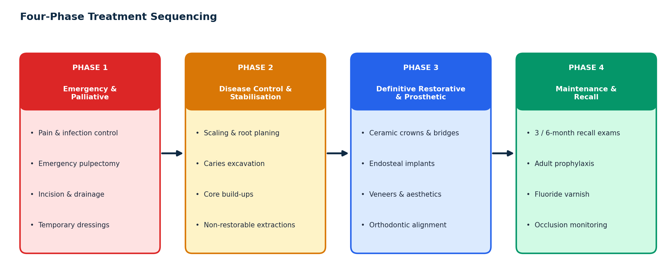
Figure 7 Standard four-phase treatment sequencing

12.2 Automated Invoicing & Financial Ledger Architecture
When procedures are charted in the operatory, Dentia populates the patient's billing ledger (via the BillingController). The financial engine resolves doctor-specific procedure fee overrides, calculates applicable taxes (e.g. 15% GST), applies clinic prepayment discounts, and records dual payment modalities: integrated credit/debit card processing, cash payments with serialized receipts, or phased milestone installment plans.
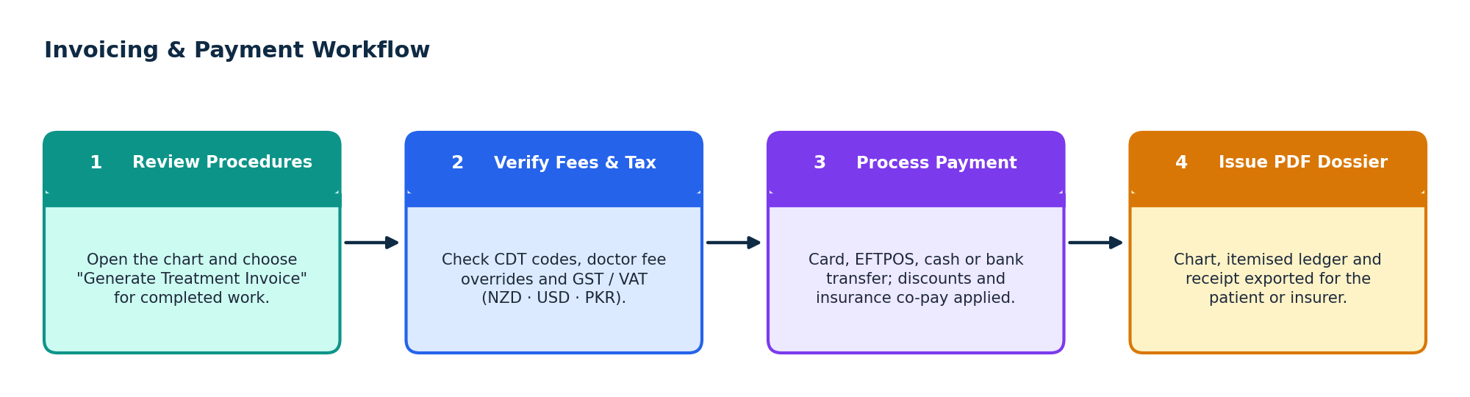
Figure 8 Invoicing and payment workflow

CHAPTER 13
Comprehensive Patient Dental Report PDF Generation System

13.1 Vector Graphics PDF Generation Architecture
Dentia generates official, multi-page patient dental reports formatted for patient presentation, specialist referrals, and insurance claim reimbursement (InvoicePdfGenerator.jsx). The document layout adheres to international medical publishing standards:
- Clinic Header & Branding: Official dental clinic logo, legal business name, address, contact telephone, email, and tax registration number.
- Patient Demographic Dossier: Patient name, EHR number, date of birth, age, gender, date of examination, and attending doctor credentials.
- Full Graphical Odontogram Chart: Vectorized dual-arch dental chart depicting all 32 teeth with exact color-coded condition indicators, missing teeth sockets, and restorative surface fills.
- Itemized Clinical Finding Ledger: Detailed table listing every tooth number, anatomical zone, diagnosed condition, recommended procedure, and ADA CDT code.
- Financial Breakdown & Treatment Estimate: Phased treatment costs, insurance co-pay estimates, out-of-pocket patient responsibility, and payment schedule terms.
- Clinician Certification & Signature Block: Formal declaration of clinical accuracy with digital signature line, practicing license number, and date of issue.

CHAPTER 14
Organization Management & Multi-Clinic Multi-Tenancy Architecture

14.1 Multi-Tenant Organization Hierarchy
Dentia is architected from the ground up to support multi-clinic dental networks, university dental schools, and Dental Service Organizations (DSOs). The tenancy hierarchy operates across three tiers:
- Organization Tier ([dentist].[Organizations]): Top-level corporate entity representing the clinic chain (e.g. 'Auckland Dental Care Group'). Controls enterprise licensing, global fee schedules, and centralized reporting.
- Branch / Clinic Tier: Physical facility or location (e.g. 'Ponsonby Branch', 'Takapuna Branch'). Manages local operatory chairs, hardware devices (Digora scanners), and inventory.
- Doctor Affiliation Tier: Links clinicians to one or more clinic locations with custom schedules, fee structures, and access privileges per facility.

CHAPTER 15
Patient Portal, Self-Service Kiosk & Tele-Dentistry Hub

15.1 Patient Portal Architecture Overview
The Dentia Patient Portal (/portal/*) is an external-facing, patient-centric web interface designed to elevate the patient experience, enhance treatment adherence, and streamline administrative intake. The portal operates under an isolated authentication pipeline (PatientAuthController.cs), shielding clinical operatory endpoints.

15.2 Key Patient Portal Modules & Functionality
The portal delivers five core self-service capabilities:
Portal Module | Patient-Facing Functionality & Clinical Value
1. Patient Dashboard (/portal) | Central overview presenting upcoming appointments, current balance due, active prescription alerts, and a summary of completed dental treatments.
2. Interactive Dental Health Map (/portal/odontogram) | A simplified, patient-friendly visualization of their teeth. Rather than complex medical jargon, teeth are labeled with understandable terms like 'Filling Completed', 'Cavity Detected', or 'Healthy Enamel'.
3. 24/7 Operatory Self-Booking (/portal/book) | Allows patients to browse available operatory time slots, select their preferred dentist, indicate their chief reason for visit, and reserve appointments in real time.
4. Electronic Billing & Payments (/portal/billing) | Presents itemized invoices, insurance coverage estimates, and secure online credit/debit card payment processing with instant PDF receipt generation.
5. Official Clinical Reports (/portal/reports) | Enables patients to view and securely download their official dentist-signed clinical treatment plans, diagnostic summaries, and X-ray records for personal records or insurance claims.

15.3 Digital Informed Consent Architecture
Prior to invasive dental procedures, patients execute digital informed consent via the portal or chairside tablet kiosk. Dentia stores executed consents with timestamps, IP addresses, and cryptographic signatures: (1) Informed Consent for Endodontic Therapy (outlining risks of instrument separation, perforation, and crown requirement), (2) Informed Consent for Surgical Extractions (outlining risks of dry socket, nerve paresthesia, and sinus involvement), and (3) Informed Consent for Dental Implant Placement (detailing osseointegration failure risks and maintenance commitments).

CHAPTER 16
Security Hardening, Session Management, HIPAA Compliance & Performance

16.1 HIPAA & International Privacy Compliance Framework
Dentia enforces stringent physical, technical, and administrative safeguards mandated by the Health Insurance Portability and Accountability Act (HIPAA Security Rule 45 CFR Part 160 and Part 164, Subparts A and C) and the General Data Protection Regulation (GDPR):
- Data Encryption at Rest: All SQL Server database files, transaction logs, and radiograph storage volumes are encrypted using AES-256 bit encryption (Transparent Data Encryption - TDE).
- Data Encryption in Transit: All communication between browsers, API services, and database servers is strictly mandated over TLS 1.3 with modern cipher suites. Insecure HTTP connections are automatically redirected.
- Cryptographic Password Hashing: Passwords are never stored in plaintext. They are hashed using salted BCrypt with adaptive cost factors preventing dictionary and rainbow-table attacks.
- Audit Logging & Accountability: Every record creation, read, update, or deletion (CRUD) is recorded in immutable audit tables ([dentist].[ClinicalLogs] and [dentist].[AIAuditLogs]) containing user identity, IP address, and SHA256 payload checksums.

16.2 Disaster Recovery & Automated Backup Strategy
To guarantee business continuity, Dentia enforces an enterprise three-tier backup protocol:
Backup Tier | Execution Schedule | Retention & Disaster Recovery Target
Full Database Backup | Nightly at 01:00 UTC | Complete snapshot of all clinical data and indexes. Encrypted and replicated to off-site cloud storage.
Differential Backup | Every 6 Hours (06:00, 12:00, 18:00) | Captures all data modifications since the last full backup, minimizing recovery time.
Transaction Log Backup | Every 15 Minutes | Continuous write-ahead transaction log streaming, achieving a Recovery Point Objective (RPO) of <15 minutes.
Disaster Recovery RTO | Recovery Time Objective < 1 Hour | Documented automated failover to standby SQL Server replica in the event of hardware host failure.

CHAPTER 17
Complete REST API Reference (12 Enterprise Web Controllers)

17.1 Master Controller Overview
The Dentia backend exposes a robust RESTful API built on ASP.NET Core 8. All responses return standardized JSON payloads with ISO 8601 timestamps and HTTP status codes (200 OK, 201 Created, 400 Bad Request, 401 Unauthorized, 403 Forbidden, 404 Not Found, 500 Internal Error).

17.2 Complete API Controller & Endpoint Catalog
Below is the exhaustive index of all API endpoints across the 12 production controllers:
Controller Name | HTTP Route & Method | Functional Scope & Payload Description
PatientsController | GET /api/patients | Returns paginated list of patients with search, doctor filter, and medical alerts.
PatientsController | GET /api/patients/{id} | Retrieves complete demographic and clinical profile for a specific patient ID.
PatientsController | POST /api/patients | Registers a new patient with medical history, emergency contacts, and age cohort.
PatientsController | GET /api/patients/{id}/chart | Fetches 32-tooth odontogram surface state, conditions, and colors from TeethState.
PatientsController | POST /api/patients/teeth/update-bulk | Executes atomic batch update of multiple tooth conditions, surfaces, and treatments.
PatientsController | GET /api/patients/{id}/treatment-history | Returns chronological ledger of all treatments performed on the patient.
PatientsController | POST /api/patients/{id}/chart/export | Triggers high-fidelity PDF export of the patient's complete odontogram chart.
AIDentalNotesController | GET /api/ai-dental-notes/patient/{id} | Retrieves all structured 8-section SOAP consultation notes for a patient.
AIDentalNotesController | POST /api/ai-dental-notes/compile | Parses consultation audio/transcript into structured SOAP format and CDT codes.
RadiographsController | GET /api/radiographs/patient/{id} | Lists all radiographic scans (bitewings, periapicals, OPG) for a patient.
RadiographsController | POST /api/radiographs/upload | Ingests raw DICOM/PNG X-ray scan from hardware bridge or manual upload.
AppointmentsController | GET /api/appointments | Returns operatory appointment calendar slots filtered by date and doctor.
AppointmentsController | POST /api/appointments | Books an operatory consultation appointment slot with doctor allocation.
BillingController | GET /api/billing/patient/{id}/invoices | Retrieves all treatment invoices, itemized procedures, and balance due.
BillingController | POST /api/billing/invoices/generate | Generates an official invoice from completed odontogram chart procedures.
TreatmentPricingController | GET /api/treatment-pricing | Fetches global master CDT procedure catalog, categories, and baseline fees.
TreatmentPricingController | POST /api/treatment-pricing/doctor-override | Configures custom procedure pricing and margins for a specific doctor.
OrganizationsController | GET /api/organizations | Lists all tenant dental organizations, clinic branches, and affiliations.
PatientPortalController | GET /api/portal/dashboard | Returns authenticated patient portal overview: appointments, balance, and health map.
PatientAuthController | POST /api/portal/auth/login | Authenticates patient portal credentials and issues portal session tokens.

17.3 Key JSON Request & Response Payloads
Representative JSON payload for bulk tooth updating (POST /api/patients/teeth/update-bulk):
// REQUEST PAYLOAD:
{
"patientId": "14",
"updates": [
{
"toothNumber": "14",
"status": "Root Canal Needed",
"color": "#8B5CF6",
"comment": "Severe symptomatic irreversible pulpitis with mesial caries",
"treatmentPlan": "Endodontic Molar Therapy D3330 & Zirconia Crown D2740"
},
{
"toothNumber": "19",
"status": "Cavity",
"color": "#3B82F6",
"comment": "MOD dentinal caries requiring composite resin",
"treatmentPlan": "Resin Composite 3 Surfaces D2393"
}
]
}

// RESPONSE PAYLOAD (200 OK):
{
"success": true,
"updatedTeethCount": 2,
"patientId": 14,
"timestamp": "2026-10-01T12:00:00Z"
}

CHAPTER 18
Deployment, DevOps, CI/CD & Production Operations Guide

18.1 Production Compilation & Build Workflow
To compile the complete production bundle, execute the following command pipeline:
# 1. Compile and Bundle Frontend Client SPA
cd f:\DentistApp_Theme2\Dentistfrontend
npm run build

# 2. Sync Production Assets to ASP.NET Host wwwroot
Copy-Item -Path 'dist\*' -Destination '..\DentistAPI\wwwroot\' -Recurse -Force
Copy-Item -Path 'dist\*' -Destination '..\DentistAPI\publish\wwwroot\' -Recurse -Force

# 3. Publish .NET 8 Backend API Host
cd ..\DentistAPI
dotnet publish -c Release -o .\publish

CHAPTER 19
Comprehensive Page-by-Page & Sub-Page Functional Specification & Clinical User Manuals

19.1 Master User Interface Navigation Architecture & Screen Hierarchy
Dentia is architected around an intuitive, high-velocity single-page application (SPA) routing hierarchy designed specifically for dental operatory environments. The interface minimizes clicks, provides instant keyboard shortcuts, and ensures that all diagnostic and restorative patient context remains accessible without navigational friction. The following architectural tree illustrates the complete route, modal, and sub-page hierarchy across the system:
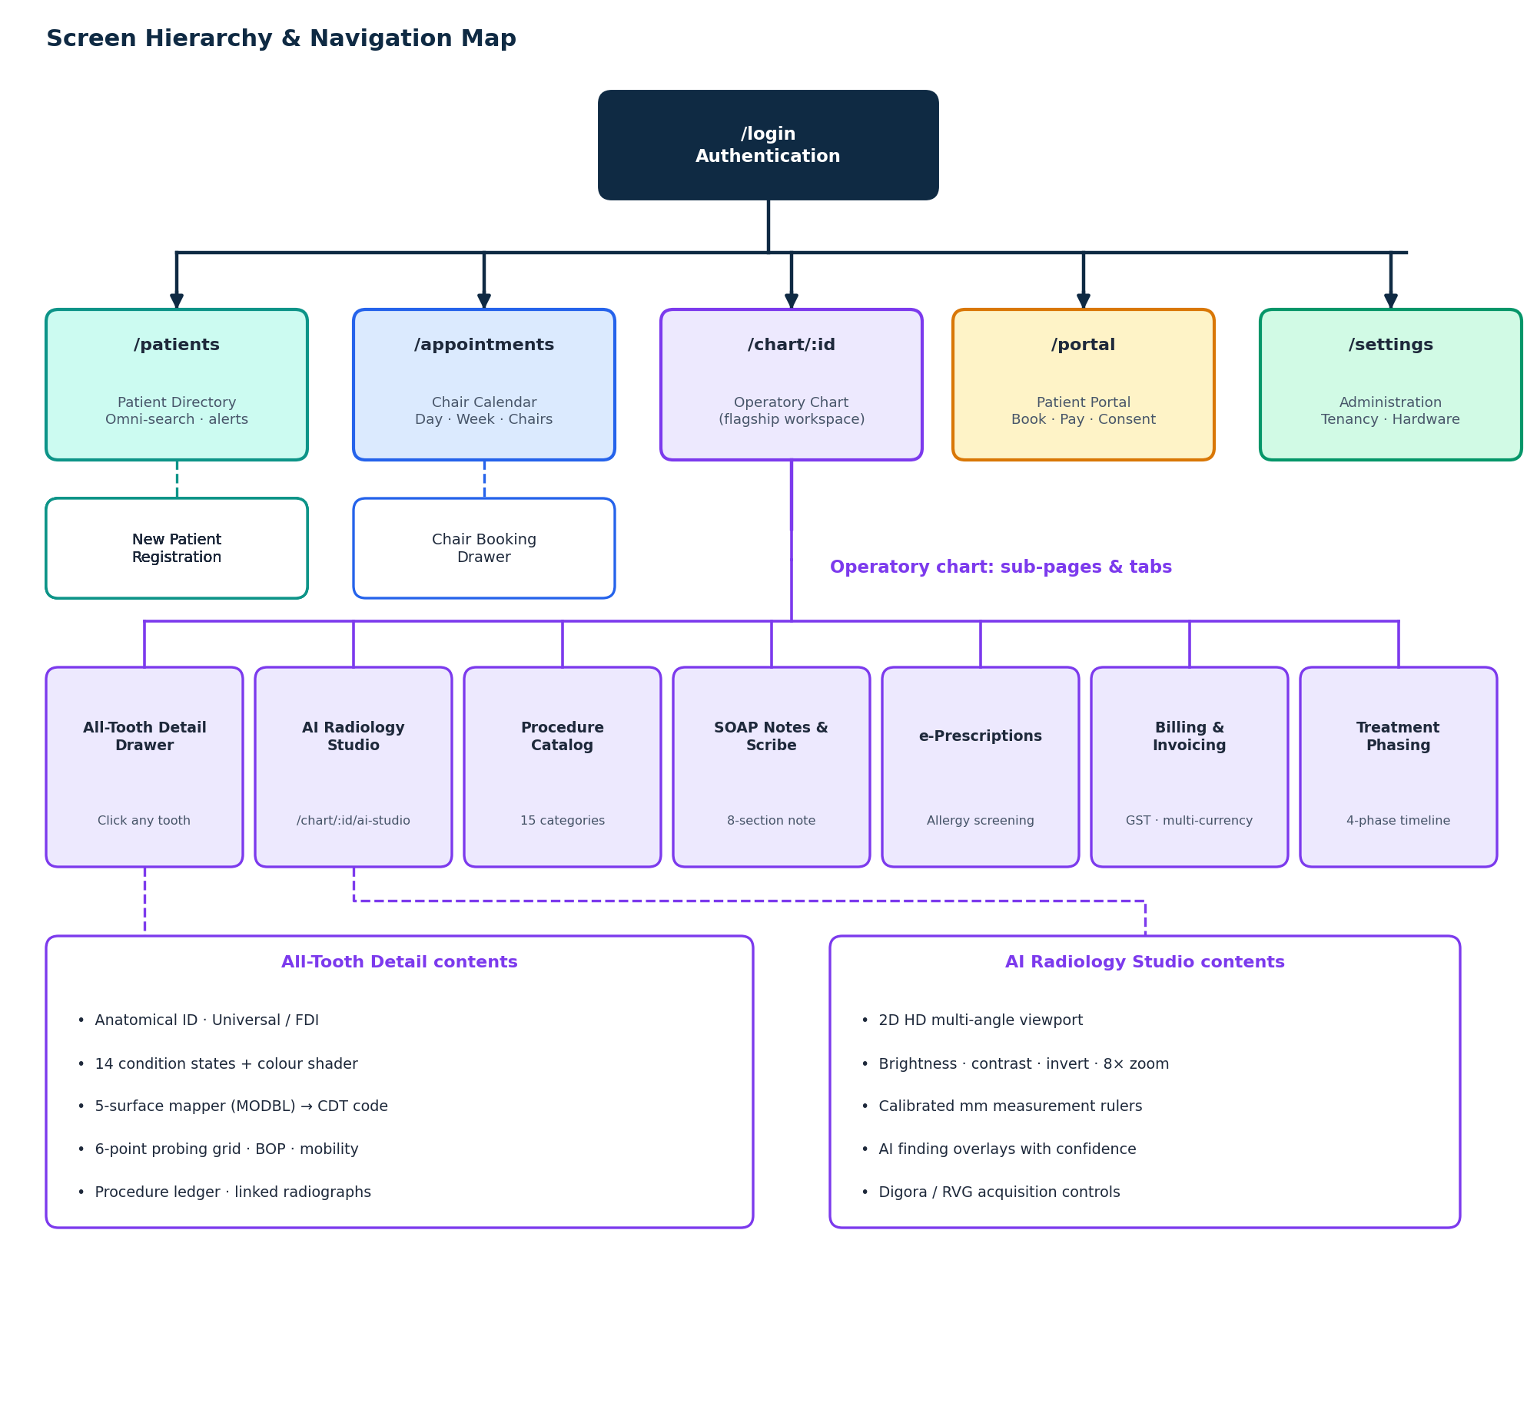
Figure 9 Complete screen hierarchy and navigation map

19.2 Screen Specification 1: Authentication & Doctor Login Page (/login)
The login interface provides the initial secure boundary for all clinicians, specialists, hygienists, and administrative personnel. Engineered to satisfy HIPAA §164.312 access control requirements, the page enforces strict credential validation, cryptographic session token issuance, and automated inactivity management.
- 1. Layout & User Interface Elements: Features a split-pane responsive layout with clinic branding on the left and a high-contrast login card on the right. Form inputs include Username / Clinical Email, Password (with interactive unmasking eye toggle), Clinic Location / Facility selector (for multi-branch DSO organizations), and 'Remember Me' checkbox.
- 2. Cryptographic Validation Pipeline: Form submission issues an encrypted POST to /api/auth/login. The ASP.NET Core backend verifies credentials against BCrypt salted hashes (adaptive work factor 12) stored in [dentist].[Doctors]. Upon verification, the server generates a signed HMAC-SHA256 JWT bearer token containing sub, doctorId, fullName, role, organizationId, and region.
- 3. Automated Inactivity Monitoring (IdleSessionManager): Client-side session monitoring (IdleSessionManager.jsx) tracks keyboard, mouse, and touch activity across operatory workstations. After 15 minutes of inactivity, a warning modal appears. Once the 60-second countdown expires without activity, the session is terminated, JWT tokens are purged from browser storage, and the user is redirected to /login?expired=true.
- 4. Error Handling & Security Defenses: Invalid credentials display sanitized RFC 7807 error banners ('Invalid username or credentials') without disclosing account existence. Fixed-window rate limiting restricts authentication attempts to 10 requests per minute per IP, protecting the operatory server from brute-force dictionary attacks.
- 5. Role-Based Landing Redirection: SuperAdministrators are routed to Organization Management (/organizations); Dental Surgeons and Specialists land on the Patient Directory (/patients); Dental Hygienists route to the Operatory Chair Calendar (/appointments); and Receptionists route to the Patient Intake Queue.

19.3 Screen Specification 2: Patient Directory & Clinical Intake Dashboard (/patients)
The Patient Directory serves as the administrative and clinical nerve center for patient retrieval, daily intake triage, and electronic health record (EHR) lifecycle management.
- 1. Real-Time Omni-Search & Filter Engine: Debounced search bar allows instantaneous filtering across thousands of records by Patient Name, Telephone Number, Patient ID, or National Health Identifier (NHI). Filter pills enable one-click toggling for 'Today's Appointments', 'In Chair Now', 'Pending Invoicing', and 'High-Risk Medical Alerts'.
- 2. Master Patient Table Architecture: Displays Patient Avatar, Full Name, Patient ID, Age & Date of Birth, Biological Gender, Phone Number, Assigned Attending Doctor, Active Treatment Plan Summary, and Esthetic Target Tooth Shade.
- 3. Color-Coded High-Risk Medical Alert Chips: Highlighted visual chips alert operatory staff prior to seating patients: Red Badge for Penicillin / Beta-Lactam Anaphylaxis; Red Badge for Anticoagulants (Warfarin/Eliquis elevated hemorrhage risk); Amber Badge for Bisphosphonates (MRONJ bone necrosis risk); Amber Badge for Cardiac Pacemaker; Amber Badge for Diabetes.
- 4. New Patient Registration Modal: Comprehensive intake modal capturing legal demographics, emergency contact info, systemic health history, cosmetic target shade (VITA Classical A1-D4), and attending doctor assignment. Submitting the form calls POST /api/patients and executes an atomic database transaction that seeds all 32 permanent teeth in [dentist].[TeethState] with status 'Healthy'.
- 5. Operatory Quick Action Shortcuts: Each row features direct one-click triggers: 'Open Clinical Chart' (routes to /chart/:patientId), 'Book Appointment' (opens operatory chair scheduler), and 'Financial Ledger' (routes to billing).

19.4 Screen Specification 3: Master Operatory Chart Page (/chart/:patientId) — Layout, Banners & Odontogram
The Master Operatory Chart Page represents the primary clinical workspace for dentists, periodontists, and oral surgeons. It combines visual odontogram charting, 3D anatomical modeling, historical procedure ledgers, and multi-specialty treatment planning into a single unified screen.
- 1. Persistent Patient Context Header Banner: Pinned header displaying Patient ID, Name, Age/DOB, Contact Phone, prominent Medical Alert Badges, Target Tooth Shade Code (e.g. VITA A1), Attending Clinician Name, and Quick Action buttons: 'Save All Chart Changes', 'Export Comprehensive PDF Dossier', and 'Back to Directory'.
- 2. Dual-Arch Interactive Odontogram Bar: Visual representation of 32 permanent teeth (#1–#16 Maxillary Arch, #17–#32 Mandibular Arch). Includes one-click toggles for International FDI Two-Digit World Notation (#11–#28, #31–#48) and Pediatric Deciduous Dentition (#A–#T / FDI #51–#85).
- 3. Color-Coded Pathology Shader Legend: Emerald Green (#10B981) indicates Healthy tooth; Crimson Red (#EF4444) indicates Active Caries; Royal Blue (#3B82F6) indicates Composite Resin; Deep Purple (#8B5CF6) indicates Root Canal Therapy; Warm Amber (#F59E0B) indicates Full Coverage Crown; Slate Gray (#64748B) indicates Missing/Extracted; Cyan (#06B6D4) indicates Dental Implant; Dark Burgundy (#991B1B) indicates Extraction Indicated.
- 4. 3D WebGL Interactive Anatomical Jaw Viewport: Interactive Three.js viewport rendering anatomical maxilla and mandible jaw geometry. Features smooth OrbitControls (360-degree rotation, pitch, and zoom), localized dental operatory spotlights, and raycast mesh selection. Hovering over any tooth produces an ambient glow; clicking opens the All-Tooth Detail Sub-Page drawer.

19.5 Screen Specification 4: Master All-Tooth Detail Sub-Page & Modal Drawer
Clicking any individual tooth in either the 32-Tooth Odontogram Bar or the 3D Jaw Viewport immediately slides out the comprehensive All-Tooth Detail Sub-Page / Modal Drawer. This view provides microscopic anatomical analysis, 5-surface restoration tracking, periodontal probing measurements, and linked diagnostic radiographs for the selected tooth.
- 1. Anatomical Identification Header: Displays Universal Tooth Number (e.g. Tooth #14), International FDI Notation (#26), Formal Clinical Anatomical Name (Maxillary Left First Molar), Arch Location (Maxilla), Quadrant (Upper Left Quadrant), and Developmental Dentition Category (Permanent vs Deciduous).
- 2. Comprehensive Clinical Condition Dropdown: Enables rapid assignment of 14 clinical states: Healthy, Cavity / Active Caries, Root Canal Needed, Existing Root Canal, PFM Crown, Zirconia Crown, Porcelain Veneer, Dental Implant, Missing / Extracted, Unerupted / Impacted, Tooth Fracture, Extraction Indicated, Composite Resin, and Amalgam. Selecting a condition immediately updates the color shader.
- 3. Microscopic 5-Surface Anatomical Mapper (MODBL): Interactive cruciform graphical selector representing the five anatomical surfaces: M (Mesial - anterior contact), O / I (Occlusal / Incisal - biting table), D (Distal - posterior contact), B / F (Buccal / Facial - cheek/lip side), and L / P (Lingual / Palatal - tongue/palate side). Multi-surface checkbox selections automatically map to ADA CDT codes: 1 Surface (D2391), 2 Surfaces (D2392), 3 Surfaces (D2393), 4+ Surfaces (D2394).
- 4. Diagnostic Notes & Periodontal Probing Grid: Free-text area for clinical pathology notes (e.g. 'Class II dentinal lesion, thermal sensitivity, pulp vitality positive'). Includes 6-point periodontal probing grid (Mesio-Buccal, Mid-Buccal, Disto-Buccal, Mesio-Lingual, Mid-Lingual, Disto-Lingual) with Bleeding on Probing (BOP) flags and Tooth Mobility Score selector (Class 0 to Class III).
- 5. Individual Tooth Historical Procedure Ledger: Embedded historical table listing every procedure performed on this specific tooth: Date of Treatment, Attending Doctor, Procedure Description, CDT Billing Code, Surfaces Treated, Fee Charged, and Operative Notes.
- 6. Linked Radiographic Previews: Displays thumbnail previews of all intraoral periapical and bitewing X-rays capturing this specific tooth. Clicking any thumbnail launches the scan in the AI Radiology Studio.
- 7. Operatory Action Triggers: Dedicated action buttons: 'Mark Tooth Healthy' (resets status and clears pathologies), 'Add to Visit Treatment Plan' (queues CDT code and fee into active plan), 'Schedule Procedure Appointment' (opens chair booking drawer), and 'Save & Close Drawer' (commits state via POST /api/teeth/state).

19.6 Screen Specification 5: AI Radiology Diagnostic Studio Sub-Page (/chart/:id/ai-studio)
The AI Radiology Diagnostic Studio provides high-definition multi-angle radiograph inspection, digital measurement, automated neural network pathology detection, and direct operatory hardware acquisition.
- 1. 2D HD Multi-Angle Viewport: High-definition Canvas/WebGL viewport rendering Bitewing, Periapical, Panoramic OPG, and Cephalometric scans. Features a multi-scan filmstrip allowing clinicians to switch angles instantly without reloading.
- 2. Diagnostic Image Enhancement Toolbar: Includes Brightness and Contrast sliders (-100% to +100%) with GPU histogram equalization; Invert Optical Negative toggle (reverses grayscale to make radiolucent apical lesions glow white); 8x Zoom and Drag-to-Pan navigation.
- 3. Calibrated Measurement Rulers: Pixel-to-millimeter calibration tool for measuring exact endodontic root canal working lengths and implant bone heights. Includes an automated horizontal alveolar bone loss ruler measuring bone crest reduction relative to the cementoenamel junction (CEJ).
- 4. Automated AI Finding Overlays & Confidence Scores: Deep learning engine identifies interproximal caries, periapical radiolucencies, and restoration overhangs, rendering interactive bounding boxes with confidence scores. Each finding features a 'Link Finding to Tooth' CTA that immediately highlights the corresponding tooth in the master odontogram bar.
- 5. Direct Operatory Hardware Acquisition Controls: 'Acquire Soredex Digora Optime LAN' sends network trigger to IP 10.0.0.50:10001 and ingests laser-scanned phosphor plates; 'Capture Eighteeth NanoPix RVG' arms the direct USB CMOS sensor, monitors exposure, and auto-uploads the 16-bit DICOM frame.

19.7 Screen Specification 6: Procedures & 15-Category Treatment Catalog Tab
The Treatment Catalog provides comprehensive procedure selection, multi-specialty treatment planning, and automated fee estimation across 15 distinct dental clinical categories.
- 1. 15 Specialty Category Tabs: Organized across Diagnostic (D0100-D0999), Preventative (D1000-D1999), Restorative (D2000-D2999), Endodontics (D3000-D3999), Periodontics (D4000-D4999), Prosthodontics Removable (D5000-D5899), Prosthodontics Fixed (D6200-D6999), Implant Services (D6000-D6199), Oral Surgery (D7000-D7999), Orthodontics (D8000-D8999), Pediatric Dentistry (D9000-D9999), Cosmetic / Esthetic Dentistry, TMJ / Occlusal Therapy, Sedation / Anesthesia, and Miscellaneous / Emergency.
- 2. Real-Time CDT Search Engine: Fast typeahead search matching ADA CDT codes (e.g. D3330) or procedure descriptions (e.g. 'Molar Endodontic Therapy').
- 3. Dynamic Fee Calculation & Multi-Currency Engine: Displays base procedure fees with automatic adjustments for doctor specialty tiers (e.g. 1.25x for Specialist Endodontist) and instant currency toggling between NZD ($), USD ($), and PKR (Rs.).
- 4. Tooth Association & Staging Priority: Allows binding procedures to specific tooth numbers (#1–#32) or full arches, assigning treatment phase priorities (Phase 1 Immediate, Phase 2 Restorative, Phase 3 Maintenance), and queuing items to the patient treatment ledger.

19.8 Screen Specification 7: Clinical Consultation SOAP Note & Ambient Acoustic Scribe Tab
The Consultation Scribe transforms operatory doctor-patient dialogues into structured, legally binding 8-section SOAP medical records.
- 1. Acoustic Recording Console: Microphone input selector with animated Web Audio API live waveform visualizer. Features 'Start Recording', 'Pause', 'Resume', and 'Complete Session & Scribe Note' controls.
- 2. Structured 8-Section SOAP Form Editor: NLP auto-populates all eight clinical sections with full clinician editability: Subjective (chief complaint, pain score 1-10), Objective (extraoral/intraoral exam, probing depths, odontogram findings), Assessment (ICD-10-CM coded diagnoses), Plan (operative procedures performed and future treatment plan), Prescriptions (medication orders), Local Anesthesia (agents, vasoconstrictor, carpules), Post-Op Instructions, and Prognosis/Recall Interval.
- 3. Pharmacological Safety & Allergy Warning Banner: Real-time alert banner warning clinicians if prescribed drugs contradict recorded patient allergies (e.g. Amoxicillin in penicillin-allergic patients).
- 4. Digital Clinician Signature & Note Archival: 'Sign & Archive Note' button applies cryptographic HMAC-SHA256 timestamp and transitions note status to 'Signed & Archived', permanently freezing the record against subsequent tampering in compliance with HIPAA §164.312.

19.9 Screen Specification 8: Electronic Prescriptions (e-Rx) Formulation & Allergy Safety Tab
The e-Rx tab manages safe drug formulation, automatic contraindication cross-checking, and prescription generation.
- 1. Formulary Monograph Typeahead: Standardized dental drug formulary including Amoxicillin, Augmentin, Clindamycin, Cephalexin, Metronidazole, Azithromycin, Ibuprofen, Naproxen, Acetaminophen, Chlorhexidine 0.12% rinse, and Dexamethasone.
- 2. Prescription Builder Inputs: Fields for dosage strength, administration route, frequency, duration, quantity to dispense, and authorized refill count.
- 3. Automated Allergy & Health Cross-Check: Cross-references proposed prescriptions against patient medical alerts in real time, preventing dangerous prescribing errors.
- 4. Prescribing Action Triggers: 'Sign & Issue e-Rx' records the prescription in [dentist].[Prescriptions]; 'Print Official Prescription Slip' generates a formal PDF prescription slip complete with clinic header, doctor registration number, and signature block.

19.10 Screen Specification 9: Practice Billing, Regional Invoicing & Tax Ledger Tab
The Billing tab handles operatory financial reconciliation, fee schedule application, multi-currency conversion, and tax invoicing.
- 1. Itemized Operatory Treatment Ledger: Automatically aggregates completed procedures from [TreatmentHistory], displaying Tooth #, Procedure Description, CDT Code, Base Fee, Doctor Override, and Total.
- 2. Regional Currency & Tax Engine: Dynamic currency toggling between NZD ($), USD ($), and PKR (Rs.) with automated sales tax / GST calculation (e.g. 15% GST for New Zealand).
- 3. Courtesy Discounts & Payment Reconciliation: Controls for applying practice courtesy discounts, calculating insurance co-payments, and recording payment methods (Cash, EFTPOS/Debit, Credit Card, Bank Transfer).
- 4. Official Dental Invoice Export: 'Generate Official Dental Invoice PDF' produces a downloadable vectorized tax invoice featuring clinic branding, tax numbers, itemized procedure breakdown, and payment confirmation.

19.11 Screen Specification 10: Multi-Stage Treatment Sequencing & Clinical Timeline Tab
This tab enables clinicians to organize complex multi-procedure oral rehabilitation into structured clinical phases.
- 1. Four-Phase Staged Architecture: Sequences procedures across: Phase 1 (Urgent / Emergency - pain relief, temporary fillings), Phase 2 (Disease Control - scaling, caries control, endodontics), Phase 3 (Restorative & Reconstructive - crowns, bridges, implants), and Phase 4 (Maintenance & Recall - preventative hygiene).
- 2. Interactive Drag-and-Drop Sequencing: Allows clinicians to re-order and move procedure cards across treatment phases to align with patient budget and clinical healing timelines.

19.12 Screen Specification 11: Appointments & Multi-Chair Operatory Scheduling Calendar (/appointments)
The Appointments calendar coordinates clinic-wide chair utilization, staff scheduling, and patient appointment flow.
- 1. Multiple Calendar Views: Supports Day, Week, Month, and Operatory Chair Column Views (e.g. Chair 1 General Operatory, Chair 2 Oral Surgery, Chair 3 Hygiene).
- 2. Appointment Status Progression Workflow: Color-coded blocks: Pending (Yellow), Confirmed (Blue), Arrived / In Chair (Green), Completed (Slate), Cancelled (Red). Drag-and-drop chair reassignment and duration adjustments.
- 3. Chair Reservation Modal: Typeahead patient search, attending doctor selection, procedure reason, chair assignment, appointment date/time, and automated SMS reminder toggles.
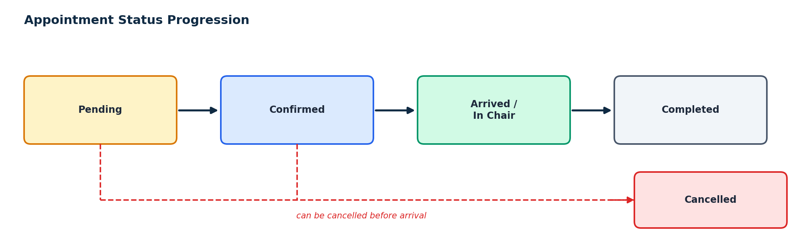
Figure 10 Appointment status progression (cancellation is possible before arrival)

19.13 Screen Specification 12: Patient Self-Service Portal & Tele-Dentistry Kiosk (/portal)
The external-facing Patient Portal allows patients to securely access their dental health records and interact with the clinic.
- 1. Patient Dashboard: Displays upcoming appointments, treatment summaries, outstanding balance, and downloadable clinical dossiers.
- 2. 24/7 Online Chair Booking: Enables patients to browse available operatory time slots, select their preferred dentist, and submit appointment requests.
- 3. Digital Informed Consent E-Signing: Allows patients to review and electronically sign informed consent forms for endodontic, surgical, and implant procedures prior to arrival.

19.14 Screen Specification 13: Practice Administration & Multi-Clinic Tenancy Settings (/settings)
The Administration module provides top-level practice configuration, multi-clinic tenancy partitioning, and hardware calibration.
- 1. Clinic Profile & Tenancy Governance: Configures clinic legal name, address, tax registration numbers, operatory chair count, and business hours.
- 2. Doctor Accounts & RBAC Permissions: Manages clinician credentials, specializations, RBAC role assignments (SuperAdmin, Doctor, Hygienist, Staff), and doctor-specific fee schedule multipliers.
- 3. Operatory Hardware Network Settings: Configures IP addresses and ports for Soredex Digora Optime LAN (10.0.0.50:10001) and driver calibration files for Eighteeth NanoPix RVG USB sensors.

19.15 Standard Operating Procedures (SOP Index) & Multi-Role Operatory Protocols
Dentia includes complete clinical Standard Operating Procedures across all clinic staff roles:
SOP ID | Standard Operating Procedure Title | Responsible Role | Operational Scope & Action Summary
SOP-01 | Operatory Morning Setup & Radiograph Scanner Calibration | Dental Assistant / Nurse | Power on Digora LAN bridge, inspect phosphor plates for scratches, verify network ping to 10.0.0.50, test sensor exposure.
SOP-02 | Patient Intake, Medical Alert Flagging & Check-In | Reception / Assistant | Register new patient demographics, verify phone/email, administer systemic health questionnaire, alert doctor of penicillin/anticoagulant flags.
SOP-03 | Full-Mouth Odontogram Charting & Treatment Planning | General Dentist / Surgeon | Perform visual inspection, record 5-surface restorations, mark missing teeth, review 2D HD transparent jaw radiograph, sequence treatment phases.
SOP-04 | Periodontal Probing & Preventative Prophylaxis | Dental Hygienist | Record 6-point periodontal probing depths (1-12mm), chart bleeding on probing, execute ultrasonic scaling, apply 5% fluoride varnish.
SOP-05 | Billing Finalization, Insurance Pre-Auth & Invoicing | Practice Administrator | Reconcile completed operatory procedures, apply doctor fee schedules, process card/cash payments, generate official ADA PDF report.

19.16 Dental Surgeon & Restorative Dentist Charting Workflow
Step-by-step protocol for charting 5-surface restorations and surgical treatments:
- Step 1: Open Chart: Navigate to /chart/:patientId. Review patient medical alerts and historical treatment ledger.
- Step 2: Tooth Selection: Click the target tooth on the 3D WebGL arch or the 32-Tooth Dentition Bar (e.g. Tooth #19). The tooth detail drawer opens.
- Step 3: Surface Mapping: Select specific anatomical surfaces (e.g. Mesial + Occlusal + Distal = MOD).
- Step 4: Select Condition / Material: Select 'Composite Resin'. The system assigns CDT code D2393, updates surface colors to Blue, and recalculates tooth health.
- Step 5: Apply to Treatment Plan: Click 'Save Condition'. The procedure appends to the active treatment plan and is queued for patient invoicing.
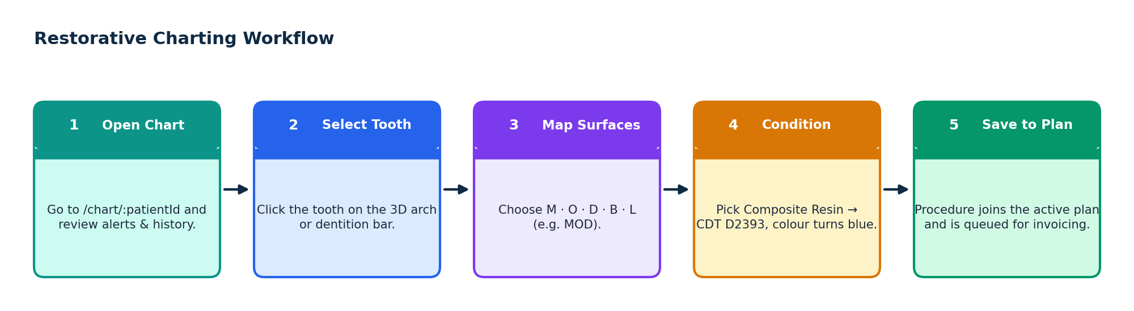
Figure 11 Restorative charting workflow for a multi-surface restoration

19.17 Practice Administrator Billing & Invoicing Protocol
Step-by-step workflow for reconciling operatory procedures and issuing patient receipts:
- Step 1: Review Completed Procedures: At the conclusion of the appointment, open the patient chart. Click 'Generate Treatment Invoice'.
- Step 2: Verify Fee Schedules: Review itemized CDT codes, applied doctor fee schedule overrides, and calculated sales tax (GST/VAT).
- Step 3: Process Payment: Select payment modality: Credit/Debit Card via integrated gateway or Cash. Record payment amount.
- Step 4: Issue Official PDF Report: Click 'Print Official ADA Dossier'. The system generates a high-definition PDF containing the graphical chart, itemized ledger, and receipt for insurance submission.

