Charles Hathaway
2013-09-23
CSCI_6140 – Queue Simulator

1)

The first thing to realize is that the short processes will starve the longer ones, at least until the time they spend on disk is great enough that larger processes get picked because they are the only ones in the queue.

For example, if we have the disk access time of 9ms, only the three smallest processes will get to run. It would look like this:

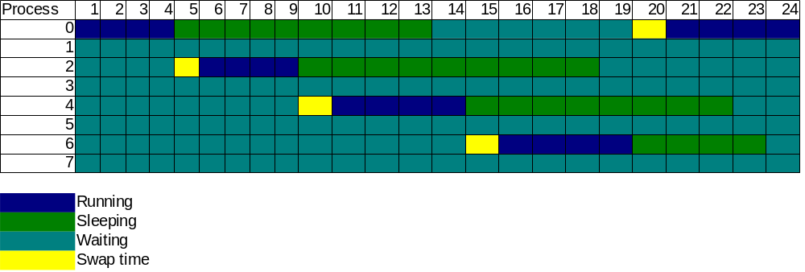

We can see that by 20ms, the first process is back and back on the processor.

So, with a 9ms sleep time, each process will eventually either starve or get a response time of approximately 10ms (Process 0 begins what will become a regular schedule, with 6ms of waiting then 4ms of executing).

At 21ms, there will be enough of a gap between when the first process goes to the disk and it's last friend (same burst time) gets on disk. It's only a 1ms window (4 * 4 = 16ms, 4ms of switching), but it's enough to get on the processor. Eventually, all the second-shortest processes will get a chance.

For the longest process, 7, we will need a really long sleep time. We need all other processes to be on the disk. To do that, the disk speed will have to equal the sum of all the process run times plus one, and the context switching time (4*4 + 3*6 + 7*1 + 1), so 42 ms.

The CPU utilization, in all cases, will be almost 100%. The only detriment is the context switching. There is never a moment when the CPU doesn't have something to work on.

You could calculate the utilization by summing the number of context switches per cycle, divided by the length of the cycle. For 9ms, it would be about 80% (4 switches for every 24 ms). For 9, it would go higher.
2)

Results for Highest response ratio next Queue with hdd speed of 9
Response time for PID(0) | 23.882883
Response time for PID(1) | 66.675
Response time for PID(2) | 30.126126
Response time for PID(3) | 68.5125
Response time for PID(4) | 52.162162
Response time for PID(5) | 71.278481
Response time for PID(6) | 60.743243
Slowdown for PID(7) | 1.296224
CPU Utilization | 0.8709191361
Results for Highest response ratio next Queue with hdd speed of 19
Response time for PID(0) | 15.344828
Response time for PID(1) | 83.105263
Response time for PID(2) | 29.304348
Response time for PID(3) | 84.045455
Response time for PID(4) | 41.909091
Response time for PID(5) | 100.619048
Response time for PID(6) | 55.428571
Slowdown for PID(7) | 0.377344
CPU Utilization | 0.9151138716
Results for Highest response ratio next Queue with hdd speed of 39
Response time for PID(0) | 20.157895
Response time for PID(1) | 197
Response time for PID(2) | 40
Response time for PID(3) | 397.5
Response time for PID(4) | 68.692308
Response time for PID(5) | 1795
Response time for PID(6) | 114.2
Slowdown for PID(7) | 0.256138
CPU Utilization | 0.779956427

3)

Results for Round Robin Queue (quanta: 4) with hdd speed of 9
Response time for PID(0) | 28.671202
Response time for PID(1) | 92.760148
Response time for PID(2) | 29.11086
Response time for PID(3) | 93.940741
Response time for PID(4) | 28.717195
Response time for PID(5) | 94.711111
Response time for PID(6) | 29.047404
Slowdown for PID(7) | 2.267401
CPU Utilization | 0.7830853563
Results for Round Robin Queue (quanta
Response time for PID(0) | 9.523364
Response time for PID(1) | 29.913753
Response time for PID(2) | 9.919937
Response time for PID(3) | 29.771889
Response time for PID(4) | 9.594679
Response time for PID(5) | 30.784038
Response time for PID(6) | 10.03937
Slowdown for PID(7) | 1.065456
CPU Utilization | 0.7824019025
Results for Round Robin Queue (quanta: 4) with hdd speed of 39
Response time for PID(0) | 7.17653
Response time for PID(1) | 17.858625
Response time for PID(2) | 7.281534
Response time for PID(3) | 18.114625
Response time for PID(4) | 7.225677
Response time for PID(5) | 18.201823
Response time for PID(6) | 7.371574
Slowdown for PID(7) | 0.696443
CPU Utilization | 0.7214760148

Bonus

Results for Round Robin Queue (quanta 2) with hdd speed of 9
Response time for PID(0) | 33.822041
Response time for PID(1) | 66.931892
Response time for PID(2) | 33.941224
Response time for PID(3) | 67.214054
Response time for PID(4) | 34.121212
Response time for PID(5) | 67.746739
Response time for PID(6) | 34.187705
Slowdown for PID(7) | 1.849858
CPU Utilization | 0.6666666667
Results for Round Robin Queue (quanta 2) with hdd speed of 19
Response time for PID(0) | 12.03745
Response time for PID(1) | 22.62549
Response time for PID(2) | 12.023515
Response time for PID(3) | 22.62402
Response time for PID(4) | 12.129844
Response time for PID(5) | 22.780177
Response time for PID(6) | 12.1288
Slowdown for PID(7) | 0.755898
CPU Utilization | 0.6666666667
Results for Round Robin Queue (quanta 2) with hdd speed of 39
Response time for PID(0) | 9.010638
Response time for PID(1) | 15.106141
Response time for PID(2) | 9.076051
Response time for PID(3) | 15.225684
Response time for PID(4) | 9.137793
Response time for PID(5) | 15.449885
Response time for PID(6) | 9.167336
Slowdown for PID(7) | 0.882172
CPU Utilization | 0.6213704994
Results for Round Robin Queue (quanta 7) with hdd speed of 9
Response time for PID(0) | 55.672727
Response time for PID(1) | 56.211538
Response time for PID(2) | 57.596154
Response time for PID(3) | 54.019231
Response time for PID(4) | 55.884615
Response time for PID(5) | 37.792208
Response time for PID(6) | 54.166667
Slowdown for PID(7) | 3.554688
CPU Utilization | 0.8380952381
Results for Round Robin Queue (quanta 7) with hdd speed of 19
Response time for PID(0) | 20.325
Response time for PID(1) | 20.825
Response time for PID(2) | 20.325
Response time for PID(3) | 19.52439
Response time for PID(4) | 19.54321
Response time for PID(5) | 21.3125
Response time for PID(6) | 21.531646
Slowdown for PID(7) | 1.740625
CPU Utilization | 0.8402154399
Results for Round Robin Queue (quanta 7) with hdd speed of 39
Response time for PID(0) | 12.480427
Response time for PID(1) | 11.794118
Response time for PID(2) | 10.797386
Response time for PID(3) | 11.754045
Response time for PID(4) | 11.411565
Response time for PID(5) | 12.165563
Response time for PID(6) | 11.736301
Slowdown for PID(7) | 0.978966
CPU Utilization | 0.7747084101

