Overview

Definitions
Action Model – The Action Model is the theoretical model being used to describe the behavior of the individuals. This could be the HMFV model, the LKF model or any other of numerous existing models. The primary focus of this package is the creation and testing on various Action Models for individuals.
Action Controller – The Action Controller is the implementation of an Action Model in code.
Action Strategy – The Action Strategy is where any Action Controller specifies methods or data for an individual resides.
Step – The simulation has an inner loop that repeats over and over to represent the passing of time. Each execution of this loop is called a Step.
Step Size- The Step Size is the time that is represented by a step. Ex: a step size of 0.2 seconds would mean that the step represented 0.2 seconds of time for whatever is being simulated.
Time step – The Time Step is the same as the step size.

Methodology
The software is being developed to look at how individuals move in an environment. This means we have to model both the environment and the individuals, along with how they move and interact. To allow a greater flexibility with the type of action models that can be made, the logic of movement of an individual is controlled by the action controller. This action controller can be written to move all individuals based on some type of group model. It contains references to all individuals that it has control over and therefore could also be written to delegate the movement to the individuals themselves. This allows for group based action models, but still allows for models where the individual is the controller of the movement. To keep a clean implementation, action strategies are used when the movement logic resides on an individual. Example: You are simulating a series of individuals controlled by the HMFV Model; then each of the individuals would contain a HMFV Strategy. This strategy contains the logic and parameters needed to move the individual.
The simulation is a “Continuous Time” simulation based loosely on the MASON simulation framework. The simulation steps forward by a time slice. At each step, all elements being simulated are moved by their action model. The time duration of the steps and step size can be the same or different. The time steps are attributes of the action models, and, therefore, the action model defines if it is a fixed step size, or a variable step size.
The simulation can be run just as a data collection, or it can generate a visual representation of the simulation. There are logs available to collect data from the simulation. There are a few different logs to collect different types of data from the simulation. There are also movie generators which can be used to record a movie file of the simulation that is being executed. Current work efforts are on generating the visualization from a previously recorded data file. This would allow for a large data set to be generated and then to only produce visualizations and movies for runs that were of interest or had visual elements which we wanted to see.

Code Description

Libraries
Java – Required for simulation and manual tracker app. Primary development language being used for the project.
Java3D – Used to define obstacles and used to check when obstacles and individuals interact with each other.
MASON – The base classes used for the simulation.
Optional
JMF (Java Media Framework) – This library is required for generating movies and for the manual tracker application.

Concepts
There are four primary sections to the simulation code: Crowd Simulation, Entities, Model, and Logging. Crowd Simulation is the core operation of the simulation. These classes contain state information of the simulation along with controlling the looping for stepping through time. Entities are the definitions of the obstacles and entities in the environment. In general, there is little difference between individuals and obstacles, except that individuals can move and obstacles are fixed. As of now, we only have circular and rectangular obstacles. These two obstacles are capable of constructing most environments which we are currently trying to simulate. Models are the objects which control the movement of the individuals. Logging refers to the classes which record data from the simulation. These recordings can be either comma separated variable style data files or generated movies.

Diagrams
Package Diagram
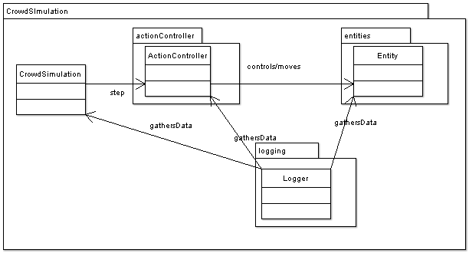
Collaboration Diagram
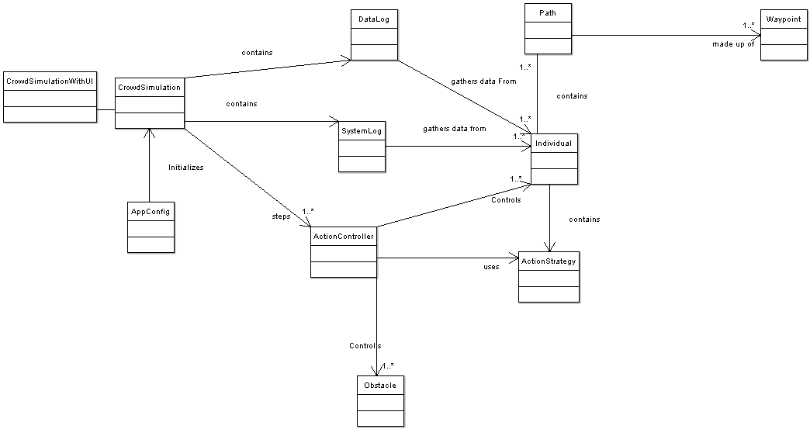

System Sequence Diagrams

Initialization
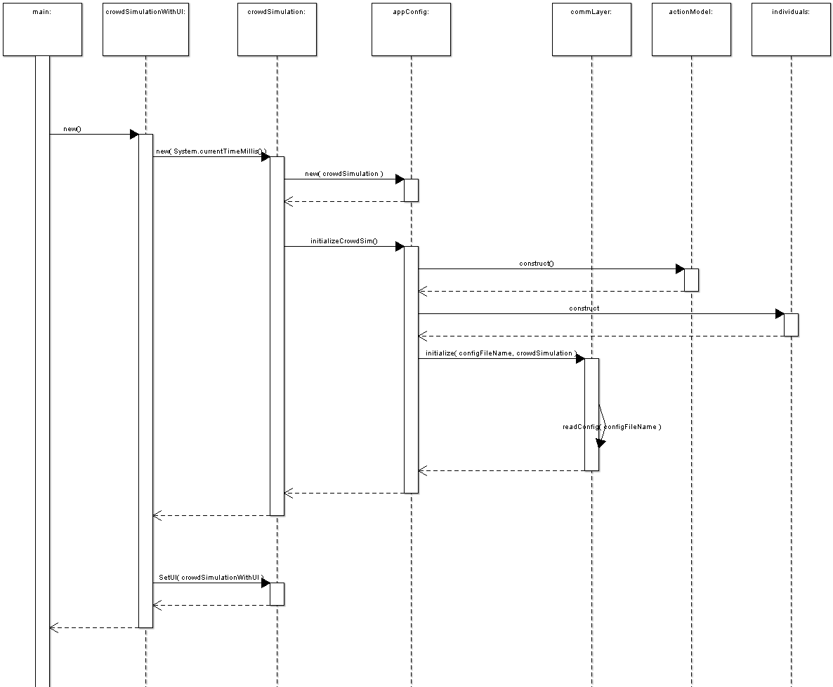
Control Loop
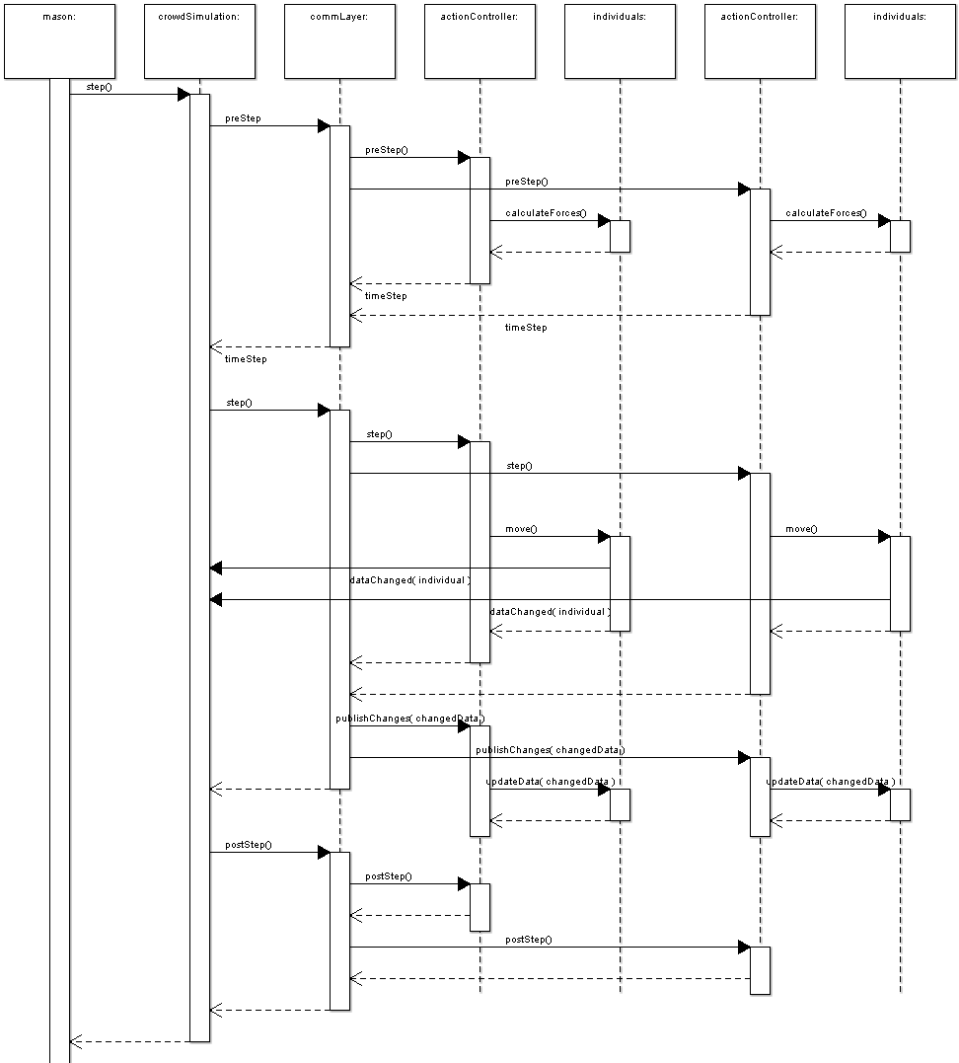

Configuration Files
The configuration files used to set up the simulations are done in an XML style. We have written our own parser to read in the needed configuration settings. Below is an example of a configuration file.
The first tag is <world>, this tag gives the size of the field on which the simulation will run and the scale at which to start a visual display. A note to be made is that the “scale” corresponds directly to the scale on the display, but does not display the proper value. EX: If you set the scale to 18, when the visualization of the simulation comes up, it will have a scale of 18, but the scale text box will still say 1. Upon clicking the up or down arrow it will react as if the scale was only a 1.
The <log> tag sets up a logger to record data from the simulation. DataLogger is the logger that collects a default data set and only samples the data at a given sample rate. Data is collected when timeFromLastCapture > 1/sampleRate.
The <movie> tag tells the simulation to generate a movie file from the simulation. This requires the machine to have JMF installed. When the simulations runs with this tag, a series of windows will pop up requesting information about how you want the movie generated and where you want the file to be stored. Currently only QuickTime movies are able to be generated (mov files). We are working on trying to get the data pulled from the configuration file instead of having to go through the different windows. We also are trying to get mpg or avi movie captures working.
The <terminate> tag defines how much simulated “time” should elapse before ending the simulation. This time is measured in seconds. EX: The time is set for 6 seconds. Once the simulation has simulated the movement of the people for 6 seconds in the simulation, it will stop the simulation.
Note: Six seconds of simulated time might take much longer than 6 seconds real world time. This depends on the model being used.
The <obstacles></obstacles> block is where the environmental obstacles are defined. The environment is made up of a series of obstacles. An obstacle can have a “type” of either Rectangular or Circular. More obstacle types may be added later. Each <obstacle> tag has you set the “location” or “center” of the obstacle and then the “width” and “height”, or “radius” depending on the type of obstacle. With rectangular obstacles, the location is the upper left corner of the box and the “angle” will rotate around that point.
To add in a bit of variability, random number generators can be used for most parameters on individuals. To do this you must define a random number generator in the <randomGenerators></randomGenerators> block. The generator is constructed using the <generator> tag and must be given an “id” and “type” to describe the type of generators to be produced. Currently there are Binomial, Exponential, Gamma, Normal, Poisson, and Uniform random number generators.
Paths are designed to give individuals an idea of where the doors in a room are located. You can have multiple doorways and therefore multiple paths, but different individuals might have different paths they are interested in. Paths are defined in the <paths></paths> block. Each path is defined in a <path> tag and must contain an “id” which is the unique identifier used to assign the path to an individual.
Next we have to define the Action Model being used. This is done in the <model></model> block. Inside this block we must define the individuals which will be controlled by this action model. Individuals are defined by a <individuals></individuals> block. A few parameters which need to be set are the “number” of individuals to create, and the “color” to make the individuals. Another standard parameter to be set is the “diameter” of the individuals being simulated. A requirement for individuals is the <region></region> block. The region contains an <obstacle> tag which defines the area in which to create the individuals. We also add a set of paths to the individuals by using a <paths></paths> block. Inside the paths block we add a <path> tag for each path that these individuals get. The path tag requires the “id” to be set. This id is the id defined in the previous paths block. The “weight” parameter allows you to make individuals more interested in certain paths. There can be multiple <individual> blocks inside of a <model> block. There can be multiple <model> blocks inside the <configuration> block.
Configuration File
<?xml version="1.0"?>

<configuration xmlns="http://tempuri.org/config.xsd">
<world height="30" width="30" scale="18" />
<log type="DataLogger" fileName="../logs/appLog.txt" sampleRate="29" fileOutput="true"/>
<movie filename="../logs/" />
<terminate time="6"/>
<obstacles>
<obstacle type="Rectangular" force="1" location="1 1" width="1" height="17" angle="0" displayCenter="true"/>
<obstacle type="Rectangular" force="1" location="2 17" width="15" height="1" angle="0" displayCenter="true"/>
<obstacle type="Rectangular" force="1" location="2 1" width="15" height="1" angle="0" displayCenter="true"/>
<obstacle type="Rectangular" force="1" location="17 1" width="1" height="7.9" angle="0" displayCenter="true"/>
<obstacle type="Rectangular" force="1" location="17 10.1" width="1" height="7.9" angle="0" displayCenter="true"/>
<obstacle type="Circular" force="1" center="17 8.9" radius="0.01" />
<obstacle type="Circular" force="1" center="18 8.9" radius="0.01" />
<obstacle type="Circular" force="1" center="17 10.1" radius="0.01" />
<obstacle type="Circular" force="1" center="18 10.1" radius="0.01"/>
<obstacle type="Circular" force="1" center="14 8" radius="1" displayCenter="true" />
</obstacles>
<randomGenerators>
<generator id="1" type="normal" mean="0.6" stdDev="0.1"/>
</randomGenerators>
<paths>
<path id="1" name="path1">
<waypoint x="18" y="9" radius="0.25"/>
<waypoint x="20" y="9" radius="0.25"/>
<waypoint x="25" y="9" radius="0.25"/>
</path>
</paths>
<model type="hmfvModel">
<individuals number="40" diameter="genID=1" color="10 180 10">
<region>
<obstacle type="Rectangular" location="4 4" width="8" height="13" angle="0" />
</region>
<paths>
<path id="1" weight="1"/>
</paths>
</individuals>
</model>
</configuration>

Execution

Environmental Settings
These are the environmental variables which must be set for the scripts to execute correctly.
JDK_HOME – The directory where you installed java.
MASON_HOME – The directory where you installed mason.
CROWDSIM_HOME – The directory where you have placed the files for the simulation.
JMF_HOME – The directory where JMF was installed.

Directories
This is the layout of the directories in the code distribution. From the root directory:
bin – The directory containing all scripts and executables for the project.
classes – This is where the compiled classes go. This is what is actually run by the java virtual machine.
configs –The directory where the configurations files are stored.
docs – These contain the documents describing the code for the simulation. This is also where the java doc documentation files are.
images – This directory contains images which are used in the simulation.
logs – The directory where the data files are stored when the simulation runs. This is only the default directory; it can be changed through the configuration files.
src- The directory where all of the source files are.

Scripts
executeSimulation.bat – This script executes the simulation without showing the graphics. This can be used to generate data files. This takes a command line parameter telling which configuration file is to be used.
executeGraphicalSimulation.bat – This is the normal way to start the simulation. This script executes the simulation with showing the graphics. This takes a command line parameter telling which configuration file is to be used.
executeSimulation – This is the unix version of executeSimulation.bat
executeGraphicalSimulation – This is the unix version of executeGraphicalSimulation.bat
runSimulations.pl – This is a perl script to execute the non-graphical simulation, and move the data files to a safe location.
executeManualTracker.bat – This is a script to execute the manual tracker application.
executeManualTracker - This is the unix version of executeManualTracker.bat.
generateDocs.bat – This script is more of a development script. It is what generated the java doc for the classes.
generateDocs – This is the unix version of generateDocs.bat.

