SE4050 – Deep Learning: Lab 4

Face Recognition – Verification and Recognition with Own Images

1. New Images Added
Two images of the same individual were used: one added to the database (me1.jpg) and a second, different image used for verification and recognition (me2.jpg).


[Insert me1.jpg here] [Insert me2.jpg here]

2. Face Verification Output
verify("images/me2.jpg", "chathu", database, FRmodel) was run using the second image against the newly added database identity.
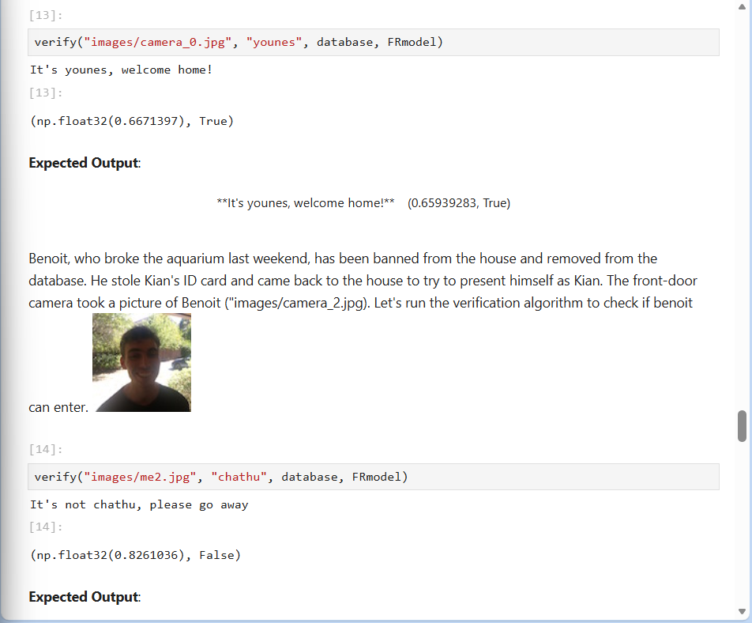

3. Face Recognition Output
who_is_it("images/me2.jpg", database, FRmodel) was run to identify the individual against the full database.
The screenshot below also shows output[2], the dictionary containing the L2 distance between the target image encoding and the database embeddings of the other images (as required by the labsheet).
