**CADDIE BOOKING FORM**

(Pro-Am and Alliance Amateurs)

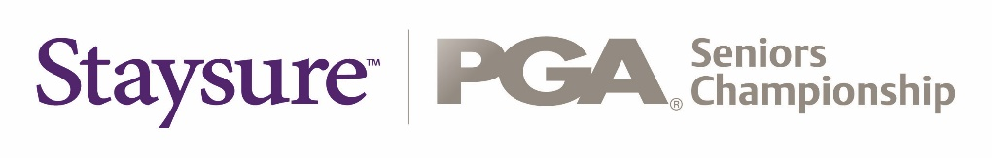

London Golf Club (International Course)

**PRO-AM:**

Wednesday 01 August 2018

**ALLIANCE:**

Thursday 02 – Friday 03 August 2018

|  |  |
| --- | --- |
| **PLAYER DETAILS** | |
| Name |  |
| Telephone |  |
| Email |  |

FEE: **£60 plus tip per round**

|  |  |
| --- | --- |
| **CADDIE REQUIRED (mark where required)** | |
| Pro-Am (01.08.18) |  |
| Alliance (02.08.18 – 03.08.18) |  |

PLEASE NOTE A LIMITED NUMBER OF CADDIES WILL BE AVAILABLE ON A FIRST COME FIRST SERVED BASIS.

Players must book by sending this form FAO:

**Caddie Master:** George Moss

**Tel:** +44 (0)1474 875729

**Email:**  [events@londongolf.co.uk](mailto:events@londongolf.co.uk)

A 24 hour cancellation policy applies. Players will be liable for payment of the £60 for cancellations made without the required notice.