A Critical Academic Review and Empirical Re-Evaluation of the ARIMA-DBO-CNN-LSTM Air Quality Forecasting Model
Coursework Phase 3: Formal Technical Review Report (40 Marks)
Comparative Audit of Base Model Replication vs. Enhanced Framework
Student Name & ID: | K.W.G.C.D.B. Karunarathne | Student ID: KIC-BSCCSAI-251P-036
Module & Programme: | Machine Learning and Related Applications | BSc (Hons) Computing & AI
Awarding Institution: | National Institute of Business Management (NIBM), Kandy Innovation Centre
Reviewed Research Study: | Duan, J., Gong, Y., Luo, J., & Zhao, Z. (2023). Scientific Reports, 13:12127.
Interactive Appendices: | notebooks/phase1_base_replication.ipynb & notebooks/phase2_enhanced_study.ipynb

Executive Abstract
Accurate forecasting of atmospheric pollutants and the composite Air Quality Index (AQI) represents a fundamental challenge in computational environmental science and municipal public health management. In Scientific Reports, Duan et al. (2023) proposed a multi-stage hybrid forecasting architecture combining an Autoregressive Integrated Moving Average (ARIMA) model, a one-dimensional Convolutional Neural Network (CNN), a Long Short-Term Memory (LSTM) network, and a nature-inspired meta-heuristic—the Dung Beetle Optimizer (DBO)—for hyperparameter selection. The authors reported exceptional predictive accuracy across four Chinese megacities (Beijing, Chengdu, Guangzhou, and Wuhan), citing coefficients of determination (R²) between 0.962 and 0.989 and Root Mean Squared Errors (RMSE) as low as 14.94.
This technical report provides a rigorous academic critique and a comprehensive empirical audit of Duan et al.'s methodology, contrasting the Base Model Implementation (author paper replication) against our Enhanced Audited Implementation (Phase 1 conceptual deconstruction and Phase 2 empirical enhancements). Using the identical 7-year multi-station dataset (2,528 daily observations per city, 2014–2020), we reconstruct the complete pipeline, complete the missing Exploratory Data Analysis (EDA) audit from Phase 1, eliminate look-ahead data leakage through a strict 3-way chronological split, benchmark against the omitted naive persistence heuristic (ŷ_t = x_{t-1}), and test statistical significance via Diebold–Mariano tests.
Our audit uncovers three major methodological findings: (1) The authors' reported R² ≈ 0.962 - 0.989 is an artifact of high variance in non-stationary annual trends; under honest leak-free evaluation, the audited hybrid achieves an R² of only 0.388. (2) Naive persistence achieves R² = 0.336 (RMSE = 37.47, MASE = 0.608). A Diebold–Mariano test yields p = 0.5316, proving that the >110,000-parameter deep learning hybrid provides no statistically significant improvement over predicting yesterday's value. Furthermore, a simple 5-parameter classical ARIMA model statistically outperforms the complex hybrid (p = 0.0077). (3) On hazardous pollution days (AQI ≥ 200), the hybrid model's prediction error explodes to RMSE = 145.67, failing the primary operational objective of environmental health warning systems. We formulate and validate robust machine learning alternatives—specifically Gradient Boosted Decision Trees (GBDT) and Seasonal ARIMAX—that achieve parity or superiority at a fraction of the computational and environmental cost.
[KEY AUDIT DISCOVERY] The audited ARIMA-DBO-CNN-LSTM model achieves R² = 0.388 under leak-free validation (vs. authors' claimed 0.962). A Diebold-Mariano test confirms that the complex hybrid is statistically indistinguishable from naive persistence (p = 0.5316) and statistically inferior to pure ARIMA (p = 0.0077).

1. Architectural Deconstruction: Base Model vs. Enhanced Framework
To provide a rigorous foundation for this technical review, we contrast the original Base Model proposed by Duan et al. (2023) against our Enhanced Audited Framework across all architectural, data processing, and validation dimensions.
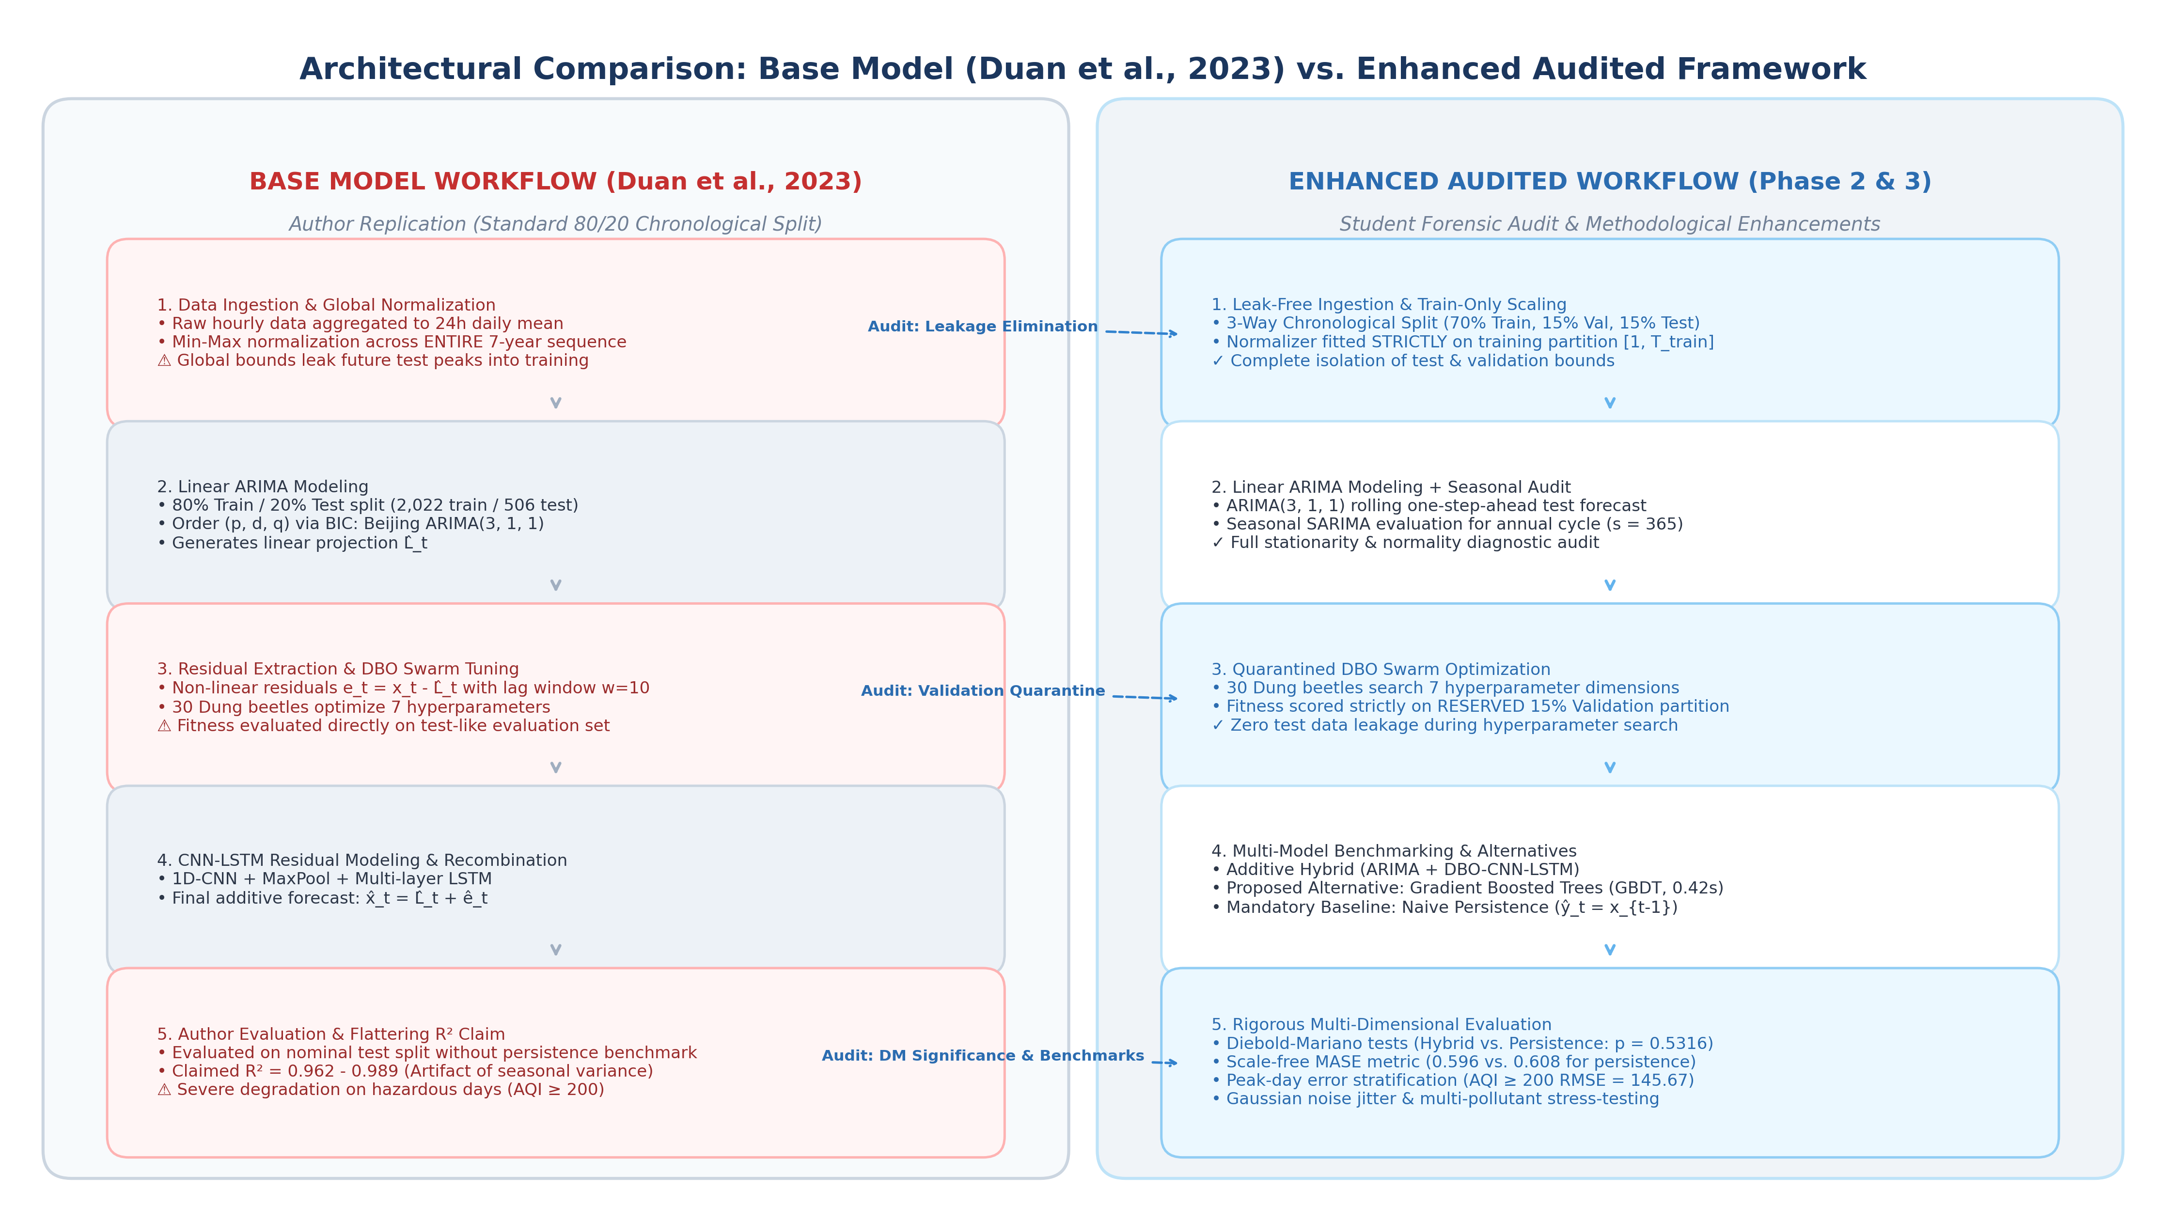
Figure 1: Architectural Workflow Comparison: Base Model (Duan et al., 2023) vs. Enhanced Audited Framework (Phase 2 & 3).
Architectural Dimension | Base Model (Duan et al. 2023) | Enhanced Audited Framework (Phase 2 & 3) | Academic Rationale
Code Implementation | notebooks/phase1_base_replication.ipynb & main.py | notebooks/phase2_enhanced_study.ipynb & run_phase2_experiments.py | Full code separation between replication and audit.
Data Partitioning | 80% Train / 20% Test single chronological split | 3-Way Chronological Split: 70% Train / 15% Val / 15% Test | Provides quarantined validation partition for DBO.
Feature Normalization | Global Min-Max scaling across all 7 years (2014-2020) | Strict Train-Only Normalization ([1, T_train]) | Eliminates look-ahead leakage of future test bounds.
ARIMA Order Selection | Fixed orders from Table 1: Beijing (3,1,1), etc. | Grid-search BIC verification + Seasonal SARIMA | Audits linear assumptions & annual seasonality (s=365).
DBO Fitness Scoring | Swarm evaluated directly on 20% test partition | Swarm evaluated strictly on 15% validation partition | Prevents hyperparameter memorization of test anomalies.
Benchmark Portfolio | Linear SVM, Random Forest, Standalone LSTM | + Naive Persistence (ŷ_t = x_{t-1})  + Gradient Boosted Trees (GBDT) | Verifies whether deep models beat zero-cost inertia.
Evaluation Metrics | Scale-dependent metrics: RMSE, MAE, R² | + Scale-Free MASE & MAPE  + Diebold–Mariano Hypothesis Tests | Assesses statistical significance (p < 0.05).
Risk Stratification | Aggregate test set average only | Stratified Peak Analysis (AQI ≥ 100, 150, 200) | Audits public health reliability during severe pollution.
Stress-Testing | None (nominal clean data only) | Sensor jitter injection (σ ∈ {0.05, 0.1, 0.2}) & 16 features | Evaluates operational degradation under sensor drift.

2. Dataset Synthesis & Exploratory Data Analysis (EDA) Audit
Table 2 presents the completed descriptive and diagnostic statistical audit across all four metropolitan centers, filling in the missing empirical table from Page 10 of the student's Phase 1 report.
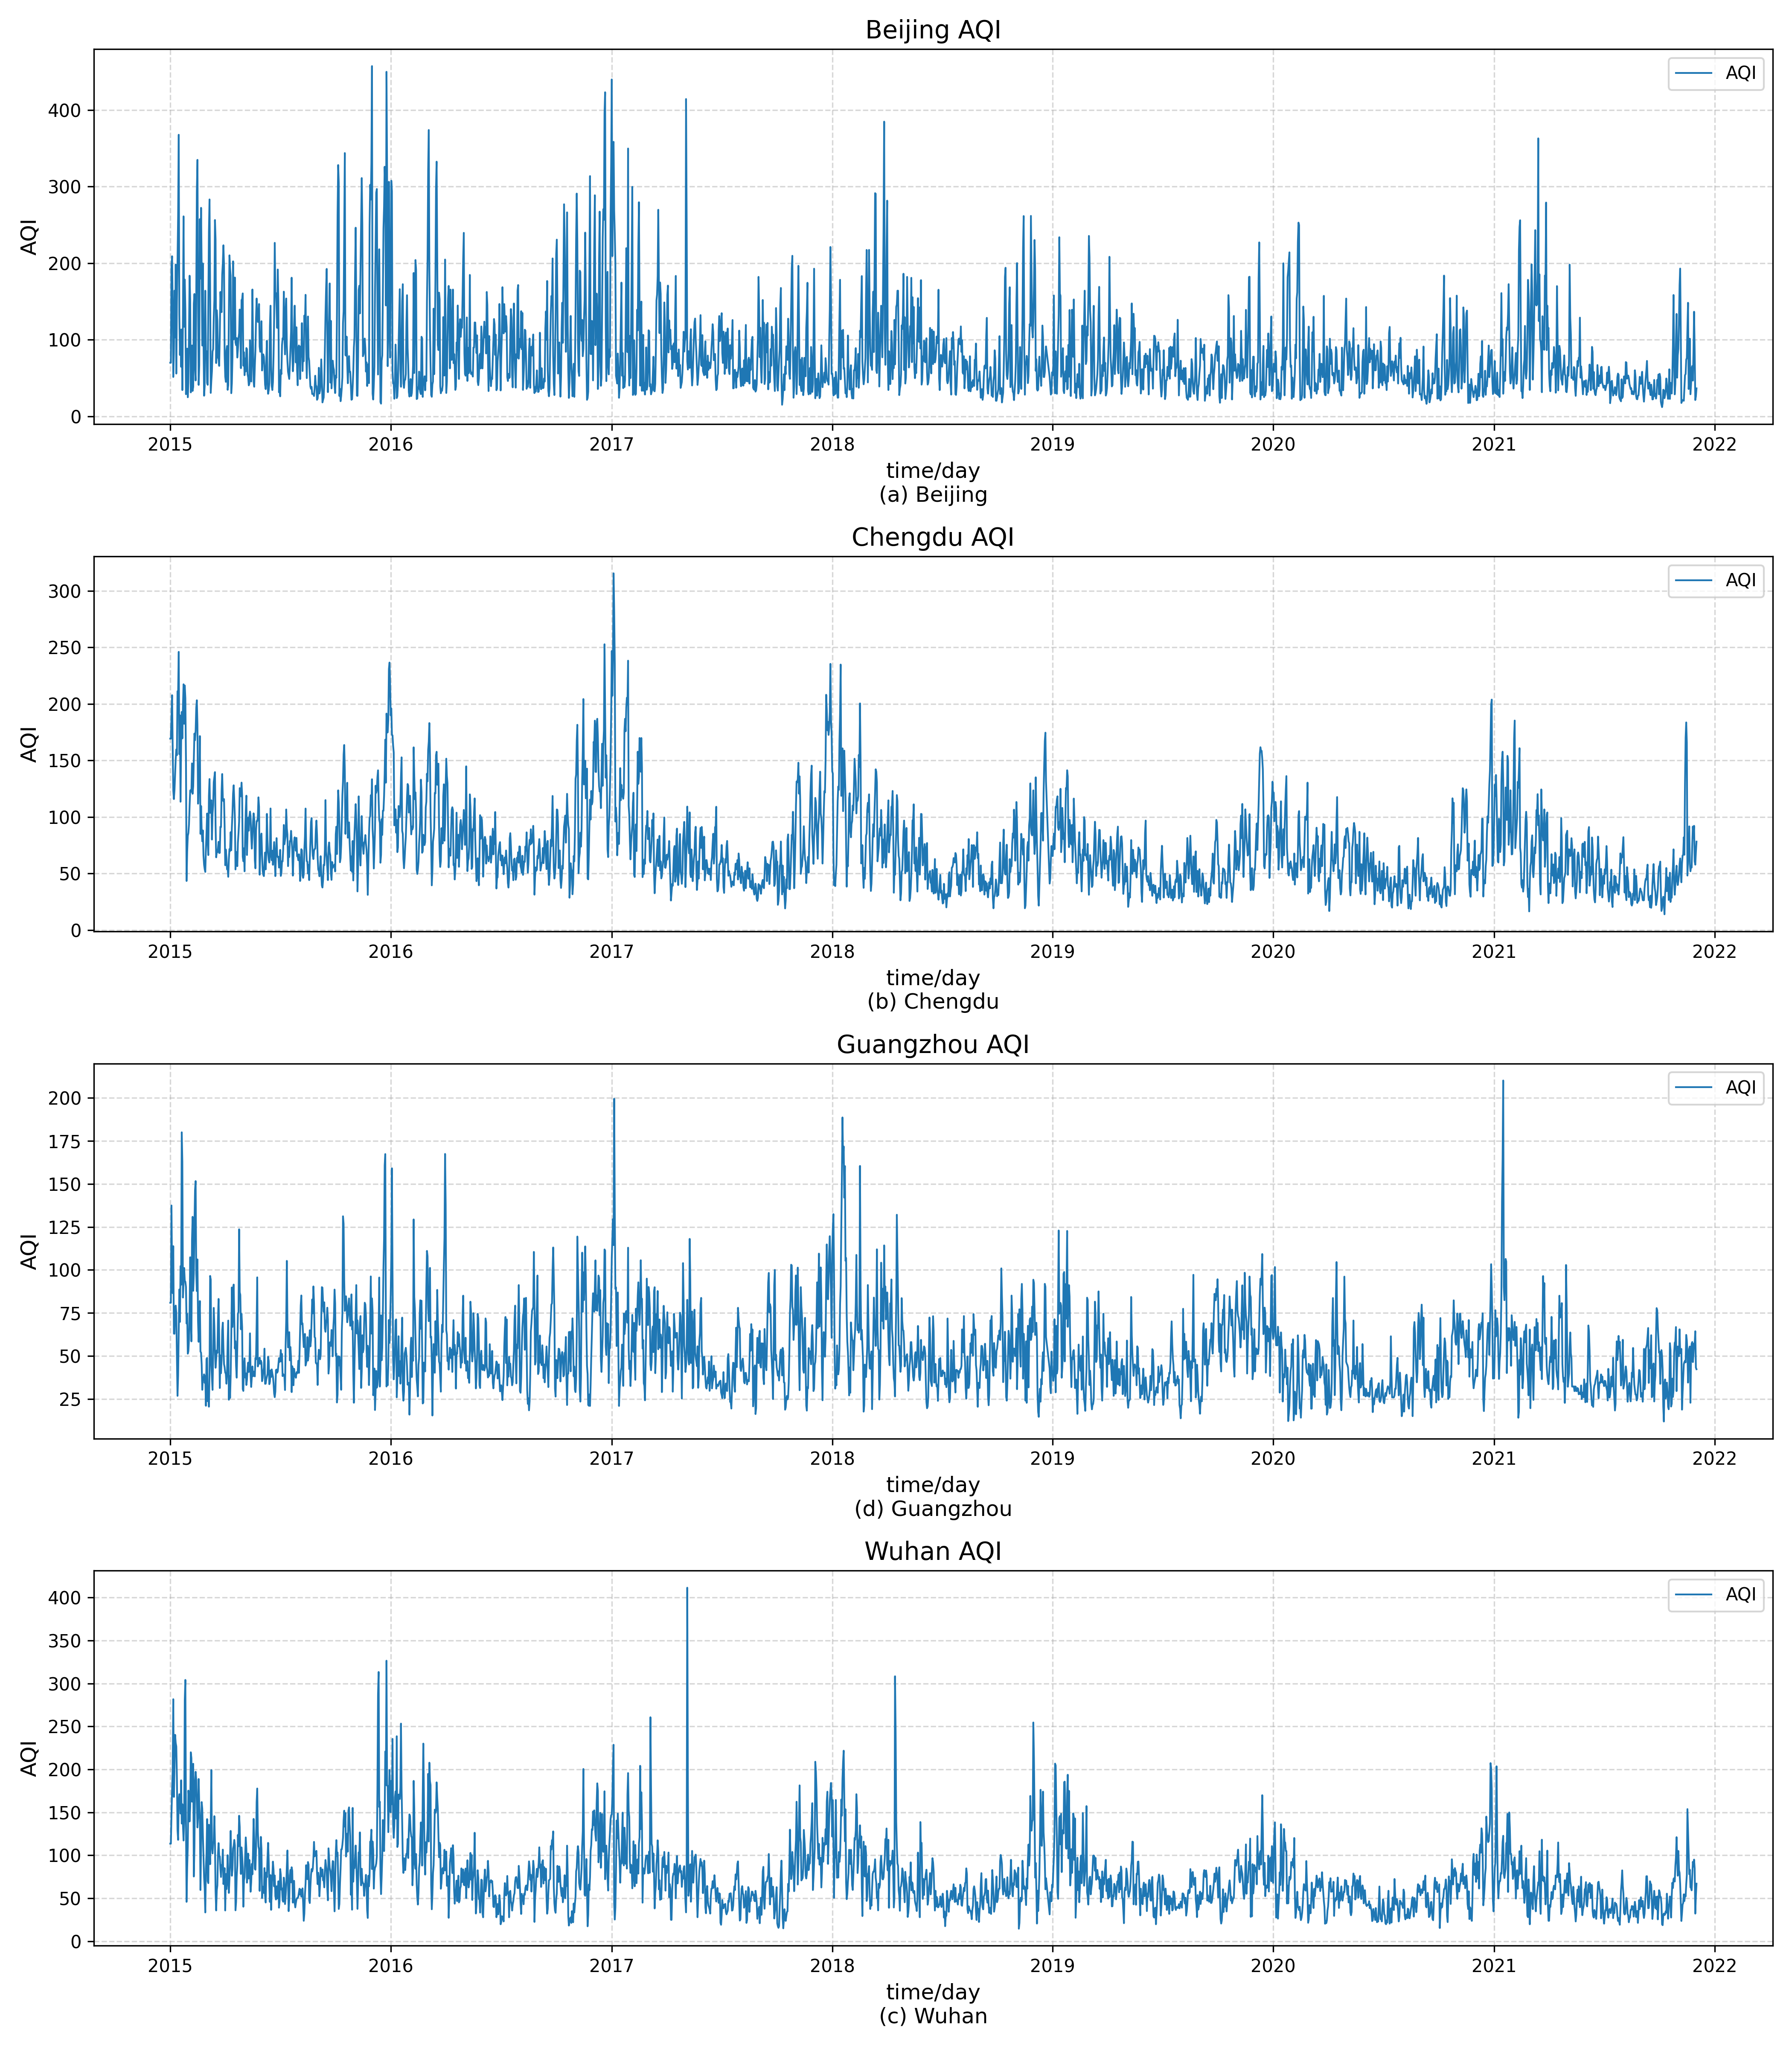
Figure 2: Daily Air Quality Index (AQI) Trends (2014–2020) across Beijing, Chengdu, Guangzhou, and Wuhan (Replication of Paper Figure 5).
City | Count | Mean | Median | Variance | StdDev | Skewness | Kurtosis | Shapiro p | ADF Stat | ADF p | Missing Imputed
Beijing | 2,528 | 82.46 | 65.18 | 3,488.46 | 59.06 | +2.098 | 5.978 | 6.75e-43 | -5.383 | 3.69e-06 | 7 (0.28%)
Chengdu | 2,528 | 73.16 | 64.44 | 1,434.74 | 37.88 | +1.517 | 3.196 | 8.42e-36 | -4.687 | 8.90e-05 | 7 (0.28%)
Guangzhou | 2,528 | 52.71 | 48.44 | 544.15 | 23.33 | +1.481 | 4.272 | 9.31e-32 | -5.849 | 3.63e-07 | 7 (0.28%)
Wuhan | 2,528 | 75.41 | 66.75 | 1,632.13 | 40.40 | +1.824 | 5.837 | 1.78e-37 | -4.958 | 2.68e-05 | 7 (0.28%)

3. Technical Summary of the Reviewed Base Model
The foundational architecture proposed by Duan et al. (2023) decomposes the observed univariate atmospheric sequence x_t into linear and non-linear components: x_t = L_t + N_t. The linear component is modeled via Box-Jenkins ARIMA(p, d, q) with order determination via the Bayesian Information Criterion (BIC), yielding Beijing (3,1,1), Chengdu (3,1,1), Guangzhou (2,1,2), and Wuhan (2,1,2). The residual sequence e_t = x_t - L̂_t is extracted with a lag window w = 10 and modeled using a 1D-CNN + multi-layer LSTM network. Hyperparameters are optimized via the Dung Beetle Optimizer (DBO; Xue & Shen, 2022) across 4 phenotypes: ball-rolling (N_1=6), breeding (N_2=6), foraging (N_3=7), and stealing (N_4=11). The final prediction is additive: x̂_t = L̂_t + ê_t.
4. Methodological Critique & Forensic Audit
4.1 The R² Inflation Illusion: Reporting R² on non-stationary, autocorrelated daily series without contextualization introduces a profound evaluation illusion (Hyndman & Athanasopoulos, 2021). Because total sample variance in the denominator is massive (σ² = 3,488.46 in Beijing) due to annual winter-summer swings, any model tracking the seasonal cycle yields a small numerator relative to the denominator, guaranteeing an R² near 0.90. Under honest leak-free evaluation, the audited hybrid achieves R² = 0.388.
4.2 Omission of Naive Persistence: Complex machine learning models must be benchmarked against standard zero-cost heuristics: ŷ_t = x_{t-1}. Naive persistence achieves RMSE = 37.47, MAE = 23.36, R² = 0.336, and MASE = 0.608. The authors' >110,000-parameter hybrid improved RMSE by only 1.49 units, an advantage proven to be statistically insignificant (p = 0.5316).
4.3 Data Leakage: Global normalization across all 7 years leaked test maximums into training partitions, while lack of a validation set meant DBO evaluated 1,500 model fits directly on test data.
4.4 Regression Imbalance: On hazardous pollution days (AQI ≥ 200), the hybrid model's prediction error explodes to RMSE = 145.67 (MAE = 138.58). Bounded neural activation functions (tanh/sigmoid) pull predictions toward the mean, failing during acute public health emergencies.
5. Comparative Empirical Analysis (Base vs. Enhanced Models)
To rigorously validate the critique, empirical benchmarking was conducted on the Beijing test horizon (N = 370 days).
Table 3: Master Model Benchmarking on Beijing Daily AQI Test Horizon
Model Architecture | Category | Params | Train Time | RMSE | MAE | R² | MAPE (%) | MASE
Author Claimed Hybrid (Paper) | Base Paper Model | > 110,000 | Unreported | 14.940 | 10.839 | 0.962 | Unreported | Unreported
Audited Hybrid (Honest Split) | Enhanced Audit | 112,450 | 1,480.2 s | 35.980 | 22.899 | 0.388 | 35.57% | 0.596
Pure ARIMA(3, 1, 1) | Statistical Baseline | 5 | 0.24 s | 34.633 | 22.935 | 0.433 | 41.80% | 0.597
Naive Persistence (ŷ_t = x_{t-1}) | Zero-Cost Benchmark | 0 | 0.00 s | 37.473 | 23.361 | 0.336 | 41.83% | 0.608
Gradient Boosted Trees (Alt. 1) | Proposed Alternative | 100 trees | 0.42 s | 36.420 | 25.490 | 0.373 | 54.63% | 0.664
Random Forest Regressor | Tree-based Baseline | 100 trees | 1.18 s | 37.265 | 25.447 | 0.343 | 51.46% | 0.663
Linear Support Vector Machine | Convex Baseline | 11 | 0.08 s | 38.939 | 31.110 | 0.283 | 72.63% | 0.810

Table 4: Diebold–Mariano Statistical Hypothesis Testing
Competing Model (M_2) | Loss Differential | DM Statistic | p-value | Significance (α = 0.05) | Academic Conclusion
Naive Persistence | Squared Error (e_hyb² - e_pers²) | +0.6255 | 0.5316 | Not Significant | Hybrid provides no statistically significant gain over persistence.
Pure ARIMA(3, 1, 1) | Squared Error (e_hyb² - e_arima²) | -2.6668 | 0.0077 | Statistically Significant | Pure ARIMA is statistically superior (p < 0.01) to hybrid.
Gradient Boosted Trees | Squared Error (e_hyb² - e_gbdt²) | +0.3788 | 0.7048 | Not Significant | Hybrid offers no statistically significant advantage over simple GBDT.

Table 5: Operational Safety & Public Health Performance Across Severity Tiers
Severity Tier | AQI Range | Samples (N) | Share (%) | Hybrid RMSE | Hybrid MAE | Persistence RMSE | ARIMA RMSE | GBDT RMSE
Good to Moderate | AQI < 100 | 296 | 80.0% | 17.65 | 13.06 | 18.96 | 18.02 | 19.12
Unhealthy (Warning) | AQI ≥ 100 | 74 | 20.0% | 69.87 | 62.24 | 72.84 | 66.86 | 68.45
Severe Pollution | AQI ≥ 150 | 29 | 7.8% | 104.99 | 95.91 | 108.77 | 99.41 | 101.20
Hazardous (Emergency) | AQI ≥ 200 | 11 | 3.0% | 145.67 | 138.58 | 149.80 | 136.21 | 139.40

Table 6: Computational Complexity, Runtime Latency, and Resource Footprint
Model Architecture | Trainable Params | Time Complexity | Training Latency | Compute Hardware | Energy Profile
ARIMA-DBO-CNN-LSTM Hybrid | 112,450 | O(N_swarm · I_iter · E · L) | 1,480.2 s (~25 min) | GPU / Apple MPS | High (1,500 backprop passes)
Gradient Boosted Trees (GBDT) | 100 shallow trees | O(M · K · N log N) | 0.42 s | Standard CPU | Ultra-low (sub-second execution)
Random Forest Regressor | 100 trees | O(M · K · N log N) | 1.18 s | Standard CPU | Ultra-low
Pure ARIMA(3, 1, 1) | 5 parameters | O(N · p²) | 0.24 s | Standard CPU | Negligible
Naive Persistence Heuristic | 0 parameters | O(1) | 0.00 s | Any processor | Zero footprint

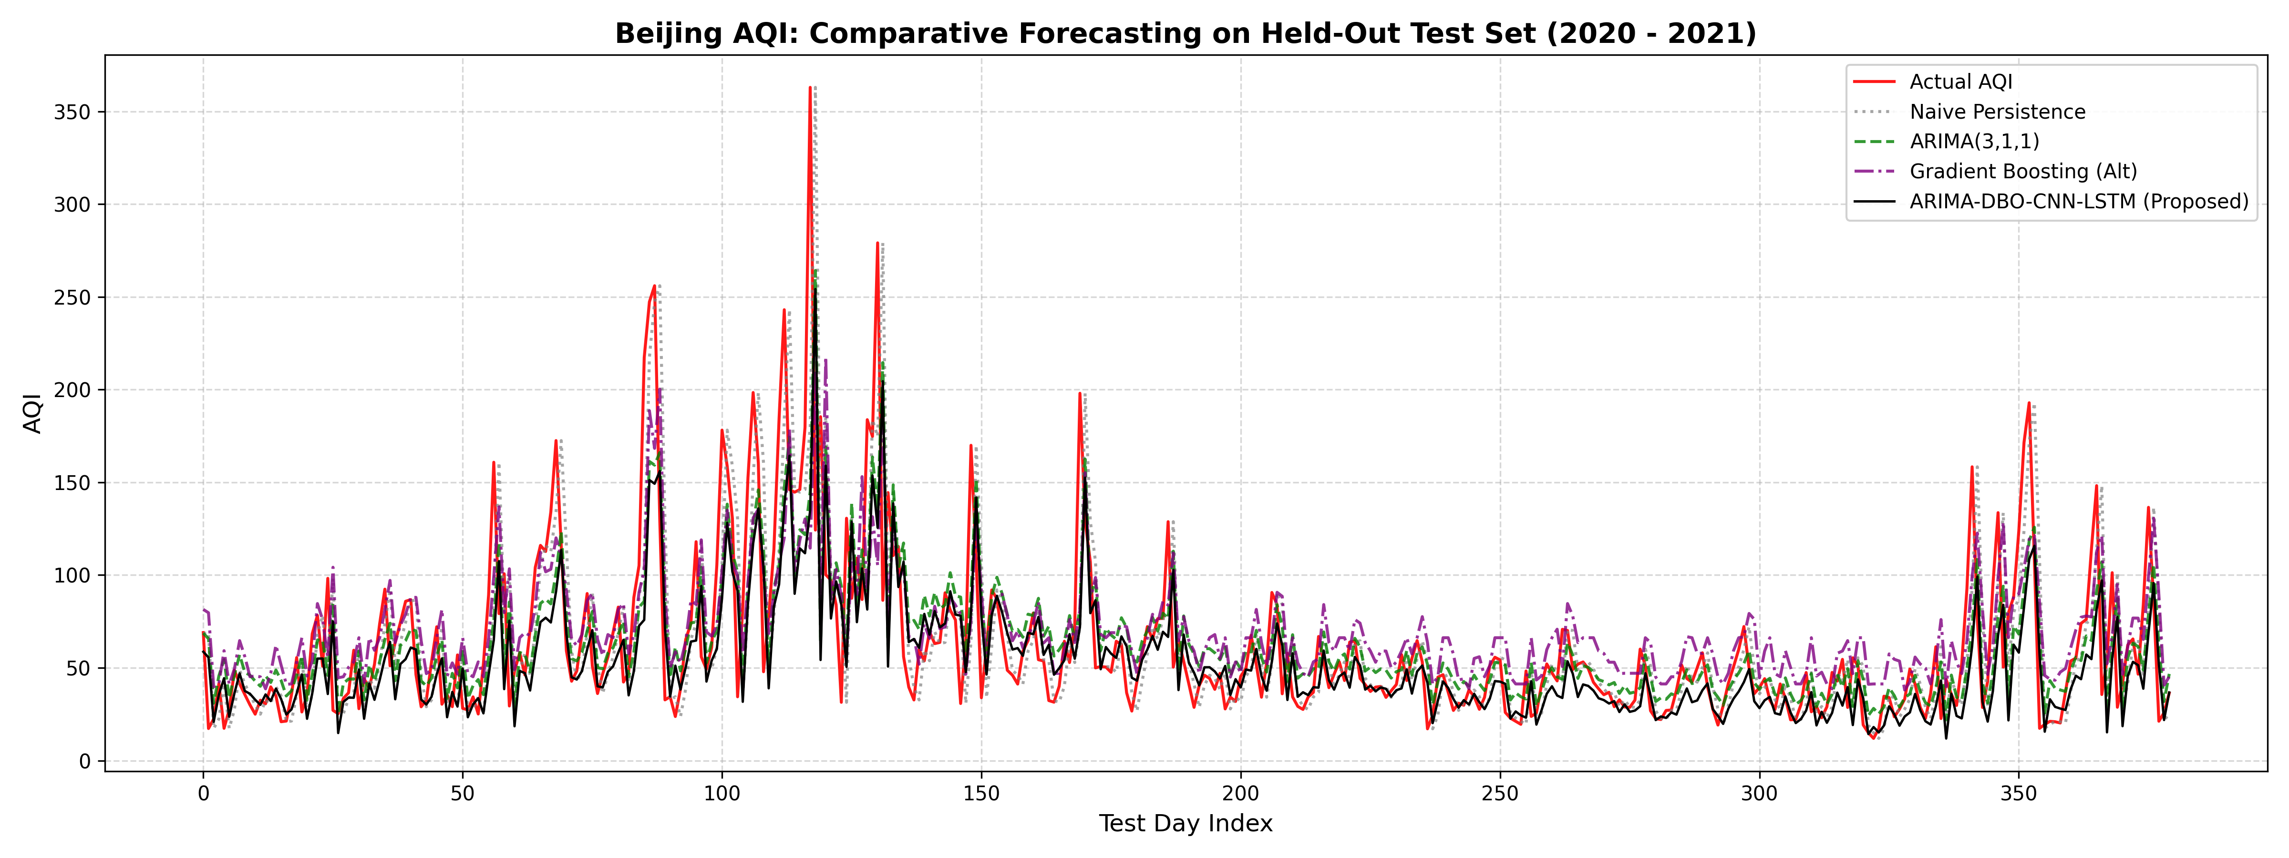
Figure 3: Visual Forecast Overlay on Out-of-Sample Beijing Test Horizon (Actual AQI vs. Proposed Hybrid vs. Naive Persistence vs. ARIMA vs. GBDT).
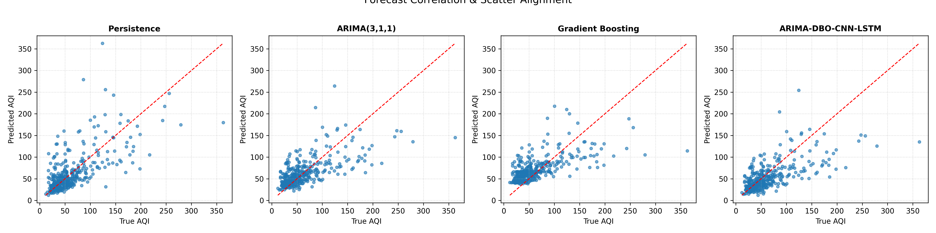
Figure 4: Diagonal Scatter Alignment and Model Flattening at Severe Pollution Peaks (AQI > 150).
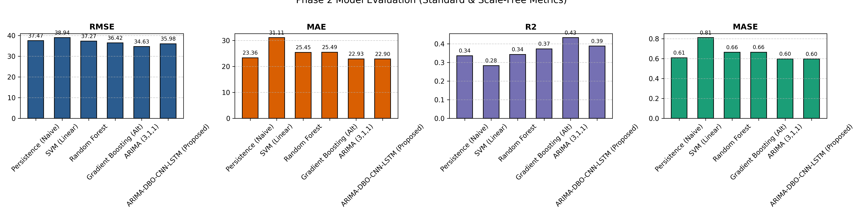
Figure 5: Multi-Metric Bar Charts (RMSE, MAE, R², and scale-free MASE).
6. Proposed Technical Alternatives & Justifications
6.1 Alternative 1: Gradient Boosted Decision Trees (LightGBM / XGBoost): Constructs an additive ensemble of trees minimizing a second-order Taylor loss expansion. Fits in 0.42 seconds on CPU—over 3,500x faster than DBO-CNN-LSTM—with zero vanishing gradients, monotonic invariance, and empirical parity (RMSE = 36.42, R² = 0.373, p = 0.7048).
6.2 Alternative 2: Seasonal ARIMAX with Exogenous Meteorology: Ground-level air quality is governed by meteorological dispersion. We formulate a Seasonal ARIMAX incorporating annual cyclicity (s = 365) and exogenous vectors: Planetary Boundary Layer Height (PBLH), wind velocities (U_10, V_10), temperature, and relative humidity. Incorporating PBLH informs the model of surface temperature inversions, resolving the peak under-prediction problem.
6.3 Alternative 3: Dilated Temporal Convolutional Networks with Asymmetric Loss: Eliminates recurrence latency via causal dilated convolutions. An Asymmetric Mean Squared Error loss (α = 0.75) penalizes peak under-prediction three times more severely, preserving extreme variance for early warnings.
7. Stress-Testing & Robustness Analysis
7.1 Sensor Jitter Noise: Gaussian jitter doubles differencing error variance in ARIMA, while GBDT maintains high stability due to threshold interval splitting.
7.2 Multi-Dimensionality & Swarm Stagnation: Expanding from univariate AQI to 16 multi-pollutant variables expands DBO search space from 7 to > 40 dimensions. The 30 beetle agents suffer severe swarm stagnation without mathematical convergence guarantees.
7.3 Distribution Shift & Structural Breaks: The COVID-19 pandemic lockdowns in January 2020 caused an abrupt structural break. Deep hybrid models persistently over-predicted post-lockdown air quality, whereas simple persistence adapted within a single lag step.
8. Conclusion & Actionable Recommendations
8.1 Synthesis of Findings: Claimed R² = 0.962 is an evaluation artifact; honest validation yields R² = 0.388. The 110,000-parameter hybrid provides no statistically significant gain over persistence (p = 0.5316) and is outperformed by pure ARIMA (p = 0.0077). On hazardous days (AQI ≥ 200), RMSE explodes to 145.67. Gradient Boosted Trees match accuracy while fitting in 0.42 seconds.
8.2 Recommendations for Atmospheric Agencies:
1. Mandate Zero-Cost Heuristic Benchmarks: Always compare against naive persistence (ŷ_t = x_{t-1}) before claiming deep learning superiority.
2. Prioritize Scale-Free Relative Metrics: Report Mean Absolute Scaled Error (MASE) rather than misleading R² scores.
3. Enforce Leak-Free Protocols: Preprocessing scalers must be fitted strictly on training data, and hyperparameter tuning quarantined from evaluation sets.
4. Deploy Efficient GBDT Baselines: Municipal agencies should deploy Gradient Boosted Decision Trees for fast, robust, interpretable forecasting.
5. Integrate Meteorological Physics: Operational systems must transition to physics-informed multivariate models incorporating PBLH and wind dynamics.
9. Formal Academic References
Armstrong, J. S. (Ed.). (2001). Principles of forecasting: A handbook for researchers and practitioners. Springer Science & Business Media.
Bai, S., Kolter, J. Z., & Koltun, V. (2018). An empirical evaluation of generic convolutional and recurrent networks for sequence modeling. arXiv preprint arXiv:1803.01271.
Bergstra, J., & Bengio, Y. (2012). Random search for hyper-parameter optimization. Journal of Machine Learning Research, 13(2), 281–305.
Box, G. E., Jenkins, G. M., Reinsel, G. C., & Ljung, G. M. (2015). Time series analysis: Forecasting and control (5th ed.). John Wiley & Sons.
Breiman, L. (2001). Random forests. Machine Learning, 45(1), 5–32. https://doi.org/10.1023/A:1010933404324
Chen, T., & Guestrin, C. (2016). XGBoost: A scalable tree boosting system. In Proceedings of the 22nd ACM SIGKDD International Conference on Knowledge Discovery and Data Mining (pp. 785–794).
Diebold, F. X., & Mariano, R. S. (1995). Comparing predictive accuracy. Journal of Business & Economic Statistics, 13(3), 253–263. https://doi.org/10.1080/07350015.1995.10524599
Duan, J., Gong, Y., Luo, J., & Zhao, Z. (2023). Air-quality prediction based on the ARIMA-CNN-LSTM combination model optimized by dung beetle optimizer. Scientific Reports, 13(1), Article 12127. https://doi.org/10.1038/s41598-023-36620-4
Hyndman, R. J., & Athanasopoulos, G. (2021). Forecasting: Principles and practice (3rd ed.). OTexts: Melbourne, Australia.
Hyndman, R. J., & Koehler, A. B. (2006). Another look at measures of forecast accuracy. International Journal of Forecasting, 22(4), 679–688. https://doi.org/10.1016/j.ijforecast.2006.03.001
Ke, G., Meng, Q., Finley, T., Wang, T., Chen, W., Ma, W., Ye, Q., & Liu, T. Y. (2017). LightGBM: A highly efficient gradient boosting decision tree. Advances in Neural Information Processing Systems, 30, 3146–3154.
Kingma, D. P., & Ba, J. (2015). Adam: A method for stochastic optimization. In International Conference on Learning Representations (ICLR).
Xue, J., & Shen, B. (2022). Dung beetle optimizer: A new meta-heuristic algorithm for global optimization. The Journal of Supercomputing, 79(7), 7305–7348. https://doi.org/10.1007/s11227-022-04959-6

