

**Automated Solar Panel Orientation Setter**

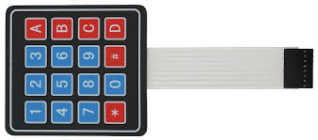

MICROCHIP

PIC 16F877A

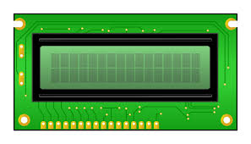

8

6

1



1



Analog in LDR1

1

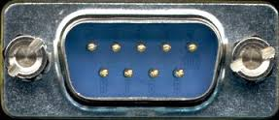

1

6

2

1

1

1

1

Stepper Motor



Digital in Limit Switch

Analog in Power

Analog in Voltage

Analog in LDR2