**Automated Solar Panel Orientation Setter – Sampath – Anguruwella.**

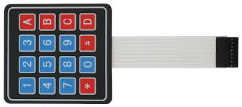

MICROCHIP

PIC 16F877A

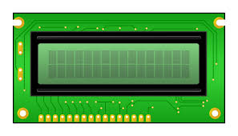

6

8

Analog in LDR1

*Ask from Kelum A.

Take from previus project

LED_Red

1

1

LED_Green

1

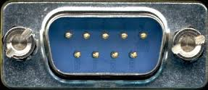

Stepper Motor

Use whatever we have. *Ask from K A

Stepper Motor

RS232 connector to PC

Analog in Power

*Use 1Ω resister series to battery charging wire. Voltage between the resister is output. Make sure one of the resister side should connect to the gnd of the circuit other wise cant get the proper input. Ask from K A

Analog in Voltage

*Battery voltage. Two R and one Zenor,

Ask from K A

Analog in LDR2

*Ask from Kelum A.

Take from previus project

LED_Amber

1

6

2

1

1

1

1

Digital in Limit Switch