

**Maxmaa Electronic and Software Solutions**

A 37/1, Hungampola, Moronthota.

Kegalle.

Tel: +94352278642

Hotline: +94718501416

www.maxmaa.com

**Contract**

Transport :

Designing and coding :

Further developments :

Total : Rs.20, 000/=

**Automation system for scheduled audio player - Software**

Date: 2015/03/14

**Details**

Project Ref. : 20150314

Project name : Automation system for scheduled audio player - Software.

Project start date : 14/03/2015

Project manager : Chathuranga Dissanayaka ([chathurangadissanayaka@yahoo.com](mailto:chathurangadissanayaka@yahoo.com))

: +94718501416, +94713984901

Compatible Platform : Windows XP/7/8/8.1

Framework : .net3.5 and upwards

Client : MAS Active – Leisure line, Phase 1, Katunayaka BOI, Katunayaka.

Contact no : +94112252430

Contact person : Mr.Nalin – [nalinwi@masholdings.com](mailto:nalinwi@masholdings.com) (+94773633457)

**System overview**

Before:

Employee from the MAS holdings, from the factory operates a pc (computer) which has audio tracks that should hear for all machine operators…..etc at exact time.

This is done by an employee who working in a line that proceeding garments manufacturing.

After:

Someone has to schedule the tracks to play and the exact time that should play. Then the software will do everything no one not to be worry.

As well as if anyone wants to play a playlist then he add the media and play them. Any software will pause playing other tracks and play the scheduled tracks without interfering each other.

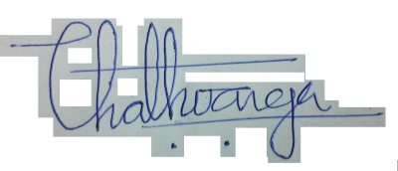

……………………………………………………….

Signature (Chathuranga)

Project Manager,

Maxmaa Electronic and Software Solutions.