MP3 Scheduler V15.1.5.3

Schedule your audios,recordings and save your time

**Key features**

* Can schedule announcements, recordings and any other audio file.
* Play mp3 songs **without** interference with announcements.
* Can select days for several announcements.
* User friendly interface.

**Interface**

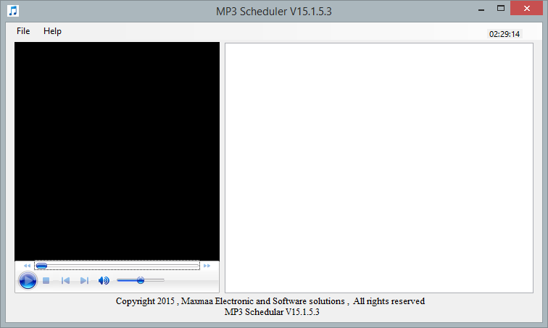

**Upcoming events**

**Audio player**

**Adding events**



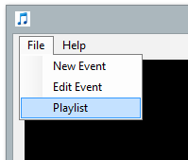

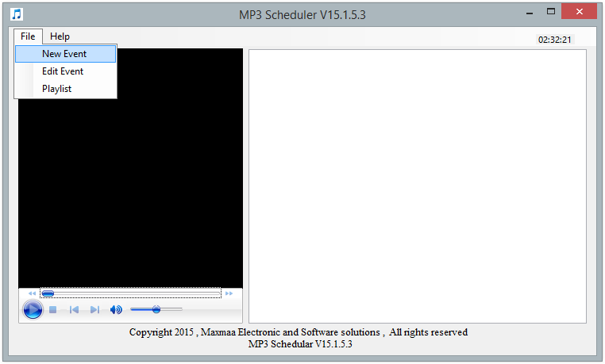

**File -> New Event**

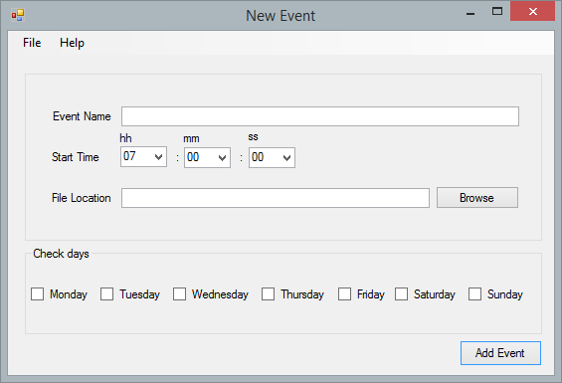

**Enter your event name here**

**Select time to play the audio file**

**Choose the relevant audio file to play**

**Select days to play**

**Click add event to add the event**

**After add several events**

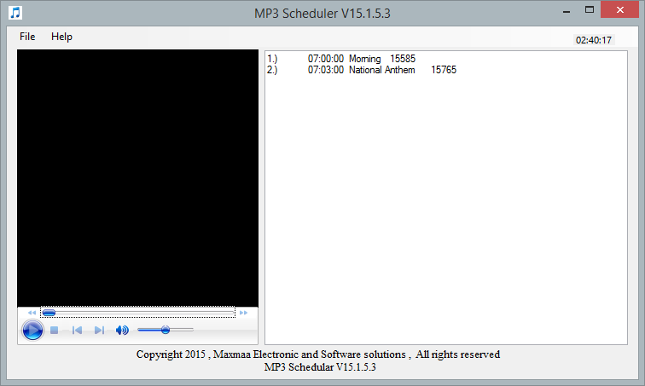

**Editing Events**

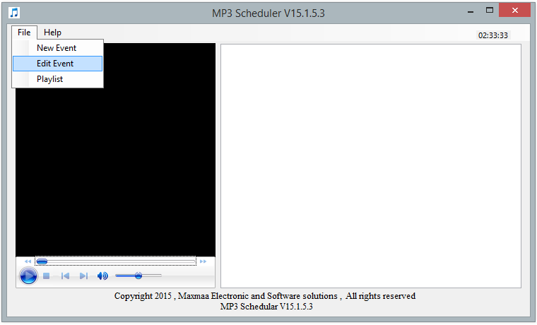

**File -> Edit Event**

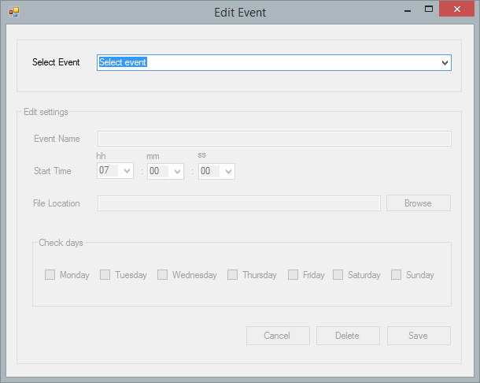

**Select the event you want to edit**

**Click ‘save’ to save your edited event**

**Click ‘delete’ if you want to delete selected event**

**Play other playlist**

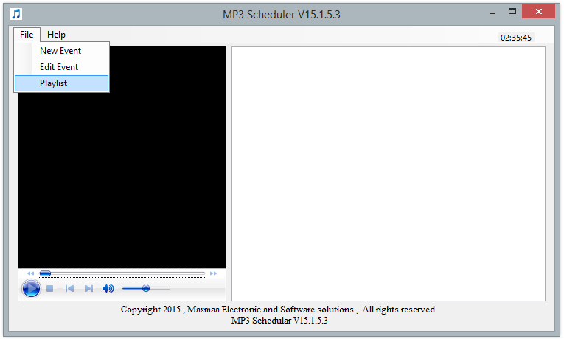

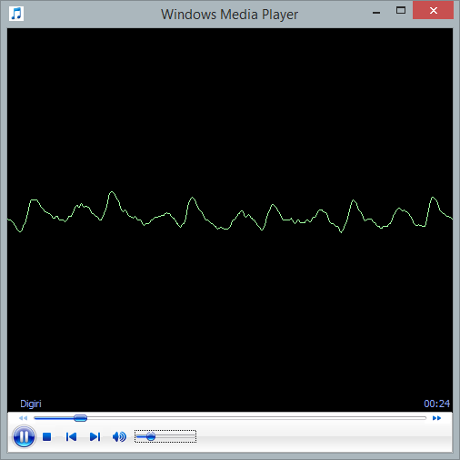

**Playlist player window**