Following diagram screenshot shows the all data captured by Wireshark when the wireless adapter on and start after resetting IPv4 IP address use the following address to obtain IP address automatically.

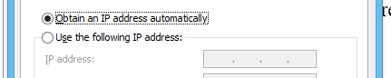

Data captured by the Wireshark

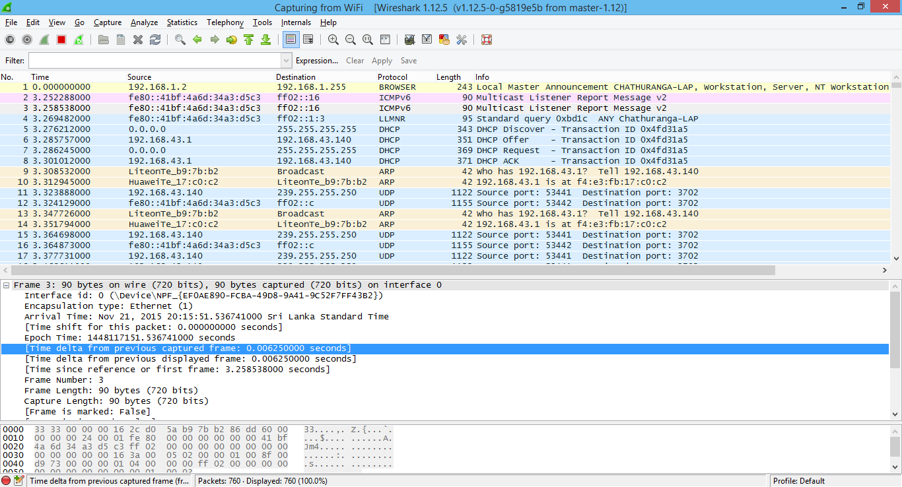

By connecting the computer with another pc with capturing Ethernet port, we realized that the both machines are sending DHCP discover messages.

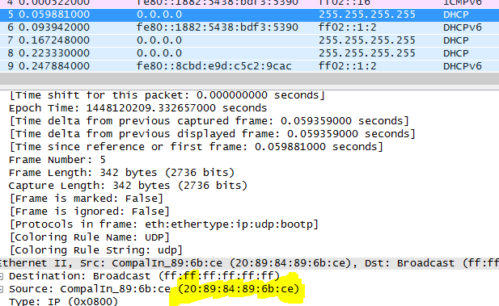

This is from one pc and the following shows the other pc mac address in the dhcp message

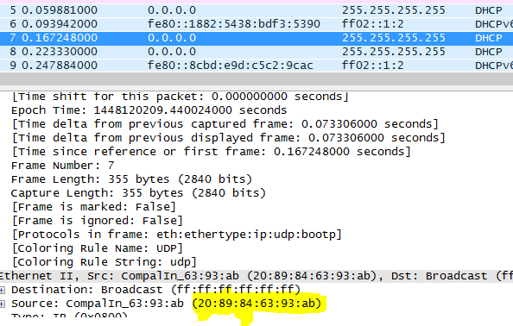

Following show the mac address of one pc which is capturing the data using the Wireshark.