Load Programs to board 2302

Flash ESP32

Things required
- Flash Download Tool. Get it from following link
https://www.espressif.com/en/support/download/other-tools
- Following firmware bin files
  - bootloader.bin
  - partitions.bin
  - boot_app0.bin
  - firmware.bin
- USB TTL device.
- Jumper
- 12VDC Power to the board.

Steps

- Turn off the power
- Load PMG1 jumper. Connect USB TTL TX, RX and GND to the UART1 port. Follow the wiring from below image. In the board, UART1 “RX,TX,0V” labels are wrong.
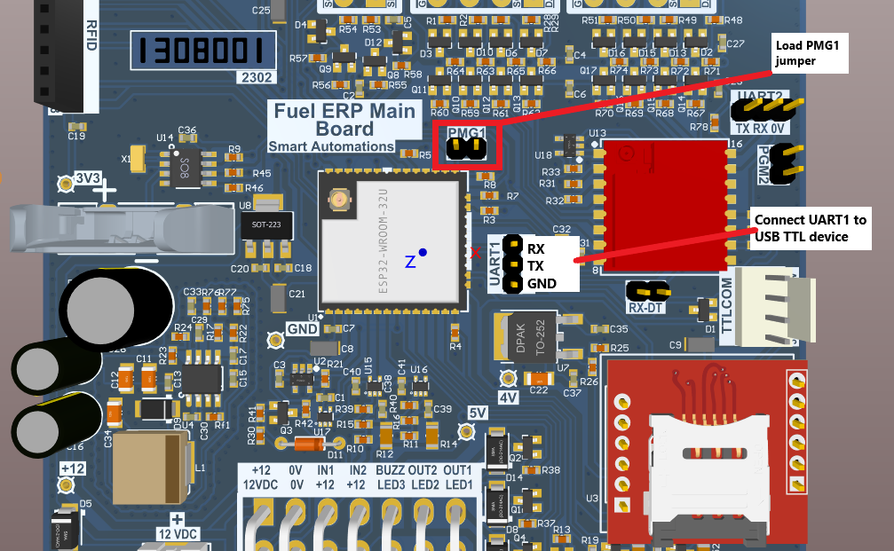
- Power the board.
- Open “flash_download_tool_3.x.x\flash_download_tool_3.x.x.exe”
- Wait couple of seconds for opening small window DOWNLAOD TOOL. Then select “ChipType” into “ESP32” and “WorkMode “Develop. Press OK.
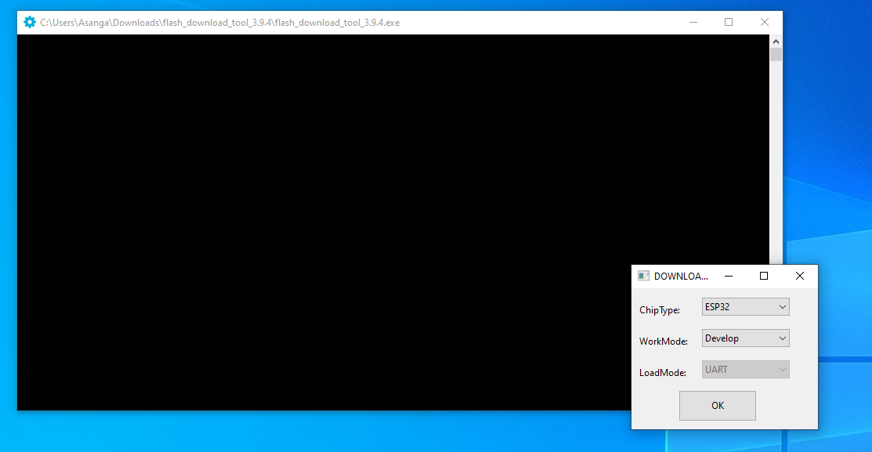

- Select the settings like below. Once you select it, the settings are going to save.
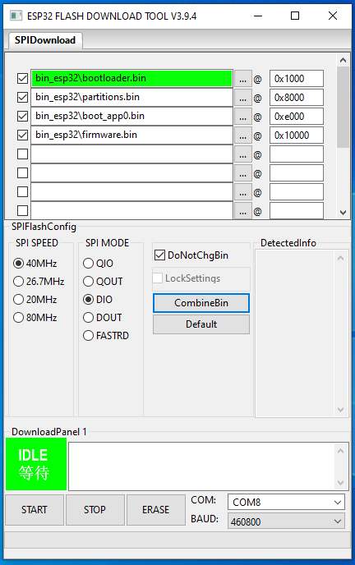
- Brows to the .bin file like in about image.
- Select “SPI SPEED” into 40MHz
- Select “SPI MODE” into DIO
- Select COM port number
- Change “BAUD” into 460800.
- Hit “ERASE” button.
- If it is successful, you make get like this. Wait until display finish the green area. If didn’t happen anything, check come port, “PGM1” jumper, and the wiring. Hit “STOP” button and do power cycle of the board. Then try again.
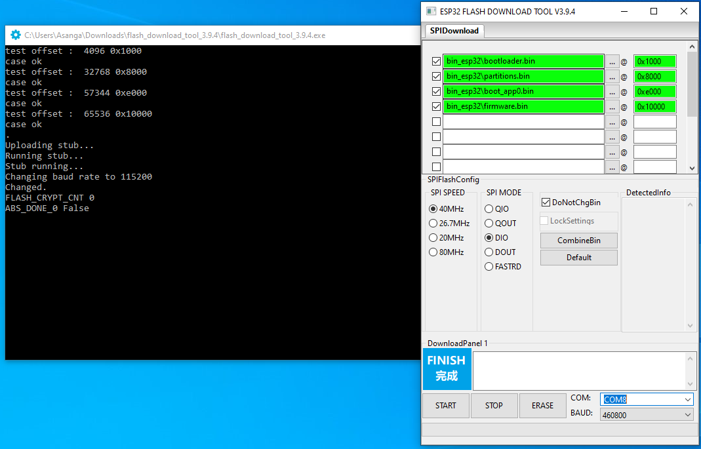
- If it is successful, do power cycle of the board again. The hit “START” button.
- After successful upload, you may see like below.
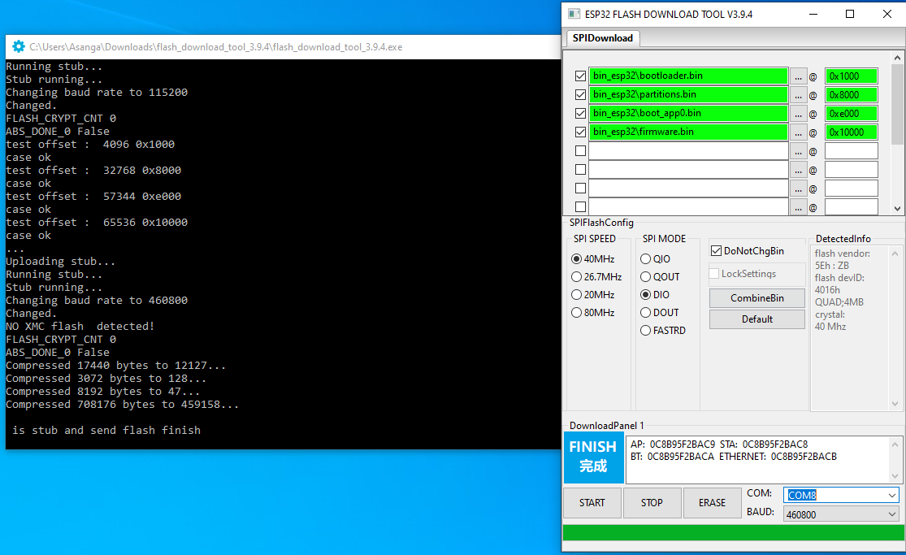
- Close the window after finishing the firmware download.
- Now remove the PMG1 jumper and power cycle. You may see printing of texts over UART1 port on baudrate 115200.
- Done.

Flash ESP07

Things required
- Flash Download Tool. Get it from following link
https://www.espressif.com/en/support/download/other-tools
- Following firmware bin files
  - firmware.bin
- USB TTL device.
- Jumper.
- 12VDC Power to the board.

Steps
- Turn off the power
- Load PMG2 jumper. Connect USB TTL TX, RX and GND to the UART2 port. Follow the wiring from below image. In the board, UART2 “RX,TX,0V” labels are wrong.
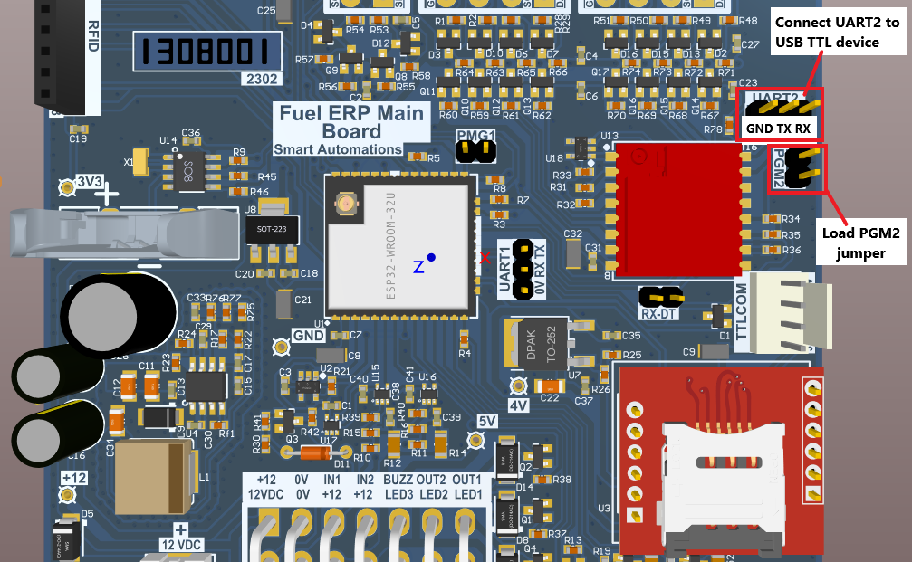
- Power the board.
- Open “flash_download_tool_3.x.x\flash_download_tool_3.x.x.exe”
- Wait couple of seconds for opening small window DOWNLAOD TOOL. The select “ChipType” to “ESP8266” and “WorkMode” to “Develop. Press OK.
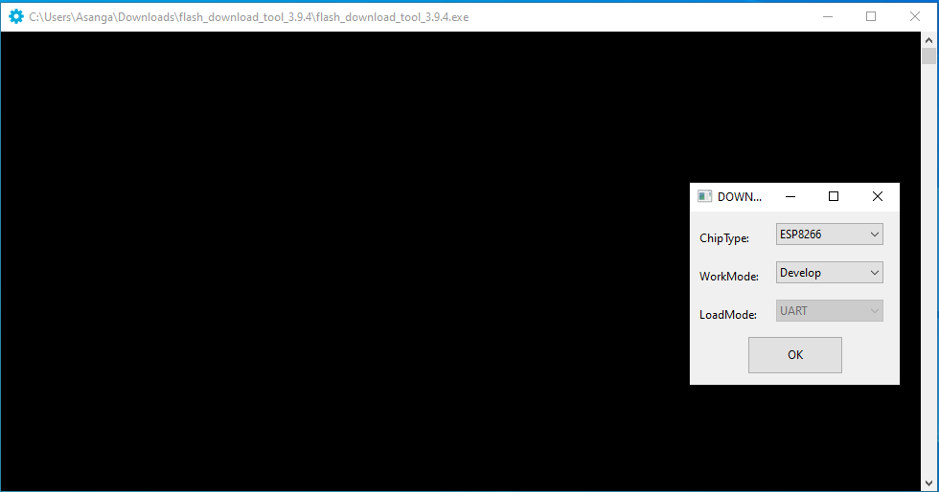
- In “SPIDownload” tab Select the settings like below. Once you select it, the settings are going to save.
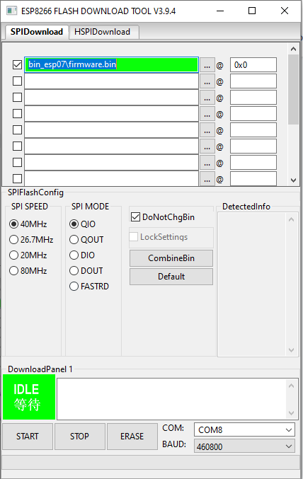
- Brows to the .bin file like in about image.
- Select “SPI SPEED” into 40MHz
- Select “SPI MODE” into QIO
- Select COM port number
- Change “BAUD” into 460800
- Hit “ERASE” button.
- If it is successful, you make get like this. Wait until display finish the green area. If didn’t happen anything, check come port, “PGM2” jumper, and the wiring. Hit “STOP” button and do power cycle of the board. Then try again.
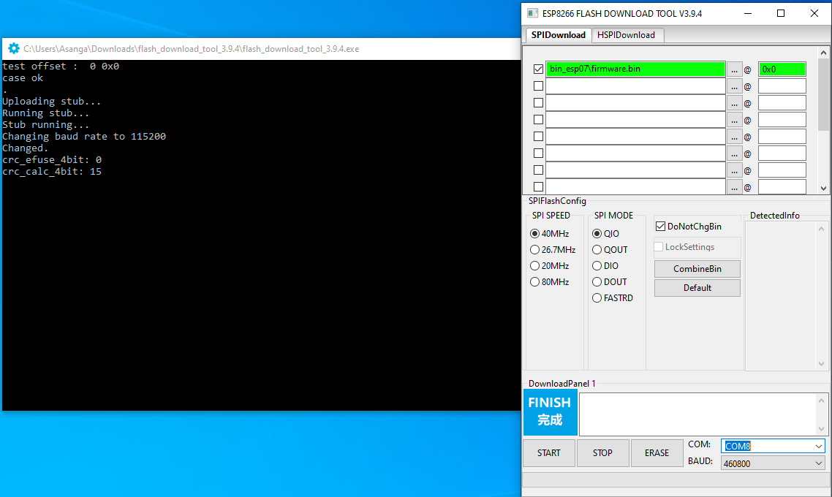

- If it is successful, do power cycle of the board again. The hit “START” button.
- After successful upload, you may see like below.
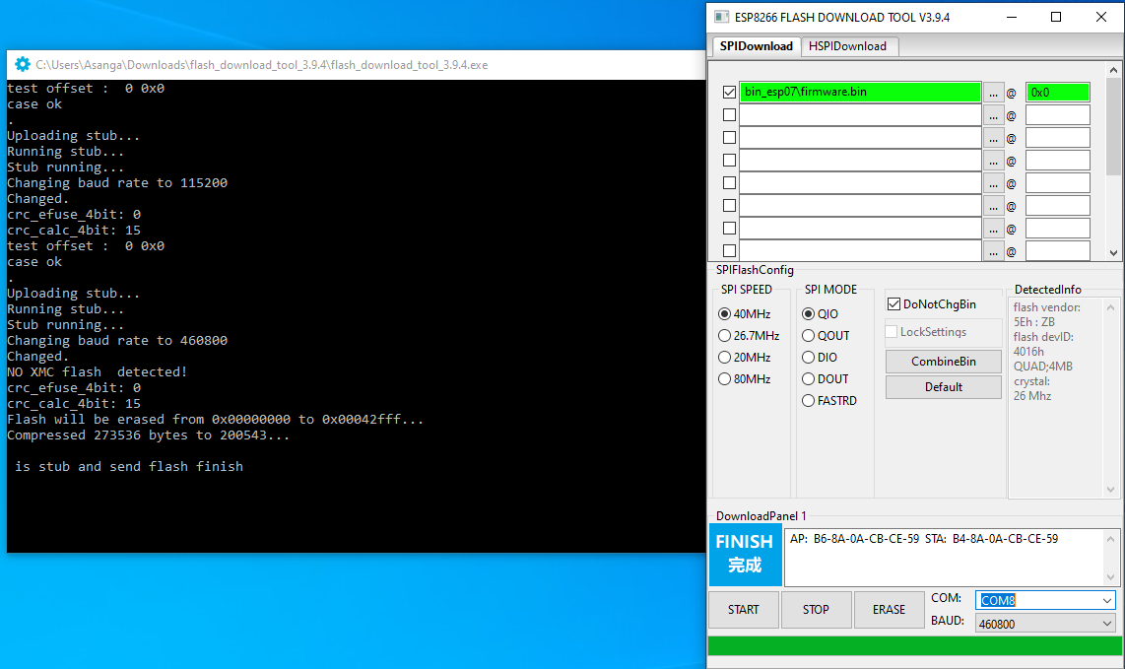
- Close the window after finishing the firmware download.
- Now remove the PMG2 jumper and power cycle. You may see printing of texts over UART2 port on baudrate 115200.
- Done.

