Censtar Small Display (Below 100,000/= LKR Total) Capture

Connector PIN Maping
10 PIN IDC Connector
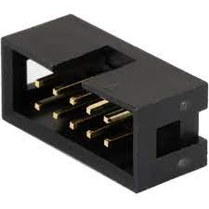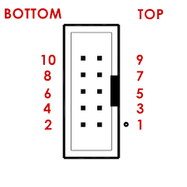

PIN | Description
1 | NOT Connected
2 | NOT USED
3 | DATA
4 | NOT USED
5 | STROBE/ DATA LATCH
6 | CLK
7 | GND
8 | NOT Connected
9 | VCC (5V)
10 | NOT Connected

Captured Data
Captured files (here)

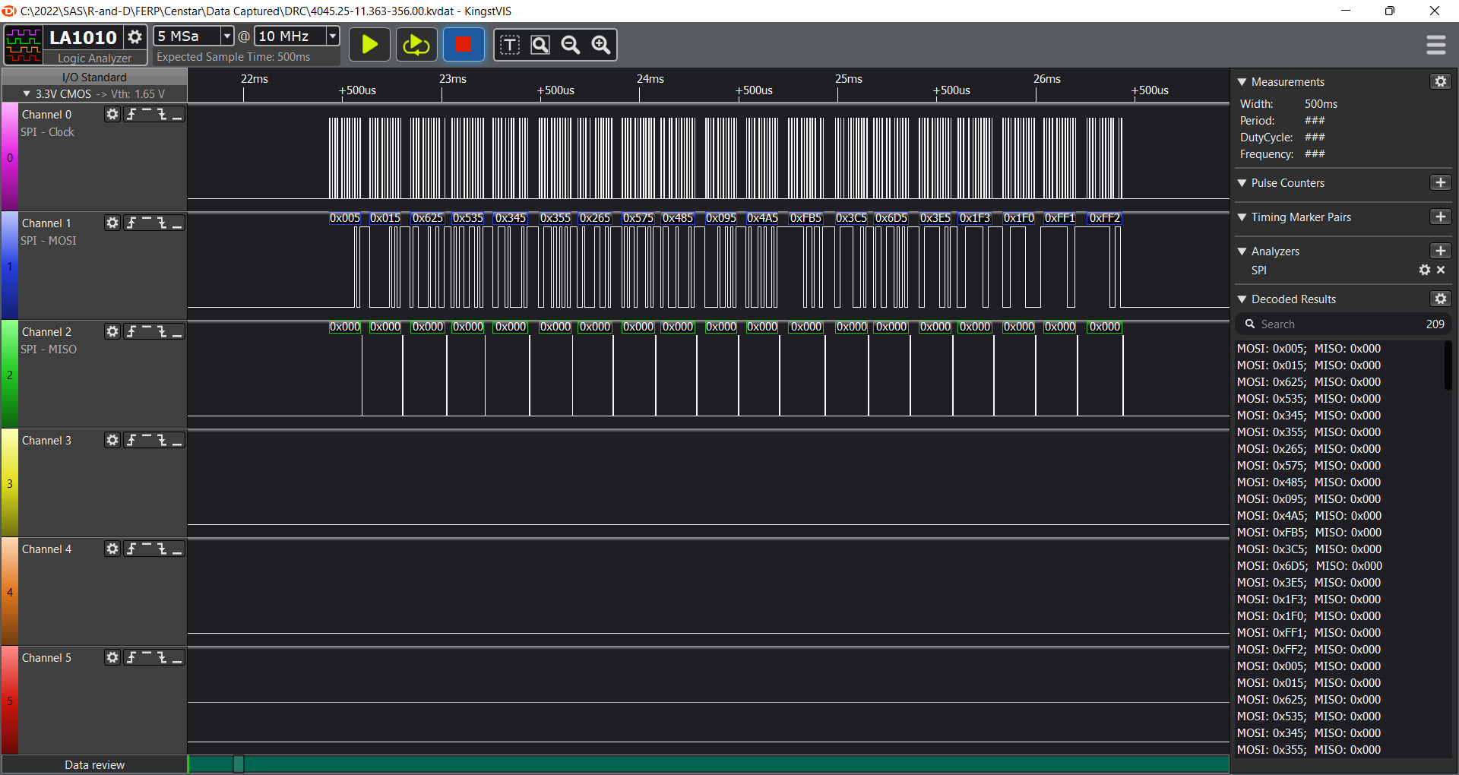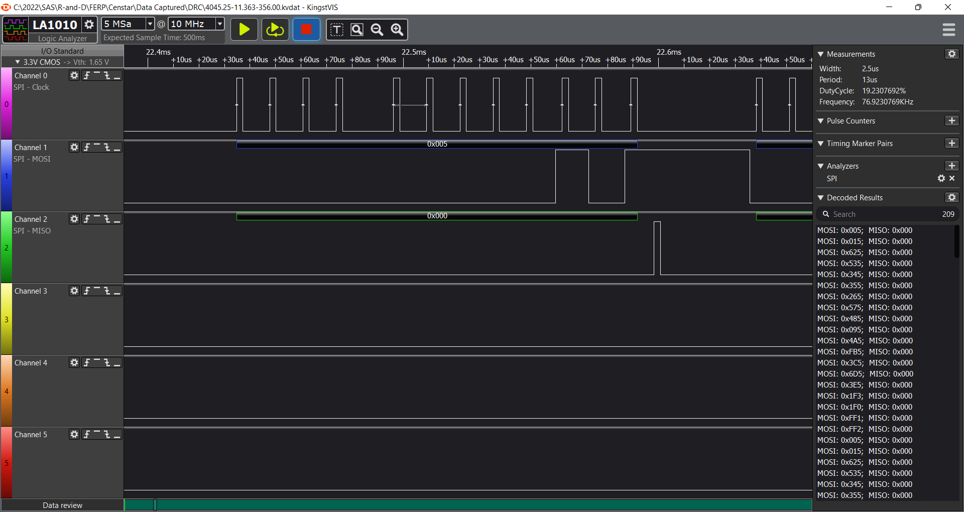

Decoding
Data is captured when the display is set to
5860.83/ 16.463/356.00 -> total / liters / fuel unit price
Total - 5860.83
Liters - 16.463
Unit Fuel Price - 356.00
G, H, I (4-22) Cells shows the consecutive data from the display. All as similar because display is fixed.
One Byte in old code is now 12 bits.
Every 12 bits there is a strobe
12 bit should taken into 3 times 4bit values.
Center 4 bit is the index which is goes from 0 to F2
And the decoding is as below.

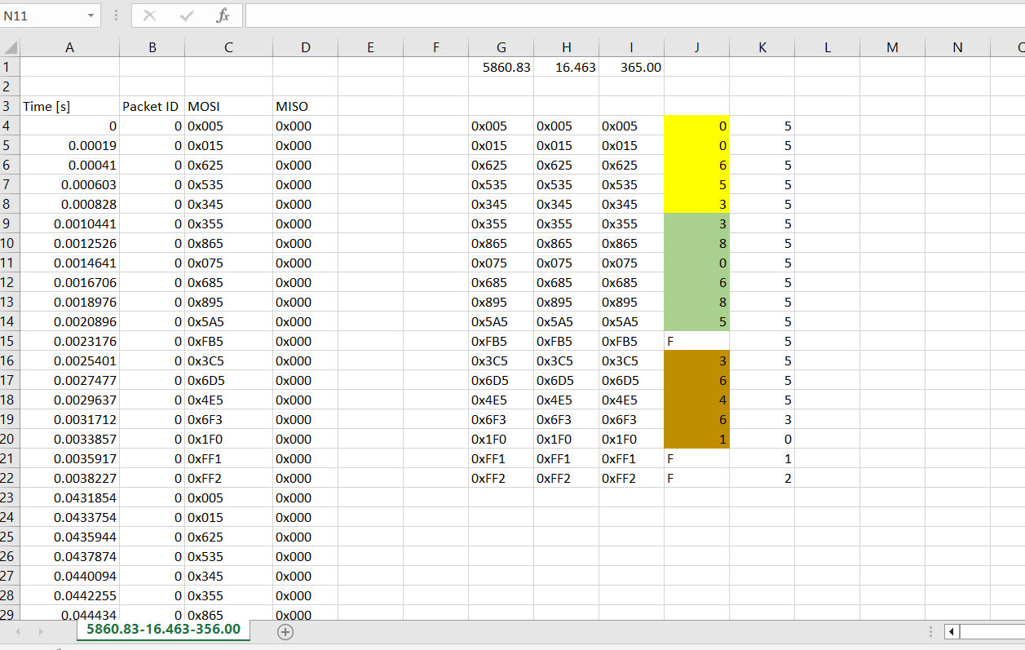

Display data behaviour

Status | Display Data Sending (Yes/ No) | Continuous or Once
Nozzle - In the Pump  Value - Non Zero | No | No
Nozzle - Remove  Value - Zero | Yes | Once
Nozzle - Removed  Value - Non Zero | Yes | Continuous

Total Liters
Example is below
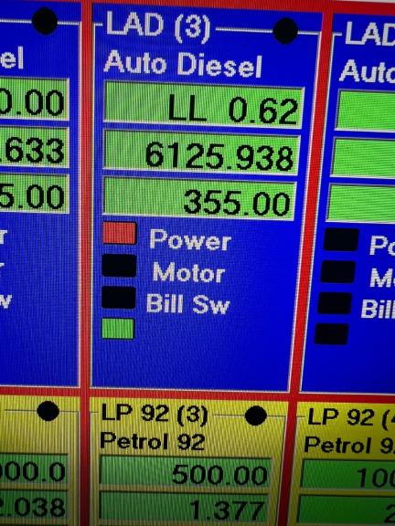
The value it 626125.938 Liters.
LL = 4,5 bytes index of Total price segmenst
Total Liters = Value in liters + (value in total * 10000000)

