WAYNE 6 Digits Display Capture
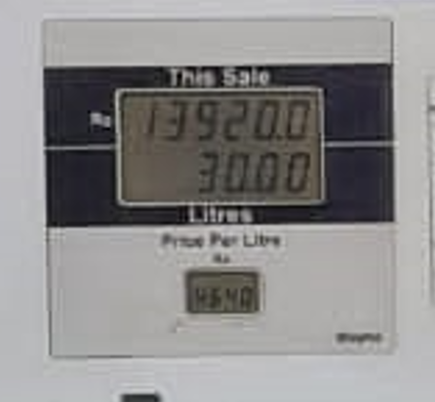
Display has 3 rows,
Row1 - 6digits
Row2 - 6digits
Row3 - 4digits (Unit Price)

Totalizer

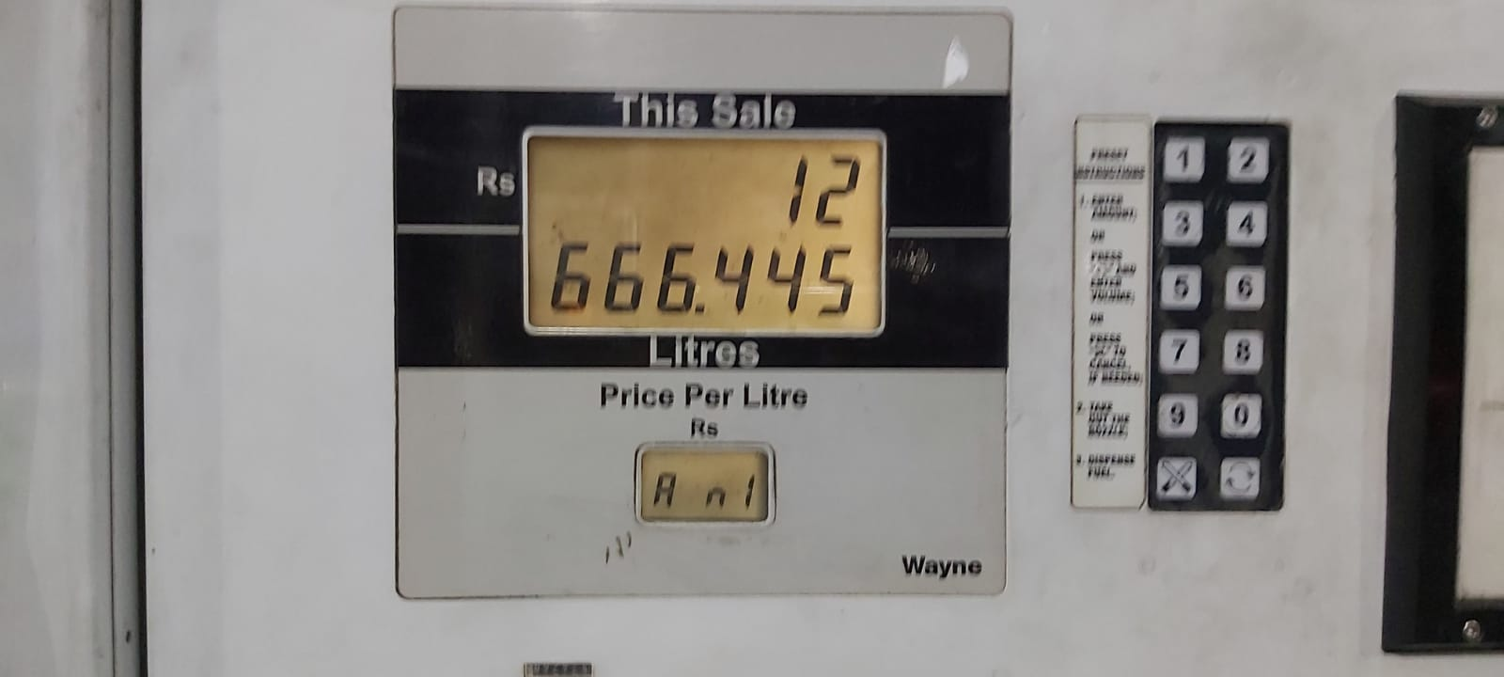

Connector PIN Maping
10 PIN IDC Connector
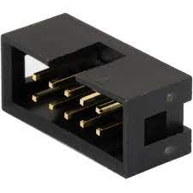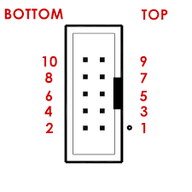

PIN | Description
1 | NOT USED
2 | DATA 1
3 | DATA 2
4 | CLOCK
5 | NOT USED
6 | NOT USED
7 | 7.86V
8 | GND
9 | 5V
10 | GND

Captured Data
Data points are received in every Second
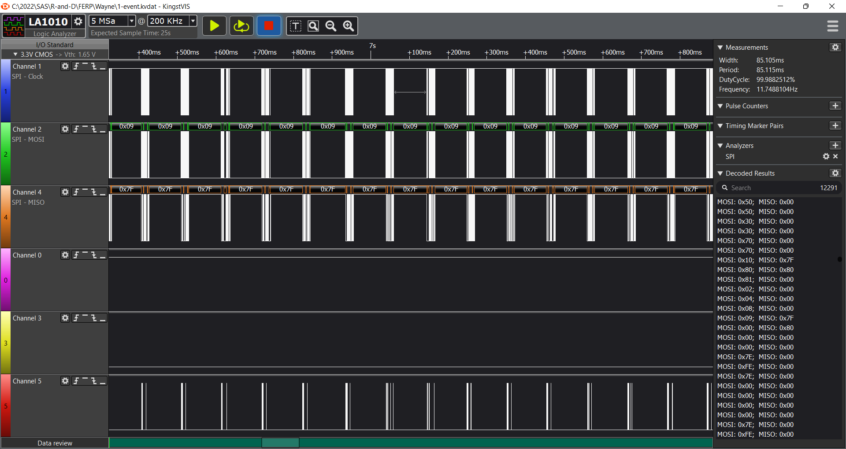

One data point has 51 bytes of data
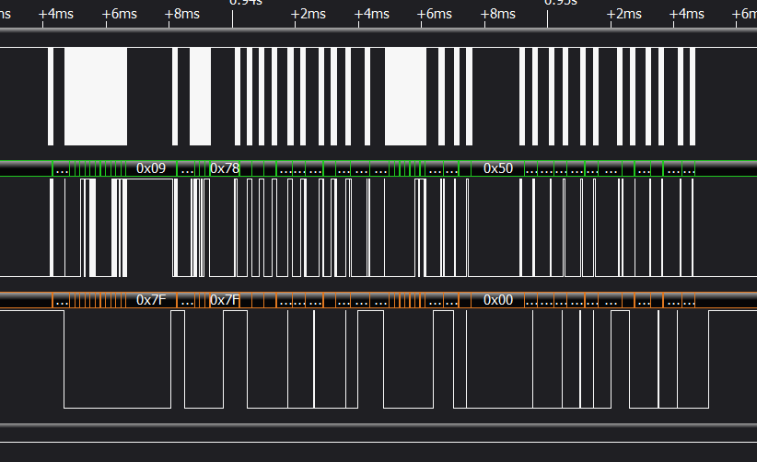

Clock is 50KHz
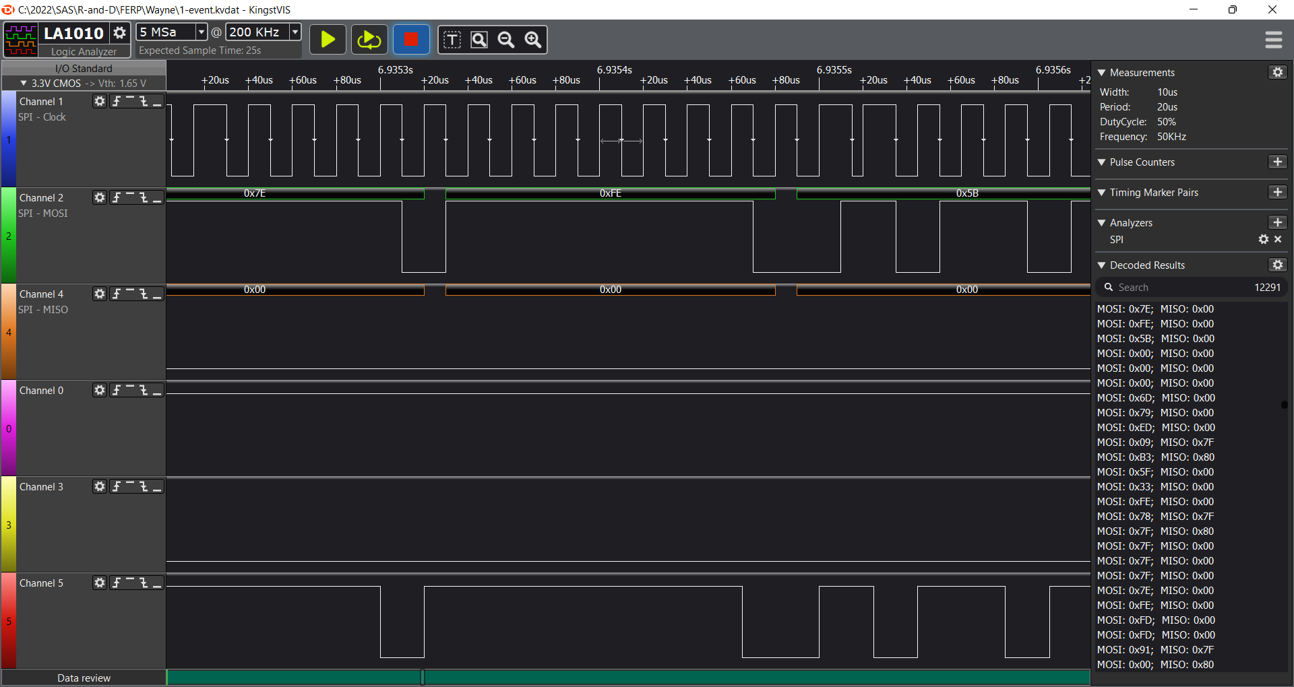

Decoding
There is two data lines, sending 51 bytes.
There is no RCLK/Strobe like data in the bus. Only SCLK, SDATA1, SDATA2 signals.
Rising edge used to capture bit. No Time gap between bytes.
Data is sending every seconds
Every data is start at 0x12 in Data1 line while Data2 line data is 0xFF
That should used to capture the start point of the data stream
After start, first 12 bytes are the 12digits in the display in the same format as 7Segments including the decimal point
The decoding key table is as below, this could be any character which can be shown in 7 segments
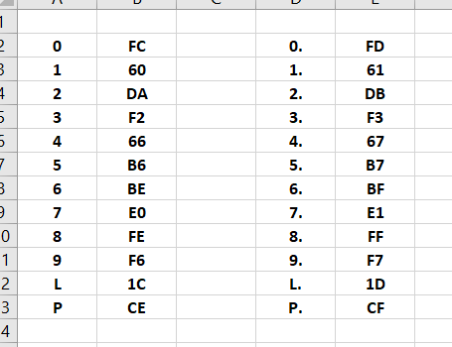

7 Segment Map is below.
/* ----------------
/ \ A / \
/ \------------/ \
| | | |
| F | | B |
\ /------------\ /
\ / G \ /
/ \--------------/ \
/ \ / \
| | | |
| E | | C |
\ /------------\ / _
\ / D \ / / H \
----------------- \ _ /

bits 7, 6, 5, 4, 3, 2, 1, 0
A, B, C, D, E, F, G, H
*/

Below shows the extracted data from captured data
