Software Requirements Specification

for

Stock Management System
Version <1.0>

Prepared by
Nandika Renapana | 200124301134 | nandikachathurangha@gmail.com |  | 0713232001

Contents
Contents 2
Introduction 3
Document Purpose 3
Product Scope 3
Definitions, Acronyms and Abbreviations 4
References and Acknowledgments 4
Overall Description 5
Software Perspective 5
Users and Characteristics 5
Operating Environment 6
Design and Implementation Constraints 6
Assumptions and Dependencies 6
Specific Requirements 8
External Interface Requirements 8
Other Non-functional Requirements 15
Performance Requirements 15
Safety and Security Requirements 15

Introduction
Stock Management System (SMS) is a tool that is designed to provide support to employees and owners to manage the stock in a computer shop. The goal is to provide a software solution that the shop functions with better efficiency and allows quick and easy access to stock information.

Document Purpose
This document will provide an overhead view of the system functions and what should be expected by the end-users. Providing a base for the foundation of project is the main goal of this Stock Management System Software Requirement Specification (SRS). Producing a specific unambiguous functional and nonfunctional requirement according to the analysis of clients’ expectations and requirements, to be used by the development team with a clear understanding of end-user needs to build the system.
The document can be used in the future as the basis for getting a detailed understanding of how the project was started and will also provide a blueprint for the developers and maintenance teams to maintain and modify this project with required changeability.

Product Scope
The SMS is intended to be implemented to help with the inner functionalities of the shop like the product purchases, product sellings, and management of stock while automating the various operations related to them. The SMS will have 2 end-users: Cashier, and Shop Management (Admin). The main features of the SMS will be the Stock Management System, DBMS Server, and Report Generator.

The system will allow the Cashier to register products, customers and suppliers, issue invoices for sellings, repair jobs, and stock purchases. It will allow Admin to view daily, and weekly profit, view reports, user management and to update stock information such as selling price.
Simplification of the everyday process of the shop is the main goal of this introduced automated SMS software. With the increase of customers and personnel on a day-to-day basis, the system needs to be automated so that the customer is provided with ease of access and the needed services in a quick manner. The software will be able to replace the drawbacks of using large customer information physical files which are difficult to handle.
The secure transaction, quicker information retrieval, ease of use, quick error recovery, and fault tolerance are some of the benefits that the development team will be working on for end-user satisfaction.

Definitions, Acronyms and Abbreviations
SRS | System Requirement Specification
SMS | Stock Management System
DBMS | Database Management System
Blueprint | A design plan
OS | Operating System
RAM | Random Access Memory
JRE | Java Runtime Environment

References and Acknowledgments
- IEEE Software Engineering Standards Committee, “IEEE Std 830-1998, IEEE Recommended Practice for Software Requirements Specifications”, October 20, 1998.

Overall Description

Software Perspective
This system is mainly of two parts application and a database.
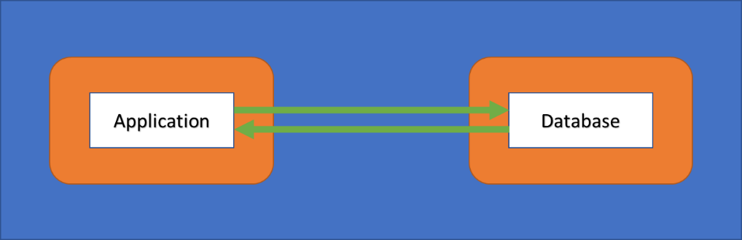
The general functions of our product are:
- Customer Registration;
- Product Registration;
- Supplier Registration;
- Stock Management;
- User Management;
- Payment;
- Reports Generation; and
- Display Profit.

Users and Characteristics
There are 2 main types of characters who connect with the system.
Admin | The admin has access to every function of the system and is solely responsible for managing resources and staff. Admin can view any report such as financial reports, customer information, and stock information. He may analyse them and take decisions accordingly.  The admin is required to have previous experience in managing a shop and have basic knowledge of database and application servers.
Cashier | Facilitating the customer service for purchases is the sole purpose of a Shop cashier. She has access to customer information and can issue invoices for customer purchases along with GRNs stock additions.  The receptionist is required to have good communication skills, command of the English language, and basic IT knowledge.

Operating Environment
OS | Windows 8.1 or higher
Processor | Intel or AMD Dual-Core 1GHz
RAM | 1GB
Monitor | Resolution: 1920x1080
Disk Space | 20GB
Peripherals | A Keyboard and a Mouse
Printers | A laser printer for bills and reports printing
Software | JRE v1.8 or above

Design and Implementation Constraints
- Language Requirement: Software must only be in English.
- Implementation Constraints: The application should be based on Java only.
- Reliability Requirements: The system should sync frequently to the backup server to avoid data loss during failure.

Assumptions and Dependencies
It is assumed that the system will be developed under Windows OS with MySQL database. In case of any difficulties, SRS will be designed to be flexible enough to change accordingly.

Specific Requirements

External Interface Requirements

User Interfaces
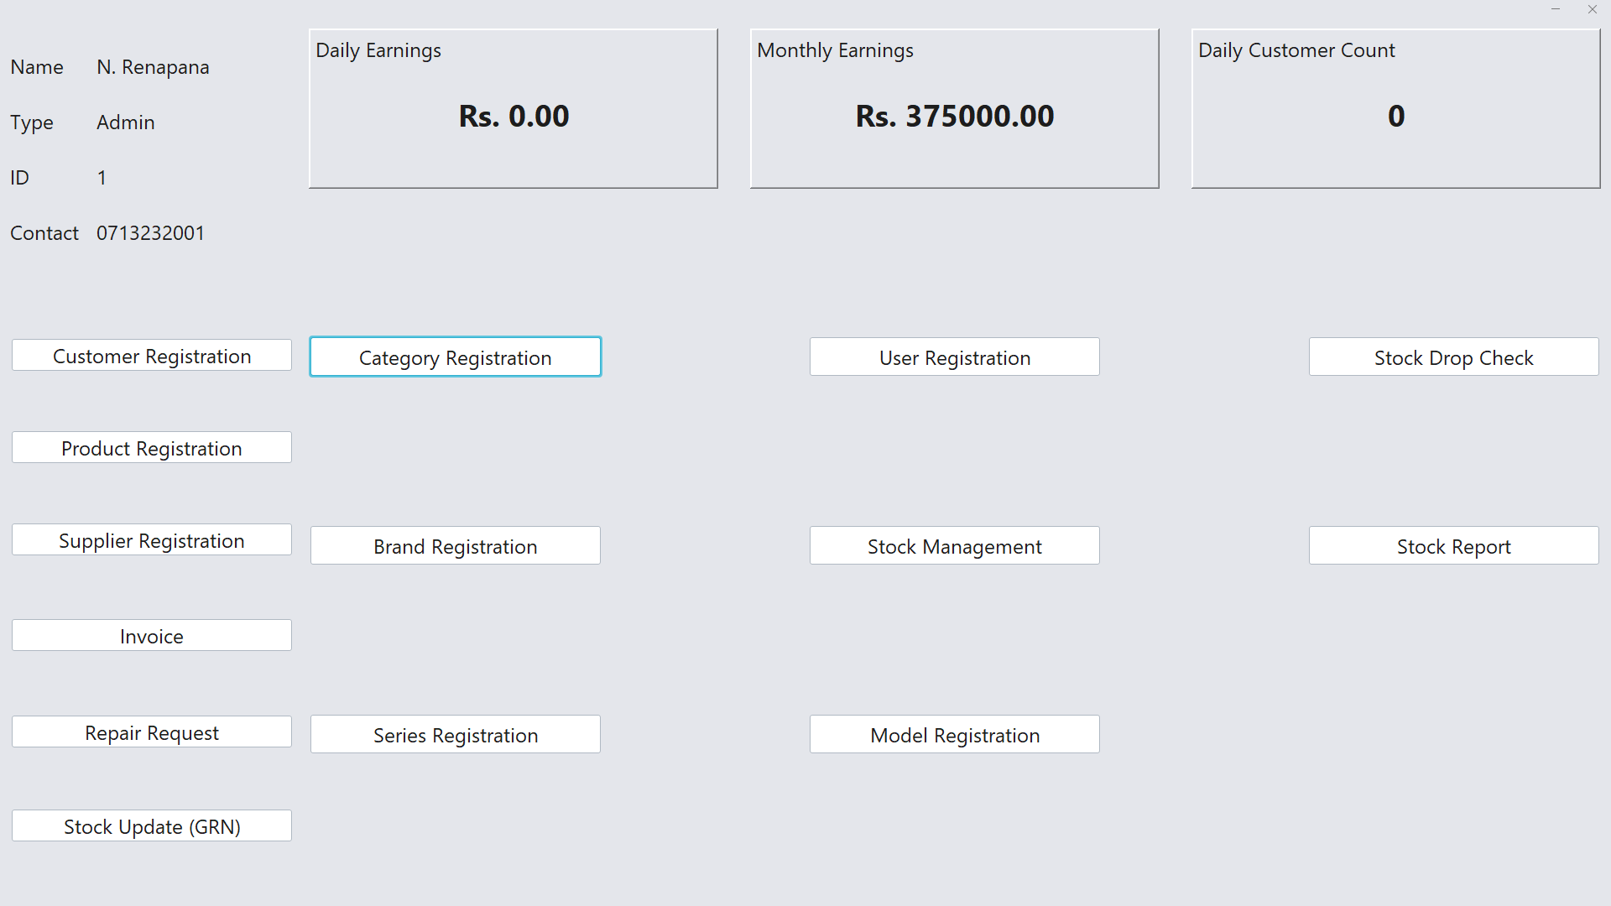
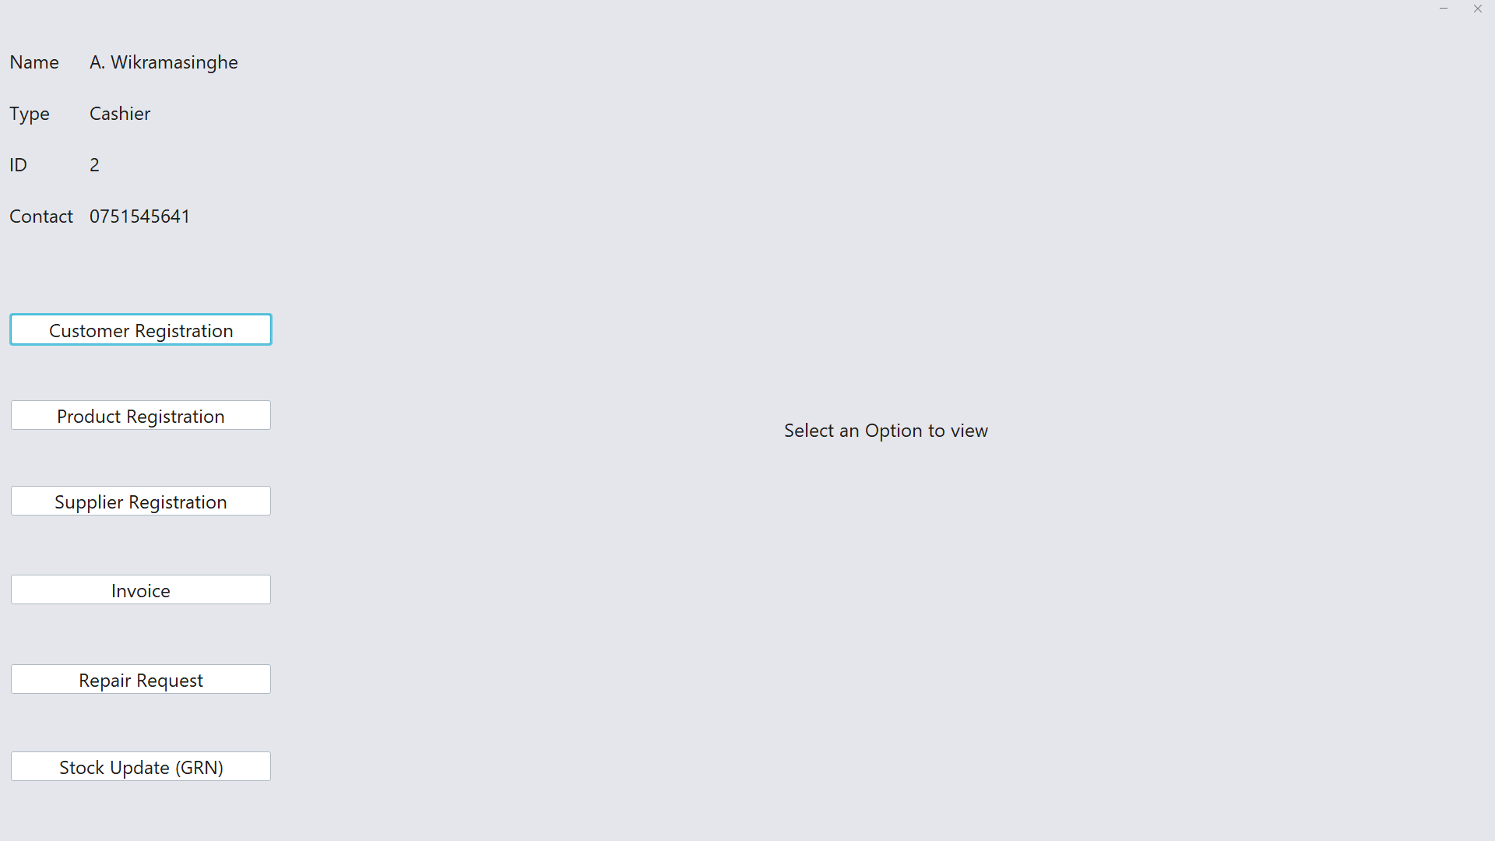
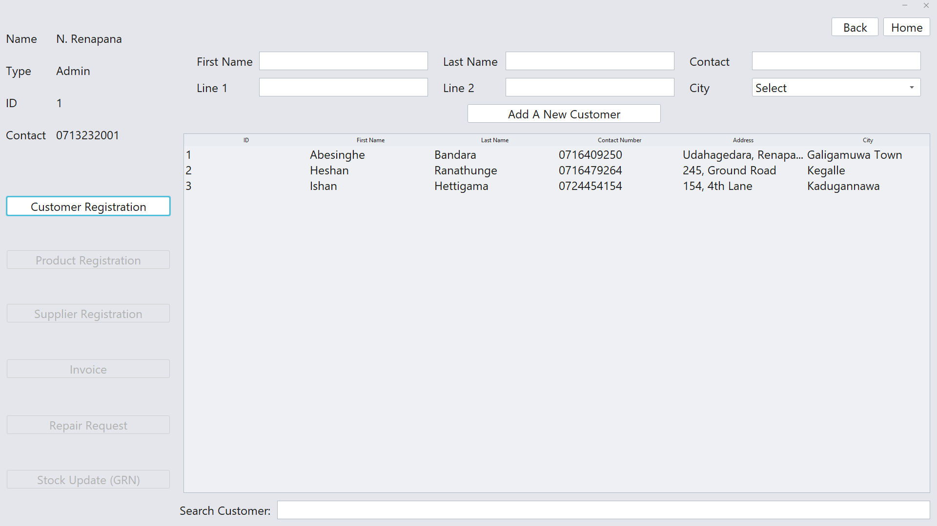
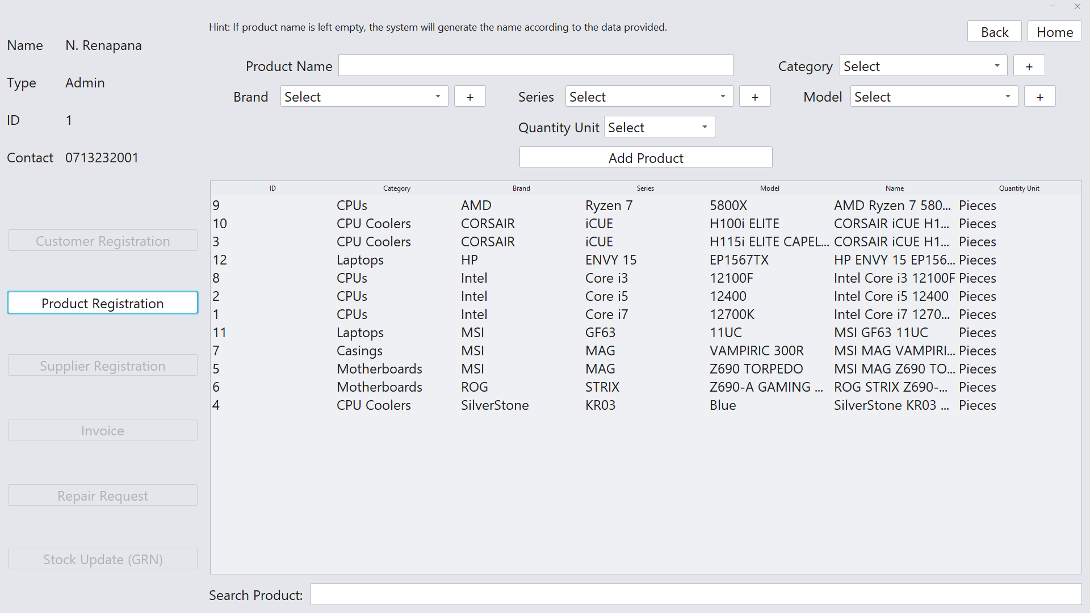
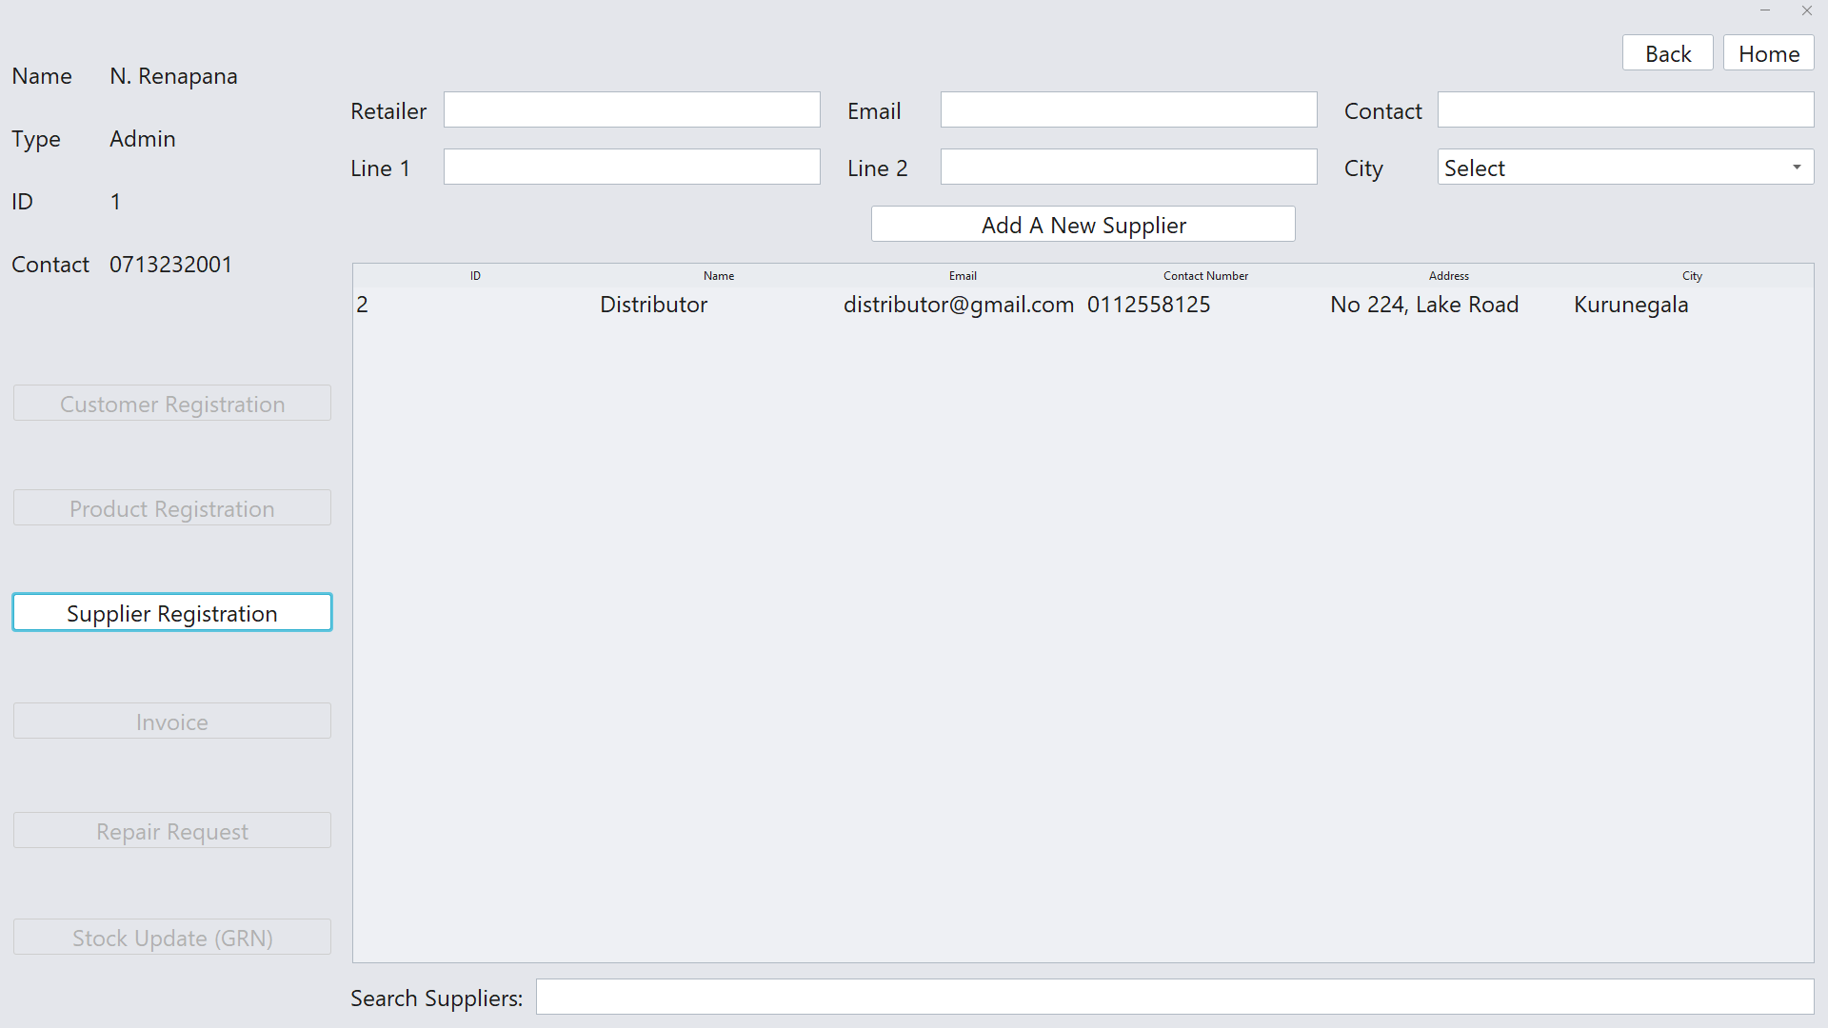
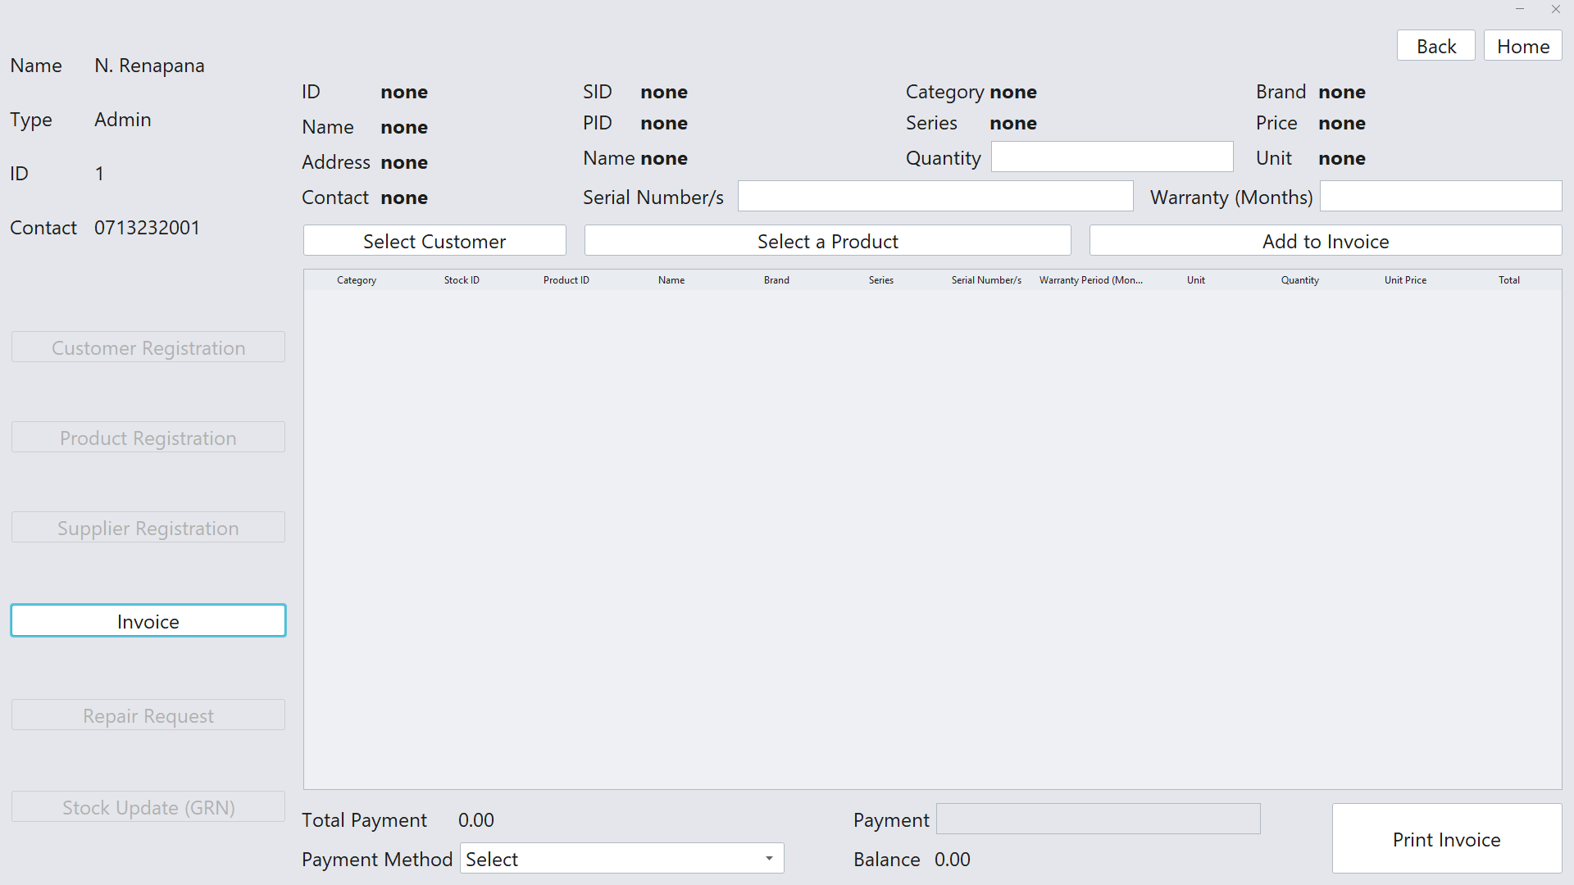
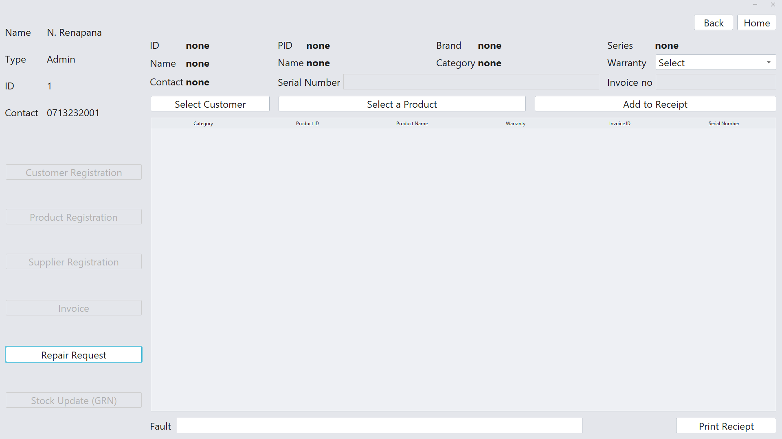
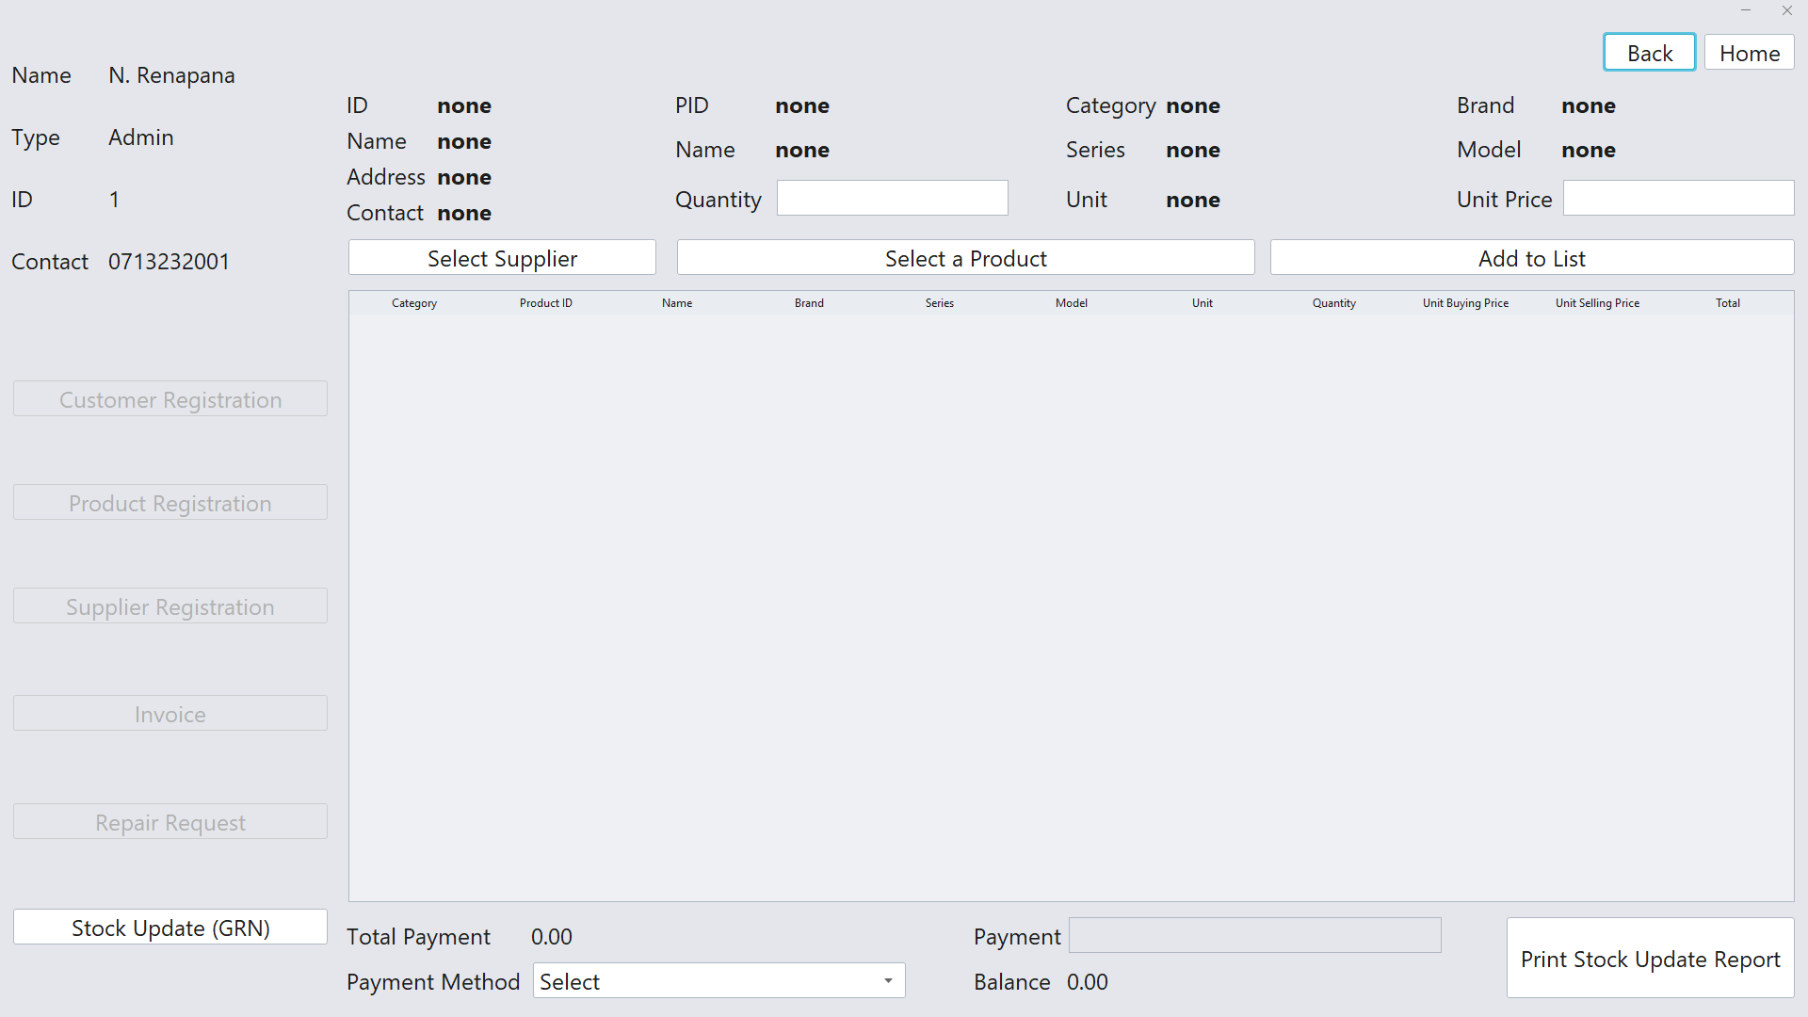
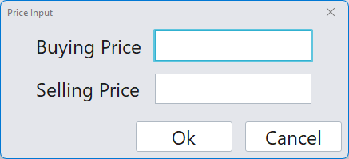
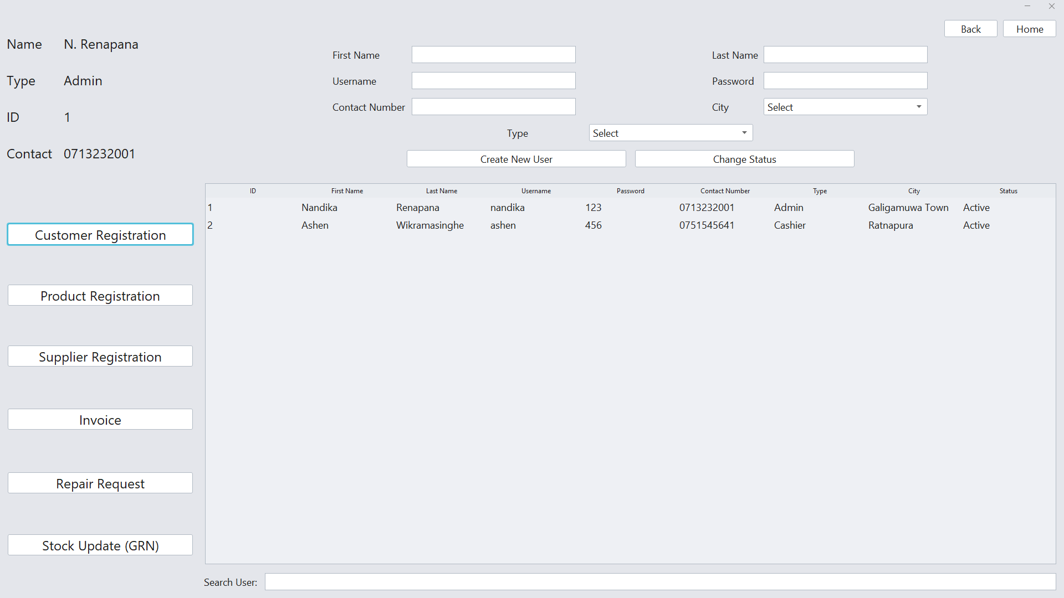
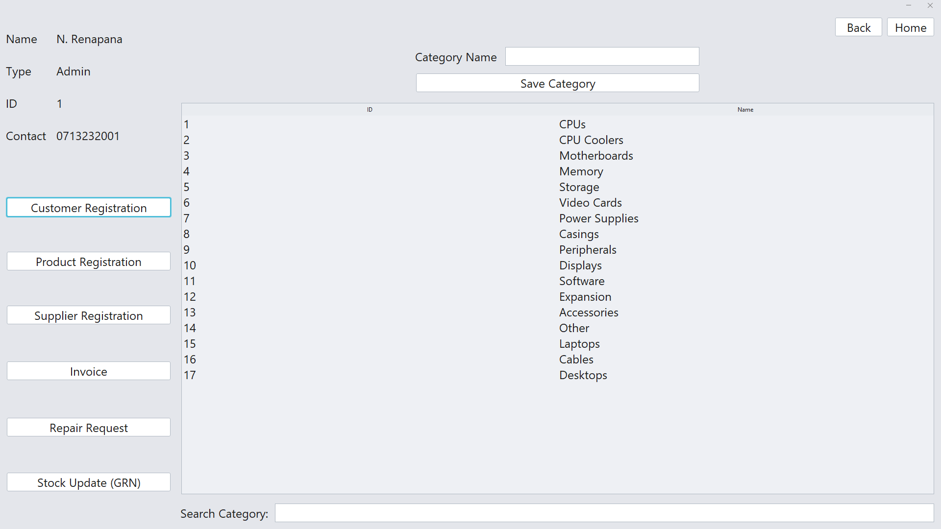
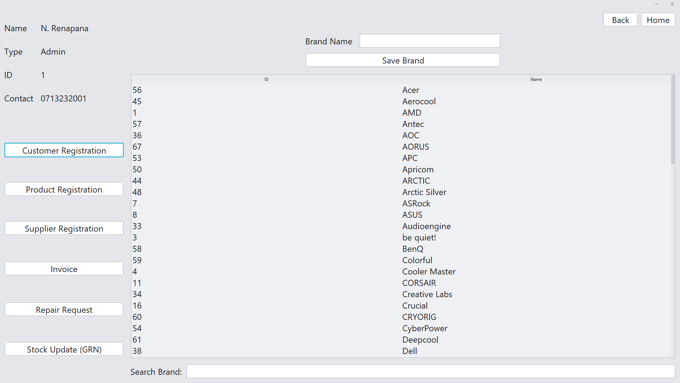
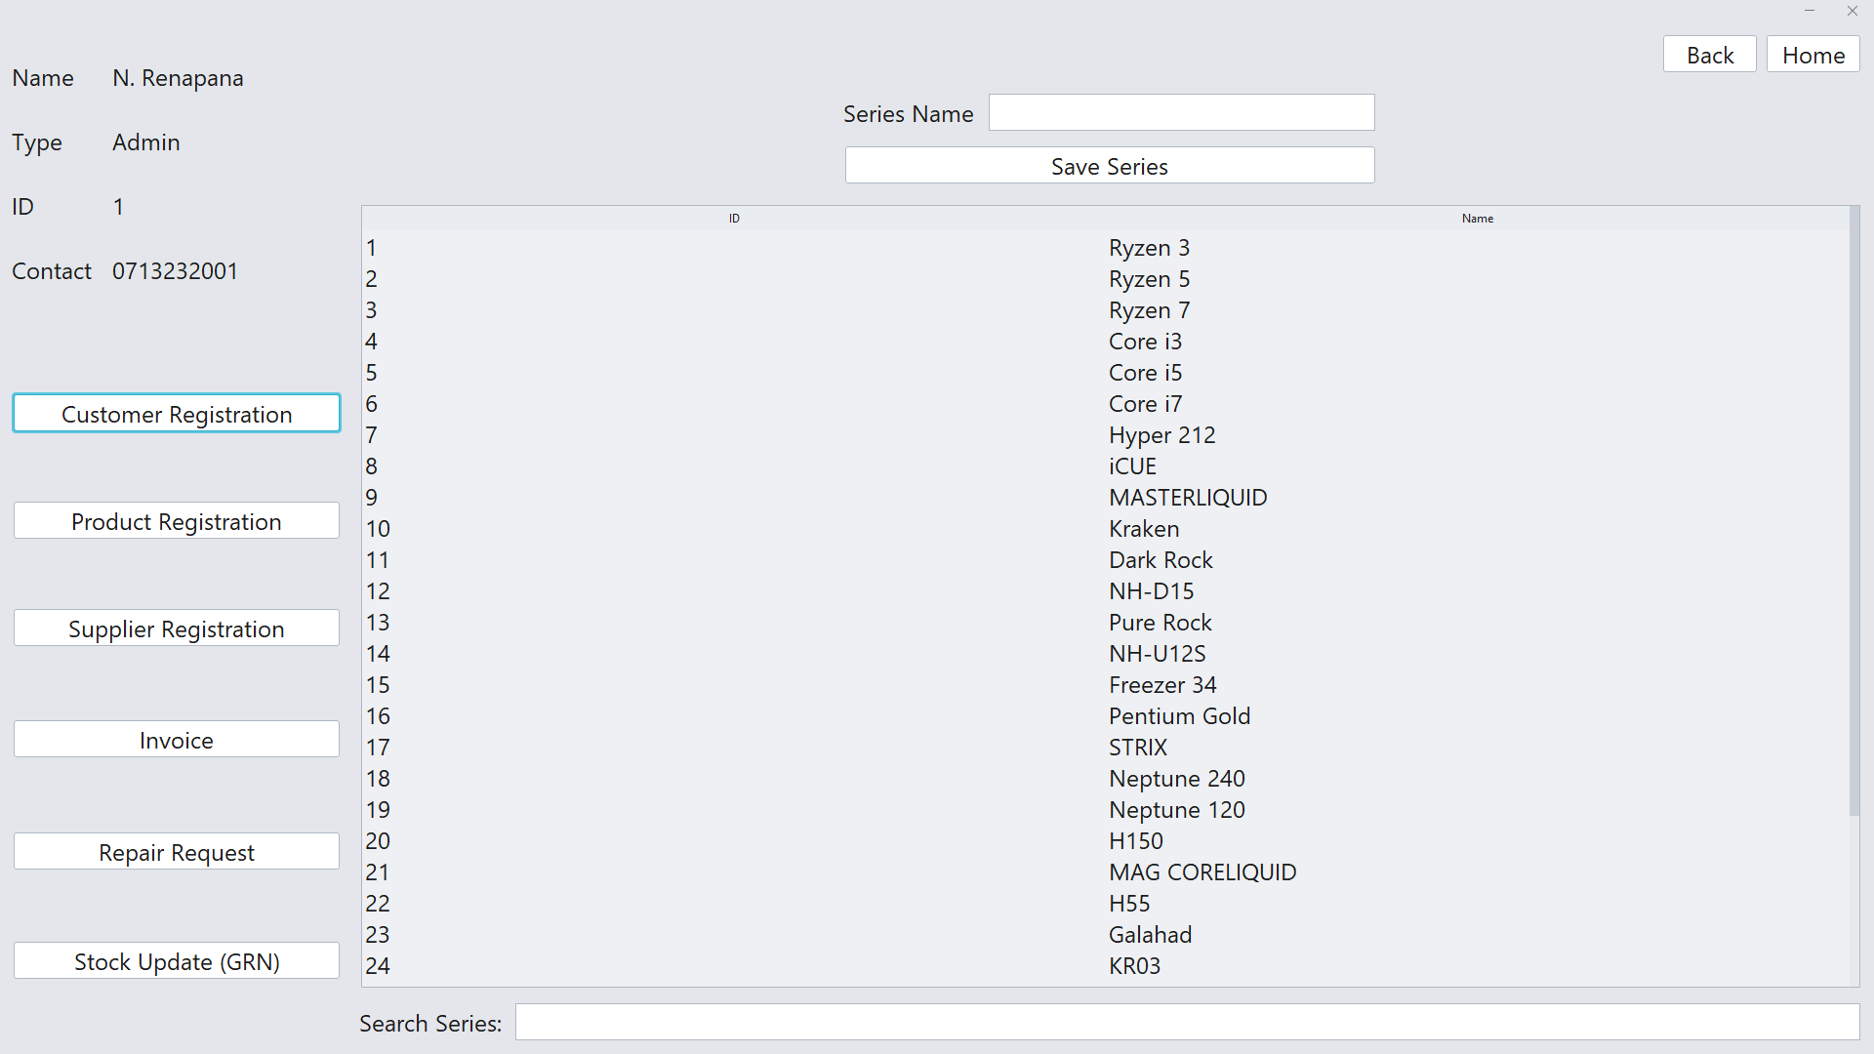
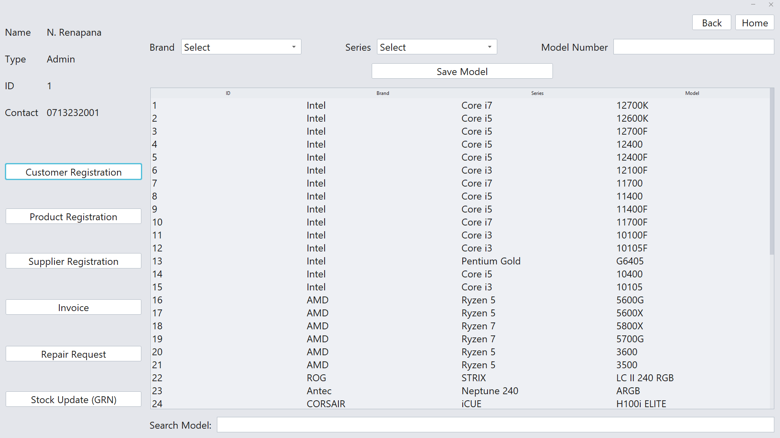
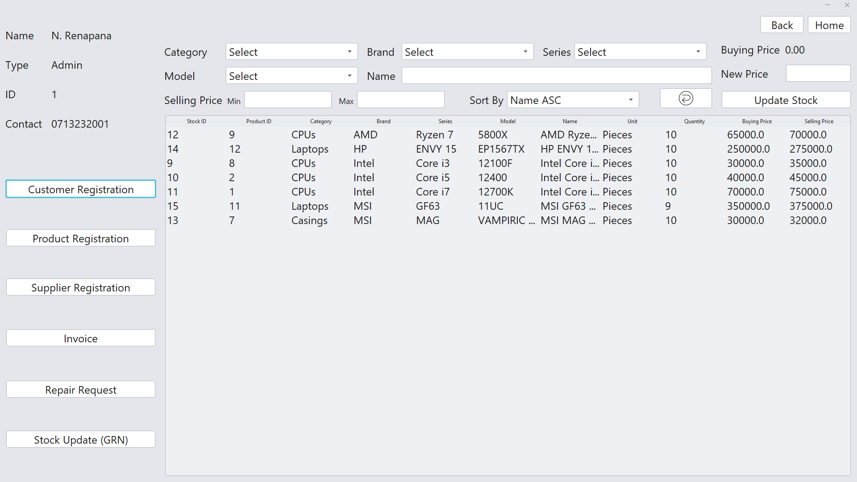

Hardware Interfaces
For full productivity of the system, the above-mentioned (in Operating Environment) requirements must be fulfilled by the computer.

Software Interfaces
Database Server
- MySQL DB, OS (Windows)

Development
- Apache NetBeans IDE v14, MySQL Workbench v8.0, TIBCO Jaspersoft Studio v6.19.1, OS (Windows)

Other Non-functional Requirements

Performance Requirements
- Data in the database should be updated within 2 seconds.
- Query results must return results within 5 seconds.
- Load time of UI Should not take more than 2 seconds.
- Login Validation should be done within 3 seconds.

Safety and Security Requirements
- All data must be stored, protected, or protectively marked.
- Database should be backed up every hour.
- Under failure, the system should be able to come back to normal operation in under an hour.

