AI Shopping Partner: A Full-Stack Conversational Product Research and Recommendation System

Master of Technology In
School of Computer Science and Engineering

By

Mr. V Rama Chandra Chathurvedi – 25MCS0067
Mr. Aravind Prasad R – 25MCS0060

For
Full Stack Application and Development Laboratory
Under the guidance of Dr. Lokeshkumar R

School of Computer Science and Engineering


VIT, VELLORE.
April 2026

Table of Contents
Section | Title | Page
- | ABSTRACT | 2
- | LIST OF FIGURES | 3
- | LIST OF ABBREVIATIONS | 4
- | LIST OF TABLES | 5
CHAPTER 1 | INTRODUCTION | 6
1.1 | SYSTEM OVERVIEW | 6
1.2 | OBJECTIVE | 7
1.3 | APPLICATIONS | 8
1.4 | LIMITATIONS | 8
CHAPTER 2 | SYSTEM ANALYSIS | 9
2.1 | EXISTING SYSTEM | 9
2.2 | PROPOSED SYSTEM | 10
2.2.1 | BENEFITS OF PROPOSED SYSTEM | 10
CHAPTER 3 | REQUIREMENT SPECIFICATION | 11
3.1 | HARDWARE REQUIREMENTS | 11
3.2 | SOFTWARE REQUIREMENTS | 12
CHAPTER 4 | SYSTEM DESIGN SPECIFICATION | 13
4.1 | SYSTEM ARCHITECTURE | 13
4.2 | DETAILED DESIGN | 14
4.3 | DATABASE DESIGN | 15
CHAPTER 5 | RESULT AND CONCLUSION | 15
5.1 | RESULT | 15
5.2 | CONCLUSION | 19
CHAPTER 6 | APPENDICES | 20
6.1 | APPENDIX 1 - SAMPLE SOURCE CODE | 20
6.2 | APPENDIX 2 - SCREEN SHOTS / OUTPUTS | 21
6.3 | REPOSITORY URL | 22
CHAPTER 7 | REFERENCES | 23
7.1 | LIST OF JOURNALS | 23
7.2 | LIST OF WEBSITES (URLs) | 25
7.3 | LIST OF BOOKS | 26

ABSTRACT
AI Shopping Partner is a full-stack conversational shopping assistant developed to reduce the time, fragmentation, and uncertainty involved in online product research. The system allows a user to ask natural-language shopping questions such as budget recommendations, comparisons, and follow-up queries, and then responds with a synthesized verdict grounded in YouTube review evidence. The project combines a React and Vite frontend, a Flask backend, Google Gemini for answer synthesis, YouTube transcript retrieval for evidence extraction, and Server-Sent Events for live response streaming. The design objective was to create a research assistant that feels like a modern AI chatbot while still remaining evidence-aware, modular, and deployment-ready.
The backend follows a modular architecture with separate layers for routing, Gemini orchestration, YouTube search and transcript extraction, and persistence. The system intelligently decides whether a new prompt requires fresh YouTube research or can be answered from prior context. When new research is needed, it searches YouTube for relevant review videos, extracts transcripts in parallel using ThreadPoolExecutor, and streams the synthesized recommendation to the frontend in real time using SSE. The application further supports persistent saved chats, smart chat titling, session rename/delete operations, browser-private chat isolation, and production deployment to Render with Postgres-backed persistence.
- Primary contribution: an evidence-grounded AI shopping assistant focused on the Indian market.
- Technical highlights: hybrid tool routing, transcript-backed reasoning, live streaming UX, and browser-private session persistence.
- Final outcome: a publicly deployed web application that demonstrates full-stack engineering, AI integration, retrieval design, UX refinement, and deployment readiness.

LIST OF FIGURES
Fig. No. | Name of the Figure | Page No.
1 | Landing page of AI Shopping Partner before interaction. | 16
2 | Prompt composition for an Indian-market recommendation query. | 16
3 | Live streaming state while the system searches YouTube and prepares a response. | 16
4 | Source transparency layer showing the YouTube review links used during answer generation. | 16
5 | Recommendation output with verdict and quick-compare format. | 16
6 | Detailed recommendation output with product-level specificity and INR pricing. | 16
7 | Final response with attached YouTube evidence chips for traceable decision support. | 16
8 | Landing page of AI Shopping Partner before interaction. | 21
9 | Prompt composition for an Indian-market recommendation query. | 21
10 | Live streaming state while the system searches YouTube and prepares a response. | 21
11 | Source transparency layer showing the YouTube review links used during answer generation. | 21
12 | Recommendation output with verdict and quick-compare format. | 21
13 | Detailed recommendation output with product-level specificity and INR pricing. | 21
14 | Final response with attached YouTube evidence chips for traceable decision support. | 21

LIST OF ABBREVIATIONS
Table 1: Key abbreviations used in the report
SNo. | Abbreviation | Expanded Form
1 | AI | Artificial Intelligence
2 | LLM | Large Language Model
3 | API | Application Programming Interface
4 | SSE | Server-Sent Events
5 | UI | User Interface
6 | UX | User Experience
7 | DB | Database
8 | ORM | Object Relational Mapping
9 | INR | Indian Rupee
10 | HTTP | Hypertext Transfer Protocol

LIST OF TABLES
Table No. | Name of the Table | Page No.
1 | Key abbreviations used in the report | 3
2 | System overview summary | 4
3 | Project objectives classified by engineering focus | 7
4 | Existing shopping research challenges | 8
5 | Benefits of the proposed system | 10
6 | Hardware requirements for development and usage | 10
7 | Software and platform requirements | 10
8 | High-level architecture flow | 12
9 | Detailed backend component design | 12
10 | Core API endpoints | 14
11 | Database schema design | 14
12 | Observed outcome summary | 15

CHAPTER 1 INTRODUCTION

1.1 SYSTEM OVERVIEW
AI Shopping Partner is a conversational web application designed to support product discovery, recommendation, comparison, and follow-up decision making through a single continuous chat interface. Unlike a conventional search workflow in which the user manually opens multiple review videos, compares features, and remembers earlier findings, the proposed system centralizes the activity into one evidence-grounded research assistant. The user enters a product query or budget constraint, the backend decides whether fresh review evidence is needed, retrieves YouTube reviews when appropriate, extracts transcript content in parallel, and asks Gemini to synthesize a buyer-friendly recommendation. The synthesized answer is streamed back to the browser in real time, and the chat is saved for future continuation.
- User-facing role: conversational personal shopping assistant for the Indian market.
- Evidence source: YouTube review videos and their transcripts, not manual copy-paste by the user.
- AI role: synthesize verdicts, shortlist options, compare alternatives, and answer follow-up questions.
- Persistence layer: session-based storage that allows users to return to prior shopping discussions.
- Deployment goal: public accessibility with privacy preserved per browser session.

Table 2: System overview summary
Aspect | Description
Primary problem | Online shopping research is fragmented, repetitive, and difficult to consolidate.
Primary users | Students, professionals, and general buyers evaluating products under a budget.
Input format | Natural-language prompts, comparisons, and follow-up questions.
Output format | Verdicts, quick comparisons, watch-outs, and source-backed responses.
Evidence mode | Transcript-backed YouTube review synthesis with UI source chips.
Interaction model | Chat-based interface with session history and revisit support.

1.2 OBJECTIVE
- To build a full-stack web application that behaves like a modern AI chat assistant while remaining grounded in product-review evidence.
- To reduce the manual effort required to compare products across multiple YouTube videos and review sources.
- To support both first-time research and follow-up questions inside the same conversation thread.
- To provide real-time streaming feedback so the user sees the assistant researching and drafting the answer live.
- To make the system modular, deployable, and maintainable through clear separation of routing, retrieval, AI logic, and storage.

Table 3: Project objectives classified by engineering focus
Objective type | Target outcome
Functional | Deliver recommendations, comparisons, follow-up handling, and evidence visibility.
Architectural | Maintain modular separation of frontend, backend, retrieval, and storage.
Experience | Provide a dark, professional, low-friction interface with live feedback.
Operational | Deploy publicly using GitHub, Render, and Postgres.
Reliability | Handle transcript failures, model errors, and cross-user privacy issues gracefully.

1.3 APPLICATIONS
- Budget-conscious product research for phones, laptops, smartwatches, appliances, and accessories.
- Shortlisting products before purchase by combining review evidence into one structured verdict.
- Follow-up comparison tasks such as battery life, performance, thermal behavior, and software trade-offs.
- Academic demonstration of full-stack AI engineering, conversational UX, and evidence-driven recommendation design.
- Prototype foundation for future extensions such as authentication, richer product cards, or multi-source evidence aggregation.

1.4 LIMITATIONS
- The system currently uses YouTube as the primary evidence layer and does not yet aggregate official e-commerce platform data.
- Cross-device identity is not supported because the privacy model is intentionally browser-scoped without login.
- Public deployment on free-tier infrastructure may experience cold-start delay and Gemini quota limits.
- Some videos may not expose transcripts, which can force the assistant to fall back to metadata and stable knowledge.
- Recommendations depend on the quality and recency of the retrieved review ecosystem for the queried category.

CHAPTER 2 SYSTEM ANALYSIS

2.1 EXISTING SYSTEM
The existing shopping research workflow for most users is highly fragmented. A buyer typically opens multiple YouTube review videos, reads article reviews, compares prices manually, and tries to mentally remember the differences between several products. Conventional chatbot systems may provide quick suggestions, but they often return generic brand-level advice without clearly citing where the recommendation came from. In practice, this results in three major inefficiencies: information overload, weak traceability, and poor continuity across sessions.
Table 4: Existing shopping research challenges
Existing approach | Observed problem | Impact on the user
Manual video review | User must watch multiple long-form videos independently | High time consumption
Standard search engine flow | Information is spread across tabs and platforms | Poor synthesis and difficult comparison
Generic AI chatbot | Answers may be broad and uncited | Low trust and weak shopping usefulness
No persistent context | Research is lost between sessions | Repeated effort for follow-up questions

2.2 PROPOSED SYSTEM
The proposed system addresses these weaknesses by combining a conversational interface with a research pipeline that actively retrieves YouTube review evidence, extracts transcript content in parallel, and uses Gemini to synthesize a structured answer. Instead of forcing the user to inspect every source manually, the application converts the evidence into a shortlist, verdict, watch-outs, and comparison output. Saved sessions and smart titles make the research reusable, while browser-private ownership ensures that public users cannot view each other's chats. The proposed system therefore acts both as an AI assistant and as a research organizer.
- Evidence-aware recommendation rather than brand-only or hallucinated advice.
- Hybrid routing that avoids unnecessary retrieval for follow-up questions.
- Parallel transcript extraction to reduce latency during fresh research.
- Live streaming feedback to keep the user informed during long-running operations.
- Persistent chat state with rename, delete, and revisit support.

2.2.1 BENEFITS OF PROPOSED SYSTEM
Table 5: Benefits of the proposed system
Benefit area | Improvement delivered by the proposed system
Decision quality | Recommendations are grounded in actual review evidence and structured into buyer-friendly verdicts.
Time efficiency | Parallel retrieval and summarized comparisons reduce manual research effort.
Continuity | Saved sessions allow users to return to old buying decisions without starting from zero.
Transparency | YouTube source chips expose what videos informed the response.
Usability | The interface behaves like a modern AI assistant rather than a traditional form-based system.
Deployment readiness | The system is already version-controlled, hosted, and backed by production persistence.

CHAPTER 3 REQUIREMENT SPECIFICATION

3.1 HARDWARE REQUIREMENTS
The hardware requirements for this project are modest for normal development and end-user operation because the computationally intensive language processing is handled by the Gemini API. However, a stable development environment, browser support, and uninterrupted network access are essential for successful execution of the application.
Table 6: Hardware requirements for development and usage
Category | Minimum requirement | Recommended requirement
Processor | Dual-core 64-bit CPU | Quad-core modern CPU
RAM | 8 GB | 16 GB or above
Storage | 2 GB free disk space | 5 GB free disk space
Display | 1366 x 768 resolution | 1920 x 1080 resolution
Network | Stable broadband internet | High-speed broadband with low latency
Input devices | Standard keyboard and mouse | Standard keyboard and mouse / laptop touchpad

3.2 SOFTWARE REQUIREMENTS
The software stack for AI Shopping Partner was selected to support rapid full-stack development, modular backend design, browser-based user interaction, and public deployment. The requirements below include both the local development environment and the production stack used on Render.
Table 7: Software and platform requirements
Software / service | Version / type | Role in the system
Operating System | Windows 10/11, macOS, or Linux | Local development and testing
Python | 3.13.x | Backend runtime
Node.js | >= 20 and < 23 | Frontend build and Vite runtime
Flask | 3.1.0 | REST API and streaming endpoint
google-generativeai | 0.8.4 | Gemini model integration
youtube-search-python | 1.6.6 | YouTube search without official data API
youtube-transcript-api | 1.2.4 | Transcript retrieval
SQLAlchemy | 2.0.46 | Persistence abstraction
React + Vite | React 18 + Vite 5 | Frontend SPA and developer tooling
Tailwind CSS | 3.4.15 | Styling system
Render | Managed cloud platform | Frontend, backend, and Postgres deployment
GitHub | Remote source repository | Version control and deployment source

CHAPTER 4 SYSTEM DESIGN SPECIFICATION

4.1 SYSTEM ARCHITECTURE
The architecture of AI Shopping Partner follows a layered full-stack pattern. The React frontend handles the user interface, composer, chat rendering, session list, and SSE event consumption. The Flask backend exposes REST endpoints for sessions and a streaming endpoint for chat. Within the backend, app.py coordinates HTTP requests and streaming, agent.py manages Gemini orchestration and title generation, scraper.py handles YouTube search and transcript extraction, and storage.py manages session and message persistence. The production deployment uses Render for hosting and Postgres for durable storage. This modular decomposition isolates concerns and made it possible to evolve the project incrementally without rewriting the entire system.
Table 8: High-level architecture flow
Layer | Inputs | Processing | Outputs
React frontend | Prompt text, active session, browser events | Fetch API calls, SSE parsing, state updates, rendering | User-visible chat experience
Flask API | HTTP requests from frontend | Validation, session lookup, streaming orchestration | Session data and SSE event stream
Gemini orchestration | User prompt, history, research context | Tool routing, synthesis, title generation | Final recommendation text
YouTube retrieval | Search query and category intent | Video search, transcript extraction, dedupe, truncation | Evidence bundle with sources
Persistence | Sessions, messages, sources, owner IDs | Create, update, load, rename, delete, privacy filtering | Durable chat state

4.2 DETAILED DESIGN
Table 9: Detailed backend component design
Component | Detailed responsibility
app.py | Initializes Flask and CORS, maintains secure viewer cookie, exposes health check, session CRUD routes, and the streaming chat endpoint.
agent.py | Defines the shopping system prompt, candidate Gemini models, hybrid routing logic, chat title generation, and streamed answer generation.
scraper.py | Normalizes shopping queries, biases them toward Indian-market review intent, runs YouTube search, and extracts transcripts in parallel.
storage.py | Creates and migrates session/message schema, scopes data by owner_id, and supports both SQLite and Postgres.
App.jsx | Maintains client-side state for sessions, messages, active streaming response, sidebar visibility, and send/stop interactions.
lib/sse.js | Parses the raw SSE stream into structured events consumed by the React state layer.

Table 10: Core API endpoints
Endpoint | Method | Purpose
/api/health | GET | Health validation for deployment and monitoring
/api/sessions | GET | Fetch all sessions for the current browser owner
/api/sessions/<id> | GET | Load a specific chat with all messages
/api/sessions/<id> | PATCH | Rename a session
/api/sessions/<id> | DELETE | Delete a session
/api/chat | POST | Create/resume a session and stream the assistant response

4.3 DATABASE DESIGN
The persistence layer is intentionally simple but production-appropriate. It revolves around two main entities: sessions and messages. Each session belongs to a browser-scoped owner and stores metadata such as title, timestamps, and title readiness. Each message belongs to a session and stores role, content, serialized sources, and timestamp. This design is sufficient to support chat replay, session listing, source-aware rendering, and privacy filtering.
Table 11: Database schema design
Table | Important fields | Purpose
sessions | id, owner_id, title, title_ready, created_at, updated_at | Stores chat metadata and browser ownership.
messages | id, session_id, role, content, sources_json, created_at | Stores user and assistant messages with optional source payloads.

- owner_id is the key field that prevents public users from seeing one another's saved chats.
- sources_json preserves the YouTube source metadata required by the frontend chip display.
- The schema runs on SQLite locally and Postgres in production without changing the higher-level API.

CHAPTER 5 RESULT AND CONCLUSION

5.1 RESULT
The final system successfully satisfies the original project goal of building a deployable, conversational, evidence-grounded shopping assistant. The application accepts product queries, autonomously researches YouTube review content, synthesizes concise product verdicts, supports follow-up clarification, preserves sessions, and streams the output live in a professional interface. The screenshots below demonstrate the main user journey from landing, prompt input, active retrieval, source visibility, and final recommendation output.
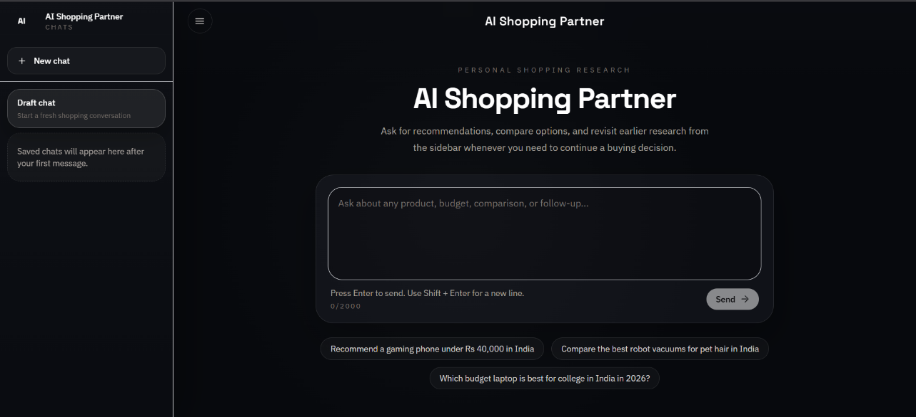
Figure 1: Landing page of AI Shopping Partner before interaction.

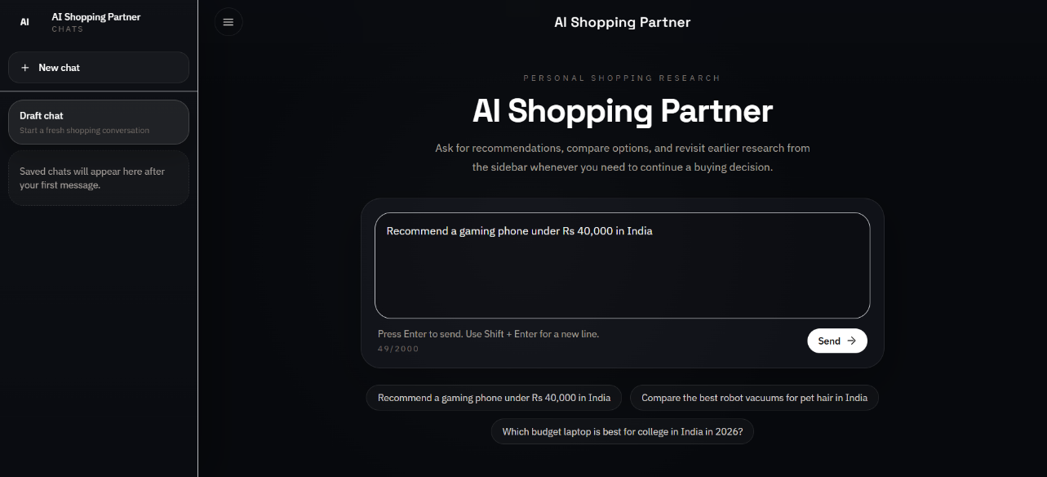
Figure 2: Prompt composition for an Indian-market recommendation query.

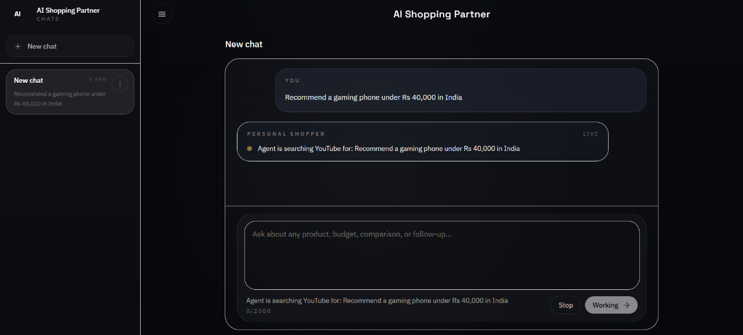
Figure 3: Live streaming state while the system searches YouTube and prepares a response.

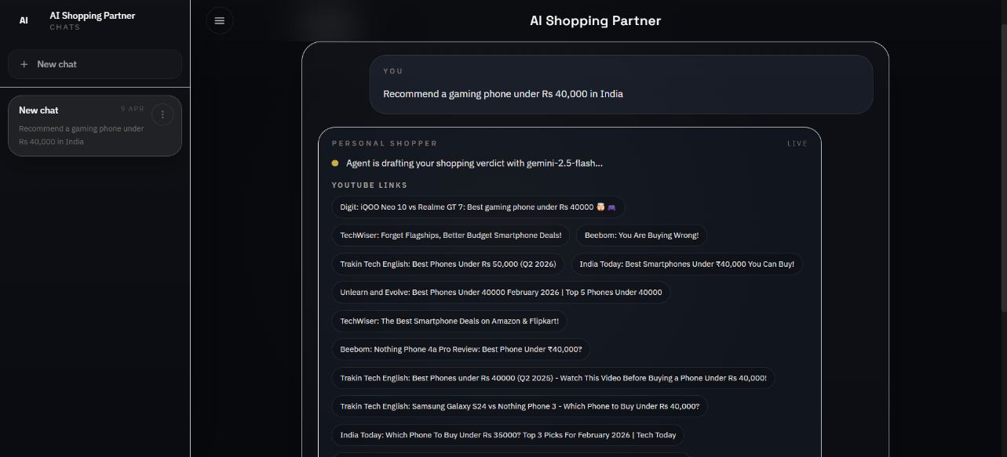
Figure 4: Source transparency layer showing the YouTube review links used during answer generation.

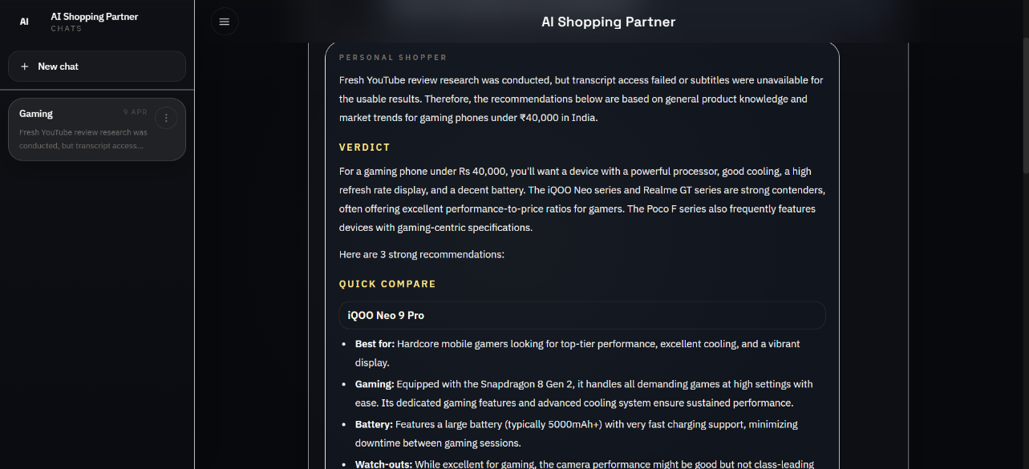
Figure 5: Recommendation output with verdict and quick-compare format.

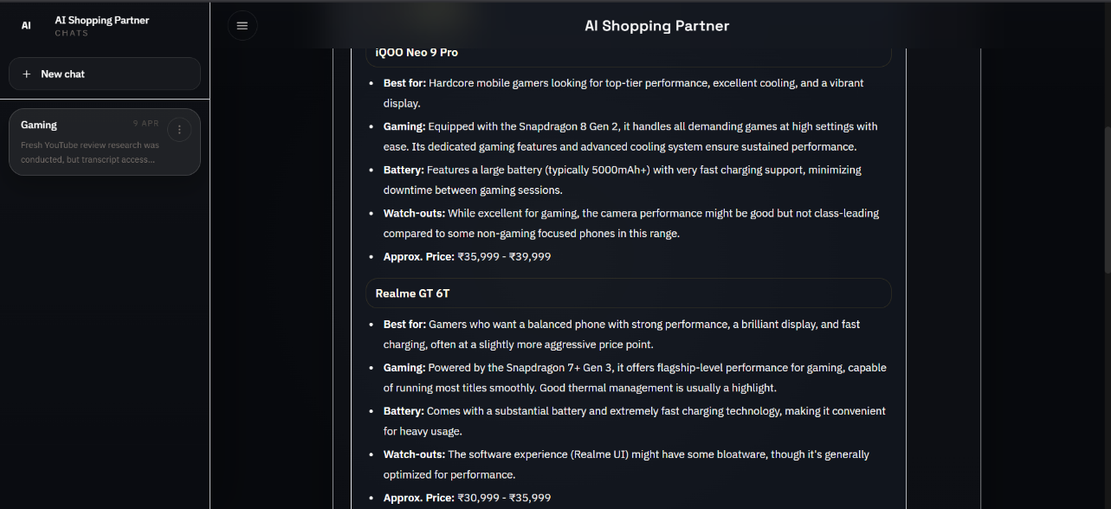
Figure 6: Detailed recommendation output with product-level specificity and INR pricing.

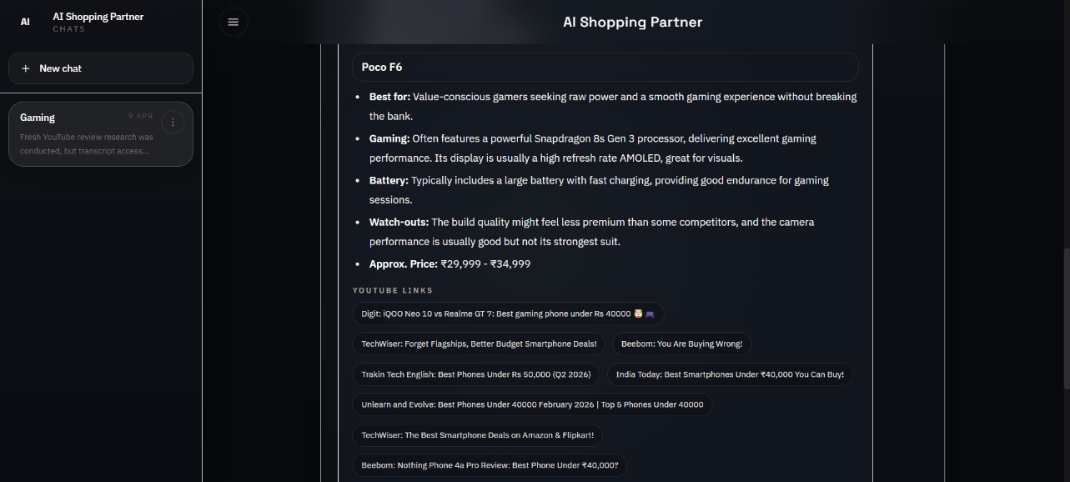
Figure 7: Final response with attached YouTube evidence chips for traceable decision support.

Table 12: Observed outcome summary
Evaluation area | Observed result
User interface | Professional dark theme, collapsible sidebar, keyboard-friendly prompt composer, and source-aware chat bubbles.
AI behavior | Supports recommendations, comparisons, follow-ups, and smart auto-titling.
Evidence handling | Uses YouTube review search and transcript-backed synthesis with graceful fallback.
Streaming UX | Shows real-time status updates and chunked answer rendering through SSE.
Persistence | Supports saved sessions, rename/delete, and revisit flow.
Privacy | Public users do not see each other's chats due to owner-scoped storage.

5.2 CONCLUSION
AI Shopping Partner began as an assignment-driven full-stack project and matured into a production-style application that demonstrates real engineering depth. The project successfully integrates frontend design, backend orchestration, streaming communication, AI reasoning, retrieval engineering, persistence, privacy, and cloud deployment into one cohesive system. Beyond meeting the initial functional requirements, the project also resolved several non-trivial real-world issues such as dependency mismatches, YouTube search breakage, model compatibility, public chat leakage, quota constraints, and UI clutter. The final application therefore stands not only as a working shopping assistant, but also as a strong case study in iterative full-stack product engineering.
- The system demonstrates that an AI assistant can remain conversational without giving up evidence awareness.
- The modular backend and persistent session model make the project maintainable and extensible.
- The deployment to Render with Postgres elevates the project from a local demo to a publicly usable web application.
- Future work could add user authentication, richer product cards, broader source aggregation, and more robust quota management.

CHAPTER 6 APPENDICES

6.1 APPENDIX 1 - SAMPLE SOURCE CODE
The following excerpts illustrate representative implementation logic from the final system. They are included to demonstrate the actual coding style, the streaming mechanism, the parallel transcript pipeline, and the frontend SSE parser.

Sample 1: SSE event formatting in server/app.py
def _sse(event: str, data: dict) -> str:
payload = json.dumps(data, ensure_ascii=False)
return f"event: {event}\ndata: {payload}\n\n"

Sample 2: Parallel transcript extraction in server/scraper.py
def fetch_transcripts_parallel(videos, max_workers=5, target_count=4):
with ThreadPoolExecutor(max_workers=workers) as executor:
future_map = {
executor.submit(_fetch_video_transcript, video): index
for index, video in enumerate(videos)
}
for future in as_completed(future_map):
item = future.result()
if item is None:
continue

Sample 3: Client-side SSE parsing in client/src/lib/sse.js
export function consumeSseEvents(buffer) {
const normalized = buffer.replace(/\r\n/g, '\n');
const blocks = normalized.split('\n\n');
const remainder = blocks.pop() ?? '';
const events = blocks.map((block) => parseEventBlock(block)).filter(Boolean);
return { events, remainder };
}

Sample 4: Session-aware fetch in client/src/App.jsx
async function fetchJson(path, options = {}) {
const response = await fetch(${API_BASE}, {
credentials: 'include',
...options
});
return response.json();
}

6.2 APPENDIX 2 - SCREEN SHOTS / OUTPUTS
This appendix consolidates key UI screenshots from the final deployed system. These figures were selected to show the full lifecycle of interaction: landing, prompt entry, live retrieval, evidence surfacing, and final product recommendation output.
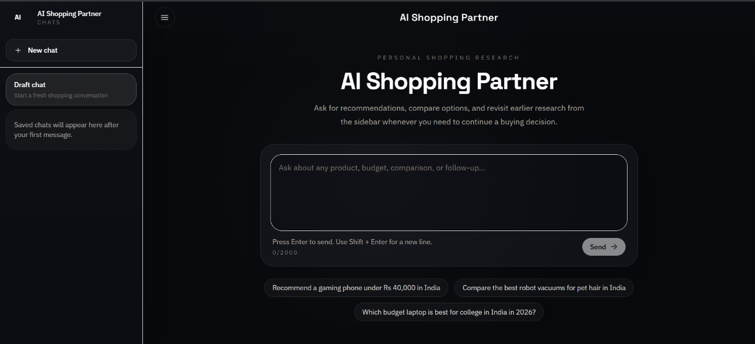
Figure 8: Landing page of AI Shopping Partner before interaction.

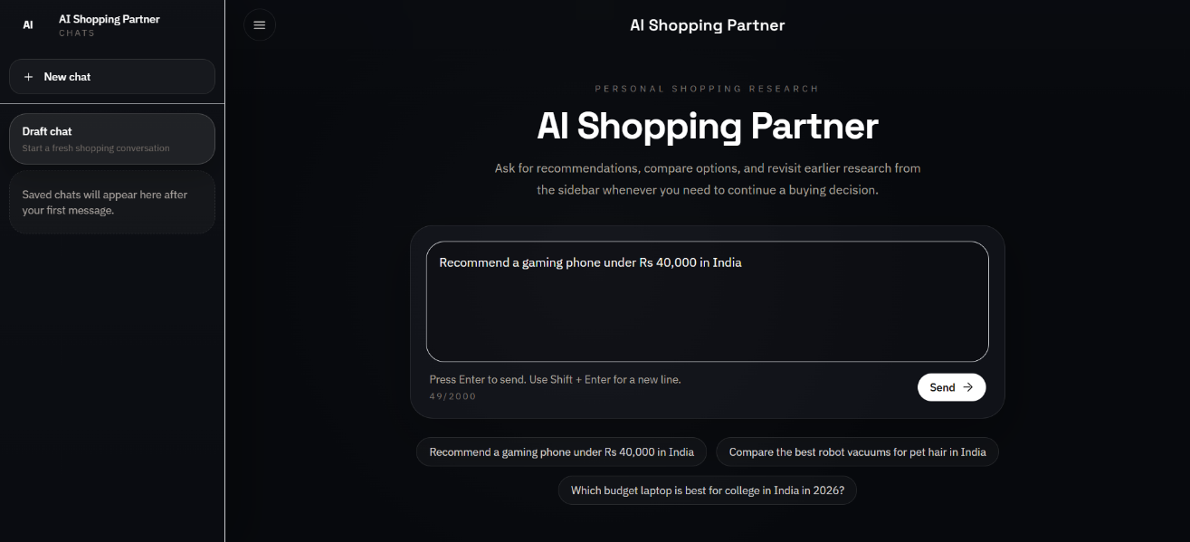
Figure 9: Prompt composition for an Indian-market recommendation query.

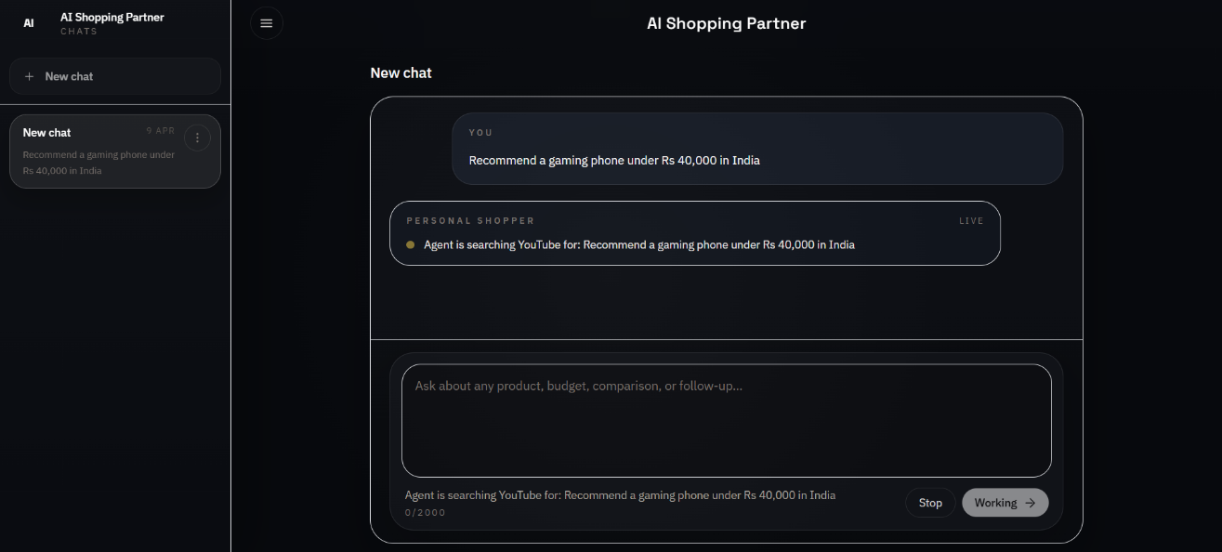
Figure 10: Live streaming state while the system searches YouTube and prepares a response.

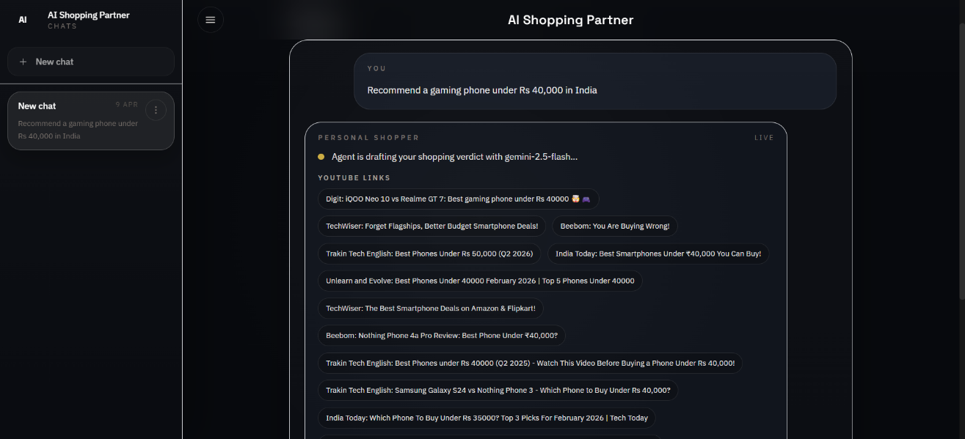
Figure 11: Source transparency layer showing the YouTube review links used during answer generation.

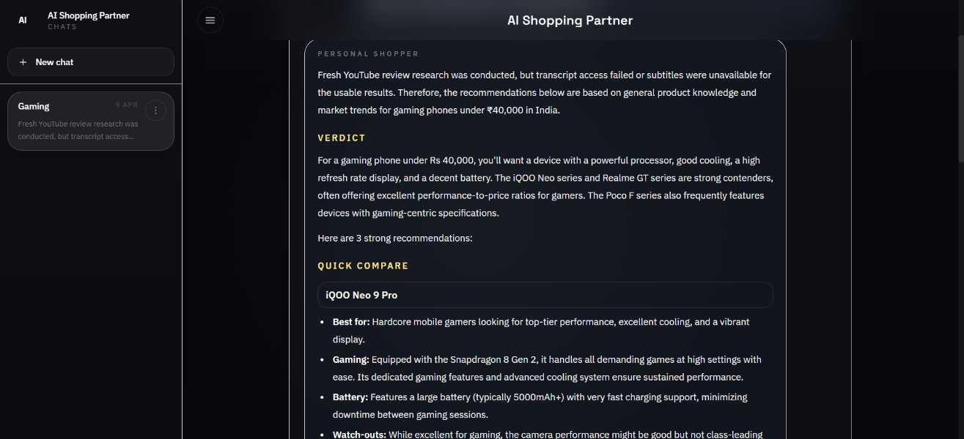
Figure 12: Recommendation output with verdict and quick-compare format.

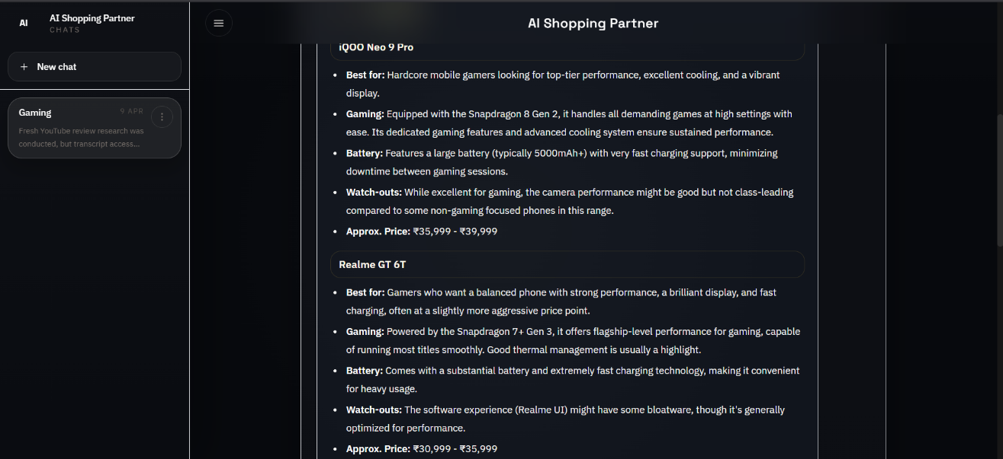
Figure 13: Detailed recommendation output with product-level specificity and INR pricing.

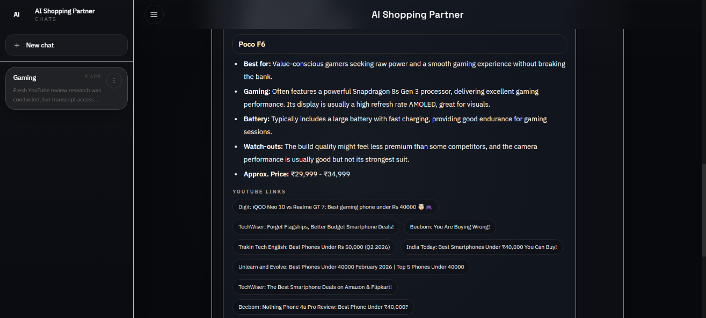
Figure 14: Final response with attached YouTube evidence chips for traceable decision support.

6.3 REPOSITORY URL
- GitHub Repository: https://github.com/chathurvedivanga/agentic-ai-personal-shopper
- Live Frontend URL: https://ai-shopping-partner-web.onrender.com/
- Backend Health Endpoint: https://agentic-ai-personal-shopper-api.onrender.com/api/health

CHAPTER 7 REFERENCES

7.1 LIST OF JOURNALS
[1] Gediminas Adomavicius and Alexander Tuzhilin, 'Toward the Next Generation of Recommender Systems: A Survey of the State-of-the-Art and Possible Extensions,' IEEE Transactions on Knowledge and Data Engineering, 2005.
[2] Dietmar Jannach, Pearl Pu, Francesco Ricci, and Markus Zanker, 'Recommender Systems: Beyond Matrix Completion,' Communications of the ACM, 2021.
[3] Chin-Yew Lin and others, 'Conversational Recommender Systems: A Survey of the State of the Art and Future Directions,' ACM Computing Surveys, 2023.
[4] Patrick Lewis et al., 'Retrieval-Augmented Generation for Knowledge-Intensive NLP Tasks,' Advances in Neural Information Processing Systems, 2020.

7.2 LIST OF WEBSITES (URLs)
[5] Flask Documentation - https://flask.palletsprojects.com/
[6] React Documentation - https://react.dev/
[7] Vite Documentation - https://vite.dev/
[8] Tailwind CSS Documentation - https://tailwindcss.com/docs/
[9] Google Gemini API Documentation - https://ai.google.dev/gemini-api/docs
[10] youtube-transcript-api - https://pypi.org/project/youtube-transcript-api/
[11] youtube-search-python - https://pypi.org/project/youtube-search-python/
[12] Render Documentation - https://render.com/docs
[13] GitHub Docs - https://docs.github.com/

7.3 LIST OF BOOKS
[14] Miguel Grinberg, Flask Web Development, O'Reilly Media, 2018.
[15] Stoyan Stefanov, React Up and Running, O'Reilly Media, 2021.
[16] Martin Kleppmann, Designing Data-Intensive Applications, O'Reilly Media, 2017.

