Screenshots of the working code from the machine learning model developed:

All necessary libraries imported:

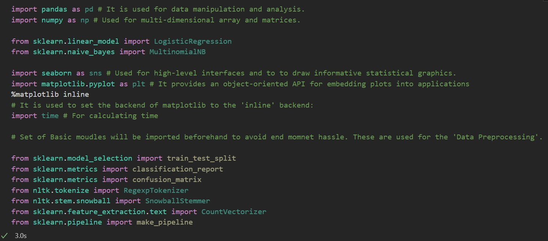

Using Logistic Regression model for training data:

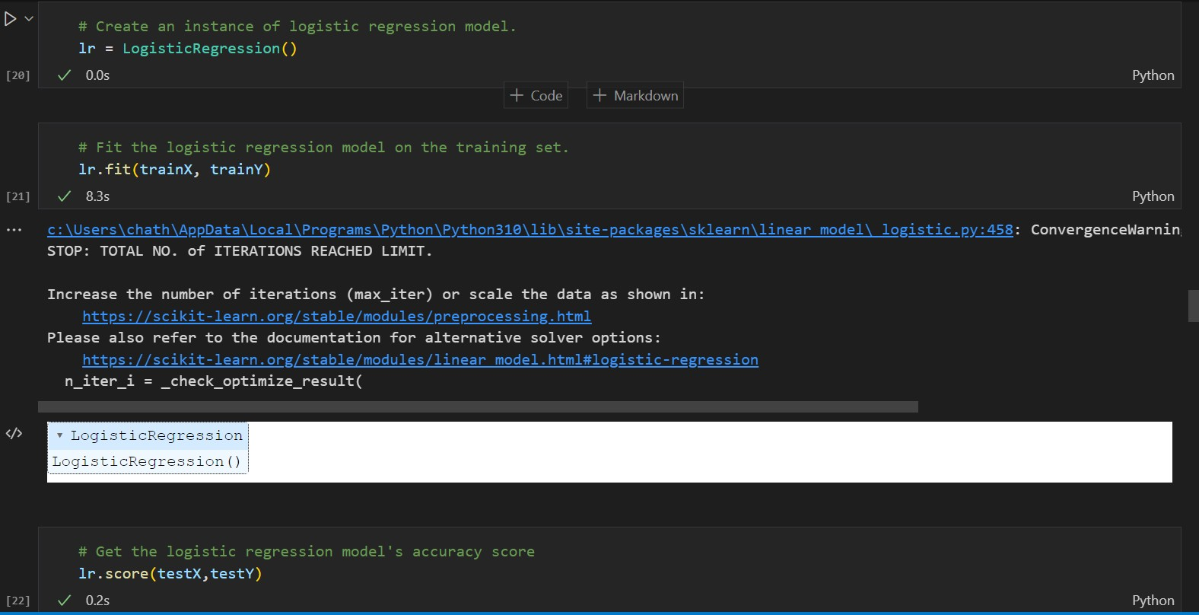

Training and Testing accuracies of the model:

Generating a pickle file that is used in the front-end application:

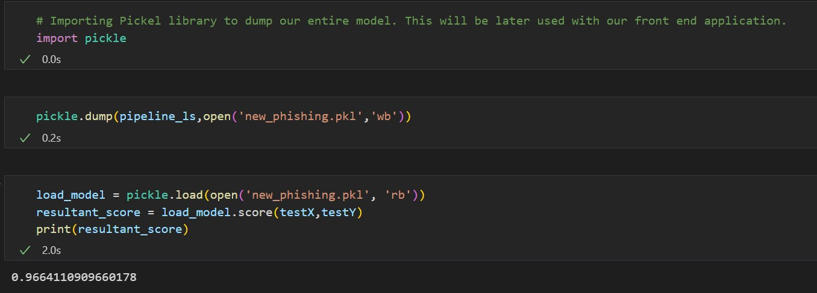

# Screenshots from the frontend web framework to check results:

FastAPI framework used:

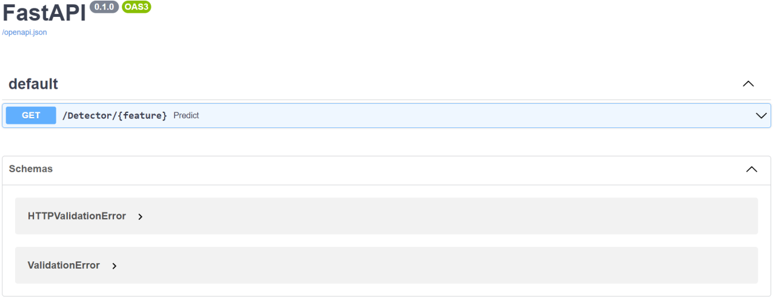

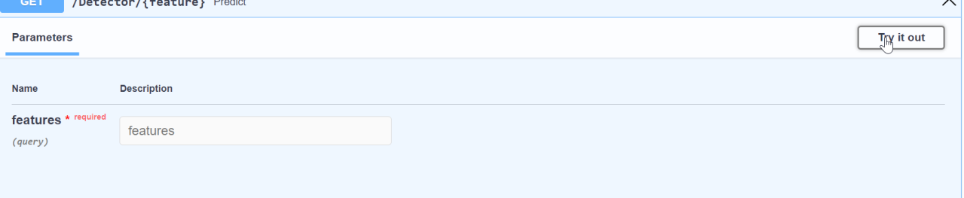

On checking for [www.google.com](http://www.google.com/) (detected as non-phishing) :

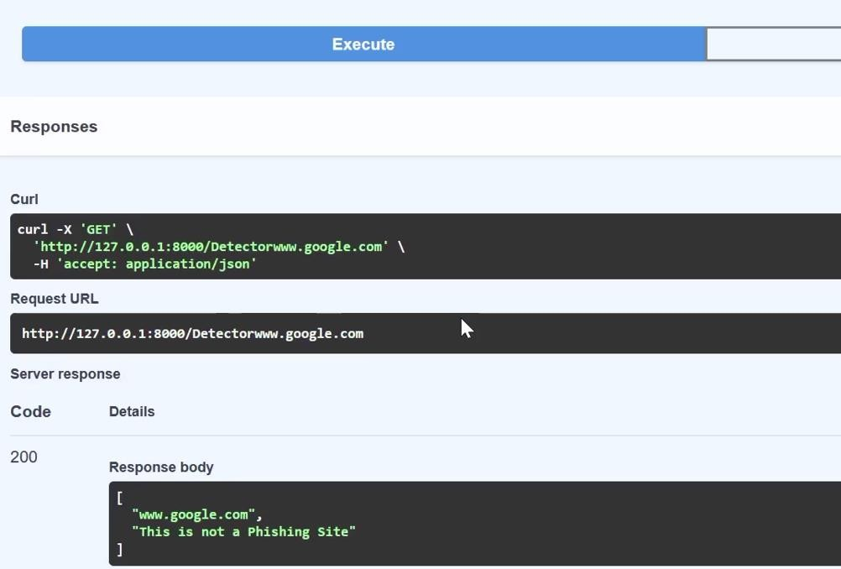

On checking for URL : <http://bit.ly/2KRPqfY> (detected as phishing) :

