**Analysis of Flag Data using Hadoop-Hive and PIG**

1. **creating table youtube for flag.txt**:



create table landmass (id int, land string) row format delimited fields terminated by ',';

create table zone (id int, name string) row format delimited fields terminated by ',';

create table language (id int, lan string) row format delimited fields terminated by ',';

create table religion (id int, rel string) row format delimited fields terminated by ',';

2. **loading data into youtube table**



insert into table landmass values (1,"N.America");

insert into table landmass values (2,"S.America");

insert into table landmass values (3,"Europe");

insert into table landmass values (4,"Africa");

insert into table landmass values (5,"Asia");

insert into table landmass values (6,"Oceania");

insert into table zone values (1,'NE'),(2,'SE'), (3,'SW'),(4,'NW');

insert into table language values (1,"English"),(2,"Spanish"),(3,"French"),(4,"German"),(5,"Slavic"),(6,"Other-Indo-European"),(7,"Chinese"),(8,"Arabic"),(9,"Japanese"),(10,"Others");

insert into table religion values (0,"Catholic"),(1,"Other Christian"),(2,"Muslim"),(3,"Budhist"),(4,"Hindu"),(5,"Ethnic"),(6,"Marxist"),(7,"Others");

**Problem solution**:

1. **Count number of countries based on landmass.**

**HIVE Solution:**

select b.land,count(a.country_name) from flag a join landmass b on a.landmass = b.id group by b.land;

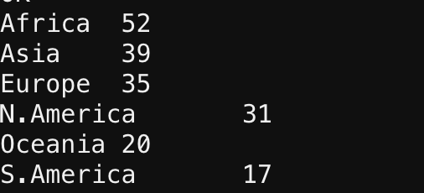

**PIG Solution:**

country_data = LOAD 'data/flag.txt' USING PigStorage(',') as (name:chararray, landmass:int, zone:int, area:chararray, population:chararray, lang:int, rel:int, bar:int, stripes:int, col:int, red:int, green:int, blue:int, gold:int, white:int, black:int, orange:int, hue:chararray, circle:int, cross:int, saltire:int, quars:int, suns:int, cres:int, triangle:int, icon:int, animate:int, text:int, left:chararray, right:chararray);

grouped_data = GROUP country_data by landmass;

count_data = FOREACH grouped_data GENERATE group,COUNT(country_data);

DUMP count_data;

1. **Find out top 5 country with Sum of bars and strips in a flag.**

**HIVE Solution:**

select country_name, SUM(bars+stripes) from flag group by country_name order by country_name limit 5;

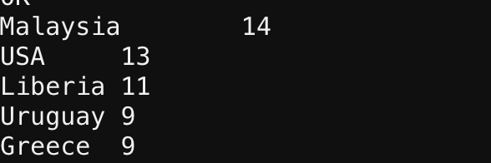

PIG Solution:

foreach_data = FOREACH country_data GENERATE name,$7+$8;

grouped_data = GROUP foreach_data All;

bar_data = FOREACH grouped_data {

ord = ORDER foreach_data BY $1 DESC;

top = LIMIT ord 5;

GENERATE FLATTEN(top);

};

DUMP bar_data;

**C. Count of countries with icon.**

**HIVE Solution:**

select count(*) from flag where icon = 1;



**PIG Solution:**

filtered_icon_data = FILTER country_data BY icon == 1;

grouped_icon_data = GROUP filtered_icon_data BY icon;

count_icon_data = FOREACH grouped_icon_data GENERATE group, COUNT(filtered_icon_data);

DUMP count_icon_data;

1. **Count of countries which have same top left and top right color in flag.**

**HIVE Solution:**

select count(*) from flag where topleft = botright;

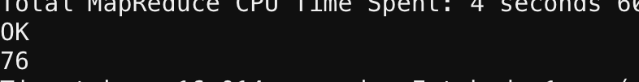

**PIG Solution:**

filtered_flag_data = FILTER country_data BY $28 == $29;

grouped_flag_data = GROUP filtered_flag_data All;

count_flag_data = FOREACH grouped_flag_data GENERATE group, COUNT(filtered_flag_data);

DUMP count_flag_data;

1. **Count number of countries based on zone.**

**HIVE Solution:**

select b.name,count(a.country_name) from flag a join zone b on a.zone = b.id group by b.name;

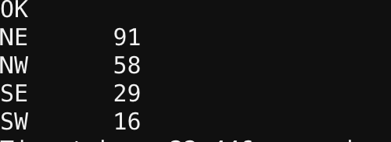

**PIG Solution:**

grouped_zone_data = GROUP country_data by landmass;

count_zone_data = FOREACH grouped_zone_data GENERATE group,COUNT(country_data);

DUMP count_zone_data;

1. **Find out largest county in terms of area in NE zone.**

**HIVE Solution:**

select country_name, area from flag where zone = 1 order by area desc limit 1;

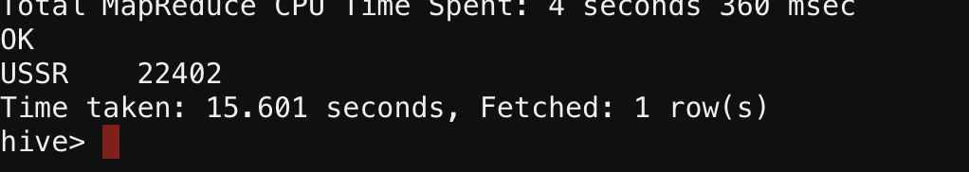

**PIG Solution:**

filtered_NE_data = FILTER country_data BY zone == 1;

grouped_NE_data = GROUP filtered_NE_data All;

max_area_data = FOREACH grouped_NE_data {

ord = ORDER filtered_NE_data BY $3 DESC;

top = LIMIT ord 1;

GENERATE FLATTEN(top);

};

max_area_country = FOREACH max_area_data GENERATE name,area;

DUMP max_area_country;

1. **Find out least populated country in S.America landmass.**

**HIVE Solution:**

select country_name, population from flag where landmass = 2 order by population asc;

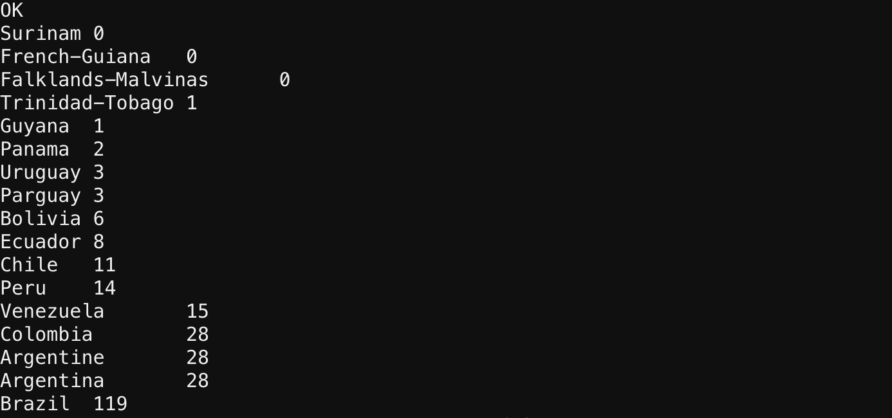

**PIG Solution:**

filtered_SA_data = FILTER country_data BY landmass == 2;

grouped_SA_data = GROUP filtered_SA_data All;

min_population_data = FOREACH grouped_SA_data {

ord = ORDER filtered_SA_data BY $4 ASC;

top = LIMIT ord 1;

GENERATE FLATTEN(top);

};

min_population_country = FOREACH min_population_data GENERATE name,population;

DUMP min_population_country;

1. **Find out largest speaking language among all countries.**

**HIVE Solution:**

select b.lan,count(*) as cnt from flag a join language b on a.language = b.id group by b.lan order by cnt desc limit 1;

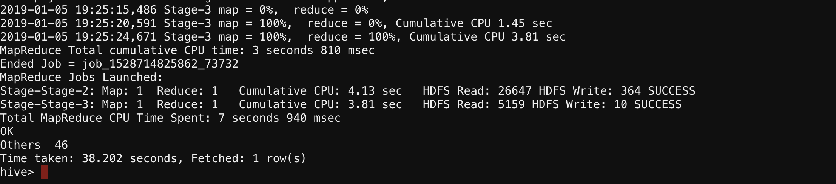

**PIG Solution:**

foreach_data = FOREACH country_data GENERATE name,lang;

grouped_data = GROUP foreach_data BY lang;

count_data = FOREACH grouped_data GENERATE group,(int)COUNT(foreach_data);

grouped_count_data = GROUP count_data All;

max_lang_data = FOREACH grouped_count_data {

ord = ORDER count_data BY $1 DESC;

top = LIMIT ord 1;

GENERATE FLATTEN(top);

};

DUMP max_lang_data;

1. **Find most common color among flags from all countries.**

**HIVE Solution:**

Select sum(red) as red, sum(green) as green,sum(blue) as blue, sum(goldyellow),sum(white), sum(black), sum(orange) from flag;



**PIG Solution:**

grouped_data = GROUP country_data All;

final_color_data = FOREACH grouped_data GENERATE group,SUM(country_data.$10),SUM(country_data.$11),SUM(country_data.$12),SUM(country_data.$13),SUM(country_data.$14),SUM(country_data.$15),SUM(country_data.$16);

dump final_color_data;

1. **Sum of all circles present in all country flags.**

**HIVE Solution:**

select sum(circles) from flag;

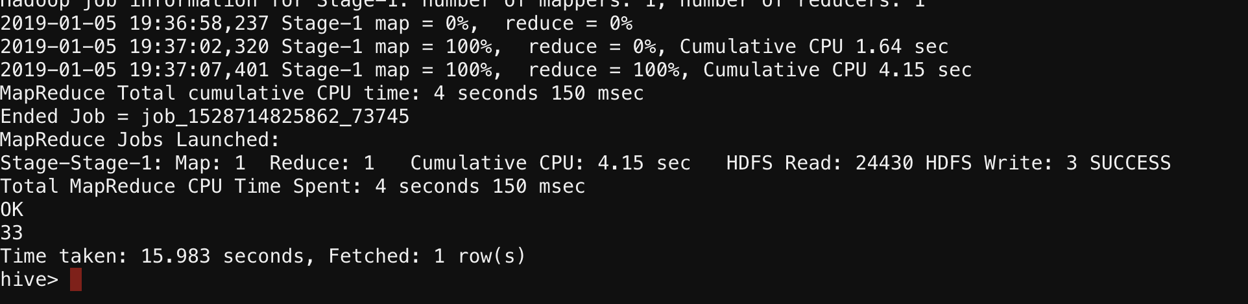

**PIG Solution:**

grouped_circle_data = GROUP country_data All;

sum_circle = FOREACH grouped_circle_data GENERATE group,SUM(country_data.circle);

dump sum_circle;

1. **Count of countries which have both icon and text in flag.**

**HIVE Solution:**

select count(country_name) from flag where icon = 1 and text = 1;

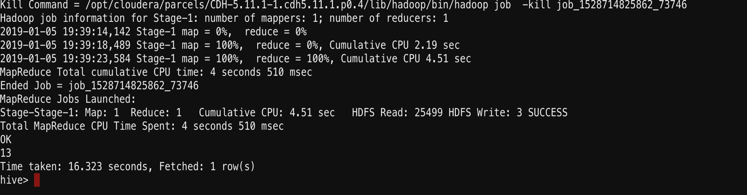

**PIG Solution:**

filtered_country_data = FILTER country_data BY ($25 == 1) AND ($29 == 1);

grouped_text_data = GROUP filtered_country_data All;

count_text_data = FOREACH grouped_text_data GENERATE group, COUNT(filtered_country_data);

DUMP count_text_data;