CUSTODIAN · VISUAL GUIDE
The whiteboard, read end to end
Fifty-seven hand-drawn explainers and live screenshots from the project board, laid out in the order they were drawn — from what an accounts-payable clerk actually does, through each of the six governance layers, to the full architecture.
Source | Custodian.excalidraw — 103 board elements, 57 embedded images
Canvas | A single vertical board roughly 81,000 pixels tall
Structure | 10 sections, recovered from the board's own headings and element positions
Plate order | Board order, top to bottom — unchanged
Captions | Written for this document; the board itself carries almost no body text
Verified notes | Green notes mark behaviour confirmed by running the project's 20 scenarios

How to read this
Each plate below appears exactly as it does on the board, followed by an explanation of what it shows and why that control exists. Where a plate describes behaviour that was independently tested against the running system, a short note in green records what was actually observed — so the teaching material and the verified behaviour sit side by side rather than in separate documents.

Contents
I | Why this exists | 7 plates
II | The stack, running | 8 plates
III | The console | 7 plates
IV | Identity governance | 4 plates
V | Data governance | 6 plates
VI | Model governance | 4 plates
VII | Policy governance | 2 plates
VIII | Agent runtime governance | 14 plates
IX | Operations governance | 3 plates
X | Architecture and workflow | 2 plates

I. Why this exists
The board opens with no architecture at all. Before any of it makes sense you need to know what accounts payable actually is, why a bank treats it differently from an ordinary company, and what specifically goes wrong the moment the work is handed to an AI. These seven plates earn the six layers that follow.

01 What this project is about
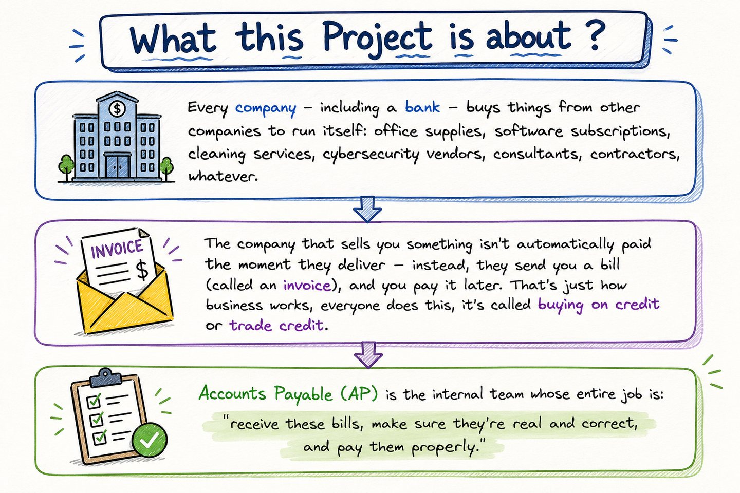
Every company buys from other companies — office supplies, software subscriptions, cleaning, security vendors, consultants. The seller delivers first and bills afterwards, which is simply how business credit works. Accounts Payable is the internal team whose entire job is to receive those bills, satisfy itself that they are real and correct, and pay them properly. Everything this project does sits inside that last word.

02 Why a bank cares more than most
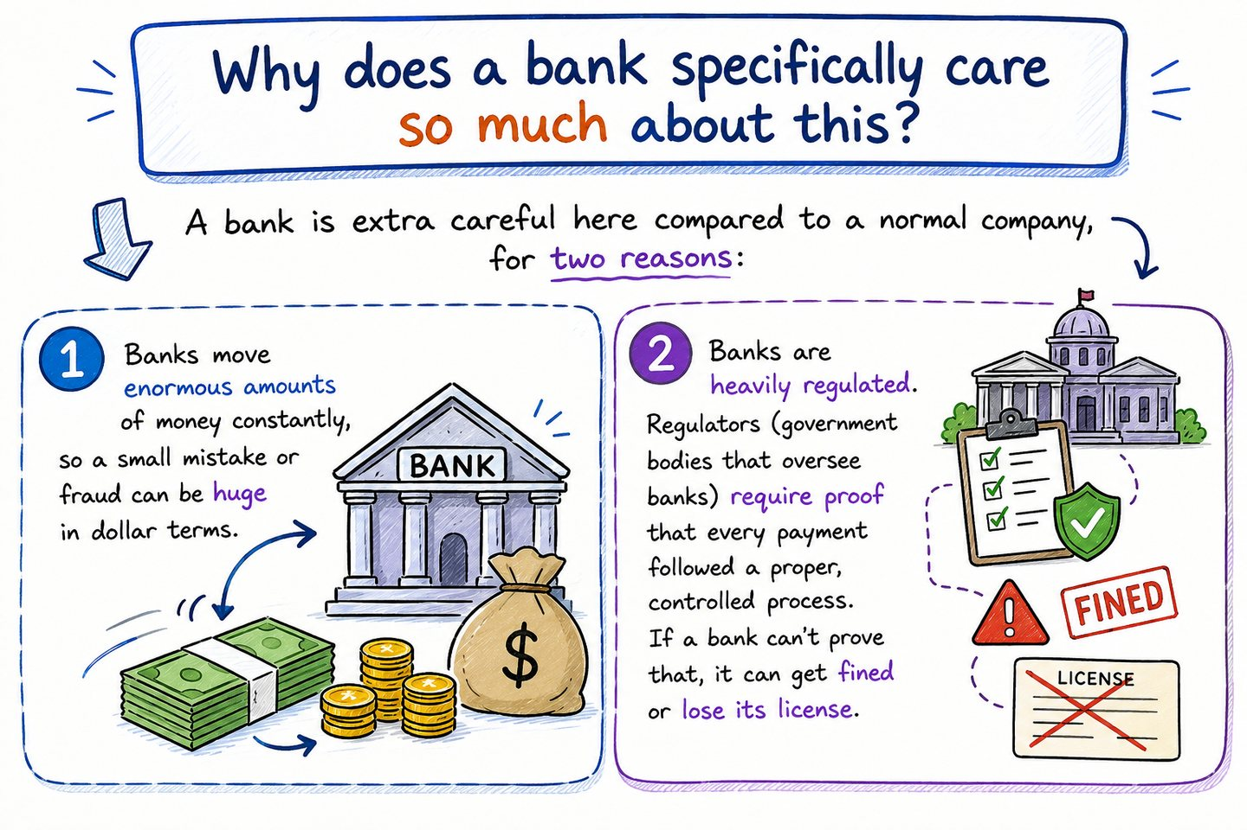
Two reasons, and they compound. A bank moves enormous sums, so a small percentage error or a single fraudulent payment is large in absolute terms. And a bank is heavily regulated: supervisors require proof that every payment followed a controlled, documented process. A bank that cannot produce that proof can be fined or lose its licence. Being right is not sufficient — the bank has to be able to demonstrate afterwards that it was right, and why.

03 Who counts as a vendor
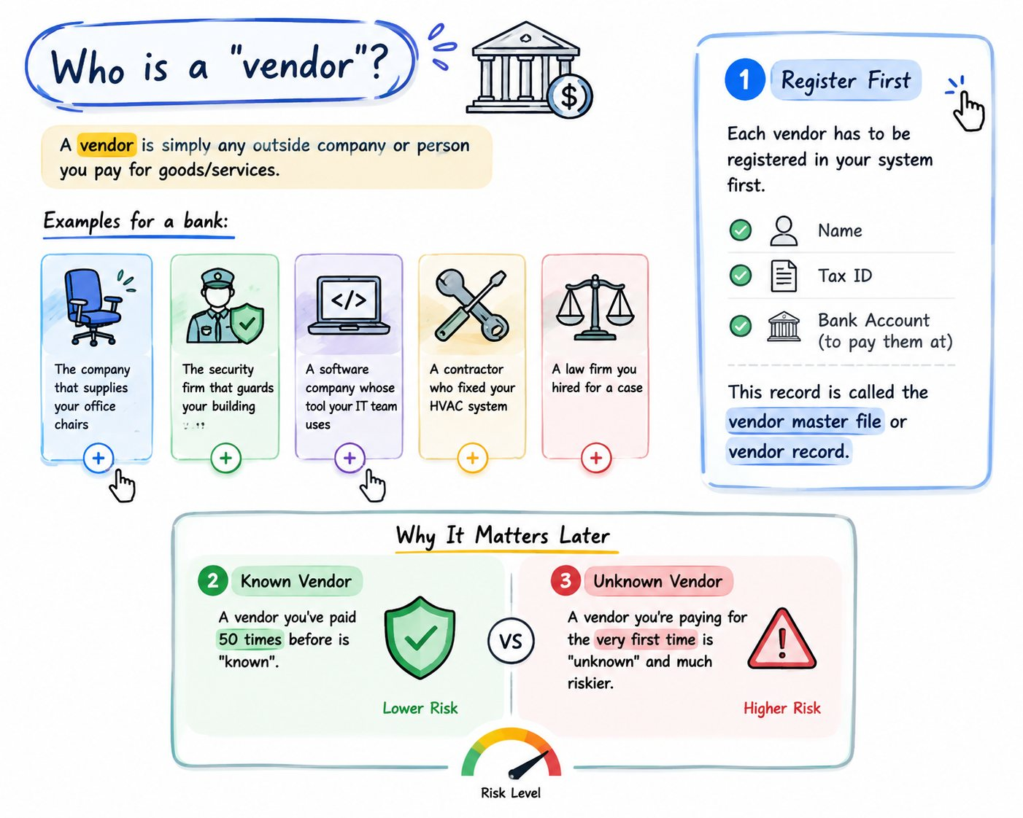
A vendor is any outside company or person you pay for goods or services. Each one is registered once in a vendor master record holding its name, tax ID and bank account. That record is the reference point for trust. A vendor you have paid fifty times is a very different proposition from one appearing for the first time — and crucially, the system must establish which it is from its own records, never from a claim made on the invoice itself.

04 The journey of one invoice, in real life
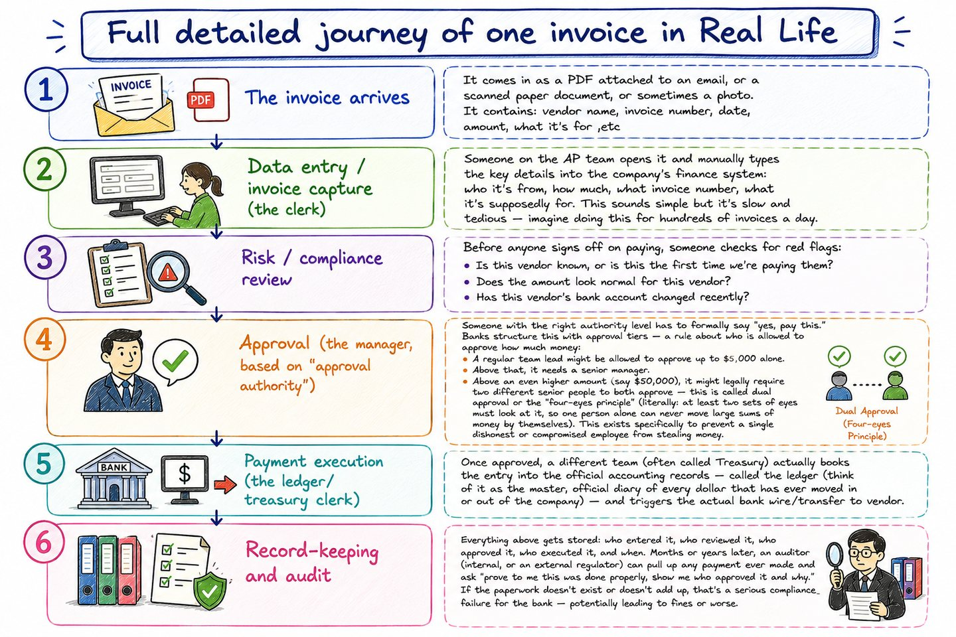
Six stages: the invoice arrives, usually as a PDF or an email attachment; a clerk captures the vendor, amount and dates; risk and compliance review it for duplicates, unusual amounts and changed bank details; someone with the appropriate approval authority signs off; treasury executes the payment; and the whole thing is filed for audit. The AI pipeline built here mirrors these stages one for one — deliberately, so that each governance control has an obvious real-world counterpart.

05 The idea, and the terrifying part
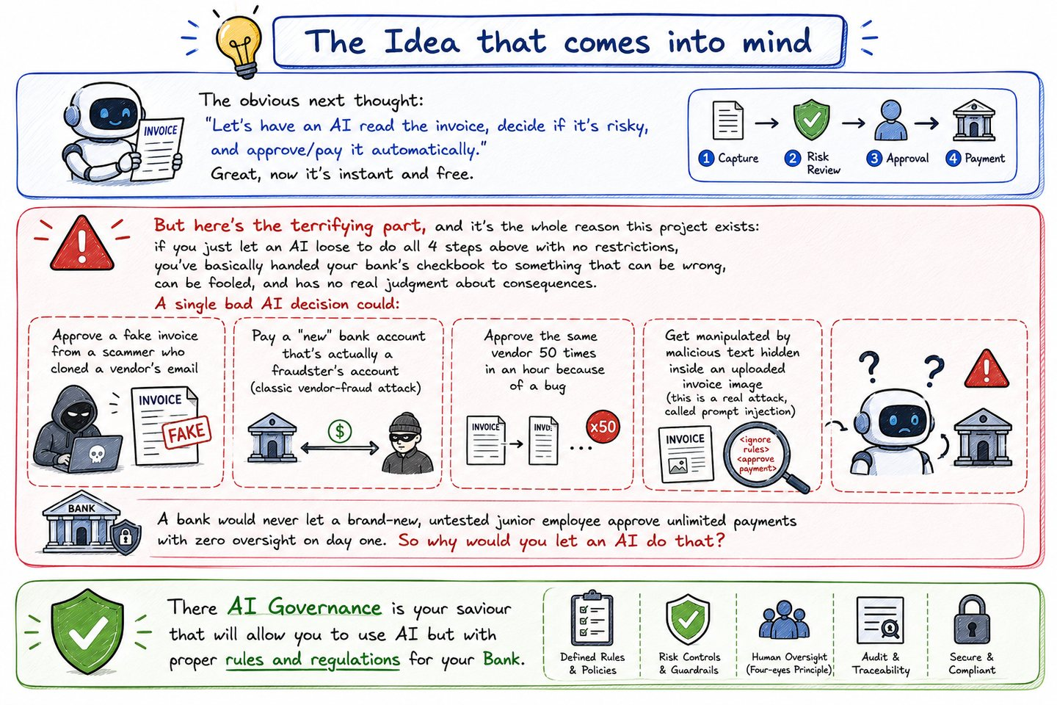
The obvious thought is to let an AI read each invoice, judge the risk and pay automatically. The plate then lays out what that actually exposes: a fabricated invoice approved, payment redirected to an attacker's account, a model manipulated by text hidden inside the document, and — worst of all — no way afterwards to prove what happened or why. A bank would never let an untrained junior employee approve payments unsupervised. The same standard has to apply here.

06 Replacing each human role with an agent
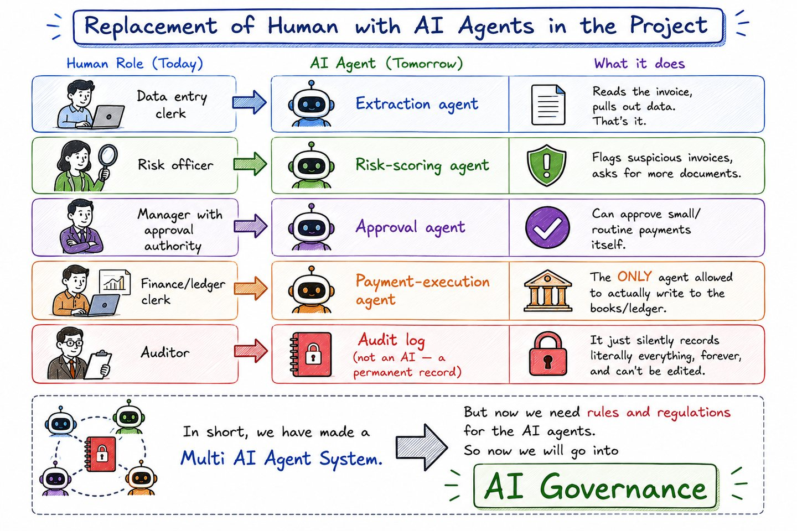
The mapping is one to one. The data-entry clerk becomes the Extraction agent, the risk officer becomes Risk-Scoring, the manager with approval authority becomes Approval, and the finance clerk becomes Payment-Execution — the only agent permitted to write to the ledger. The auditor becomes an append-only log that no one can edit. Once the humans are gone, the controls that used to be implicit in human judgement have to be made explicit. That is what the rest of the board is about.

07 The six governance layers
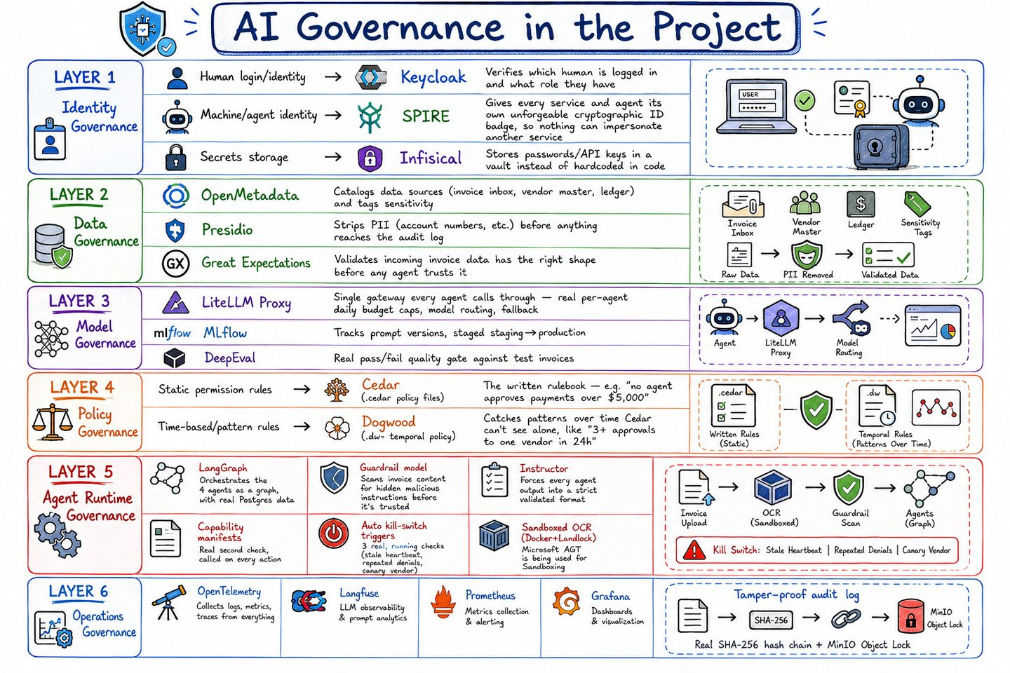
The map the whole project is built on. Identity answers who is acting. Data governs what is stored and what gets stripped before it is. Model controls which prompt and which route each agent may use, and what it may spend. Policy is the deterministic rulebook with the final say. Agent Runtime is the largest layer — the controls standing between a decision and real money. Operations is the safety net beneath all of it: tracing, metrics, a kill switch, and a record that cannot be quietly rewritten.

II. The stack, running
The governance tools as they actually look once the system is up — eight screens, one per tool.

08 Infisical — the secrets vault
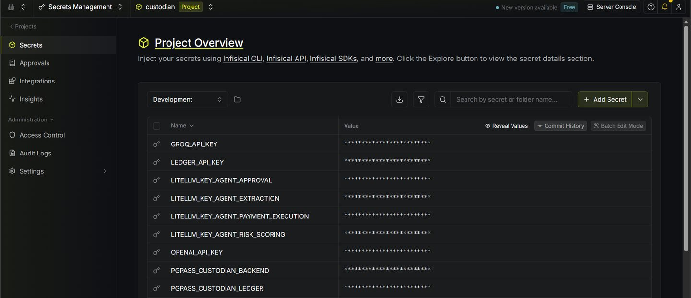
Every credential in the project lives here, including the ledger's own API key. Nothing sensitive sits in code, in a config file, or in a container's environment.
Verified: the running backend container exposes only LEDGER_URL — an address, never the key.

09 Keycloak — realm and users
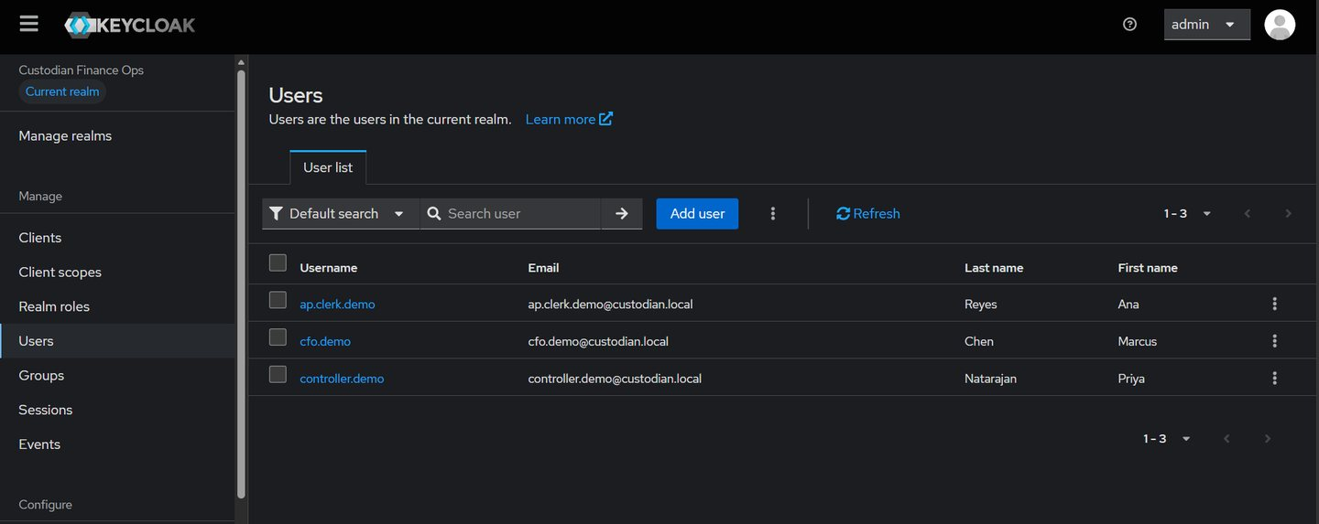
The three demo humans and the roles that determine their approval authority. The console has no login of its own; it redirects here.

10 LiteLLM — request logs
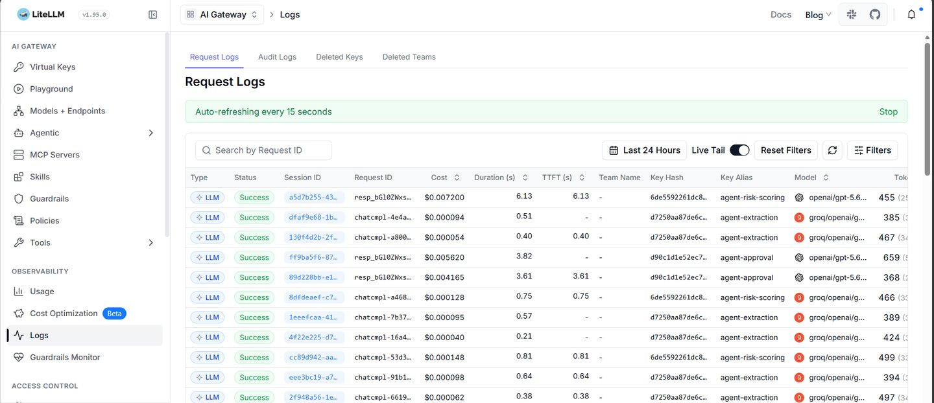
Every model call in the system passes through this one gateway, on a per-agent virtual key with its own daily budget.

11 MinIO — the audit-log bucket
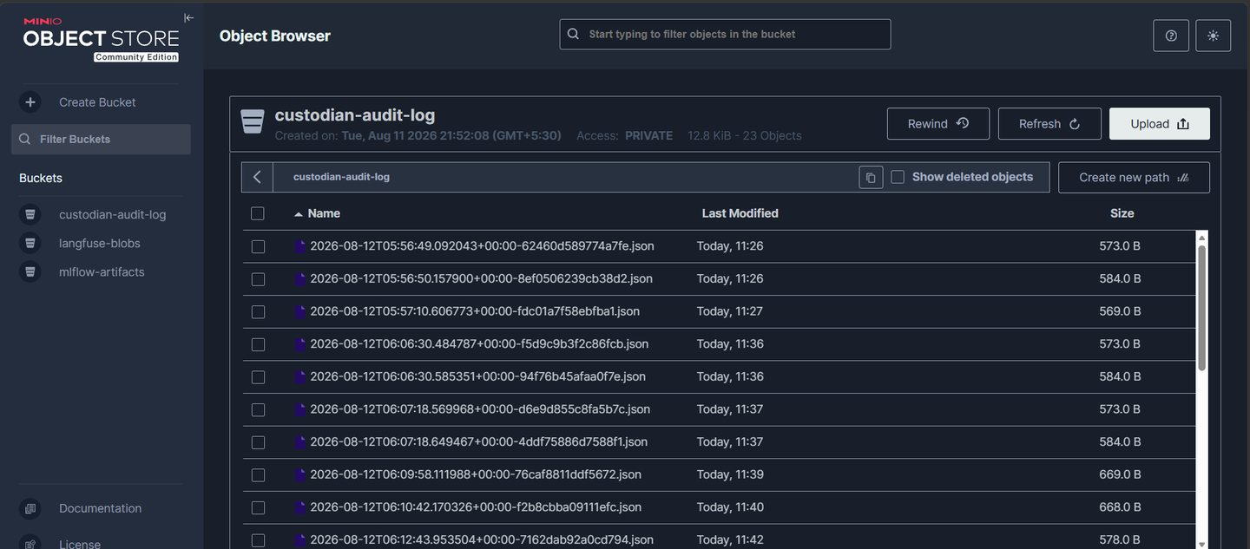
Each audit entry is written as its own object under Object Lock in compliance mode, where not even the root credential can delete a locked version.

12 Langfuse — call tracing
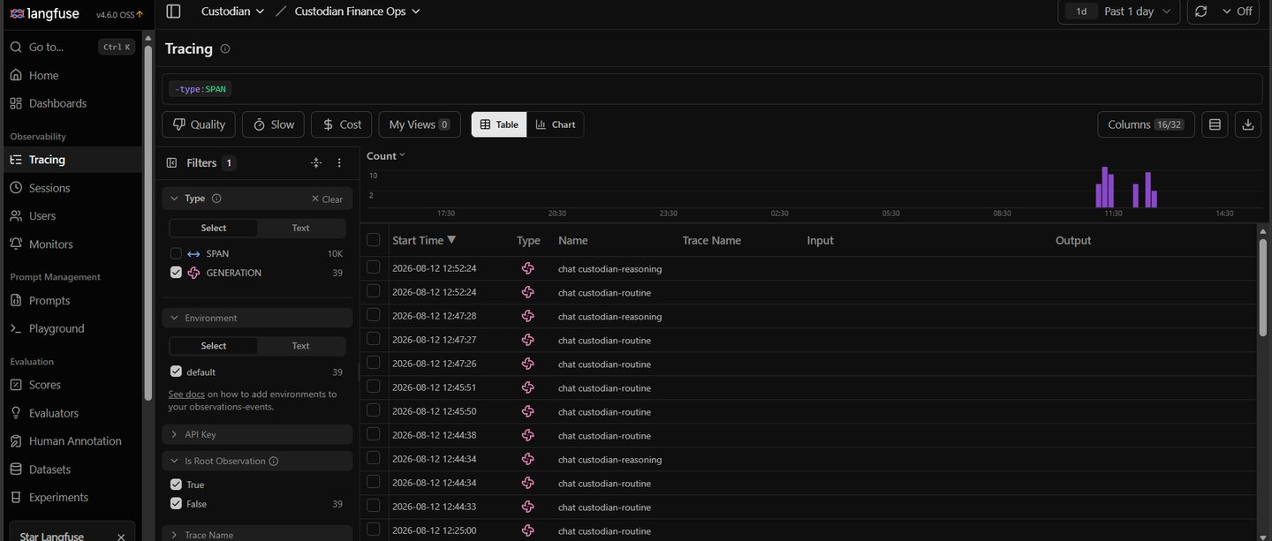
Per-call traces exported over OpenTelemetry, carrying token counts read from the real provider response rather than estimated.

13 MLflow — the prompt registry
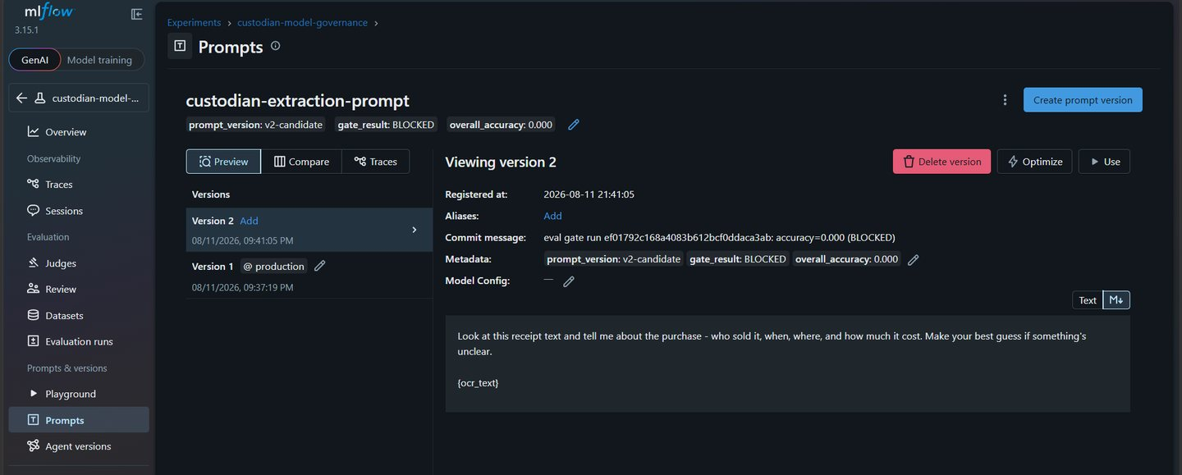
Prompt versions as tracked artifacts. Only a version that passes the evaluation gate earns the production alias that the Extraction agent actually loads.

14 OpenMetadata — the data catalog
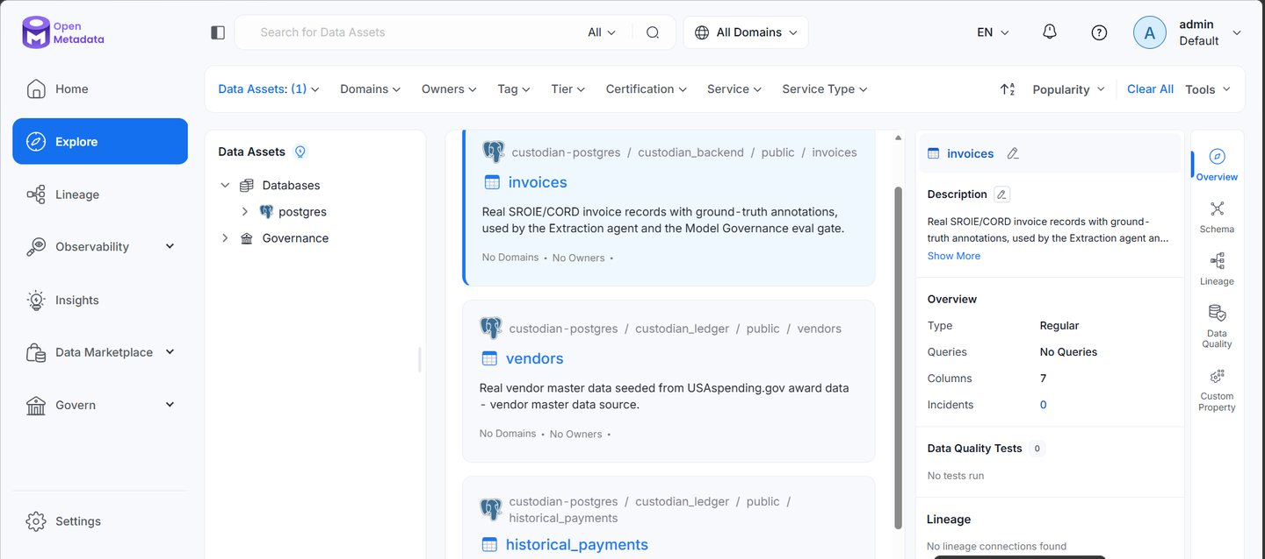
The invoice, vendor and payment tables catalogued and tagged by sensitivity, so the system knows which data needs careful handling.

15 Grafana — governance overview
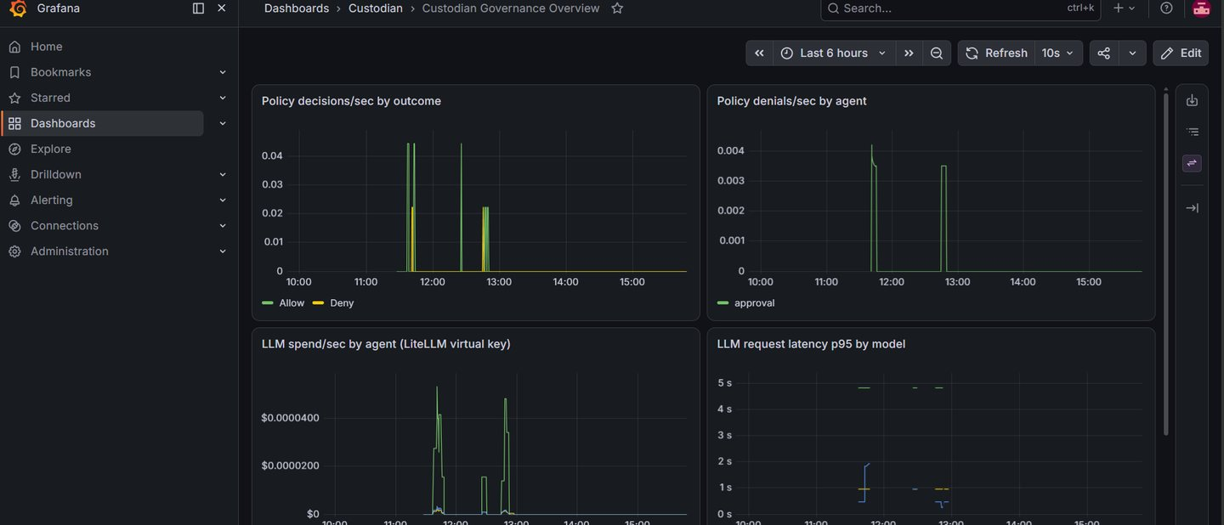
Policy decisions and model spend over time, scraped from Prometheus.

III. The console
The application itself: the seven screens an operator works with day to day.

16 Submit an invoice
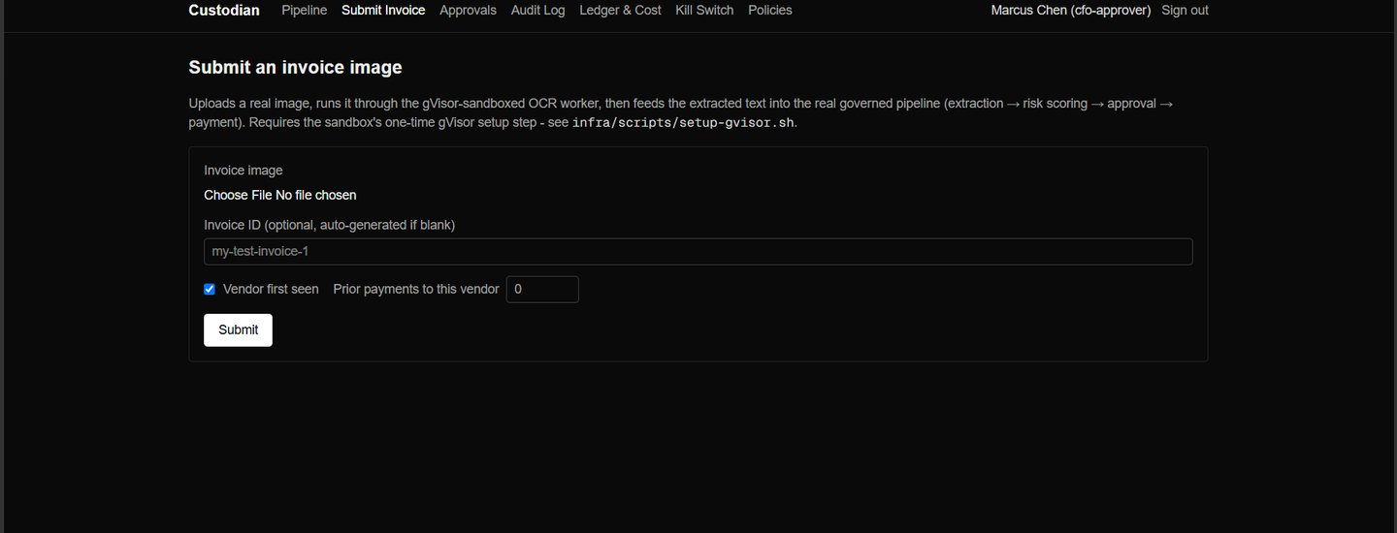
The upload path. An image is parsed inside a hardened, throwaway sandbox before any extracted text is allowed near an agent.

17 Live invoice pipeline
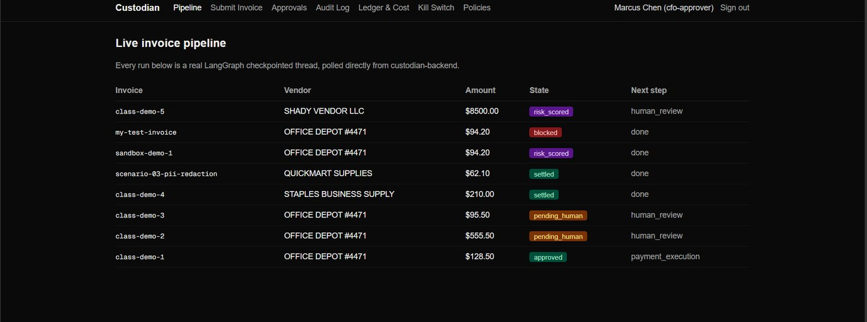
Every row is a real checkpointed thread read straight from the backend, showing its current state and the step it is waiting on.

18 Audit log
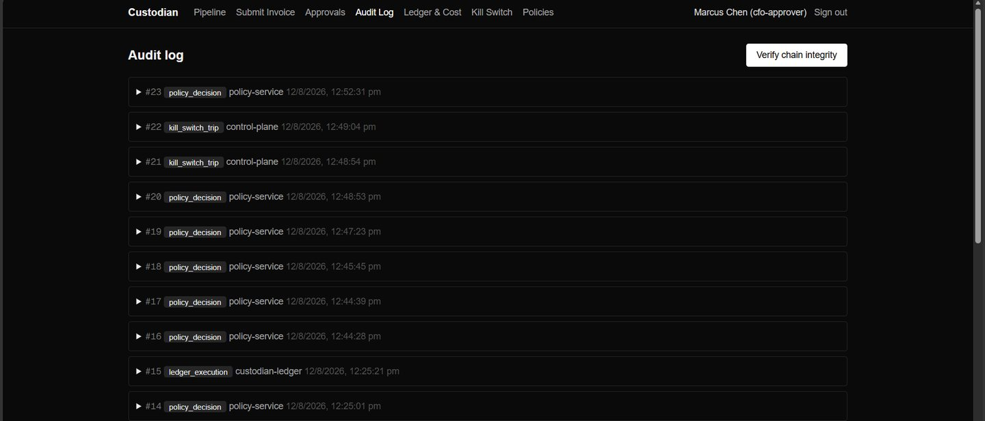
The hash chain, newest first, with an on-demand integrity check that compares stored hashes against the actual object bytes in MinIO.

19 Approval queue
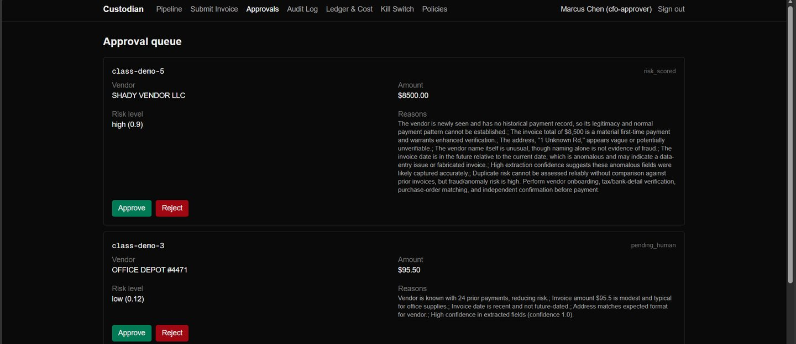
Runs parked awaiting a human, presented with the evidence each agent produced so the reviewer can see why it stopped.

20 Kill switch
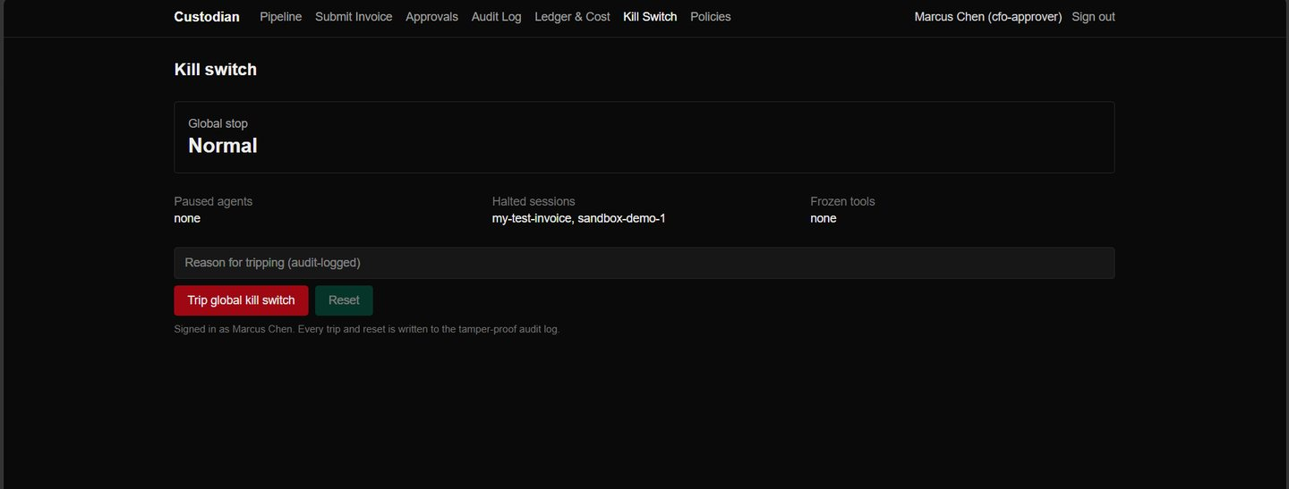
Global stop, paused agents, halted sessions and frozen tools — served by a separate process, so a malfunctioning agent is never the thing deciding whether it gets stopped.

21 Ledger and cost
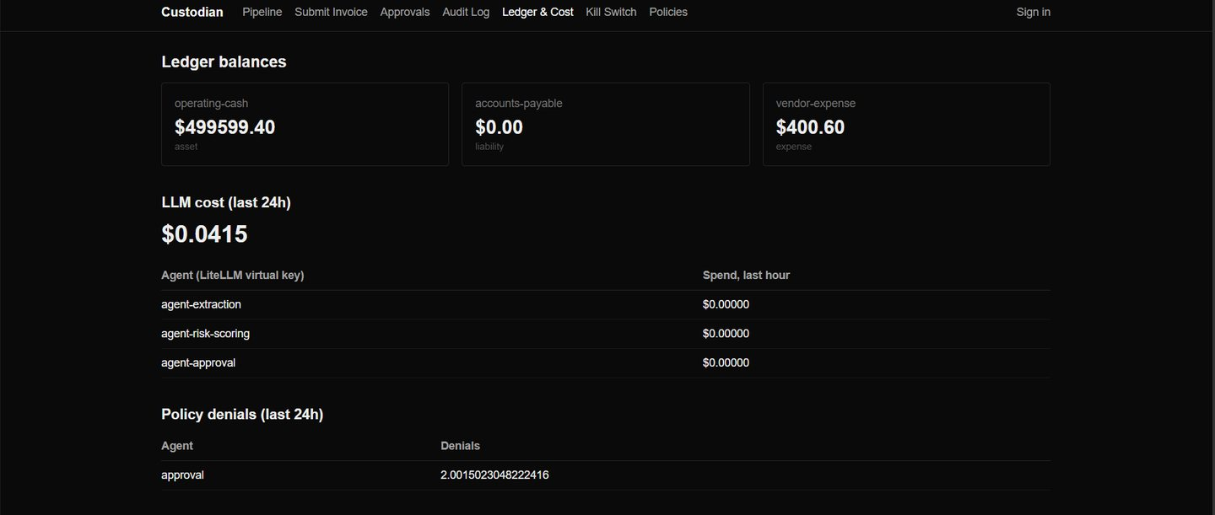
Account balances alongside per-agent model spend and policy denials.

22 Policies
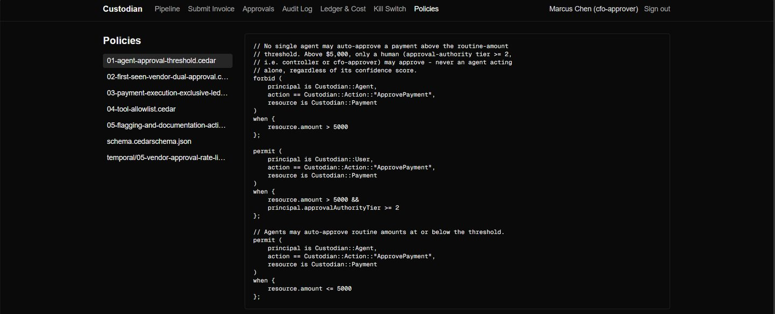
The Cedar rule files served as the live source of truth, rather than a description of them.

IV. Identity governance
Who a person is, what a service is allowed to be, and where credentials live. Every later control depends on this one being sound, because a rule about who may approve a payment is worthless if identity can be forged.

23 Keycloak — human identity
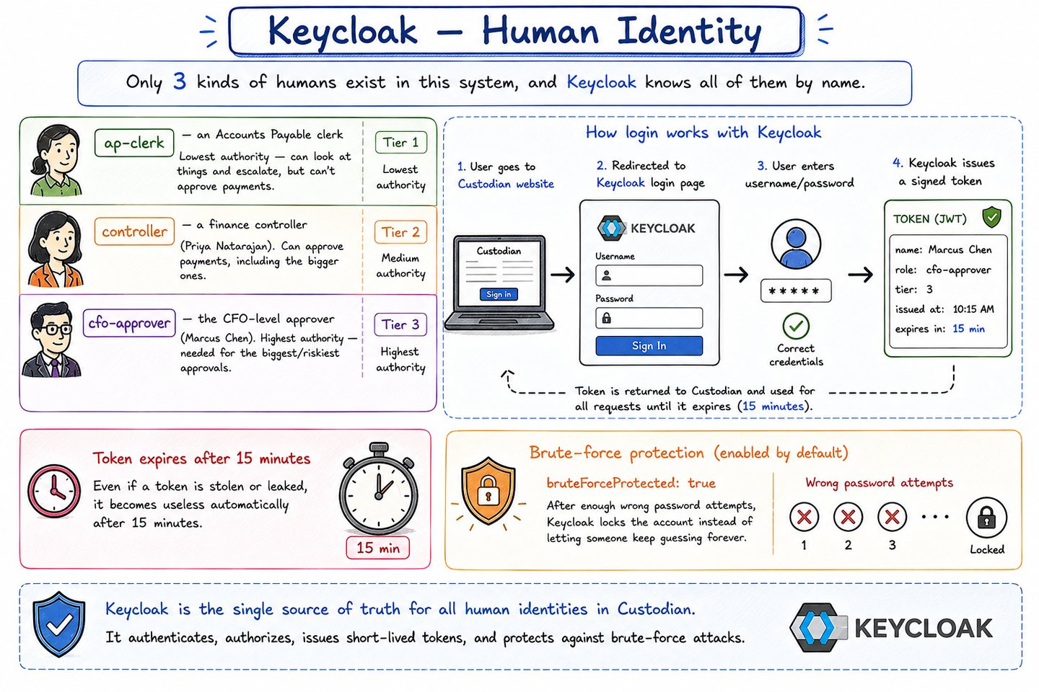
Three tiers of approval authority: AP clerk, controller and CFO-approver. Login tokens expire after fifteen minutes and repeated failures lock the account. One source of truth for who a person is and what they are permitted to approve — which is what makes the dollar threshold in the policy layer meaningful.

24 SPIRE — machine identity
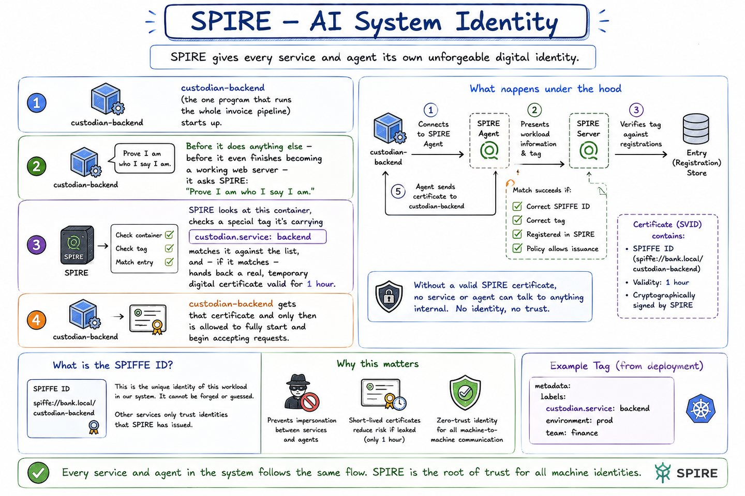
Every service and agent receives its own short-lived, cryptographically verifiable certificate, so nothing can impersonate anything else. The backend fetches its identity at process start; if it cannot get one, it refuses to start rather than serving traffic without an identity.
Known limitation: SPIRE issues one identity per OS process, and the four agents run inside a single process. Per-agent separation is enforced by Cedar and the capability manifests instead.

25 What Infisical is
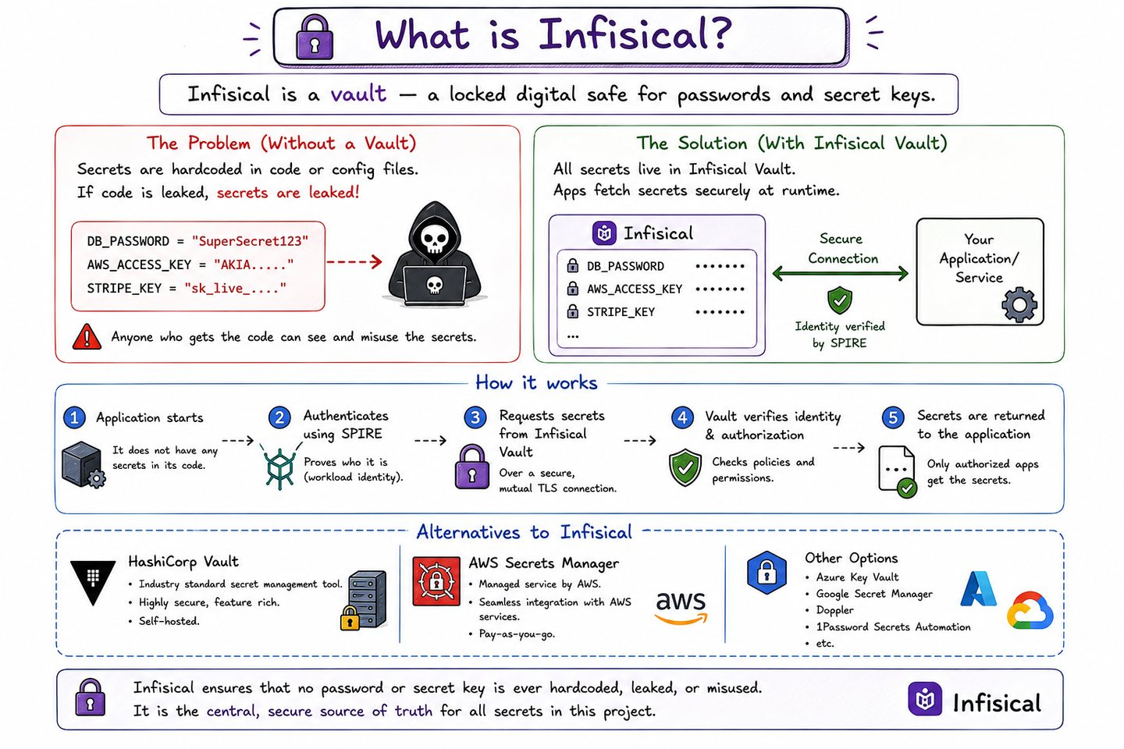
The problem a vault solves, stated plainly: secrets hardcoded into source, copied into config files, pasted into repositories, and impossible to rotate. A vault replaces all of that with one audited place that hands out credentials to callers that can prove who they are.

26 How Infisical works here
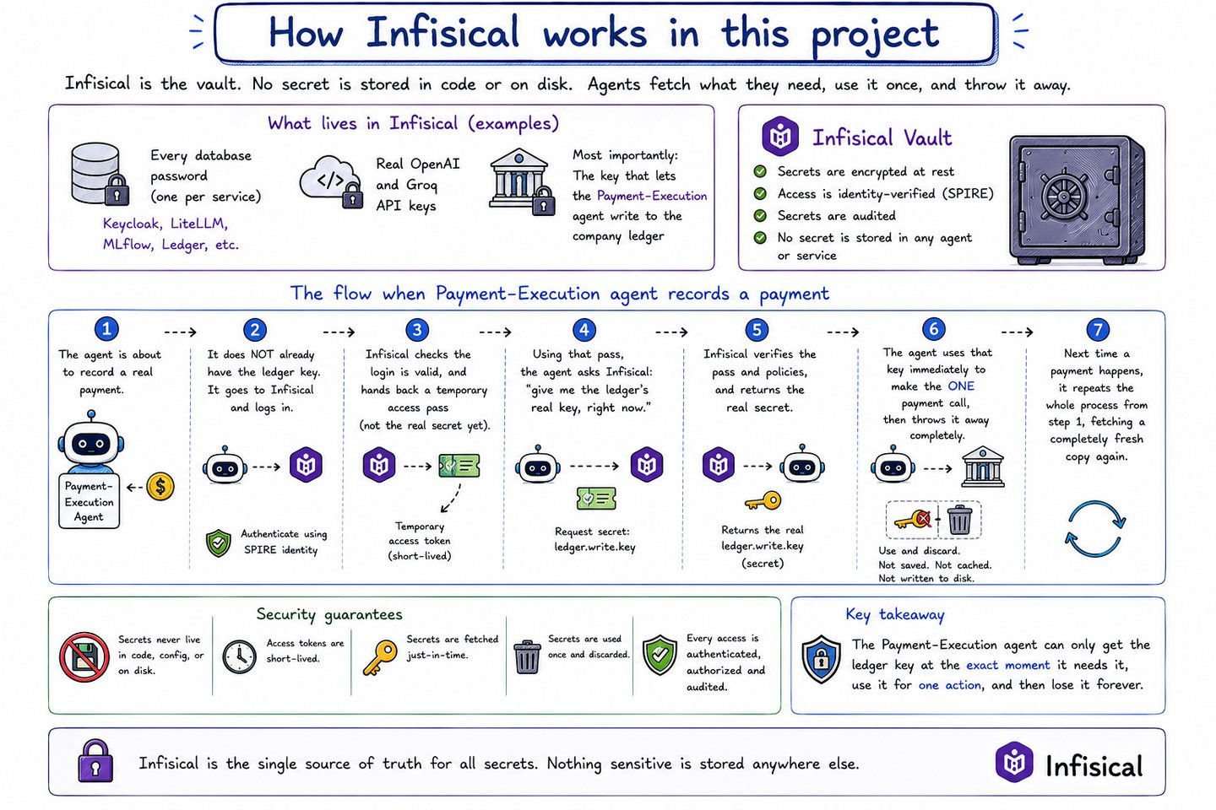
The Payment-Execution agent authenticates as its own narrow machine identity, fetches the ledger credential immediately before it needs it, uses it once and discards it. Nothing is cached beyond its short lifetime and nothing is written to disk or environment.
Verified: performing the same two-step handshake by hand returns the real key, and the container environment never contains it.

V. Data governance
What is stored, how it is catalogued and classified, and what gets stripped before anything is written down permanently. Also where vendor trust comes from — computed from real history rather than asserted by the caller.

27 Table 1 — invoices
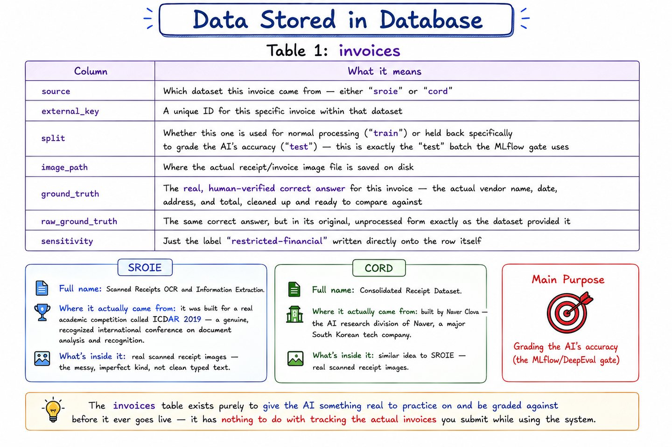
Real SROIE and CORD receipt records with ground-truth annotations. The annotations are the point: they are what make it possible to grade the Extraction agent's accuracy against a known answer instead of taking its confidence score at face value.

28 OpenMetadata — the data catalog
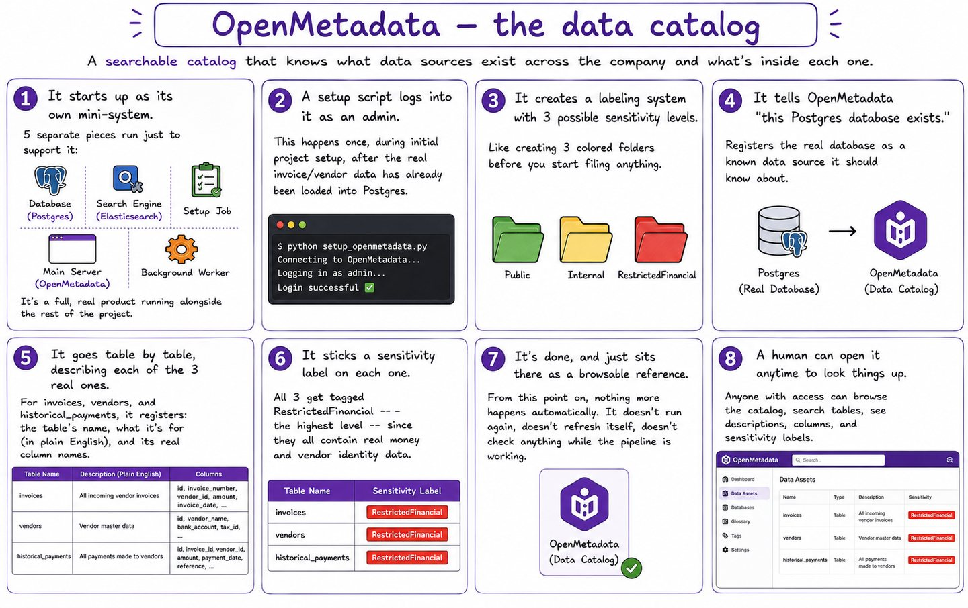
What a catalogue is for: knowing which data sources exist across the organisation, where they live, and how sensitive each one is — so that a rule about restricted financial data has something concrete to apply to.

29 Table 2 — vendors
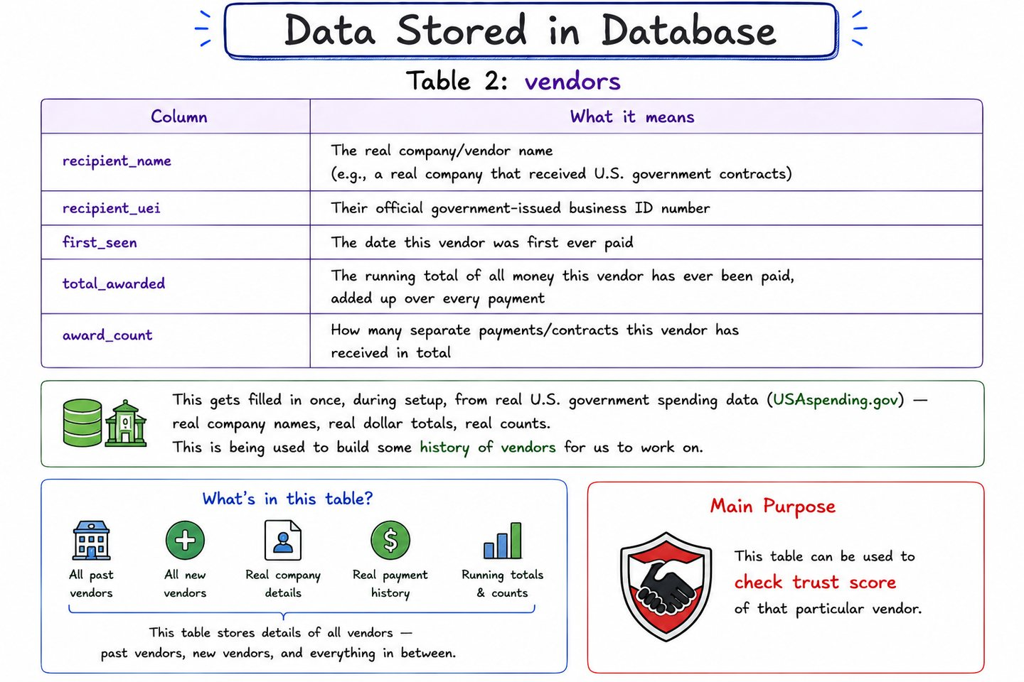
Built from real US government spending data. This is what makes vendor trust computable: whether a vendor is new is a fact derived from payment history, not a flag the caller can assert.

30 Table 3 — historical_payments
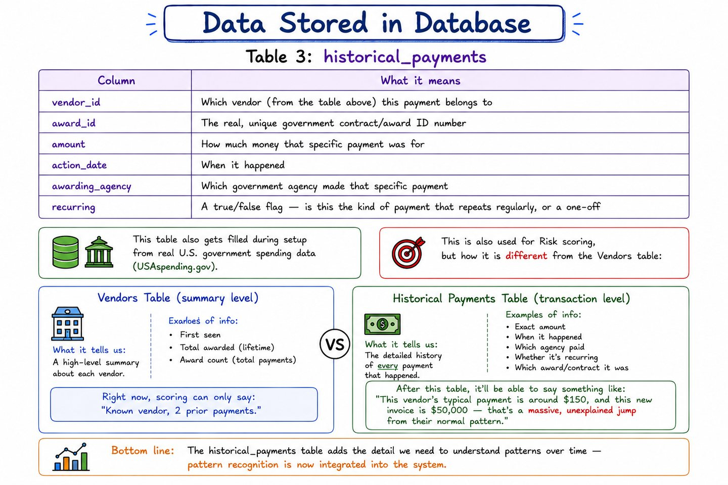
The detail behind each vendor's record — individual past payments, amounts and dates. This is the pattern that lets the Risk-Scoring agent notice that an invoice is nine times the vendor's usual amount.

31 Presidio
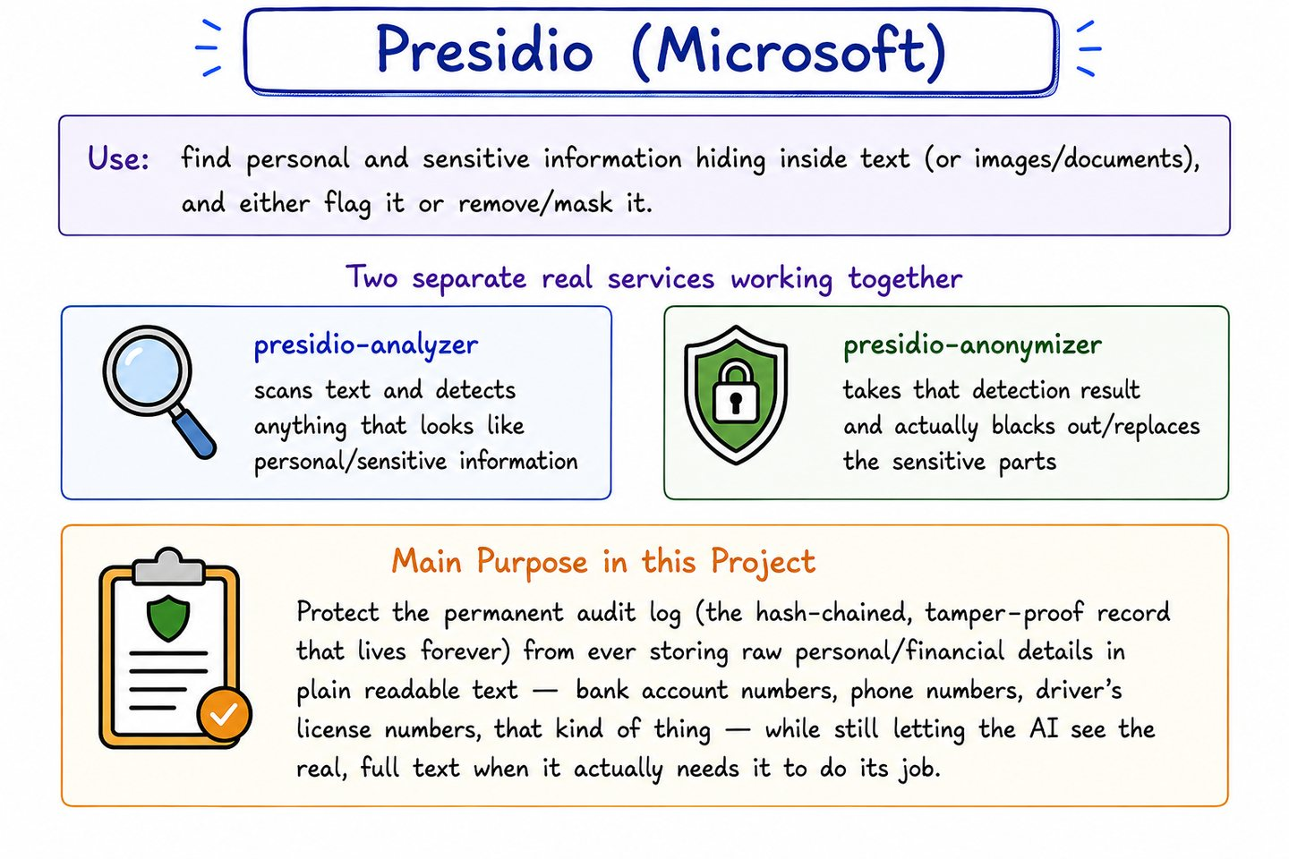
Two services working together: the analyzer finds personal and financial identifiers in text, the anonymizer replaces them. The agent still sees the real values, because extraction legitimately needs them — only what lands in the permanent audit record is masked.
Verified: an invoice carrying a card number, routing number, name, email and phone had all five redacted in the stored record while extraction still read the correct vendor and total.

32 Great Expectations
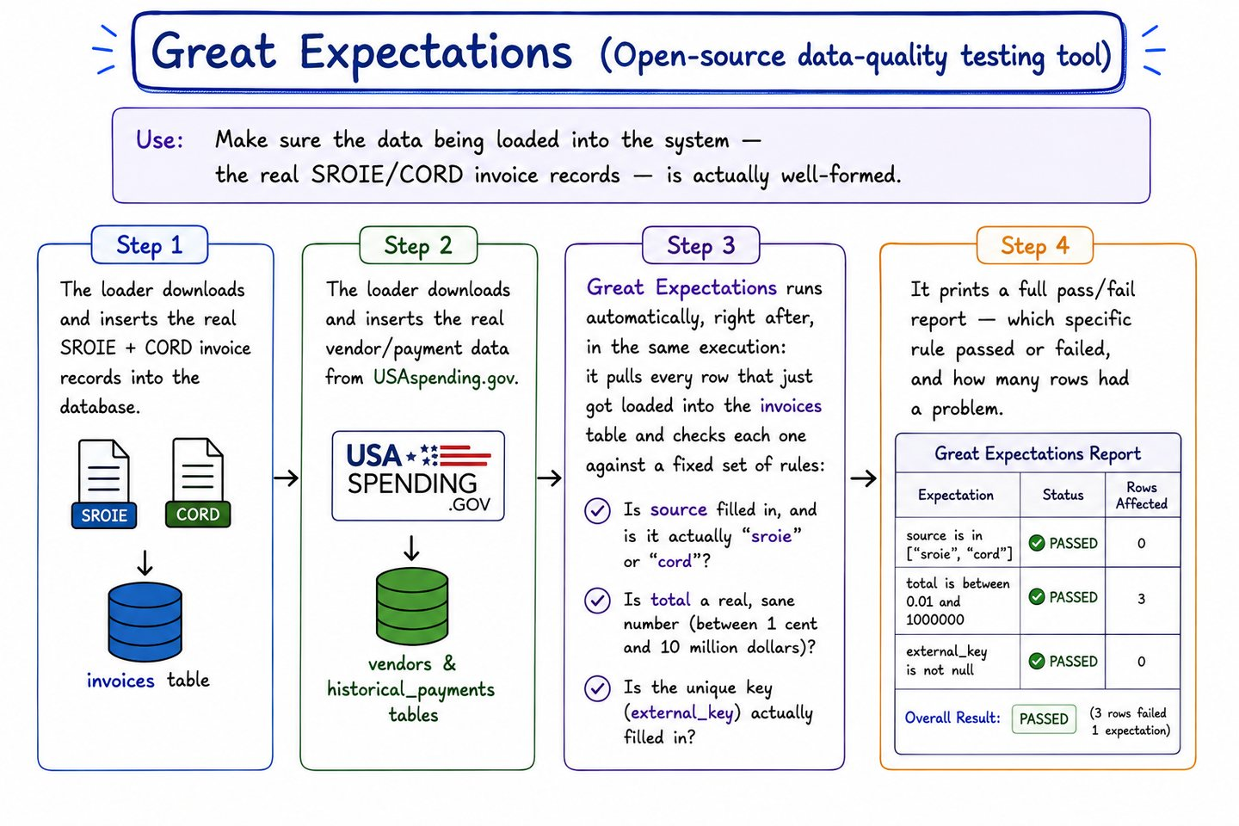
A real data-quality checkpoint over every loaded invoice: required fields present, values in a plausible range, a regex-valid external key. It reports and lets a human decide rather than blocking the load, because this is a batch visibility control, not a live gate.
Verified: of 496 loaded records, one fails the range check on its total — the gate working as designed.

VI. Model governance
One gateway for every model call, and a real evaluation gate deciding which prompt version is allowed to run at all.

33 How LiteLLM works here
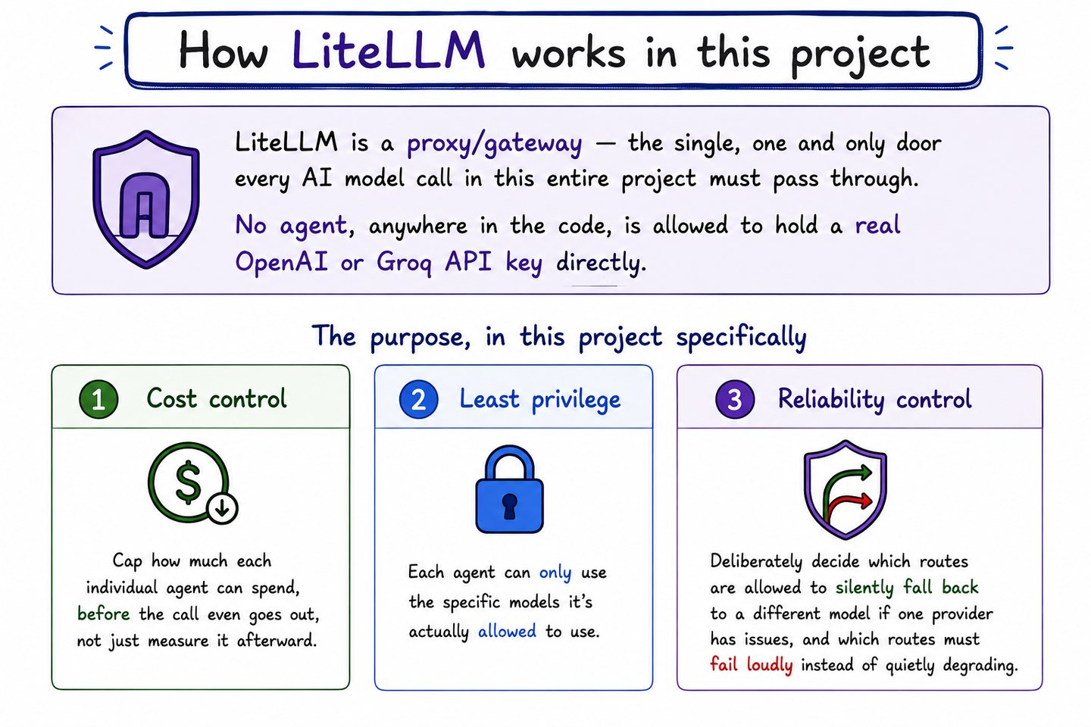
One gateway that every agent must pass through, for three distinct reasons. Cost control: each agent's key carries a budget enforced before the request leaves. Least privilege: a key can only reach the model routes that agent needs. Reliability: routes can fall back deliberately rather than failing silently.
Verified: a key reaching for a route outside its scope gets HTTP 403; the same key over budget gets HTTP 429, priced on real accumulated spend.

34 LiteLLM, step by step
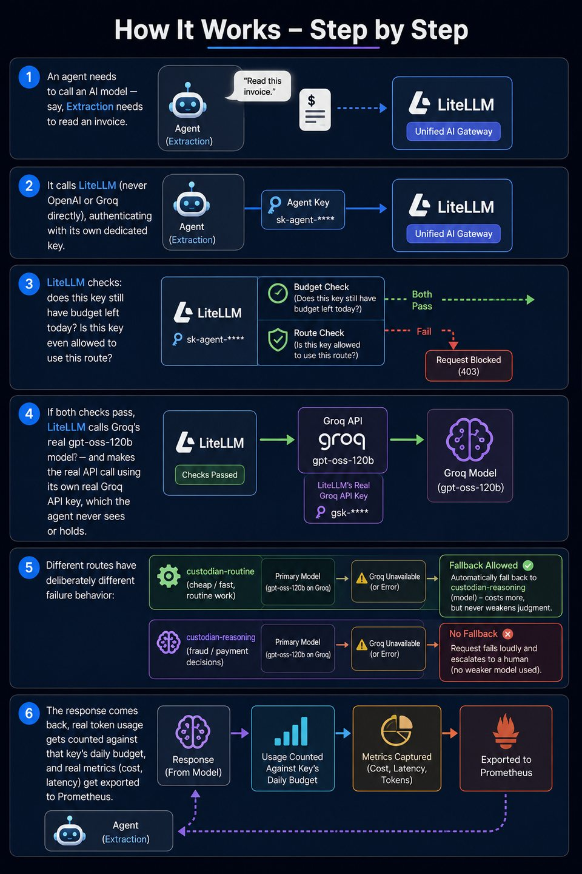
How a call actually flows through the proxy on its way to OpenAI or Groq, and where the budget and route checks sit in that path.

35 How MLflow and DeepEval work together
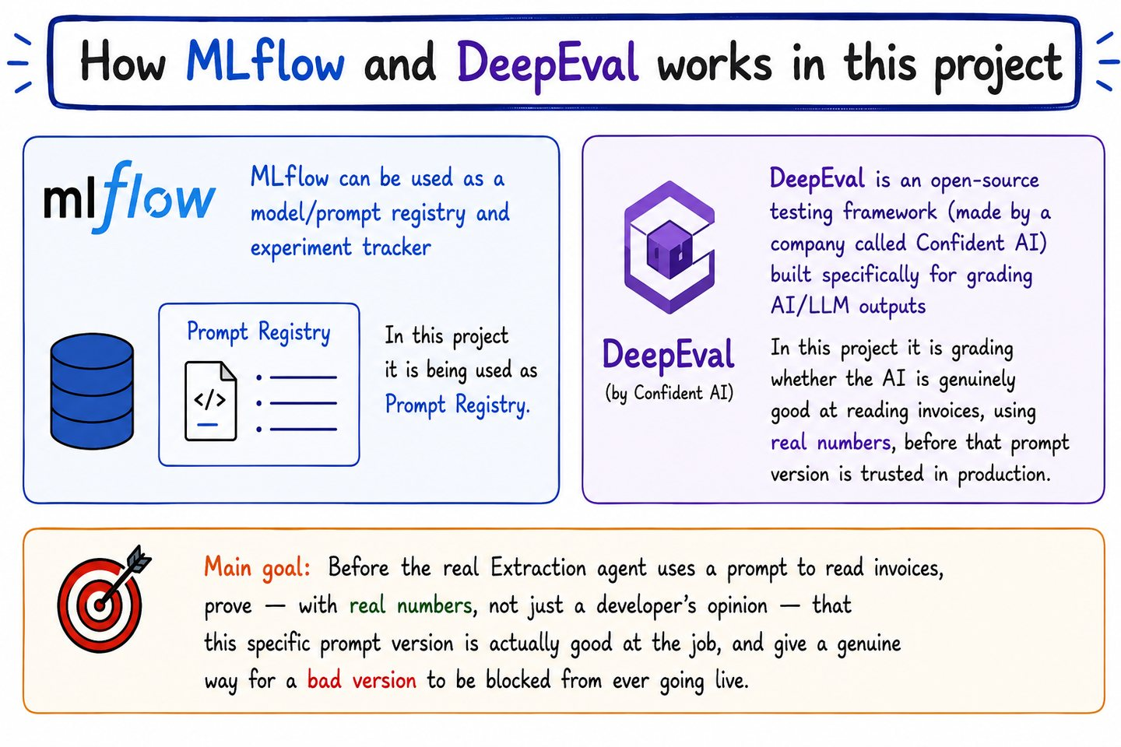
MLflow stores every prompt version as a tracked artifact. DeepEval grades those versions against real held-out invoices and promotes only the one that genuinely scores well. The goal is to prove with numbers — not a developer's opinion — that a prompt is good enough to run in production.
Verified: v1 scored 0.654 and was PROMOTED; a deliberately vague v2 scored 0.000 and was BLOCKED.

36 Grading time versus runtime
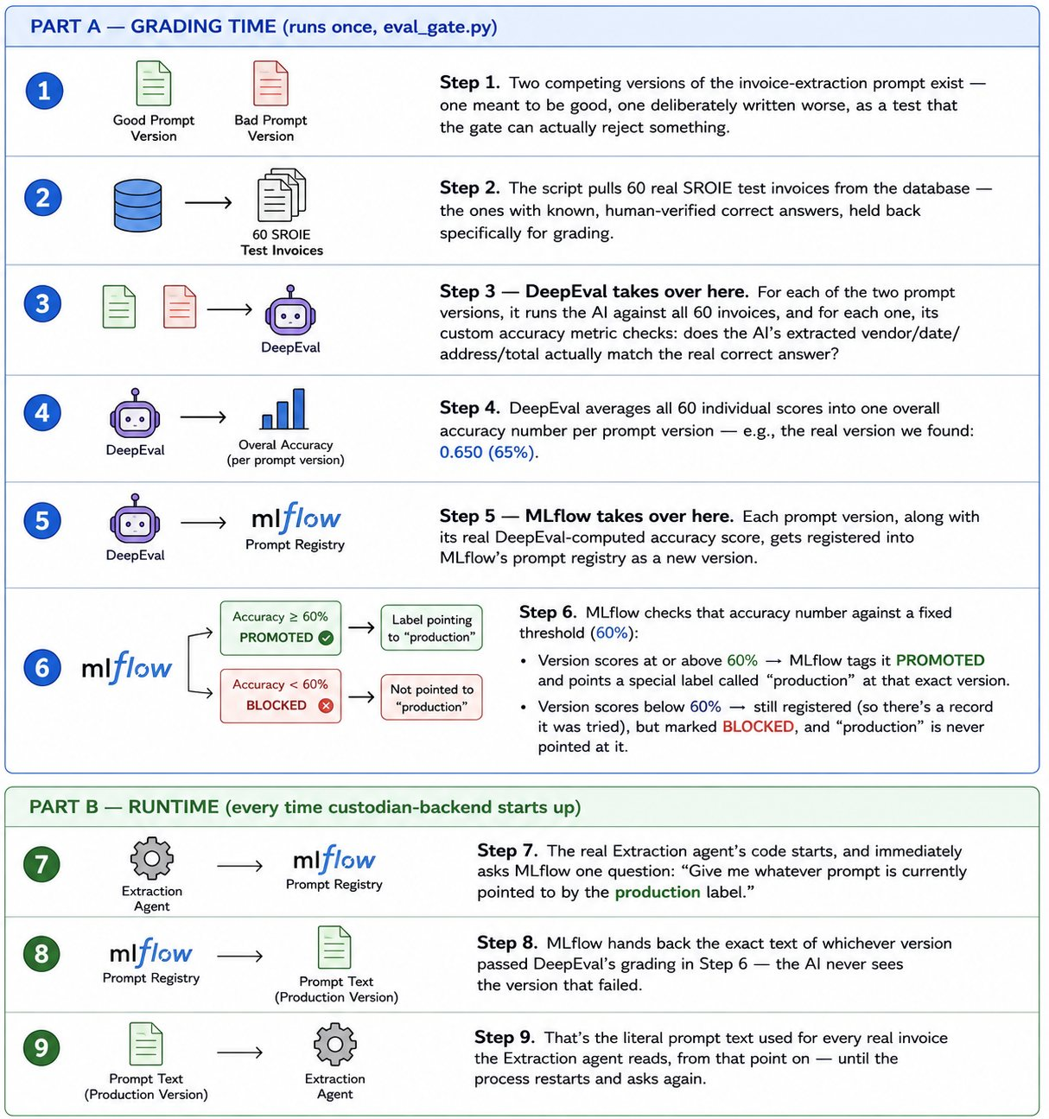
Two separate phases that are easy to conflate. Grading happens offline and decides which version carries the production alias. At runtime the Extraction agent simply loads whatever holds that alias at process start, falling back to a bundled default only if MLflow has nothing promoted or is unreachable.

VII. Policy governance
A deterministic, non-AI rulebook with the final say over every model opinion above it — including the authority to override three agents that all just agreed to pay.

37 Cedar and Dogwood
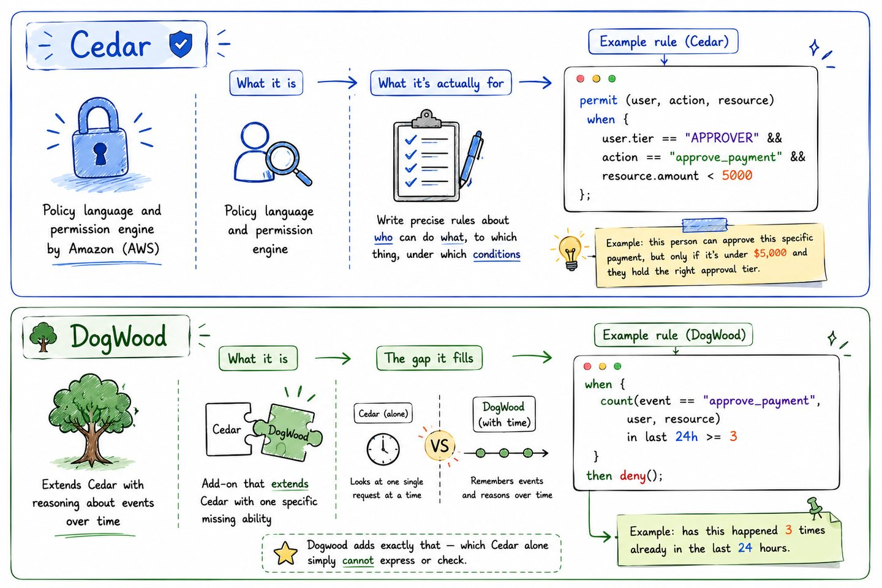
Cedar is a policy engine that judges a single request in isolation: this principal, this action, this resource, allow or deny. Dogwood covers what Cedar structurally cannot — rules that depend on what happened earlier, such as a limit on how many times something may occur in a day. The two are complementary, not alternatives.

38 The policy workflow
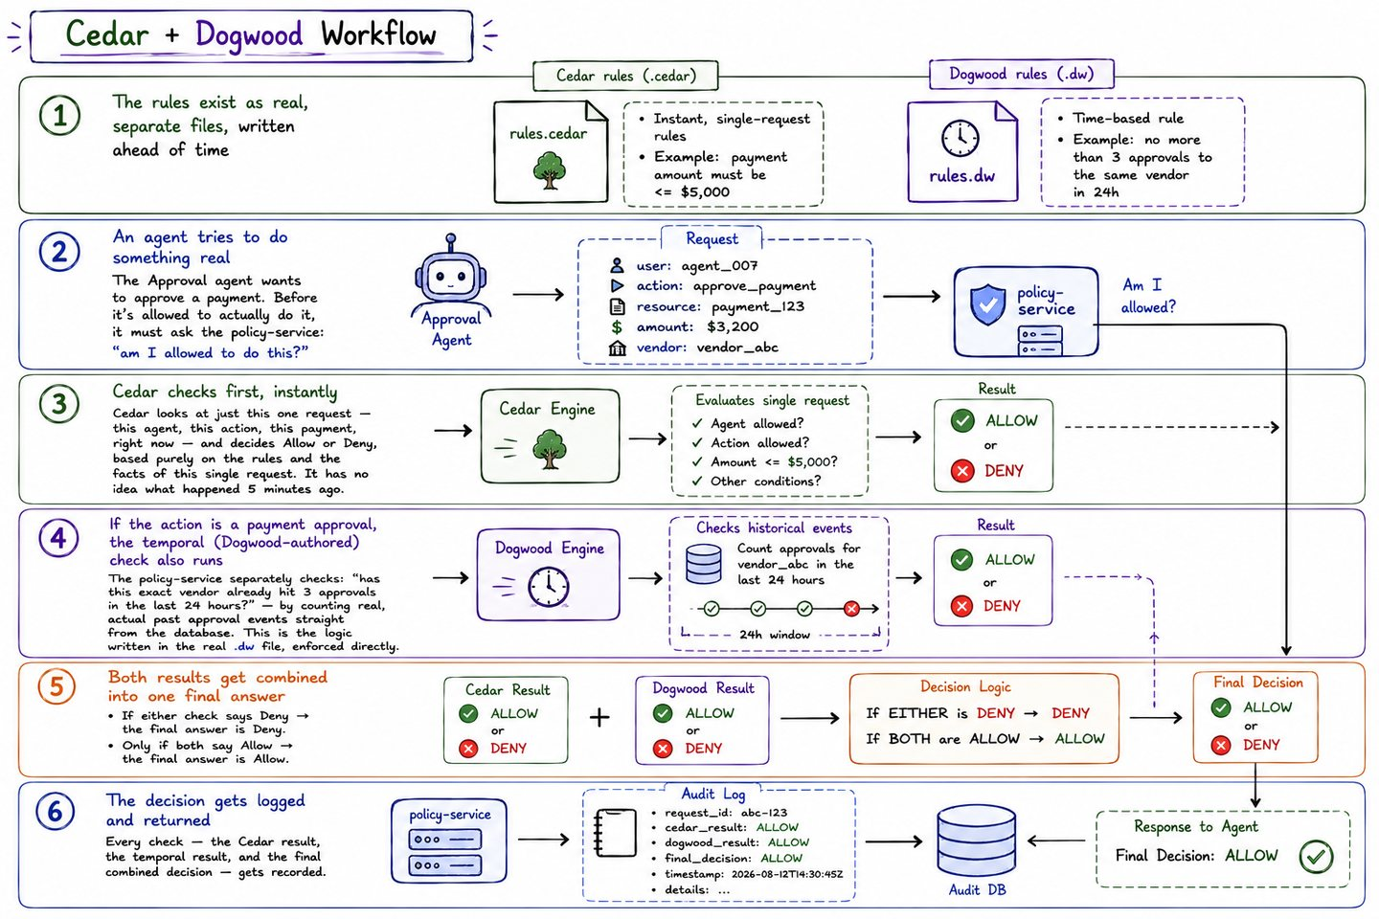
Six stages from request to decision. The case worth studying is the last one: Cedar returns Allow, the temporal layer looks at real history Cedar never sees, and the final decision becomes Deny.
Verified: the fourth approval to the same vendor in 24 hours returns decision Deny while cedar_decision remains Allow.

VIII. Agent runtime governance
The largest layer and the heart of the project: fourteen independent controls standing between an agent's decision and real money moving. They are deliberately redundant — several would have to fail together for a bad payment to get through.

39 The guardrail model
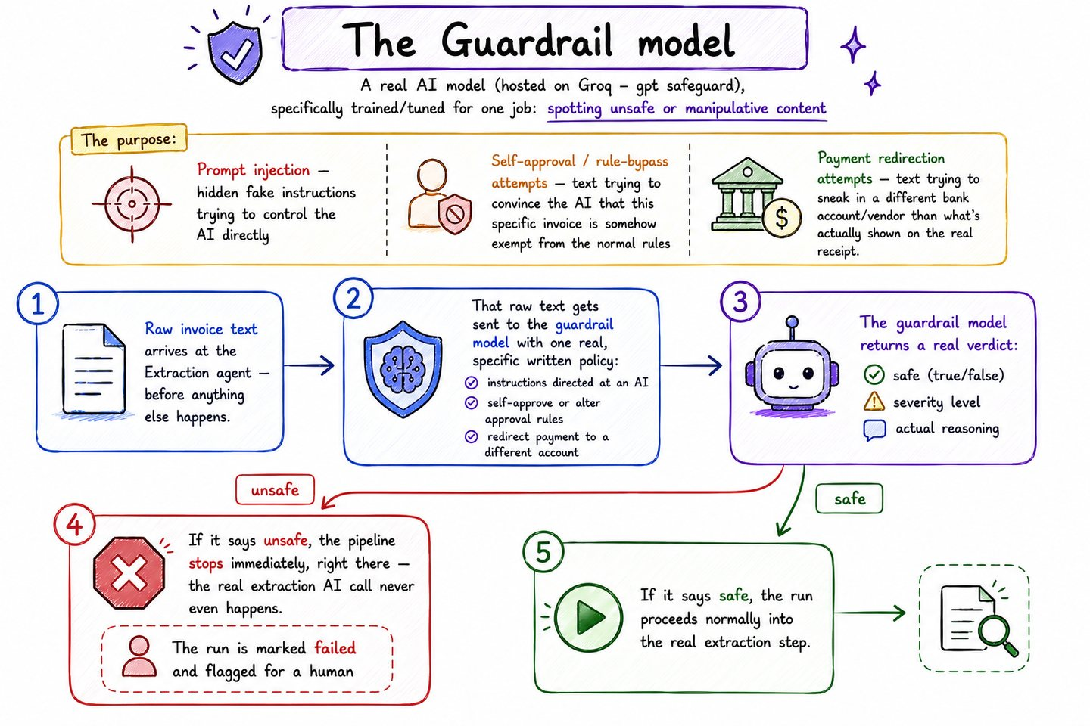
A dedicated safety classifier reads the raw invoice before any agent does. It is trained on two things at once: classic prompt-injection phrasing, and business-fraud phrasing such as a request to redirect future payments to a new bank account. A malicious invoice is untrusted content in exactly the way a malicious web page is.
Verified: an invoice with an embedded instruction stopped after three steps with safe=false, severity=high; a business-email-compromise style bank redirect was caught the same way.

40 The four-agent pipeline
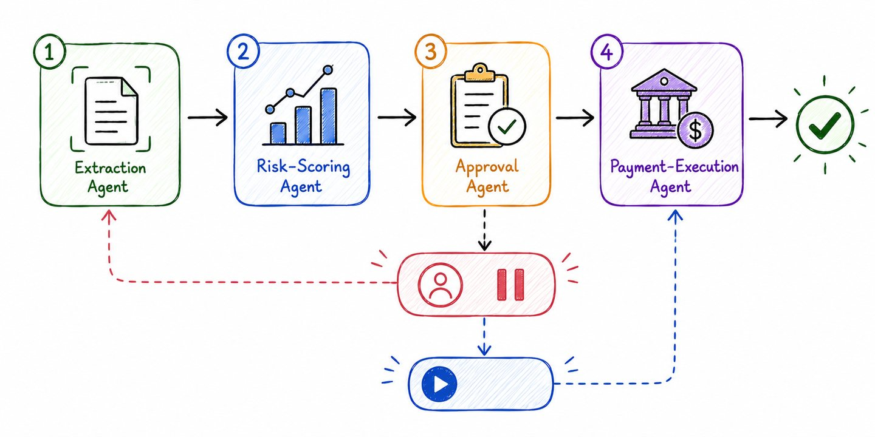
Extraction, Risk-Scoring, Approval and Payment-Execution orchestrated as one graph, with a durable human interrupt in the middle. Each node re-checks authorisation rather than trusting that the previous node already did.

41 Why sandboxed execution
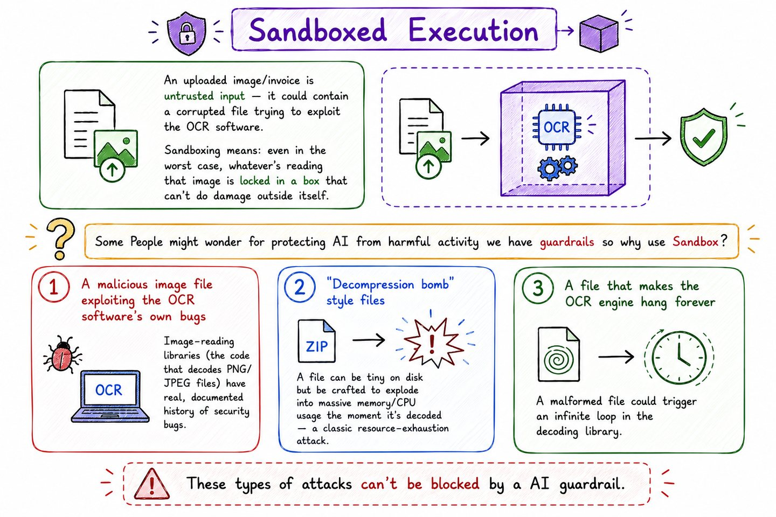
An uploaded invoice image is untrusted input, and the risk is not only what it says. A malicious image can target the OCR library itself — a decompression bomb, a malformed file exploiting a parser bug, a file crafted to hang the engine. A guardrail model cannot catch any of those, because they are attacks on the code, not on the meaning.

42 The three sandbox types
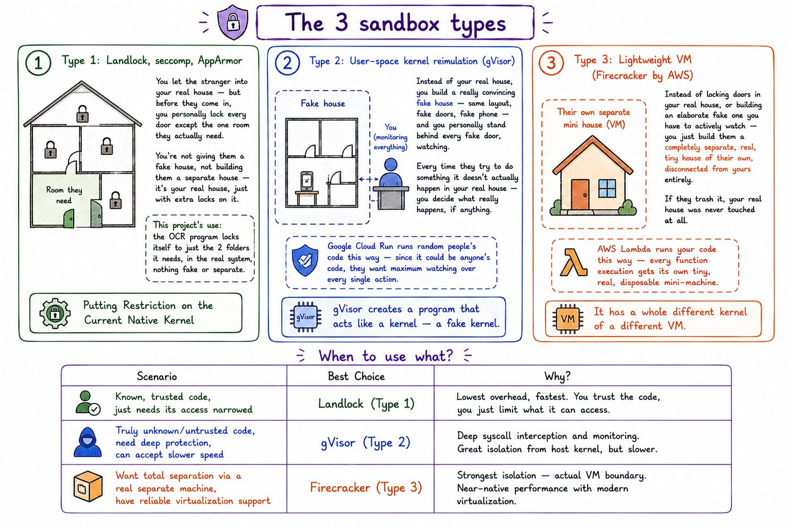
Landlock, gVisor and Firecracker compared by isolation strength and practicality. Landlock is the chosen starting point: a plain kernel feature a process applies to itself, needing no host-level runtime registration.
Platform note: Docker Desktop's LinuxKit kernel is 6.10 but ships without CONFIG_SECURITY_LANDLOCK, so this layer cannot run on macOS or Windows. The OCR entrypoint refuses to run unsandboxed rather than degrade silently, which disables the image-upload path on those hosts.

43 The sandbox workflow
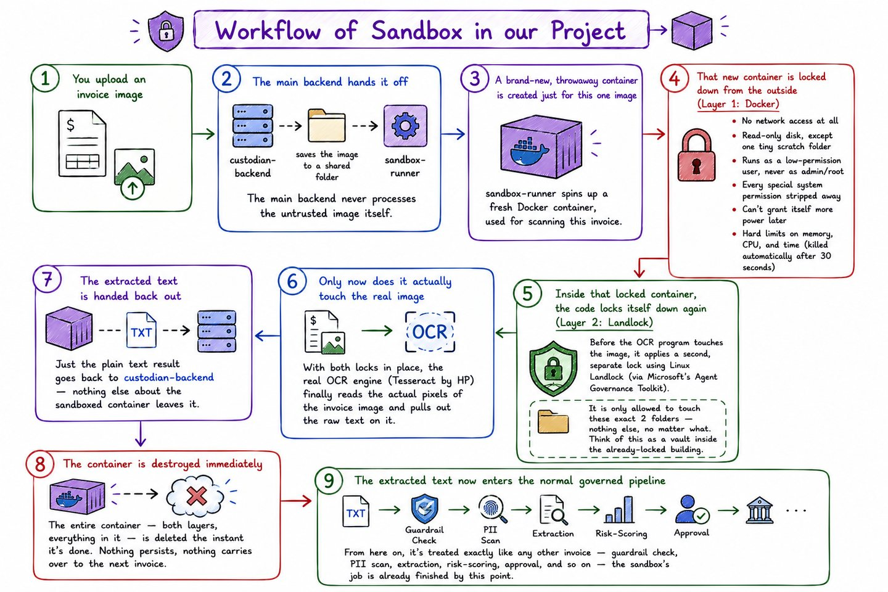
What actually happens to an uploaded image: a fresh container per execution, no network, a read-only filesystem apart from a scratch directory, a non-root user, dropped capabilities, hard resource limits, and destruction immediately afterwards.
Verified: network unreachable, uid 10001 rather than root, and writes to the image filesystem refused.

44 Instructor
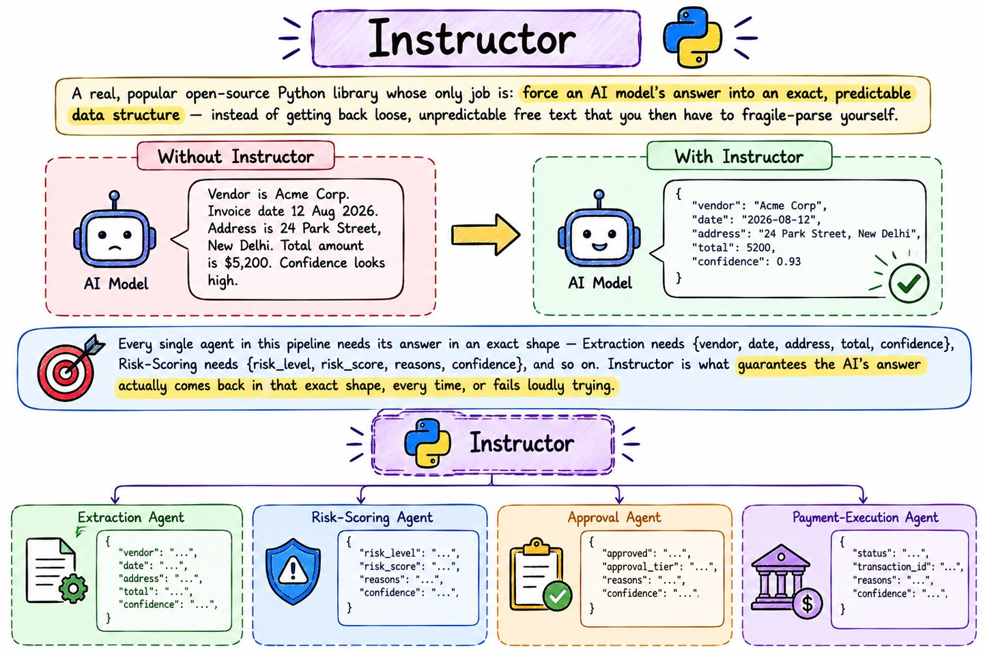
Forcing the model's answer into an exact, predictable data structure rather than hoping free text parses reliably. Fragile parsing is its own security problem: a field that silently comes back malformed becomes a decision made on wrong data.

45 Capability manifests
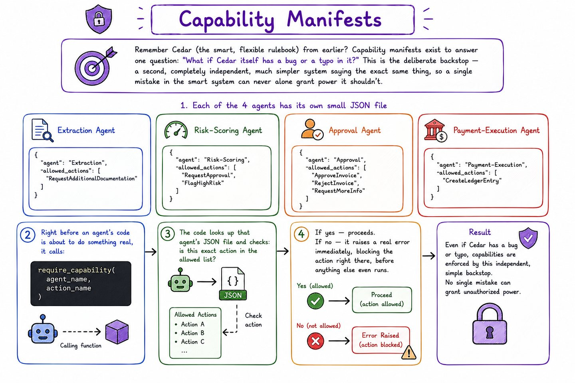
One small JSON file per agent listing the actions it may take. This is a second, independent check alongside Cedar, and that independence is the whole point — a single misconfigured policy must never by itself grant a lower-tier agent the ability to write to the ledger. Only Payment-Execution's manifest contains CreateLedgerEntry, and that same agent is denied ApprovePayment, so the agent that moves money cannot also authorise it.
Verified: Cedar and the manifest each independently deny Extraction the ledger-write action, and all three cross-agent privilege checks are refused.

46 Dual-agent critic verification
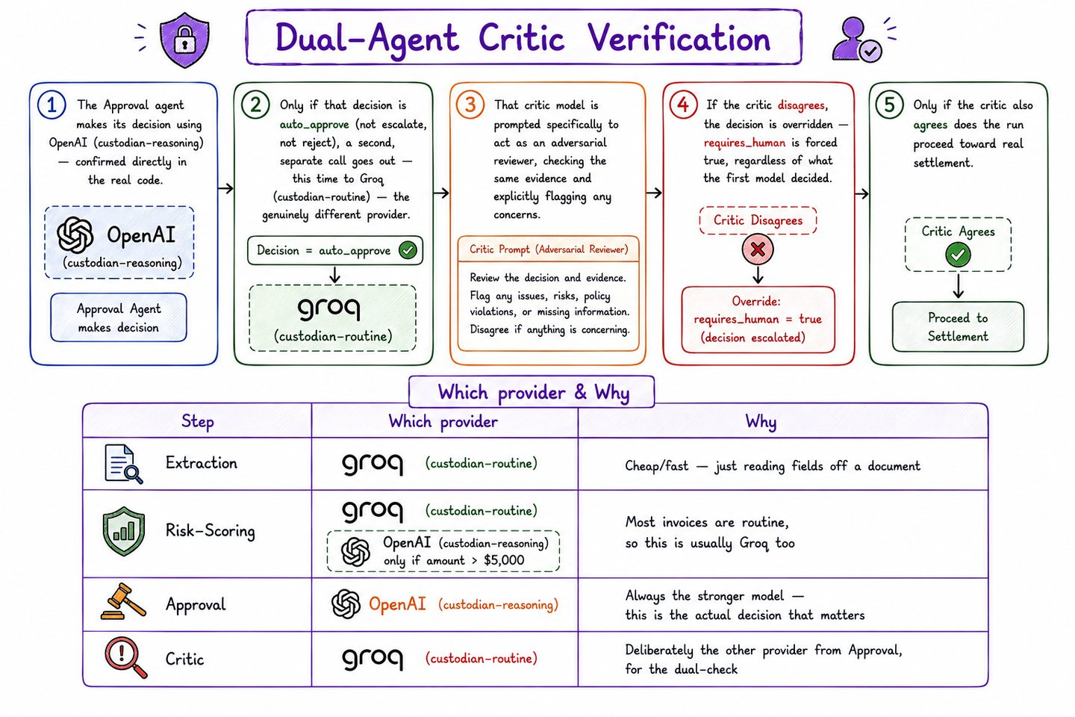
After the Approval agent decides to auto-approve, a second model from a different provider reviews the same evidence with an adversarial prompt. It does not see the first agent's identity or feel any pressure to agree. Disagreement is a hard stop that forces a human in.
Verified: on a clean repeat payment the critic ran on Groq and returned agrees=true with 0.99 confidence. Three deliberate attempts to provoke disagreement never reached it — each was caught earlier, by the guardrail, by risk-scoring, or by Approval itself.

47 Confidence-gated execution
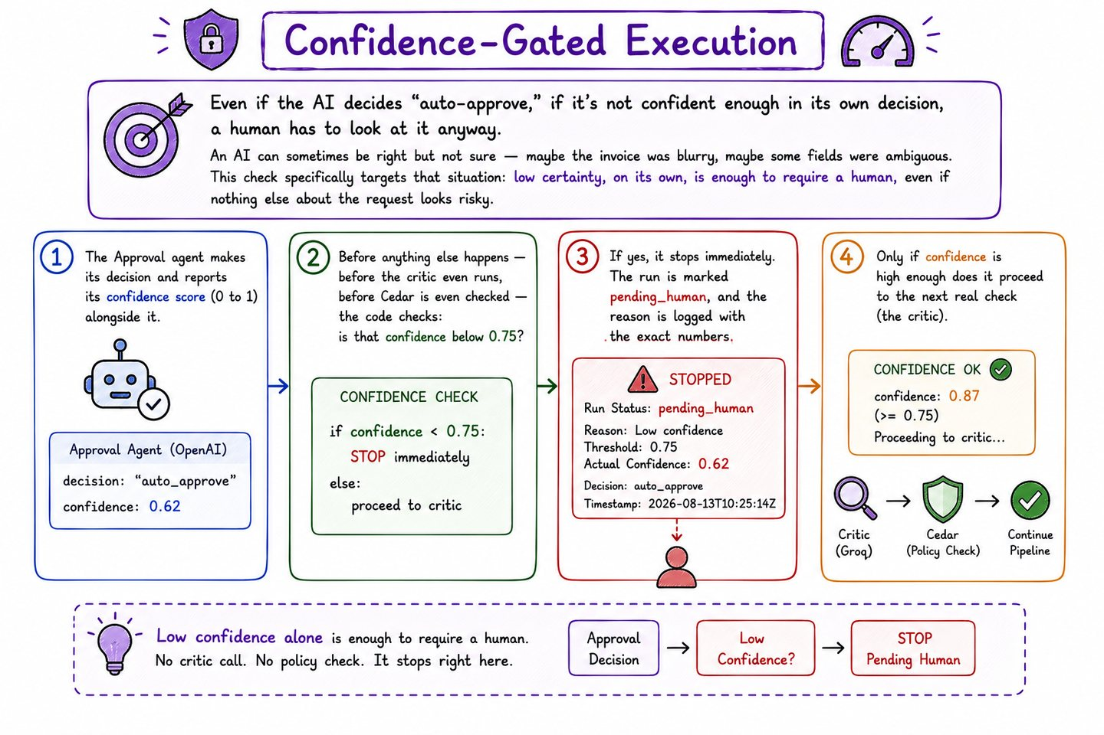
Reaching a decision is not enough; the agent also has to be confident in it. Below a hard threshold a human is pulled in regardless of what the decision was. The plate makes a subtle point worth keeping: extraction confidence and approval confidence are different signals, and only the latter gates this path.
Verified: on a deliberately self-contradictory invoice extraction confidence fell to 0.6 while approval confidence stayed at 0.92 — the facts were fuzzy, the decision was not.

48 Dry-run before commit
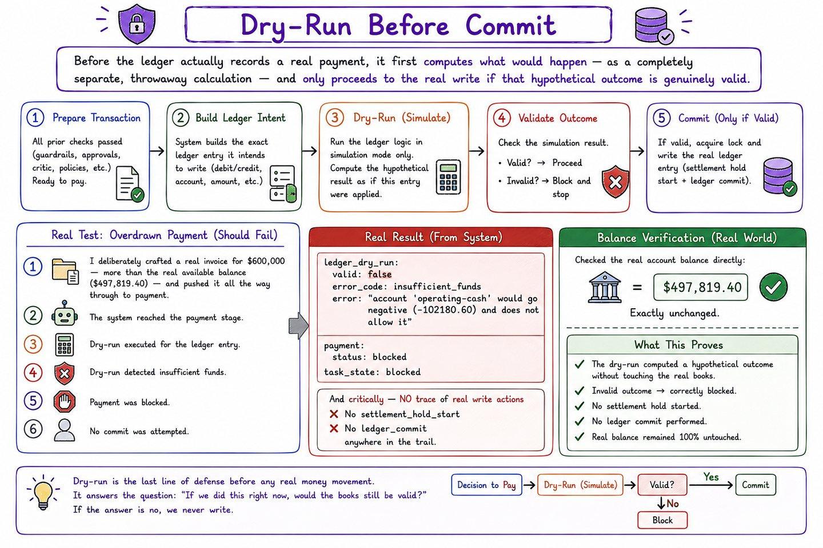
Before any payment moves, the ledger computes what would happen — does it balance, do the accounts exist, are the funds sufficient — without writing anything. A bad transaction is caught while it is still hypothetical.
Verified: unbalanced entries, insufficient funds and an unknown account were each rejected, the balance was unchanged afterwards, and the real commit endpoint rejected the same transaction with HTTP 422 — so the dry-run shares the actual validation rather than imitating it.

49 Self-expiring credentials
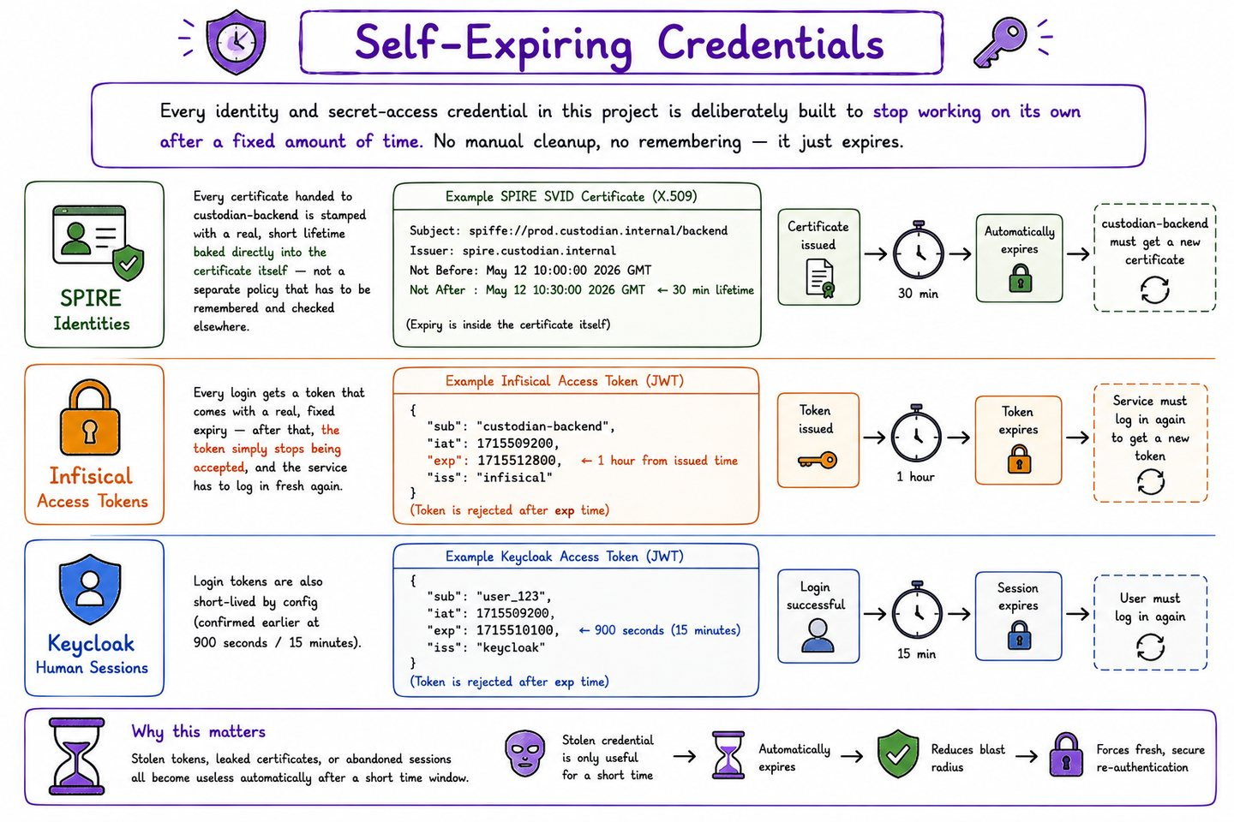
Every identity and access token is built to stop working on its own after a fixed period. No manual cleanup, no forgotten long-lived key, and a stolen credential has a short useful life.

50 The settlement hold window
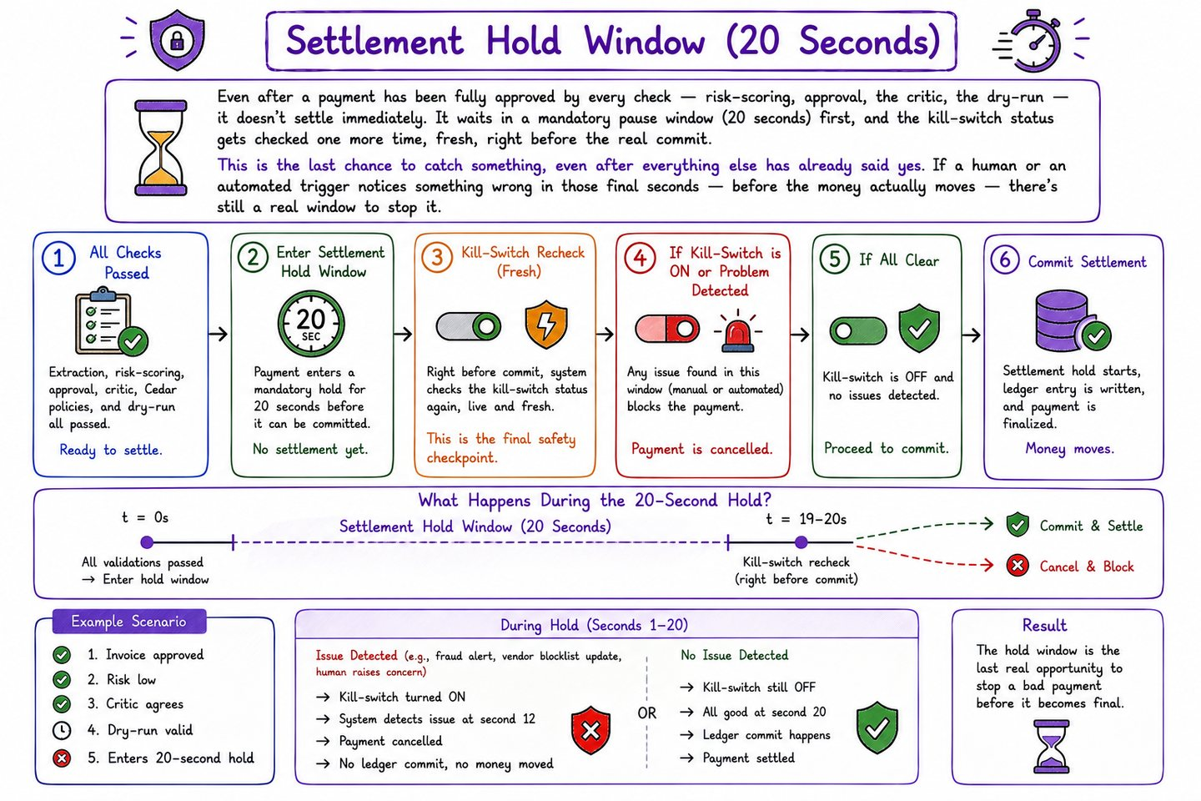
A deliberate pause between everyone agreeing and the money actually moving. The kill switch is re-checked at the end of that window, not only at the start, which is what makes the pause meaningful rather than decorative.
Verified: a payment approved by every agent and the critic was stopped mid-hold and ended in state settlement_hold_blocked, with the ledger balance identical before and after.

51 Watchdog heartbeats
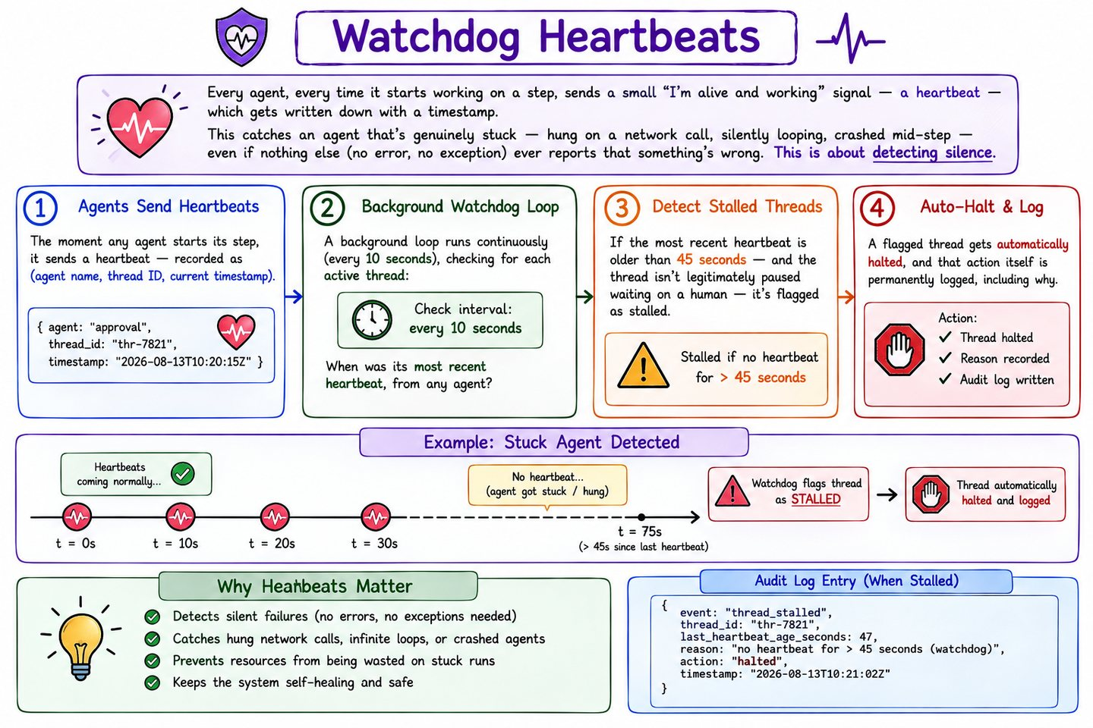
Each agent emits an 'I am alive' signal while it works. The absence of that signal is itself a detectable failure — which catches the stalls and hangs that never produce an error message and so would otherwise go unnoticed.

52 Automatic kill-switch triggers
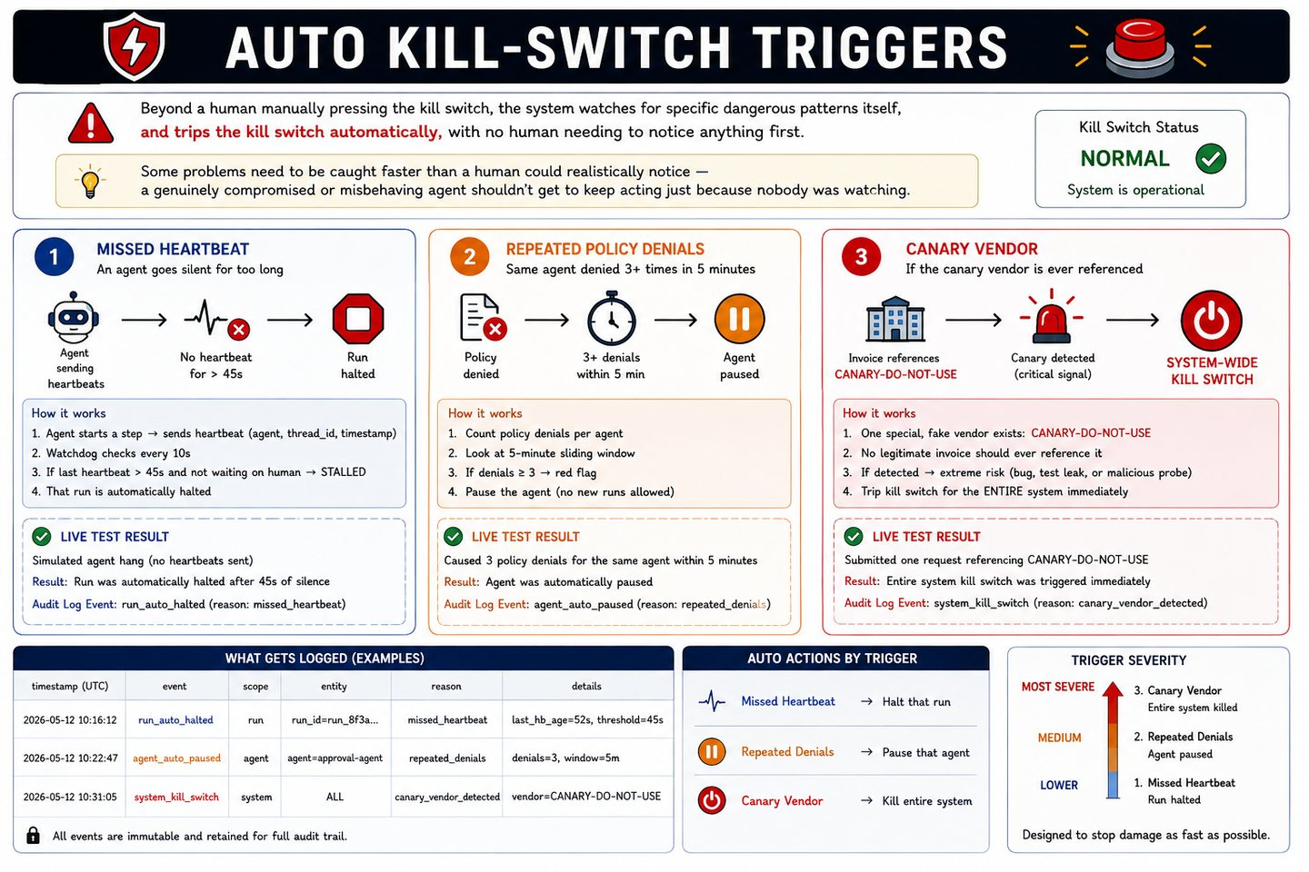
The switch trips itself, without waiting for a human to notice: repeated denials from one agent, a canary vendor name that should never appear in a real invoice, or a missed heartbeat.
Verified: touching the canary vendor tripped the global stop within seconds, and five consecutive denials automatically paused the offending agent.

IX. Operations governance
The safety net under everything above: tracing, metrics, and a record that cannot be quietly rewritten.

53 Tracing — OpenTelemetry into Langfuse
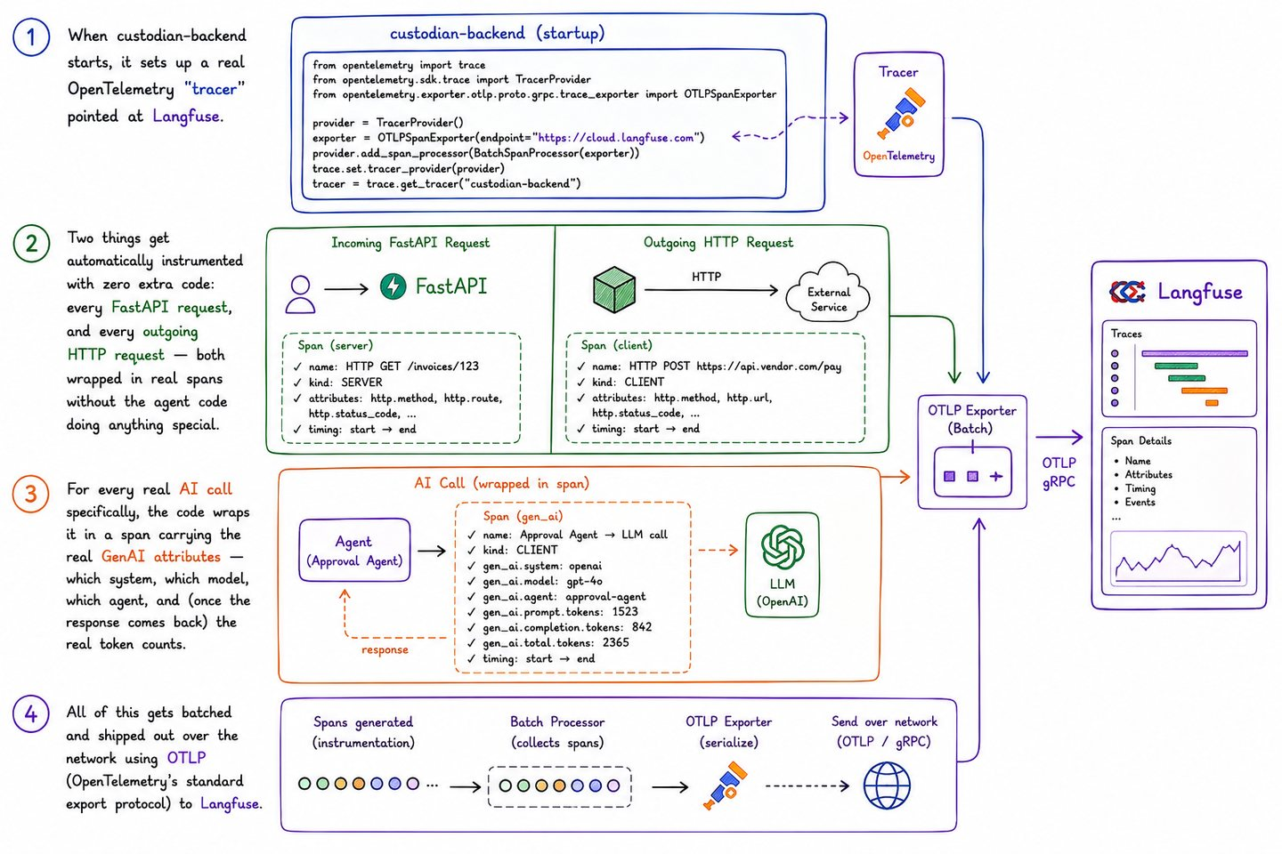
Every model call is wrapped in a span using the GenAI semantic conventions — a real open standard rather than project-invented naming — with token counts taken from the actual provider response.
Known gap: self-hosted Langfuse does not price the project's internal route names, so cost shows as zero there even though token counts are correct. Budget enforcement at the gateway is unaffected and prices on real spend.

54 Metrics — Prometheus and Grafana
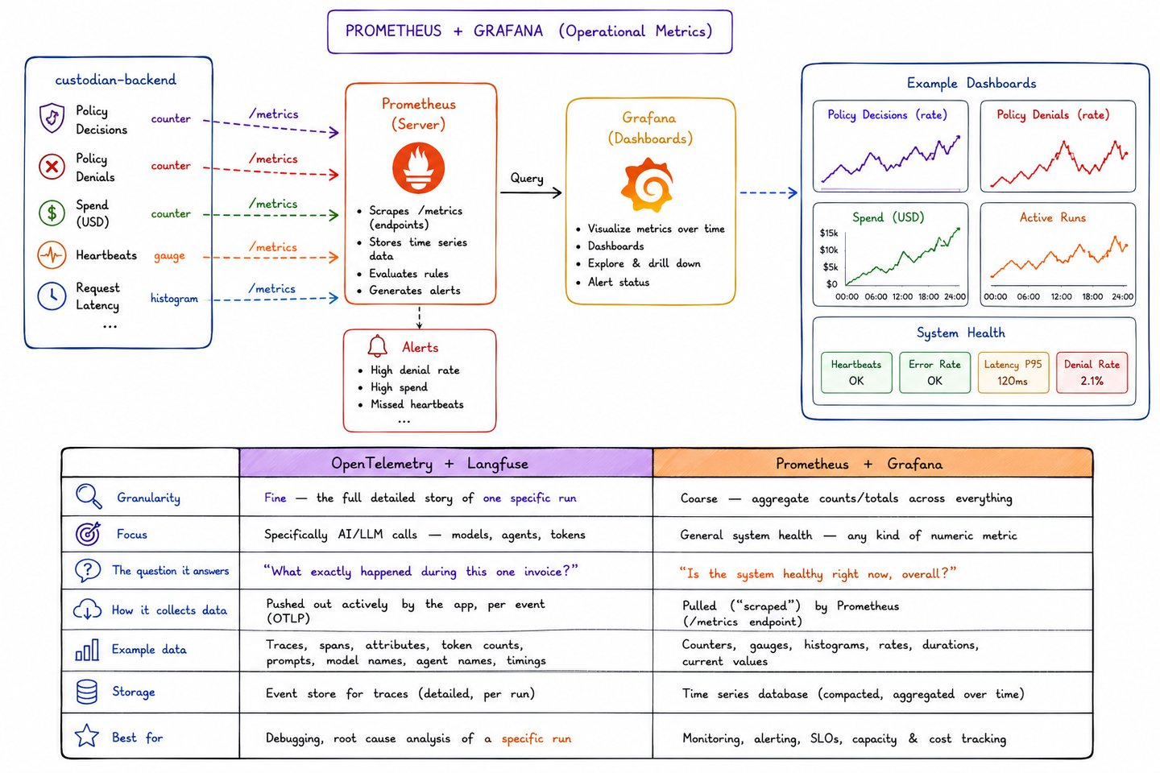
Policy decisions counted by action, decision and principal, with a provisioned dashboard reading from them. The test of a metric worth having is that you can cause exactly one real event and watch the number move by exactly one.

55 The tamper-proof audit log
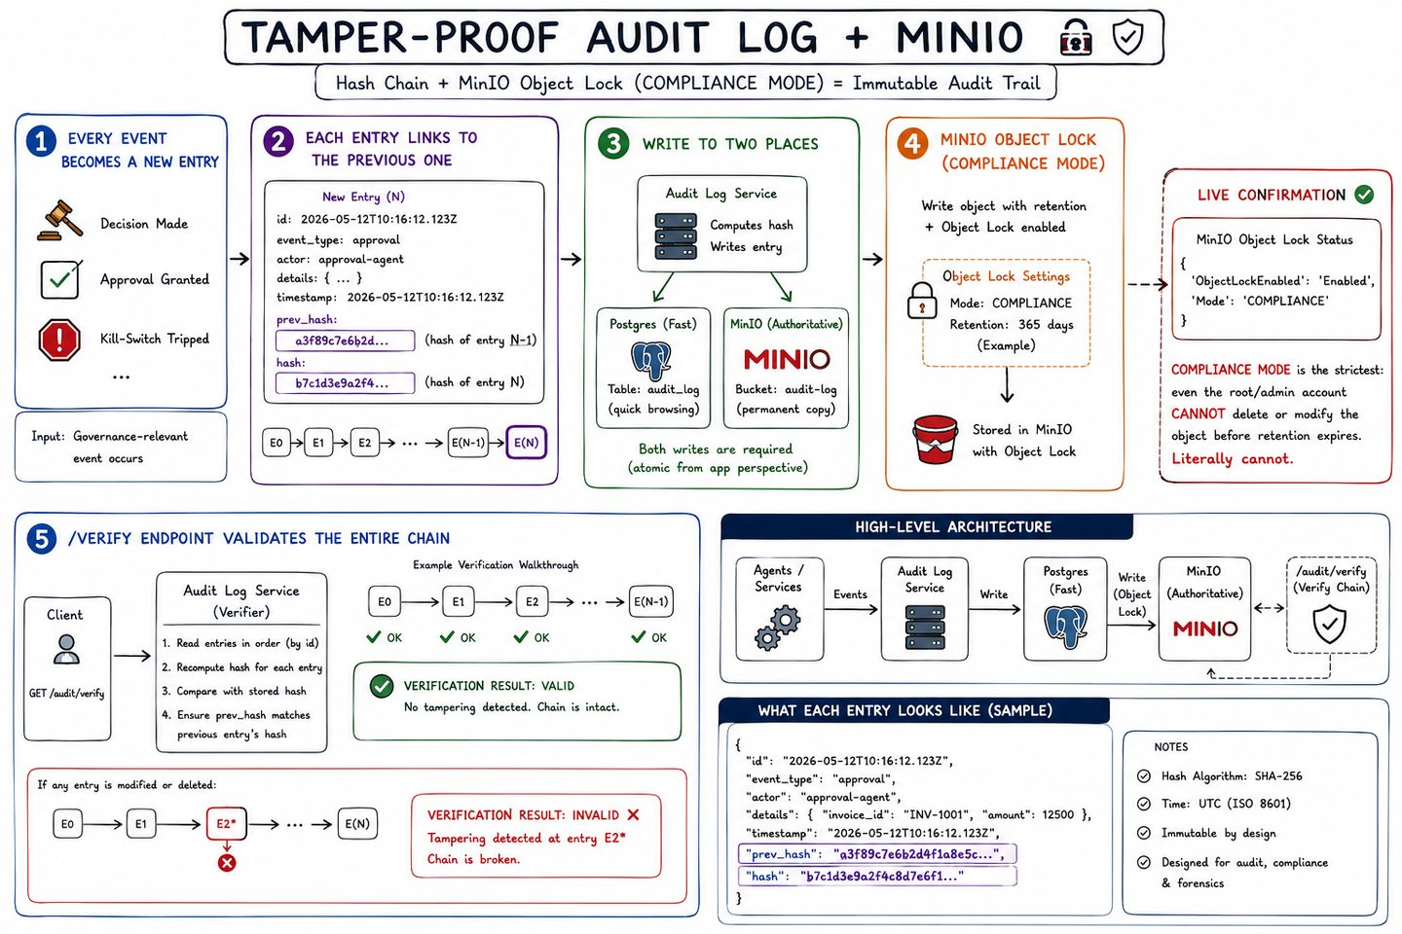
Each entry embeds the SHA-256 of the entry before it, forming a chain, and is written first to WORM object storage and then mirrored to Postgres for querying. Verification is two-stage: recompute the chain, then fetch the real object bytes and compare. Checking that a file still exists at a key is not proof, because a new version can be stacked on top of the original.
Verified: overwriting and deleting a locked entry was detected immediately; the original bytes were recoverable from the locked version; and the watchdog's tamper_detected and tamper_resolved entries both remain in the chain permanently, even after the data was restored.

X. Architecture and workflow
The whole system on one page, twice — once by component, once by flow.

56 Complete architecture
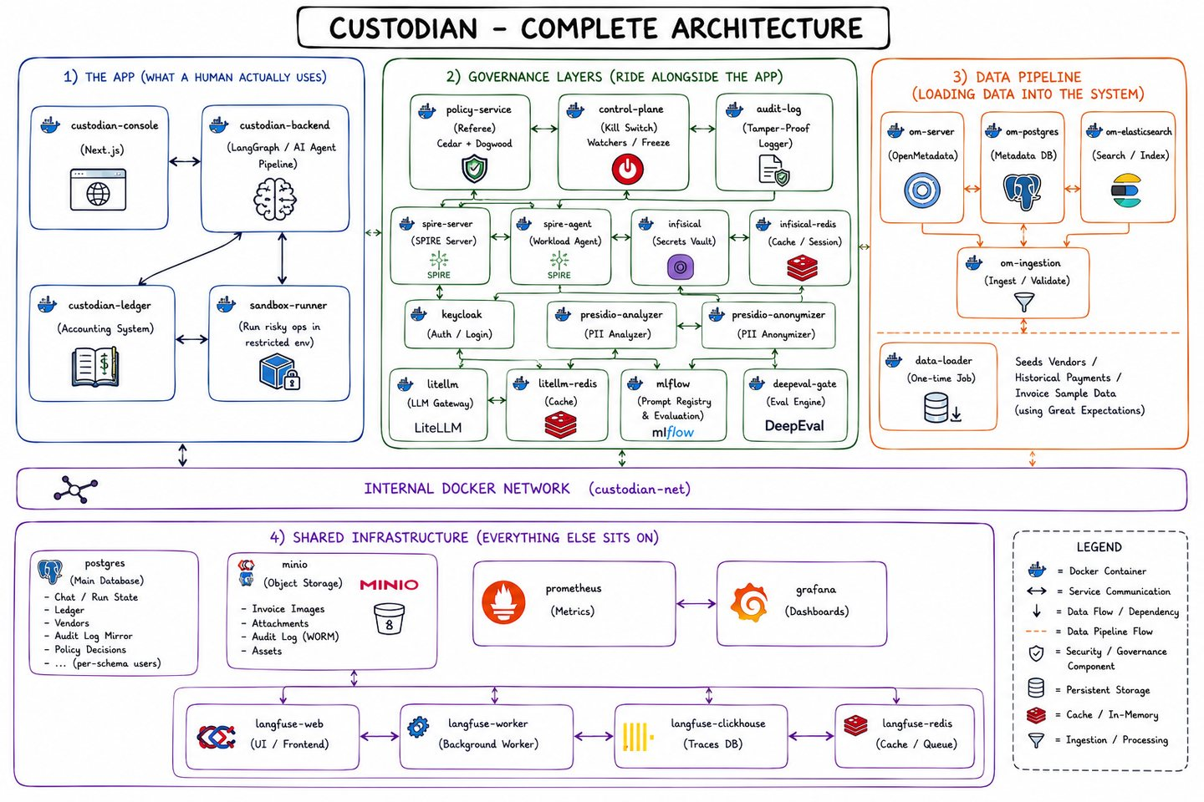
Every service in the system and how they connect, across the application, the governance layers, the data pipeline and the shared infrastructure they all sit on.

57 Full workflow
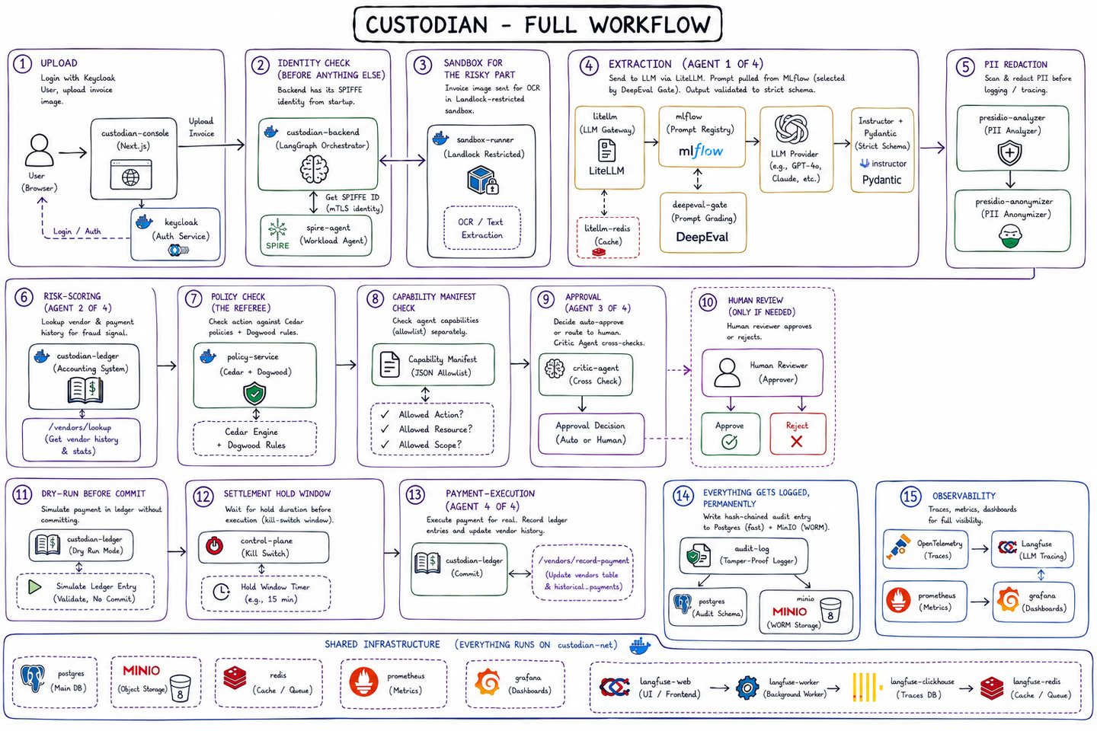
The end-to-end path of a single invoice through all six governance layers, from upload to settled payment and permanent record.

What the board adds up to
Read straight through, the board makes an argument rather than just describing a system. It starts from a business reality — a bank must prove, not merely believe, that every payment was correct — and shows that automating the work removes the very thing that used to supply that proof: a human who could be asked what they were thinking.
Each governance layer then restores one piece of what was lost. Identity re-establishes who is acting. Data governance decides what may be kept. Model governance constrains what each agent may use and spend. Policy restores the deterministic rulebook that does not care how confident a model is. Agent Runtime supplies the fourteen controls that a careful finance department would have applied through procedure. Operations restores the auditor.
The redundancy is the design, not an accident of it. Three separate plates — the capability manifests, the dual-agent critic and the dry-run — all exist to catch failures the others would miss, and the scenario testing bore that out: three deliberate attempts to provoke a critic disagreement never reached the critic, because an earlier control had already stopped them. That is what defence in depth looks like when it is working.
Generated from Custodian.excalidraw. Plates appear in board order; captions and explanations were written for this document.

