Custodian
  - Governed multi agent invoice processing
Project overview | September 2026 | Source baseline c1276d4
Custodian processes supplier invoices through four specialized agents: Extraction, Risk-Scoring, Approval, and Payment-Execution. A separate set of policy, identity, data, model, and operational controls determines what those agents may do and records evidence of their actions.
The project demonstrates accounts payable automation from invoice intake to internal ledger settlement. It combines automatic processing with durable human review, so a questionable invoice can pause for a decision before execution.
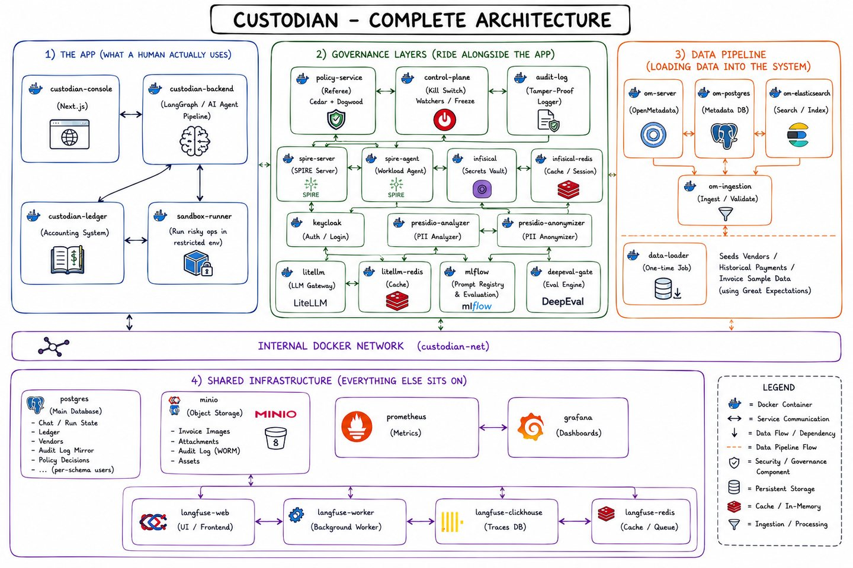
Figure 1. Platform architecture from the Visual Guide, plate 56. The drawing groups application services, governance, data loading, and shared infrastructure. [2]
Demonstrated scope. The recorded suite contains 20 scenarios: 15 pass, four pass with notes, and one partial result. Payments update the project’s double-entry ledger; an external bank-transfer integration and production acceptance are outside the demonstrated scope. [1]
Source repository • Architecture, workflow, controls, screenshots, setup, and validation in one reference.

02 / CUSTODIAN

The invoice journey
LangGraph connects four agent nodes and a checkpointed human-review node. The critic is an additional model call inside Approval, not a separately deployed fifth agent.
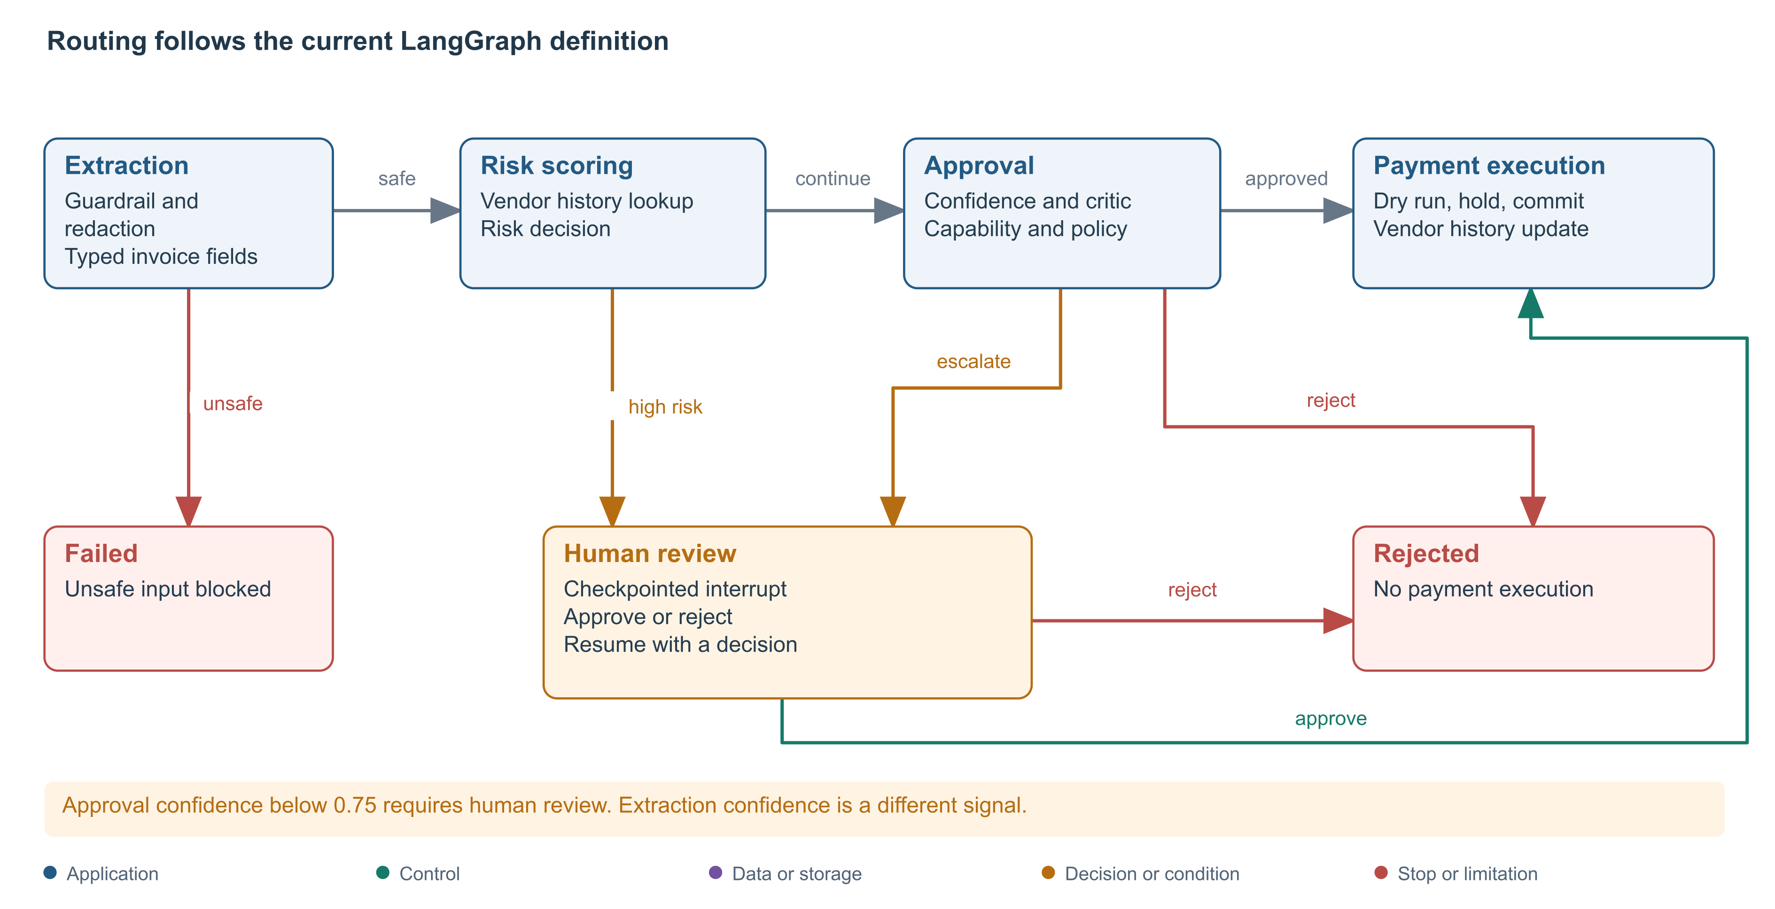
Figure 2. Execution branches from graph.py and the agent nodes. Unsafe input and rejection end the run; approved human review resumes toward payment. [3]
1 Intake and extraction. The console accepts text or an image. Images pass through isolated OCR on a supported host. A guardrail checks the resulting text, Presidio prepares an audit-text copy, and safe input is extracted into typed vendor, date, address, and total fields.
2 Risk assessment. Risk-Scoring looks up the vendor’s stored payment count, average amount, and recent amounts. High risk can route directly to human review without visiting Approval.
3 Approval. Approval can reject, escalate, or propose automatic approval. Confidence below 0.75 requires a person. A proposed automatic approval receives a critic review, followed by capability and policy checks. Disagreement or a policy denial escalates.
4 Settlement. Payment-Execution checks its own authority, validates the ledger entries, waits through the settlement hold, rechecks stop state, and commits. It then records the settled payment in vendor history and returns the transaction identifier.
What persists. PostgreSQL stores graph checkpoints, including the interrupted state. A human decision resumes the same thread. Run evidence is sent to the audit service; token usage and model-call traces support investigation.
Implementation: custodian-backend/app/graph.py, nodes/, main.py, and schemas.py. [3]

03 / CUSTODIAN

Technology stack
The application is implemented in Python and TypeScript. Docker Compose assembles six configuration layers around a shared network; supporting services provide identity, storage, policy, evaluation, and observability.
Area | Technology | Purpose
Operator console | Next.js, React, TypeScript, Tailwind CSS, NextAuth.js | Invoice submission, review queues, run status, audit, ledger, and controls.
API and agents | Python 3.12, FastAPI, Uvicorn, LangGraph | Service APIs, workflow routing, and durable human interrupts.
Typed model outputs | Instructor, Pydantic, OpenAI-compatible client | Validate model responses against explicit schemas and retry malformed output.
Identity and secrets | Keycloak, SPIFFE/SPIRE, Infisical | Human login and roles, workload identity, and ledger credential brokering.
Data governance | OpenMetadata, Microsoft Presidio, Great Expectations | Catalog data, redact selected audit text, and report batch data quality.
Model access | LiteLLM, OpenAI, Groq | Named model routes, per-agent virtual keys, route restrictions, and spending caps.
Prompt lifecycle | MLflow, DeepEval | Track extraction prompts, evaluate held-out fields, and promote a production version.
Authorization | Cedar through cedarpy; Dogwood specification; Python | Static permission decisions plus temporal rules over stored decision history.
OCR isolation | Tesseract, Docker, Agent Governance Toolkit, Landlock | Read invoice images in a disposable container and restricted subprocess.
Database and ledger | PostgreSQL, psycopg, SQLAlchemy | Run checkpoints, service data, vendor history, and transactional ledger entries.
Objects and support | MinIO Object Lock, Redis, ClickHouse, Elasticsearch | Audit objects, caches and queues, trace storage, and catalog search.
Operations | OpenTelemetry, Langfuse, Prometheus, Grafana | Model-call traces, metrics, dashboards, and investigation.

Service boundaries
The console calls the backend; the backend consults policy, ledger, identity, and operational services. The control plane and audit log run separately from the agent process. Shared PostgreSQL hosts service databases, while OpenMetadata and Langfuse add their own supporting components.
Version authority: package.json, service requirements.txt files, Dockerfiles, and infra/compose/. Tool names describe the inspected repository, not a claim about the latest vendor releases. [4]

04 / CUSTODIAN

Governance and decision authority
Each layer answers a different question. Model confidence contributes to a decision, but deterministic policy and execution checks constrain the actions the runtime can take.
Layer | Control in the implementation
Identity | Keycloak authenticates console users. SPIRE supplies workload identity to the backend process. Infisical brokers the ledger credential for payment requests.
Data | OpenMetadata catalogs invoice and vendor data. Presidio prepares redacted audit text. Great Expectations reports quality results for loaded invoice records.
Model | LiteLLM scopes routes and budgets. MLflow and DeepEval govern extraction prompt promotion. Instructor and Pydantic validate structured answers.
Policy | Cedar evaluates principal, action, and resource. Python applies the Dogwood temporal specification using the PostgreSQL decision log.
Agent runtime | Capability manifests constrain actions independently of Cedar. Guardrail, critic, confidence, human review, sandbox, dry-run, and hold checks constrain processing.
Operations | A separate control plane handles stops and heartbeats. Audit verification, traces, metrics, and dashboards expose what happened.

Configured decision rules
Cedar forbids agent approval above $5,000 and defines a permit for a human with approval tier 2 or higher above that threshold. A separate rule requires an approval count of at least two for first-seen vendors. The temporal layer denies a fourth approval to the same vendor within a rolling 24-hour window, even if Cedar allows the individual request.

Separation of duties
Only Payment-Execution’s manifest contains CreateLedgerEntry. That agent is denied ApprovePayment. Risk-Scoring has a narrower credential for vendor-history lookup; payment calls fetch the ledger write credential through Infisical. The vault access token is cached until shortly before expiry, while the ledger key is fetched for each request.

Human review boundary
The console permits controller and cfo-approver roles to submit a review decision. The backend resume handler currently forwards the decision without independently evaluating the person against Cedar or counting distinct approvers. The dual-approval policy therefore exists, but complete two-person enforcement is not established by the application evidence.
Sources: capability manifests, policies/, policy-service/app/temporal.py, ledger_client.py, and console/backend resume handlers. [3]

05 / CUSTODIAN

Data and model lifecycle
Custodian uses recorded vendor history to inform risk, and separates prompt evaluation from runtime inference. Both paths have explicit operational limits.
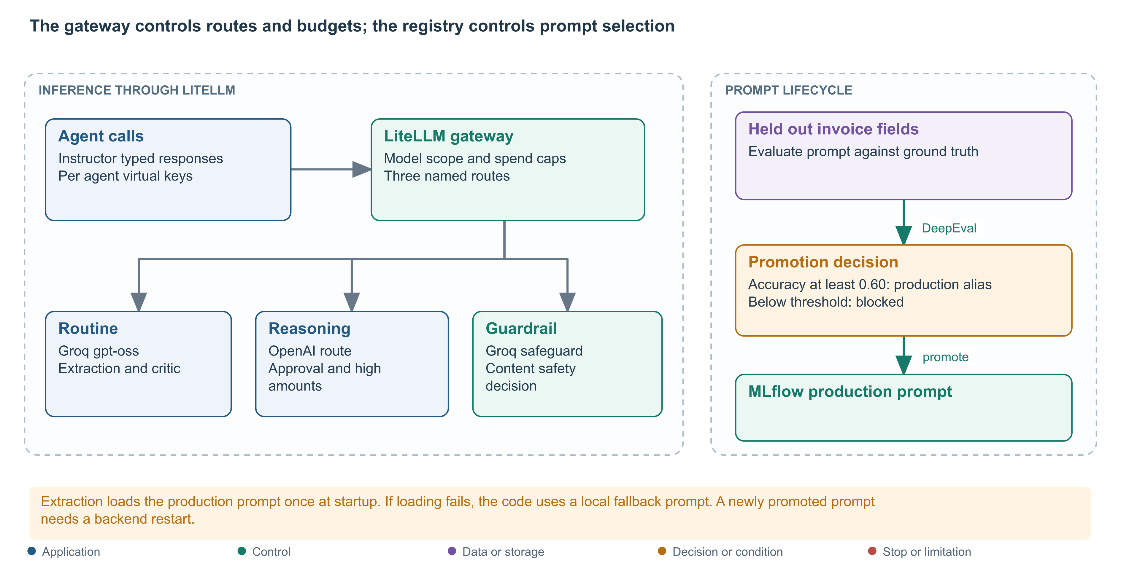
Figure 3. Inference routes and extraction prompt promotion. The production alias is loaded at backend startup; a local fallback prompt is used if loading fails. [3]

Data entering the system
The loader seeds SROIE and CORD invoice examples, with vendor and historical award data from USAspending. Great Expectations reports quality failures without blocking the batch. OpenMetadata adds catalog and sensitivity information. At runtime, vendor trust is calculated from stored history rather than a caller-supplied “known vendor” flag.

Model selection and quality
The routine route serves extraction, lower-value risk assessment, and the critic through Groq. Approval and risk assessment above $5,000 use the OpenAI reasoning route. A separate Groq safeguard route classifies unsafe invoice content. LiteLLM constrains model access and spend through scoped virtual keys.
DeepEval grades extraction fields against held-out annotations. The configured promotion threshold is 0.60: the recorded evaluation promoted v1 at 0.654 and blocked v2 at 0.000. These are extraction-quality results, not fraud-detection accuracy. A newly promoted prompt takes effect after the backend restarts. [1]

Privacy boundary
Extraction receives raw text so it can read invoice fields. Presidio redacts selected audit text, but raw input also exists in checkpointed state and other structured fields may contain personal data. On a Presidio request failure, the helper returns the original text. The successful redaction test does not prove protection of every storage path.
Sources: data-loader/, nodes/extraction.py, nodes/risk_scoring.py, pii.py, litellm/config.yaml, and deepeval/eval_gate.py. [3, 4]

06 / CUSTODIAN

The operator experience
The console provides a working view of the pipeline and the evidence behind a review decision. The screenshots below are existing captures from the project documents, not new runs performed for this publication.
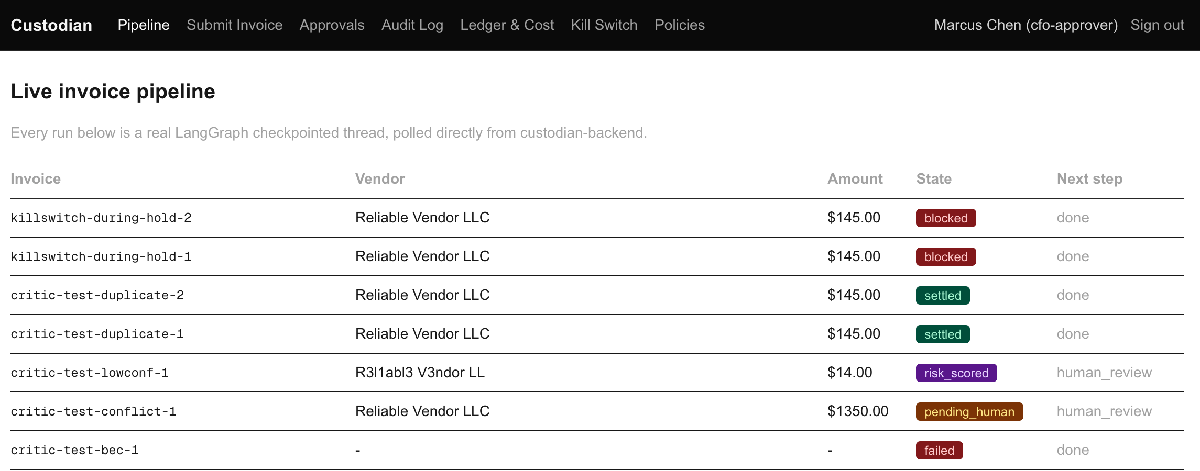
Figure 4. Pipeline excerpt from the recorded validation run. Settled, blocked, failed, and human-review paths are visible together. Lower rows are omitted for readability. [1, Figure 1]
Track the run. A row corresponds to a checkpointed workflow thread. A blocked or failed invoice can be the correct result when a governance control prevents unsafe execution; it does not automatically mean the test failed.
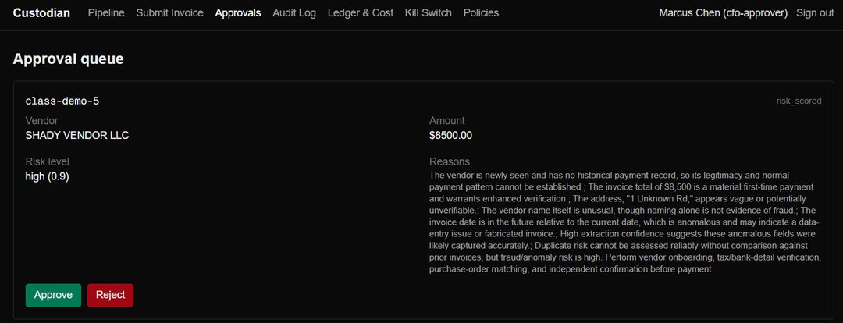
Figure 5. Approval queue excerpt from the Visual Guide, plate 19. The operator sees the vendor, amount, risk assessment, and Approve or Reject actions. [2]
Review the evidence. Inspect the extracted fields and risk rationale, then approve or reject using an authorized console role. Approval resumes the existing thread toward payment. A rejected decision ends the workflow.
Screenshots show demo identities and scenario data. Their invoice states and model explanations belong to those captures; they are not promises of identical future model output.

07 / CUSTODIAN

Payment execution and settlement
Settlement is a real transaction in the project ledger. The implementation posts a debit to vendor-expense and a credit to operating-cash, using an idempotency key derived from the invoice ID.
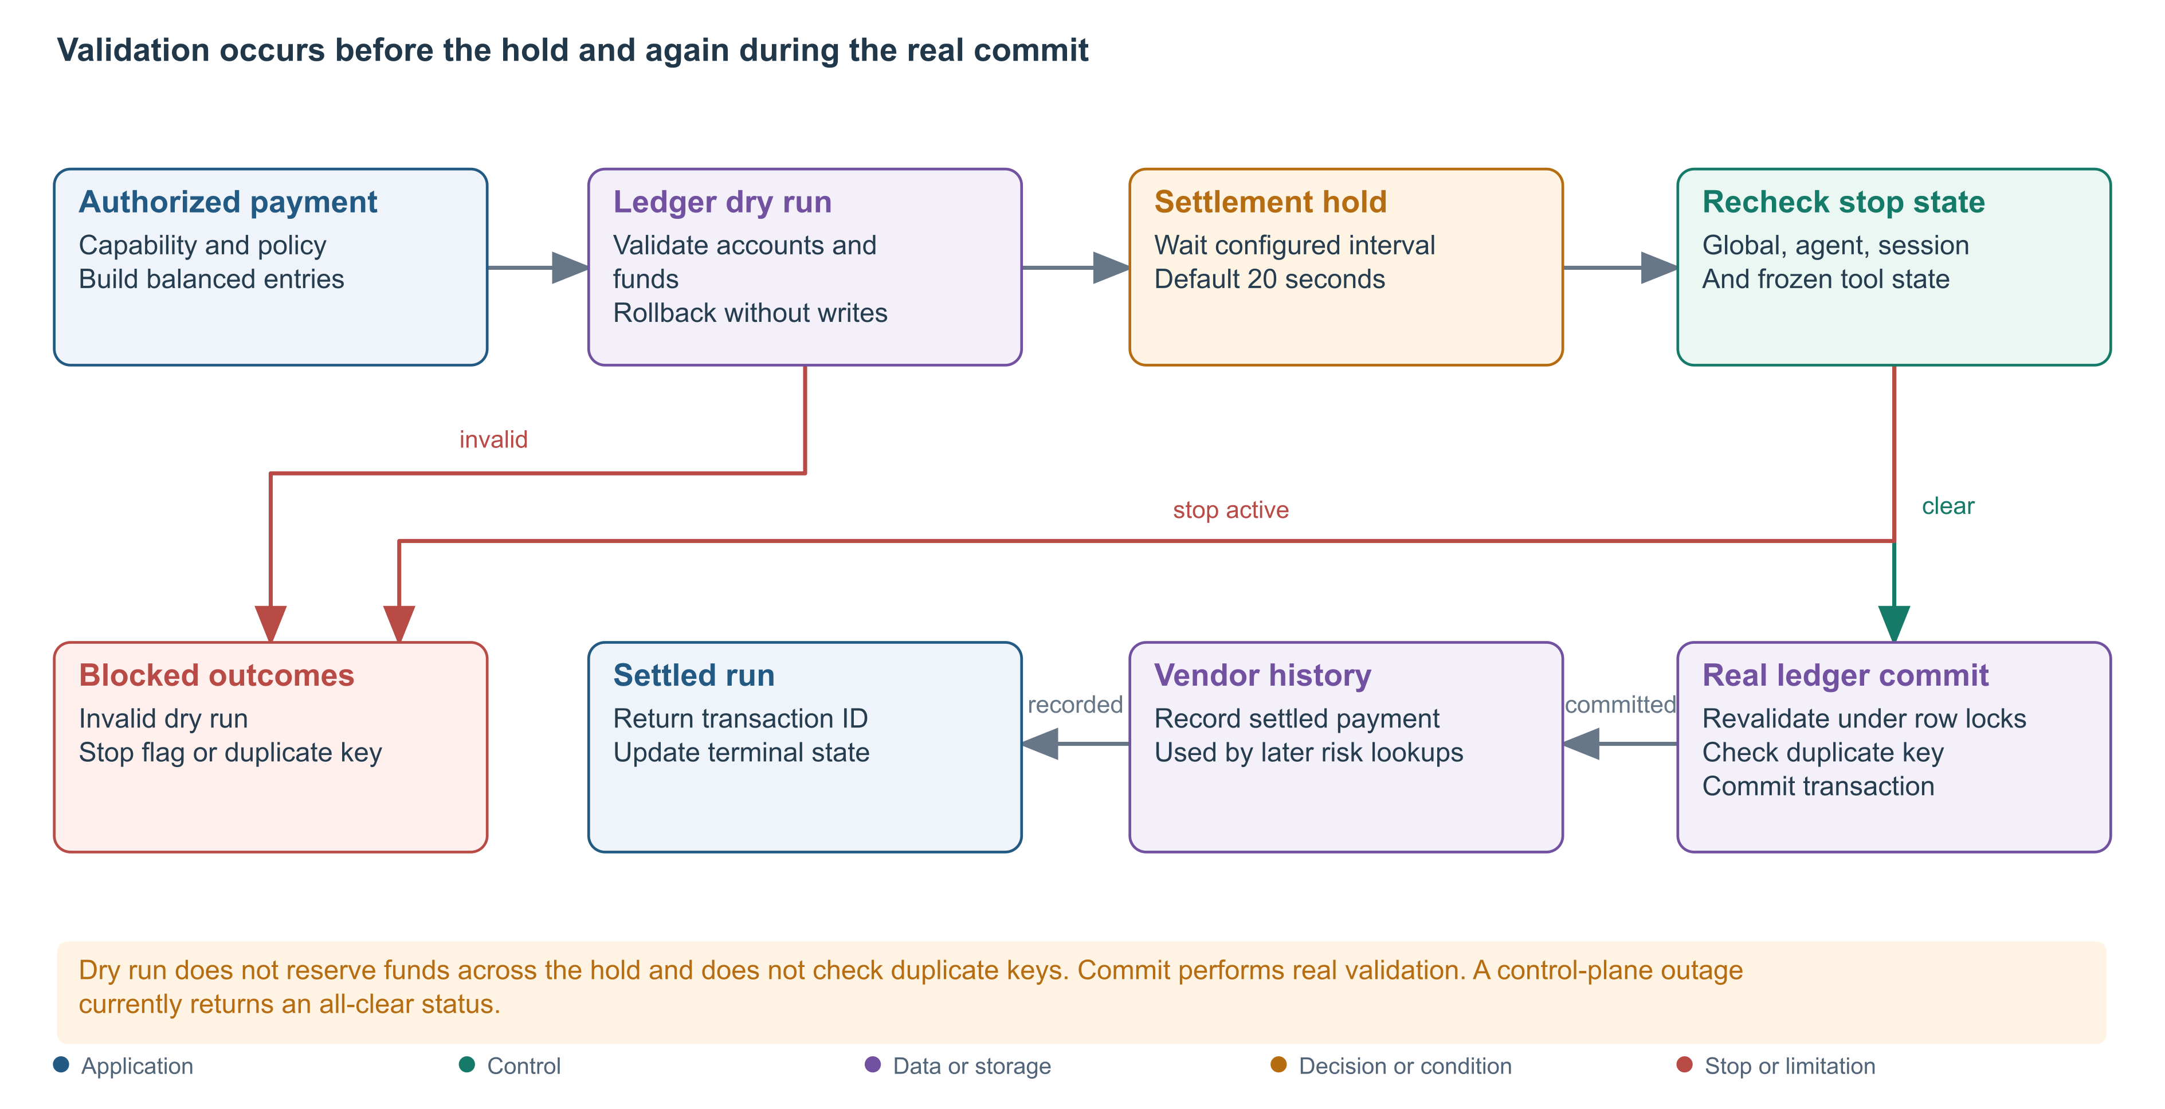
Figure 6. Settlement checks from payment_execution.py and ledger.py. The default hold is 20 seconds and can be configured. [3]
The dry-run checks balanced entries, valid accounts, and sufficient funds without committing. It does not reserve funds across the hold or check duplicate keys. The real commit repeats validation under database row locks and rejects an existing invoice idempotency key.
After the hold, the runtime checks global stop, paused agent, halted session, and frozen tool state. Scenario 19 records a stop during this window with no ledger movement. If vendor-history recording later fails, the successful ledger settlement remains and the bookkeeping failure is recorded separately. [1]
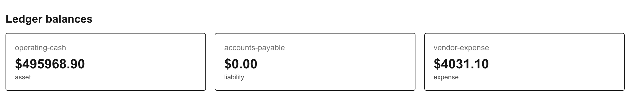
Figure 7. Ledger balances from the recorded suite: operating cash $495,968.90 and vendor expense $4,031.10. This excerpt shows aggregate balances after multiple scenarios, not one invoice. [1, Figure 4]
Duplicate boundary. Reusing the same invoice ID is rejected. Equivalent invoice content submitted under a new ID is not covered by that idempotency check.
Operational limit: the runtime currently treats a control-plane request failure as all-clear. A verified stop during a healthy-service test does not establish safe outage behavior. [3]

08 / CUSTODIAN

Audit evidence and operational control
The audit log combines a SHA-256 chain with retained MinIO object versions. Verification checks both hash linkage and the actual bytes currently served by object storage.
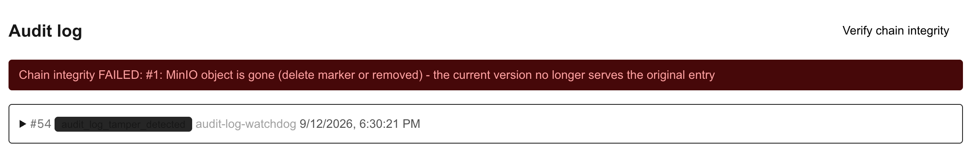
Figure 8. Tamper-detection excerpt. The current object view fails integrity verification, and the watchdog records audit_log_tamper_detected. [1, Figure 2]
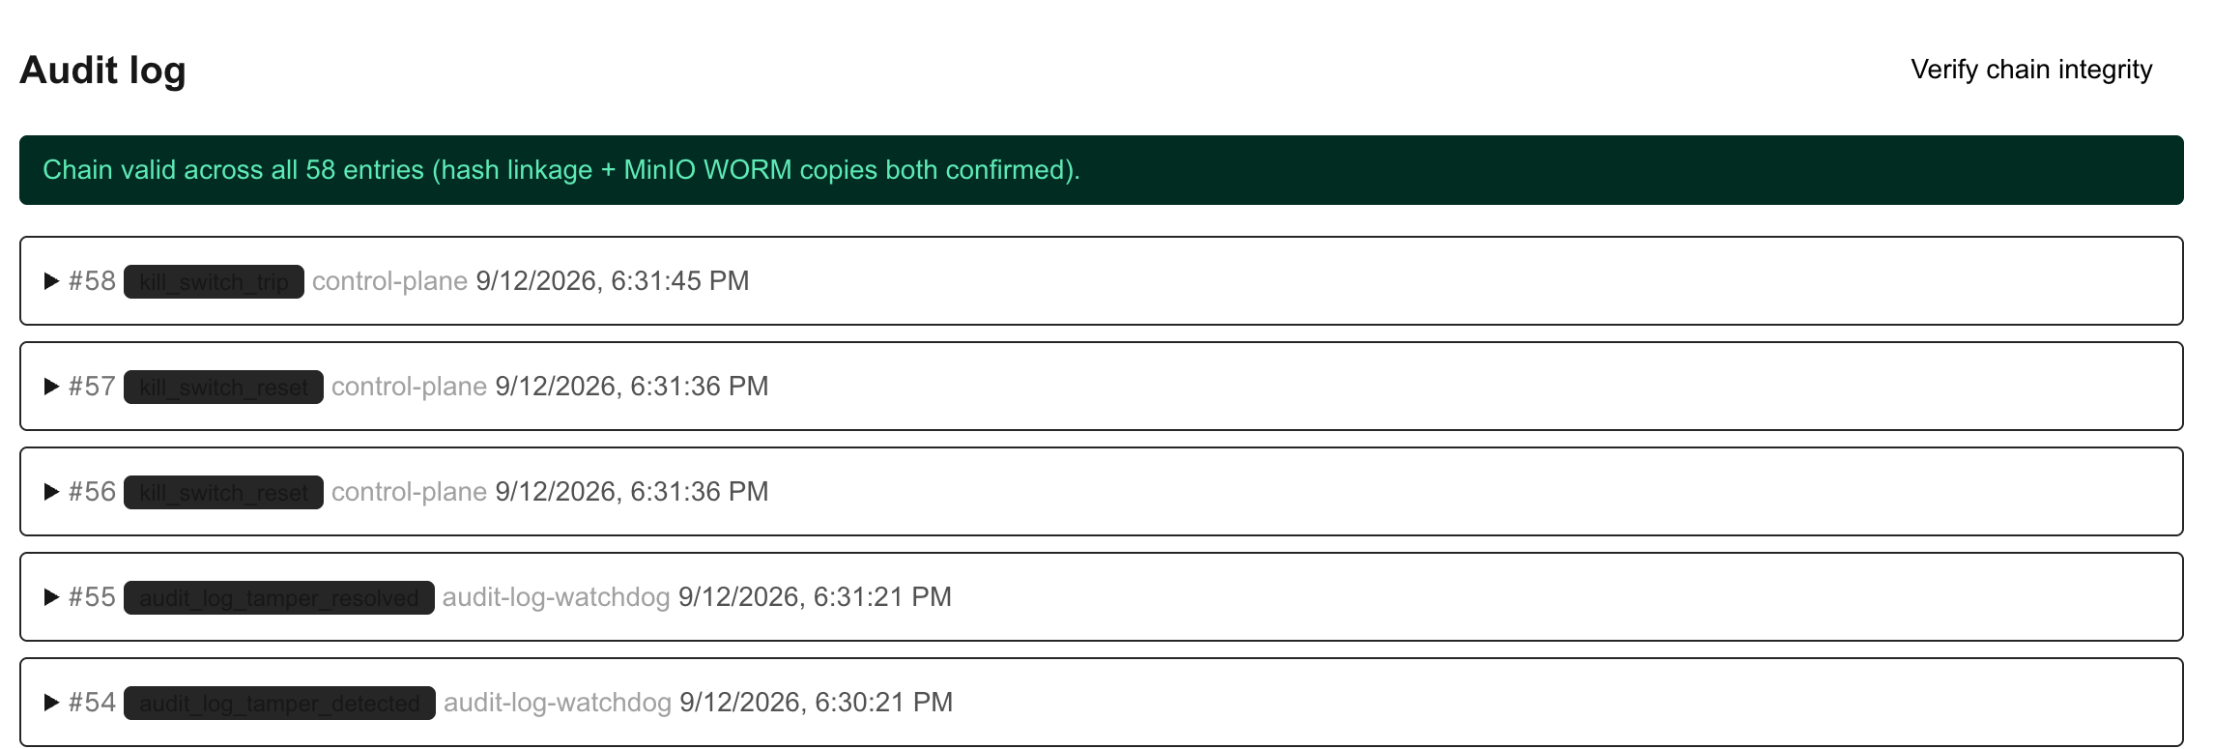
Figure 9. Recovery excerpt. Verification succeeds across 58 entries in this capture, while detection and resolution events remain in the chain. [1, Figure 3]

What the audit design establishes
The service writes the MinIO object before committing the PostgreSQL query row. These are ordered application steps, not one distributed atomic transaction. Object Lock protects a retained version; a newer version or delete marker can still change the current view. In scenario 15, an operator restored the original bytes and verification recovered without erasing the detection history.

How operators stop and investigate a run
The control plane supports a global stop, agent pauses, session halts, and tool freezes. Watchdogs inspect stale heartbeats, repeated denials, and a canary vendor. OpenTelemetry exports model-call spans and actual token counts to Langfuse; Prometheus scrapes policy-service and LiteLLM, with Grafana providing dashboards.
The report’s final-state table records 57 verified entries, while the screenshot displays 58. These are separate captures. Neither count is presented as the current live system state. [1, 3]

09 / CUSTODIAN

What the validation demonstrated
The supplied report dated 12 September 2026 records 20 scenarios on a live Docker Desktop instance using real OpenAI and Groq calls. This document reuses that evidence; it does not represent a fresh test run.
Verdict | Count | Interpretation
Pass | 15 | Behavior matched the scenario.
Pass with notes | 4 | Protective behavior worked, with documented qualifications.
Partial | 1 | Docker isolation passed; Landlock was unavailable on the tested kernel.
Fail | 0 | No failed scenarios were reported in that suite.

Test area | Observed result
Workflow and credentials | Scenario 01 moved from human review to settlement with 12 audit steps. Scenario 02 verified ledger credential brokering.
Unsafe input and privileges | Scenario 08 blocked an injected instruction. Scenarios 09–10 demonstrated capability and policy denials across agent boundaries.
Models and budgets | Scenarios 04–05 promoted and blocked different prompts. Scenario 12 returned HTTP 403 for an out-of-scope route and HTTP 429 over budget.
Authorization over time | Scenarios 06–07 tested valid and invalid policy changes. Scenario 20 allowed three approvals and denied the fourth for the same vendor.
Operational stops | Scenarios 13–14 exercised manual and automatic stops. Scenario 19 stopped an approved payment during the hold without moving funds.
Audit and accounting | Scenario 15 detected tampering and verified recovery. Scenario 18 rejected invalid dry-runs and invalid real commits.

How to interpret the qualified results
The four passes with notes are redaction labels, the macOS policy-edit command, critic behavior, and differing extraction versus approval confidence. The critic-agreement path was observed; attempted disagreement inputs were stopped earlier, so the disagreement branch was not independently demonstrated.
The partial result is scenario 11. Docker network isolation, non-root execution, and a read-only filesystem passed. The tested LinuxKit kernel lacked Landlock support, so the OCR worker refused to continue. Text submission remained usable.
Evidence source: Custodian-Scenario-Validation-Report.docx, summary, detailed results, and findings. Scenario-specific results are historical and bounded by that environment. [1]

10 / CUSTODIAN

Deployment and demonstration
The repository provides a staged local setup. The full stack combines application containers with identity, catalog, model, and monitoring services, so the supporting infrastructure must be ready before the invoice workflow starts.

Prepare the host
The project README calls for at least 20 GB allocated to Docker, about 25 GB of image storage, and six or more CPU cores. Obtain OpenAI and Groq API keys, copy .env.example to .env, and follow the provisioning steps. Use a Linux kernel with Landlock enabled for image intake; use text invoices on the recorded unsupported Docker Desktop host. [5]
Step | Bring up or provision | Expected outcome
1 | Network, PostgreSQL, MinIO | Shared network, service databases, and object buckets.
2 | Keycloak, SPIRE, Infisical | Human realm, backend workload identity, vault, and machine credentials.
3 | Data loader, OpenMetadata, Presidio | Invoice/vendor records, catalog entries, and redaction services.
4 | LiteLLM, MLflow, DeepEval | Scoped agent keys and budgets; evaluated extraction prompt.
5 | Cedar validation and application services | Policy rules checked; backend, ledger, audit, control plane, and console running.
6 | OCR image and observability | Sandbox image built on a supported host; trace and metric services available.

Demonstrate one invoice
Open the console at localhost:3000 and submit a text invoice with a unique ID. Inspect the run, complete human review if requested, and confirm its final state. For settlement, inspect the transaction and ledger balances; for a blocked run, confirm the reason and absence of ledger movement. Finish by verifying the audit chain and reviewing model-call traces.
For repeat-vendor critic and hold scenarios, first establish the vendor history required by scenarios 16, 17, and 19. Reusing an existing invoice ID tests duplicate protection rather than a new payment. Model judgments and prior decision history can change which branch is taken.

Operating commands
sh infra/scripts/compose.sh ps
sh infra/scripts/compose.sh logs -f custodian-backend
python3 infra/scripts/validate-cedar-policies.py
Follow the complete setup and provisioning instructions
This is the bring-up sequence, not a replacement for the credential-generation steps in the repository. The document contains no provider keys or deployment passwords. [5]

11 / CUSTODIAN

Implementation limits and source reference
Custodian is a working governance demonstration with recorded scenario evidence. The following boundaries matter when evaluating it for use beyond that environment.
Human authority. The UI checks approver roles, but the backend does not independently evaluate the human against Cedar or count distinct approvals. Complete server-side authorization and two-person enforcement before relying on the first-seen vendor rule.
Identity and network boundaries. Four agent nodes share one backend process and its SPIRE identity. Per-agent controls are logical policy and capability checks. Workload identity acquisition alone does not establish authenticated service-to-service transport for every HTTP endpoint.
Outages and privacy. The redaction helper can return raw text, the runtime stop check can return all-clear, and extraction can load a bundled prompt if their services are unavailable. Raw input also persists in checkpoints. These behaviors require explicit hardening and outage tests.
Platform and repeatability. The tested Docker Desktop kernel lacked Landlock. The scenario index also lists more procedures than the 20 files present, and some test commands or vendor-history prerequisites need correction. Reproduce results from the actual files and recorded conditions.
Evidence and scale. Gateway budget enforcement was observed. Console cost-display findings and screenshots differ and require reconciliation. The evidence does not establish throughput, high availability, complete disaster recovery, regulatory certification, or external payment integration.

Source reference
Implementation descriptions use repository commit c1276d48b16970acca70faf28c7bca650336dc09. Screenshots retain their source content; selected Word viewports omit unrelated rows and margins for readability. No screenshot is presented as a new execution.
[1] Scenario Validation Report — Recorded outcomes, test environment, findings, and screenshots.
[2] Visual Guide — Original architecture illustration and approval queue screenshot.
[3] Implementation and diagrams — Diagram provenance; graph, node, ledger, policy, audit, and control-plane source.
[4] Deployment configuration — Compose files, Dockerfiles, requirements.txt files, and console package.json.
[5] Project README — Setup, bootstrap scripts, runtime prerequisites, and documentation entry points.
Browse the source baseline

