E
PROJECT PAPER · WORKING PROTOTYPE
Evidensia AI
Autonomous Research & Evidence Intelligence Platform

A local-first research system that discovers scholarly sources, builds a traceable evidence index, runs corrective multi-step retrieval, and produces citation-checked research outputs.
Implementation report · Version 0.1.0 · 20 August 2026

Executive summary
Evidensia is a working development prototype for evidence-grounded research. It moves beyond one-pass retrieval-augmented generation by planning an investigation, searching for supporting and conflicting passages, correcting weak retrieval, synthesizing claims, and checking citation links before returning a report.
The current build combines a FastAPI backend, Pydantic data contracts, a LangGraph corrective workflow, document-aware ingestion, hybrid retrieval, scholarly discovery through arXiv and OpenAlex, and a polished browser-based Research Studio. Local persistent storage keeps the evidence library available across restarts.
CURRENT PROTOTYPE SNAPSHOT 66 indexed documents, 1,879 retrieval chunks, 15 automated tests passing, and live arXiv/OpenAlex discovery. Counts reflect the local library captured on 20 August 2026.

Scope status
Phase | Capability | Current status
1 | Retrieval foundation | Implemented locally: parsing, hierarchical chunks, dense + BM25, RRF, reranking, metrics
2 | Core agentic RAG | Implemented development baseline: planner, sub-questions, correction loop, synthesis
3 | Evidence intelligence | Implemented development baseline: claims, supporting/opposing spans, citation checks
4 | Evaluation platform | Metrics, ablation API, tests, and UI implemented; dashboard values are illustrative until benchmark execution
5 | Production platform | Deferred: PostgreSQL, Redis, workers, S3, auth, tenancy, rate limits, tracing, Docker
6 | Research Studio | Implemented: research, discovery, evidence explorer, library, debugger, evaluation workspace
7 | Scale | Deferred: Kubernetes, queues, autoscaling, Terraform, CI/CD quality gates

Phases 5 and 7 are intentionally out of scope for this stage. The API seams remain explicit so production storage, hosted models, authentication, queues, and autoscaling can be introduced without redesigning the user-facing research contracts.

1. Problem and product vision
Traditional RAG typically performs a single retrieve-and-generate pass. That is useful for straightforward lookup, but it is fragile for multi-hop questions, benchmark comparisons, and research tasks where sources conflict or omit important conditions.
PRODUCT THESIS A defensible answer is not just fluent. It should expose the investigation plan, the retrieved passages, the direction of each piece of evidence, and the checks applied before synthesis.
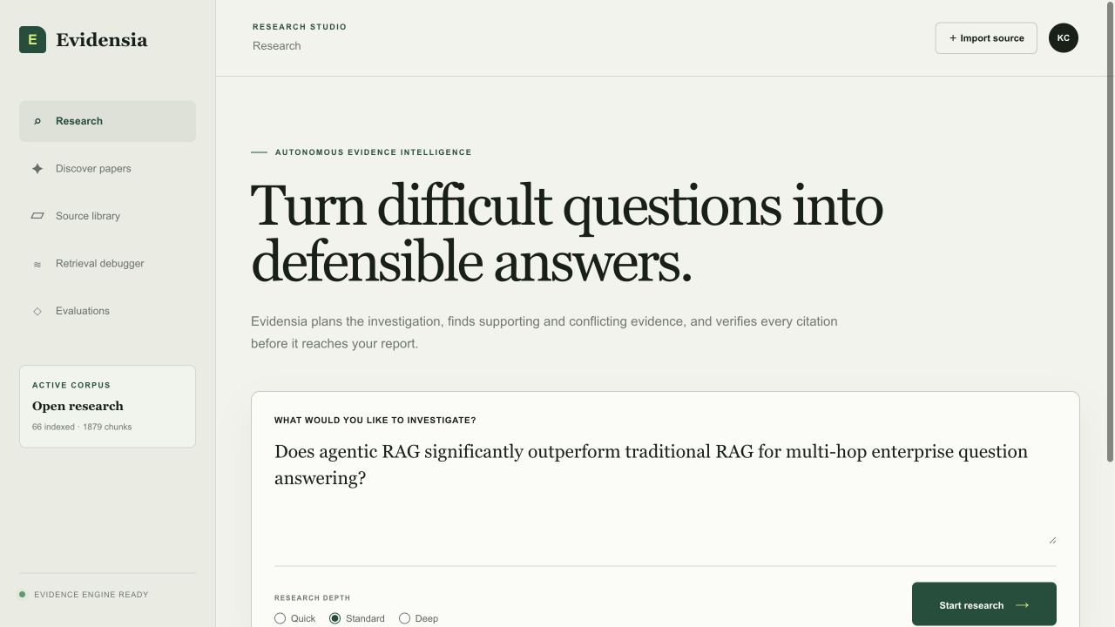
Figure 1. Research Studio landing workspace with live corpus status.
- Plan: decompose a difficult question into focused lines of inquiry.
- Challenge: search for disconfirming evidence and boundary conditions.
- Verify: trace synthesized claims back to exact source passages.

2. System architecture
The prototype is organized as replaceable services behind stable API contracts. The local implementation favors deterministic components so retrieval and evidence behavior can be tested before production infrastructure or hosted model providers are introduced.
- Research Studio sends ingestion, discovery, retrieval, research, and evaluation requests to FastAPI.
- The knowledge service parses source files, extracts metadata, creates section-aware parent context, and emits smaller retrieval chunks.
- The retrieval service combines local dense scoring with BM25, applies reciprocal-rank fusion, and reranks a smaller candidate set.
- The LangGraph workflow plans, retrieves, evaluates sufficiency, corrects gaps, synthesizes, and verifies.
- Evidence objects preserve document identity, section, page, exact text span, stance, and confidence for the UI and report schema.
PROVIDER SEAM Pinecone, hosted embeddings, cross-encoder reranking, model-backed agents, PostgreSQL, Redis, and object storage are planned replacements—not assumptions hidden inside the current local baseline.

Core runtime modules
- Ingestion: PDF, Markdown, HTML, and plain text parsing with deterministic metadata extraction.
- Retrieval: local dense index, BM25, RRF fusion, query classification, and reranking.
- Research: planner, evidence extraction, sufficiency assessment, synthesis, and citation verification.
- Evaluation: retrieval metrics, ablation runner, API endpoints, unit/integration/e2e coverage.

3. Scholarly discovery and ingestion
The paper-discovery workspace searches a bounded 2025–2026 date range across arXiv and OpenAlex. Results are normalized and deduplicated using persistent paper identity, DOI, title, and author signals before import.
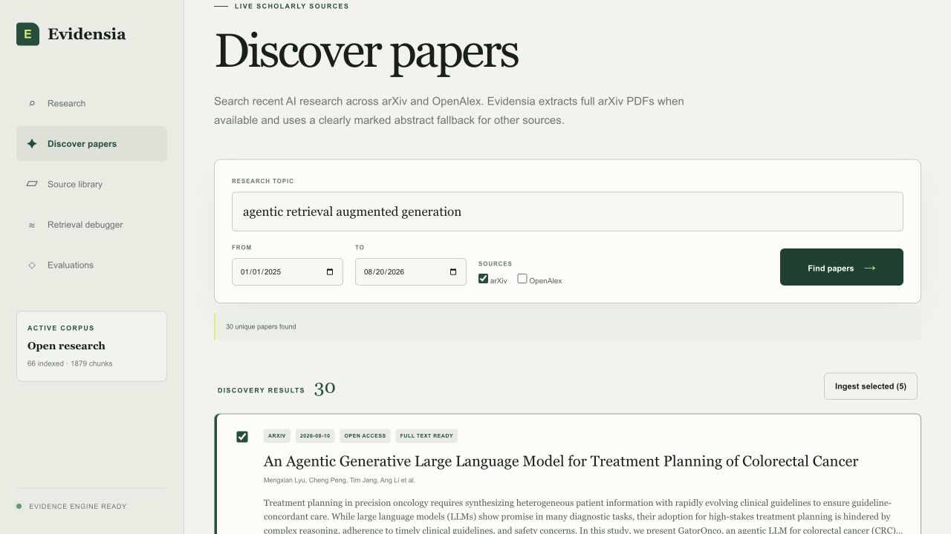
Figure 2. Live arXiv discovery for agentic retrieval-augmented generation.
- arXiv imports prefer the full open-access PDF, extracted into page-aware research chunks.
- OpenAlex results—and failed PDF downloads—use a clearly labeled abstract fallback.
- Every imported record retains its repository or publisher URL and source metadata.
- The application indexes evidence for the local user; it does not redistribute copied PDFs.

4. Evidence library and persistence
The source library is the durable knowledge foundation for research. It separates source-level records from retrieval chunks, preserves document provenance, and makes corpus growth visible to the researcher.
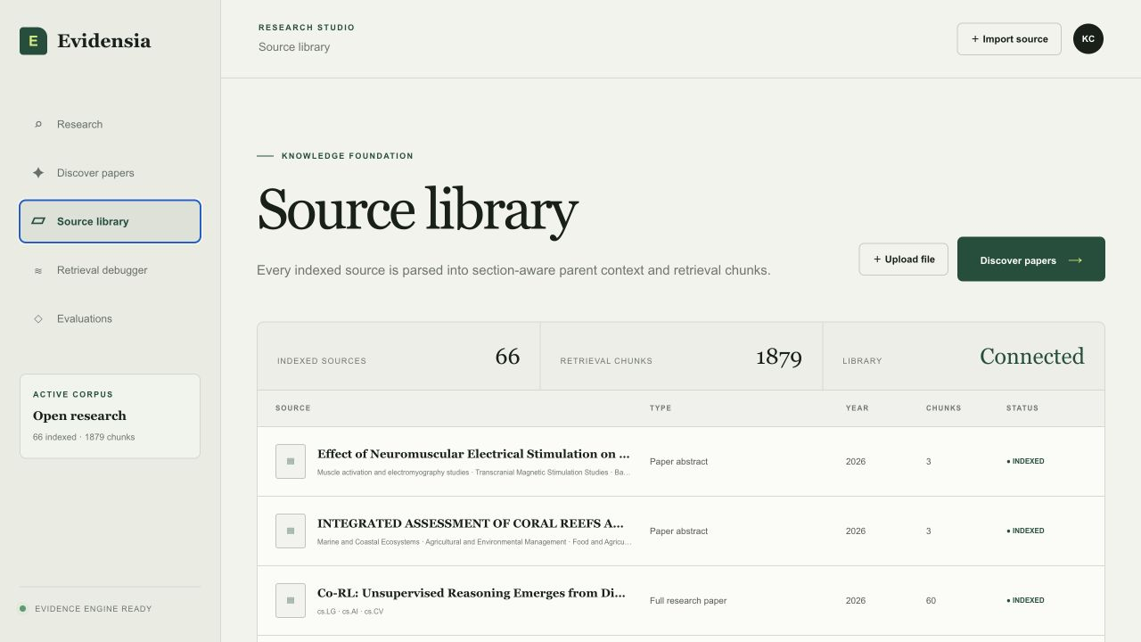
Figure 3. Persisted source library showing 66 indexed documents and 1,879 chunks.
- Source records store title, source type, year, provenance, and ingestion status.
- Parent sections preserve context; smaller child chunks improve retrieval precision.
- The local .evidensia_data directory survives API restarts and prevents a three-document demo ceiling.

5. Hybrid retrieval and observability
A research system must reveal why a passage was selected. Evidensia exposes the full ranking path rather than presenting a single opaque relevance score.
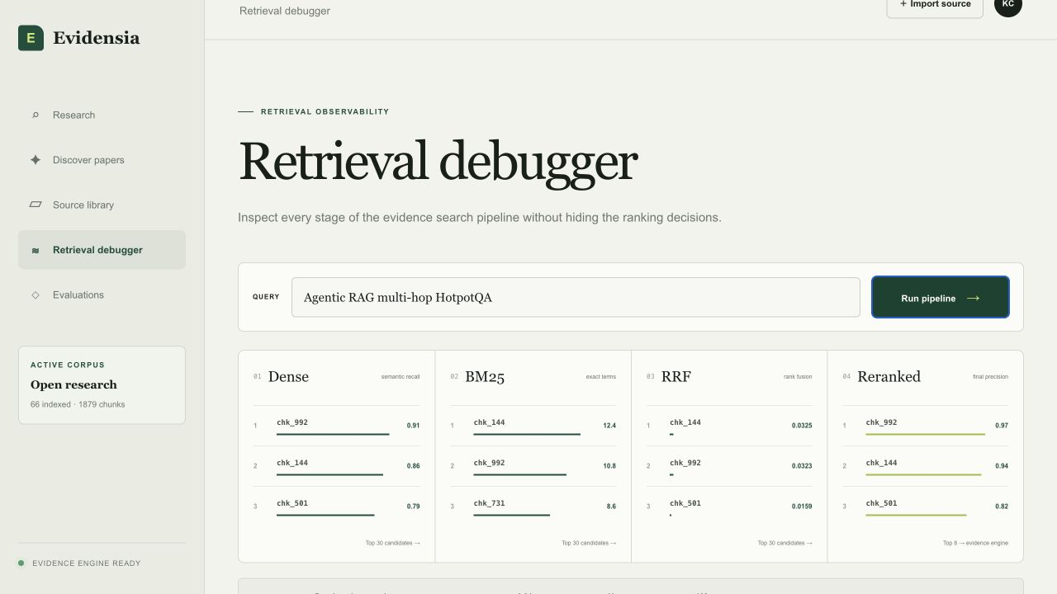
Figure 4. Retrieval debugger showing dense, BM25, RRF, and reranked stages.
- Dense retrieval broadens semantic recall.
- BM25 preserves exact terminology, benchmark names, and identifiers.
- Reciprocal-rank fusion rewards evidence surfaced by both channels without assuming comparable raw scores.
- Reranking concentrates the final evidence set and keeps intermediate candidates auditable.

6. Corrective research and evidence intelligence
The LangGraph workflow treats research as a stateful investigation. It can repeat retrieval when the evidence set is weak, search specifically for contradictions, and keep the trace visible alongside the selected passages.
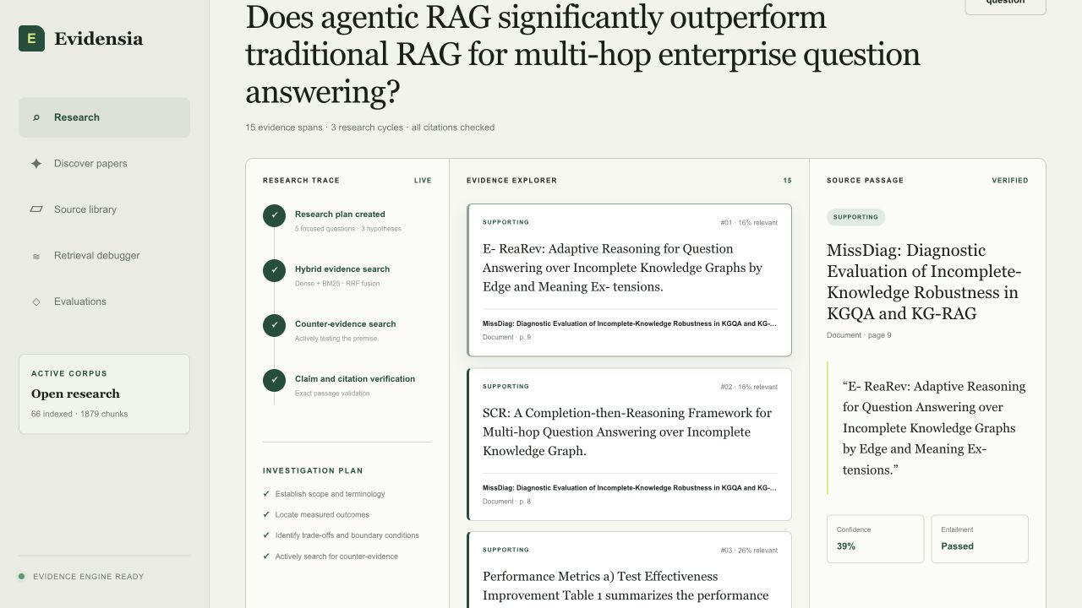
Figure 5. Completed research run with trace, evidence explorer, and verified source passage.
- ResearchState records the question, plan, sub-questions, evidence, claims, confidence, and final report.
- Evidence spans include source, page or section, exact passage, stance, and relevance score.
- Sufficiency checks can trigger corrective retrieval instead of forcing a premature answer.
- Current synthesis and entailment logic are deterministic development baselines; hosted model-backed components remain future provider integrations.

7. Evaluation and verification
Evaluation is implemented as a product surface and API capability, not an after-the-fact notebook. The codebase includes Recall@K, Precision@K, MRR, NDCG, hit rate, ablation support, and end-to-end tests covering ingestion, discovery, retrieval, research, and evaluation.
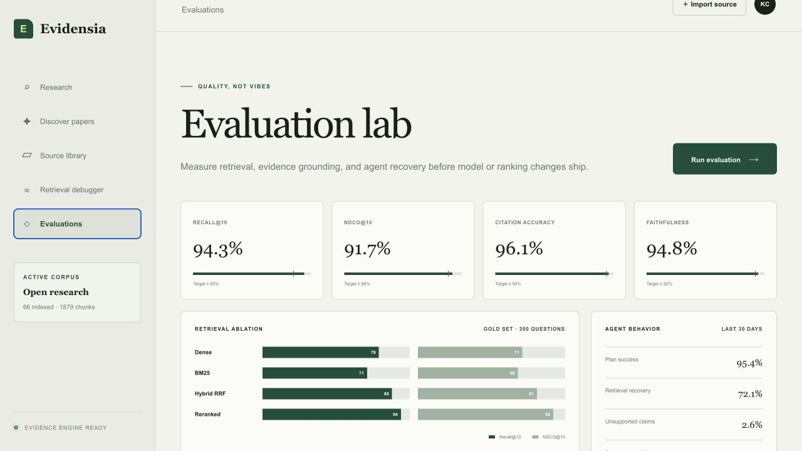
Figure 6. Evaluation Lab interface for retrieval, grounding, and agent behavior.
IMPORTANT INTERPRETATION The percentages visible in the current Evaluation Lab are UI demonstration values. The evaluation APIs and metric calculations are implemented, but production claims require a versioned gold set, recorded experiment run, and model/index configuration.
- 15 automated unit, integration, and end-to-end tests passed on the documented build.
- Tests cover parsing, persistence, arXiv/OpenAlex normalization, full-text fallback behavior, RRF, hybrid search, research correction, and the API workflow.

8. API and application contract
The application contract is already broad enough to support a future hosted backend while keeping the Research Studio stable. Structured Pydantic models prevent uncontrolled free-form model output from becoming the system of record.
Endpoint | Purpose
POST /v1/documents | Ingest PDF, Markdown, HTML, or text
GET /v1/documents | List the persisted source library
POST /v1/sources/discover | Search and deduplicate arXiv/OpenAlex records
POST /v1/sources/import | Extract arXiv full text or ingest a marked abstract fallback
POST /v1/search | Run hybrid evidence retrieval
POST /v1/search/debug | Expose dense, BM25, fusion, and reranking stages
POST /v1/research | Start a corrective evidence-research run
GET /v1/research/{id}/events | Stream run progress
POST /v1/evals/run | Execute retrieval evaluation and ablation

Research modes
- Quick: minimal decomposition and retrieval budget for fast orientation.
- Standard: balanced planning, evidence search, correction, and verification.
- Deep: larger sub-question and search budgets for difficult literature reviews.

9. Constraints, risks, and roadmap

Known limitations
- The local dense scorer, reranker, planner, synthesis, and entailment checks are deterministic baselines, not production-quality learned models.
- Source authority is preserved as metadata but is not yet converted into a calibrated trust score.
- OpenAlex discovery can return broad matches; topic/category filters and Crossref validation would improve precision.
- The UI and local API are complete enough for development use, but the hosted site cannot use a localhost backend.

Near-term work
- Build a versioned AI research gold set and connect the Evaluation Lab to recorded runs.
- Introduce provider-backed embeddings and reranking behind the existing retrieval interfaces.
- Improve scholarly filters, authority signals, duplicate resolution, and source-quality indicators.
- Add hosted backend persistence and secure configuration when production-platform work is authorized.
DEFERRED BY DESIGN Phase 5 production infrastructure and Phase 7 scale remain excluded from the current scope. This prevents premature platform work from obscuring retrieval and evidence quality.

10. Conclusion
Evidensia has progressed from a system design into a working evidence-intelligence prototype. The strongest result is not a single generated answer; it is the end-to-end research contract connecting scholarly discovery, source persistence, hybrid retrieval, corrective investigation, exact evidence spans, verification, and evaluation observability.
The next quality milestone is to replace demonstration scores and deterministic model seams with reproducible experiment runs and provider-backed components—while preserving the transparent evidence trace already visible in the Research Studio.
PROJECT TAKEAWAY The prototype now demonstrates the differentiated product idea: research as an auditable evidence process, not a one-shot generation feature.

Source basis
- Autonomous Research & Evidence Intelligence Agent, System Design v1.0 (provided project design document).
- Evidensia AI local repository: README, API, ingestion, retrieval, research graph, evaluation modules, and automated tests inspected on 20 August 2026.
- Product screenshots captured from the local Research Studio at http://localhost:3000 with API-backed corpus counts.
This paper distinguishes the target production architecture in the source design from the capabilities implemented in the current local prototype. Phase 5 and Phase 7 items are described only as deferred roadmap work.

