PRESENTER RUNBOOK · VERSION 1.0
Evidensia Demo Plan
A 12-minute live story from research question to citation-verified answer
12 MIN  target runtime | 5  workspace views | 1  research story | 3–5  papers ingested
DEMO PROMISE Evidensia does not merely generate an answer. It exposes how sources were found, how evidence was ranked, where retrieval was corrected, and which exact passages support every verified claim.
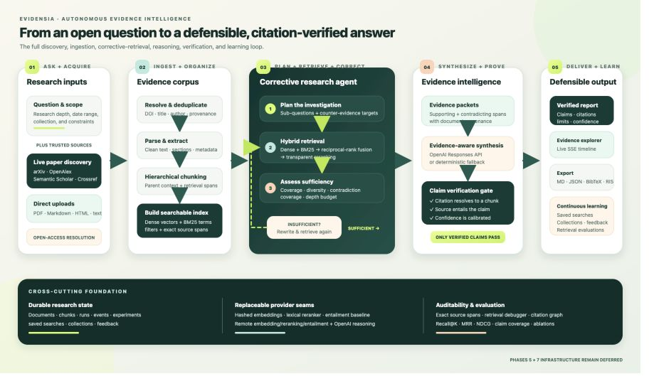
Figure 1. The complete Evidensia evidence-intelligence workflow.

1. Demo strategy
AUDIENCE OUTCOME By the end of the demo, the audience should trust that Evidensia can discover current research, retrieve transparently, correct weak evidence, and produce an inspectable report rather than an unsupported answer.

Three messages to repeat
- Evidence first: the answer is constrained by retrieved source passages.
- Correction is visible: insufficient retrieval triggers query rewriting and another search.
- Verification is a gate: citations must resolve and the cited passage must entail the claim.

Opening script
SAY THIS Research tools can find documents, and AI models can generate answers—but neither guarantees that every claim is supported. Evidensia combines discovery, retrieval, contradiction analysis, synthesis, and citation verification in one auditable workflow.

2. Run of show — first half
00:00–01:00 Frame the problem
SHOW Architecture diagram or title slide.
DO State the trust problem in one sentence, then point to the five-stage flow.
SAY The important product is not just an answer; it is a defensible path from a difficult question to verified evidence.
PROOF The diagram separates acquisition, retrieval, reasoning, verification, and delivery.
01:00–02:00 Introduce the Research Studio
SHOW Research landing page and left navigation.
DO Name the five workspaces without opening each one yet.
SAY The same workspace supports live discovery, local sources, transparent retrieval, autonomous research, and evaluation.
02:00–04:00 Discover current papers
SHOW Discover papers workspace.
DO Search ‘agentic RAG multi-hop enterprise question answering’ across 2025–2026 with all four providers selected. Choose three to five strong results.
SAY Evidensia searches arXiv, OpenAlex, Semantic Scholar, and Crossref, then normalizes and deduplicates provider records while preserving provenance.
PROOF Point to provider labels, dates, DOI/source links, open-access status, and deduplicated results.
04:00–05:00 Ingest and inspect sources
SHOW Ingest selected, then Source library.
DO Import only the selected papers and open one indexed source.
SAY Full open-access text is used when it can be resolved lawfully; otherwise Evidensia records an explicit abstract fallback instead of hiding the gap.
PROOF Show extracted metadata, source identity, status, and chunk count.

3. Run of show — evidence to answer
05:00–07:00 Expose retrieval quality
SHOW Retrieval debugger.
DO Search ‘Does agentic RAG improve multi-hop evidence recall?’ and inspect a top passage.
SAY Dense retrieval finds semantic matches, BM25 protects exact terminology, reciprocal-rank fusion combines both, and reranking improves precision.
PROOF Show dense and sparse ranks, fused score, rerank score, document identity, and exact passage text.
07:00–09:00 Run autonomous research
SHOW Research workspace with Standard depth.
DO Submit: ‘Does agentic RAG significantly outperform traditional RAG for multi-hop enterprise question answering?’
SAY The agent plans sub-questions, retrieves evidence, tests sufficiency, rewrites weak queries when necessary, synthesizes bounded claims, and then verifies each citation.
PROOF Point to the live event timeline: plan → retrieve → assess → rewrite if needed → synthesize → verify.
09:00–11:00 Inspect the verified report
SHOW Completed report and evidence explorer.
DO Open one strong claim, one limitation or contradiction, and its source passage.
SAY Confidence comes from inspectable evidence and explicit limitations—not from the fluency of the generated prose.
PROOF Show claim verification, citation resolution, entailment result, supporting and contradicting evidence, and confidence.
11:00–12:00 Export and close
SHOW Export strip, saved searches, citation graph, or evaluations.
DO Export Markdown or BibTeX, then return to the completed report for the closing line.
SAY Evidensia transforms research from document search plus unverified generation into a repeatable evidence-intelligence process where every important claim can be challenged.

Closing line
END HERE The result is not simply an answer. It is a research record: current sources, transparent retrieval, counter-evidence, verified claims, exact citations, and exportable outputs.

4. Pre-demo readiness checklist
- Start the Evidensia API at http://127.0.0.1:8002 and confirm the health/provider endpoints respond.
- Open the local Studio at http://localhost:3001 and keep the hosted Studio available as a second tab.
- Confirm the provider manifest shows openai:gpt-5.4-mini when the OpenAI-backed path will be demonstrated.
- Pre-ingest three to five relevant papers and keep one completed research run available.
- Open the architecture diagram, presentation deck, and backup screenshots before screen sharing.
- Use a readable browser zoom, hide notifications, and close unrelated tabs or terminals.
- Do not ingest dozens of PDFs or run a deep research workflow during the timed presentation.
- Practice the transition from retrieval debugger to the completed report; this is the proof moment.

Fast technical checks
curl http://127.0.0.1:8002/v1/providers
open http://localhost:3001
# Expected research provider: openai:gpt-5.4-mini

Fallback ladder
- If a scholarly provider is slow, use the already-discovered results and explain multi-provider resilience.
- If ingestion is slow, switch to the pre-ingested source library and continue with retrieval.
- If the live research run is slow, open the prepared completed run and narrate the event timeline.
- If the local API stops, restart it on port 8002; if time is short, continue with screenshots and the architecture flow.
- If the OpenAI provider fails, demonstrate the deterministic fallback and make reliability—not failure—the point.
PRESENTER DISCIPLINE Never wait silently for a network request. While a step runs, narrate the architectural value of that step, then move to the prepared state if it exceeds the time budget.

5. Questions to expect
How is Evidensia different from ordinary RAG?
It adds multi-source scholarly discovery, corrective retrieval, counter-evidence targets, sufficiency assessment, claim-level citation verification, durable runs, and retrieval evaluations around the basic retrieval-and-generation pattern.
Which AI model is used?
The configured research path uses OpenAI gpt-5.4-mini for structured planning, evidence-aware synthesis, batch verification, and report composition. Deterministic fallbacks remain available for resilience and testing.
How does it reduce hallucinations?
The model receives bounded retrieved evidence; citations must resolve to real chunks; entailment checks compare each claim with its cited passage; and unsupported claims are marked or rejected instead of silently passing.
Are the papers trustworthy?
Evidensia preserves provider, DOI, author, date, venue, and source-link provenance from established scholarly APIs. Open-access resolution is explicit, and abstract-only fallback imports are clearly reported.
Why use dense retrieval and BM25 together?
Dense retrieval captures paraphrases and semantic similarity, while BM25 preserves exact names, benchmark labels, identifiers, and terminology. Reciprocal-rank fusion combines complementary recall before reranking.
What happens when evidence is insufficient?
The sufficiency evaluator measures coverage, diversity, and contradiction coverage. The graph rewrites uncovered queries and retrieves again until evidence is sufficient or the depth-specific correction budget is exhausted.
Is it production-ready?
The research product and durable local workflow are implemented. The source design intentionally defers Phase 5 production infrastructure and Phase 7 large-scale deployment.

Final presenter cue
REMEMBER Lead with trust, prove transparency in the retrieval debugger, and finish on the verified report. The audience should leave remembering that Evidensia makes the evidence chain visible.

