**Analysis of Movie Data using Hadoop-PIG**

**Problem solution**:

1. **Find the number of movies released between 1950 and 1960.**

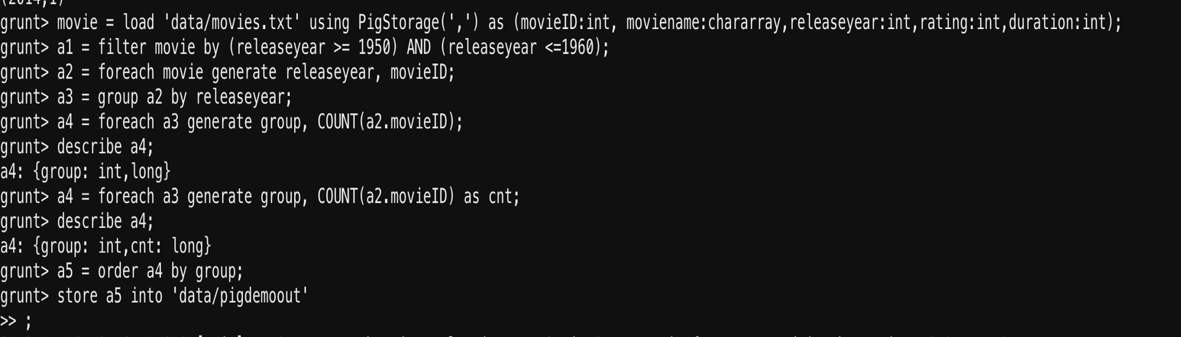

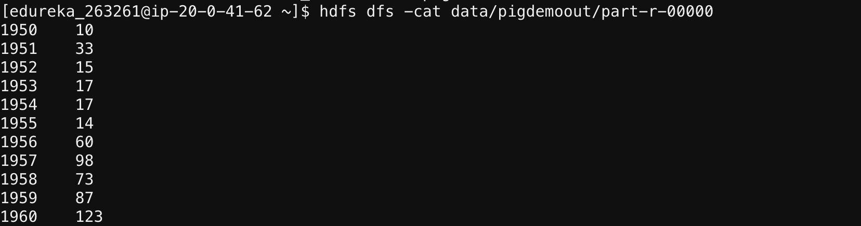

1. **Find the number of movies having rating more than 4.**

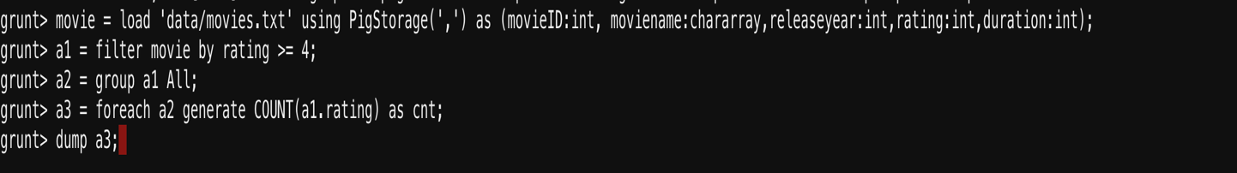

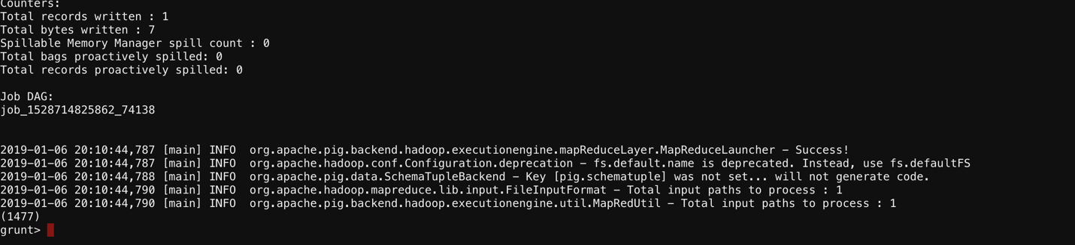

1. **Find the movies whose rating are between 3 and 4.**



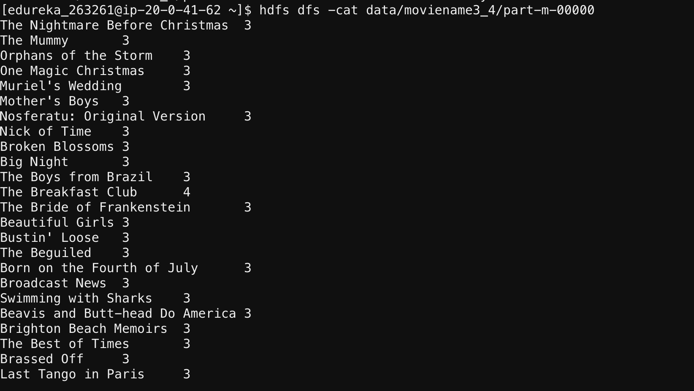

1. **Find the number of movies with duration more than 2 hours (7200 second).**

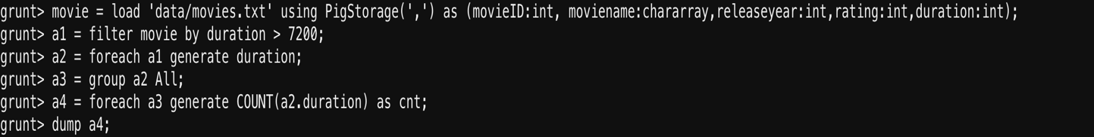

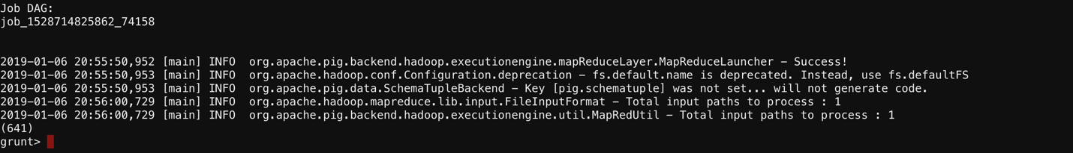

1. **Find the list of years and number of movies released each year.**



1. **Find the total number of movies in the dataset.**



