**Analysis of Youtube Data using Hadoop-Hive and PIG**

1. **creating table youtube for youtubedata.txt**:

create table youtube (video_id string,uploader string,interval int,category string,length_video int,num_views int,rating float,num_ratings int,num_comments int,related_id string) row format delimited fields terminated by '\t';



2. **loading data into youtube table**

load data local inpath 'Desktop/data/youtubedata.txt' into table youtube;



**Problem solution**:

1. **Find out the top 5 categories with maximum number of videos uploaded.**

HIVE Solution:

select category, count(*) as cnt from youtube group by category order by cnt desc limit 5;

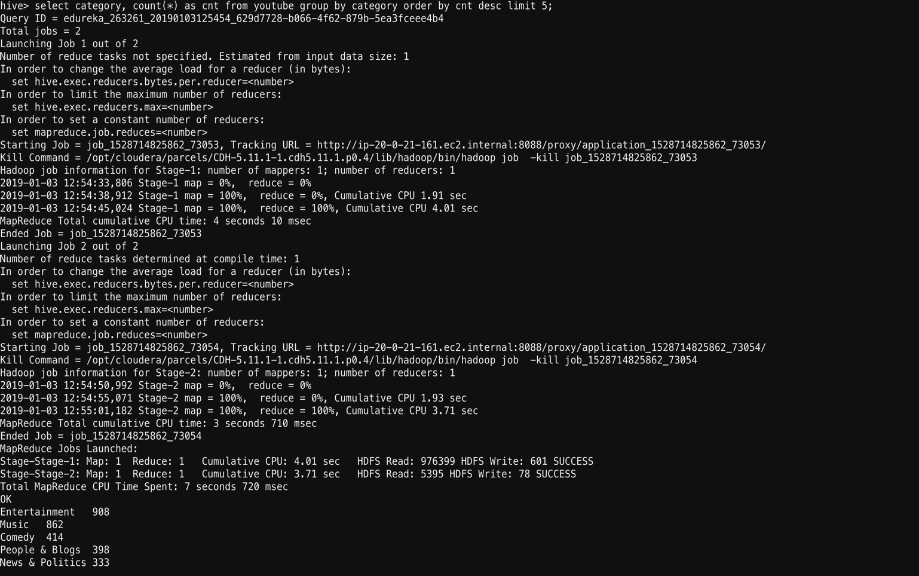



PIG Solution:

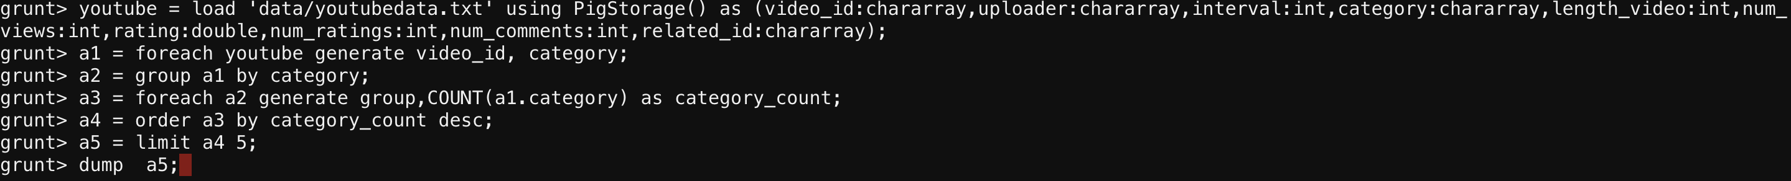

**B. Find out the top 10 rated videos.**

**HIVE Solution:**

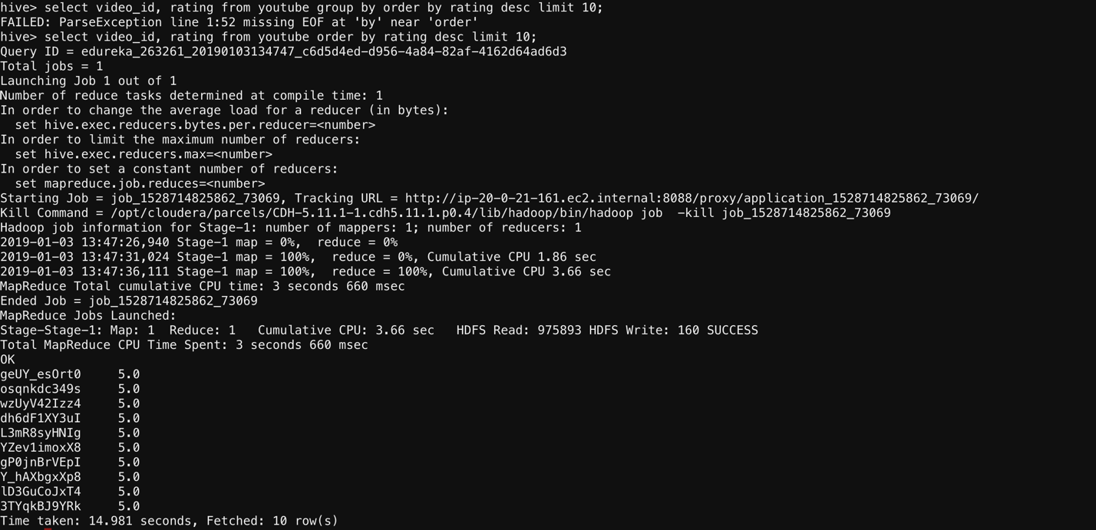

PIG Solution:



**C. Find out the most viewed videos.**

**HIVE Solution:**

select video_id,sum(num_views) sum from youtube group by video_id order by sum desc limit 5;

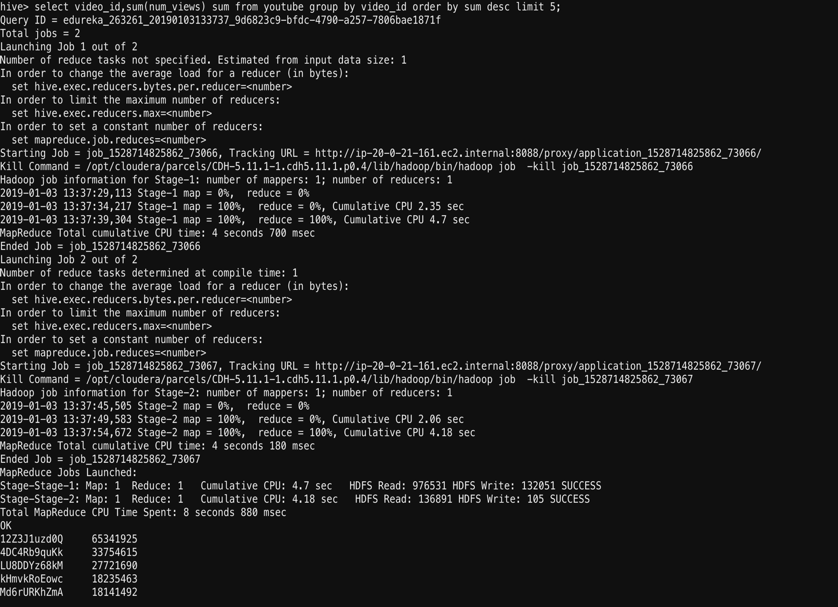

**PIG Solution:**

