ASSIGNMENT 4

Kausik Chattapadhyay

2022-10-04

# Markdown Basics

## Favorite Foods

1. Pasta
2. Pizza
3. Chicken curry

## Images

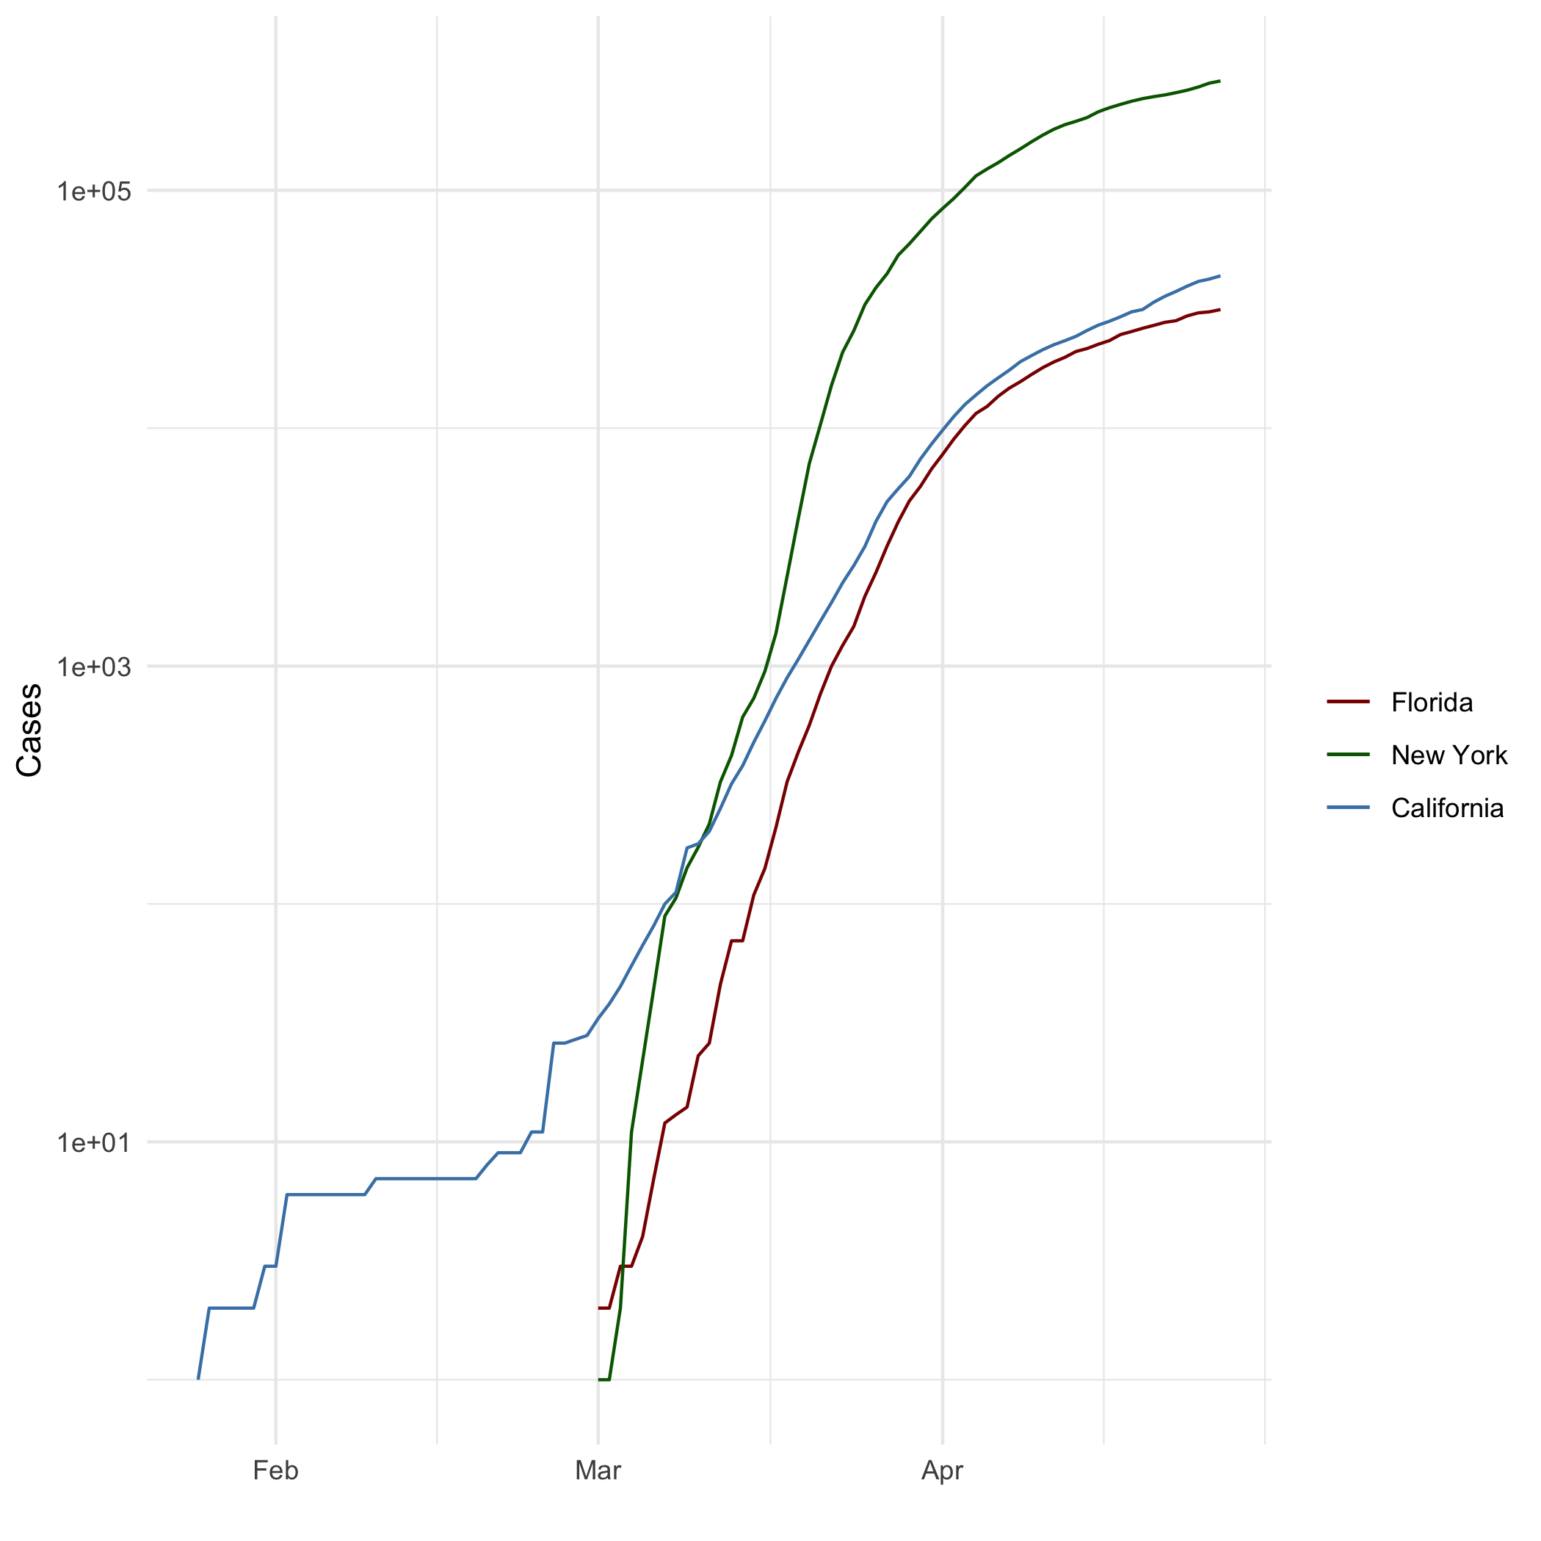

All cases(log plot)

## Add a Quote

“Would you like me to give you a formula for success? It’s quite simple, really: Double your rate of failure. You are thinking of failure as the enemy of success. But it isn’t at all. You can be discouraged by failure or you can learn from it, so go ahead and make mistakes. Make all you can. Because remember that’s where you will find success.”

Kausik Chattapadhyay

## Add an Equation

$$\hat{β}={\left(X^{T}X\right)}^{−1}X^{T}Y$$

## Add a Footnote

[1]

## Add Citations

* R for Everyone (Lander 2014)
* Discovering Statistics Using R (Field, Miles, and Field 2012)

# Inline Code

## NY Times COVID-19 Data

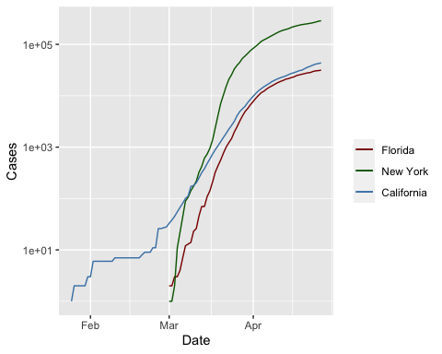

## R4DS Height vs Earnings

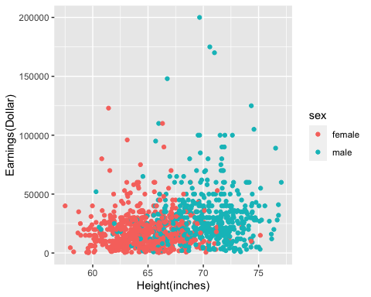

# Tables

## Knitr Table with Kable

One Ring to Rule Them All

| name | race | in_fellowship | ring_bearer | age |
| --- | --- | --- | --- | --- |
| Aragon | Men | TRUE | FALSE | 88 |
| Bilbo | Hobbit | FALSE | TRUE | 129 |
| Frodo | Hobbit | TRUE | TRUE | 51 |
| Galadriel | Elf | FALSE | FALSE | 7000 |
| Sam | Hobbit | TRUE | TRUE | 36 |
| Gandalf | Maia | TRUE | TRUE | 2019 |
| Legolas | Elf | TRUE | FALSE | 2931 |
| Sauron | Maia | FALSE | TRUE | 7052 |
| Gollum | Hobbit | FALSE | TRUE | 589 |

## Pandoc Table

##   
## ---------------------------------------------------------  
## name race in_fellowship ring_bearer age   
## ----------- -------- --------------- ------------- ------  
## Aragon Men TRUE FALSE 88   
##   
## Bilbo Hobbit FALSE TRUE 129   
##   
## Frodo Hobbit TRUE TRUE 51   
##   
## Galadriel Elf FALSE FALSE 7000   
##   
## Sam Hobbit TRUE TRUE 36   
## ---------------------------------------------------------  
##   
## Table: One Ring to Rule Them All

# References

Lander (2014)

Field, Miles, and Field (2012)

Field, A., J. Miles, and Z. Field. 2012. *Discovering Statistics Using r*. SAGE Publications. <https://books.google.com/books?id=wd2K2zC3swIC>.

Lander, J. P. 2014. *R for Everyone: Advanced Analytics and Graphics*. Addison-Wesley Data and Analytics Series. Addison-Wesley. <https://books.google.com/books?id=3eBVAgAAQBAJ>.

1. This is a footnote.