|  |  |
| --- | --- |
|  | Data Analytics |

[Welfare and Inequality Analysis]

Hye-Jin Cho-Drugeon

Choh9323@gmail.com

June, 2023

**Table of content**

1. **Introduction**
2. **Data and data sources**
3. **Data collection**
4. **Data cleaning and Exploratory data analysis**
5. **Data base type selection**
6. **Entities. ERD**
7. **DATA Visualization**

**Introduction**

Business Use Case

Goal: This project studies intergenerational transfers such as tax and social security in the field of welfare and inequality for Euro-currency using countries with the OECD distribution data. It intends to explain the behavior of working age generation of 18-65 and old generation of above 65.

Domain: Economics and Statistics

Output

In Github [DAFT_0410/module5 at main · chatlapin/DAFT_0410 · GitHub](https://github.com/chatlapin/DAFT_0410/tree/main/module5)

Erdiagram_OECD.drawio.pdf

Jira

OECD Data Cleaning and EDA.ipynb

OECD.sql

OECD.API31.ipynb

OECDRawData.ipynb

Project Toymodel.ipynb

UnitRootTestOECD meandi.ipynb

UnitRootTestOECDCI.ipynb

UnitRootTestOECDCPI.ipynb

UnitRootTestOECDP90P10.ipynb

UnitRootTestOECDTE.ipynb

UnitRootTestOECDtaxsecu.ipynb

UnitRootTestOECD transfer.ipynb

France.csv

Welfare_DataVisualisation.xlsx

Plan

1. Planning of my project in Jira
2. Code in Python for Data collection and cleaning
3. ER Diagram
4. Data source and Meta Data
5. Database Script
6. Report (10 pages)
7. Slides

Jira <https://chatlapin.atlassian.net/jira/software/projects/CHAT/boards/1>

**Data and data sources**

RAW data from: <https://www.oecd.org/social/income-distribution-database.htm#:~:text=The%20OECD%20Income%20Distribution%20Database%20provides%20information%20on%20the%20equivalised,households%20on%20a%20comparable%20basis>.

**Data collection**

Income components, disposable, market and primary income

From Term Reference of OECD in 2017-2018 (ref: [IDD-ToR.pdf (oecd.org)](https://www.oecd.org/els/soc/IDD-ToR.pdf), OECD project on the distribution of household incomes studies the relationship between welfare and inequality. Income distributions refer to a particular year, which should be indicated in the Excel spreadsheet “Metadata”. All income components should be reported on an annual basis and in nominal prices. Five main components of household disposable income are identified in the OECD questionnaire:

-E: employee income, including wages and salaries, cash bonuses and gratuities, commissions and tips, directors’ fees, profit sharing bonuses and other forms of profit-related pay, shares offered as part of employee remuneration, free and subsidized goods and services from an employer, severance and termination pay.1 Sick pay paid by social security should also be included.

-KI 2: capital and property income, including income from financial assets (net of expenses), income from non-financial assets (net of expenses) and royalties. Regular receipts from voluntary individual private pension plans and life insurance schemes should also be included in this income component. In line with the 2011 Canberra Handbook, capital gains should not be included in KI.

-SEI 3: income from self-employment, including profits and losses from unincorporated enterprises, as well as goods produced for own consumption (net of the costs of inputs). [The inclusion of this latter variable aims to adjust the OECD income concept to the realities of middle-income countries (such as Brazil, South Africa and others), where subsistence agriculture represents a significant income source for people at the bottom of the distribution. Countries that do not collect information on this income item should indicate so in the metadata sheet of the OECD questions

-TRR: current transfers received, including transfers from social security (including accident and disability benefits, old-age cash benefits, unemployment benefits, maternity allowances, child and/or family allowances, all income-tested and means-tested benefits that are part of social assistance, including quasi-cash transfers given for a specific purpose such as food stamps); transfers from employment related social insurance; as well as cash transfers from both non-profit institutions and other households.

-• TRP: current transfers paid, including direct taxes on income and wealth, social security contributions paid by households, contributions to employment-related social insurance, current transfers paid to both other households and non-profit institutions. Taxes on realised capital gains should be excluded from wealth taxes when possible. [Values for transfers paid should be reported in the OECD questionnaire with a negative sign].

While relevance and data availability for the sub-components of current transfers will vary across countries (depending on the structure of their social protection system and on features of their micro-data), this more detailed breakdown allows better reflecting the situation of countries with an important employment-related pension pillar.

• In the case of current transfers received (TRR):

-TRRSS: current transfers received from social security.

− TRRER: current transfers received from employment-related social insurance schemes (e.g. occupational pensions), where such schemes meet at least one of the following conditions: i) participation is obligatory; ii) the scheme is collective; and iii) the employer makes a contribution on behalf of an employee. 4

-− TRROT: current transfers received from non-profit institutions and other private households, e.g. alimonies.

• In the case of current transfers paid (TRP):

TA: direct taxes on income and wealth paid by households (net of refunds), as well as contributions paid by households to public social security schemes.

− TRPER: contributions paid by households to employment-related social insurance schemes (as defined above). − TRPOT: current transfers paid by households to non-profit institutions and other households, e.g. alimonies.

Essential equations related to this study are:

1. Disposable income from primary income, market income, gross income (ref: [IDD-ToR.pdf (oecd.org)](https://www.oecd.org/els/soc/IDD-ToR.pdf). P.5)

1. Gini index (ref: [IDD-ToR.pdf (oecd.org)](https://www.oecd.org/els/soc/IDD-ToR.pdf). P.8)

**Data cleaning and Exploratory data analysis**

Starting to import all necessary libraries, This code imports necessary modules for data analysis and machine learning, including pandas for data manipulation, matplotlib and seaborn for data visualization, re for regular expressions, numpy for numerical computing, and scikit-learn for machine learning. • The **%matplotlib inline** command sets the backend of matplotlib to the 'inline' backend, which allows the plots to be displayed in the Jupyter notebook. • The **sns.set()** command sets the default style of the plots to the Seaborn style. • The code then imports the training and test data from CSV files using pandas' **read_csv()** function and stores them in dataframes **df_train** and **df_test**, respectively.

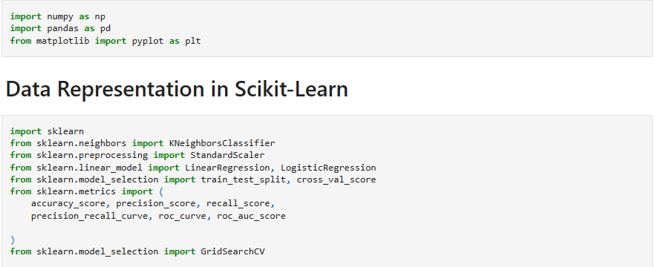

(1) Toy model: France

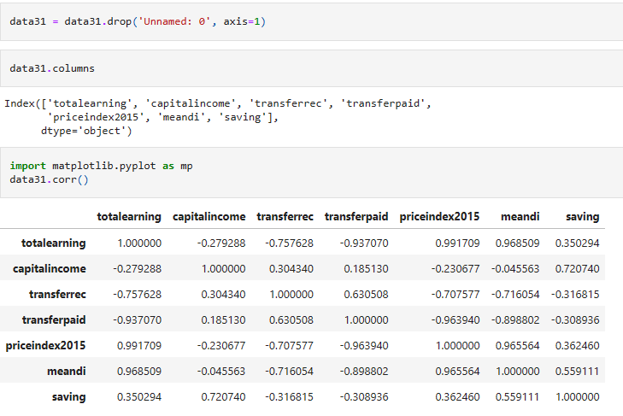

The data with key variables in France have variance with different range of mean values. Except for paid transfers, variables are greater than 49. For price index in 2015, the index is defined as percentage but mean values are 100 which is ideal for accommodating current market prices.

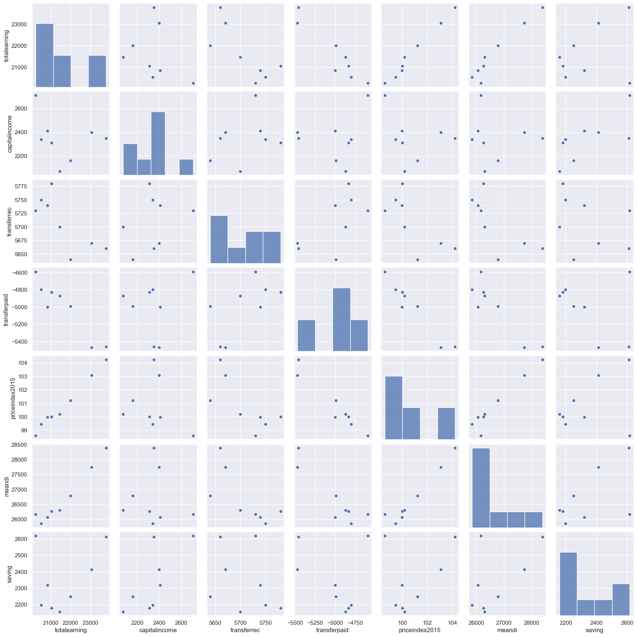

I may compare the heatmap with or without the index as percentage as below:

With price index 2015:

Without price index 2015

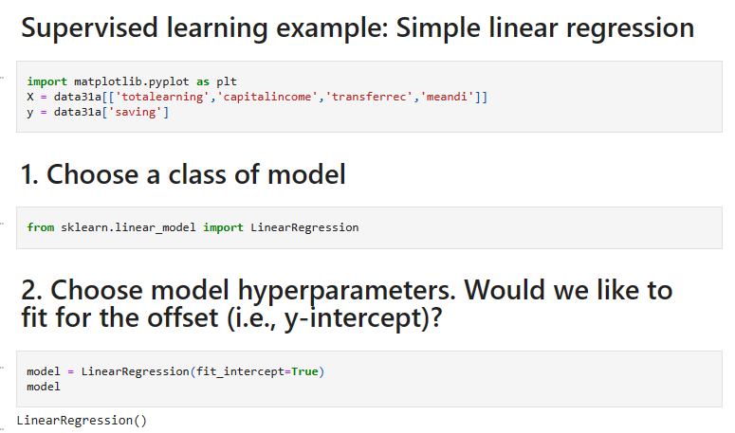

**Data base type selection**

Stationary Test by Dickey-Fuller test

Except for Capital Income, variables are stationary.

|  |  |  |  |
| --- | --- | --- | --- |
| data31['saving'] | data31['meandi'] | data31['priceindex2015'] | data31['transferpaid'] |
| ADF Statistic: -2.09  Critial Values:  1%, -6.05  Critial Values:  5%, -3.93  Critial Values:  10%, -2.99  p-value: 0.25  Stationary | ADF Statistic: 1.32  Critial Values:  1%, -6.05  Critial Values:  5%, -3.93  Critial Values:  10%, -2.99  p-value: 1.00  Stationary | ADF Statistic: -0.44  Critial Values:  1%, -6.05  Critial Values:  5%, -3.93  Critial Values:  10%, -2.99  p-value: 0.90  Stationary | ADF Statistic: -0.72  Critial Values:  1%, -4.94  Critial Values:  5%, -3.48  Critial Values:  10%, -2.84  p-value: 0.84  Stationary |

|  |  |  |
| --- | --- | --- |
| data31['transferrec'] | data31['capitalincome'] | data31['totalearning'] |
| ADF Statistic: -0.93  Critial Values:  1%, -4.94  Critial Values:  5%, -3.48  Critial Values:  10%, -2.84  p-value: 0.78  Stationary | ADF Statistic: -8.90  Critial Values:  1%, -6.05  Critial Values:  5%, -3.93  Critial Values:  10%, -2.99  p-value: 0.00  Stationary  p-value: 0.00  Non-Stationary | ADF Statistic: 1.85  Critial Values:  1%, -5.35  Critial Values:  5%, -3.65  Critial Values:  10%, -2.90  p-value: 1.00  Stationary |

**Entities. ERD**

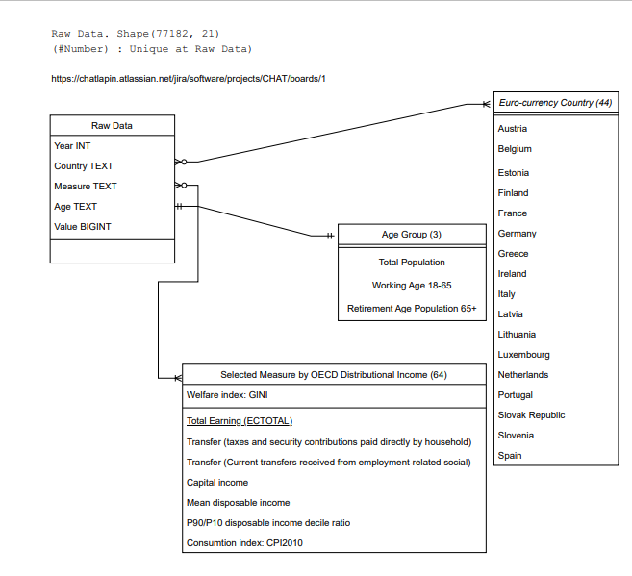

**DATA Visualization**

**