**Automation (Selenium-Tool)**

**Advantages of Automation Testing**

1. Regression Testing can be done in less time
2. Less Human efforts are required.
3. Reusability of test script.
4. Test cycle duration / Project duration will be reduced.
5. Compatibility Testing is easy.

**Disadvantages of manual testing:**

1. More human resources are required.
2. Time consuming
3. Compatibility testing is difficult.
4. Test cycle/Project duration will be increased.
5. Regression testing is time consuming
6. More human efforts are required.
7. More Documentation required.

Automation Tool:

1. Selenium
2. QTP
3. Sahi
4. Sahipro
5. Protractor (Angular application)
6. Appium
7. Selendroid etc..

Why Selenium?(Advantages of selenium)

1. Open source
2. Multi language support (java - selenium, Python-selenium, C#-selenium)
3. Compatibility testing is possible
4. We can automate only web based application

Disadvantages.

1. Standalone (desktop based application) cannot be automated.
2. We cannot upload and download file
3. We can’t automate captch and barcode

Definition: Testing the functionality of application using automaton tool is automation testing.

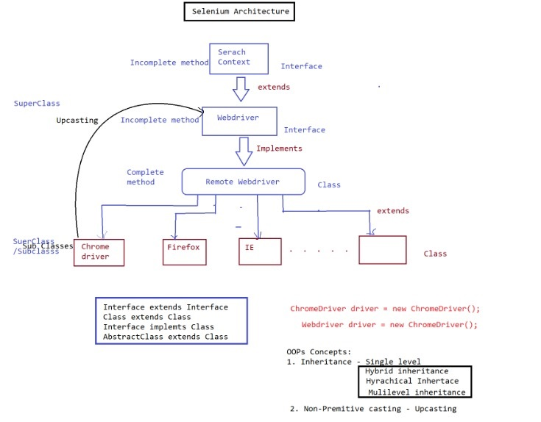

Selenium:

1. Search context is the super most interface which contains abstract method.
2. Webdriver is an interface which contains abstract methods of search context and its own abstract method.
3. All the abstract method from search context and webdriver are implemented in Remote webdriver class.

Remote Web driver Class:

1. It is the class which implements all abstract method from both interface
2. RemoteWebdriver Class is extended to different browser lik ChrimeDriver, IEDriver, …etc.
3. To run application in multiple browser that is writing test script for single browser but run the same script in multiple browser we need achive this by using upcasting in selenium.

WebDriver driver= new ChromeDriver();

Opps concept:

1. Inheritance: Single level, Hybrid, Multilevel,
2. Casting: Non-premitive – Upcasting

Selenium: previous

selenium webdriver: latest tool

Selenium Component: there are 3 components of selenium:

1. Selenium IDE: Integrated development environment

In this it is easy to use already developed test cases.

It is only used with Firefox browser which provide graphical user interface

1. Selenium RC:

-It is hardly in use because webdriver provide more feature.

- It allows to write automated web application UI test can be done using different languages like java, C#, pyton etc.

1. Selenium Grid:

-This is to execute multiple instances webdriver or selenium RC

-It executes script with the help of webdrive,hub,remote RC.