CytoSoftware-RPQ User Manual
Red Particle Quantification (RPQ) for MP4 time-lapse microscopy
Version: 1.0
Date: 24 Dec 2025

RPQ detects and counts red fluorescent particles (spots/blobs) in MP4 videos without cell segmentation. It is designed for pHrodo-zymosan kinetics, red puncta acidification assays, and other red particle time-series quantification tasks.

What RPQ does | Detects and counts red fluorescent particles (spots/blobs) in MP4 videos without cell segmentation.
Typical use-cases | pHrodo zymosan kinetics, red puncta acidification assays, general red particle time-series counting.
Main outputs | Counts vs time CSV, per-blob features CSV, annotated MP4, and run_config.json (parameters).
Manual scope | How to run RPQ, tune parameters, and interpret outputs.

This manual is written for notebook users (Google Colab or local Jupyter) who want a repeatable, parameter-controlled workflow for red particle quantification.

Workflow at a glance
Use Apply & Preview to tune detection first, then run a full analysis.
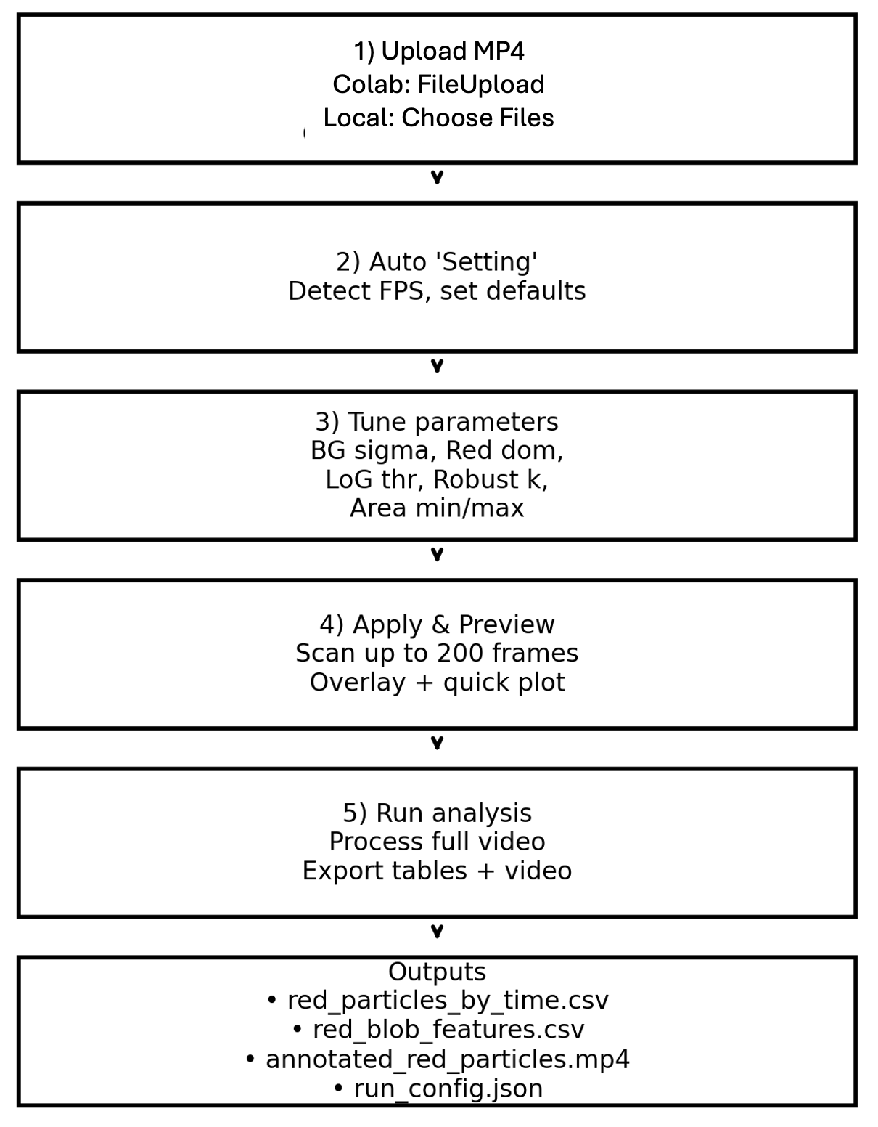
Figure 1. RPQ workflow at a glance (Apply & Preview then Run Analysis).

1. Getting started

1.1 Recommended environment
RPQ runs in a Jupyter notebook. Google Colab is the recommended environment because the notebook includes built-in upload and download helpers for Colab.

1.2 Install dependencies
Run the first code cell to install required Python packages:
!pip -q install opencv-python-headless scikit-image pandas tqdm ipywidgets
If SciPy is available, RPQ can compute an optional 95% uncertainty band for the time-series plot.

2. Uploading an MP4

2.1 Supported inputs
- MP4 videos (time-lapse microscopy or recorded sequences).
- Any frame size; RGB is derived from MP4 frames.

2.2 Upload behavior
In Colab, RPQ uses the standard “Choose Files” dialog. After upload, the notebook automatically runs the Setting step to detect FPS and initialize default parameters.
In local Jupyter, the notebook displays an in-notebook FileUpload widget and saves the video under /mnt/data. If you run locally and see an import error for google.colab, remove the google.colab imports and the Colab-specific download helper, or run in Colab.

3. Parameter tuning

3.1 Parameter groups
RPQ exposes detection parameters as interactive widgets. Conceptually they fall into four groups: (i) background handling, (ii) red-dominance/intensity filters, (iii) LoG blob detection (size and threshold), and (iv) post-detection area filtering.

3.2 What each widget controls
Widget | Internal variable | Practical effect / tips
BG sigma | BG_BLUR_SIGMA | Controls smoothing for background estimation in the red-enhanced image. Increase to remove slow background gradients; decrease to preserve local signal.
Red dom | RED_DOM_RATIO | Minimum red-dominance ratio (red vs green/blue) inside a candidate spot. Increase to suppress yellow/white artifacts; decrease if true spots are dim or mixed-color.
Red min abs | RED_MIN_ABS | Minimum absolute mean red intensity (0–1 scale) within the spot mask. Increase to reduce faint noise; decrease to detect very dim particles.
sigma min | LOG_SIGMA_MIN | Lower bound of blob size range for LoG detection. Match to expected particle radii.
sigma max | LOG_SIGMA_MAX | Upper bound of blob size range for LoG detection. Broader ranges can find more sizes but may increase duplicates/noise.
#sigma | LOG_NUM_SIGMAS | Number of sigma steps between min and max. Higher improves size coverage but increases compute time.
LoG thr | LOG_THRESH | Base threshold for LoG detection on the enhanced image. Lower increases sensitivity; higher reduces false positives.
Robust k | ROBUST_K | Adaptive threshold term: threshold = max(LoG thr, median + k*MAD). Larger k is stricter; smaller k is more permissive.
Area min | MIN_PARTICLE_AREA | Minimum spot area (pixels) to reject tiny speckles.
Area max | MAX_PARTICLE_AREA | Maximum spot area (pixels) to reject saturated regions or merged blobs.
Apply & Preview | — | Applies current widget values and scans up to PREVIEW_SCAN_MAX_FRAMES to show overlay and a quick count trend.
Run Analysis | — | Runs the full processing and exports all outputs (CSV, blob features, annotated MP4, run_config.json).
Tip: Tune parameters on a representative frame range (mid-video) to avoid overfitting to the first few frames.

4. Preview and full analysis

4.1 What Apply & Preview does
- Applies widget values to the global parameters.
- Scans a limited number of frames (PREVIEW_SCAN_MAX_FRAMES) to estimate detection quality quickly.
- Displays an example overlay frame and a preliminary count-vs-time plot.

4.2 Example: what the algorithm “sees”
The detector first builds a red-enhanced image (red − 0.5*(green+blue) minus background), then applies Laplacian-of-Gaussian blob detection and filters candidates by red dominance and area.

4.3 Running the full analysis
Click Run Analysis after Preview looks correct. RPQ will:
- Iterate through all frames (or every Nth frame if PROCESS_EVERY_N_FRAMES > 1).
- Detect blobs per frame and collect per-frame counts.
- Export results and generate an annotated MP4 with circles drawn on detected particles.

5. Outputs
All outputs are written under the output directory shown by the notebook (default: /mnt/data/red_particles_no_seg_out).
File | What it contains | When to use it
red_particles_by_time.csv | Per-frame time (sec) and n_red_particles. | Primary quantitative readout for kinetics plots and statistics.
red_blob_features.csv | Per-blob features: x/y, radius, area, mean RGB, red-dominance ratios, peak enhanced value, background mean/std, SNR. | QC, artifact filtering, and post-hoc analysis (e.g., intensity or size distributions).
annotated_red_particles.mp4 | Video with detected spots outlined (circles). | Visual validation and figure-making.
run_config.json | Snapshot of all key parameters used in the run. | Reproducibility and sharing settings.
Note: The Download CSV button uses google.colab.files.download and is intended for Colab. In local Jupyter, open the output directory and copy the files directly.

6. Post-run inspection tools

6.1 Time-axis scaling
After the run, RPQ provides interactive controls to rescale the x-axis in seconds/minutes/hours and to match the plot to experimental observation schedules.
- Fit to total time: map analyzed frames across a user-defined total observation duration (Total obs).
- Use interval: use a fixed interval between frames (Interval).
- Plot at obs intervals: bin data by the interval and aggregate (mean/max/median/sum).

6.2 Frame viewer and spot inspection
RPQ includes a frame index slider to scroll through analyzed frames with detection overlays for quick visual QC. An additional single-spot tool can compute intensity profiles or gradients around a selected blob for deeper inspection (optional).

7. Troubleshooting

Too many false positives (noise or red bleed-through)
- Increase Robust k.
- Increase Red dom ratio and/or Red min abs.
- Increase LoG thr.
- Increase Area min to remove tiny speckles.

Missing true particles (too strict)
- Decrease Robust k.
- Decrease LoG thr.
- Decrease Red dom ratio (only if true signal is not purely red).
- Expand sigma range to match expected spot size.

Detections outline big saturated regions
- Decrease Area max.
- Increase Red dom ratio to reject white/yellow regions.
- Consider a rolling-ball background method if there are strong uneven backgrounds.

Notebook errors in local Jupyter about google.colab
Run the notebook in Google Colab, or remove the google.colab imports and the Colab-specific download helper.

Appendix A. Algorithm summary
For each frame: (1) compute red-enhanced image = R − 0.5*(G+B), clip to [0,1]; (2) estimate smooth background (Gaussian blur or rolling-ball) and subtract; (3) detect blobs using Laplacian-of-Gaussian across a sigma range; (4) compute adaptive threshold using median + k*MAD; (5) filter blobs by red dominance, minimum red intensity, optional SNR, and area limits; (6) count accepted blobs and save features.

