Homework 2: AI Agent System with RAG and Tools
Anjali Katta
FDA Device Recall AI Agent System

1. Writing Component
This project builds an AI agent system that analyzes FDA medical device recalls by combining three techniques we learned over the past three weeks: multi-agent orchestration, retrieval-augmented generation (RAG), and function calling with tools. The system is built entirely in Python and uses a local Ollama LLM (smollm2:1.7b) for all agent interactions.
The system works as a three-agent pipeline. Agent 1 (the Data Fetcher) uses function calling to query the openFDA Device Recall API and retrieve live recall records for a given year. The LLM decides the tool arguments based on the task prompt, calls the get_fda_recalls() function, and returns a structured DataFrame of results. Agent 2 (the Context Researcher) uses RAG to search a local knowledge base I created, which is a text file containing FDA domain expertise about recall classification levels, common root causes, the regulatory process, and patient safety impact. This context gives the system understanding that the raw API data alone cannot provide. Agent 3 (the Executive Reporter) receives both the live data from Agent 1 and the synthesized context from Agent 2, then writes a professional executive brief with sections for overview, key findings, regulatory context, and recommendations.
The main design challenge was making the three components work together coherently. The function calling component required injecting the tool function into the functions module so Ollama's tool dispatch could find it. For RAG, I chose a text-based knowledge base over CSV or SQLite because the domain context is naturally unstructured (paragraphs of regulatory explanations), and a simple line-based substring search was sufficient given the focused scope of the knowledge base. The multi-agent chaining uses the agent_run() helper from the course's functions.py, passing each agent's output as the next agent's task input. One limitation is that smollm2:1.7b is a small model, so its outputs are sometimes imprecise, whereas a larger model would produce better reports, but the pipeline architecture itself is solid and model-agnostic.

2. Code — Git Repository Links
All code is in the dsai repository on GitHub:
- Multi-agent orchestration script (Lab 1): https://github.com/chatterjee-srinjoy/dsai/blob/main/06_agents/lab_prompt_design.py
- RAG implementation (Lab 2): https://github.com/chatterjee-srinjoy/dsai/blob/main/07_rag/lab_custom_rag_query.py
- RAG knowledge base data: https://github.com/chatterjee-srinjoy/dsai/blob/main/07_rag/data/fda_recall_knowledge.txt
- Function calling / tool definitions (Lab 3): https://github.com/chatterjee-srinjoy/dsai/blob/main/08_function_calling/lab_multi_agent_with_tools.py
- Main system file (Homework 2 — all components combined): https://github.com/chatterjee-srinjoy/dsai/blob/main/08_function_calling/homework2_fda_agent.py
- Documentation: https://github.com/chatterjee-srinjoy/dsai/blob/main/08_function_calling/DOCUMENTATION.md
- Helper functions (course-provided, used by all scripts): https://github.com/chatterjee-srinjoy/dsai/blob/main/08_function_calling/functions.py

3. Screenshots / Outputs

3.1 Multi-Agent Workflow (lab_prompt_design.py)
This screenshot shows three agents chaining together: Agent 1 summarizes FDA recall data, Agent 2 analyzes trends, and Agent 3 writes an executive report.
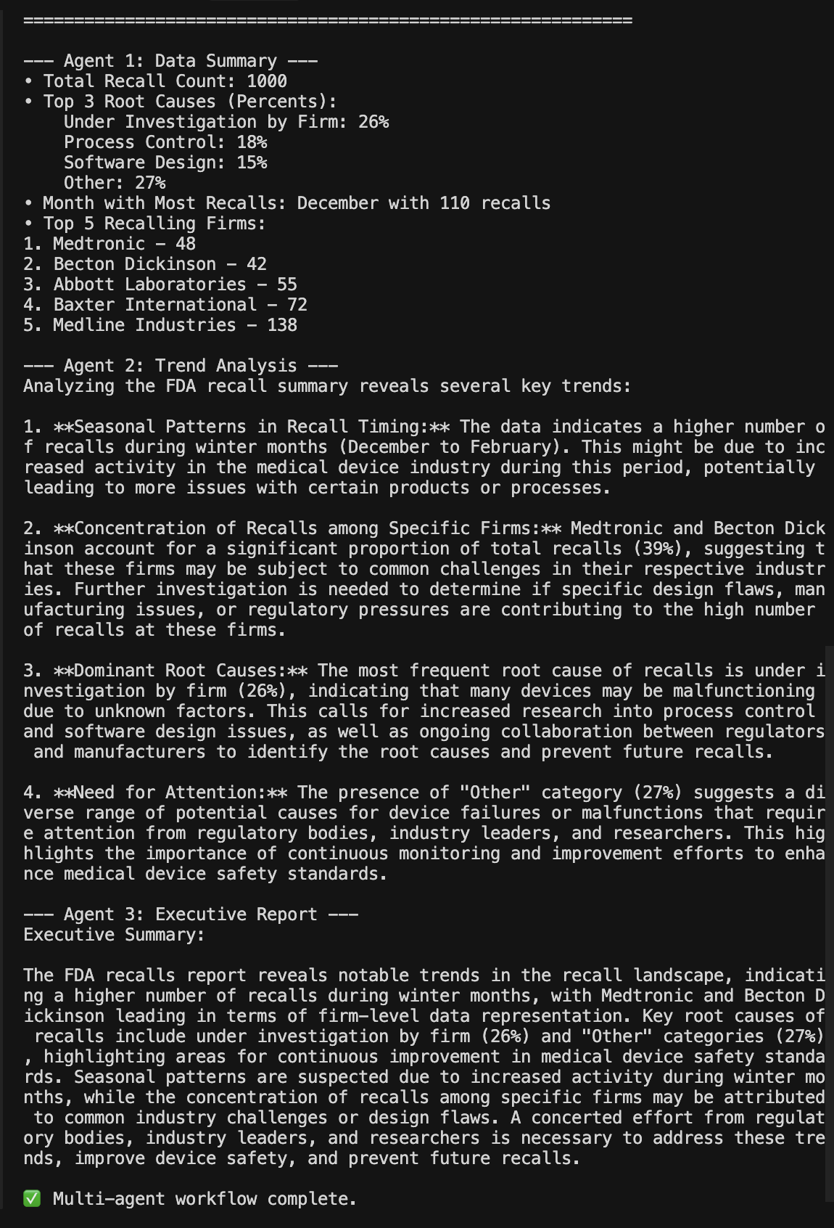

3.2 RAG Retrieval and Response (lab_custom_rag_query.py)
This screenshot shows the RAG workflow: searching the knowledge base for matching lines, then passing retrieved context to the LLM for context-aware answers.
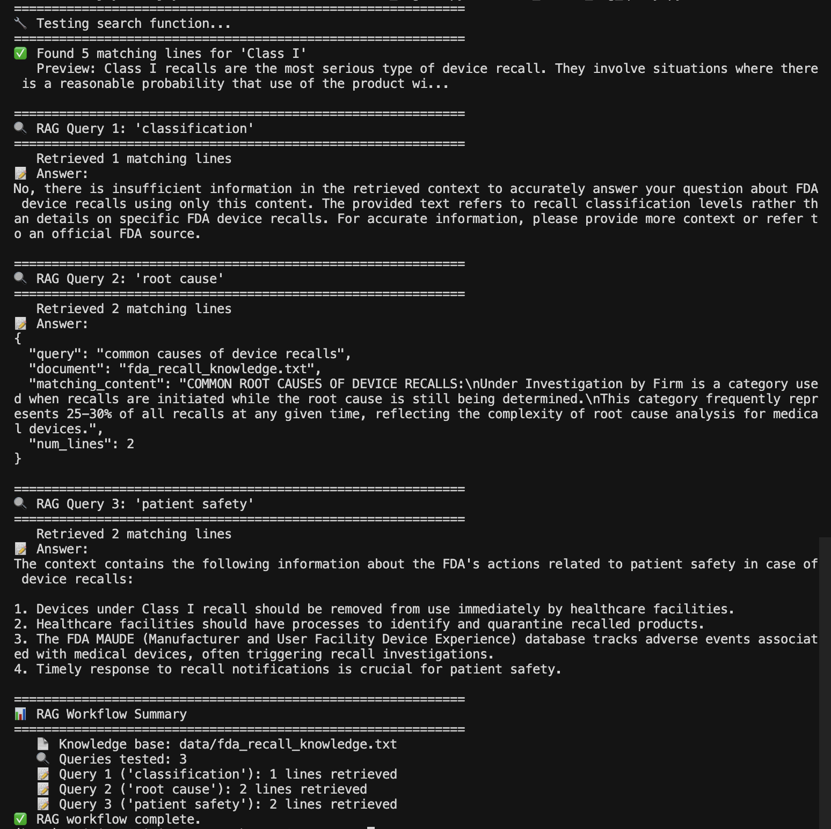

3.3 Function Calling / Tool Usage (lab_multi_agent_with_tools.py)
This screenshot shows Agent 1 calling the get_fda_recalls() tool to fetch live data from the openFDA API, returning a DataFrame of recall records. Agent 2 then analyzes the data.
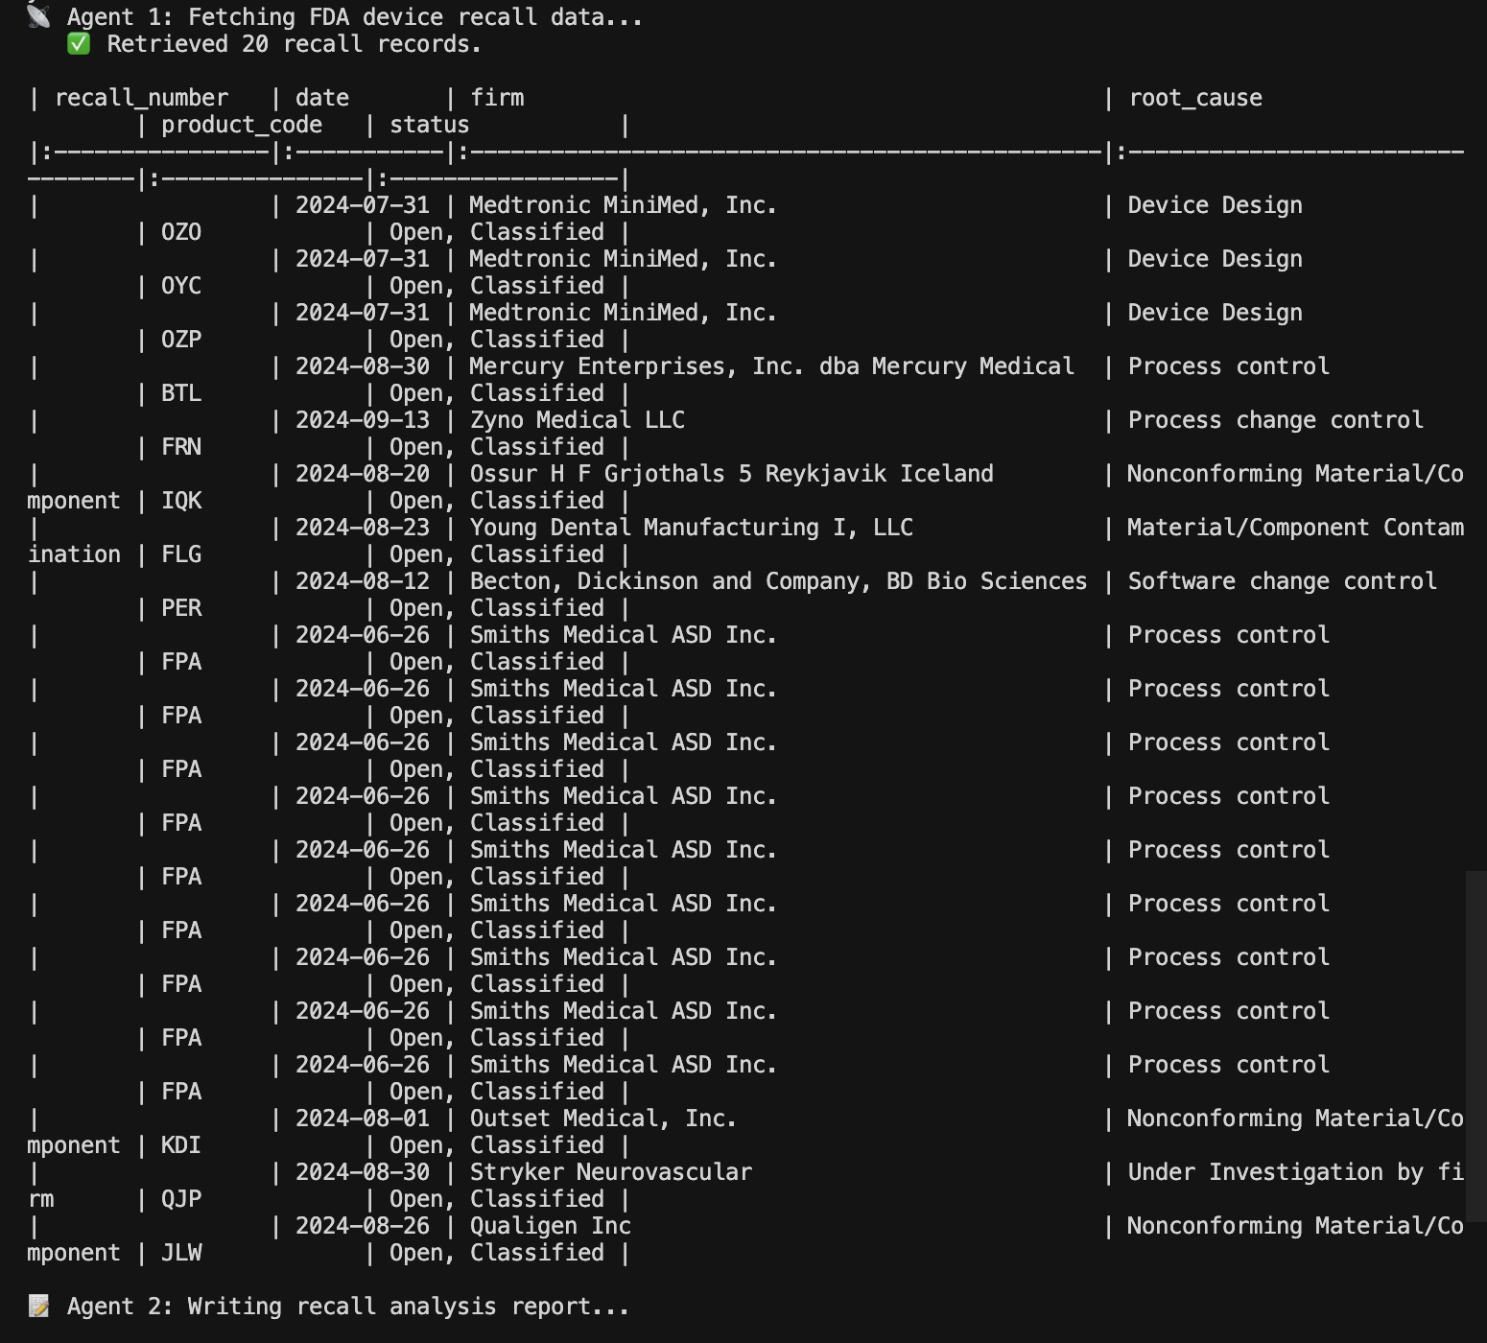
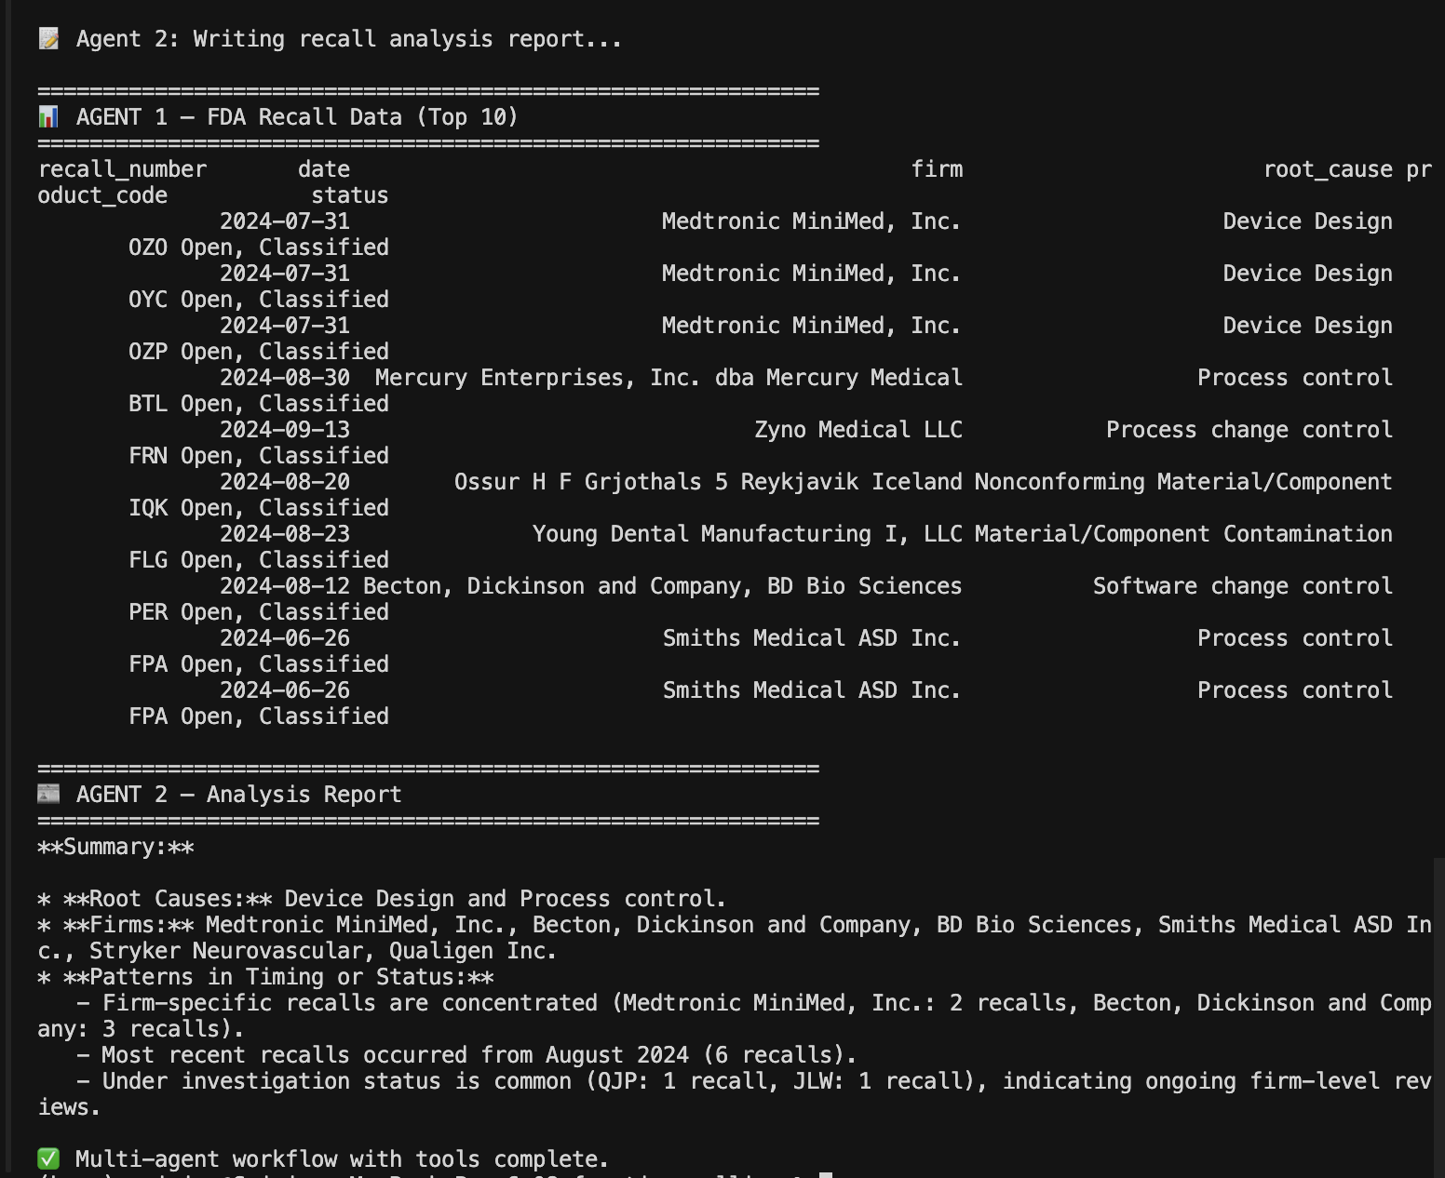

3.4 Combined System (homework2_fda_agent.py)
This screenshot shows the unified system with all three components: function calling (Agent 1), RAG (Agent 2), and the final executive report (Agent 3).

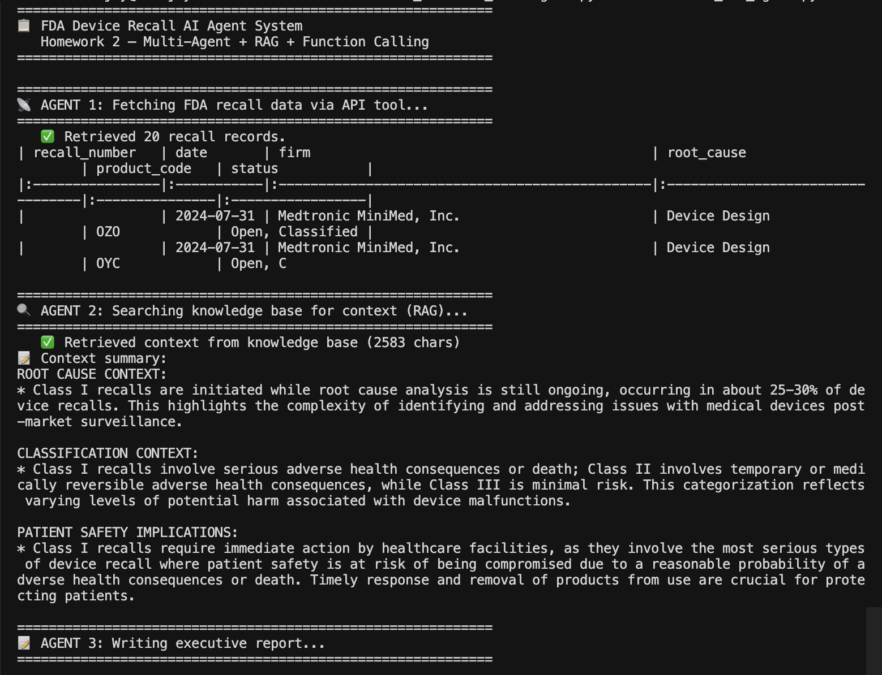

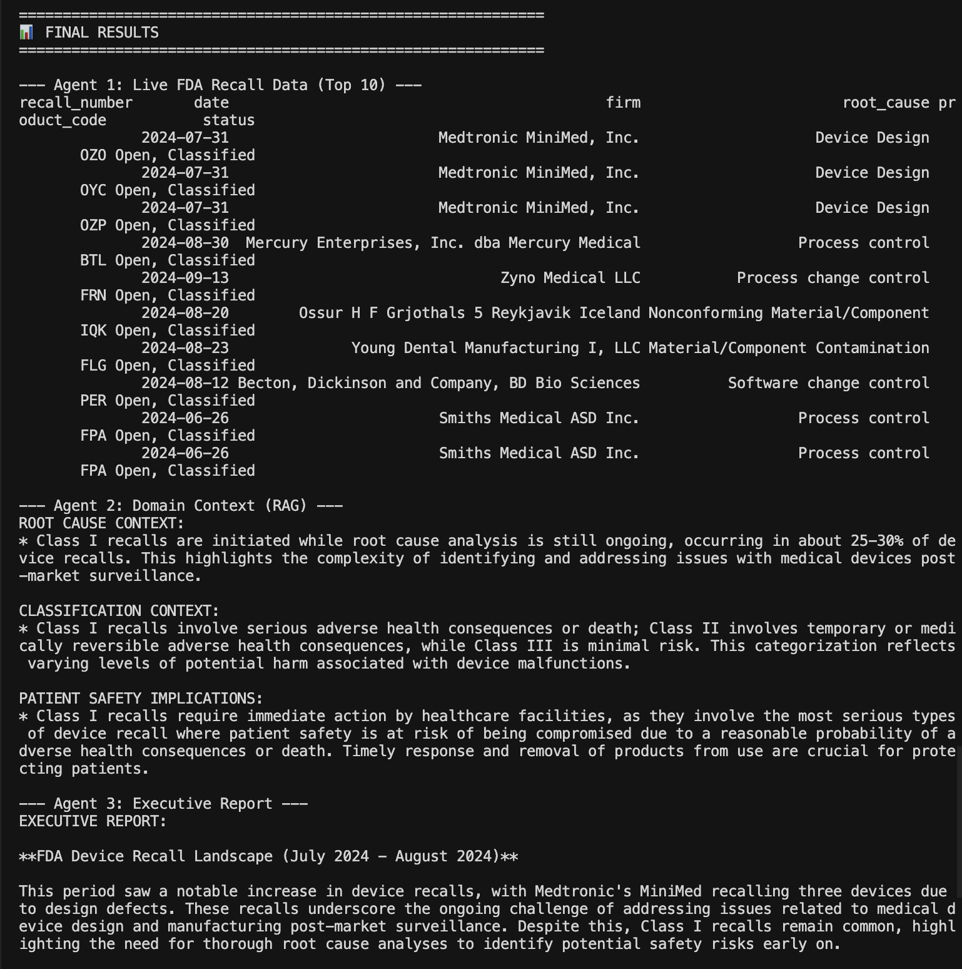
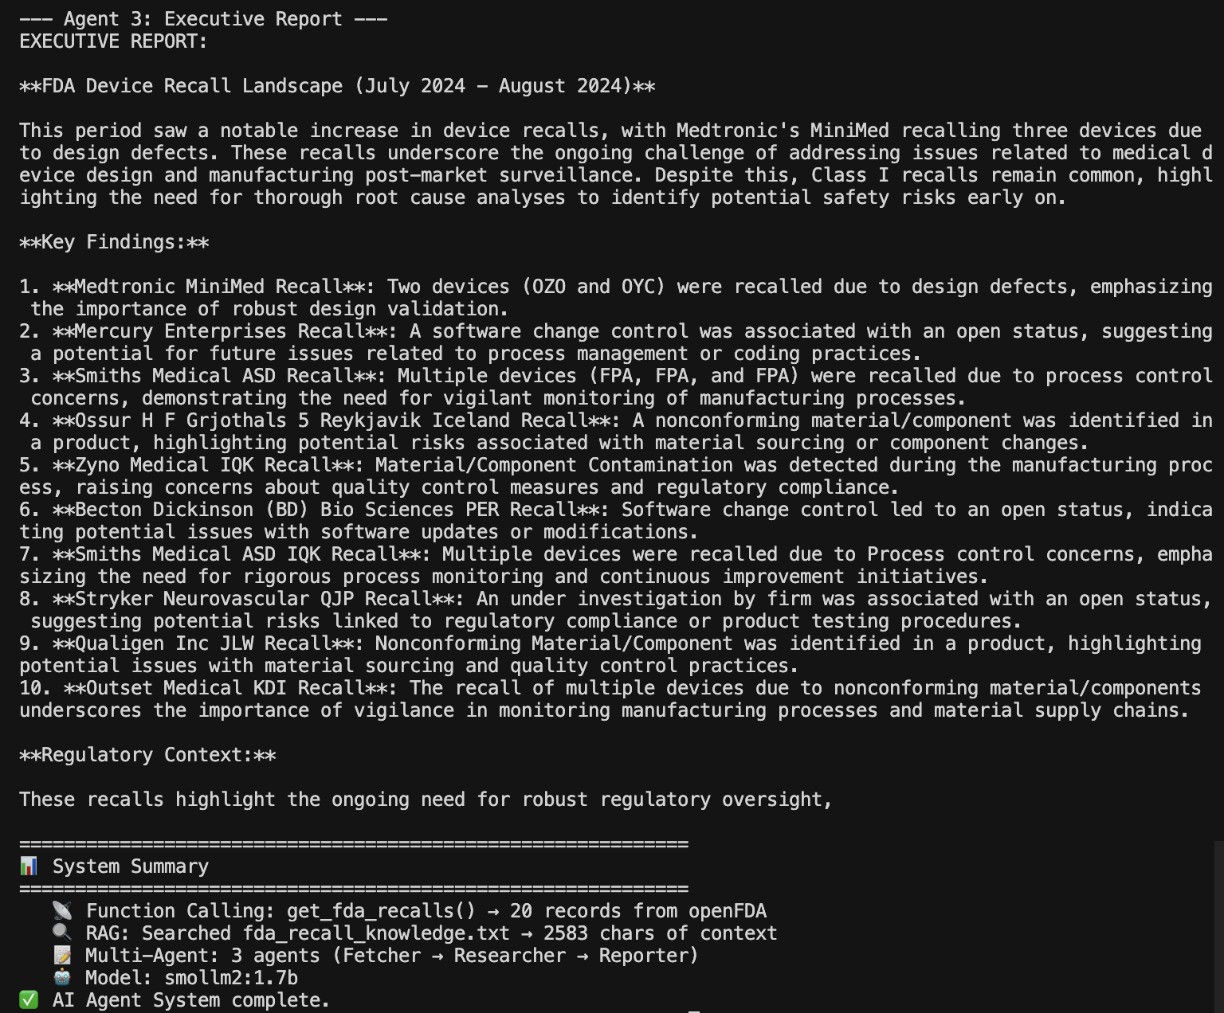

4. Documentation

4.1 System Architecture
The system uses a 3-agent pipeline where each agent has a specific role:
Agent | Role | Component | Input | Output
Agent 1: Data Fetcher | Queries openFDA API | Function Calling | LLM picks tool args (year, limit) | DataFrame of recall records
Agent 2: Context Researcher | Searches local knowledge base | RAG | search results for root causes, classifications, safety | Synthesized domain context
Agent 3: Executive Reporter | Writes professional report | Multi-Agent | Data from Agent 1 + context from Agent 2 | Executive brief (Overview, Findings, Context, Recommendations)

Workflow: Agent 1 output and Agent 2 output are both passed to Agent 3, which synthesizes them into a final executive report.

4.2 RAG Data Source
- File:
07_rag/data/fda_recall_knowledge.txt
- Type:
Plain text file (~40 lines) of FDA domain knowledge
- Search method:
Case-insensitive substring matching across all lines
The knowledge base contains information not available from the API:
Topic | Content
Recall Classifications | Class I / II / III definitions, severity, examples, required actions
Root Causes | Process Control, Nonconforming Material, Software Design, Design, Labeling, Under Investigation
Regulatory Process | CDRH oversight, 21 CFR Part 806, recall status types (Ongoing, Terminated, Completed)
Metrics & Trends | Annual recall volumes (~3,000-4,000/year), top firms, product categories
Patient Safety | Class I immediate action requirements, MAUDE database, facility quarantine processes

4.3 Tool Functions
Function | Purpose | Parameters | Returns
get_fda_recalls(year, limit) | Query openFDA Device Recall API for recall records | year (int): e.g. 2024; limit (int): 1-1000 | pandas DataFrame with columns: recall_number, date, firm, root_cause, product_code, status
search_fda_knowledge(query, path) | Search local knowledge base for matching lines | query (str): search term; path (str): file path | String of matching lines concatenated

4.4 Technical Details
API:
- Endpoint: https://api.fda.gov/device/recall.json
- Auth: Optional API_KEY in .env (higher rate limits)
- Query: Lucene search on event_date_initiated with date range filter
LLM:
- Provider: Ollama (local, http://localhost:11434)
- Model: smollm2:1.7b
- Tools API: /api/chat with tools parameter for function calling
Python Packages:
Package | Version | Purpose
requests | 2.32+ | HTTP requests to FDA API and Ollama
pandas | 3.0+ | Data manipulation and DataFrames
python-dotenv | 1.2+ | Loading .env for API keys
tabulate | 0.10+ | df.to_markdown() for table output

File Structure:
dsai/
├── .env # API keys (gitignored)
├── 06_agents/
│ ├── functions.py # Agent helpers (course-provided)
│ └── lab_prompt_design.py # Lab 1: Multi-agent prompt design
├── 07_rag/
│ ├── functions.py # RAG helpers (course-provided)
│ ├── data/
│ │ └── fda_recall_knowledge.txt # RAG knowledge base
│ └── lab_custom_rag_query.py # Lab 2: RAG query workflow
└── 08_function_calling/
├── functions.py # Function calling helpers (course-provided)
├── lab_multi_agent_with_tools.py # Lab 3: Multi-agent with FDA tool
└── homework2_fda_agent.py # Main system (all 3 components)

4.5 Usage Instructions
Step 1: Install dependencies
pip install requests pandas python-dotenv tabulate

Step 2: Configure API key (optional)
Create .env in the repo root with: API_KEY=your_fda_key

Step 3: Start Ollama
ollama serve
ollama pull smollm2:1.7b

Step 4: Run the main system
cd 08_function_calling
python3 homework2_fda_agent.py

Step 5: Run individual lab scripts (optional)
cd 06_agents && python3 lab_prompt_design.py # Lab 1
cd 07_rag && python3 lab_custom_rag_query.py # Lab 2
cd 08_function_calling && python3 lab_multi_agent_with_tools.py # Lab 3

