CONTROLLABILITY AND REACHABILITY
OF LINEAR DIDCRETE-CONTINUOUS SYSTEMS

Prof. Grigory Agranovich

Ariel University Center of Samaria, Dept. of Electrical and Electronic Engineering, Ariel, Israel

ABSTRACT. The linear discrete-continuous systems, are studied in this work, contain the two coupled subsystems: subsystem with continuous-time dynamics and subsystem with discrete-time dynamics. Continuous dynamics is described by ordinary linear differential equations, and a discrete one is described by difference equations for system's state jumps in prescribed time moments. For this class of models with time-varying, periodical and constant parameters the reachability and the controllability properties are investigated. As well controls are found for such systems state’s transition. Those solutions were applied for dynamical systems control design.

INTRODUCTION

Discrete-continuous systems (DCS) are those that combine both discrete and continuous dynamics. Many examples of DCS can be found in manufacturing systems, intelligent vehicle systems, robots etc. All computer-controlled systems are included in this wide class of dynamics. Modern complex engineering and other automatic control systems have hierarchical architecture. Common practice is to use digital stabilizing local controllers also at the lower levels. Therefore, the controlled system for an upper level control has discrete-continuous nature. At the same time hybrid systems constitute a wider class in which a controller has essentially nonlinear control logic. Because of great practical importance of hybrid, and specifically discrete-continuous, systems they have been the subject of intensive research for many years. An important characteristic of these systems from a control point of view is that they are simultaneously driven at each time instant by a continuous-time control signal plus by a discrete-time control signal at each preceding sampling time instants. The continuous-time control and the discrete-time control have not only a different physical nature, but they have also a different dynamical meaning. Indeed a continuous-time control excites the system’s state time variations by means of velocity change, however, a discrete-time control results in an instantaneous system’s state changes (“jumps”). In this way, there are two different control signals acting on the plant at the same time and the two kinds of a subsystem dynamics. The mathematical models of such systems are well known in literature [1], [2], [5], [8], [10], [11] etc.
Great effort was concentrated on optimal control and filtering problems' solution, such as LQG [1], [2], [3], [10] 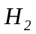and 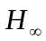 [2], [3], [10]. Various stabilization techniques were developed for hybrid systems [9], [10], [11] etc.
At the same time, problems of reachability and controllability analysis of linear discrete-continuous systems (LDSC), which are well-known for continuous-time and for discrete-time models and are effective design tools of a practical engineer, still remain unsolved in full. This paper is devoted to comparative analysis of reachability and controllability properties of time-variable LDSC, time-periodical LDSC, and time-constant LDSC. The reachability property of the system means an existence of a control signal, which transposes the system from zero initial state to any designed final state. The controllability of the system means an existence of a control signal, which transposes the system from any initial state to final zero state. For continuous-time nonsingular linear systems these properties are coinciding. But for both discrete-time and discrete-continuous linear systems, which transition matrix is singular as a rule, this is not the case. In this work for such systems the Kalman-like reachability and controllability criteria are developed.

STATE MODEL AND TRANSITION MATRIX OF LDCS

Consider the set 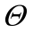 of prescribed discrete time instants

, (1)

and time functions 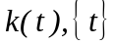, defined on this set as

, (2)

which specify the operating time of a discrete-time subsystem.

If in equation (1) the interval between successive time instants is constant, then the equation (1) and functions (2) can be represented as:

. (3)

Equations (2) are useful for describing an interaction between continuous-time and discrete-time subsystems of discrete-continuous system. Consider linear model of DCS in the form of a system with jumps ([1], [2], [3], [5], [6], [8], [10]).

DEFINITION 1. The 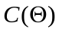 denotes a space of real-valued bounded functions, continuous on time segments 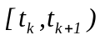, and right-continuous in 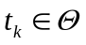.

Equations of a state vector evolution of the linear discrete-continuous system (LDCS) are

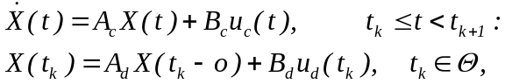 (4)

where
- 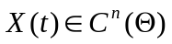 is the state vector;
- 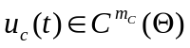, and 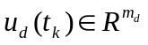 are continuous-time and discrete-time control excitations;
- 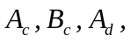 and 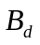 are the coefficient matrices of compatible dimensions, elements of continuous-time subsystem matrices 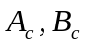 belong to .
We shall consider LDCS of the following three degrees of generality, depending on the structure of the discrete-time instants set 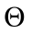 and time-dependence of model (4) coefficient matrices:

DEFINITION 2. (Time-variable, time-periodical and time-invariant LDCS)
2.1. A system (4) is said to be time-varying LDCS (LTVDCS or in brief LDCS) if
at least on of the assertions holds:
- its discrete-time instants set is defined by (1),
- at least one element of its continuous-time part coefficient matrices is a time-varying function of class , and the rest are constants,
- at least one element of its discrete-time part coefficient matrices 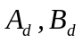 is a time-varying function, and the rest are constants.
2.2. A system is said to be h-periodical LDCS (LTPDCS) if the following assertions
hold
- its discrete-time instants set 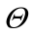 is defined by (3),
- at least one element of its continuous-time part coefficient matrices is h-periodical function of class , and the rest are constants,
- all elements of its discrete-time part coefficient matrices are constants .
2.3. A system is said to be time-invariant LDCS (LTIDCS) if the following
assertions are hold
- its discrete-time instants set is defined by (3),
- all elements of its coefficient matrices are constants.

The state vector of LDCS (4) can be represented as follows ([1], [2], [5], [6], [10]):

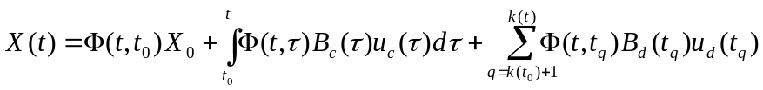 (5)

where 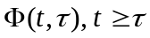 is the transition matrix of LDCS, which satisfies the following equations
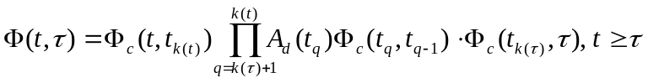. (6)

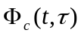 in (6) is a transition matrix of the continuous-time part of LDCS (4). The direct corollary of (6) is the semigroup property

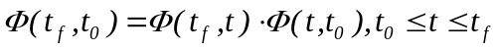 (7)
of the LDCS.
The following expression is an equivalent representation of the expression (6)

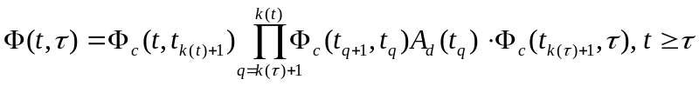. (8)

It should be remind that for continuous-time system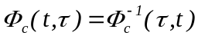, but this identity is not valid for LDCS with singular discrete-time part coefficient matrix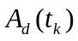.
For h-periodic LTPDCS a transition matrix representations (6), (8) take the following two equivalent forms

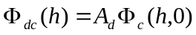, (9)
and
,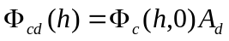. (10)

For LTIDCS a transition matrix of the continuous-time part can be expressed by the matrix exponent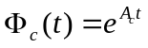, and therefore

, 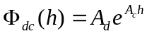, (11)
and
, 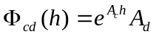. (12)

It is essential that the transition matrix of LTIDCS, equations (11) and (12), be a function of two arguments, and , as long as the system (4) with constant coefficients remains to be periodic by its nature (i.e. time-variant).
The main part, 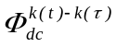 (or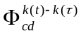) of the transition matrices representations (9) – (12) of LTPDCS and LTIDCS is the function of the difference 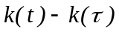, the rest multipliers are the h-periodic nonsingular matrices. This is crucial property of the LTPDCS (LTIDCS) transition matrix, which, for example, yields immediately the following necessary and sufficient condition of system stability.

CRITERION 1. (Stability of a LTPDCS) A LTPDCS )4) is exponentially stable if and only if the modules of all eigenvalues of its 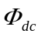component (or, equivalently, 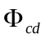), are less than one.

It makes sense to define eigenvalues of as spectrum of the operator described by equation (4). It should also be recalled that matrix 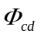 (11) is similar to matrix (10) and therefore has the same eigenvalues. The singularity (or non-singularity) of a linear system's transition matrix is of primary importance for its analysis. It follows from (9), (10) that the transition matrix of LTPDCS is singular if and only if discrete-time subsystem dynamical matrix 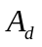 is singular. It should be noted that, as a rule, the transition matrix of a LTPDCS controlled by a built-in computer is singular. This is due to a data-processing time delay that occurs as a time shift between the input and output signals of the discrete-time subsystem. This time delay coincides with zero eigenvalue of matrix , which implies singularity of .

REACHABILITY AND CONTROLLABILITY OF LDCS

The majority of definitions of the notions reachability (and controllability) can be divided on the two following types. The first type determines reachability as property of a system in preset instant of time 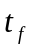, the second - determines reachability as property of a system on preset time interval 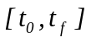. The reachability of a system in time instant is important condition for solution of the control, the optimization problems. The second type of definitions is more convenient for derivation of reachability and controllability criteria. In the case of time-invariant continuous-time systems the technique for those two approaches are coincide. Since LDCS, even with constant coefficients, do not keep properties of time-invariant continuous-time system, we will consider the both types of the definitions.

DEFINITION 3. (Reachability and Controllability on a time interval)
3.1. A LDCS (4) is said to be reachable on the time interval 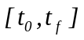 if for any state 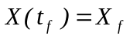 exists admissible control 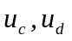 on time interval 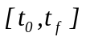which converts zero initial state 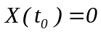 to the state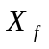.
3.2. A LDCS is said to be controllable on the time interval if for any state 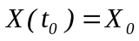 exists admissible control on time interval which converts zero initial state 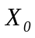 to the zero final state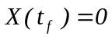.

DEFINITION 4. (Reachability and Controllability at a time moment)
4.1. A LDCS (4) is said to be reachable at time if for any state exists time instant 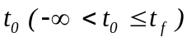 and admissible control on time interval which converts zero initial state to the state.
4.2. A LDCS is said to be controllable at time if for any initial state exists time instant 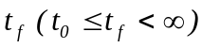 and admissible control on time interval which converts the initial state to the zero final state.

DEFINITION 5. (Complete Reachability and Controllability)
5.1. A LDCS (4) is said to be completely reachable if it is reachable at any time, including limiting time instants 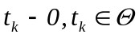.
5.2. A LDCS is said to be completely controllable if it is reachable at any time, including limiting time instants .

From (3) it follows, that the space of states of the LDCS, reachable on is represented by
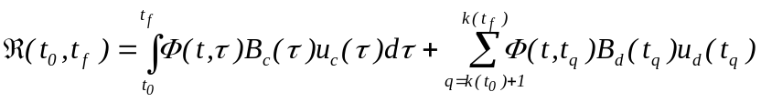 . (13)

where - admissible continuous and discrete controls.
Then for reachability of LDCS on it is necessary and sufficient that 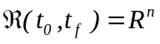. It can be proven that
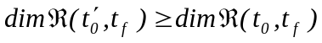 for all 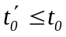 (14)
and
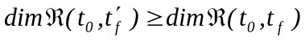 for 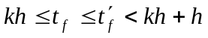 . (15)
By analogy with continuous-time systems [13] it is shown in [7], [11] that reachability space 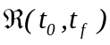 and range space of the symmetric positively semidefinite reachability matrix
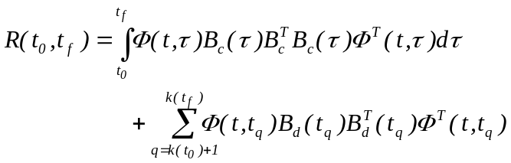 (16)
are coincide. Therefore LTIIS is reachable on the segment if and only if reachability matrix (16) is nonsingular. It follows from state vector LDCS representation (5) and (13) that system’s reachability on imply its controllability on this time segment. But the inverse proposition is no always the true. It is true for nonsingular transition matrix 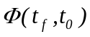.

REACHABILITY CRITERIA OF LDCS

CRITERION 2. (Reachability on a time interval). A LTDCS (4) is reachable on the time interval if and only if the reachability matrix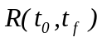(16) is nonsingular.
The following corollaries are useful for verification of system’s reachability in a prescribed time moment.

COROLLARY 2.1. If LDCS is reachable on the time interval,
then it is reachable on any time interval 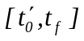, where .
COROLLARY 2.2. If LDCS is reachable in the time moment and for 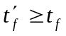 the transition matrix 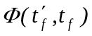 is nonsingular, then the system remains reachable in the time moment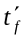. If belongs to continuity interval 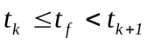 , then the system is reachable in any time moment , which belong to the time segment 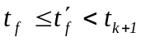.

For h-periodical LTPDCS, which have the following additional properties

(17)

the standard time interval for reachability test is defined by the next criterion.

CRITERION 3. (Reachability of h-periodical LDCS in a time moment). A LTPDCS is reachable in time moment if and only if it is reachable on the time interval 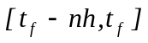.
For h-periodical and, as a special case, for LTIDCS the following assertion is valid.

ASSERTION 1. A LTPDCS (LTIDCS) is completely reachable, if and only if it is reachable in arbitrary time moment 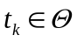. If in addition, the matrix is nonsingular, then for complete reachability it is necessary and sufficient the system reachability in arbitrary time moment .
Using this assertion, the following Kalman - like criterion is obtained.

CRITERION 4. (Complete reachability of LTIDCS) A LTIDCS is completely reachable completely reachable if and only if one of the two following equivalent assertions is fulfilled:
1) 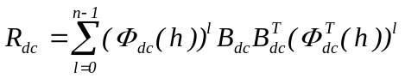 (18)
where
(19)
is nonsingular;
2) Rank of the matrix
(20)
is equal to .

CONTROLLABILITY CRITERIA OF LDCS

By analogy to reachability, controllability properties of LDCS can be investigate of base of linear subspace 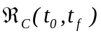of of system’s states 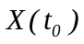, controllable on a time interval . This subspace of a LDCS state space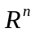 is defined as the solution of the linear set-theoretical equation

. (21)

Using (21), the following criterion is proved.

CRITERION 5. (Controllability on a time interval). A LTDCS (4) is controllable on the time interval if and only if one of these equivalent statements is valid

(22)
(23)

The following corollaries are useful for verification of LDCS controllability in the time moment and its complete controllability.

COROLLARY 5.1. If a LDCS is controllable on the time interval, then it is controllable on any including time interval 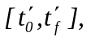where 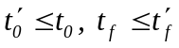.

COROLLARY 5.2. If a LDCS is controllable in the time moment , then it is controllable in any time moment 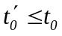.

A h-periodical LDCS has the following additional properties.

COROLLARY 5.3. A LTPDCS is controllable in time moment t if and only if it is controllable on time interval 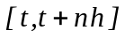.
COROLLARY 5.4. A LTPDCS is completely controllable, if and only if it is controllable in arbitrary time moment .

By analogy to reachability criterion 4 it was obtained the following the Kalman - like algebraic criterion of complete controllability of LTIDCS.

CRITERION 6. (Complete controllability of LTIDCS) A LTIDCS (4) is completely controllable if and only if if one of the two following equivalent assertions is fulfilled:
1) 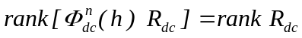, (24)
2) 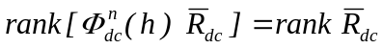 . (25)

CONCLUSIONS

This paper has been devoted to the derivation of Kalman - like reachability and controllability criteria for LDCS time-varying, time-periodical and time-invariant dynamical systems. The analogous problems of observability and constructibility are solved by means of the duality principle. From these results known Kalman - like criteria for LTI continuous-time and discrete-time systems follow as a special cases [4], [12], [13], [14]. These solutions give mathematical foundation for applications of optimal control and other methods for discrete-continuous systems design.

REFERENCES

- Barabanov A.T., Agranovich G.A., “Continuous-discrete Dynamic System's Linear Models and Optimization”, Dynamic Systems, 1983 (2), 17 - 24.
- Weiqian Sun, Krishan M. Nagral, Pramod P. Khargonekar, “H∞ Control and Filtering for Sampled-Data Systems”, IEEE Transactions on Automatic Control, 1993, 38 (8), 1162-1175.
- N. Sivashankar, Pramod P. Khargonekar, “Characterization of the L₂-induced Norm for Linear Systems with Jumps with Applications to Sampled-Data Systems”, SIAM Journal of Control and Optimization, 1994, 32, (4), 1128-1150.
- Tongwen Chen, Bruce A. Francis, “Optimal Sampled-Data Control Systems”, Springer-Verlag, 1995.
- Agranovich G.A., “Some Properties of Transition Matrix of Linear Continuous-Discrete Systems”, Transactions of Sevastopol Technical University, 1996, (2), 62-65.
- Agranovich G.A., “Some Questions of General Linear Continuous-Discrete Systems Theory”, Proc. of 1st Ukrainian National Automatic Control Conference, Kiev, 1994, (1), 6 - 7.
- Agranovich G.A., “Continuous-Discrete Systems Controllability Criterion”, Proc. of the 3rd Ukrainian National Automatic Control Conference, Sevastopol, 1996, (1), 8 - 9.
- M. de la Sen, “The Reachability and Observability of Hybrid Multirate Sampling Linear Systems”, Computers Math. Applic., 1996, 31, (1), 109-122.
- M. de la Sen, “Simple asymptotic stabilizing control laws for linear time-invariant hybrid systems”, Cybernetics and Systems, 1997, 28, (7), 547-570.
- A.Ichikawa, H.Katayama, “Linear Time Varying Systems and Sampled-data Systems” , Springer, 2001.
- Grigory Agranovich, “Some Problems of Discrete/Continuous Systems Stabilization”, Functional Differential Equations, 2003, 10, (1-2), 5-17.
- T. Kailath, “Linear Systems”, Prentice-Hall, 1980.
- P. Antsaklis, A. N. Mitchel: “Linear Systems”, McGraw_Hill, 1997.
- E. D. Sontag, “Mathematical Control Theory: deterministic Finite Dimensional Systems”, 2nd Ed., Springer, 1998.

