Project Title: V.I.A.T.O.R
Visitor Intelligence and Adaptive Tourism Optimization Resource
Subtitle:
A Community-Driven Intelligent Navigation and Travel Experience Platform

1. Introduction
V.I.A.T.O.R (Visitor Intelligence and Adaptive Tourism Optimization Resource) is an intelligent, community-driven navigation and travel experience platform designed to redefine urban exploration. Unlike traditional navigation systems that strictly focus on finding the fastest or shortest routes, VIATOR transforms navigation into a rich, immersive travel journey. By integrating real-time community insights, local business discovery, and cultural landmarks, the platform offers personalized route recommendations—such as scenic, tourist-friendly, or food-centric paths. It bridges the gap between travellers seeking authentic experiences and local communities or businesses looking for greater visibility.

2. Problem Statement
Traditional navigation applications prioritize efficiency optimizing routes solely for the shortest distance or fastest travel time. In doing so, they overlook qualitative travel factors like scenic beauty, local culture, hidden attractions, and community recommendations.
As a result, travellers miss out on meaningful experiences and authentic local exploration, and local businesses & lesser-known spots suffer from low visibility and reduced foot traffic.
VIATOR addresses this gap by offering a community-powered platform that balances route efficiency with rich travel experiences and local insights.

3. Objectives
- Rethink route planning: Give people choices beyond just the fastest path, like scenic, food-focused, or tourist-friendly routes.
- Spotlight local gems: Help travellers discover hidden spots, cultural landmarks, and neighbourhood cafés they’d otherwise drive right past.
- Support local businesses: Give small, lesser-known shops and restaurants a chance to be seen and visited.
- Tap into local wisdom: Let locals and fellow travelers share authentic reviews, hidden spots, and real-time tips.
- Turn travel into an experience: Make getting to a destination just as enjoyable as arriving there.

5. Functional Requirements
- User Management: Secure signup/login, user profiles, and role-based permissions.
- Smart Route Navigation: Route selection based on specific goals like fastest, scenic, tourist-friendly, or food & café paths.
- Community Contributions: Submitting reviews, photos, travel tips, hidden spots, and reporting road updates.
- Local Business Module: Profiles, ratings, reviews, and category-based searches for nearby businesses.
- Tourism Discovery: Search for historical landmarks, museums, parks, local markets, and cultural sites.
- Recommendation Engine: Smart route suggestions powered by user preferences, ratings, and sentiment analysis.
- Interactive Map: Visual map interface with route displays, location pins, and filterable points of interest.
- Review & Rating System: Rating places and routes, liking helpful feedback, and reading community tips.
- Admin Dashboard: Moderating content, managing user access, handling spam, and tracking platform analytics.

6. Non-Functional Requirements
- Performance: The system delivers search results loads interactive maps quickly and creates routes, in just a few seconds.
- Reliability: The system has secure data storage, reliable authentication, high availability and uses cloud services that can handle faults.
- Security: The system is protected by Firebase Authentication uses role-based authorization has secure Firestore rules and includes input validation.
- Scalability: The system is built on an architecture that can handle more users and can be easily expanded to new cities.
- Maintainability: The code is clean and organized using Object-Oriented Design so it is easy to update and reuse parts of the system.
- Usability: The interface is easy to use has a learning curve and works well on all screen sizes.
- Availability & Compatibility: The system has uptime and can be accessed through the cloud and it works with all major mobile and desktop browsers.

7. User Types
- Traveler: Primary user who searches destinations, navigates routes, explores tourist attractions, discovers hidden gems, and reviews or rates locations.
- Local Contributor: Local resident or experienced traveller who adds travel tips, uploads photos, submits reviews, recommends spots, and reports road conditions.
- Administrator: Platform manager responsible for user management, content moderation, spam removal, verifying reports, and tracking analytics.

9. Tech Stack
- Frontend: Google Stitch, React, TypeScript, Mapbox GL JS
- Backend: Firebase Authentication, Cloud Firestore, Firebase Cloud Storage, Firebase Cloud Functions
- GIS & Analytics: Python, OSMnx, NetworkX, GeoPandas, Pandas
- AI & Data Processing: NLTK / DistilBERT (Sentiment Analysis), Scikit-learn (Recommendation & Clustering), DBSCAN
- Development Tools: Git, GitHub, Figma (UI Design), Visual Studio Code

10. UML Diagrams
1. Class Diagram (by Sumukh Mallikarjuna)
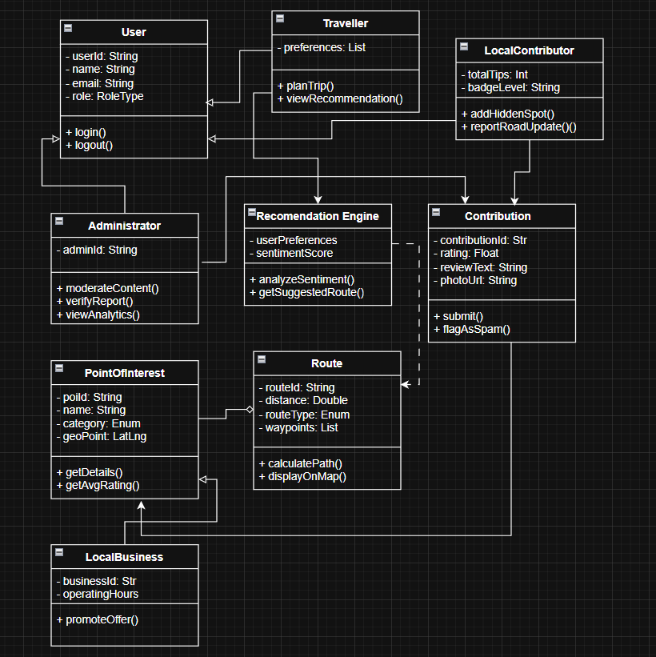
2. Use-case Diagram(by Neelesh Sandyapudi)
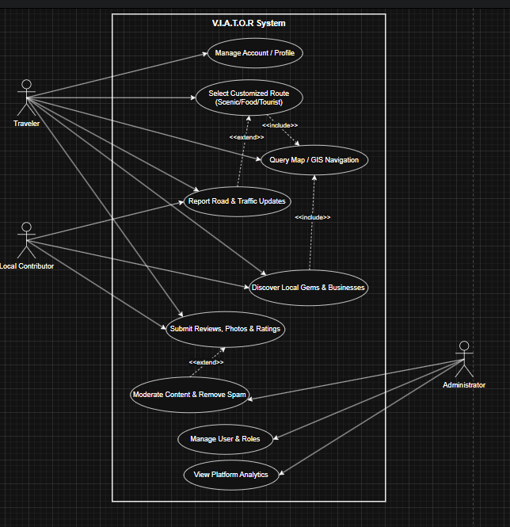

11. Team Roles
- Chaturvedi Dulam: Backend Development, Firebase Integration, Database Design, AI Integration, Recommendation Engine, Software Architecture
- Sumukh Mallikarjuna: Frontend Development, UI/UX Design, Google Stitch, React Development, Mapbox Integration, AI Feature Integration
- Ganesh Ravullapalli: GIS Integration, OSMnx, Route Generation, GeoJSON Processing, Data Engineering, System Testing
- Neelesh Sandyapudi: System Analysis, UML & OOAD Documentation, Quality Assurance, Integration Testing, Deployment, Technical Documentation

12. Conclusion
VIATOR is a way to get around cities. It makes traveling from one place to another fun by letting people share their experiences with each other. VIATOR is not about finding the best route from point A to point B. It is like having a friend who shows you cool things about the place you are visiting like local customs and secret spots that are not well known. VIATOR also helps you find businesses that're close by. The people who made VIATOR used design principles and the latest technology to build it. This means VIATOR can help solve problems that people have when they are trying to get. At the time VIATOR makes traveling more enjoyable and interesting. VIATOR is a tool, for people who want to explore new places and meet new people.

TEAM ODYSSEY

