**Traffic Simulation**

|  |  |  |
| --- | --- | --- |
| Enrollment No. | - | 9910103458 |
| Name of Student | - | Shishir Kumar Chaubey |
| Name of Supervisor(s) | - | Himanshu Mittal |



**May – 2017**

**Submitted in partial fulfillment of the Degree of**

**Bachelor of Technology**

**in**

**Computer Science Engineering**

**DEPARTMENT OF COMPUTER SCIENCE ENGINEERING & INFORMATION TECHNOLOGY**

**JAYPEE INSTITUTE OF INFORMATION TECHNOLOGY, NOIDA**

**(I)**

**TABLE OF CONTENTS**

|  |  |  |
| --- | --- | --- |
| **Chapter No.** | **Topics** | **Page No.** |
|  | Student Declaration  Certificate from the Supervisor  Acknowledgement  Summary  List of Figures  List of Tables  List of Symbols and Acronyms | II  III  IV  V  VI  VII  VIII |
| **Chapter-1** | **Introduction** | Page No. 6 To Page No. 7 |
|  | * 1. General Introduction   2. List some relevant current/open problems   3. Problem Statement   4. Overview of proposed solution approach and Novelty/benefits |  |
| **Chapter-2** | **Background Study** | Page No.8To Page No. 9 |
|  | * 1. Literature Survey      1. Summary of Papers      2. Integrated summary of the literature studied |  |
| **Chapter-3** | **Analysis, Design and Modeling** | Page No.10 To Page No.20 |
|  | * 1. Requirement Specifications   2. Functional and Non-Functional Requirements   3. Overall Architecture with component description and dependency details |  |
| **Chapter-4** | **Implementation and Testing** | Page No.21 To Page No.25 |
|  | * 1. Implementation details and issues   2. Testing      1. Testing Plan      2. List all test cases in prescribed format      3. Limitations of the solution |  |
| **Chapter-5** | **Findings & Conclusion** | Page No. 26To Page No. 27 |
|  | * 1. Findings   2. Conclusion   3. Future Work |  |
| References | ACM format | Page No. To Page No. |
| Resume | Resume – Shishir Kuamr chaubey | Page No. To Page No. |

**(II)**

**DECLARATION**

I/We hereby declare that this submission is my/our own work and that, to the best of my knowledge and belief, it contains no material previously published or written by another person nor material which has been accepted for the award of any other degree or diploma of the university or other institute of higher learning, except where due acknowledgment has been made in the text.

|  |  |  |  |
| --- | --- | --- | --- |
| **Place:** | Noida | **Signature:** | ______________ |
|  |  | **Name:** | Shishir Kumar Chaubey |
|  |  | **Enrollment No.** | 9910103458 |

**(III)**

**CERTIFICATE**

This is to certify that the work titled “**Traffic Simulation** ” submitted by “ **Shishir kumar Chaubey (9910103458)** ” in partial fulfillment for the award of degree of **B. tech** of Jaypee Institute of Information Technology University, Noida has been carried out under my supervision. This work has not been submitted partially or wholly to any other University or Institute for the award of this or any other degree or diploma.

|  |  |
| --- | --- |
| **Signature of Supervisor** | _____________________ |
|  |  |
| **Name of Supervisior** | Himanshu Mittal |
| **Date** | 24/03/2017 |

**(IV)**

**ACKNOWLEDGEMENT**

We would like to place on record our deep sense of gratitude to Asst prof. **Himanshu Mittal**, Jaypee Institute of Information Technology, Noida for her generous guidance, help and useful suggestions.

We also wish to extend our thanks to Prof. **Krishan Kant**, Dept. of **Computer Science & Engineering,** India for his stimulating guidance, continuous encouragement and supervision throughout the course of present work and other classmates for their insightful comments and constructive suggestions to improve the quality of this project work.

|  |  |
| --- | --- |
| **Signature of Student** | _______________ |
| **Name of Student** | Shishir Kumar Chaubey |
| **Enrollment Number** | 9913103419 |
|  |  |
| **Date** | 24/03/2017 |

**(V)**

**SUMMARY**

This is simple 2-D traffic simulator which represent 2 D graphical and animated view of traffic simulation . Ever wondered whether their controlling mechanisms could not better suit the flow of traffic? This is advances traffic simulator with detection of passing road provided by users and better traffic light and junction algorithms are to be implemented to optimize traffic flow in the better way . This is simple object oriented approach for traffic simulation is used . Graphical and animated representation give user a clear understanding. And user can see how traffic can view and controlled

|  |  |
| --- | --- |
| **___________________** | **_____________________** |
| **Signature of Student** | **Signature of Supervisor** |
| **Name: Shishir Kumar Chaubey** | **Name:** Himanshu Mittal |
| **Date:** 24/03/2017 |  |

1. **INTRODUCTION**
   1. **General Introduction**

The key element in improving traffic operations and performing real-time management is the ability to access the effectiveness of various alternatives prior to implementation. Simulation methods have long been recognized as the most effective tool for such analysis, and various simulators have been developed by different agencies for analyzing freeway and/or arterial networks. However, simulation has not yet become a suitable tool for practical application. One reason for is the extensive labor required to input the different kinds of traffic data into most simulation programs, which points to the need for a simulation tool that provides automatic access to large amounts of traffic data. The purpose of this research, therefore, is to develop an Automated Simulation Tool with automatic access to both traffic geometry and traffic measurement data.

* 1. **Problem Statement**

Transportation is an important aspect of our lifestyle. In the India,14.4 percent of Gross National Product is spent on transportation. 23.4 m automobiles . Congestion and environmental issues are an increasing problem that attracts much research. The motivation of the project is the observation that road-traffic networks are model-based systems ideally suited to an java-oriented programming approach. Each component in a traffic network can be modelled by an object that specifies its behaviour and interaction rules. Examples of objects that occur in a road network are vehicles, roads, junctions and traffic lights

* 1. **Overview of Proposed Solution approach and Novelty/benefits**

The project aim to give a 2d graphical representation of existing traffic modal The project aim to investigate traffic models and fit them into a flexible graphical . The application should allow user based road and traffic signal . The junction algorithm implemented in project to allow user based junction . The application will provide an interface to specify traffic levels before animation starts or to dynamically change it during animation. The application will also provide test cases results for any traffic data that is run on the simulation. User can give input to decide which type of traffic they want to simulate .ether urban or ruler ,big cities or small towns

1. **BACKGROUND STUDY**
   1. **Literature Survey**
      1. **Summary of Papers**

* **SIMULATION MODELS OF TRAFFIC FLOW**

**Authors: John Taplin**

**Summery:** This paper reviews the what is the effective way to prevent the traffic author suggest that. . the simple way to simulate a traffic according network that make sure no driver could find shortest way .define a indvisual lane for each vichel like truck lane ,bus lane or light vechil lane . .

* **A Microscopic Traffic Simulation Model for Transportation Planning in Cyprus**

**Authors: Aphames Thrasos**

**Summary:** The mathematical study of traffic flow, and indivisual vichile study that which type vichile craete more traffic congestion problem. The first attempt of mathematical study carried out in 1930 .we should need the a good mathematical modal to mittigate a traffic congestion problem . is carried out with the aim of understanding and assisting in the prevention and remedy of traffic congestion problems. we still do not have a satisfactory mathematical theory to which can use in real traffic congestion problem.

* + 1. **Integrated summary of the Literature Studied**

Well the total 02 list of shortlisted research paper among many is the very tedious but helpful task. These research papers give us the good amount of knowledge about trafiic, algorithms, external factors. Such problem faces by the people

urban automobile traffic has led to serious traffic congestion in most cities. Since travel demand increases at a rate often greater than the addition of road capacity, the situation will continue to deteriorate unless better traffic management strategies are implemented. One of the most attractive remedial measures for addressing the congestion problem is the deployment of Intelligent Transportation Systems (ITS). ITS is the application of current and evolving technologies to transportation systems and the careful integration of system functions to provide more efficient and effective solutions to multi modal transportation problems. A wide range of technological developments fall under the ITS agenda.

.

1. **ANALYSIS, DESIGN AND MODELLING**
   1. **Requirement Specifications**

* **Software**
* java virtual machine
* Linux or Windows
* java machine with jdk
* java simulator
* Xampp
* Browser (Firefox or Chrome)
* **Hardware**
* Intel Core processior
* min 2 gb ram
  1. **Functional and Non-Functional Requirements**
* **Functional Requirements**
* Mac OS sierra
* PHP for the simulation
* **Non-Functional Requirements**
* **Performance Requirements**

As for this prototype version we will keep on detecting if the system crashed, hanged or an operating system error occurred. Also detecting the performance of the system in terms of the efficiency of integration of the different component.

* **Security and Privacy Requirements**

There are no specific security requirements, anyone can access and use the portal but only authorized persons who are allowed to use and access the database, web pages and the product engine.

* **Software Quality Attributes**
* **Reliability**

The solution should provide reliability to the user that the product will run with all the features mentioned in this document are available and executing perfectly. It should be tested and debugged completely. All exceptions should be well handled.

* **Accuracy** The solution should be able to reach the desired level of accuracy. But also keeping in mind that this prototype version is for proving the concept of the project
  1. **Overall Architecture with Component Description and Dependency details**

**Fig:-1 Overall Architecture**

**MS Excel:**

The MS Excel is used to plot the graph of the tables which we recorded during our database making system.

**Java machine**

The java machine in windows and linux system to write code and running simulation .we use jdk

**Gliffy:**

We have used the gliffy software to make the Diagram and the Overall Architecture of our project which tells us about the distance.

**Browsers:**

Google Chrome Browser is used for the making of simulation of and testing of the html tags to make the simulation UI better.

**Application Architecture**

The project divide in to three parts first the network desigen and the simulator show the result and view of current traffic and its show the how traffic control. The link between simulator and editor class called main class it contain application control such as buttons and the menu bar.

Object-oriented approach for cars and trucks .objects define as cars. Main class also contains the 4 lane road networks and simulate using java virtual machine.

Main class also contain action class providing functionality for controls. Main class is the only class with the detail knowledge.

**3.3.1 Desigen Diagrams**

Road Desigen

**3.3.2 Road**

The main class contains 4 lane road with the traffic signals .and user can draw the road on the screen and user can also extend the road .Java’s road object perfect for drawing road.

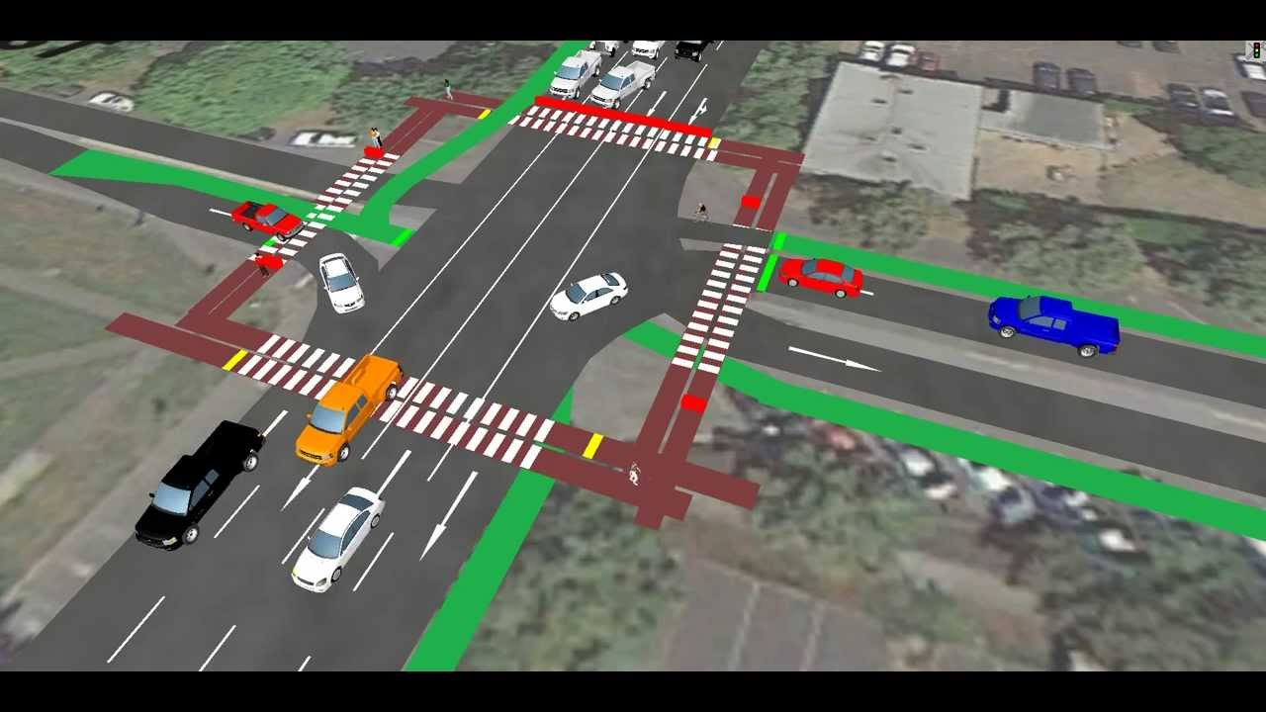

public void start()

{ startcar1=1;

startcar2=1;

car1=getimage(getbase(),"photo1.jpg");

car2=getimage(getcode(),"photo3.jpg");

car1X=0;

car1Y=(int) (((200-car1.getheight(this))-0+1)*Math.random()+0);

car2X=(int)(((400-car2.getidth(this))-0+1)*Math.random()+0);

car2Y=0;

mt=new Tracker(this);

mt.addphoto(car1,1);

mt.addphoto(car2,2);

setbackground(Color.green);

try{

mt.wait();

}catch(interruptedexception e){}

resize(200,200);

thisThread=new Thread(this);

thisThread.start();

}

**3.3.2 The Timing System**

It is important to track a time when car come in queue and when car is going out of queue to do this process any class that use to time function need to register with the timer function .the car object access the timer function and delay will be calculated in in timer function.

public T dequeue() throws EmptyCollectionException

{

if (isEmpty())

{

throw new EmptyCollectionException("queue");

T res = head.getelement();

head = head.getnext();

number--;

}

if (isEmpty())

tail = NULL;

return res;

}

public String toString()

{

String queuestring = "";

try

{

linearnode<T> elemnt = head;

T elemnt2 = elemnt.getalement();

while(i--)

{

queuestring += (elemnt2);

if(i > 1)

{

queuestring += "\n";

elemnt = elemnt.getnext();

elemnt2 = elemnt.getelement()}}}

catch(NullPointerException j)

{

System.err.println(" emptyend");

}

return queuestring;

}

**3.3.3 The vehicle movement**

the vehicle movement of car following a straight line queue. This mean if the car running there is no traffic and the car is out of queue and if the car is not moving then car is in the queue . update queue after the new car exit and enter .

The car in queue follow the following code

public void enqueue(T element)

{

linrnod1<T> node = new linnod1<T>(element);

if (isEmpty())

head = node;

else

tail.setNext(node);

tail = linnode;

count++;

}

if the car out of queue

public T dequeue() throws EmptyCollectionException

{

if (isEmpty())

throw new EmptyCollectionException("queue");

T result = head.getelement();

head = head.getnext();

count--;

if (isempty())

tail = null;

return result;

}

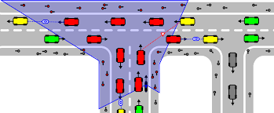

**3.3.4 Car generation**

we create object for car generation which is call by main class and and object can access to queue function and dequeue function and timer function also. We have to specify exactly how many cars enter in particular time interval. Because we need to compare two road variations .The user can specify how many time time interval occurred before a car is generated at any user input . The user can do it with right clicking. User can also check the size of a input.

class RoadMap extends RoadMap {

public static RoadMap create(int lanecount) {

lanegeometries lanegeometries = new Lanegeometries();

lanegeometries.setright(new lanegeometry(lane_count));

return new Road_map(lane_geometries);

}public static Road_map create(int laneCount, double roadLength) {

Lane_geometries lane_geometries = new lane_geometries();

lane_geometries.setright(new Lane_geometry(lane_count));

return new Road_Map(lane, roadlength);

} private RoadMappingConcrete(LaneGeometries laneGeometries) {

super(laneGeometries, 0, 0);

}private Road_map(Lanegeometries lanegeometries, double roadlength) {

this(lane_geometries);

this.roadl = roadl;

}@Override

}

}

**3.3.5 Junction models**

modeling a junction is most complex part of the project .User can also design the junction which is very complex .an alternative design is use in the project which is more generic .

**3.3.5.1 Non signal Junction**

non signaled junction also consider in the project. Priority of road decide which car go to first and which path last



**4.0 IMPLEMENTATION AND TESTING**

**4.1 Analysis of car movement**

the simulation show that a simple straight car-following queue gives a good results. speed and acceleration can also clearly visual and vehicle movement can also be fairly visible. When can reach an object such as traffic light or queue or near cars can also be fairly visible. when car A is faster than car B can also be visible .we can control the speed of car.

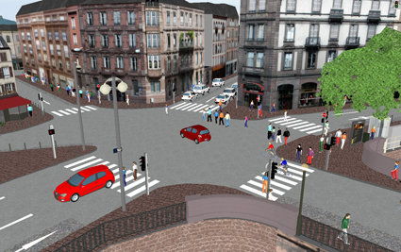

**4.2 Bridges**

the bridges are normal as lane there are nothing different than normal lanes but they are improve user visualization .

**4.3 Performance**

Although the simulater runs fine and performance is good. But when the cars (object )increase the performance graph is down .the editer become slower when we take the large road network. Because simulater has take more user event .

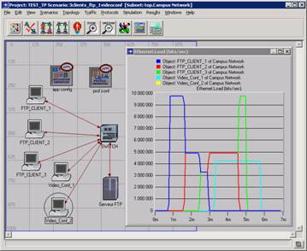

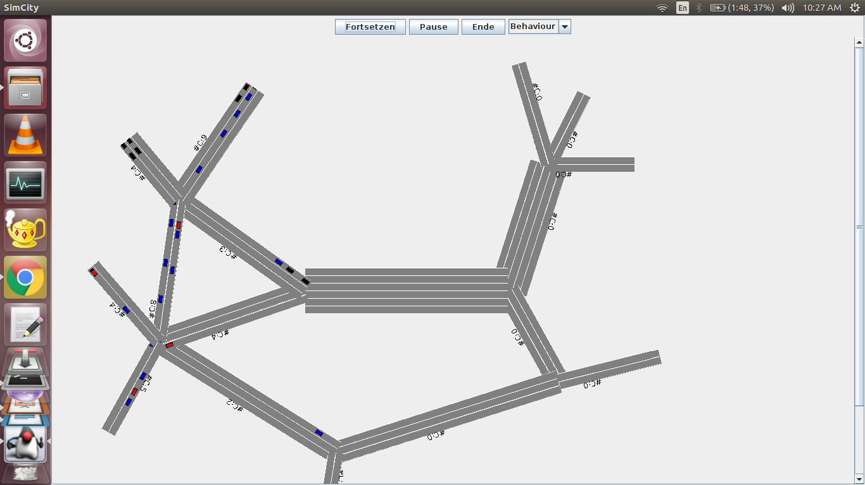

|  |  |  |  |  |
| --- | --- | --- | --- | --- |
| **TEST SCHEDULE** | | | | |
| **Activity** | **Start Date** | **Completion Date** | **Hours** | **Comments** |
| Research paper(Reading and Selection) | 8 Jan 2017 | 14 Jan 2017 | 5 | The research paper selection is the most important part to pursue the proper research |
| Simple code in jvm | 24 Jan 2017 | 4 Feb 2017 | 20 | Write code in java |
| Simulater work | 17 Feb 2017 | 22 Feb 2017 | 4 | The most important part of our project to collect the data from Wi-Fi by connecting different number of devices. |

|  |
| --- |
| **TEST ENVIRONMENT- PROVIDE A DESCRIPTION OF THE TEST PLATFORMS SOFTWARE ITEMS** |
| * Xampp * Wi-Fi Diagnostic Tool * Terminal * MS Excel |
| **HARDWARE ITEMS** |

1. **FINDINGS AND CONCLUSION**

.

* 1. **Conclusion**

the result of project are simple and can be road map for any road network projects. User can choose the road network and according to work. The project give a very goos idea for how can design the roads and its future impact for traffic . Traffic flow through animation give a good idea for users. From this its has been learnt that object orianted approach can adopt to good sample design for different traffic models .

* 1. **Future Work**

If given additional time to expand this project a number of key weaknesses in the project would be addressed.

* **Junction modelling** this will be allow path ways through a junction and automatically aanalyse conflicting path
* **Emergency vehicle tracking** this would track ambulance and other emergency vehicle
* **Map reading** we can try image recognition techniques to model of real road networks

**References**

* [1] Markos Papageorgiou (1991) Concise encyclopaedia of traffic and transportation systems. ISBN:0-08-036203-6
* [2] Microscopic traffic simulation for Advanced Transport Telematic (ATT) systems analysis, a parallel computing version. J.Barcelo, J.L.Ferrer, D. Garcia and R. Grau, Centre de Recherche sur les Transports, Universite de Montreal (http://www.tss-bcn.com/crtpap1st.pdf)
* [3] Traffic Flow Theory carried out by Oak Ridge National Laboratory under the guidance of an advisory committee established by Transportation Research Boards Committee A3A11. (http://www-cta.ornl. gov/cta/research/trb/tft.html)
* [4] Kent County Council. Intelligent Transport Systems (http://www. kent.gov.uk/sp/roads/inteltrans.html)
* [5] SMARTEST Project. (Simulation Modelling Applied to Road Transport European Scheme Tests) Micro-simulation links. (http://www. its.leeds.ac.uk/projects/smartest/links.html)
* [6] KLM. Development of Simulation models (http://www. kldassociates.com/simmod.htm)
* [7] The Traffic Simulation Group at the ZPR (http://www.zpr. uni-koeln.de/GroupBachem/VERKEHR.PG/) [8] US Department Of Transportation Adaptive Control of Transit Operations. (http://www.fta.dot.gov/library/technology/APTS/ITS/ CHAP0.HTM) [9] TRAFFIC WAVES. William Beaty 1998 (http://www.amasci.com/ amateur/traffic/traffic1.html) [10] Urban Traffic Control (UTC) Systems. SIEMENS (http://www. siemens.co.uk/traffic/utc.htm