Generated Math Questions (LLM Output)

This document contains two newly generated math questions following the required output format, including an illustrative image for Question 2.

# Question 1

@title Mix-and-Match Backpacks  
@description Counting combinations using the multiplication principle with a table of color choices.  
  
@question Each backpack is assembled using exactly 1 body color and 1 zipper color. The available colors are listed in the table below.  
  
| Body Color | Zipper Color |  
| :---: | :---: |  
| Blue | Black |  
| Green | White |  
| Gray | Red |  
| Purple | |  
  
How many different backpacks can be assembled?  
  
(A) Six  
(B) Eight  
(C) Nine  
(D) Twelve  
(E) Sixteen  
  
@instruction Choose the correct number of possible backpacks.  
@difficulty easy  
@Order 1  
@option Six  
@option Eight  
@option Nine  
@@option Twelve  
@option Sixteen  
@explanation There are 4 choices for the body color and 3 choices for the zipper color (Black, White, Red). By the multiplication principle, the total number of different backpacks is \(4 \times 3 = 12\).  
@subject Quantitative Math  
@unit Data Analysis & Probability  
@topic Counting & Arrangement Problems  
@plusmarks 1

# Question 2

Illustration (top view):

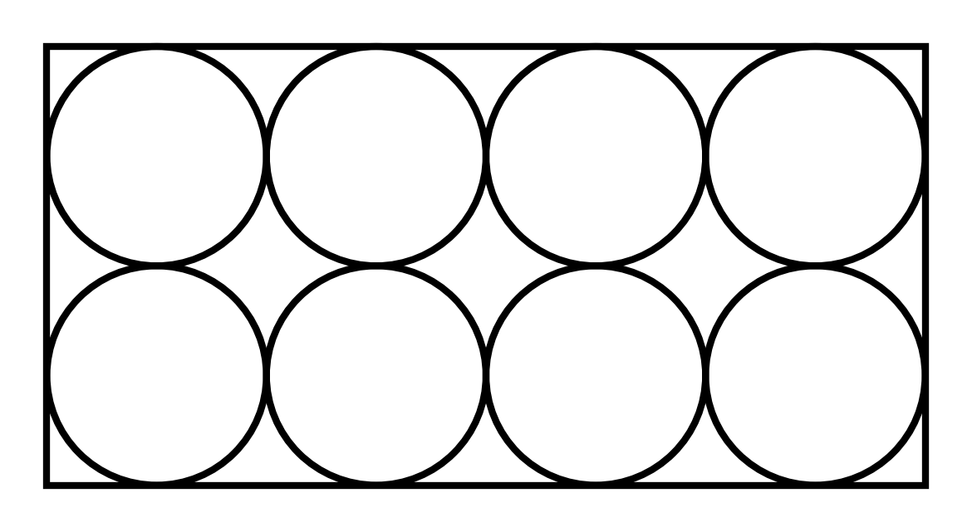

@title Packing Cylindrical Cans  
@description Spatial reasoning with dimensions of a rectangular package containing tightly packed identical cylinders.  
  
@question The top view of a rectangular package of 8 tightly packed identical cans (arranged in 2 rows and 4 columns) is shown below. Each can is a right circular cylinder with radius \(r = 3\) centimeters and height \(h = 12\) centimeters. Which of the following are closest to the dimensions, in centimeters, of the rectangular package (length \(\times\) width \(\times\) height)?  
  
[Image: top view with 2-by-4 circles inside a rectangle]  
  
(A) \(6 \times 12 \times 12\)  
(B) \(12 \times 24 \times 12\)  
(C) \(6 \times 24 \times 12\)  
(D) \(12 \times 18 \times 24\)  
(E) \(24 \times 24 \times 12\)  
  
@instruction Choose the correct package dimensions.  
@difficulty moderate  
@Order 2  
@option \(6 \times 12 \times 12\)  
@@option \(12 \times 24 \times 12\)  
@option \(6 \times 24 \times 12\)  
@option \(12 \times 18 \times 24\)  
@option \(24 \times 24 \times 12\)  
@explanation In a tight pack, the center-to-center spacing equals the diameter \(2r = 6\) cm. With 4 cans along the length, the length is \(4 \times 2r = 24\) cm; with 2 cans along the width, the width is \(2 \times 2r = 12\) cm; the height equals the can height \(h = 12\) cm. So dimensions are \(12 \times 24 \times 12\) (order can vary), matching option (B).  
@subject Quantitative Math  
@unit Geometry and Measurement  
@topic Coordinate Geometry  
@plusmarks 1