??function 🡪 shows function shit

Sklearn.metrics import precision, recall score

Make scorer = add metrics

Refit = optimise for one score

Add return_train_score = True, 🡪 will give a cv result for train score as well

Increase cv then you get more accurate metrics

Np.linspace (1, 20, 30). Start at 1 end at 20 and take 30 steps 🡪 change v to this

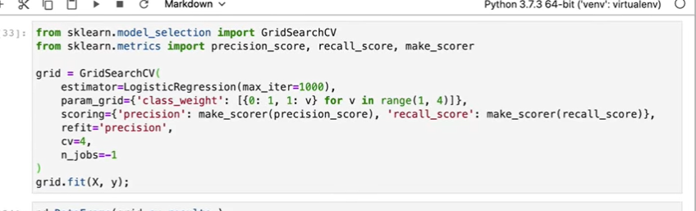

Plot:

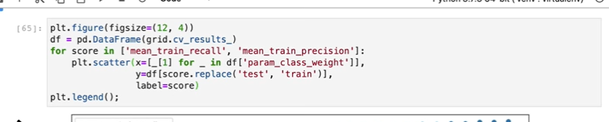

Meta Estimators

Usually you make a pipeline and that pipeline has processing & featurizers then a model.

Maybe you want to add post processing steps such as voting classifier

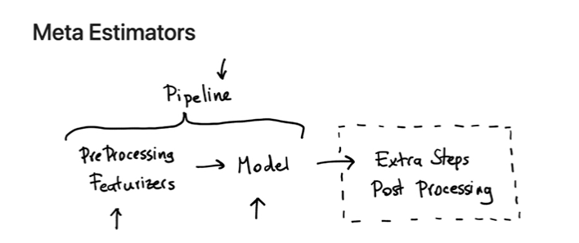

Voting Classisfier

From sklearn.ensemble import VotingClassifier

* Give a list of estimators and a weight for each estimator (Estimator eg logisticsregression, kneighbors)
* The weight can be used in the gridsearch
* Basically allows you to mix estimators

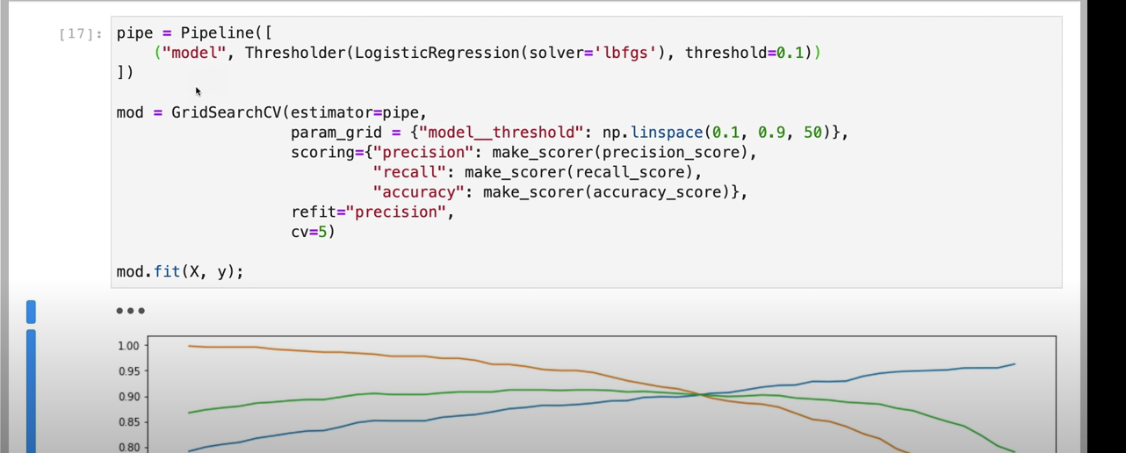

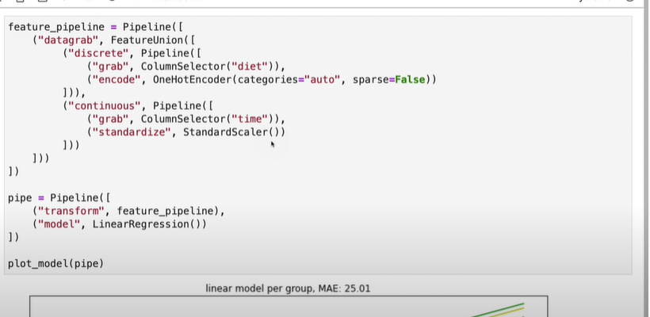

* Same with time and standardize
* columselector takes the diet column and onehotencodes it

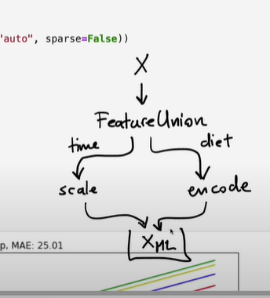 make X in to X for ML then use that in prediction