**Name : Chhaya Suresh Baviskar.**

**Roll No : 12**

**Practical No : 8**

**Title : Use git merge to merge your changes to the primary branch.**

**Before :**

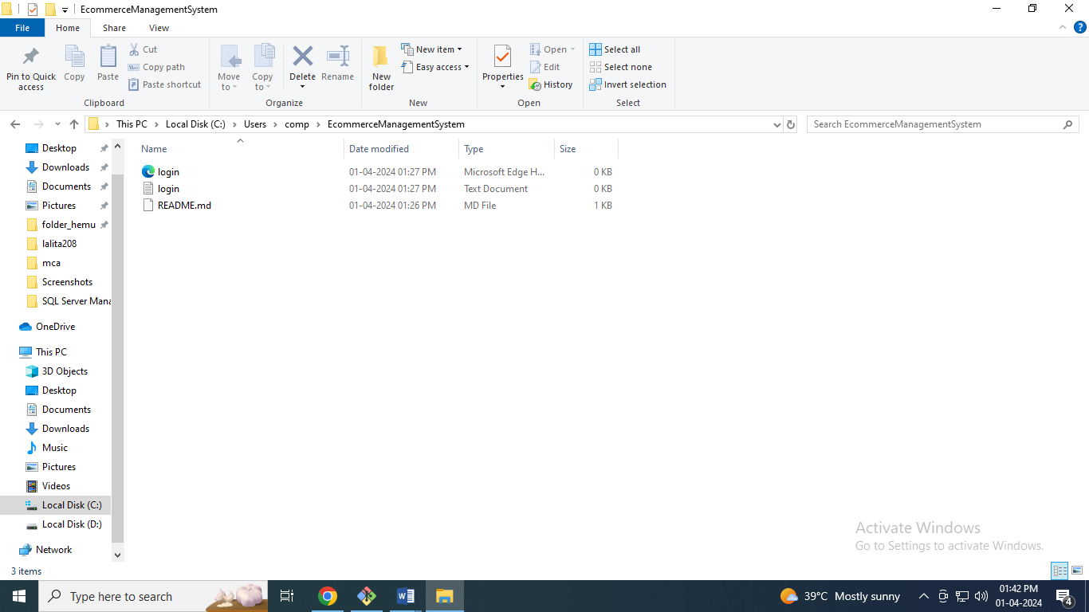

comp@com135 MINGW64 ~ (master)

$ git clone https://github.com/ChhayaBaviskar/EcommerceManagementSystem.git

Cloning into 'EcommerceManagementSystem'...

remote: Enumerating objects: 3, done.

remote: Counting objects: 100% (3/3), done.

remote: Compressing objects: 100% (2/2), done.

remote: Total 3 (delta 0), reused 0 (delta 0), pack-reused 0

Receiving objects: 100% (3/3), done.

comp@com135 MINGW64 ~ (master)

$ cd EcommerceManagementSystem

comp@com135 MINGW64 ~/EcommerceManagementSystem (main)

$ touch login.txt login.html

comp@com135 MINGW64 ~/EcommerceManagementSystem (main)

$ ls

README.md login.html login.txt

comp@com135 MINGW64 ~/EcommerceManagementSystem (main)

$ git status

On branch main

Your branch is up to date with 'origin/main'.

Untracked files:

(use "git add <file>..." to include in what will be committed)

login.html

login.txt

nothing added to commit but untracked files present (use "git add" to track)

comp@com135 MINGW64 ~/EcommerceManagementSystem (main)

$ git add .

comp@com135 MINGW64 ~/EcommerceManagementSystem (main)

$ git status

On branch main

Your branch is up to date with 'origin/main'.

Changes to be committed:

(use "git restore --staged <file>..." to unstage)

new file: login.html

new file: login.txt

comp@com135 MINGW64 ~/EcommerceManagementSystem (main)

$ git commit -m "two files are added"

[main 37d919b] two files are added

2 files changed, 0 insertions(+), 0 deletions(-)

create mode 100644 login.html

create mode 100644 login.txt

comp@com135 MINGW64 ~/EcommerceManagementSystem (main)

$ ls

README.md login.html login.txt

comp@com135 MINGW64 ~/EcommerceManagementSystem (main)

$ git branch branch2

comp@com135 MINGW64 ~/EcommerceManagementSystem (main)

$ git branch

branch2

* main

comp@com135 MINGW64 ~/EcommerceManagementSystem (main)

$ git checkout branch2

Switched to branch 'branch2'

comp@com135 MINGW64 ~/EcommerceManagementSystem (branch2)

$ ls

README.md login.html login.txt

comp@com135 MINGW64 ~/EcommerceManagementSystem (branch2)

$ git merge branch2 main

Already up to date.

comp@com135 MINGW64 ~/EcommerceManagementSystem (branch2)

$ touch prac1.txt prac2.txt

comp@com135 MINGW64 ~/EcommerceManagementSystem (branch2)

$ git status

On branch branch2

Untracked files:

(use "git add <file>..." to include in what will be committed)

prac1.txt

prac2.txt

nothing added to commit but untracked files present (use "git add" to track)

comp@com135 MINGW64 ~/EcommerceManagementSystem (branch2)

$ git add .

comp@com135 MINGW64 ~/EcommerceManagementSystem (branch2)

$ git status

On branch branch2

Changes to be committed:

(use "git restore --staged <file>..." to unstage)

new file: prac1.txt

new file: prac2.txt

comp@com135 MINGW64 ~/EcommerceManagementSystem (branch2)

$ git commit -m "two more txt files are added"

[branch2 a056376] two more txt files are added

2 files changed, 0 insertions(+), 0 deletions(-)

create mode 100644 prac1.txt

create mode 100644 prac2.txt

comp@com135 MINGW64 ~/EcommerceManagementSystem (branch2)

$ ls

README.md login.html login.txt prac1.txt prac2.txt

comp@com135 MINGW64 ~/EcommerceManagementSystem (branch2)

$ git checkout main

Switched to branch 'main'

Your branch is ahead of 'origin/main' by 1 commit.

(use "git push" to publish your local commits)

comp@com135 MINGW64 ~/EcommerceManagementSystem (main)

$ ls

README.md login.html login.txt

comp@com135 MINGW64 ~/EcommerceManagementSystem (main)

$ git merge branch2 main

Updating 37d919b..a056376

Fast-forward

prac1.txt | 0

prac2.txt | 0

2 files changed, 0 insertions(+), 0 deletions(-)

create mode 100644 prac1.txt

create mode 100644 prac2.txt

comp@com135 MINGW64 ~/EcommerceManagementSystem (main)

$ ls

README.md login.html login.txt prac1.txt prac2.txt

**After :**

