**ACKNOWLEDGMENT**

I am immensely grateful to all those who have guided, supported, and inspired me throughout the successful completion of my **Student Feedback Analysis Project**. This project would not have been possible without the valuable contributions and encouragement of several individuals.

First and foremost, I would like to express my profound gratitude to **Prof. Seema Purandare** my project supervisor, for their constant guidance, insightful suggestions, and constructive feedback. Their expertise and encouragement were instrumental in helping me understand the intricacies of data collection, preprocessing, analysis, and visualization. Their support not only helped me clarify complex concepts but also motivated me to approach problems critically and systematically. Without their patience and guidance at every stage, from conceptualization to completion, this project would not have reached its present form.

I would also like to extend my sincere thanks to my classmates and friends who actively supported me during the project. Their willingness to discuss ideas, provide constructive criticism, and assist with data analysis helped me enhance the quality of my work. Their collaboration and teamwork created a productive and motivating environment that made the challenging tasks manageable and more enjoyable.

I am sincerely grateful to all those who directly or indirectly contributed to the successful completion of this project.

**INDEX**

|  |  |  |  |
| --- | --- | --- | --- |
| No. |  | Title | Page no |
| **1.** |  | **Introduction** |  |
|  | 1.1  1.2  1.3 | Problem Definition  Need for the Analysis  Project Scope |  |
| **2.** |  | **Analysis** |  |
|  | 2.1 | Feasibility Study   * Technical Feasibility * Economic  Feasibility * Operational Feasibility |  |
|  | 2.2 | Hardware and Software Requirements |  |
| **3.** |  | **Design** |  |
|  | 3.1  3.2  3.3 | ER Diagram  Database Design/Data Dictionary  DFD Diagram |  |
| **4.** |  | **Methodology** |  |
| **5.** |  | **Result** |  |
| **6.** |  | **Screenshots and Code** |  |
| **7.** |  | **Limitations** |  |
| **8.** |  | **Future Enhancements** |  |
| **9.** |  | **Conclusion** |  |
| **10.** |  | **References and Bibliography** |  |

1. **Introduction**
   1. Problem Definition

In academic institutions, collecting student feedback is crucial for understanding the effectiveness of teaching methods, course content, and overall educational quality. Traditionally, feedback collection has been performed using paper-based surveys or unstructured digital forms, which presents multiple challenges. Manual feedback collection is time-consuming, error-prone, and often results in incomplete or inconsistent data. Furthermore, collating and analyzing this feedback requires significant human effort, delaying actionable insights.

Institutions face difficulty in identifying trends or patterns in student opinions because the feedback data is often scattered or unstructured. For example, text-based responses about faculty performance or course effectiveness may contain valuable insights, but extracting meaningful patterns manually is tedious and subjective. This often leads to misinterpretation or overlooking critical feedback.

Moreover, administrators need to make timely decisions to improve teaching quality and academic outcomes. Traditional methods fail to provide real-time insights, making it hard to address student concerns proactively. Without a structured mechanism to collect, clean, and analyze feedback, institutions cannot accurately assess faculty performance, student satisfaction, or the effectiveness of courses.

The **Student Feedback Analysis Project** addresses these challenges by providing a systematic approach to feedback analysis. By leveraging tools like Google Forms for collection, Excel for data cleaning, Python for analysis, and Power BI for visualization, this project ensures that feedback is organized, analyzed, and presented in a meaningful manner. The system allows educational institutions to convert raw feedback into actionable insights, enabling informed decision-making and continuous improvement in teaching and learning practices.

* 1. Need for the Analysis
* Student feedback serves as a primary indicator of teaching quality, course effectiveness, and overall student satisfaction. Analyzing this feedback is essential for several reasons. Firstly, it helps institutions identify areas where faculty performance or course content can be improved. For example, repeated student concerns about clarity of explanation or pace of lectures can be addressed once trends are identified.
* Secondly, feedback analysis allows administrators to make **data-driven decisions**. Instead of relying on intuition or sporadic observations, they can base improvements on systematic analysis of student opinions. This ensures that efforts to enhance teaching and learning are targeted and effective.
* Thirdly, analyzing feedback fosters transparency and accountability. Faculty members can understand how their teaching methods are perceived by students, and institutions can demonstrate their commitment to quality education. Feedback analysis also empowers students by making them active participants in the evaluation and improvement process.
* Furthermore, modern data analysis tools like Python and Power BI enable **advanced insights**. Textual feedback can be analyzed for sentiment, key concerns, and patterns that are not immediately apparent. Visual dashboards allow administrators to view real-time metrics, identify trends across departments, and compare faculty performance, making the process efficient and insightful.
* Overall, the analysis of student feedback is crucial for improving academic quality, enhancing teaching effectiveness, and ensuring student satisfaction. It transforms raw opinions into actionable information that drives improvement in a systematic, measurable, and transparent manner.
  1. Project Scope

The **Student Feedback Analysis Project** has a broad and practical scope. It is designed for implementation in schools, colleges, and universities to collect, clean, analyze, and visualize student feedback. The system supports multiple departments and categories of feedback, including faculty performance, course content, and infrastructure or facilities.

Feedback is collected digitally through **Google Forms**, which ensures accessibility, convenience, and accuracy. Responses are automatically stored in **Google Sheets**, providing a structured dataset for further processing. This eliminates the errors and delays associated with manual feedback collection.

The collected data is then exported to **Microsoft Excel** for cleaning and preprocessing. This ensures that duplicate entries are removed, missing values are handled, and the dataset is standardized for analysis. Cleaned data is analyzed using **Python**, where statistical techniques and sentiment analysis are applied to extract meaningful insights. Visualizations such as charts, graphs, and word clouds help in highlighting key trends.

Finally, insights are presented through **Power BI dashboards**, allowing administrators to monitor trends, compare faculty performance, and identify areas for improvement in real-time. The system provides actionable insights that support data-driven decision-making and enhance overall educational quality.

The project also has potential for future enhancements, such as AI-based sentiment prediction, faculty comparison reports, and predictive analysis to forecast student satisfaction trends. Overall, the system bridges the gap between raw feedback and actionable insights, making feedback analysis efficient, reliable, and impactful.

1. **Analysis**
   1. Feasibility Study
2. Technical Feasibility

Technical feasibility assesses whether the project can be implemented using the available technology, tools, and expertise. The Student Feedback Analysis Project relies on widely accessible digital tools such as Google Forms for data collection, Google Sheets for storage, Microsoft Excel for data cleaning, Python for advanced analysis, and Power BI for visualization. All these tools are compatible with standard personal computers and require minimal hardware specifications, such as a Windows OS with moderate processing power and RAM.

The project does not involve the development of complex software or integration of multiple systems, making it technically straightforward. Python libraries like Pandas, NumPy, Matplotlib, and NLP tools provide built-in functions for efficient data analysis and visualization. Power BI allows the creation of real-time dashboards without requiring extensive programming skills. Furthermore, the team or individual performing the analysis can quickly learn and operate these tools with basic technical training.

Overall, the technical feasibility of the project is high because it uses existing, reliable technologies, does not require specialized hardware or software, and is supported by abundant documentation and online tutorials. This ensures smooth implementation and minimizes technical risks.

1. Economic Feasibility

Economic feasibility evaluates whether the project can be completed within a reasonable budget and if the benefits outweigh the costs. The Student Feedback Analysis Project is highly cost-effective because it leverages free or low-cost tools. Google Forms and Google Sheets are freely available, Excel is commonly provided in academic institutions, and Python is an open-source programming language. Power BI offers a free desktop version sufficient for project requirements.

The cost of implementing this project is primarily limited to minor hardware requirements, such as a standard personal computer and internet access, which are already available in most educational institutions. Additionally, since the project does not involve software development or expensive licensing, overall financial investment is minimal.

Thus, the project is economically feasible, providing high value at minimal cost while delivering measurable benefits to the institution.

1. Operational Feasibility

Operational feasibility assesses whether the project can be effectively integrated into existing processes and whether users can adopt it successfully. The Student Feedback Analysis Project is operationally feasible because it fits seamlessly into current academic practices. Students are already familiar with submitting digital forms, and administrators can easily access Google Sheets, Excel, and Power BI dashboards.

The system enhances efficiency by automating data collection, cleaning, analysis, and reporting, reducing manual effort. The interactive dashboards provide administrators with intuitive visualizations, making it easy to interpret trends and make data-driven decisions. Minimal training is required to use these tools effectively, which ensures smooth adoption.

Furthermore, the project improves transparency and accountability, allowing stakeholders to monitor feedback systematically. Since it does not disrupt existing academic processes, and feedback collection can be scheduled alongside normal course activities, its operational integration is simple and practical.

In conclusion, the project is highly operationally feasible as it aligns with existing workflows, requires minimal training, and provides significant improvements in feedback management and decision-making.

* 1. Hardware and Software Requirements

1. Software Requirements

**Operating System:**

The project requires a Windows 10 or later operating system. It provides a stable and compatible environment for running Python, Excel, Power BI, and accessing Google Forms and Google Sheets.

**Feedback Collection Tool:**

Google Forms is used for collecting student feedback online. It is user-friendly, accessible from any internet-connected device, and ensures structured data storage in Google Sheets.

**Data Storage:**

Google Sheets is employed for storing all responses. It allows automatic data synchronization, easy export for analysis, and secure cloud-based storage.

**Data Cleaning Tool:**

Microsoft Excel is used to preprocess the collected data. It helps remove duplicate entries, handle missing values, and standardize the dataset for accurate analysis.

**Programming Language and Libraries:**

Python 3.x is used for advanced data analysis and visualization. Libraries such as Pandas, NumPy, Matplotlib, Seaborn, and wordCloud, textBlob facilitate data manipulation, statistical calculations, sentiment analysis, and graphical representation of feedback trends.

**IDE / Environment:**

Jupyter Notebook provides an interactive environment for writing, testing, and documenting Python code efficiently.

**Dashboard Tool:**

Microsoft Power BI Desktop is used for creating real-time interactive dashboards. It enables administrators to visualize insights, track trends, and make informed decisions easily.

**Web Browser:**

A stable browser such as Google Chrome or Microsoft Edge is required to access Google Forms and Sheets, ensuring smooth data collection and synchronization.

1. Hardware Requirements

**Processor:**

A minimum of Intel Core i3 (6th Generation) is required; Intel Core i5/i7 or AMD Ryzen 5 and above is recommended for faster processing of large datasets and real-time visualization.

**RAM:**

At least 4 GB RAM is necessary; 8 GB or more is recommended for smooth multitasking during data analysis and dashboard creation.

**Storage:**

Minimum 500 MB of free storage is required to install software and store data files; 2 GB or more is recommended for large datasets and backup.

**Display:**

Minimum resolution of 1366 × 768; recommended 1920 × 1080 (Full HD) for clear visualization of dashboards and charts.

**Internet Connection:**

A stable broadband connection is necessary for accessing Google Forms, syncing data in Google Sheets, and updating Power BI dashboards.

**Input Devices:**

Standard keyboard and mouse are required for data entry, analysis, and navigation through dashboards.

1. **Design**

3.1 ER Diagram

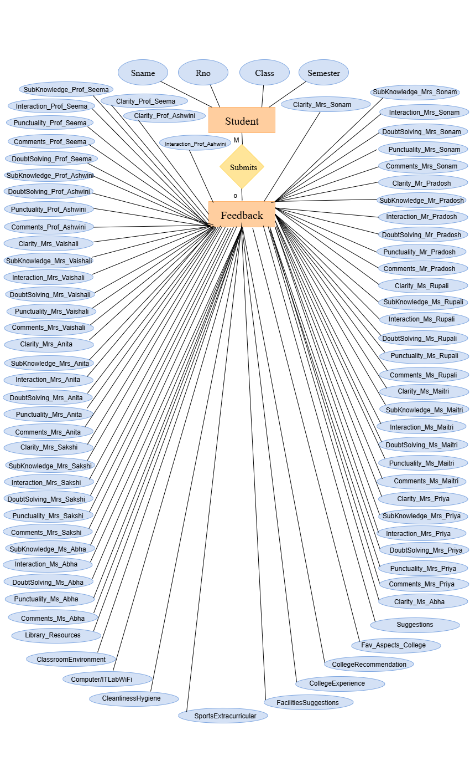

* 1. Database Design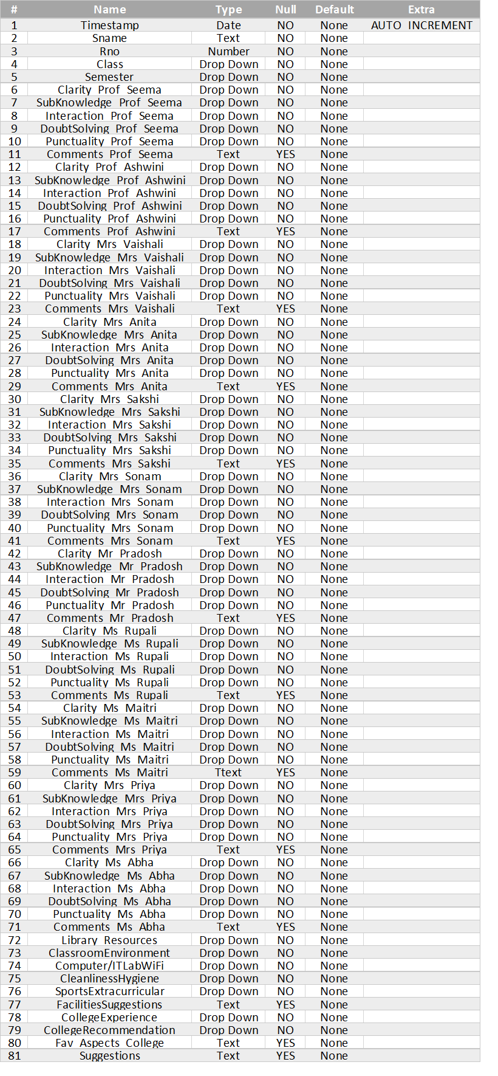
  2. Data Flow Diagram

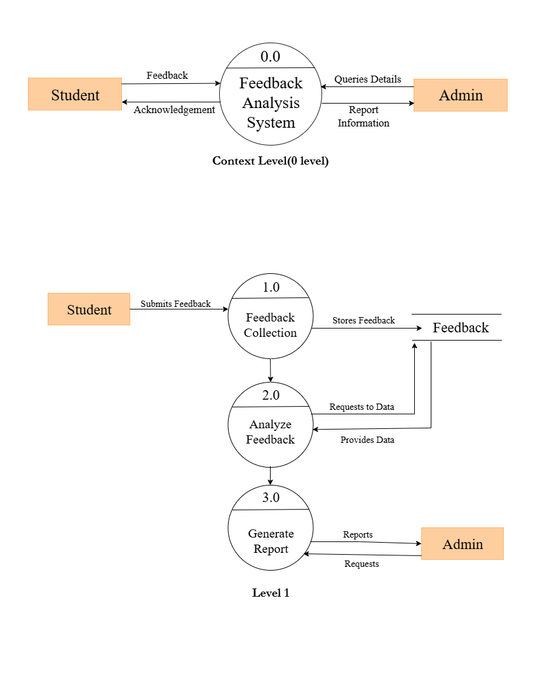

1. **Methodology**

Step 1: Feedback Collection (Google Forms):

The process begins with creating and distributing Google Forms to students. Each form includes questions related to various feedback categories such as faculty performance, course content, classroom facilities, and overall satisfaction. Google Forms are selected because they are easily accessible, mobile-friendly, and automatically record responses in a structured format.

Step 2: Data Storage (Google Sheets):

Once the students submit their responses, the data is automatically stored in Google Sheets. This ensures all feedback is centralized, organized, and instantly accessible for further processing. Google Sheets also enables cloud-based collaboration, allowing multiple users (faculty or admin staff) to view data simultaneously.

Step 3: Data Cleaning and Preprocessing (Microsoft Excel):

Raw data often contains missing values, duplicates, or inconsistent entries. To ensure accuracy, the collected data is cleaned using Microsoft Excel. Unnecessary columns are removed, errors are corrected, and data is formatted properly. This preprocessing phase ensures the dataset is ready for accurate analysis.

Step 4: Data Analysis and Visualization (Python):

Once the cleaned data is prepared, it is imported into Python (Jupyter Notebook) for statistical analysis and visualization.

Libraries used include:

• Pandas – for data manipulation and summarization

• NumPy – for numerical calculations and data transformation

• Matplotlib & Seaborn – for creating charts and graphs

• WordCloud/TextBlob – for sentiment analysis (to classify feedback as positive, neutral, or negative)

This stage extracts meaningful insights, such as satisfaction trends, common complaints, and performance ratings of faculty or departments.

Step 5: Dashboard Creation and Insights (Microsoft Power BI):

The analyzed data is then imported into Microsoft Power BI to design interactive dashboards. Power BI enables the creation of visual elements such as bar charts, pie charts, heat maps, and trend lines that summarize the findings.

These dashboards provide real-time insights and allow administrators to explore feedback across multiple dimensions (faculty, subject, department, semester, etc.) with ease.

Step 6: Decision-Making and Reporting:

Finally, administrators and academic heads use these dashboards to identify strengths and weaknesses within the institution. The insights help in making data-driven decisions to enhance the overall educational experience and ensure continuous improvement.

**5. Result**

1.Teacher Performance:

Prof. Seema is the top-performing teacher, excelling in most categories such as subject knowledge, doubt solving, and punctuality. Ms. Sakshi ranks second, performing particularly well in interaction and student engagement. Mr. Pradosh ranks third, showing strengths in subject knowledge but lower overall ratings compared to the top two. Ms. Sonam receives mostly lower ratings, highlighting the need for targeted improvement.

2.Category-wise Teacher Ratings:

Prof. Seema and Ms. Sakshi consistently score above 4 in most categories, reflecting balanced teaching quality. Ms. Sonam has ratings mostly below 3, suggesting widespread dissatisfaction in multiple teaching aspects.

3.Facilities Ratings:

Library, cleanliness, and computer lab are highly rated, indicating strong academic infrastructure. Sports and extracurricular activities receive lower ratings and show higher variability, suggesting mixed opinions and room for improvement. Classroom environment has the highest average rating and consistent feedback, reflecting general satisfaction in learning spaces.

4.College Experience & Recommendation:

Most students have a neutral perception of their college experience, with a notable portion reporting positive experiences, and very few negative. Recommendations are mixed, with most students uncertain ("maybe") about endorsing the college, a smaller portion saying "yes," and some saying "no."

5.Sentiment Analysis:

Overall, teacher feedback is mostly neutral or positive. Ms. Sonam and Mr. Pradosh have a few negative comments, indicating minor areas for improvement.

**6. Screenshots and Code**

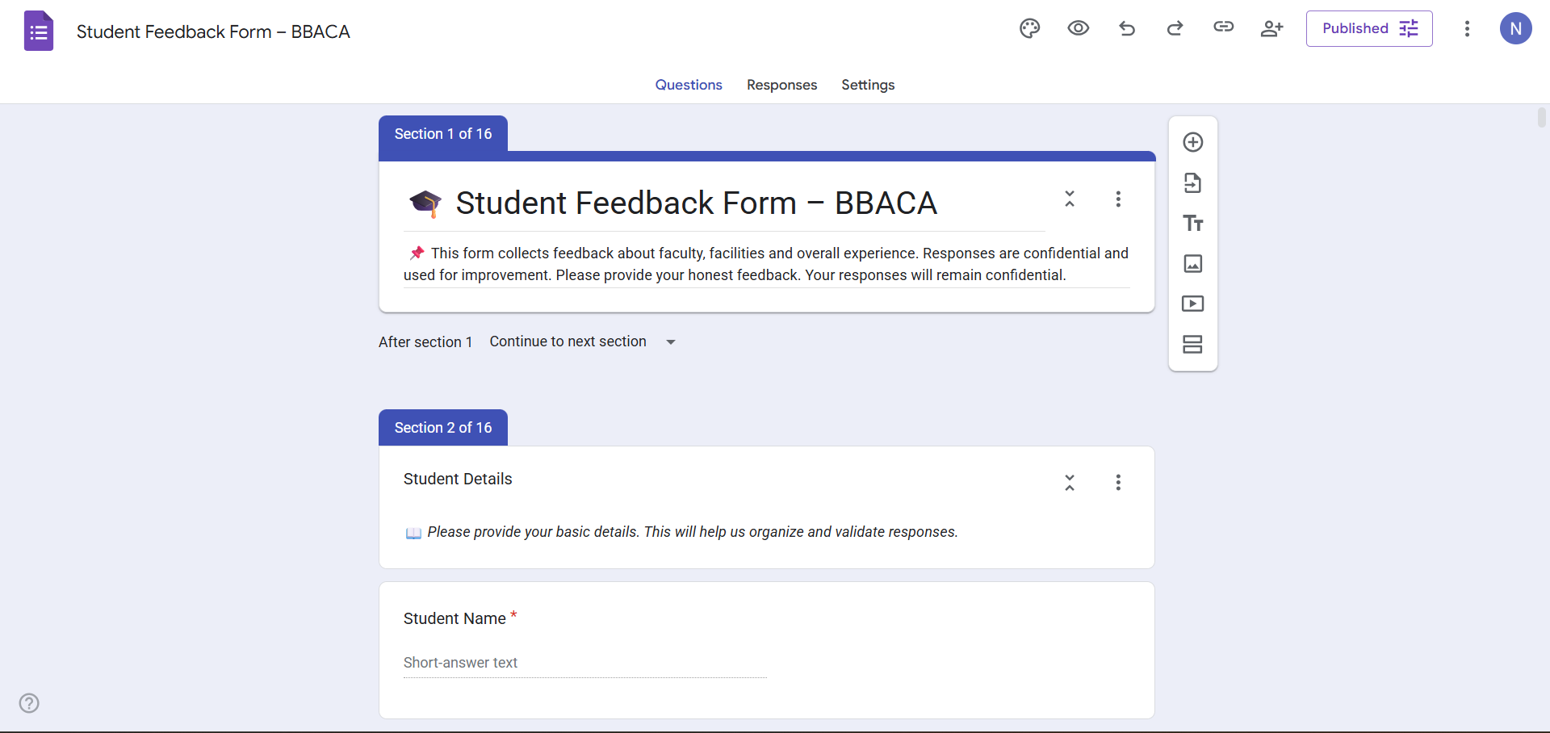

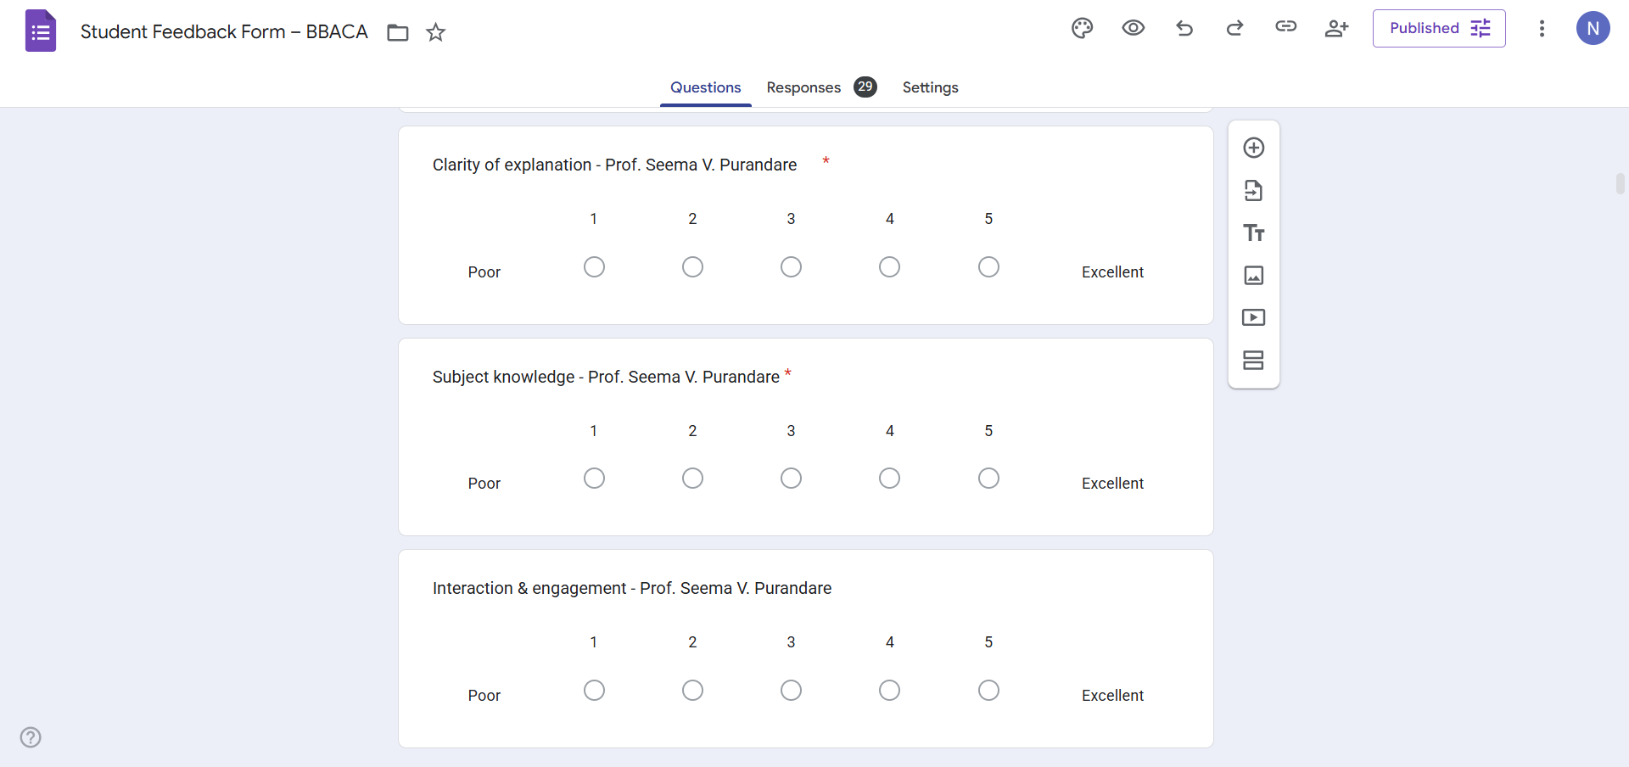

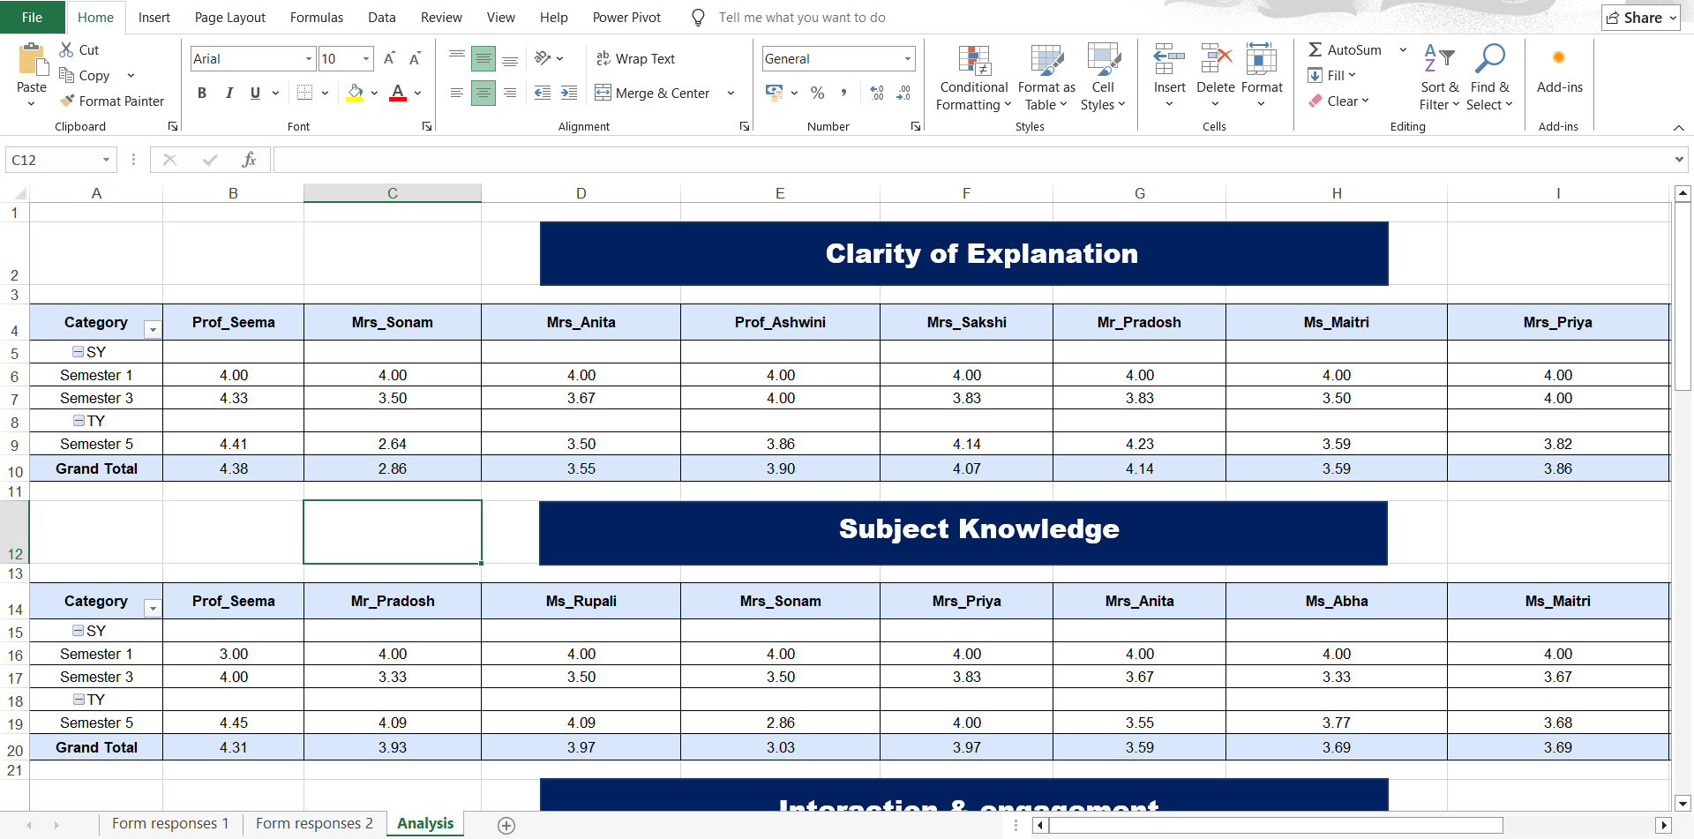

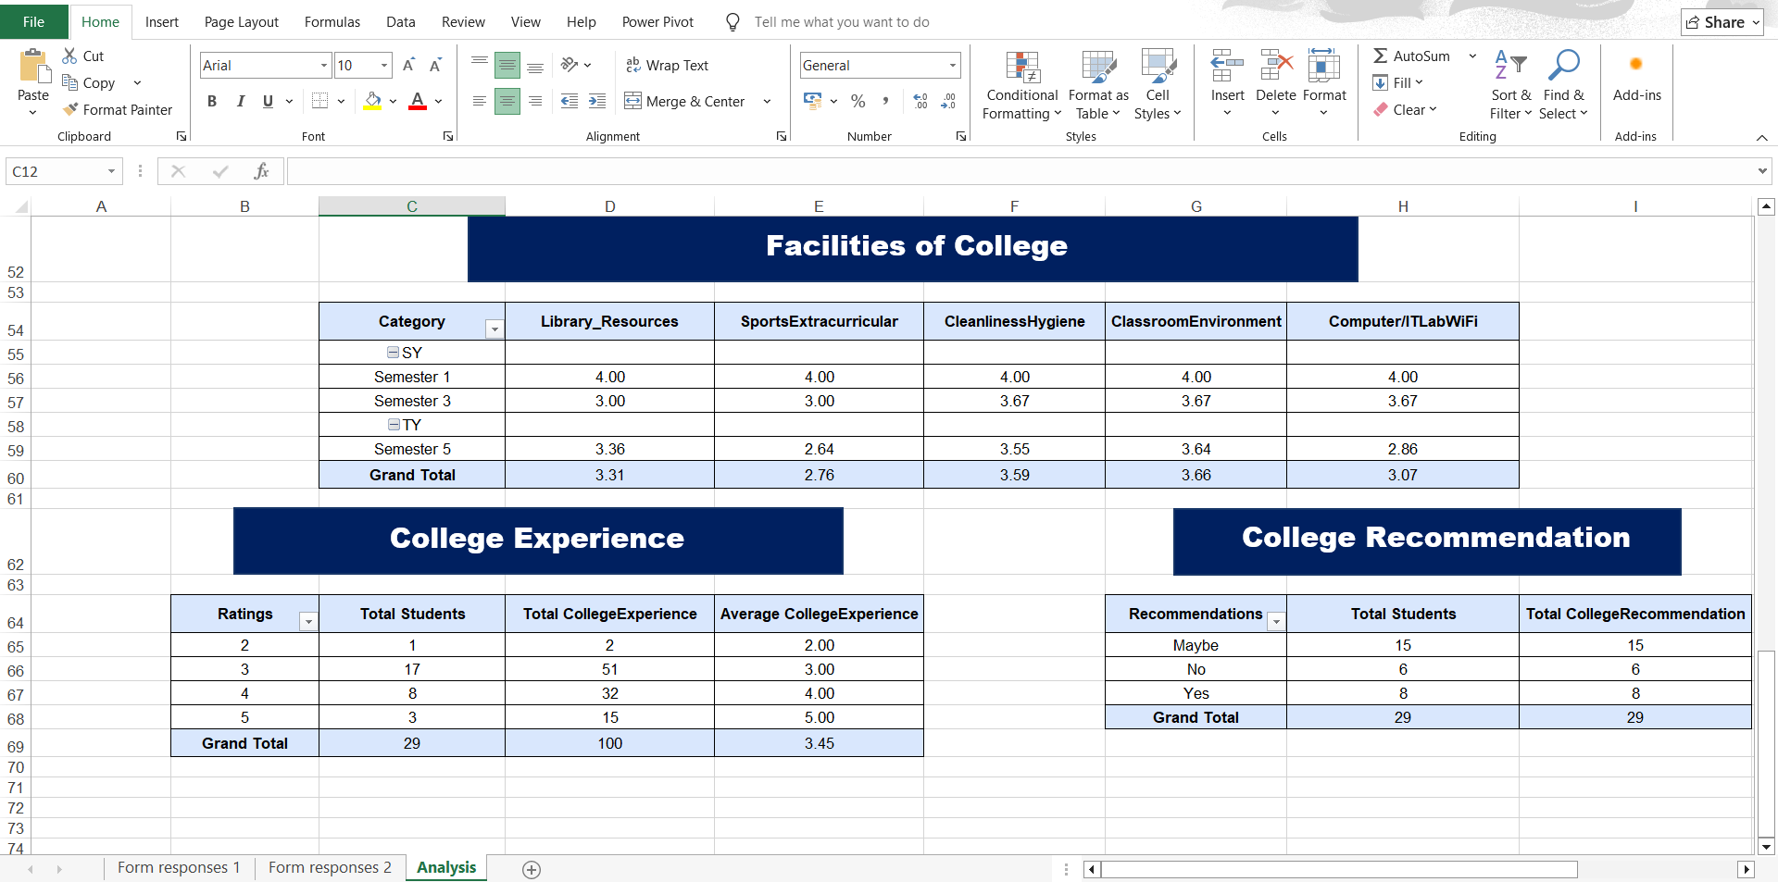

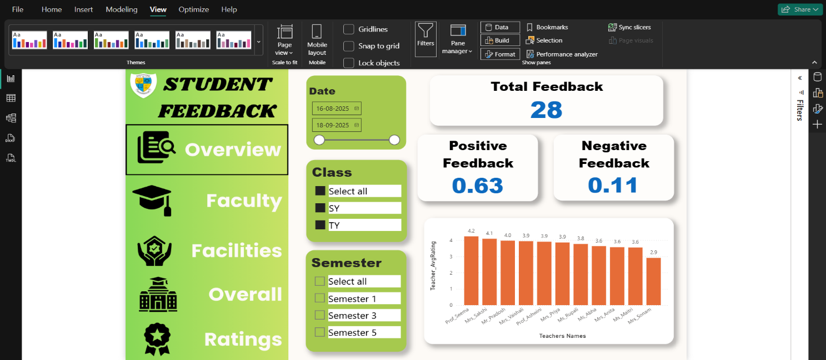

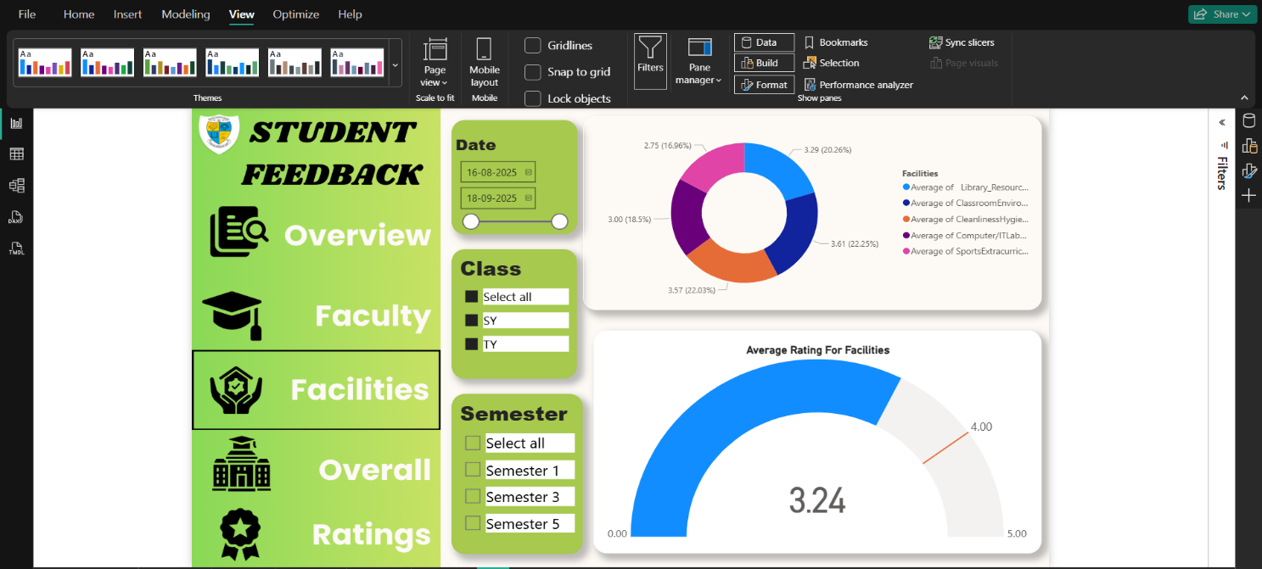

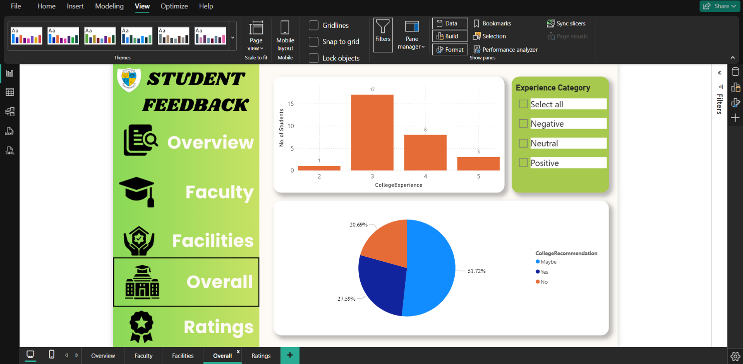

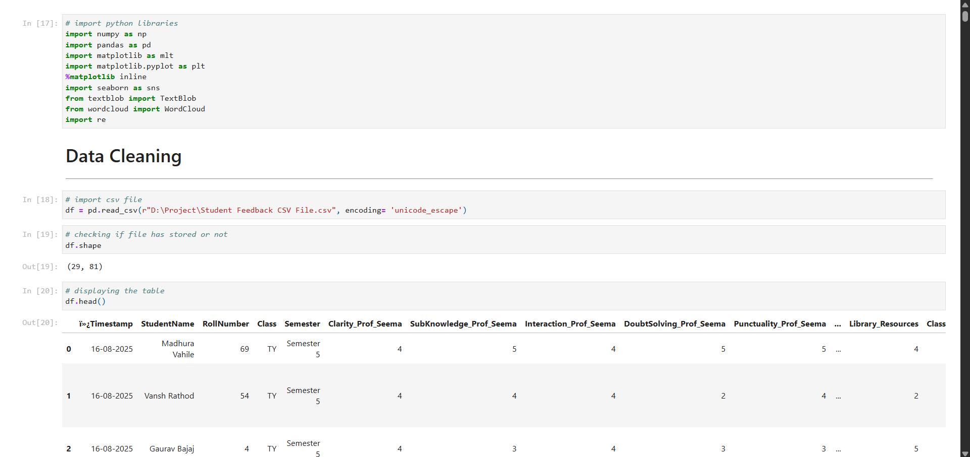

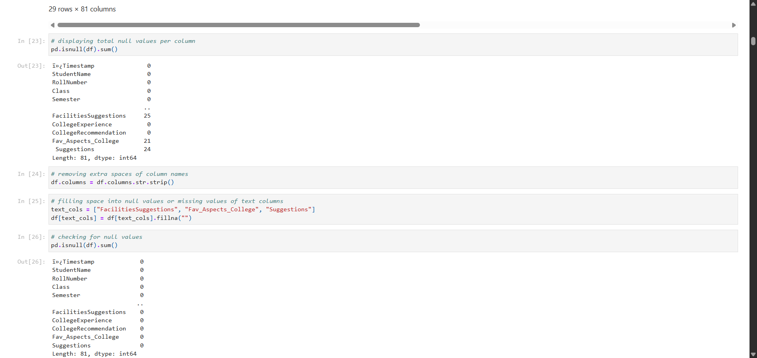

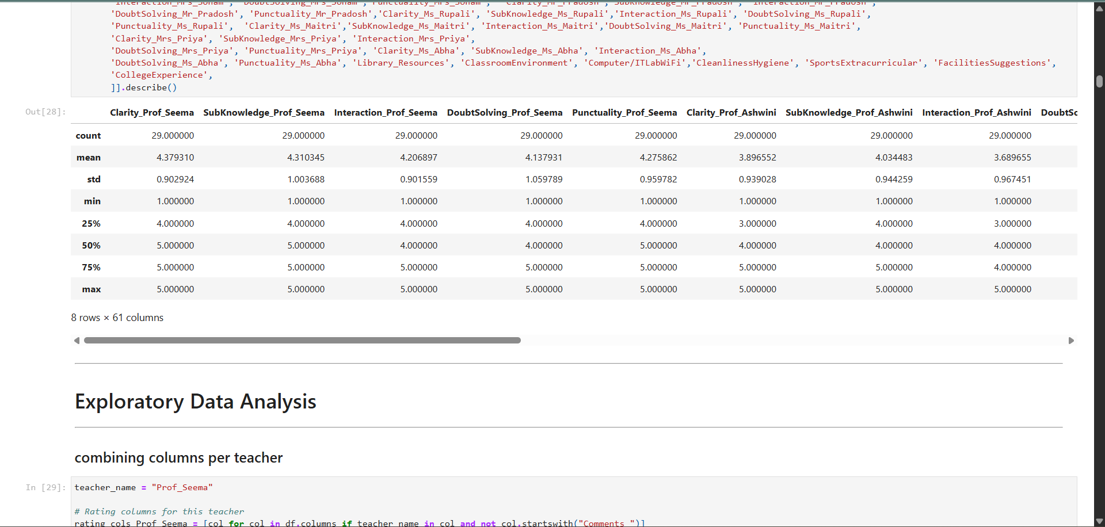

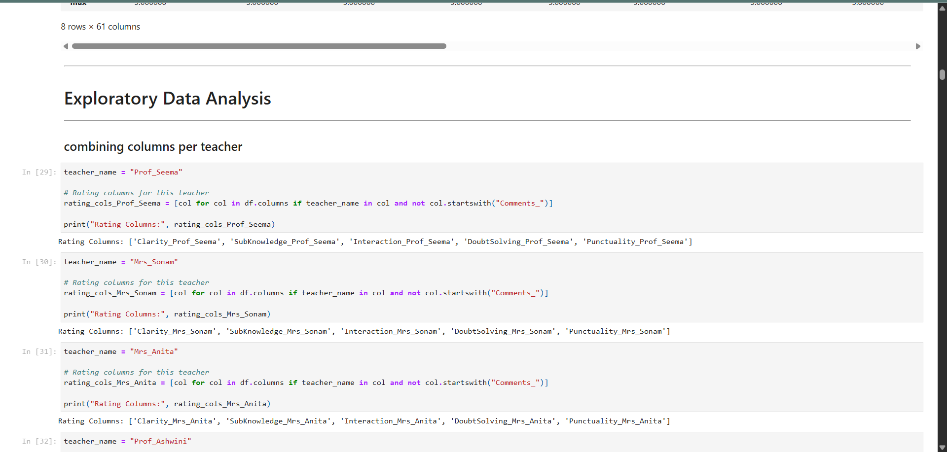

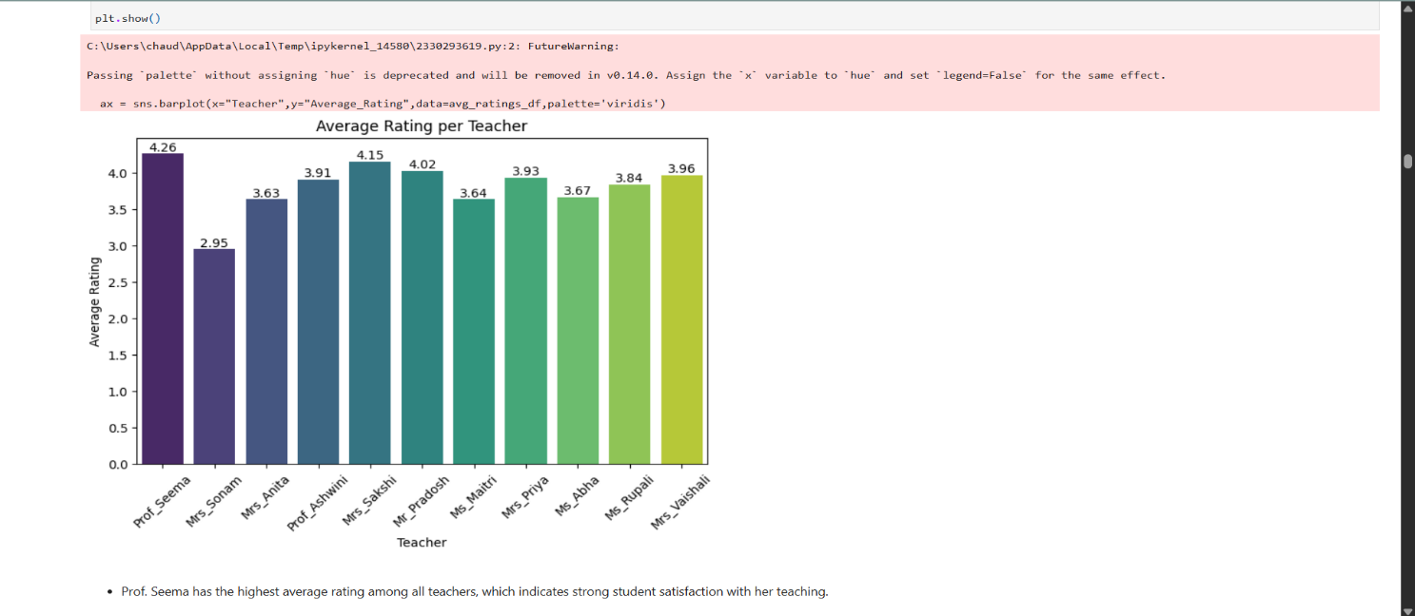

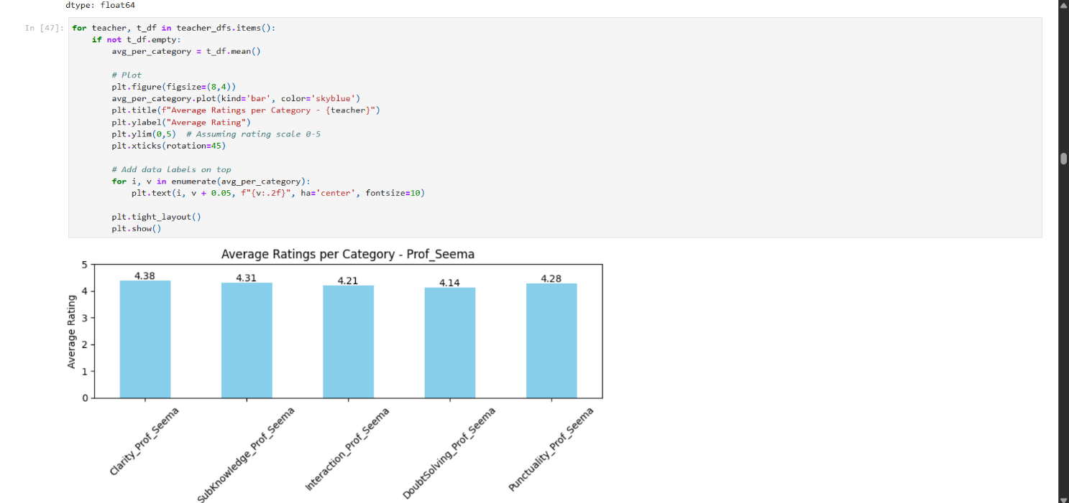

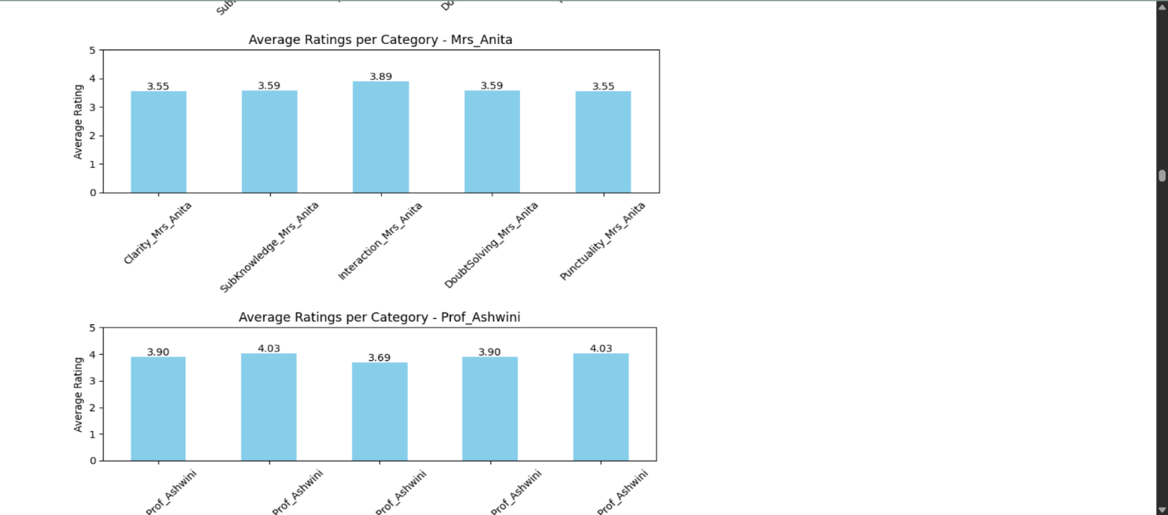



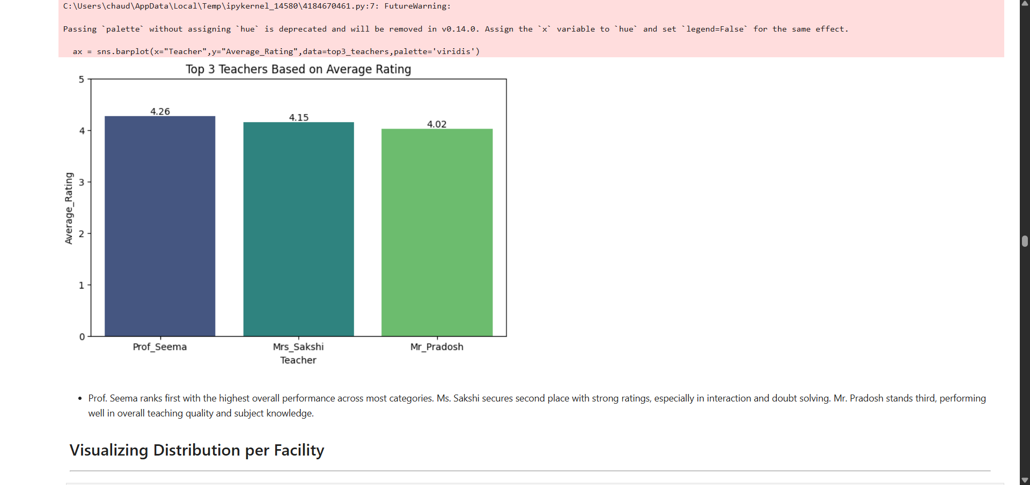

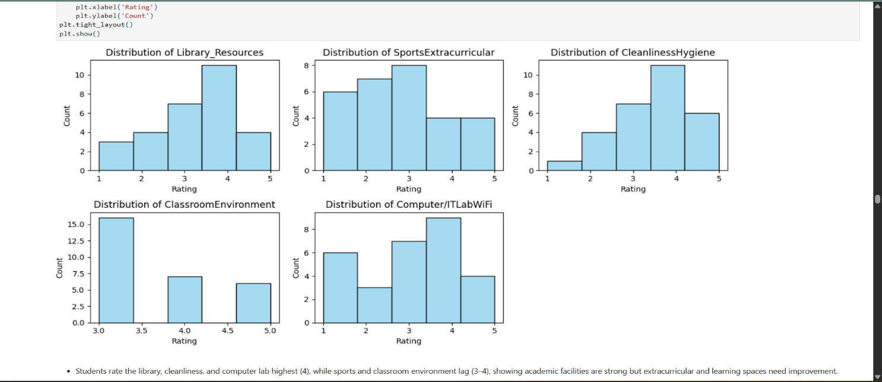

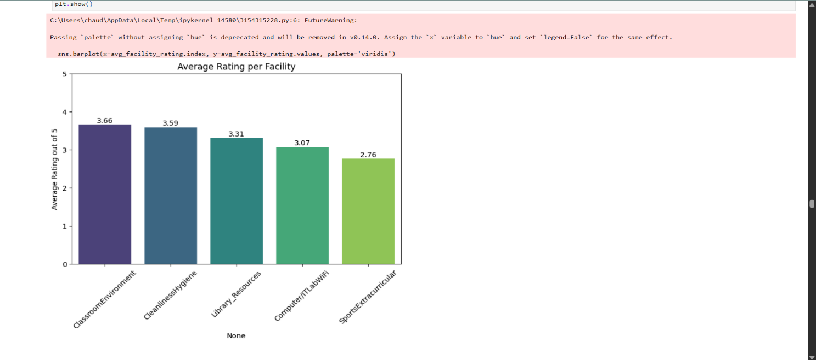

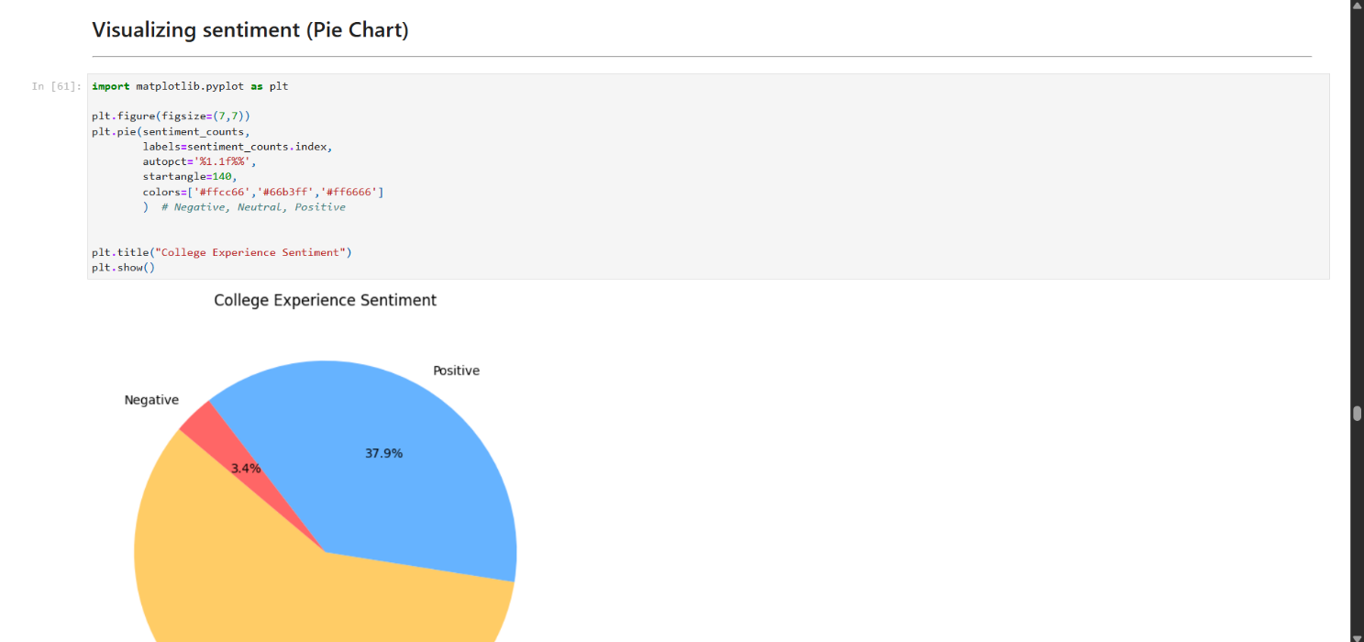

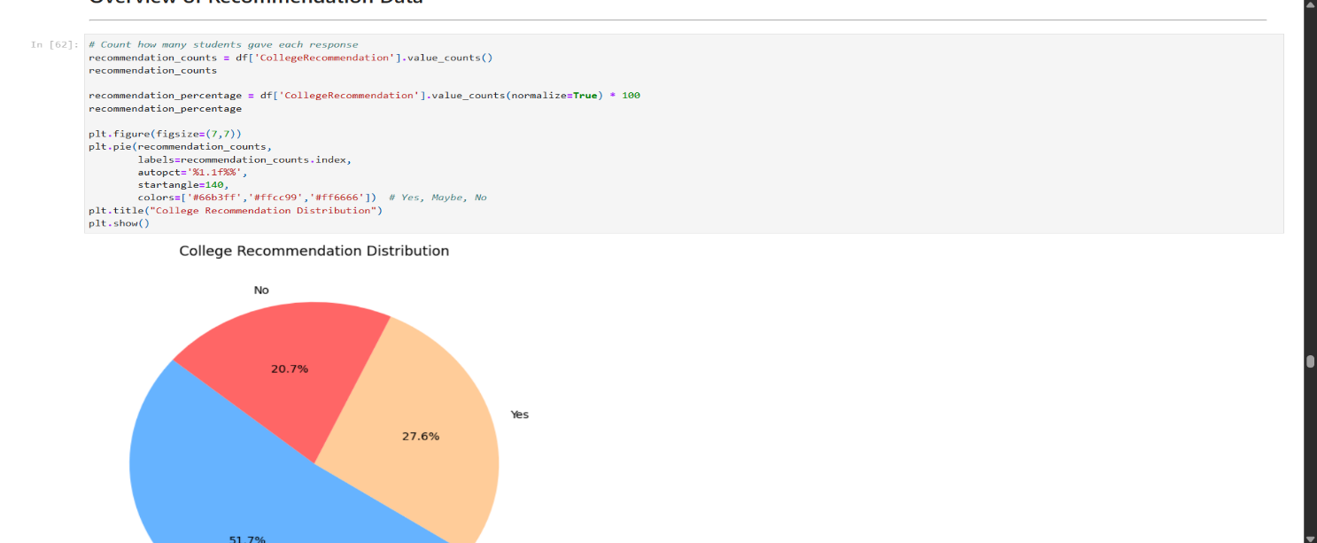

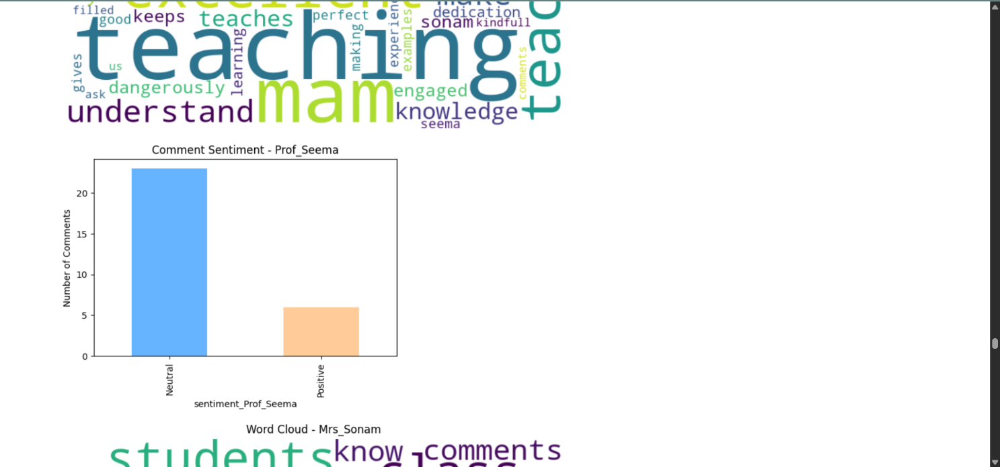

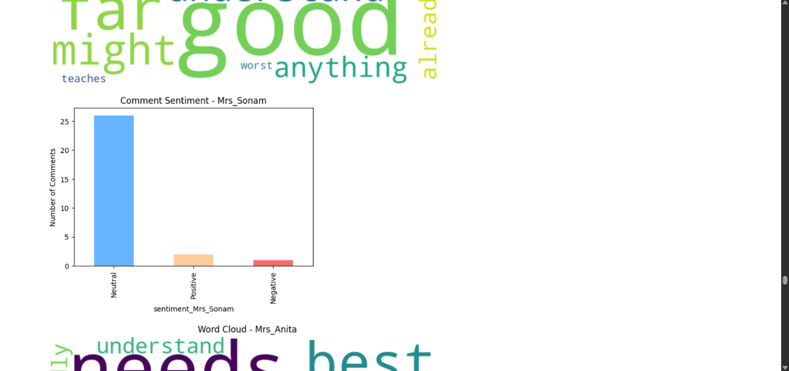

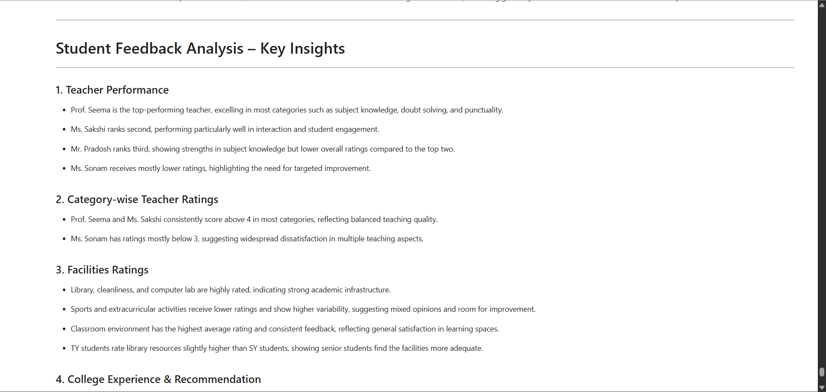

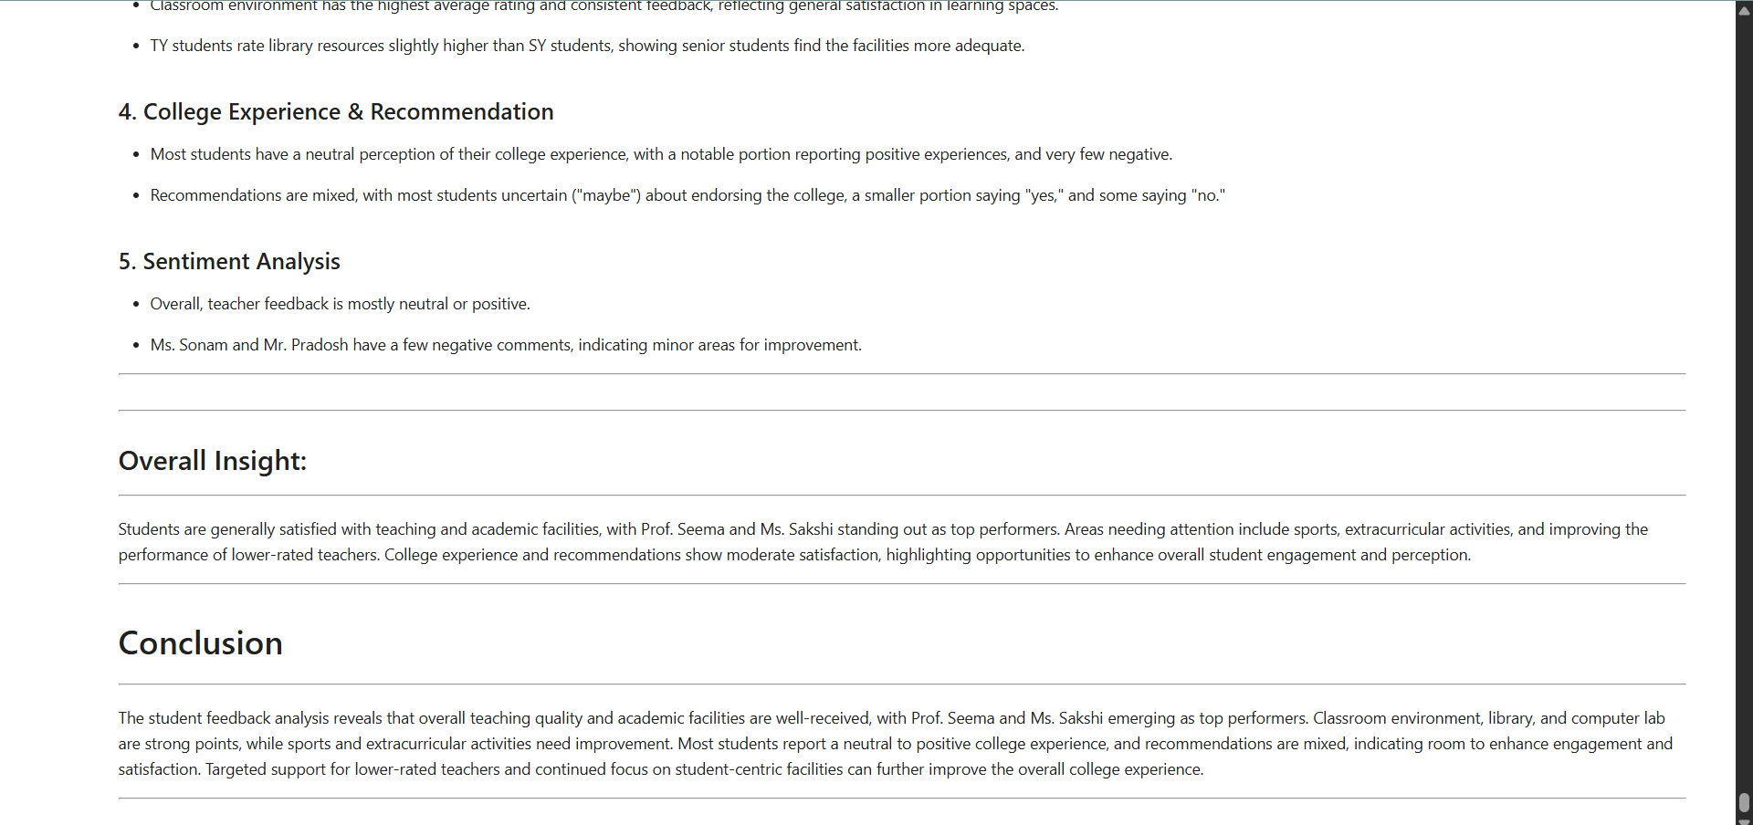

1. **Limitations**

**1. Dependence on Internet Connectivity**

The entire system from Google Forms and Sheets to Power BI dashboards relies heavily on a stable internet connection. Without proper connectivity, users cannot submit feedback, access the stored data, or view real-time dashboards.

**2. Limited Automation in Data Cleaning**

While Excel provides basic data-cleaning tools, it still requires manual intervention to correct inconsistent entries or fill missing values. Fully automated data-cleaning capabilities would require advanced scripting or integration with machine learning models, which were beyond the project’s scope.

**3. Static Nature of Python Visualizations**

The charts and graphs generated in Python (Matplotlib/Seaborn) are static. Users cannot interact with these visuals directly. Although Power BI offers interactivity, it would be ideal if all analytics platforms supported dynamic data exploration.

**4. Data Accuracy Dependent on User Input**

The reliability of analysis depends entirely on the accuracy and honesty of student responses. If students provide random or biased feedback, the results and insights may not truly reflect the institutional performance.

**5. Lack of Automated Report Generation**

Currently, summary reports and dashboards need to be updated manually after every new feedback cycle. Automation to update data pipelines in real time or to schedule reports could make the system more efficient.

**6. Limited Scope of Sentiment Analysis**

The sentiment analysis in Python uses basic NLP techniques (like TextBlob) that rely on word polarity and do not fully understand the context or sarcasm in feedback. More sophisticated AI or deep-learning models could improve the accuracy of sentiment detection.

**7. Restricted Integration with Institutional Systems**

The project is standalone and not integrated with college ERP or LMS systems. Integration would enable automatic identification of faculty, subjects, and student records to make feedback collection more seamless.

**8. Restricted Customization Options**

Google Forms provides limited design flexibility and does not support advanced question logic or personalized feedback formats. This restricts the variety of data that can be collected, especially for multi-department institutions with diverse course structures. A custom-built web-based form or portal could overcome this limitation.

**9. Lack of Historical Data Tracking**

The system analyzes data for one feedback cycle at a time. Long-term comparisons, such as improvements across semesters or faculty over multiple years, require manual data merging. Adding database support (MySQL, Firebase, etc.) could allow automatic tracking and longitudinal performance comparison.

1. **Future Enhancements**

* **Automated Sentiment Analysis using AI and NLP:**

At present, the analysis primarily relies on manual interpretation or basic keyword-based analysis. In the future, integration of Natural Language Processing (NLP) models such as TextBlob or BERT can automatically detect sentiment polarity (positive, negative, or neutral) from open-ended responses. This enhancement would allow the system to identify student satisfaction levels more accurately and provide deep insights into teaching quality and institutional facilities.

* **Integration with Learning Management Systems (LMS):**

The system can be expanded to connect with popular LMS platforms such as Moodle or Google Classroom. This integration would enable real-time feedback collection on courses, assignments, and teaching methods, making the analysis more dynamic and continuous throughout the academic session.

* **Student Dashboard for Personalized Insights:**

A future version can include an individual student dashboard where each student can view their submitted feedback history, receive personalized recommendations, or track institutional improvements based on their previous suggestions.

* **Automated Report Generation:**

Currently, feedback reports are prepared manually using Excel, Python, or Power BI. Future enhancements could involve automated PDF or dashboard report generation, where monthly or semester-wise reports are sent directly to faculty and management via email.

* **Mobile Application Version:**

To improve accessibility, the feedback system could be developed into a mobile app. Students would be able to submit feedback instantly using their smartphones, receive notifications, and access visual dashboards anytime and anywhere.

* **Predictive Analytics for Decision-Making:**

By incorporating machine learning models, the system could predict trends in student satisfaction and identify potential problem areas before they escalate. For instance, if feedback consistently reflects issues with a specific subject or faculty, the system could automatically alert the administration for early intervention.

* **Multi-language Support:**

Adding multilingual capabilities would make the system inclusive, allowing students from diverse linguistic backgrounds to comfortably share their opinions in their preferred language.

1. **Conclusion**

The Student Feedback Analysis serves as an effective and data-driven approach to understanding students’ opinions about various academic and institutional aspects. By combining tools such as Google Forms, Google Sheets, Microsoft Excel, Python, and Power BI, the project successfully demonstrates how technology can simplify and enhance the process of feedback collection, analysis, and visualization.

The use of Google Forms has made the data collection process seamless and user-friendly, allowing students to provide honest feedback anytime and from anywhere. The collected responses are automatically stored in Google Sheets, ensuring secure and centralized data management. Through Excel, the raw data is cleaned and pre-processed, which helps eliminate errors, standardize responses, and prepare the dataset for further analysis.

The integration of Python for advanced analytics adds great value to the project. Using libraries like Pandas, NumPy, and Matplotlib, the project performs in-depth analysis and visualization, helping to uncover meaningful patterns and insights from student responses. This analytical process transforms simple data into actionable knowledge for decision-makers.

Finally, Power BI is used to design interactive dashboards that provide a real-time visual representation of feedback trends. These dashboards make it easier for administrators and faculty members to monitor key indicators such as student satisfaction, teaching quality, and infrastructure effectiveness all in one place.

This project not only enhances institutional transparency but also encourages continuous improvement through evidence-based decision-making. It bridges the gap between students and administrators by providing a reliable medium for communication and evaluation. Moreover, the system’s modular nature allows for future integration of artificial intelligence and predictive analytics, which can further automate insights and improve educational quality.

In conclusion, the Student Feedback Analysis Project demonstrates how modern data tools can transform simple survey data into meaningful institutional intelligence. It promotes accountability, improves teaching methodologies, and contributes to overall academic excellence. The implementation of this system highlights the potential of combining data analytics and visualization to create a smarter, more responsive educational environment one that values every student’s voice and continually strives for growth and quality enhancement.

1. **Bibliography and References**

* **Google Forms Documentation**

Google Workspace, Create and analyze surveys, for free, <https://developers.google.com/workspace/forms>

* **Google Sheets Help Center**

Google Support, Manage and analyze data in spreadsheets, <https://support.google.com/a/users/answer/9282959?hl=en>

* **Microsoft Excel Documentation**

Microsoft Learn, Excel for data analysis and visualization, <https://support.microsoft.com/en-us/excel>

* **Python Official Documentation**

Python Software Foundation, Python Language Reference, <https://docs.python.org/>

* **Pandas Documentation**

McKinney, Wes, Python Data Analysis Library (Pandas), <https://pandas.pydata.org/docs/>

* **NumPy Documentation**

Harris, C.R. et al., Array programming with NumPy, Nature, <https://numpy.org/doc/>

* **Matplotlib Documentation**

Hunter, J.D., Matplotlib: A 2D Graphics Environment, <https://matplotlib.org/stable/index.html>

* **Microsoft Power BI Documentation**

Microsoft Learn, Create interactive reports and dashboards, <https://learn.microsoft.com/en-us/power-bi/>

* **Data Cleaning in Excel and Python**

Stack Overflow and GeeksforGeeks, Techniques for preprocessing and cleaning datasets, <https://www.geeksforgeeks.org/excel/top-5-excel-data-cleaning-techniques-to-know-in-2023/>

* **Data Visualization Techniques**

Towards Data Science, Practical guide to effective data visualization in Python and Power BI[, https://towardsdatascience.com](,%20https:/towardsdatascience.com)

* **Online Tutorials and YouTube Channels**

Tutorials Point, Simplilearn, and freeCodeCamp, Practical guides for data analysis and visualization tools.