MD2201 Data Science
Course Project
S.NoDivBatch NoGroup NoRoll NoGr.NoName of Student1

A

2

54412210573Atharva Bonde24512211506Om Borse34812210003Harshal Chaudhari44912210370Sanskar Chaudhari

Date of performance:

Project Title: Laptop Price Prediction

Data Set Name: Laptops

Data set Link: https://www.kaggle.com/datasets/arnabchaki/laptop-price-prediction

Data Set Description:

Several different factors can affect laptop computer prices. These factors include the brand of computer and the number of options and add-ons included in the computer package. In addition, the amount of memory and the speed of the processor can also affect pricing. Though less common, some consumers spend additional money to purchase a computer based on the overall “look” and design of the system.

In many cases, name brand computers are more expensive than generic versions. This price increase often has more to do with name recognition than any actual superiority of the product. One major difference between name brand and generic systems is that in most cases, name brand computers offer better warranties than generic versions. Having the option of returning a computer that is malfunctioning is often enough of an incentive to encourage many consumers to spend more money.

Functionality is an important factor in determining laptop computer prices. A computer with more memory often performs better for a longer time than a computer with less memory. In addition, hard drive space is also crucial, and the size of the hard drive usually affects pricing. Many consumers may also look for digital video drivers and other types of recording devices that may affect the laptop computer prices.

Variables: Categorical – 8

Numerical – 3

Description of Work Done :

The provided R code analyzes a dataset to predict laptop prices. It begins by loading and preprocessing the data, including converting certain features to numeric format.

The dataset is split into training and testing sets (70/30 ratio). Three models are employed: Random Forest, XGBoost, and Decision Tree, each making price predictions.

The models' predictive accuracy is assessed using Mean Squared Error (MSE), Root Mean Squared Error (RMSE) and R- squared, indicating how well they predict prices. Lower MSE and RMSE values signify better accuracy.

Recursive Feature Elimination (RFE) is performed for Random Forest and XGBoost models to identify the most important features, improving model interpretability and efficiency.

In summary, the code preprocesses data, trains and evaluates models, reports accuracy metrics, and conducts feature selection to enhance model understanding and performance.

Literature Survey : https://docs.google.com/spreadsheets/d/1Tzocx9etxdxmEDtuZzKpzoKskRjMK0AEmuvnP5qyK2I/edit#gid=0

Data Preprocessing (if any) : For data preprocessing,

For the "Screen.Size" column, the code removes double quotes and converts the values to numeric data type.

For the "RAM" column, it removes the "GB" unit and converts the values to numeric.

For the "Weight" column, it removes the "kg" unit and converts the values to numeric.

Feature Selection (if any):

Random forest and Decision tree

The top 5 variables :- CPU, Weight, RAM, Model.Name, GPU

XGBoost

The top 3 variables :- Weight, CPU, RAM

Algorithms Implemented:

Random forest

XGBoost

Decision Tree

CODE:

library(stats)

library(dplyr)

library(randomForest)

library(xgboost)

library(e1071)

library(ggplot2)

library(caret)

library(mlbench)

library(tree)

# Read the dataset

mydata <- read.csv("laptops.csv")

mydata<- subset(mydata, select = -11)

#for screen size

mydata$Screen.Size <- gsub("\"", "", mydata$Screen.Size)

mydata$Screen.Size <- as.numeric(mydata$Screen.Size)

#for RAM

mydata$RAM <- sub("GB", "", mydata$RAM)

mydata$RAM <- as.numeric(mydata$RAM)

#for Weight

mydata$Weight <- sub("kg", "", mydata$Weight)

mydata$Weight <- as.numeric(mydata$Weight)

# Splitting data into training and testing sets

set.seed(123)

index <- sample(2, nrow(mydata), replace = TRUE, prob = c(0.7, 0.3))

Training <- mydata[index == 1, ]

Testing <- mydata[index == 2, ]

# Random Forest Model

RFM <- randomForest(Price ~ ., data = Training)

Price_Pred1 <- predict(RFM, Testing)

#XGboost

xgb_model <- xgboost(data = as.matrix(Training[, "Price"]),label = Training$Price,nrounds = 100,objective = "reg:squarederror", eta = 0.1, max_depth = 6)

Price_Pred2 <- predict(xgb_model, as.matrix(Testing[, "Price"]))

Testing$Price_Pred1 = Price_Pred1

Testing$Price_Pred2 = Price_Pred2

#decission Tree

DTM <- tree(Price ~ ., data = Training)

# Predict using the decision tree model

Price_Pred3 <- predict(DTM, Testing)

Testing$Price_Pred1 = Price_Pred1

Testing$Price_Pred2 = Price_Pred2

Testing$Price_Pred3 = Price_Pred3

mse1 <- mean((Price_Pred1 - Testing$Price)^2)

rmse1 <- sqrt(mse1)

mse2 <- mean((Testing[, "Price"] - Price_Pred2)^2)

rmse2 <- sqrt(mse2)

mse3 <- mean((Price_Pred3 - Testing$Price)^2)

rmse3 <- sqrt(mse3)

#SVR

#SVR_model <- svm(Price ~ .,data = Training,kernel = 'radial')

#Price_Pred3 <- predict(SVR_model,newdata = Testing)

cat("Mean Squared Error (MSE) for RFM :", mse1, "\n")

cat("Root Mean Squared Error (RMSE) for RFM:", rmse1, "\n\n")

cat("Mean Squared Error (MSE) for XGboost :", mse2, "\n")

cat("Root Mean Squared Error (RMSE) for XGboost:", rmse2, "\n")

cat("Mean Squared Error (MSE) for Decision Tree:", mse3, "\n")

cat("Root Mean Squared Error (RMSE) for Decision Tree:", rmse3, "\n")

# View the Testing dataset with prediction columns

View(Testing)

control <- rfeControl(functions = rfFuncs, method = "cv", number = 10)

# You can change the 'number' parameter to specify the number of cross-validations.

# Create a data frame without the 'Price' column as the target variable

TrainingWithoutPrice <- Training[, -which(names(Training) == "Price")]

# Perform RFE for the Random Forest model

rfe_rf <- rfe(TrainingWithoutPrice, Training$Price, sizes = c(1:ncol(TrainingWithoutPrice)),

rfeControl = control)

# 'sizes' specifies the number of features to select. In this example, it selects from 1 to the number of columns.

# Output the results

print(rfe_rf)

# Identify the selected features for Random Forest

selected_features_rf <- rfe_rf$optVariables

print(selected_features_rf)

# Perform RFE for the XGBoost model

rfe_xgb <- rfe(TrainingWithoutPrice, Training$Price, sizes = c(1:ncol(TrainingWithoutPrice)),

rfeControl = control, method = "xgbLinear")

# 'method' specifies the method to use. In this case, "xgbLinear" for XGBoost linear regression.

# Output the results

print(rfe_xgb)

# Identify the selected features for XGBoost

selected_features_xgb <- rfe_xgb$optVariables

print(selected_features_xgb)

r_sq.lm= lm(Testing$Price~Price_Pred1, data = Testing)

r_sq.lm_sum <- summary(r_sq.lm)$r.squared

cat("\n r_sq Random forest : ",r_sq.lm_sum)

r_sq.lm= lm(Testing$Price~Price_Pred2, data = Testing)

r_sq.lm_sum <- summary(r_sq.lm)$r.squared

cat("\n r_sq XGBoosr : ",r_sq.lm_sum)

r_sq.lm= lm(Testing$Price~Price_Pred3, data = Testing)

r_sq.lm_sum <- summary(r_sq.lm)$r.squared

cat("\n r_sq Decision Tree : ",r_sq.lm_sum)

Evaluation Parameters used:

The following parameters are used for evaluation –

Manufacturer

Model Name

Category

Screen Size

Screen

CPU

RAM

Storage

GPU

Operating System

Weight

Results and Discussions:

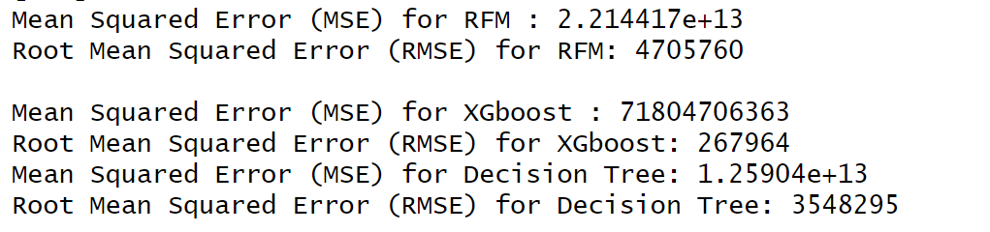

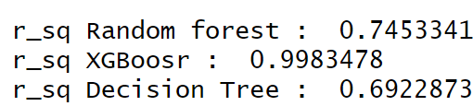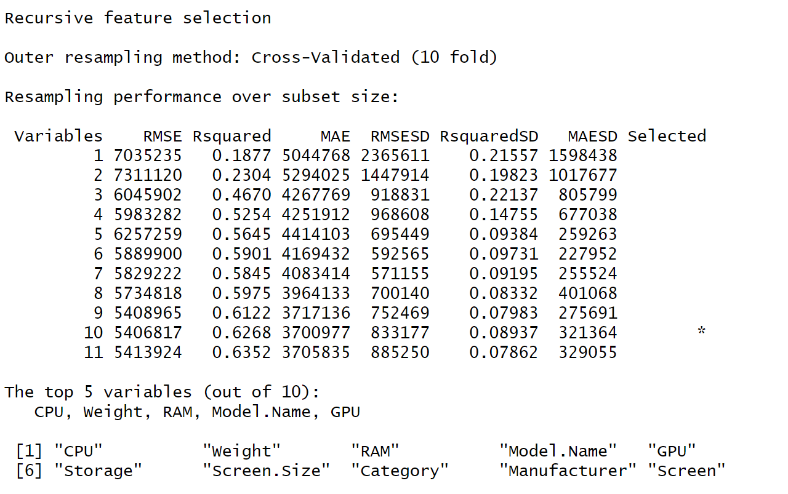

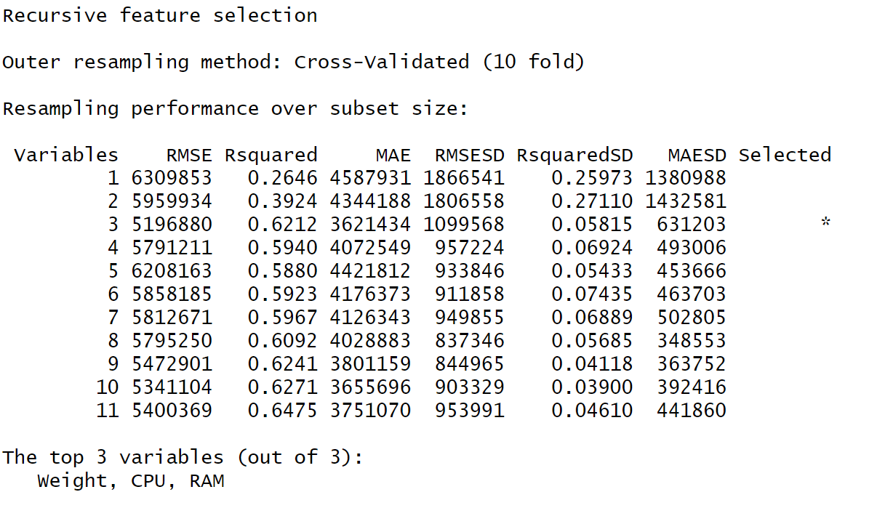

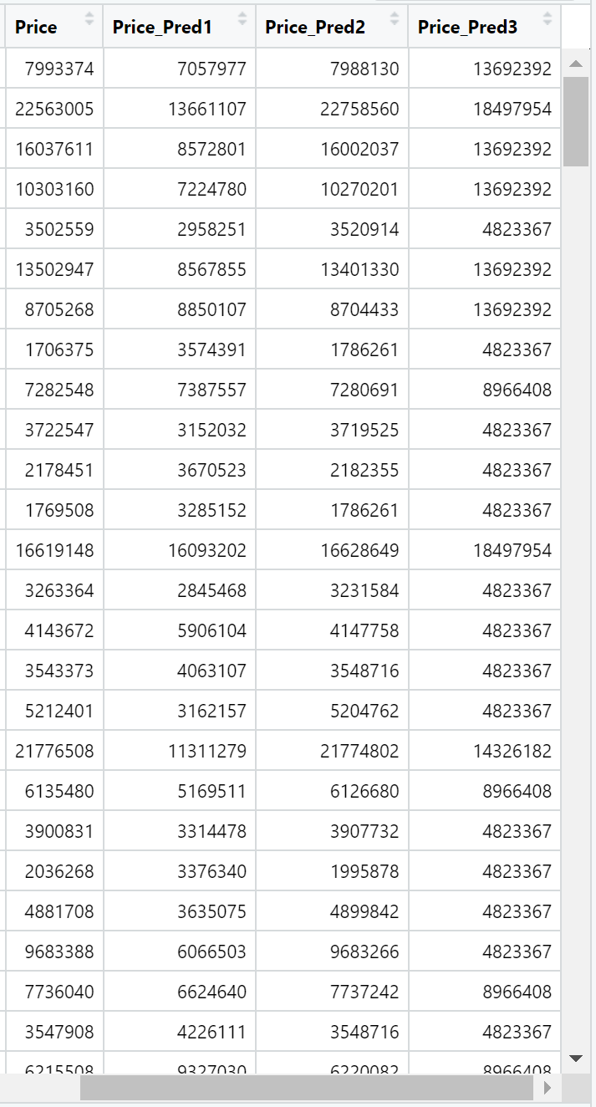

12.Conclusions:

R_Square Values

Random Forest (RFM): r_sq Random forest : 0.7453341

XGBoost (XGBoost): r_sq XGBoosr : 0.9983478

Decision Tree (DTM): 0.6922873

Based on the R-squared values, XGBoost has the highest R-squared value, indicating that it performs the best in terms of explaining the variance in the Price variable. This suggests that XGBoost is the most suitable model for this dataset among the three models you tested.

References:
[1] M. Jadrić, Ž. Garača, M. Ćukušić, “Student Dropout Analysis With Application Of Data Mining Methods”, European Journal Of Higher Education, Vol. 15, pp. 31-46, 2010.

