**Project**: Super-Resolution [1]

**Name**: Achint Chaudhary, D Awadhesh Tanwar

**Problem Statement**: Enhancing low-resolution images using deep neural networks to produce high-resolution images.

**Datasets**: Training (DIV2K, Flick2K, CLIC-mobile, CLIC-professional), Benchmarking (PIRM, BSDS100, Urban100, Manga109, Set14, Set5 and validation sets from training) are datasets used in the literature.

**Abstract**

Single Image Super-Resolution (SISR) is the task of constructing high resolution from a low-resolution image, which finds its usage in satellite, security, medical imaging. Deep learning-based solutions in recent years have outperformed various classical techniques. A lot of literature work, neural architectural innovations and datasets are released in various challenges. This project aims to analyse both qualitative and quantitative aspects of various methods and datasets in the past few years, that have contributed towards the state of the art in SISR.

We have proposed a novel image sampling algorithm for selecting images during training, for better convergence. We have used popular CNN architecture: SRResNet, for verification of our sampling algorithm. In the process, we also built a framework for easy implementation of CNN based techniques for low-level vision applications like Super-Resolution, De-noising, and Compression Artefacts Removal.

**Description**

Classical interpolation techniques for SISR like nearest or bicubic upsampling are non-iterative and fast in nature but suffer in term of quality of results.

Various CNN based models for SISR can be classified into two categories: For type(a) (VDSR, DRRN, OA-DNN) models, the image is upsampled using classic interpolation methods and then fed as input. type(ii) (SRResNet, EDSR) models take LR image as input and extract features in LR space itself, and later use a learnable upsampling. We used type(ii) models because type(in) is memory-intensive and time-consuming for both training and testing, and they did not converge under the settings specified in their specified literature. Our input images are of different formats and sizes, which is managed by taking multiple fixed-sized patches from the images.

Like Mini-batch gradient descent, which takes batches in memory, we have taken batches of images on disk. This allows us to work in memory-constrained systems and to sample over entire available training dataset. With multiple large-sized, high-quality datasets, it becomes more important which data set to choose from & if possible which images from specific datasets suit more for training. Recently, E-SRGAN has combined DIV2K & Flickr2K for obtaining best results at the cost of more training resources. This approach will saturate in case of very large datasets.

For this reason, we have proposed a novel sampling algorithm for selection of images.

**Experiment 0 (Model Selection)**

We tried various models of type(i) & type(ii). We chose SRResNet from type(ii) for further experiments, as it provides best results, and is fastest among all models taken under consideration (type(i) were unfeasibly slow for training).

**Experiment 1 (Data-Set Ranking)**

We trainedseparate instances of SRResNet, for each training dataset. Our performance metric is Peak Signal to Noise Ratio (PSNR).

PSNR distribution using bicubic for training sets is plotted **(Fig 1.).** Order of peak values in PSNR distribution for training sets is DIV2K < Flickr2K < CLIC-P < CLIC-M. This shows that CNN models have more opportunity to learn in reverse order, which is also empirically verified in results.

Distribution of PSNR Gain on various test sets, obtained from CNN trained on DIV2K is plotted in **(Fig 2.).** This shows that datasets having fewer details like Manga109, Set5 have more PSNR gain as compared to other real ones.

We compared the performance of each model instance on test sets and obtained PSNR gain **(Fig 3).** Testing on independent data sets from the recent challenges also supports our claim that DIV2K is the best data set to learn from.

|  |  |
| --- | --- |
| [1] | W. Yang, X. Zhang, Y. Tian, W. Wang, J.-H. Xue and Q. Liao, “Deep Learning for Single Image Super-Resolution: A Brief Review,” *IEEE Transactions on Multimedia,* pp. 1-1, 2019. |

Results of mean PSNR Gain for all instances of SRResNet on all test sets are shown in Table 1.

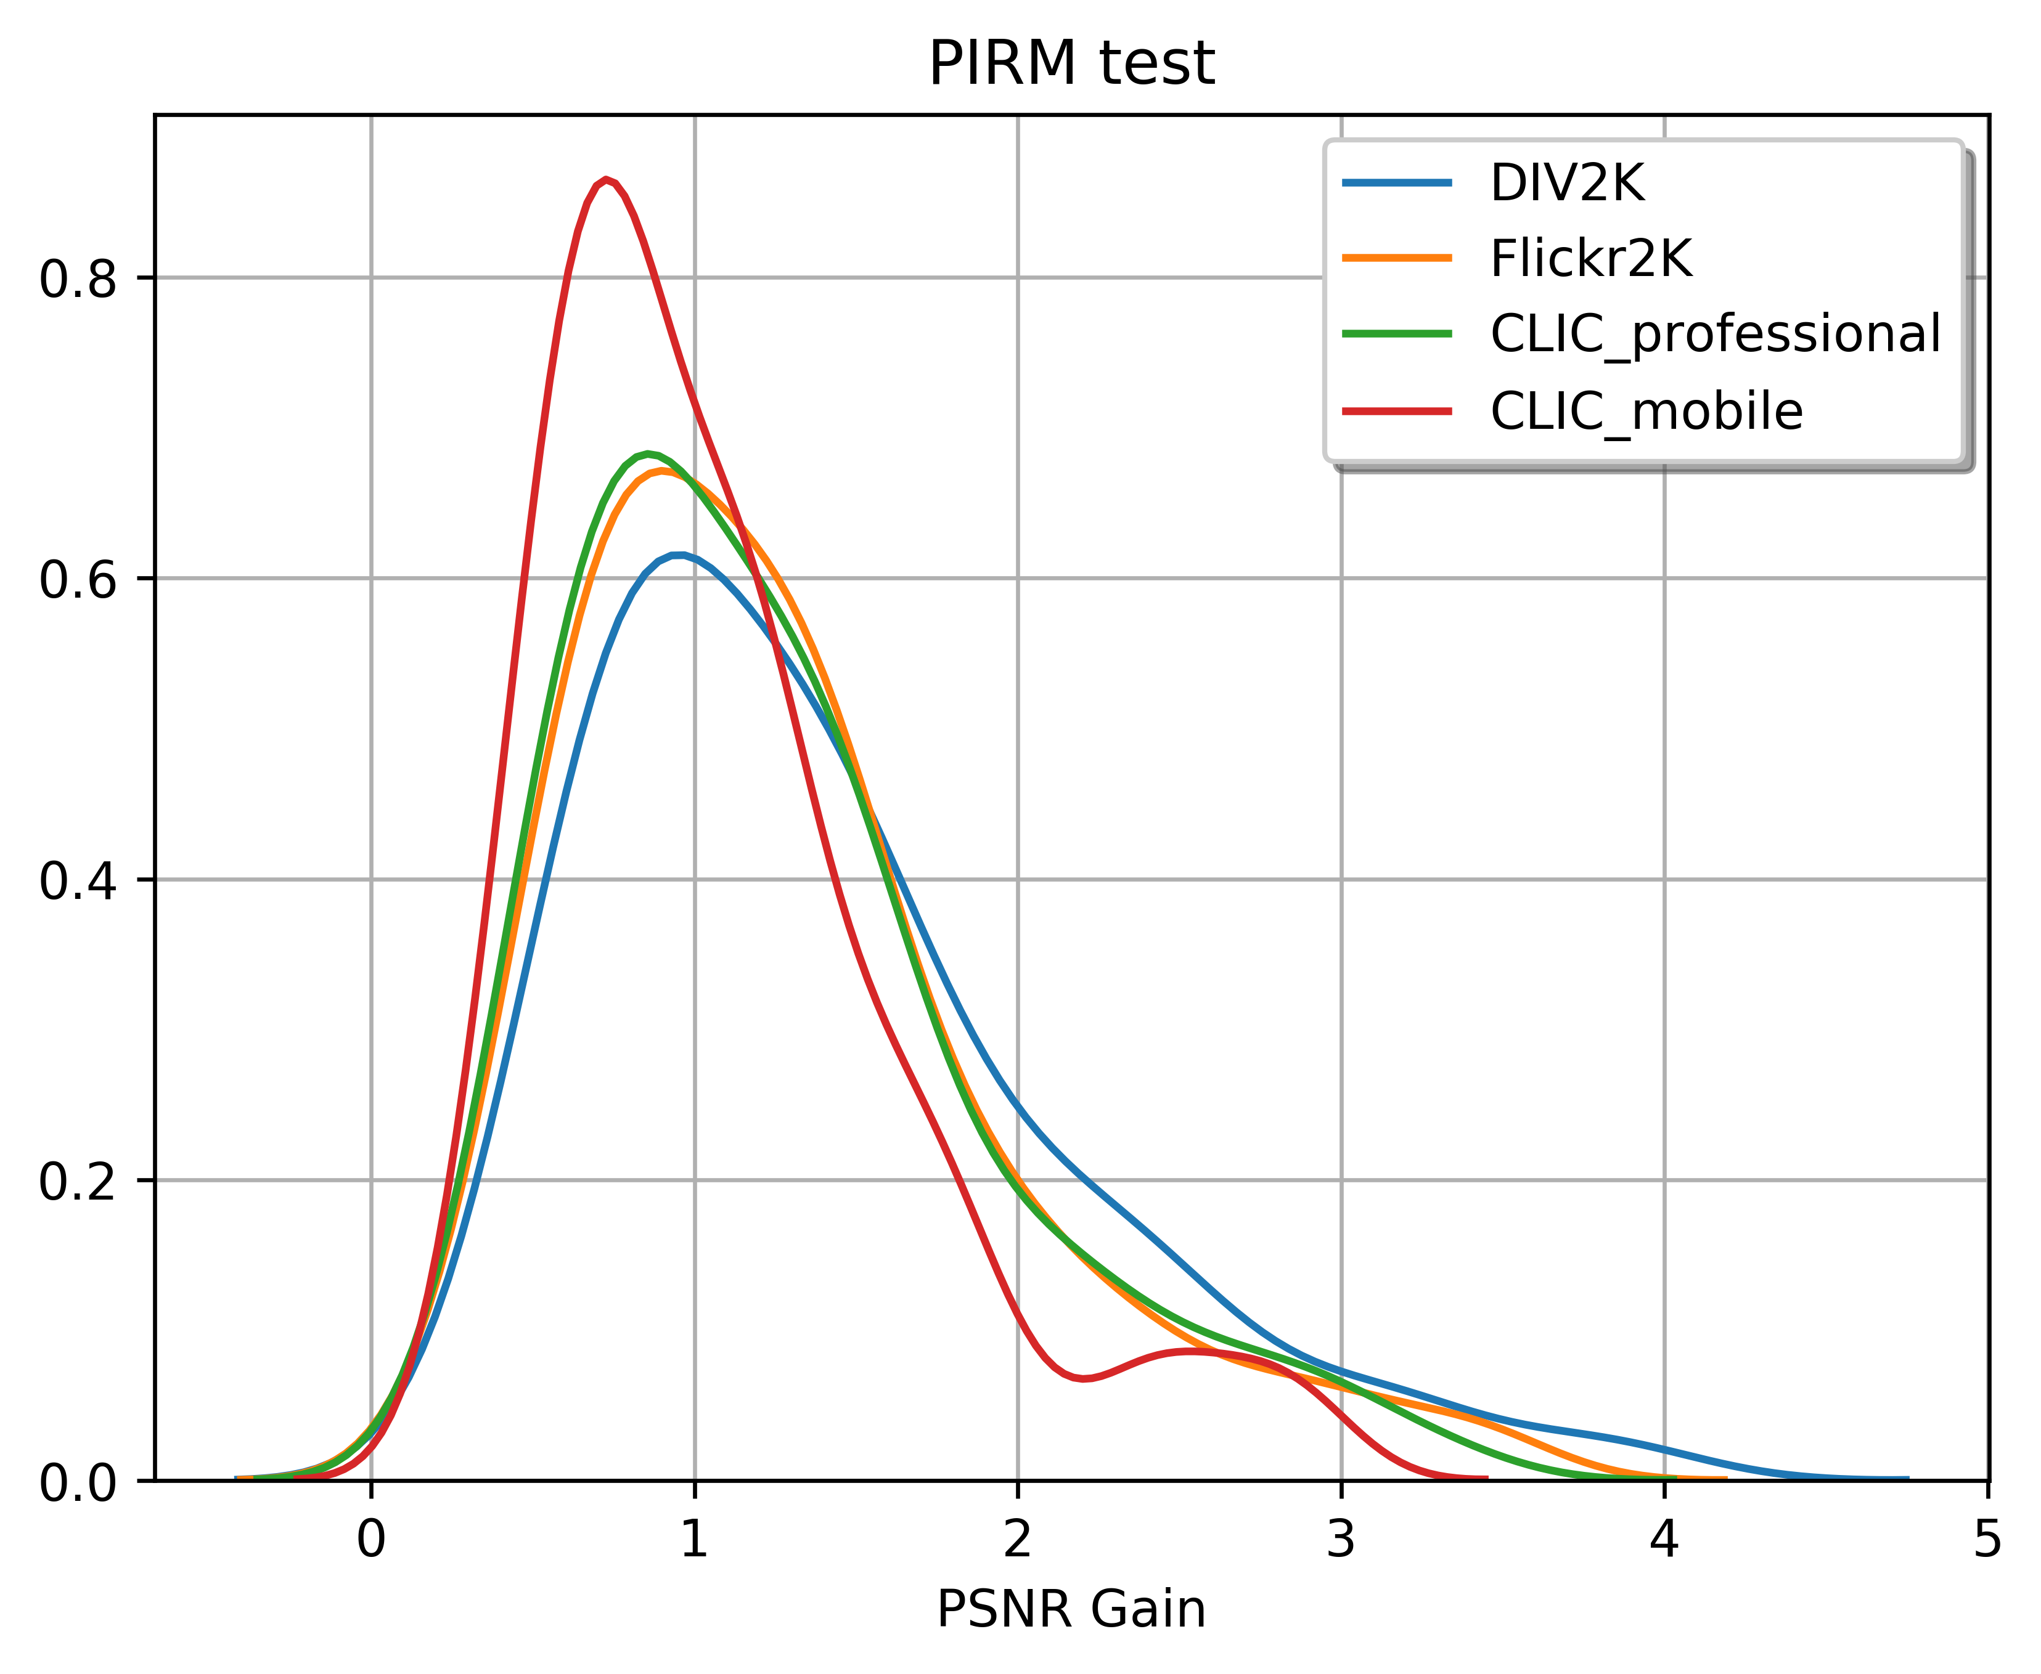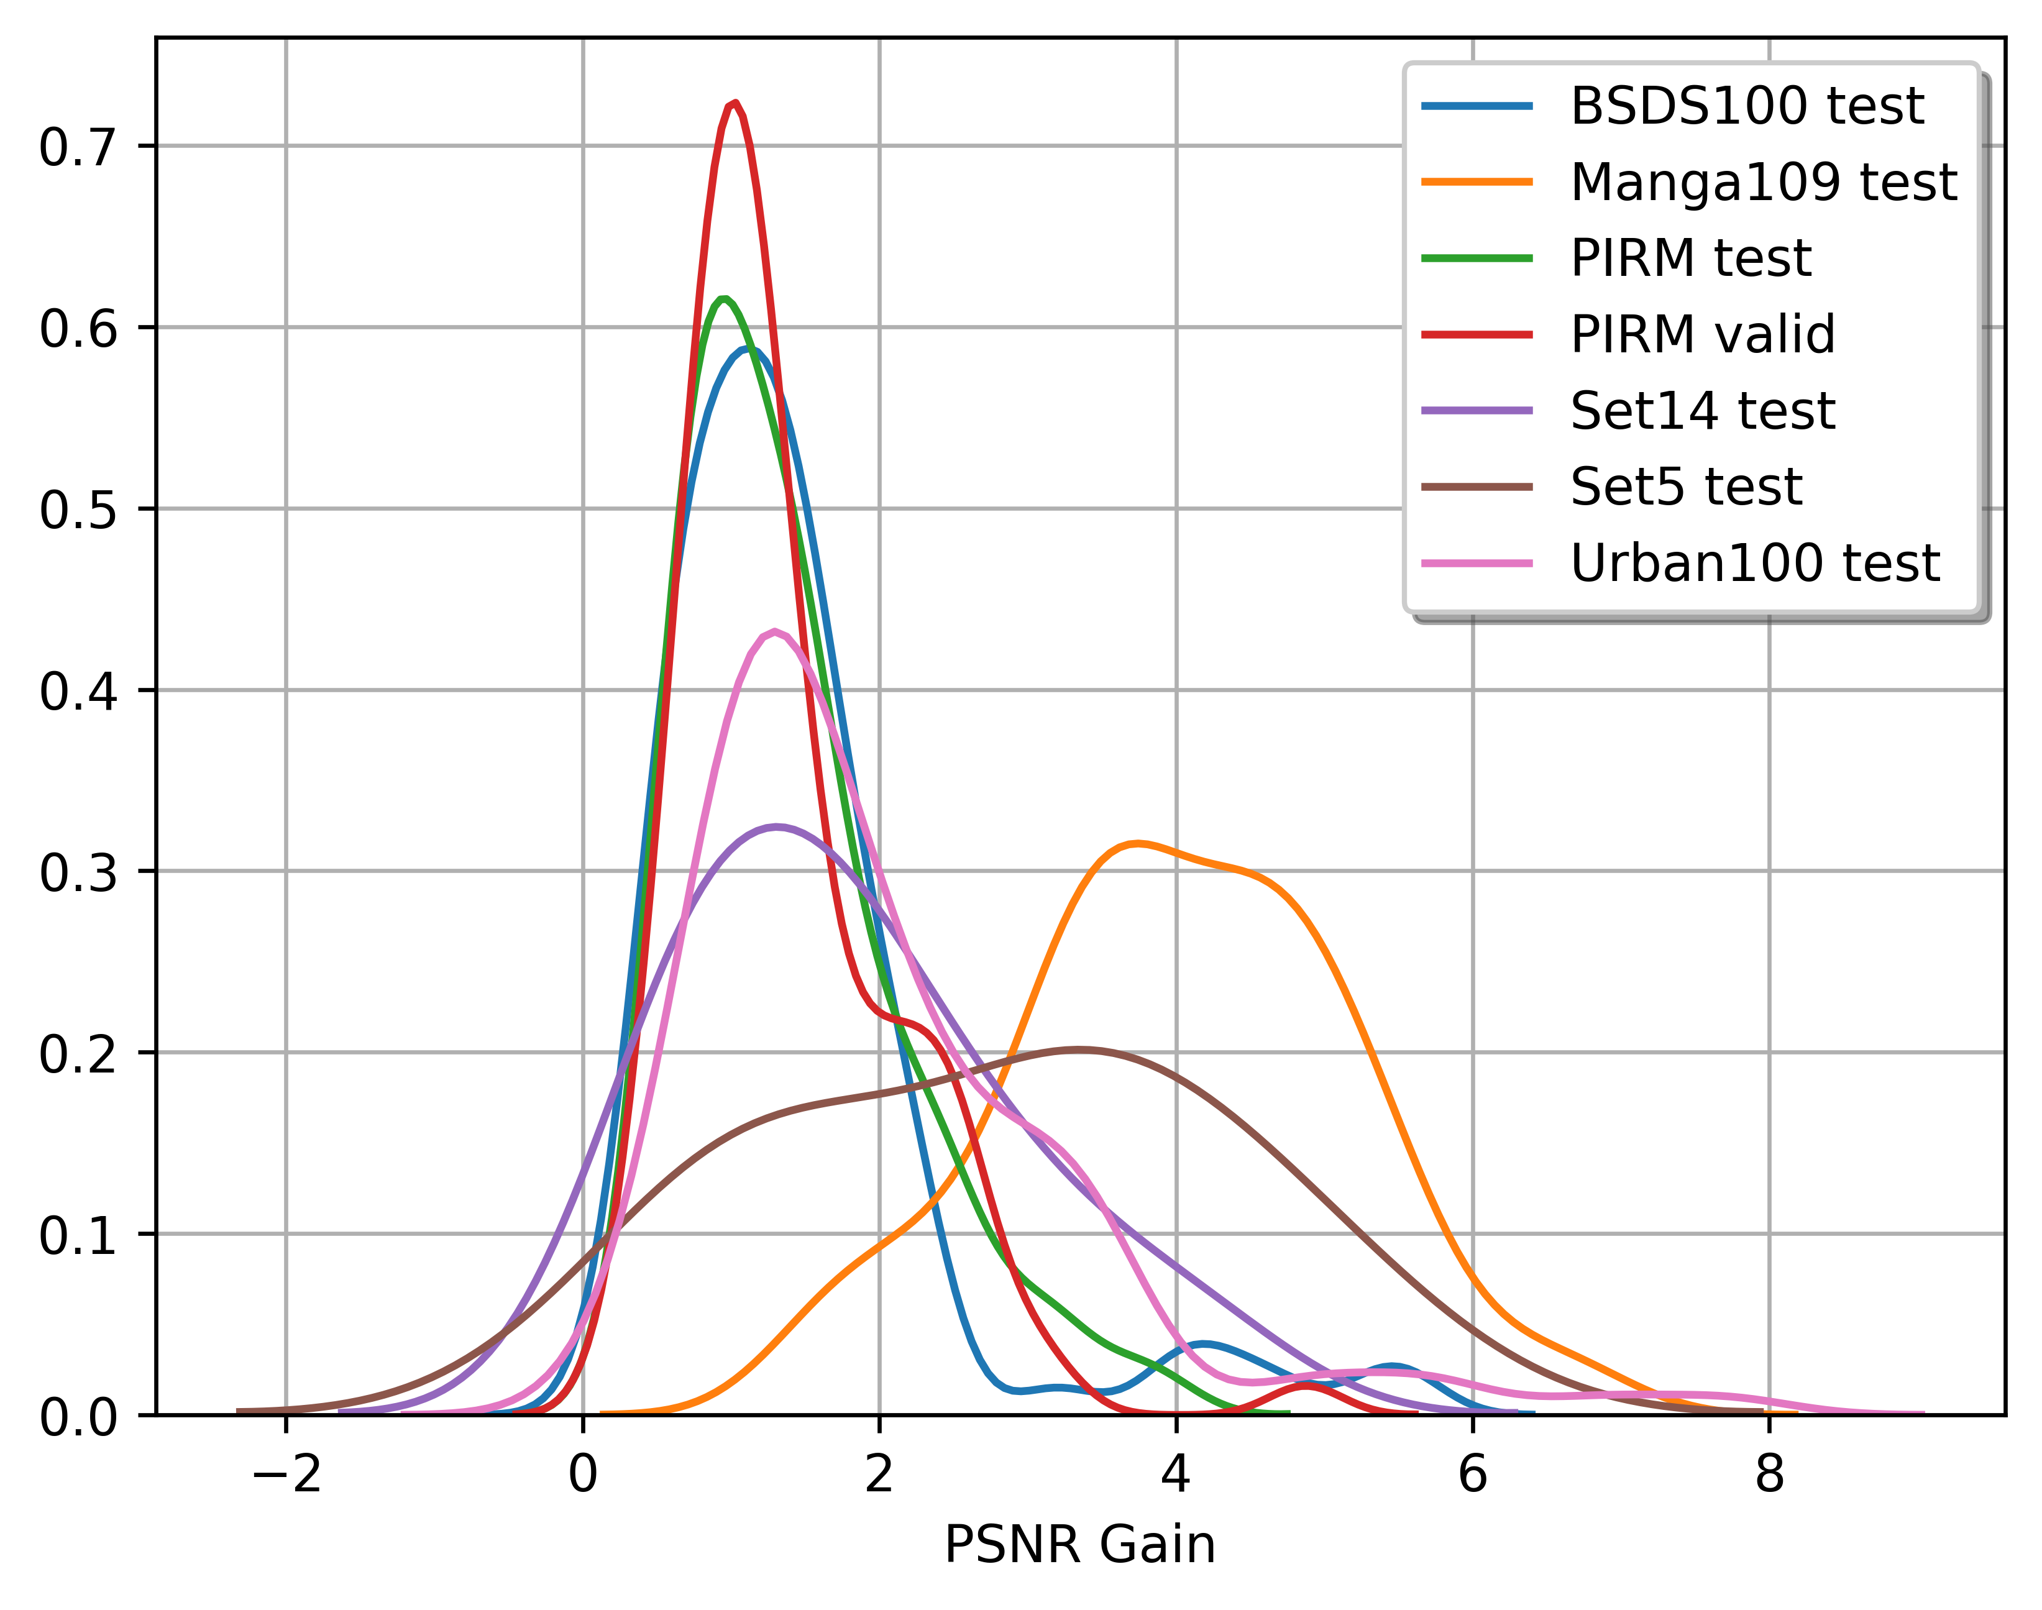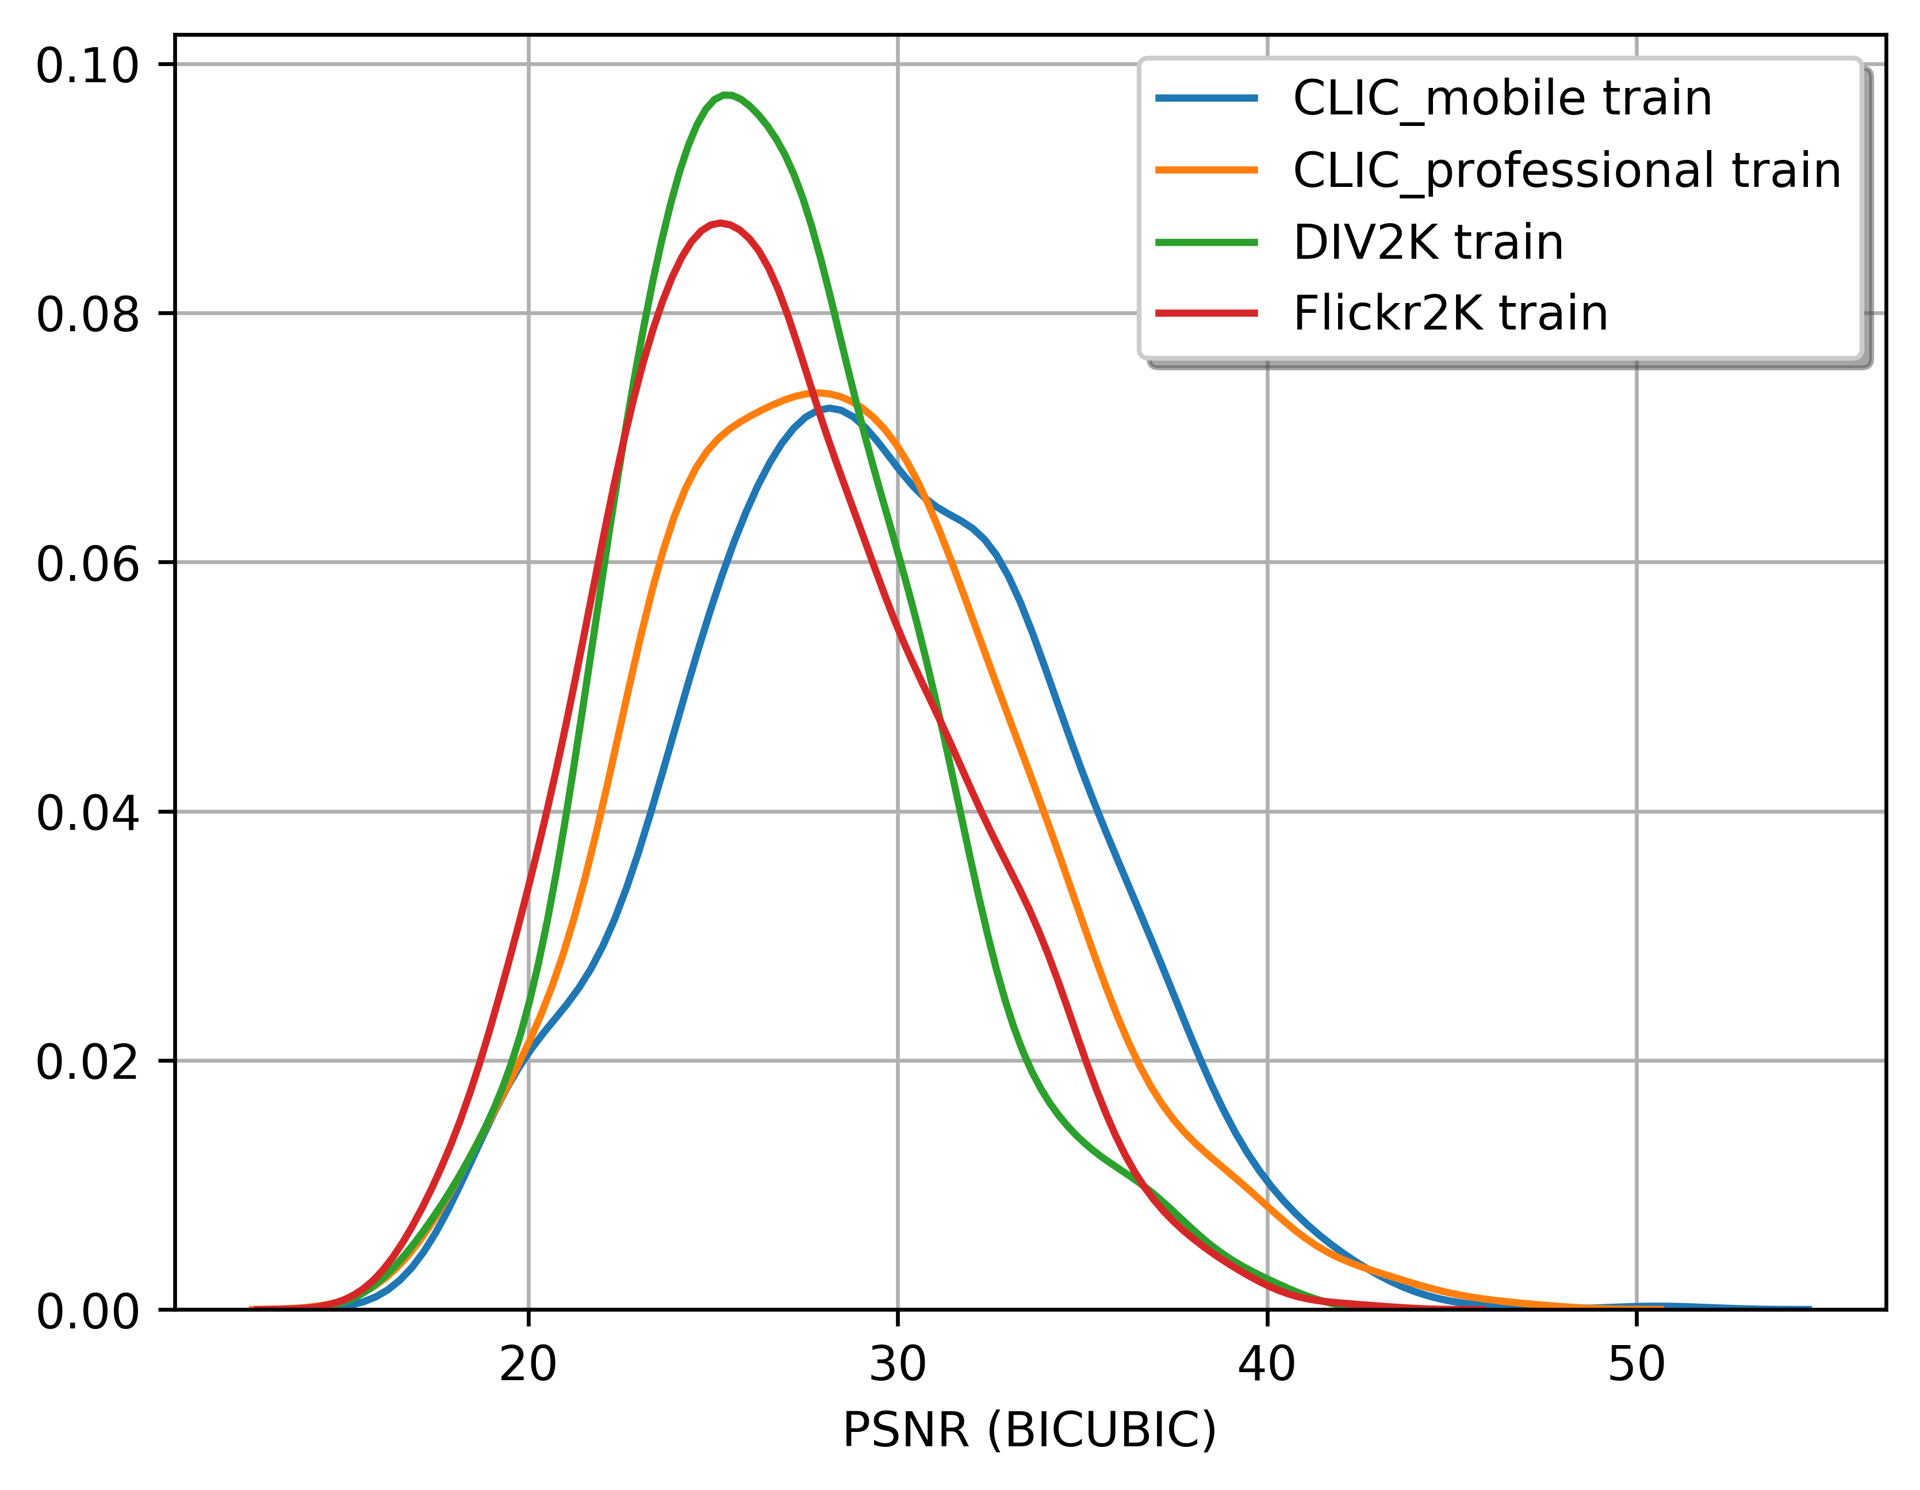**Figure 1 Figure 2 Figure 3**

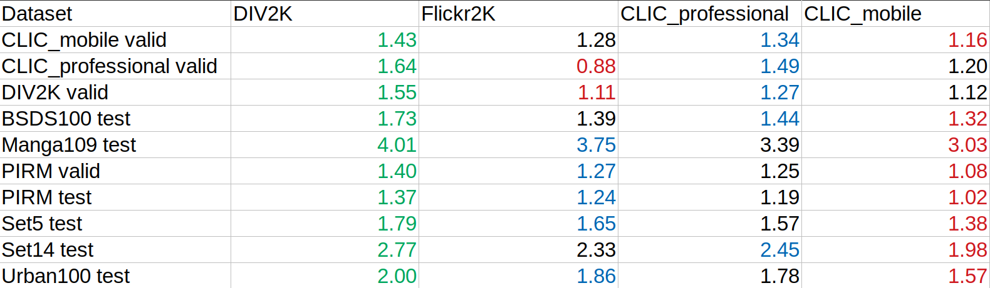

**Table 1. (Performance of different trained instances of SRResNet on various test sets)**

**Experiment 2 (Data-Set Sampling)**

In experiment 1, we have ranked the data sets for the best performance. This motivates us to rank images while training for faster model convergence verified by **Early Stopping**. Since we have disk batching to sample images. We propose a novel sampling algorithm that ranks images for disk batching on-the-fly.

**Algorithm:** Let N be number of images in the entire training dataset

Step 0: Assign each image, a uniform probability of 1/N

While (Model not Converges)

Step 1: Take a sample of K images, proportional to present probabilities of images

Step 2: Calculate the PSNR gain over these images

Step 3: Update probabilities of K images, (using sample distribution of PSNR gain)

**Figure 4 Figure 5**

Performance of our sampling algorithm over uniform sampling is shown in **Fig 5 & 4** respectively. We observe our algorithm will help training to converge faster than the uniform approach (1600 over 2500). Both these observations from Experiment 1 & 2 favour our algorithm.

**Conclusion & Take-away**

1. Analysed & Benchmarked various CNN models from the literature.
2. Characteristics of various training & performance benchmark datasets are utilised for finding best training sets.
3. Proposed & empirically verified an Image sampling algorithm for faster convergence of the model.

**Future Work**

1. Initial probability values can be assigned based on Bicubic Up-sampling rather than Uniform assignment.
2. Usage of Dataset ranking & sampling approaches can be explored in other domains like Compression Artefacts Removal, De-noising.