Contents

Analysis 2

2.1 Introduction 2

2.2 Methodology 3

Steps of Hard Approach Methodology: 3

DFD (Data Flow Diagram) 4

2.3 Feasibility Study 4

Types of feasibility study 5

2.4 SRS (Software Requirement Specification) 5

Functional Requirements 5

Non-Functional Requirements 6

2.5 MoSCoW Prioritization 7

2.6 Use Case Diagram 10

2.7 System Architecture 11

2.7.1 NLA (Natural Language Analysis) 11

2.7.2 Initial Class Diagram 12

2.7.3 System Architecture 13

Conclusion: 13

References: 14

# Analysis

## 2.1 Introduction

Analysis (David, 2002) is the process of examining the complicated subject deeply in order to get the right information. It is the most important step in the whole development process. Better analysis leads to the better understanding of the system. It concerns about what the users want from the system as a result it makes the project successful. Generally, analysis consists of two activities i.e. requirement analysis & requirement specification.

In requirement analysis, requirements are gathered and then analyzed deeply. Gathering of requirements are done through different processes such as survey, questionnaires, interviews, observations, focus groups, etc. But I felt interview would be the affordable and fruitful for my project. Interview is a process of gathering requirements where questions are asked and answers are given. Similarly, I have asked some questions with clients and the questions goes like

Me: What is your requirements sir?

Client: There should be login and registration system.

Me: Ok. Sir, what about home?

Client: There should be my location, contact details, funds details, drop down list, adopting system and so on.

Me: Ok. Thank you sir!

So, these are some examples of questions and answers asked and given in the interview.

Requirement specification is the collection of the outcome of all those analyzed requirements. It establishes the basis for an agreement between clients and contractors or suppliers on how the software product should function.

## 2.2 Methodology

Methodology (Johanson, 1999) is the scientific and systematic theoretical analysis of the methods applied to a field of study. They could be soft approach, hard approach, combine approach, etc. In this task we are using hard approach of analysis methodology.

Hard Approach Methodology is a problem solving process where the involvement of users can be also seen. It follows many steps in order to meet the requirements with the product. Therefore, hard approach is used in my project so that it would be fast, reliable, scalable and effectual.

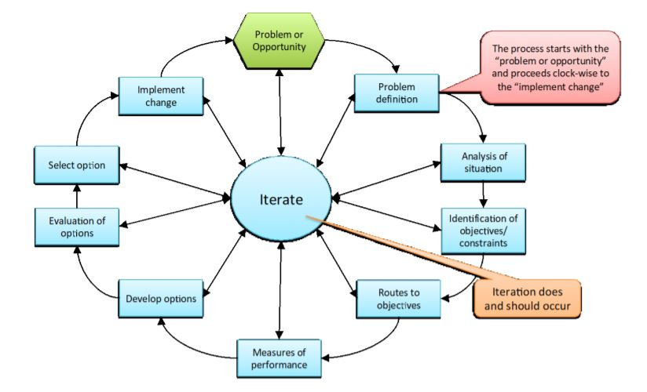

Figure 1: Screenshot of hard approach

### 

### Steps of Hard Approach Methodology:

* **Problem definition**

Our initial stage is to find out the problems that we have and will have in the future so that we could fix all those problems and the product would run efficiently and smoothly in the market.

* **Analysis of situation**

We must define the current performance level and its boundary in order to decide “what’s in and what’s out”. It requires the collection of data to quantify the current performance level so that it could increase.

* **Identification of objectives/constraints**

It is an important step because it forces stakeholders to clarify what they hope to achieve, but also to understand the external factors and constraints that will restrict our change choices and therefore the level of change.

* **Routes to objectives**

It is about exploring different methods for achieving our requirements and objectives. At this stage, we are seeking for “solution” in outline with sufficient detail to be able to remove the “weaker” ones to leave the definite possibilities.

* **Measures of performance**

It says about the performance level of our product that what is the current status and what could be done to enhance the performance of the product.

* **Develop options**

It involves doing sufficient works on each option for the technical and other details to be defined, and for the costs and benefits to be assessed, while at the same time it also works for minimizing time and resources devoted to the task.

* **Evaluation of options**

It is about the evaluating that how well each options is going to work such as whether it will meet the operational objectives or not, technically feasible, etc.

* **Select option**

It is about making choice. Here, any quantitative measures of performance are brought into play.

* **Implement change**

It is about the detailed design, development and installation tasks required to get the agreed proposal operating. This step is about establishing measures and controls to hold and embed the change.

### DFD (Data Flow Diagram)

A data flow diagram (DFD) (Loggan, 2001) maps out the flow of information for any process as well as system. It uses the defined symbols such as rectangles, circles, arrows, plus short text labels in order to show data inputs, outputs, storage points and the routes between each destination.

## 

## Figure 2: Screenshot of data flow diagram

## 2.3 Feasibility Study

Feasibility study is an initial stage of analyzing all those suitable factors of project in order to determine the possibilities & probabilities of completing a project successfully. It determines whether the product that is going to be developed is economically, socially, technologically, politically and legally feasible or not.

### Types of feasibility study

1. **Economically**

The budget of project on which is not too high. Similarly, the project that is going to be developed would be beneficial and fruitful financially. Therefore, we could say that the project on which the work is going on is economically feasible.

1. **Socially**

The product that is going to be developed is good for the society. It has the good impact on the society since those parents who could not have child could adopt child. This brings positive message to the society. Therefore, the product is socially feasible.

1. **Technically**

In order to develop any project, we must have all the required technical resources such as hardware, software, skilled human resources, etc. In case of my project, these all resources are fulfilled. Hence, it is technically feasible.

1. **Politically**

The product that is going to be developed does not harm or have the bad aspects in response to the political status of the nation. So, it is politically feasible.

1. **Legally**

The product that is going to be developed meets the requirements and all the features. Therefore, it is legally feasible too.

## 2.4 SRS (Software Requirement Specification)

### Functional Requirements

All those necessary operations that are necessary for using the product on day to day life are known as functional requirements.

The functional requirements of my project are listed below:-

|  |  |  |  |  |  |
| --- | --- | --- | --- | --- | --- |
| **Fid** | **Functions** | **Data** | **Rational** | **Dependency** | **Remarks** |
| F01 | Registration | Users details | Users information | F01 | Add new users |
| F02 | Login | Username and password | Security to credential | F01 | Opens dashboard |
| F03 | Reset Password | Username | Update password | F02 | Add new password |
| F04 | Post Notice | Login First | To post notice about funds and new child | F02 | Notice will be shown to all users |
| F05 | Donation | Donation Details | Users could see | F02 | Easy understanding for users |
| F06 | Adoption | Users details | Users could see all available children | F02 | Easy for users to be satisfied |
| F07 | Asking Questions | Children Details | Users to admin | F02 | Users can ask questions to admin |
| F08 | Answering Questions | Question Details | Admin to users | F02 | Admin can answer to users |
| F09 | Admin Login | Admin Details | Admin | F09 | Open Admin Dashboard |
| F010 | Admin Profile Update | Admin Details | Admin | F09 | Admin can update profile |
| F011 | Logout | - | To maintain session | F02 | Admin or users could logout |

### Non-Functional Requirements

Non-functional requirements are criteria of the product which are used to judge the operations of the system. It can be divided into two parts i.e. execution qualities (observable during runtime like usability, etc.) and evolution qualities (can be found in static structure of the system like testability, maintainability, etc.)

The non-functional requirements of my product are listed below: -

|  |  |  |  |  |  |
| --- | --- | --- | --- | --- | --- |
| **N:id** | **Functions** | **Data** | **Rational** | **Dependency** | **Remarks** |
| N01 | Responsive | - | Supports different resolutions | N01 | Automatically fits in different screen sizes. |
| N02 | Usability | - | User friendly | N02, N01 | Easy to use |
| N03 | Maintainability | - | Easy to change | N03 | Easy to Maintain & optimize |
| N04 | Reliability | - | Accurate outputs | N01, N02 | Gives accurate outputs as per the inputs given |
| N05 | Robustness | - | Supports many platforms | N05 | Should works with different platforms |
| N06 | Multi-Browsers supports | - | Tested in many browsers | N02, N01 | Runs in different browsers |
| N07 | Scalability | - | Able to handle workloads | N02 | Should handles the data flow easily |

## 2.5 MoSCoW Prioritization

MoSCoW Prioritization is one of the methods of maintaining the requirements/features in the sequential order as per the importance with regards to must have, should have, could have and won’t have.

The features of my project on the basis of MoSCoW prioritization are given below:

1. **M**ust have: It is vital and project won’t be complete without it.

* Registration
* Login
* Adoption
* Donation
* CRUDE operation
* Admin Panel

1. **S**hould have: It is important but vital.

* Reset password
* Notification

1. **C**ould have: It is desirable but less importance.

* Cookies

1. **W**on’t have: It is not possible to add this time.

* Logout

MoSCoW Prioritization for functional requirements is:-

|  |  |  |
| --- | --- | --- |
| **F.ID** | **Functions** | **Priority** |
| F01 | Registration | Must have |
| F02 | Login | Must have |
| F03 | Reset Password | Should have |
| F04 | Post Notice | Must have |
| F05 | Donation | Must have |
| F06 | Adoption | Could have |
| F07 | Asking Questions | Should have |
| F08 | Answering Questions | Must have |
| F09 | Admin Login | Must have |
| F10 | Admin Profile Update | Should have |
| F11 | Logout | Won’t have this time |

MoSCoW Prioritization for non-functional requirements is:-

|  |  |  |
| --- | --- | --- |
| **N:ID** | **Functions** | **Priority** |
| N01 | Responsive | Must have |
| N02 | Usability | Must have |
| N03 | Maintainability | Must have |
| N04 | Reliability | Should have |
| N05 | Robustness | Must have |
| N06 | Multi-Browsers supports | Must have |
| N07 | Scalability | Could have |

## 2.6 Use Case Diagram

A use case diagram (Mousan, 2005) is a graphic depiction of the interactions among the elements of a system. It is the significant tool in handling the abstractions. Here, the working mechanism of the product could be seen where actors and system plays vital role.

The use case diagram of the project that is going to be developed looks like:-

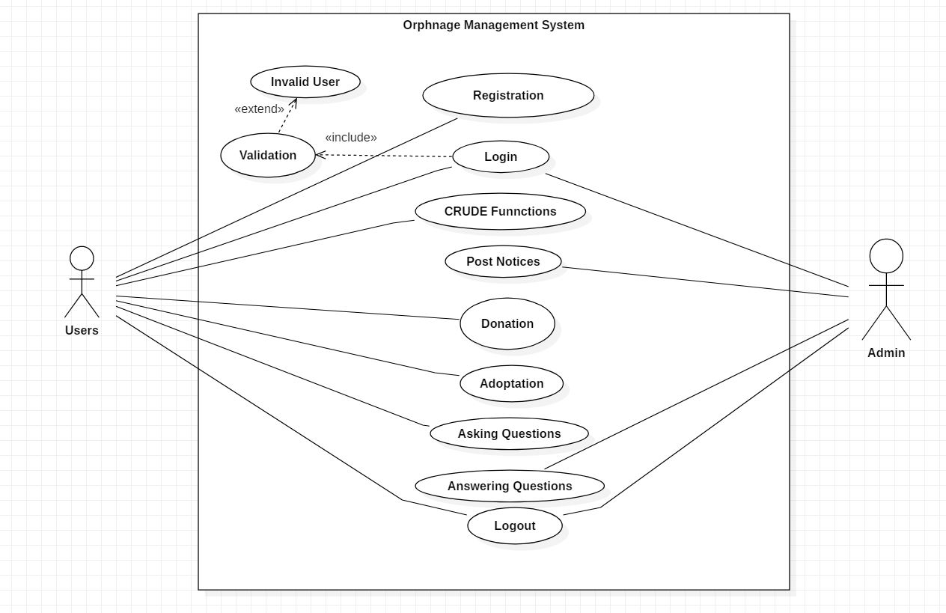  
 Figure 3: Screenshot of use case diagram

## 2.7 System Architecture

### 2.7.1 NLA (Natural Language Analysis)

#### Background of the project:

Orphanage Management System is one of the social institutes where children are taken under the good care. Here, all children are orphans and our project is going to develop a platform where users (parents) could easily adopt child as well as donate some money and admin (care taker) keeps all the records of these activities. It’s not compulsion that only those can involve in donation who is involved in adoption. It’s open for everyone.

Similarly, programming of the project should be done in PHP language using My SQL for managing databases for Orphanage Management System. The product that is going to be developed should meet the following criteria:-

* User can register and login to the system.
* Admin can also login to the system.
* User can see the donation records and can donate money too after accessing to the product.
* User can adopt child by submitting their details.
* Admin can add and remove, delete and update the number of child and some other activities too.
* Database would be designed to keep the details of the users, donation, adaptation and children.

#### NLA (Natural Language Analysis):

It is the process of identifying nouns, adjectives and verbs in a part wise of the descriptive texts. It is a technology that is used to aid computers in order to understand the human’s natural language.

|  |  |  |
| --- | --- | --- |
| **Nouns** | **Adjectives** | **Verbs** |
| Institutes, children, project, platform, users, parents, child, money, admin, records, activities, donation, adoption, everyone, language, databases, system | Social, some, these | Add, remove, delete, update, register, login, donate, adopt, is, are, keep, see, submitting, accessing |

### 2.7.2 Initial Class Diagram

Initial Class Diagram (Kalapy, 2002) in the UML (Unified Modeling Language) is a type of static diagram which describes the structure of the system by showing the system’s classes, their attributes, methods and relationships among the objects.

Similarly, the product which is going to be developed shows the following class diagram:-

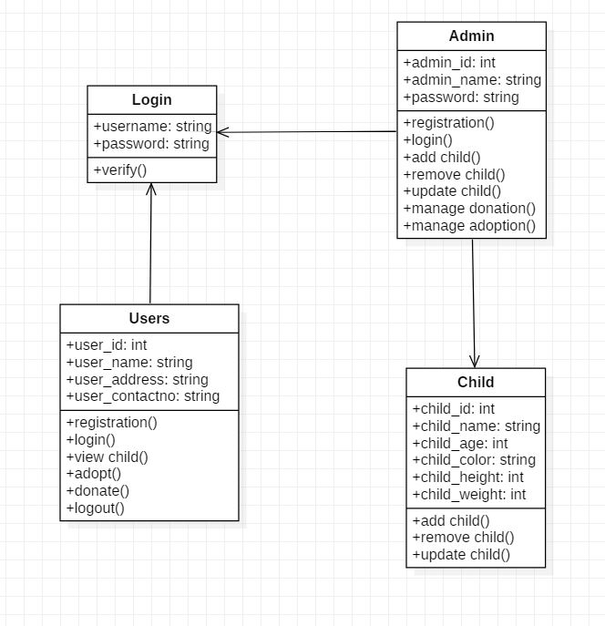

Figure 4: Screenshot of initial class diagram

### 2.7.3 System Architecture

System architecture (Hoana, 2004) is a conceptual model which is used to define the structure, behavior and more views of the system. There are many processes to complete the system architecture but among those all I have used the three-tier architecture.

Three-tier architecture is a type of software architecture that is composed of three layers of logical computing. They are often used in applications as a specific type of client-server system. It provides many benefits for the producing and developing interfaces, business logic and data storage layers.

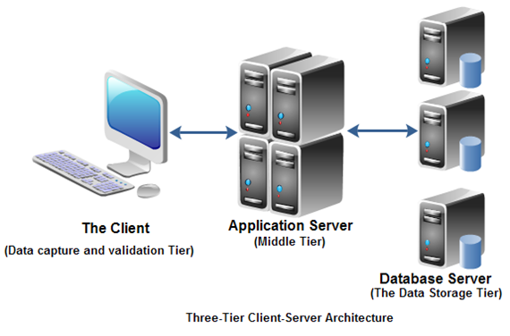

Figure 5: Screenshot of three-tier architecture

## Conclusion:

Hence, in this way the product is going to be developed. During analysis phase, feasibility study is done in order to find out the important factors. Similarly, Hard Approach Methodology is used and then requirements are gathered via interview. After that MoSCoW prioritization is done in order to divide the features on the basis of their importance. Then use case diagram and class diagram is done along with NLA and system architecture.

# References

David. (2002). Retrieved from www.merriam-webster.com: https://www.merriam-webster.com/dictionary/analysis

Hoana. (2004). Retrieved from www.lix.polytechnique.fr: https://www.lix.polytechnique.fr/~golden/systems_architecture.html

Johanson. (1999). Retrieved from www.merriam-webster.com: https://www.merriam-webster.com/dictionary/methodology

Kalapy. (2002). Retrieved from www.visual-paradigm.com: https://www.visual-paradigm.com/guide/uml-unified-modeling-language/what-is-class-diagram/

Loggan. (2001). Retrieved from www.lucidchart.com: https://www.lucidchart.com/pages/data-flow-diagram

Mousan. (2005). Retrieved from creately.com: https://creately.com/diagram/example/hk9yp8cz1/Orphanage%%20Management20System