# **Testing**

Testing is the process of checking out the errors and bugs that has been in the developed system. Here, only testing have been performed and i.e. Unit Testing and Black-Box Testing.

## **Unit Testing**

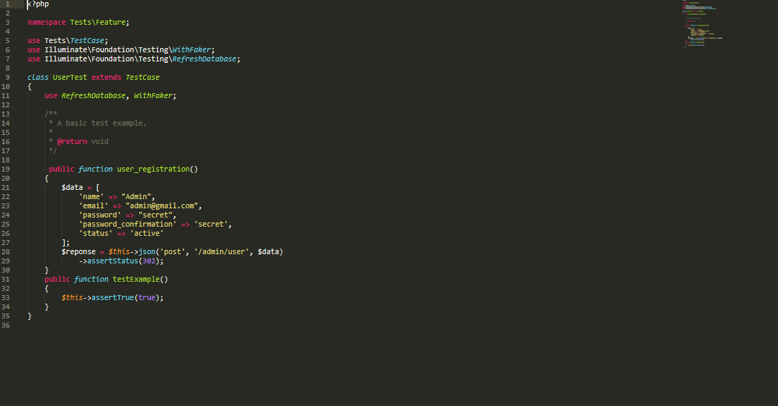

Figure 16: Screenshot of admin login test

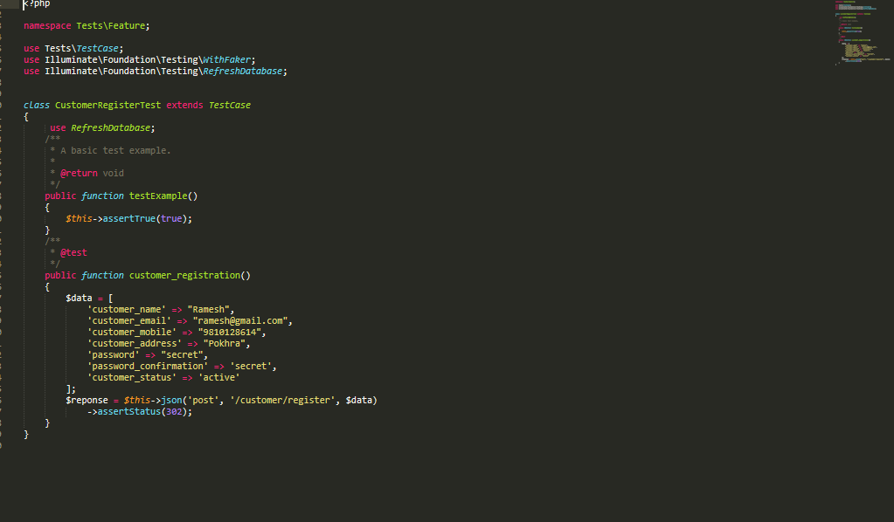

Figure 17: Screenshot of customer register

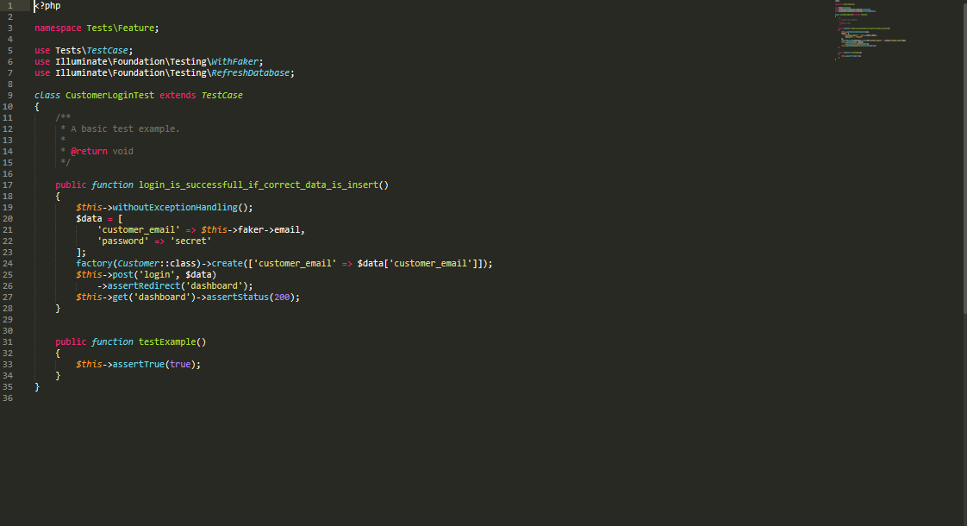

Figure 18: Screenshot of customer login test

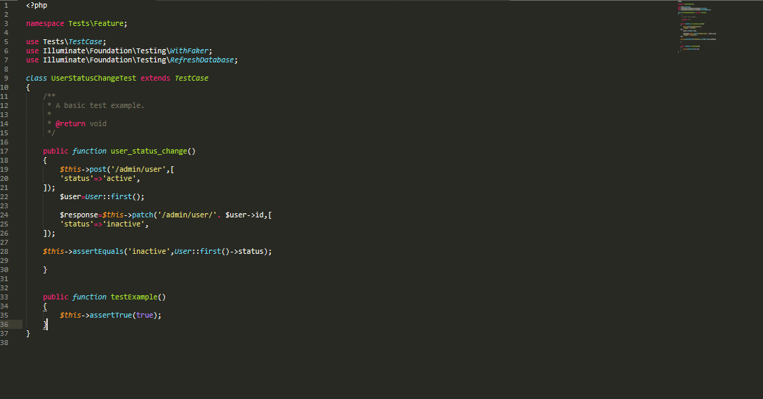

Figure 19: Screenshot of user status

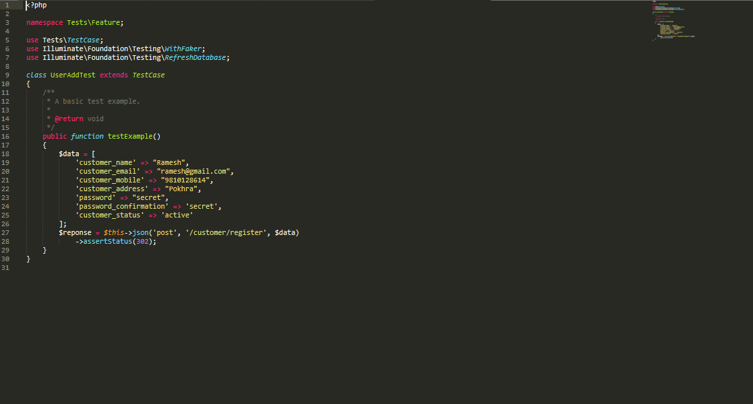

Figure 20: Screenshot of add user

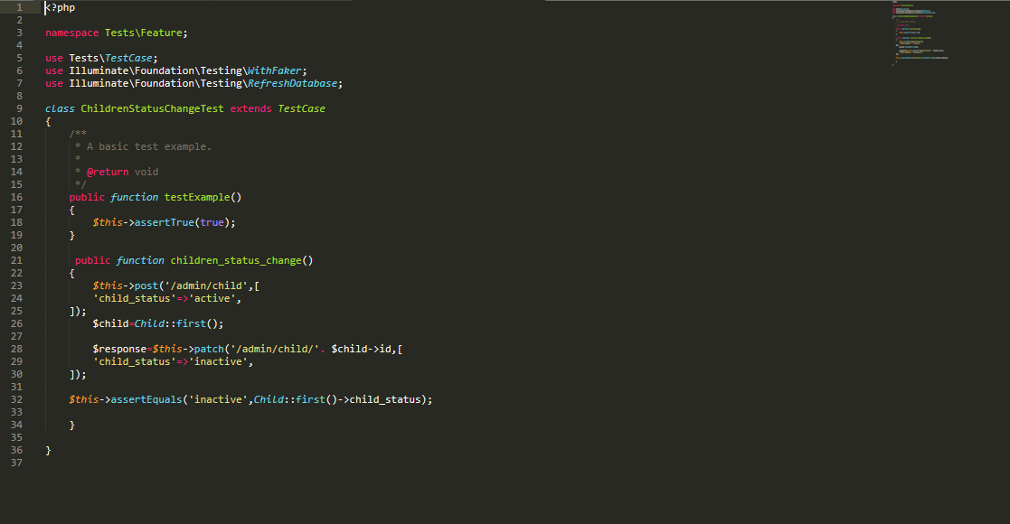

Figure 21: Screenshot of child status

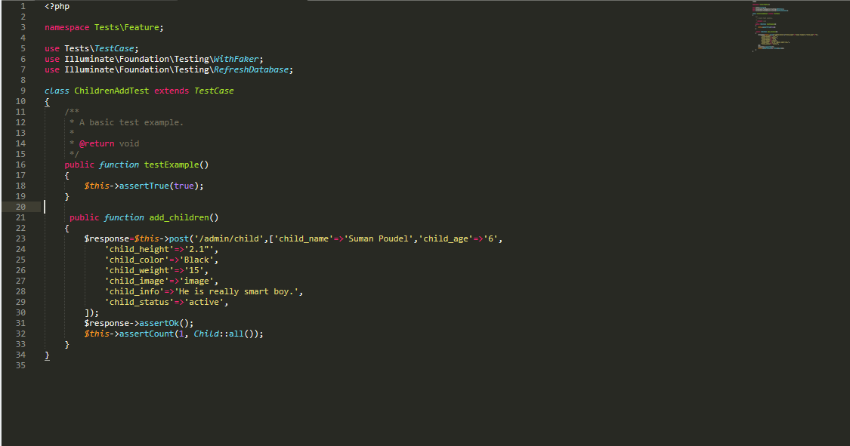

Figure 22: Screenshot of add child

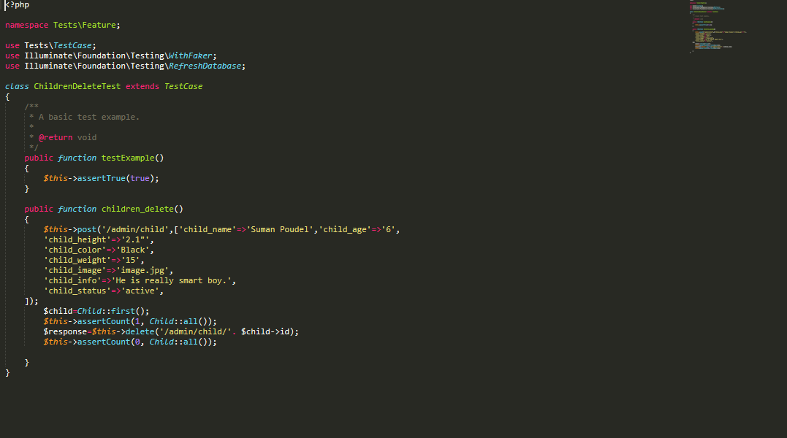

Figure 23: Screenshot of delete child

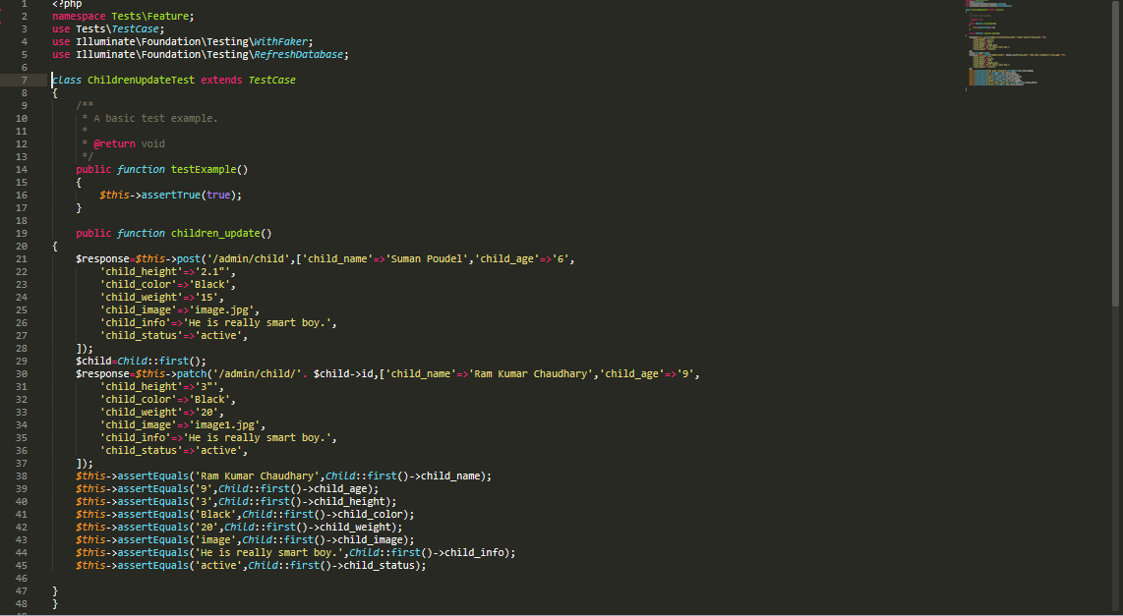

Figure 24: Screenshot of update child

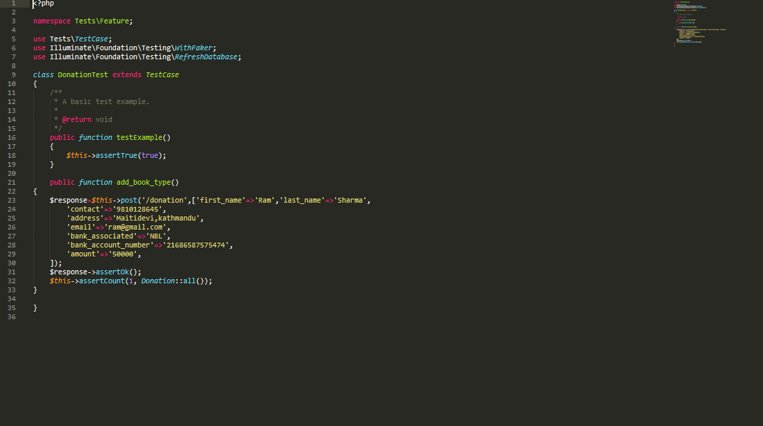

Figure 25: Screenshot of donation form

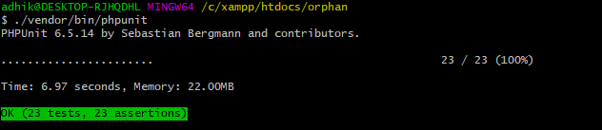

Figure 26: Screenshot of results of all unit testing

## **Black box Testing**

**Testing Table:**

|  |  |  |  |  |  |
| --- | --- | --- | --- | --- | --- |
| **Test No.** | **Test Scenario** | **Test Input Data** | **Expected Result** | **Actual Result** | **Result Pass/Fail** |
| 1 | should be allowed to login | username/password | should be login | login successfully | pass |
| 2 | should be registered | full name/email/mobile/address/password/confirm password | should be registered | registered successfully | pass |
| 3 | should be allowed to donate | first name/last name/phone/email/bank associated/bank account no/amount | should be donated | donated successfully | pass |
| 4 | users should be allowed to contact | name/phone/email/write message | should be contacted | contact unsuccessful | fail |
| 5 | should be allowed to update | name/mobile/address | should be updated | update unsuccessful | fail |
| 6 | should be allowed to change password | old password/new password/confirm password | password should be changed | change password unsuccessful | fail |
| 7 | should be allowed to sign out |  | users should be allowed to sign out | sign out successfully | pass |
| 8 | should be allowed to go back to front |  | users should be allowed to go back to front | back to front successfully | pass |

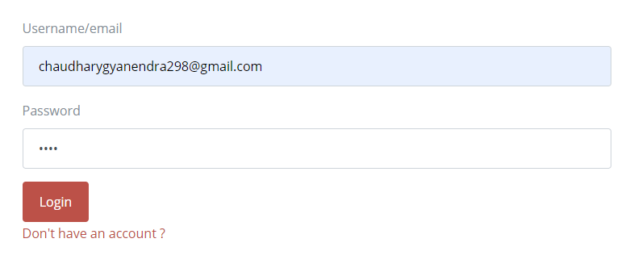

Figure 27: Screenshot of login test

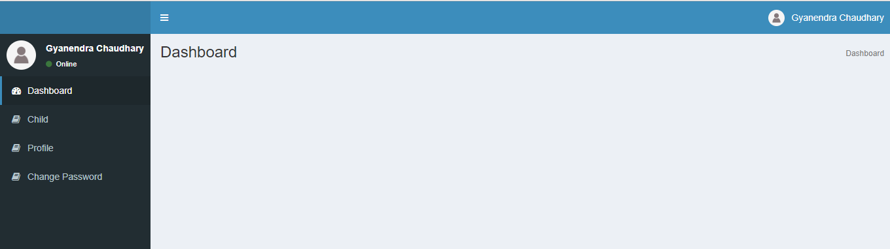

Figure 28: Screenshot of page after login successful

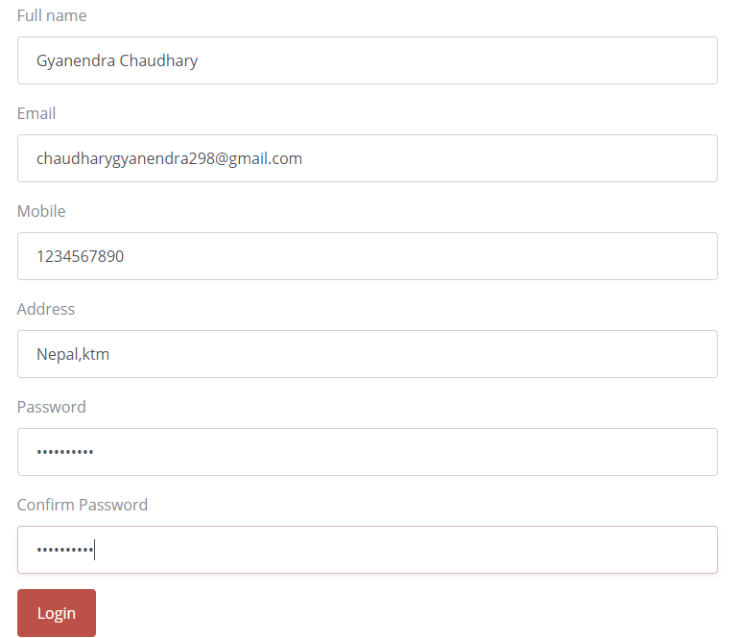

Figure 29: Screenshot of registration test

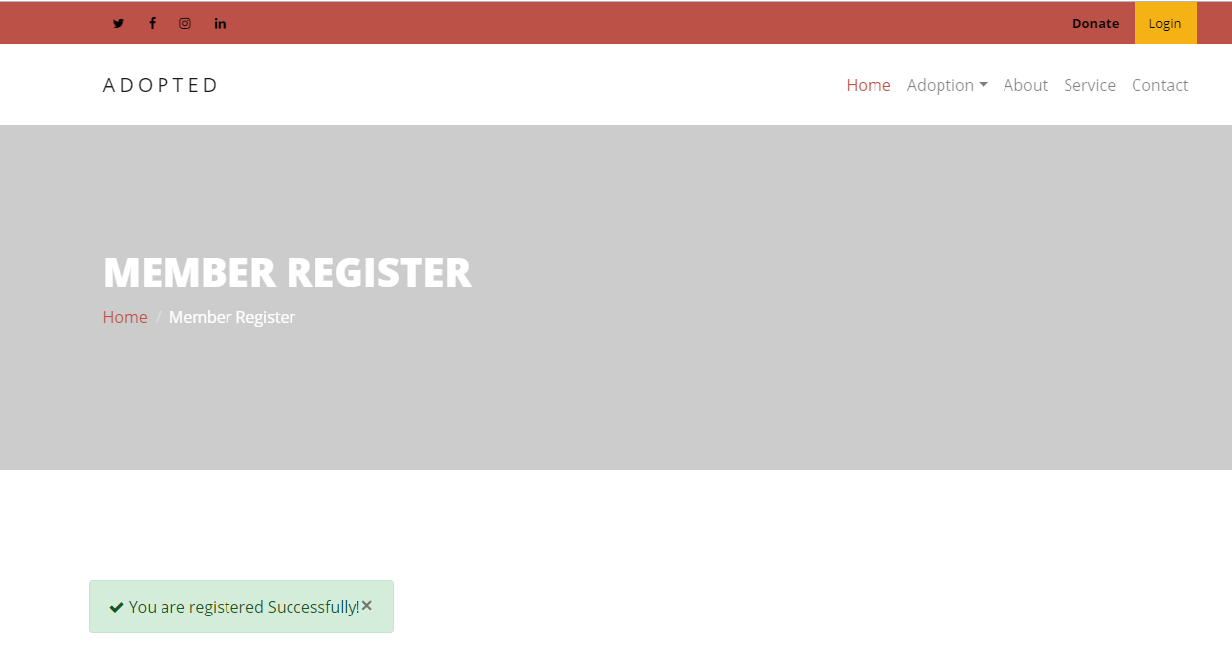

Figure 30: Screenshot of page after registration successful

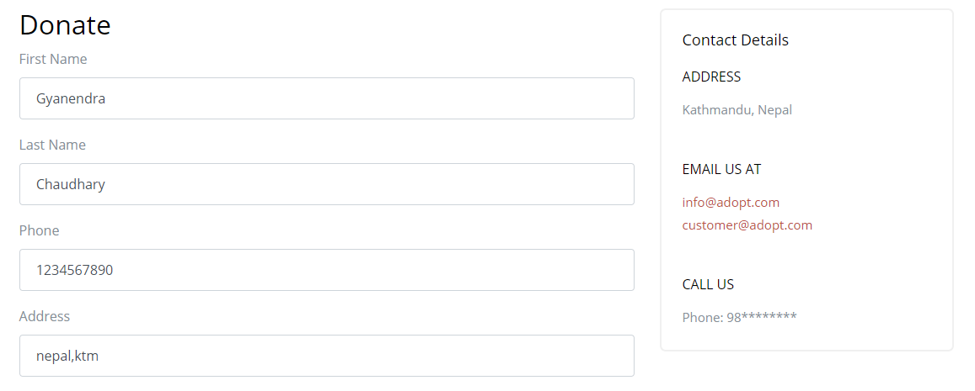

Figure 31: Screenshot of donation test

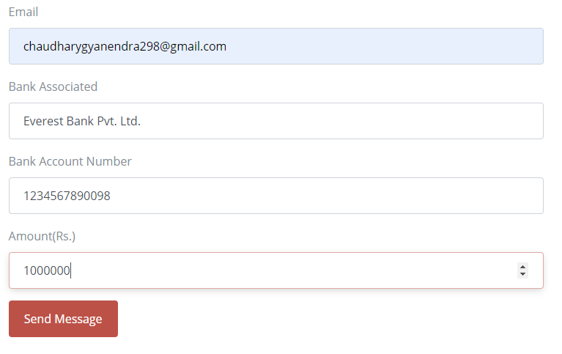

Figure 32: Screenshot of donation test

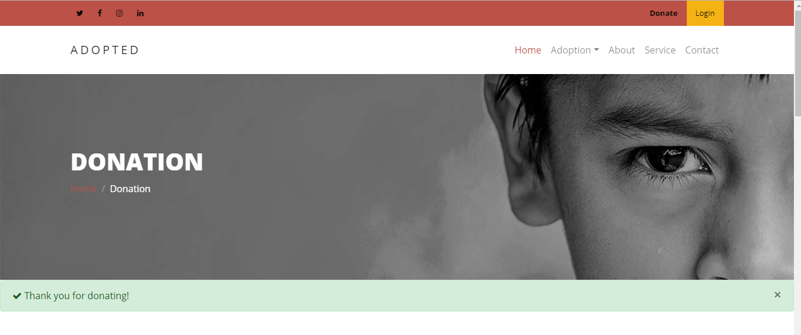

Figure 33: Screenshot of page after donation

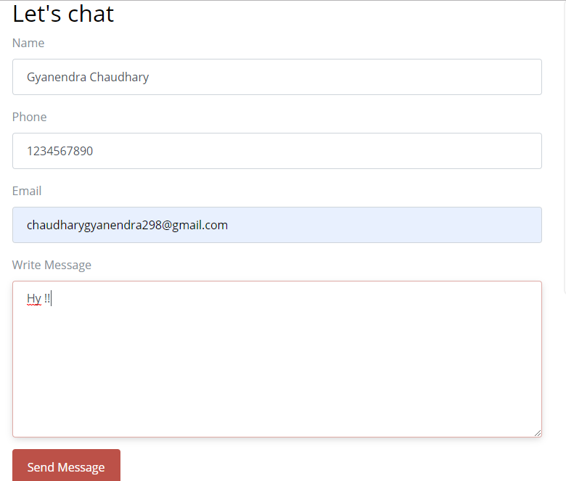

Figure 34: Screenshot of contact test

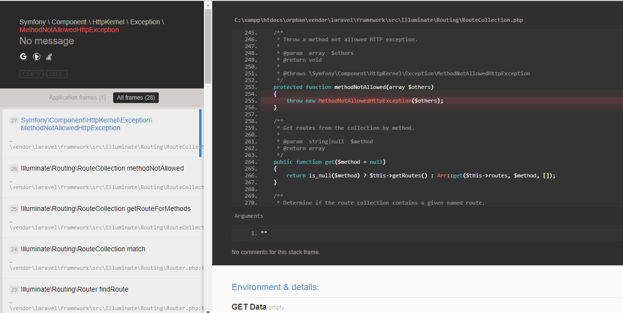

Figure 35: Screenshot of error after contact test

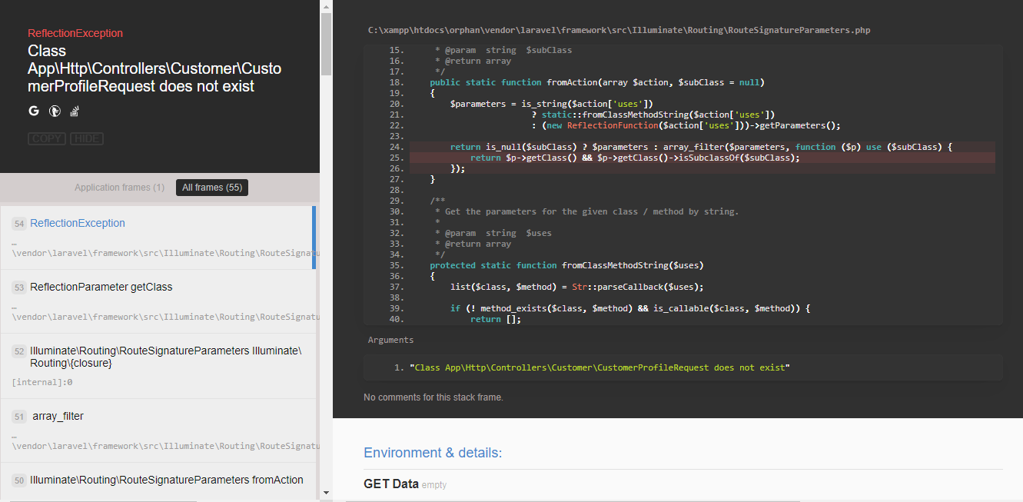

Figure 36: Screenshot of error after update test

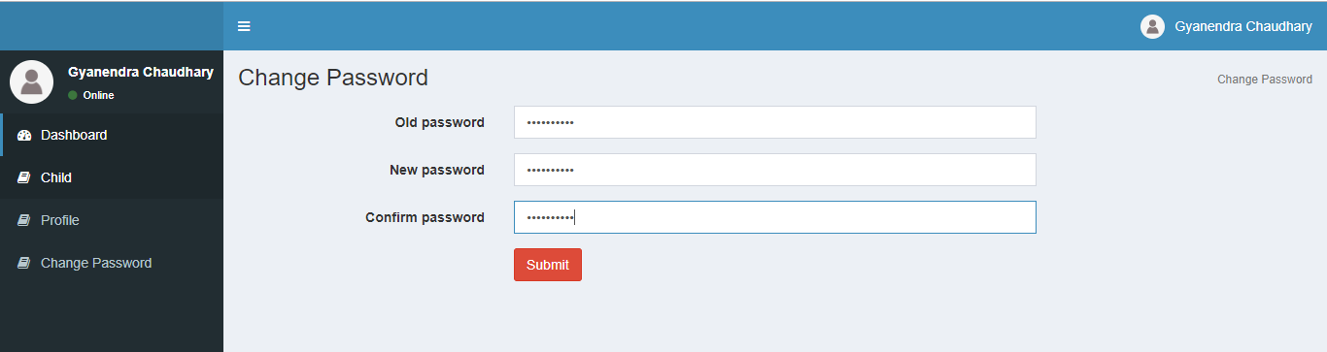

Figure 37: Screenshot of change password test

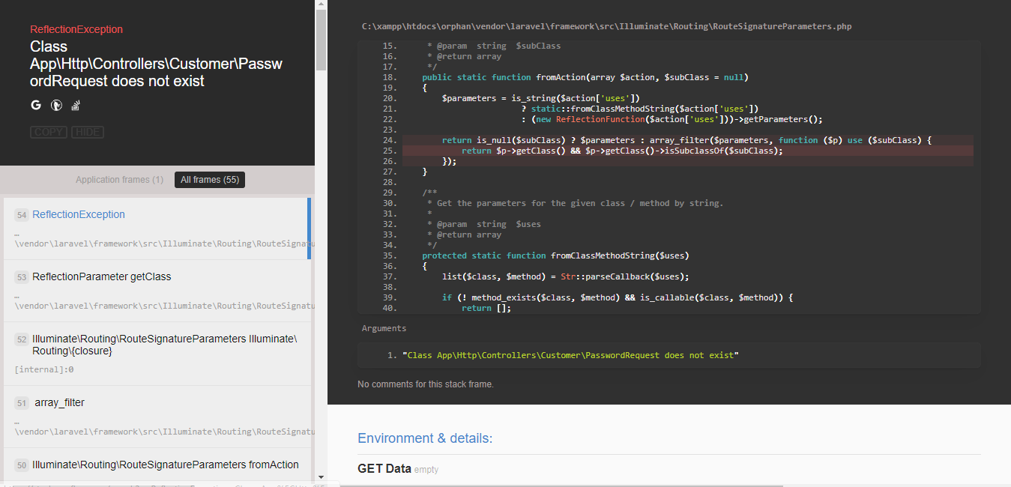

Figure 38: Screenshot of error after change password test

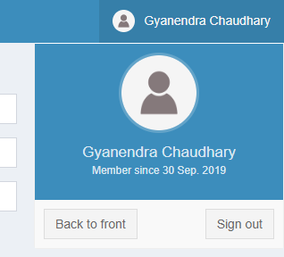

Figure 39: Screenshot of sign out

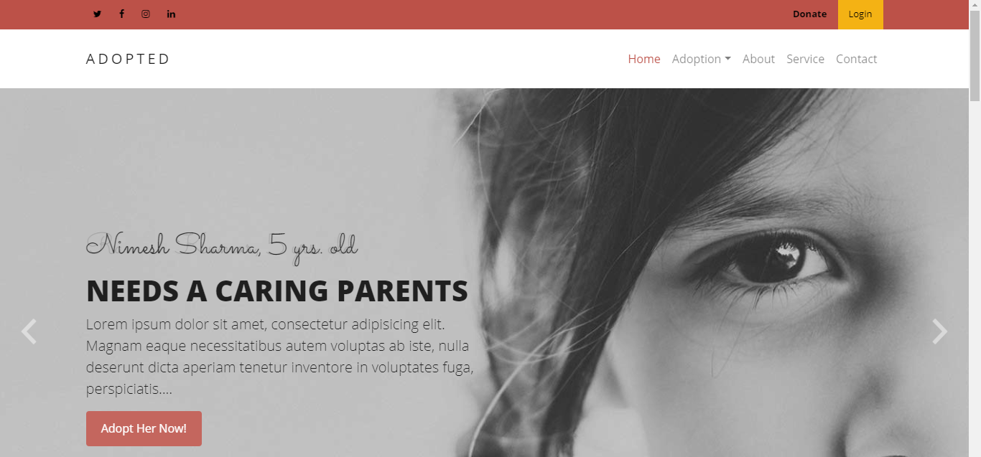

Figure 40: Screenshot of page after sign out successful

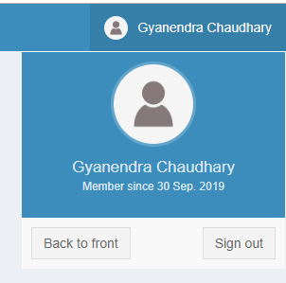

Figure 41: Screenshot of back to front test

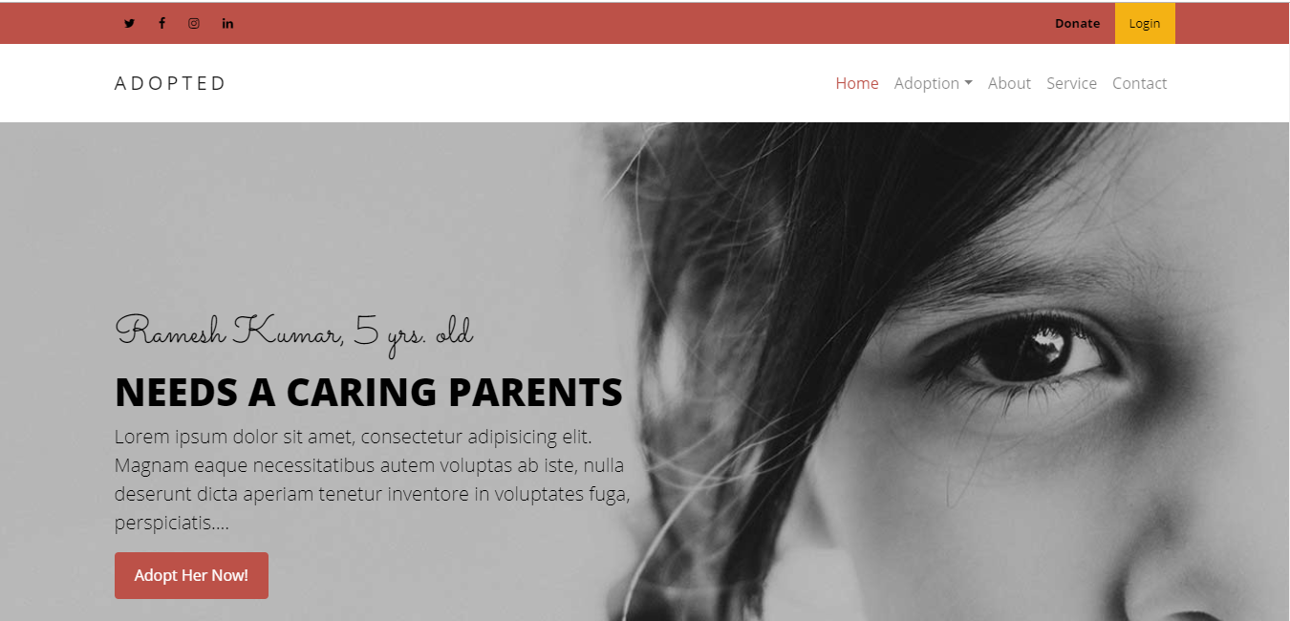

Figure 42: Screenshot of page after back to front successful