!PACMAN!

Shubham, 2018CS10641

Hi there, welcome to my implementation of an awesome game PACMAN with SDL2 and C++. I have tried to implement much more than just Pacman. In this implementation, I have tried to make use of the best design practices i could, so as to make the implementation easier to understand for everyone. I have used as much Object-Oriented Programming as possible. This definitely kept me feel less confused during the design, but also motivated to plan ahead and make something much more than just PACMAN. I have added to some other scenes in the game for that.

So, when we run “make”, the makefile compiles all the files, prepares the final executable and runs it. The first screen looks like this:
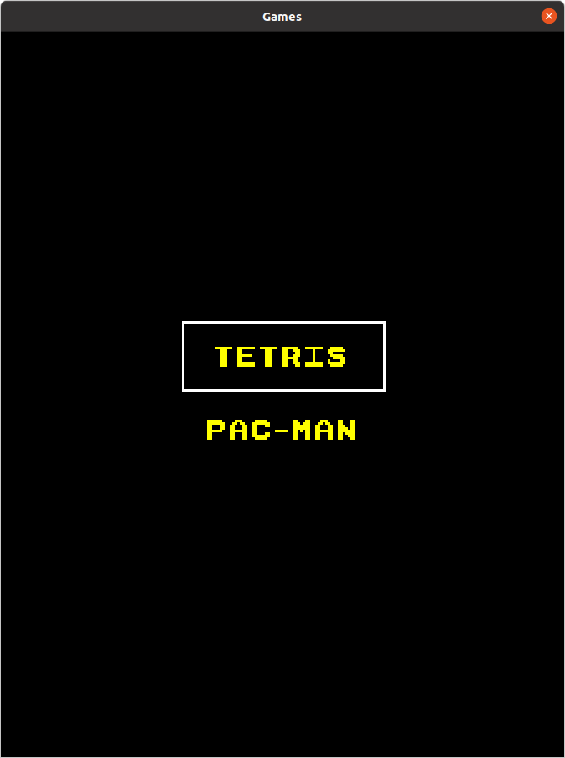

We can scroll up or down using UP and DOWN keys. Press ENTER to the game you want. Right now, I haven’t implemented TETRIS so if you click on it, it will say, “NOT IMPLEMENTED”. So, go to PAC-MAN and hit ENTER. You will be greeted by this screen.

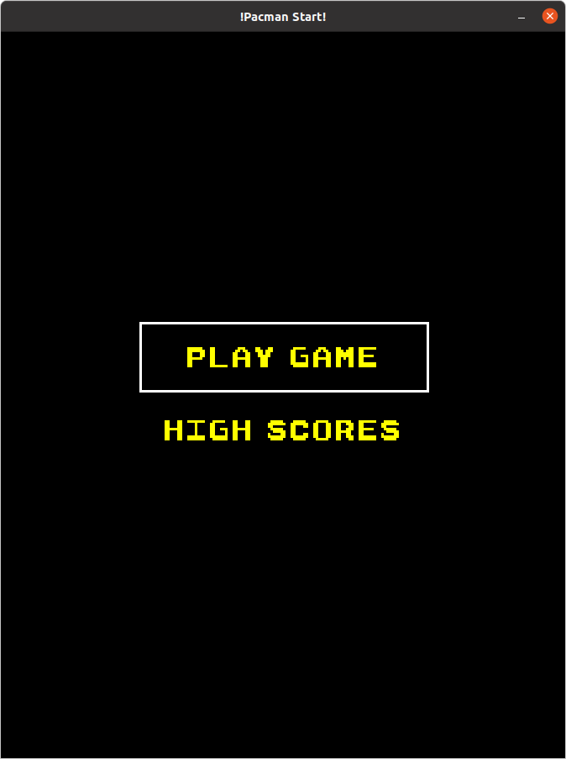
Hit ENTER on the play Game and TADA, you will greeted by Pacman! You can press ESCAPE key to go back.

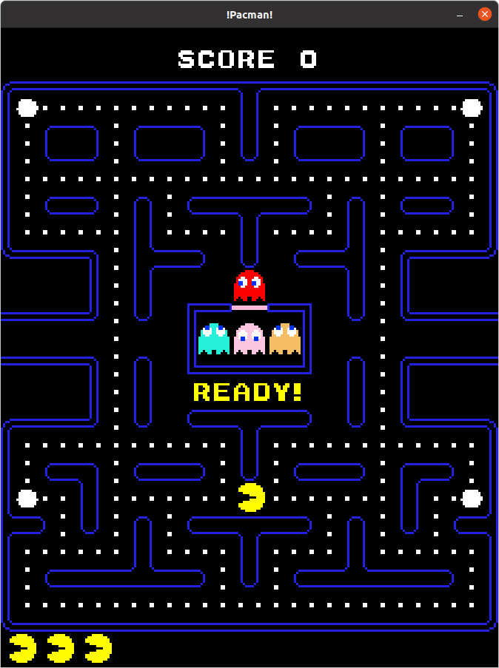
PACMAN

UI of the game:
As you can see in the above image, UI will contain:
1. Score: On the top of the screen you will be able to see the Score
2. lives left: bottom bottom left of the game screen will display the no of lives left
3.READY/ GAME OVER label

Some details about the game procedure

The game will start after 5 seconds, and READY text will disappear. Now you can move PACMAN using the arrow keys.

All the ghosts will be at the spawn locations initially, as the game starts, first BLINKY will start moving(RED ghost). After 5 seconds, PINKY(PINK ghost) will come out of the gate and after 5 seconds each, INKY(CYAN) and CLYDE(Orange) will also come out of the gate.
Also, for the first 10 seconds, the ghosts are in scatter mode, then they come in chase mode(after 10 sec from the start of the game).
- PACMAN speed is 50 pixels per second while ghosts speed in normal alive state is 45 pixels per second (just so that ghosts can’t chase the pacman)

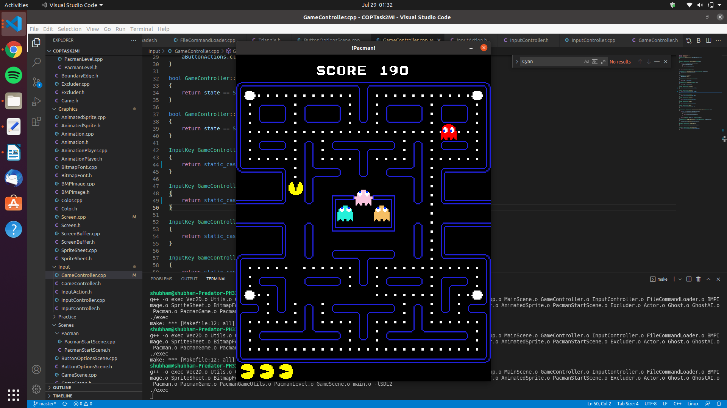
IMAGE: Ghost PINKY coming out of the gate

How to play the game:

You can move PACMAN in the maze using the ARROW keys.
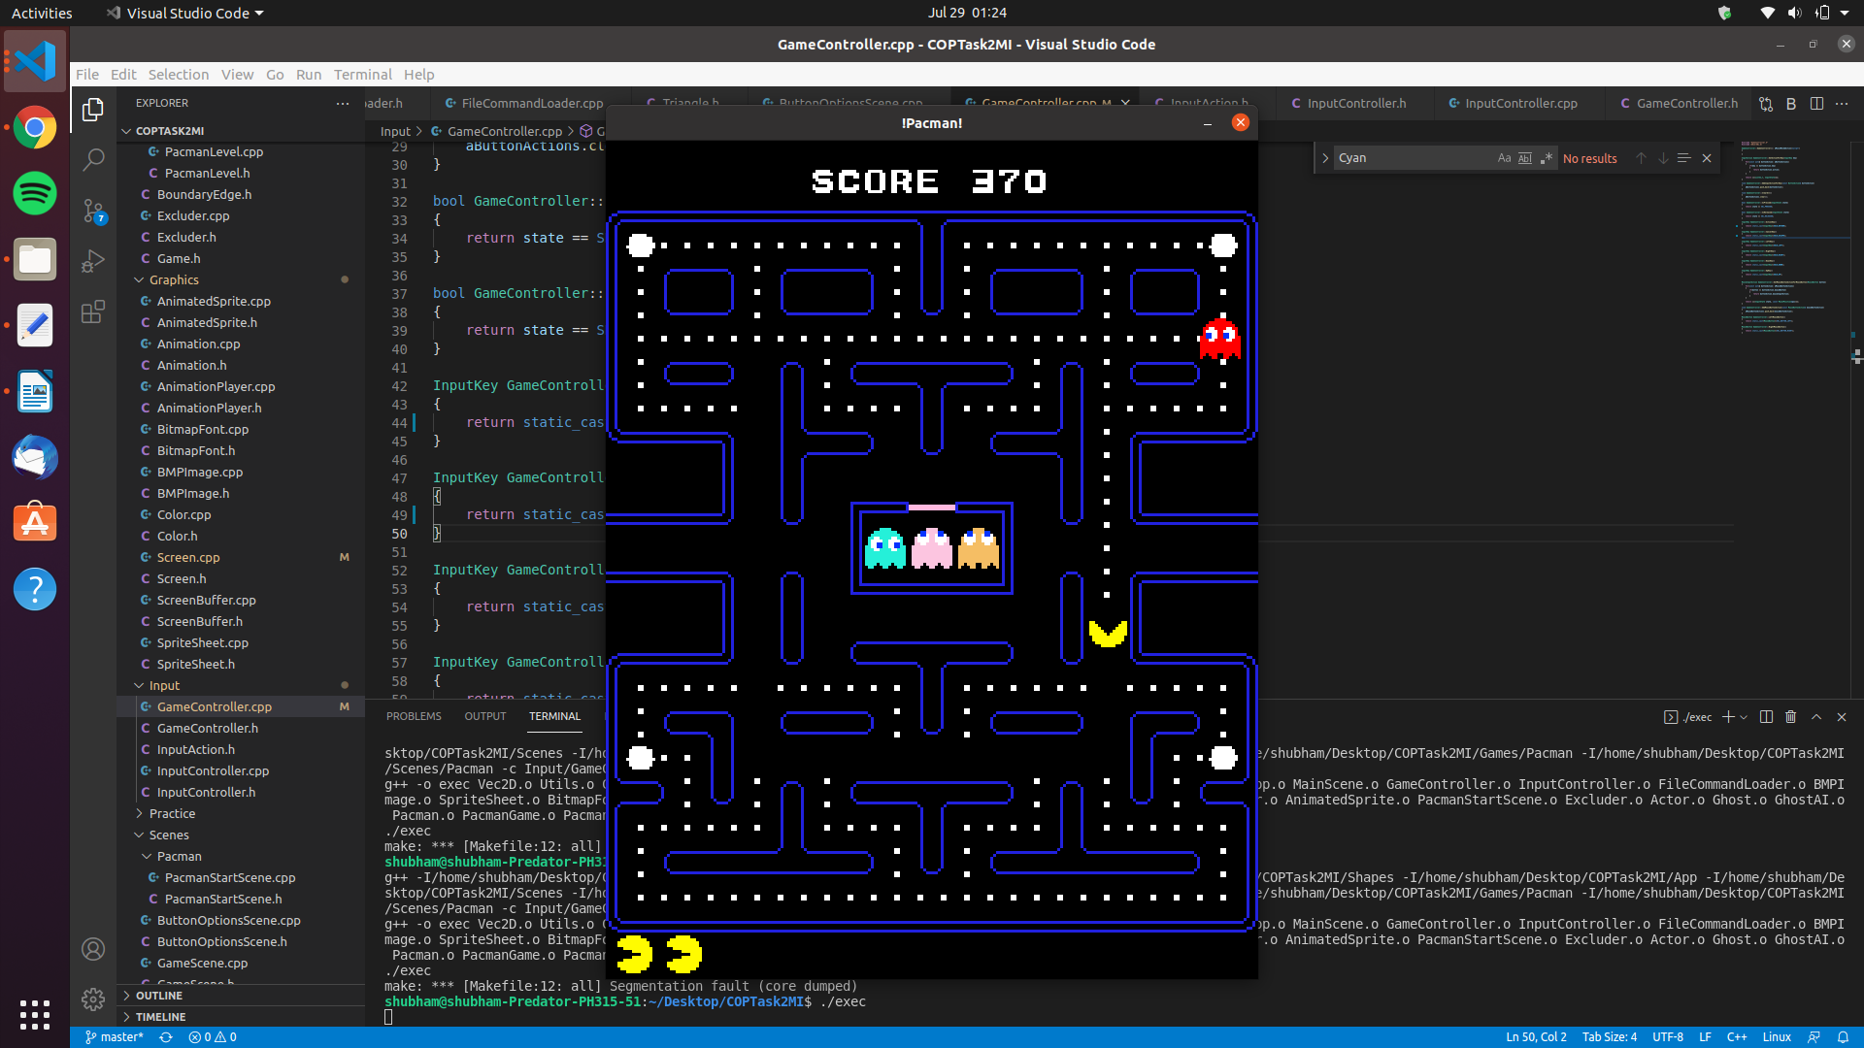
IMAGE: Pacman moving

Some details about the score are:
- Score is calculated in the following manner;
1. Eating one normal sized pellet results in increment of 10 points in the total score.
2. Eating GHOST results in increment of 200 points. The ghost will only be eaten if the ghost is in vulnerable state. With each ghost eaten, the MULTIPLIER doubles, hence eating the next ghost will result in 400 points, then next 800 points.

Some properties of PACMAN are:
- It eats pellets if it’s bounding box intersects with the pellet bounding box.
- Can move in four directions, i.e, (up, down, left, right) by player input
- The pacman is animated.
- The pacman can be eaten by a ghost, leading to loss of a life. If all the lives are over, GAME OVER text will be displayed.
- Total of 3 lives

Ghosts: There are a total of 4 ghosts in the game. There names are: Blinky, Pinky, Inky and Clyde.
- If the ghost is not in vulnerable state, it can eat PACMAN.

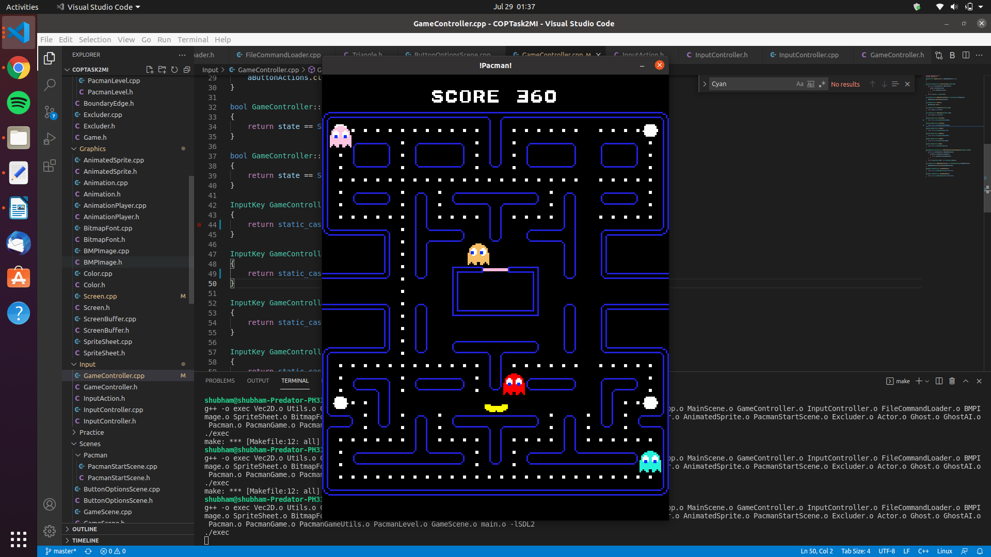
IMAGE: Pacman Dying

- Moves in 4 directions (up, down, left, right)
- Ghosts are also animated
- It can be in different states (Alive, Vulnerable, Vulnerable ending, dead)
-Has specific spot on the level that it starts at(spawn location)
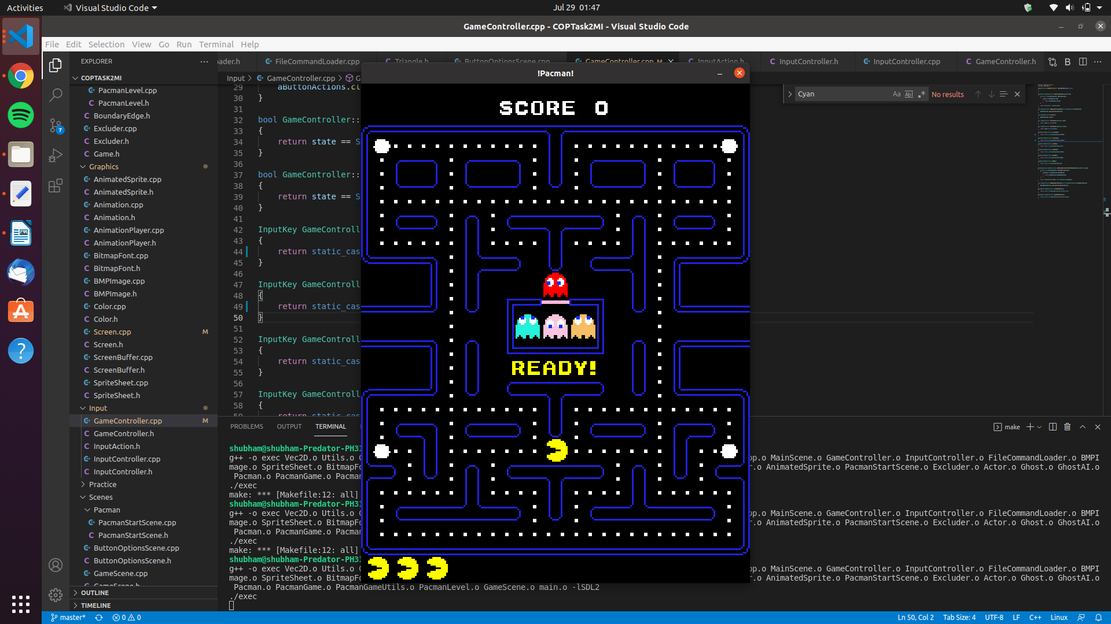
IMAGE: Spawn locations of Ghosts and Pacman

- If eaten, results in a score for PACAM(scoring criteria defined above).
AI in ghosts:
Chase mode: Each ghost has a specific personality:
- Blinky: Chase
- Pinky: Cut off/Ambush
- Inky: Pinser attack with Blinky
- Clyde: Wanders
Scatter mode: All of them go in any direction. When pacman eats a power pellet, ghosts state becomes vulnerable and they starts scattering(scatter mode) with half the original speed.

Levels:
- Contains all the walls(maze)
- Contains pellets
- Wraps Pacman/Ghosts at a specific location
- gate releases the ghosts, each after 5 seconds

There are also some teleport tiles in the image, with which when collided, the pacman comes in from another tile location.

Pellets:
- Super pellet: turns ghost to vulnerable state if PACMAN eats it (bigger in size than the normal pellets). Total count 4
- Has a specific score value

Special items: In between the game, different items appear with different score values.
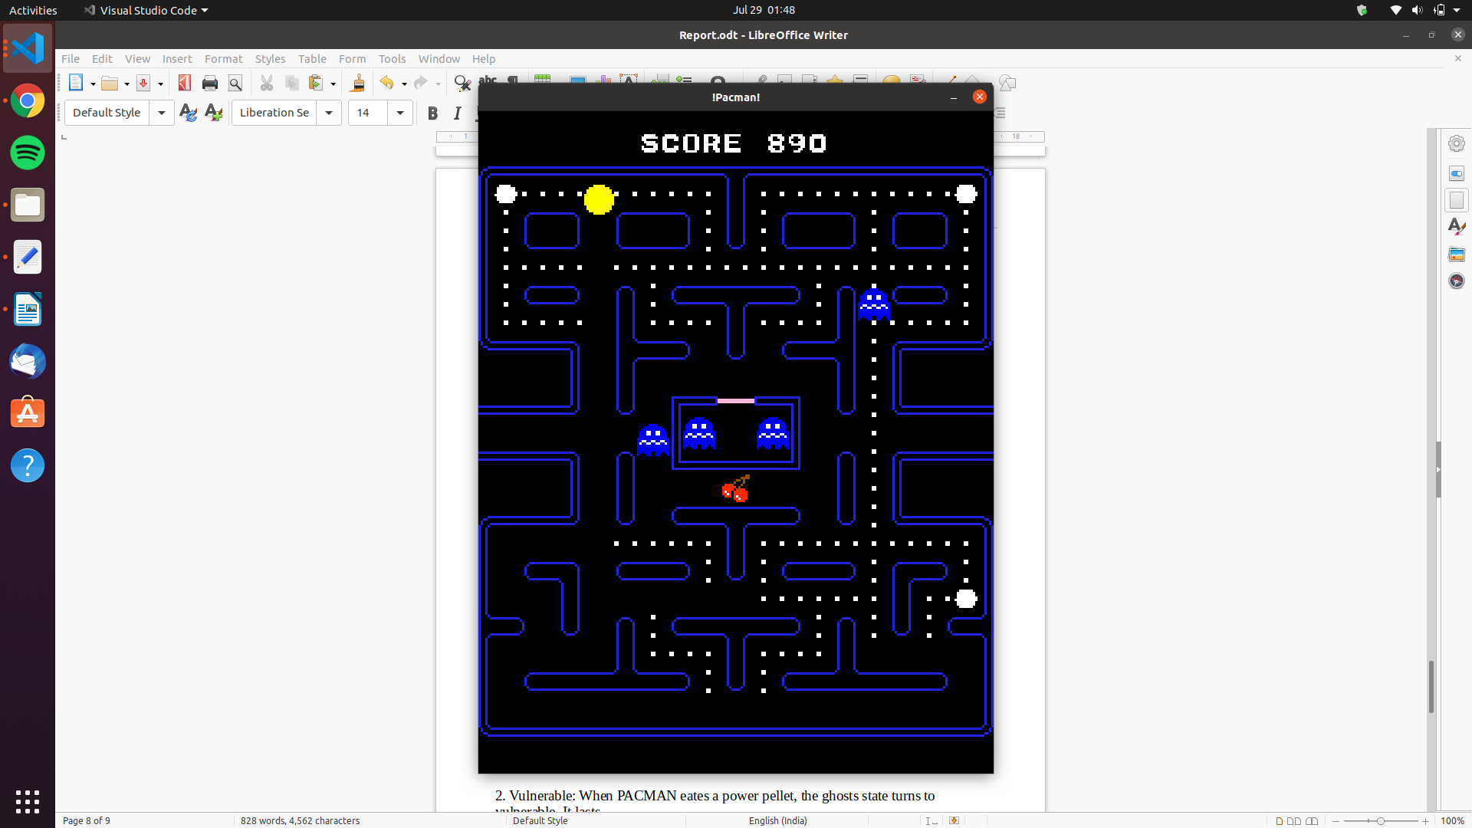
IMAGE: One of the special items(the berries)

- Different states of the game
- Level starting
- Play game
- Lost life
- Game over

Ghost states:
There are 4 different states of the ghosts
1. Alive: Normal coloured
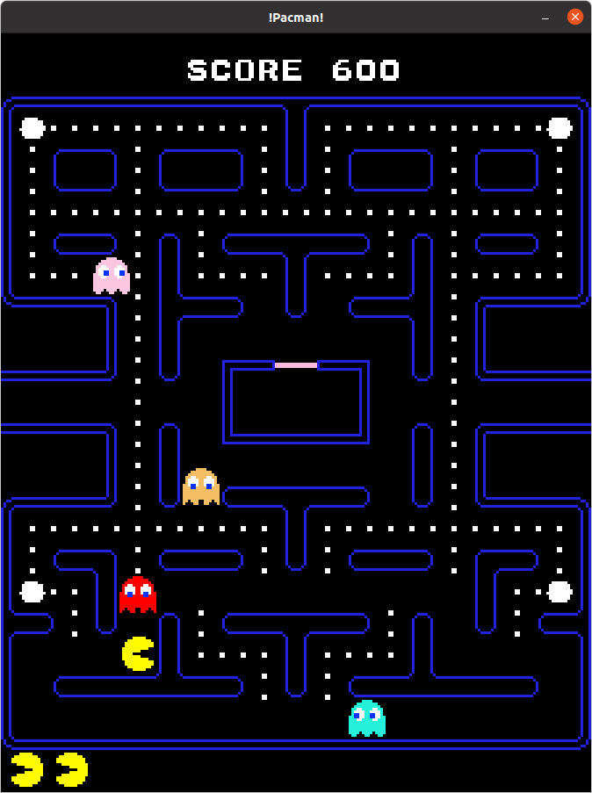

IMAGE: Alive State of Ghosts

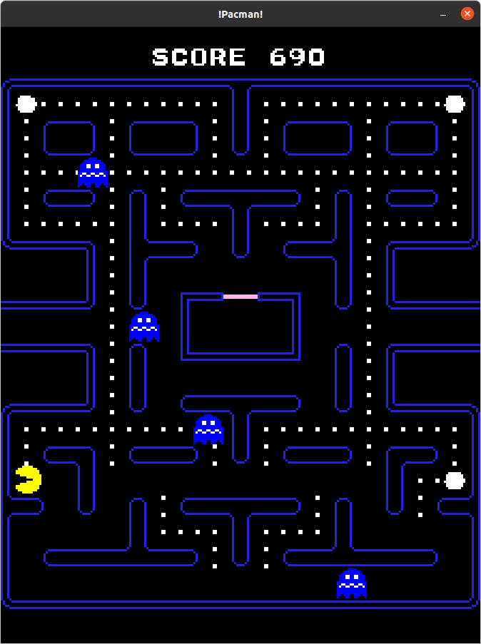

2. Vulnerable: When PACMAN eates a power pellet, the ghosts
state turns to vulnerable. It’s speed becomes 25 pixels per seconds. It lasts 6 seconds(VULNERABILITY_TIME)

IMAGE: Vulnerable
state of Ghosts

3. Vulnerable ending: If in this state, the ghosts blink blue and white for 4 seconds, they can still be eaten by the pacman and have same speed of 25 pixels per second.

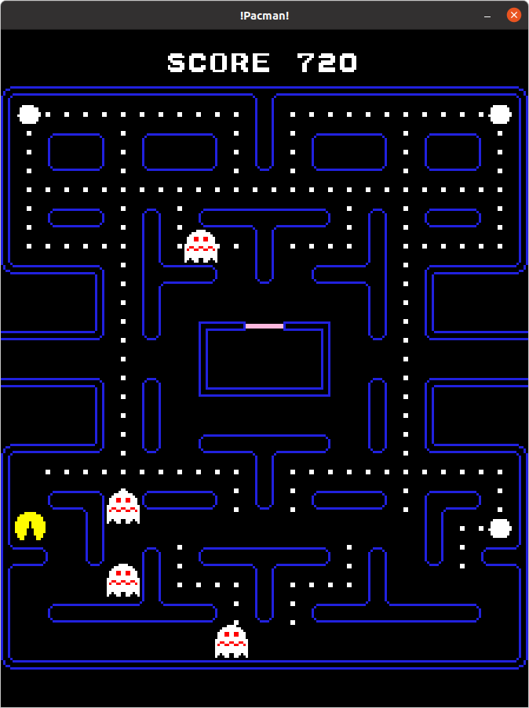

IMAGE: Vulnerable ending state of ghosts

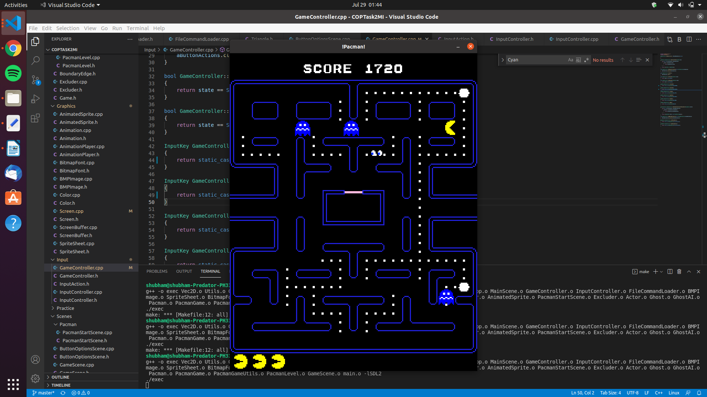
4. Dead: When eaten by a ghost, the state of ghost turns DEAD, it looks like the image shown below. And it goes back to the original spawn location with speed 100 pixels per second.

After the loss of each life, the level will reset with the pacman and ghosts at their original spawn location.

When all the lives are over, following screen will appear with GAME OVER text

