**INITIAL PREREQUISITES**

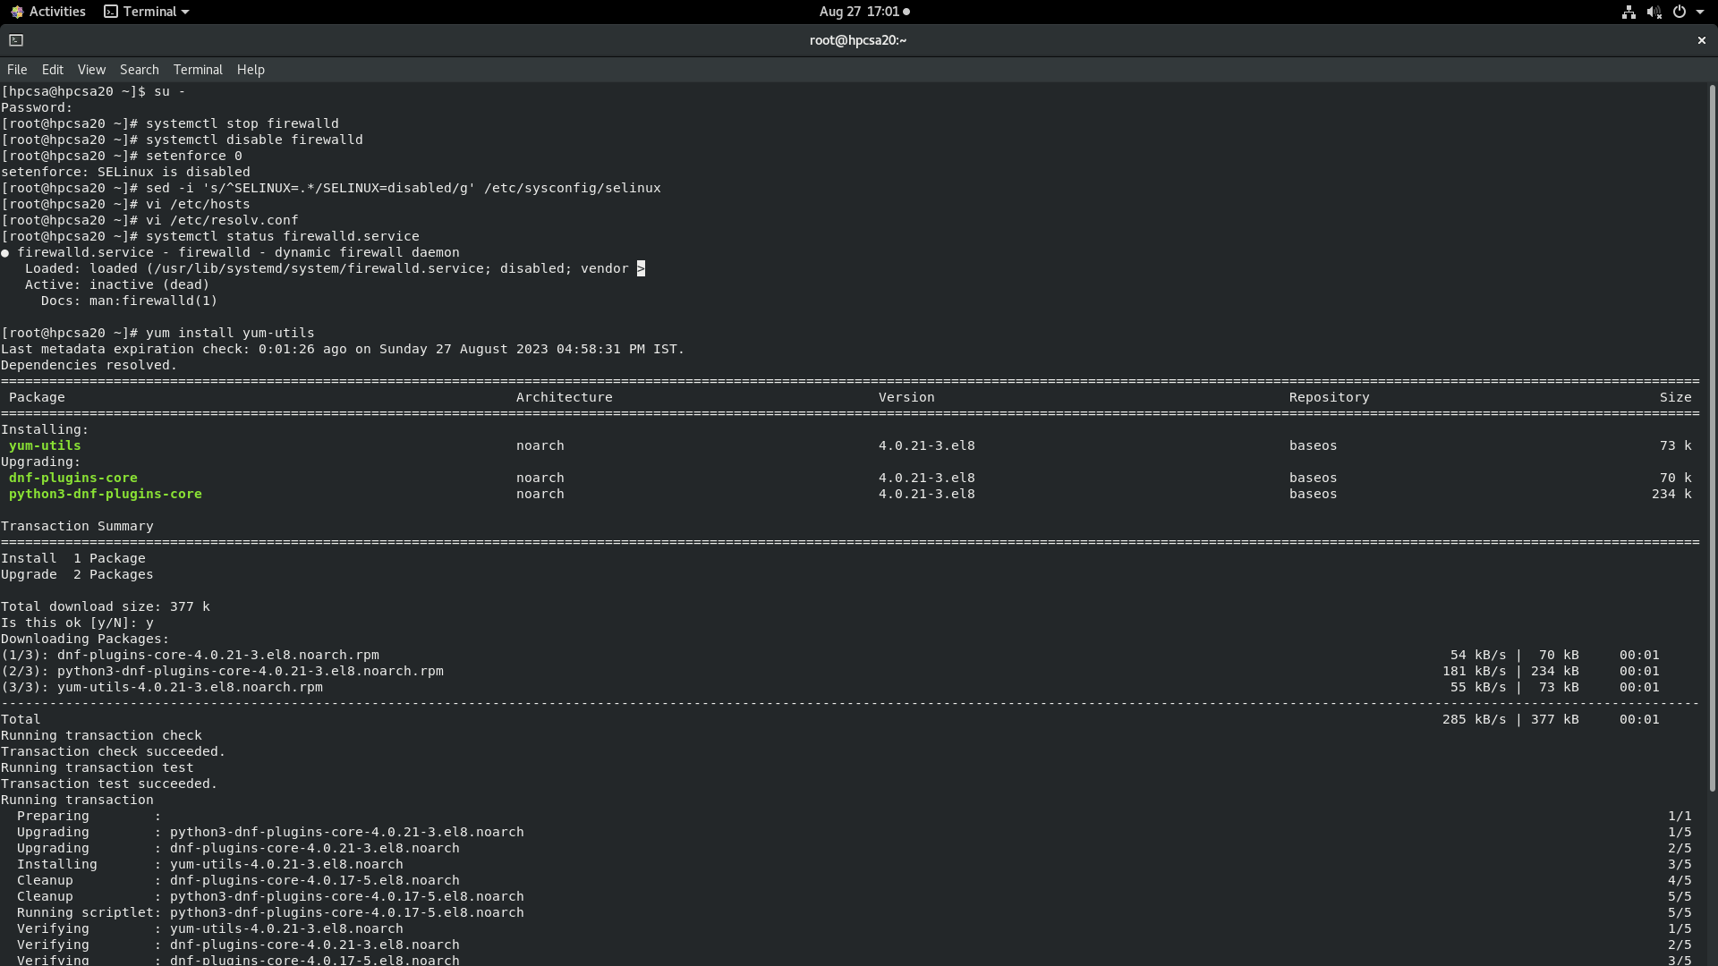

**XCAT DOWNLOAD**

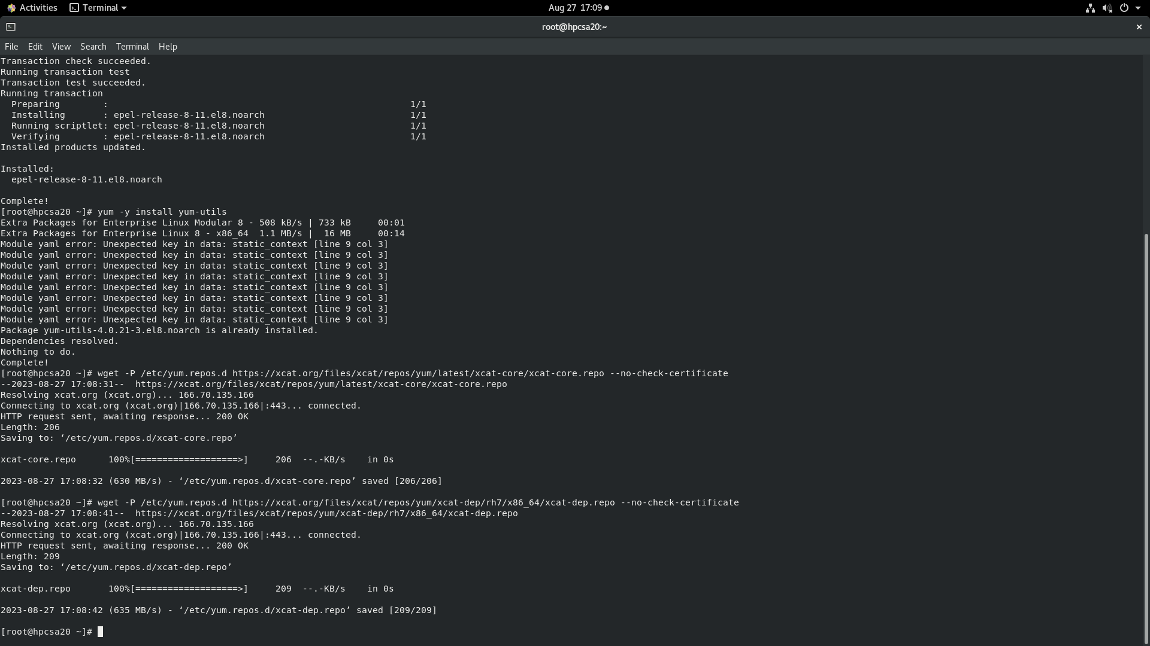

**XCAT INSTALLATION**

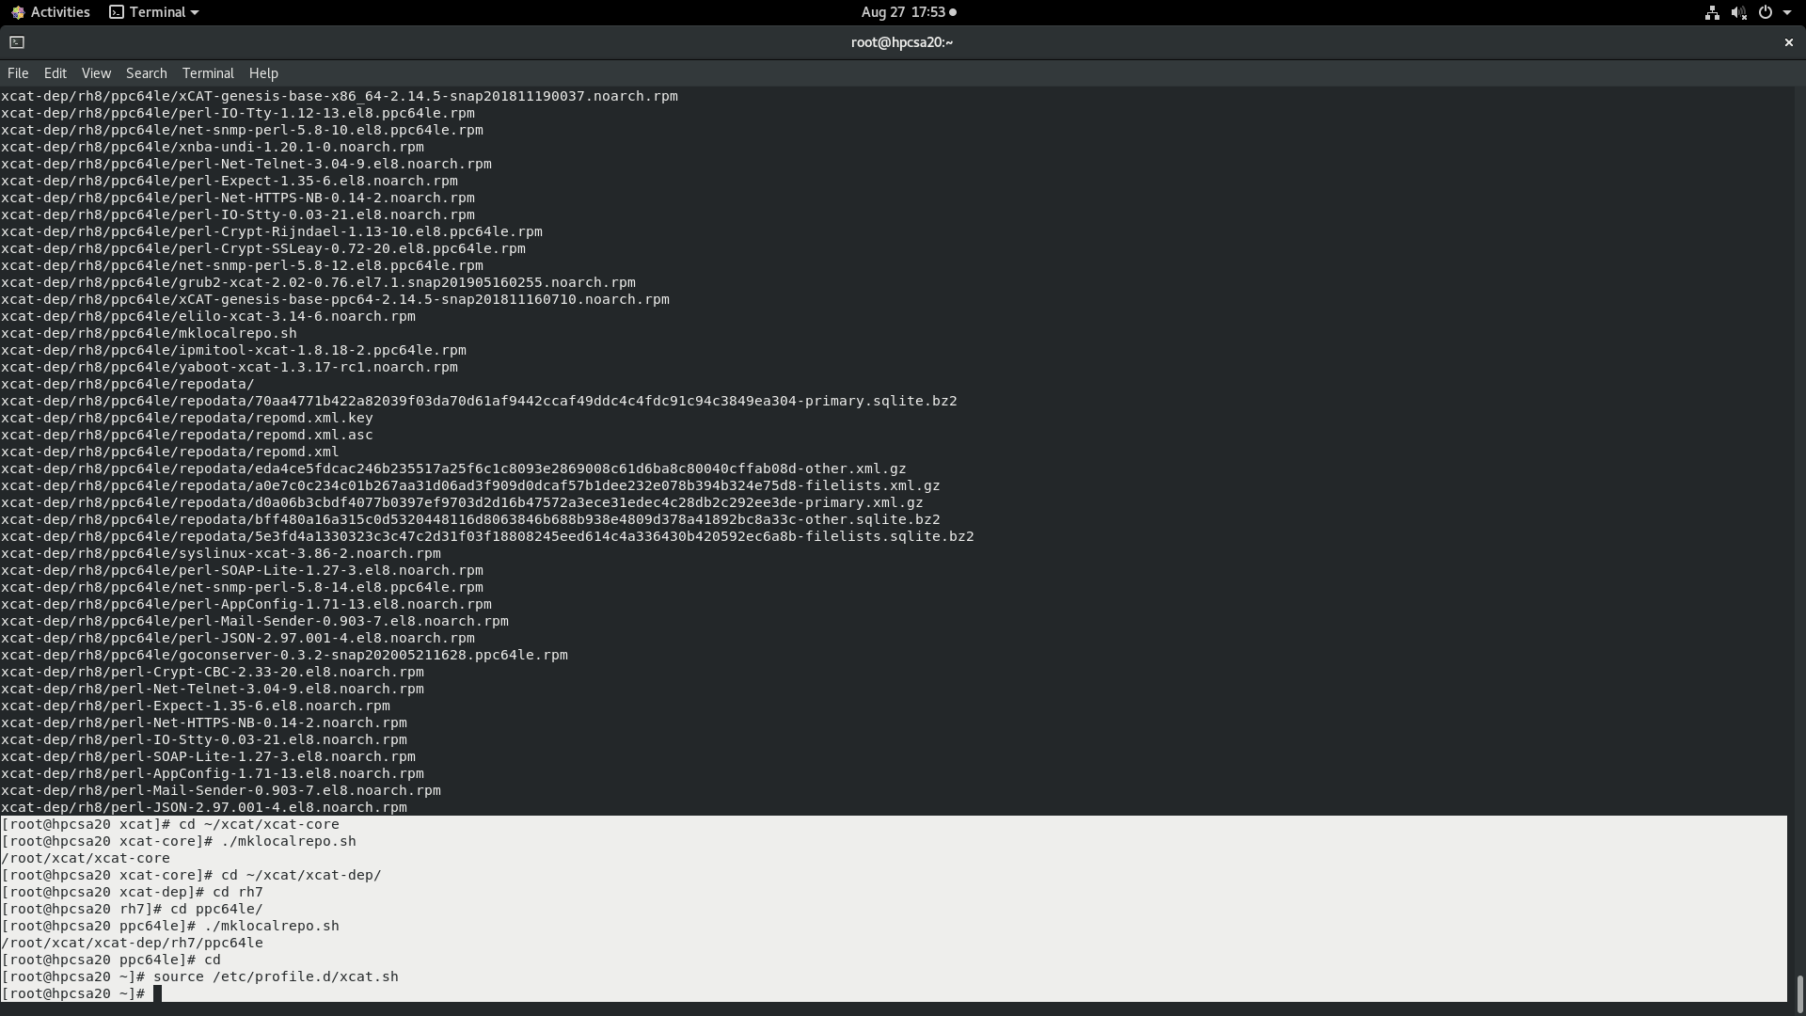

**XCAT CONFIGURATION (1)**

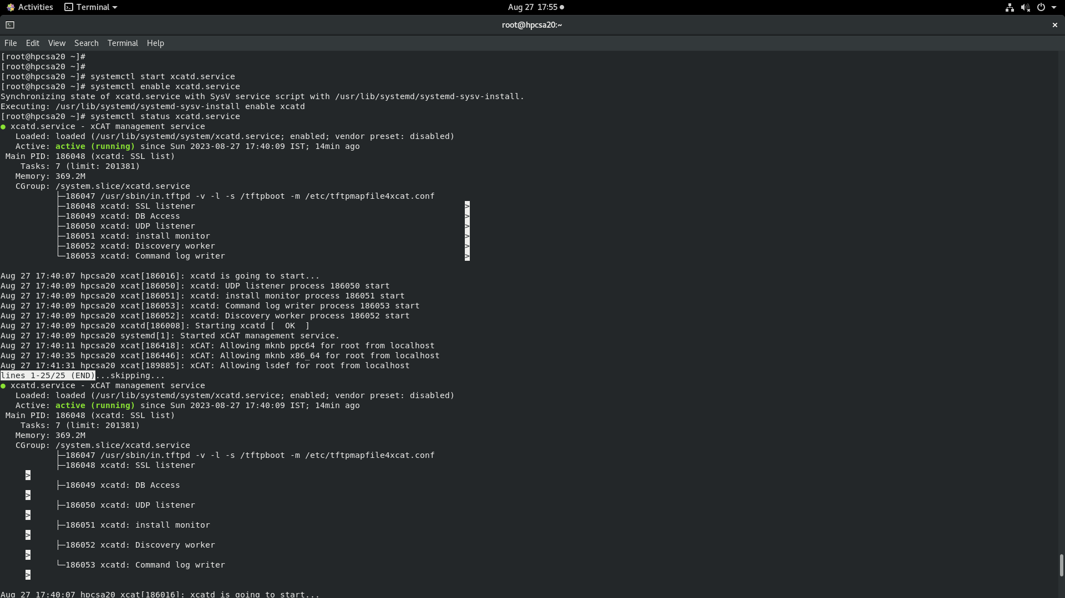

**XCAT CONFIGURATION (2)**

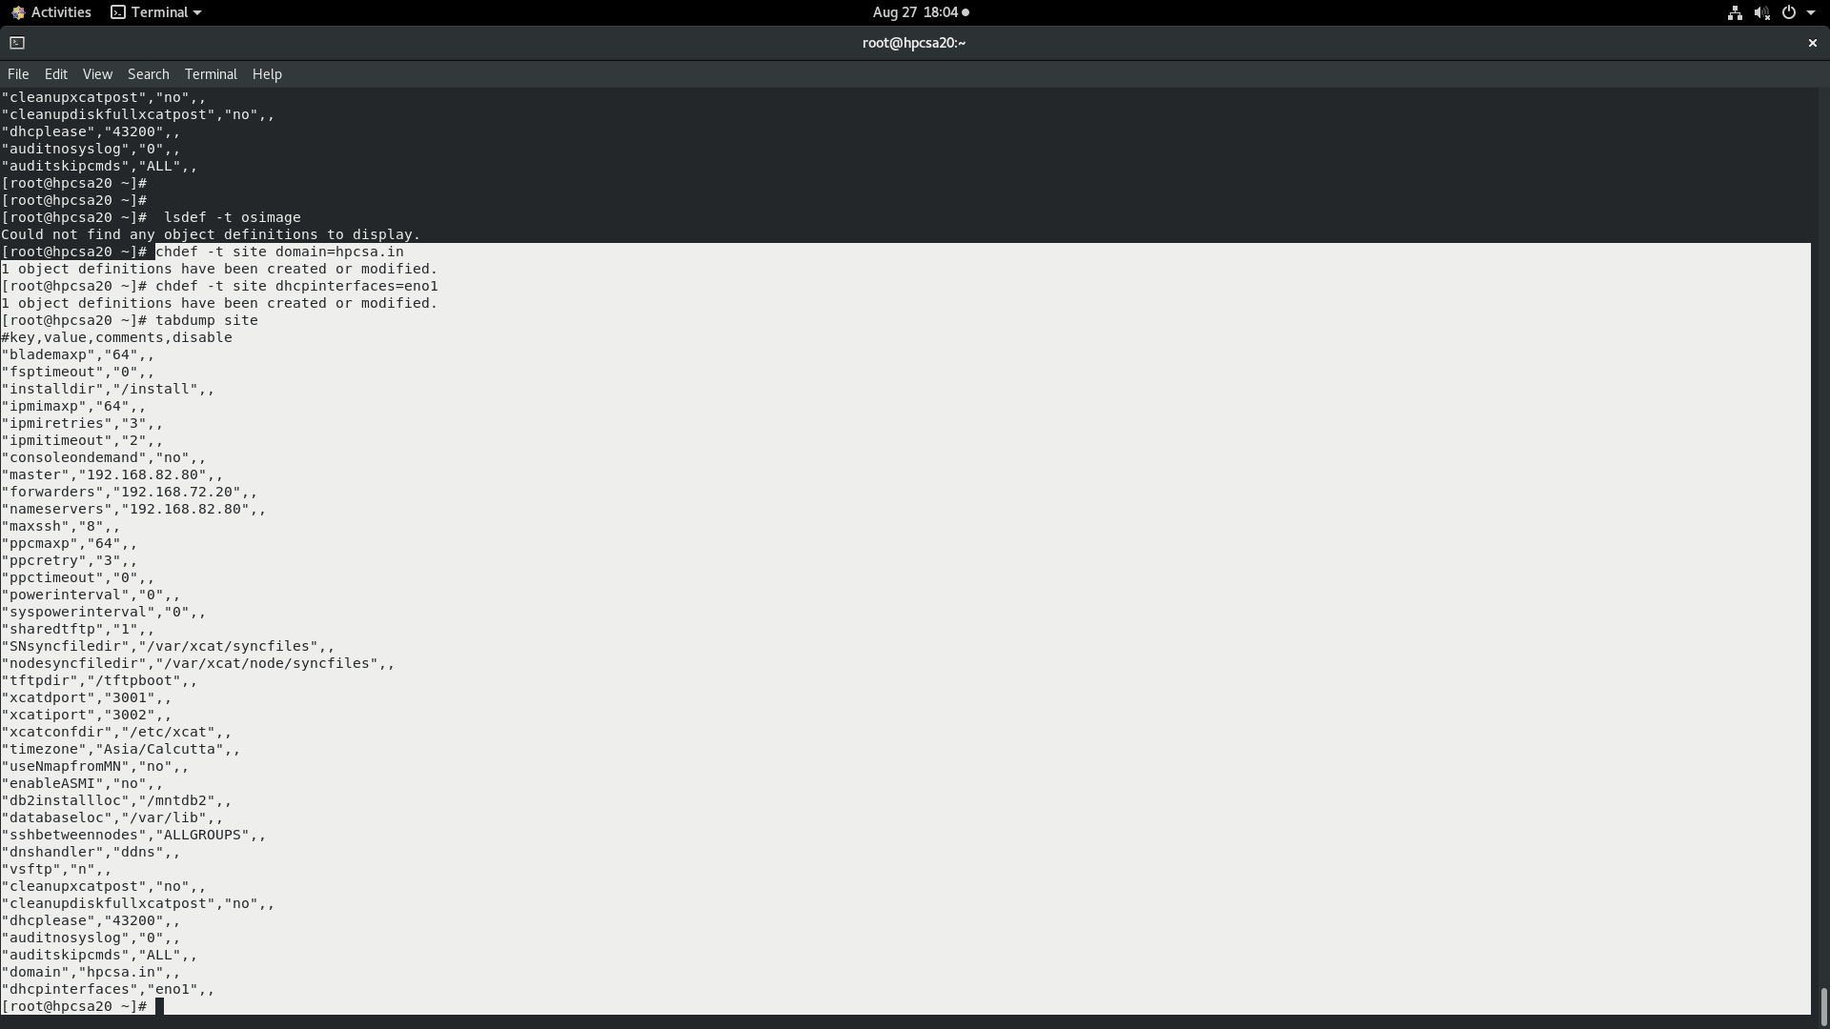

**XCAT CONFIGURATION (3)**

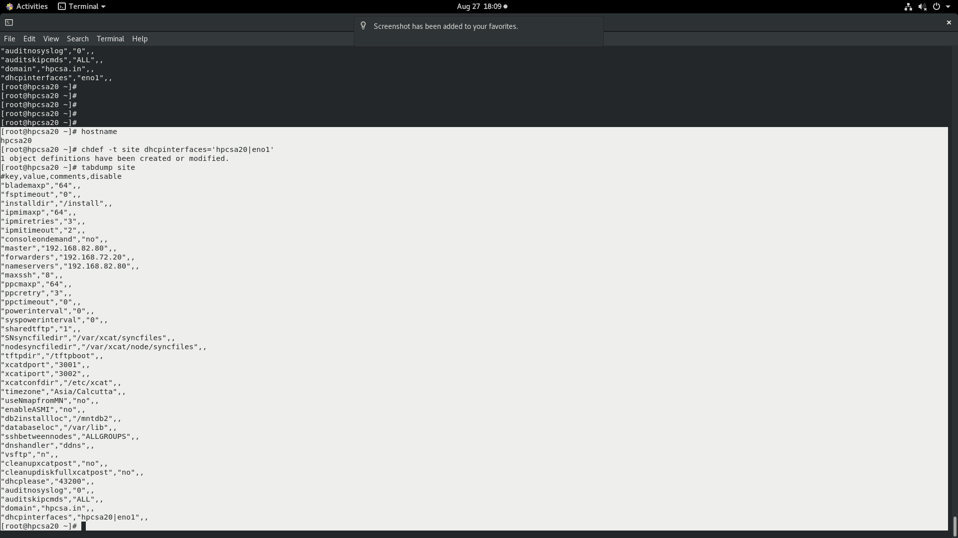

**XCAT CONFIGURATION (4)**

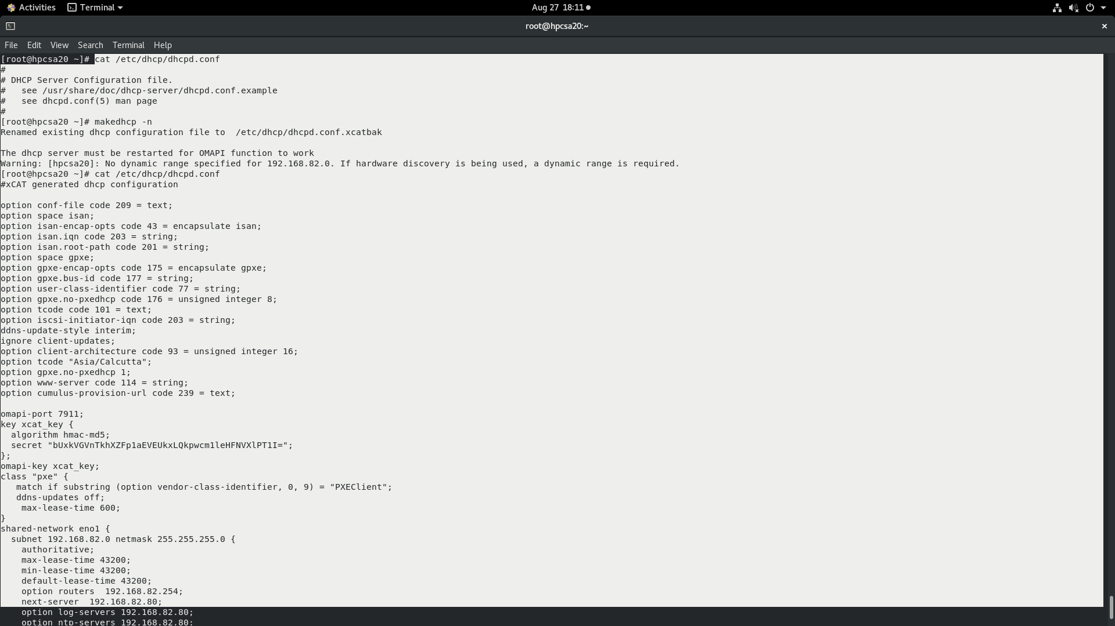

**XCAT CONFIGURATION (5)**

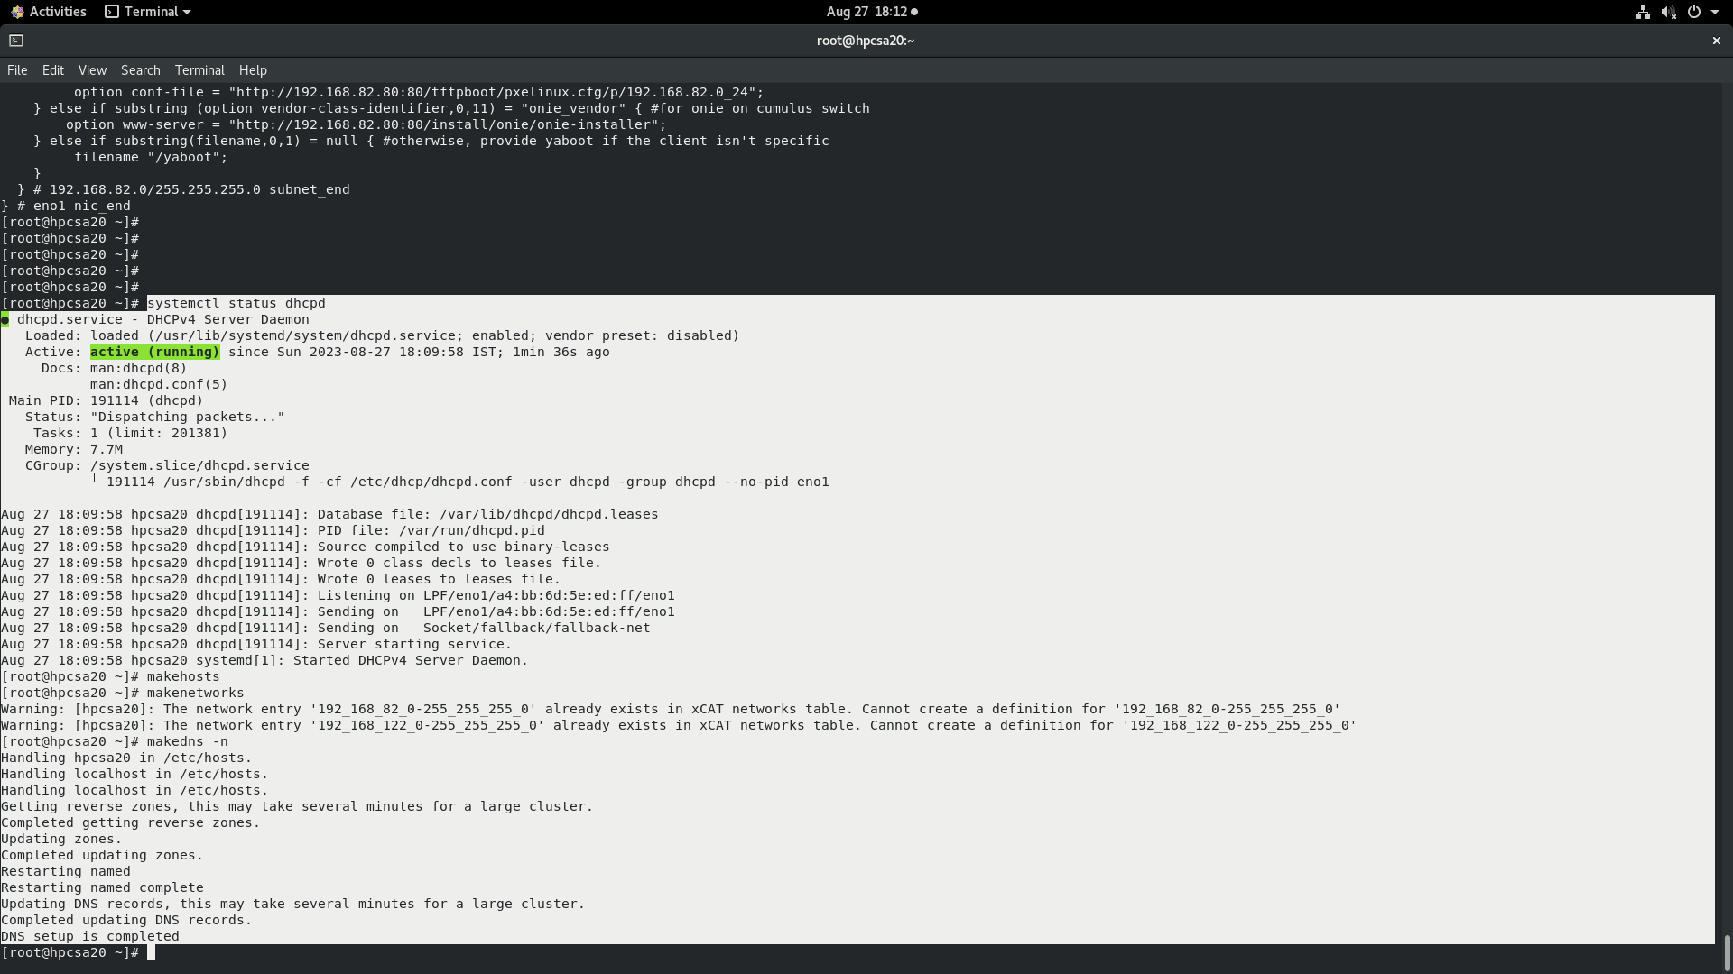

**XCAT DIAGNOSIS**

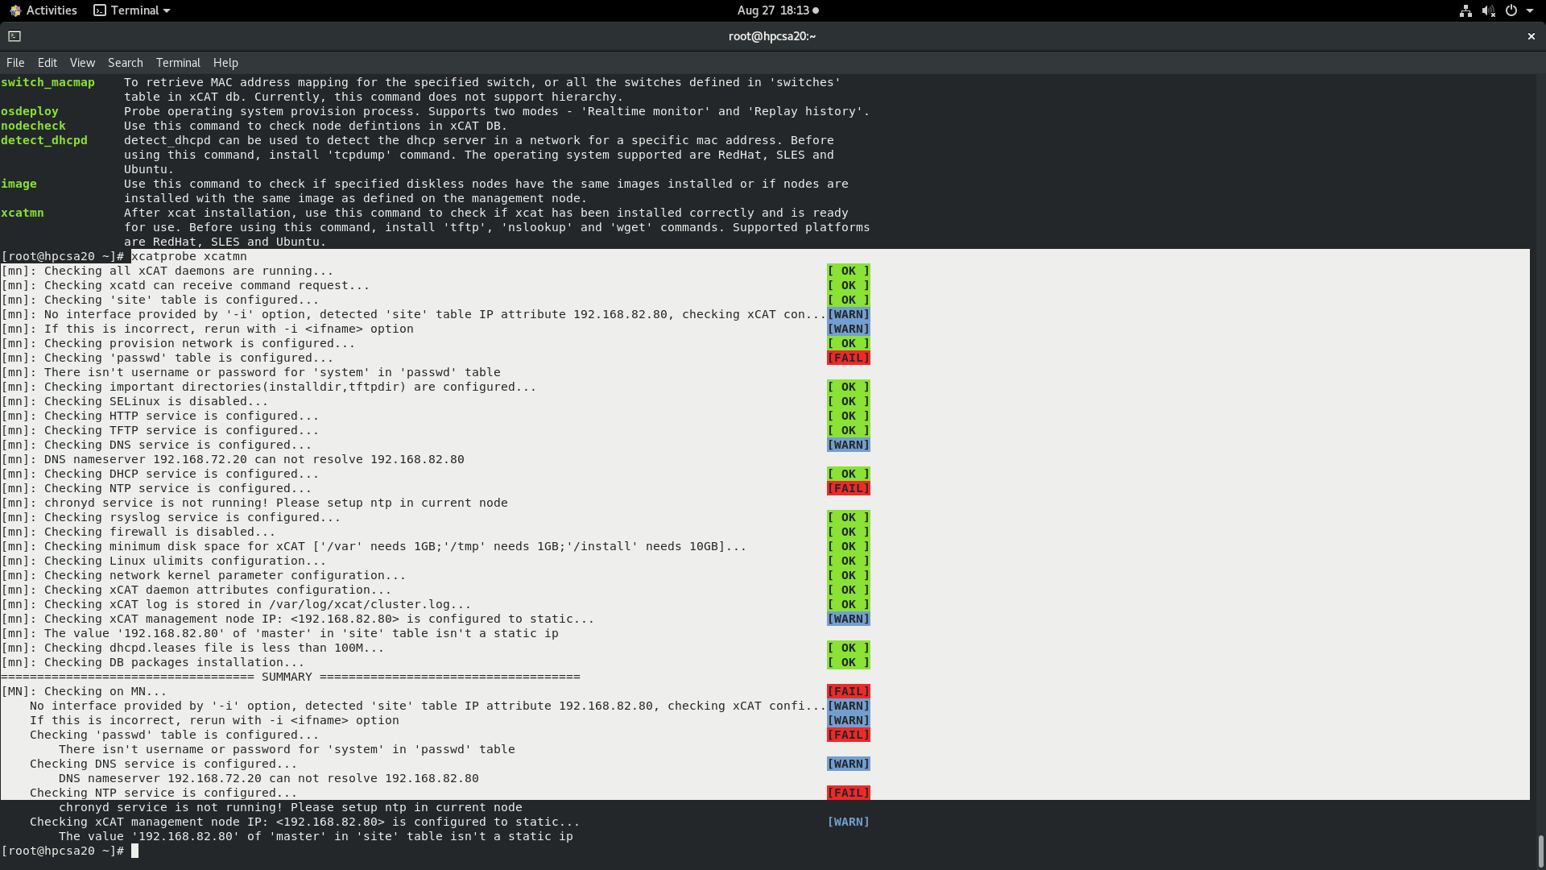

**XCAT CONFIGURATION (6)**

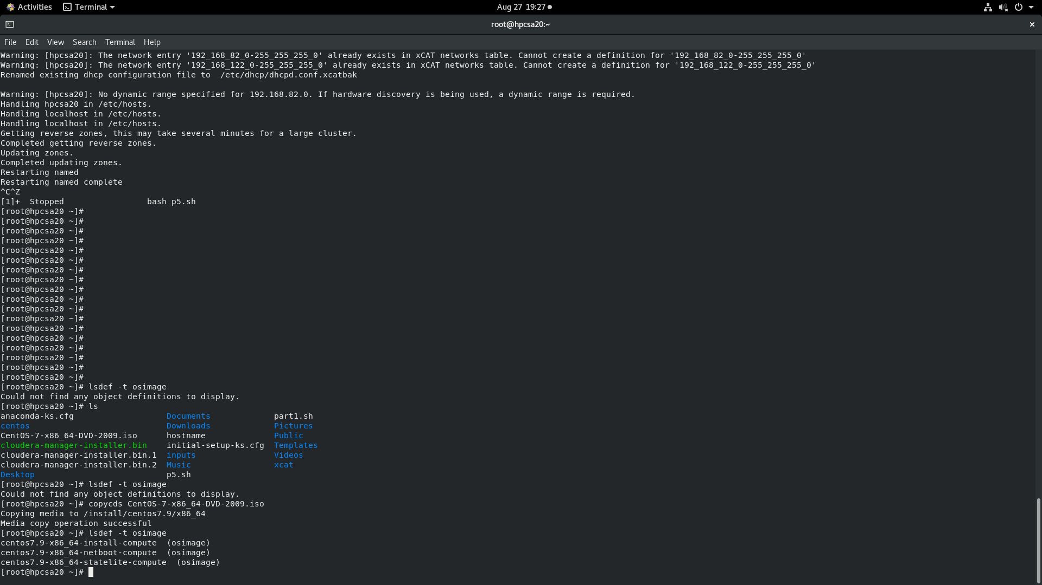

**MAKING THE NODE DEFINAMTION ENTRY IN MASTER**

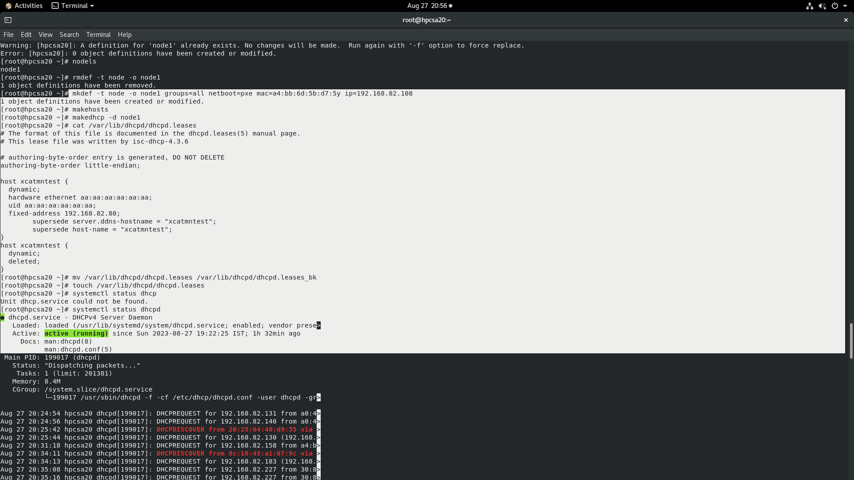

**OS IMAGE GENERATION FOR NETWORK DEPLOYMENT**

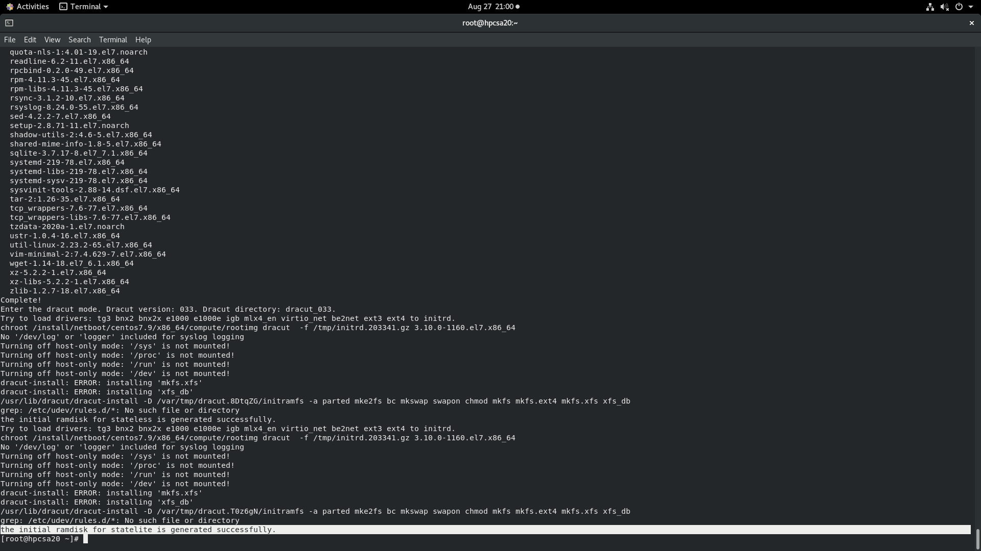

**DEFINATION OF NODE IN MASTER**

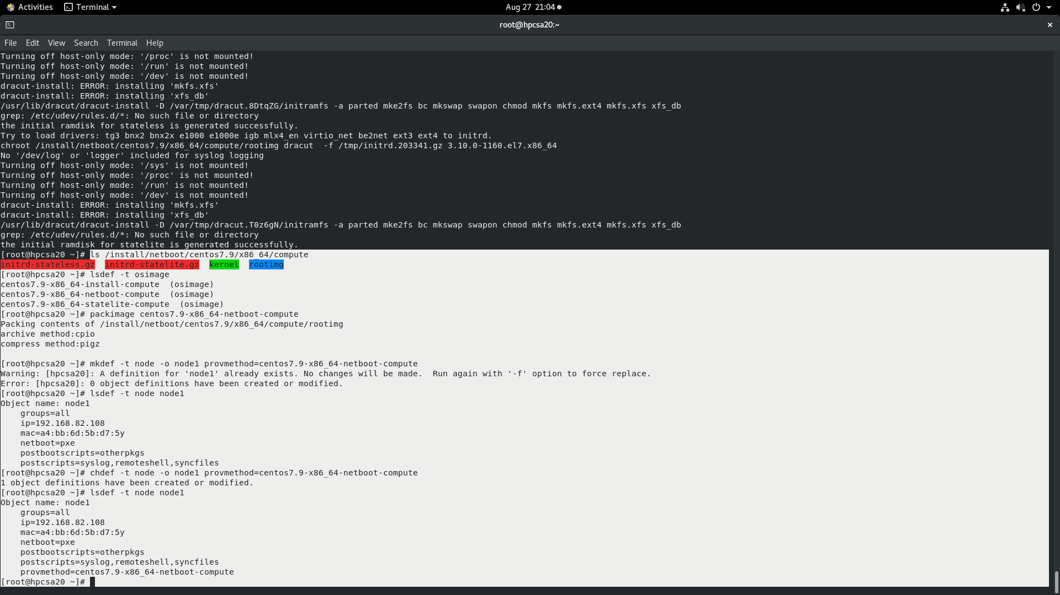

**OS DEPLOYMENT OVER THE NETWORK**

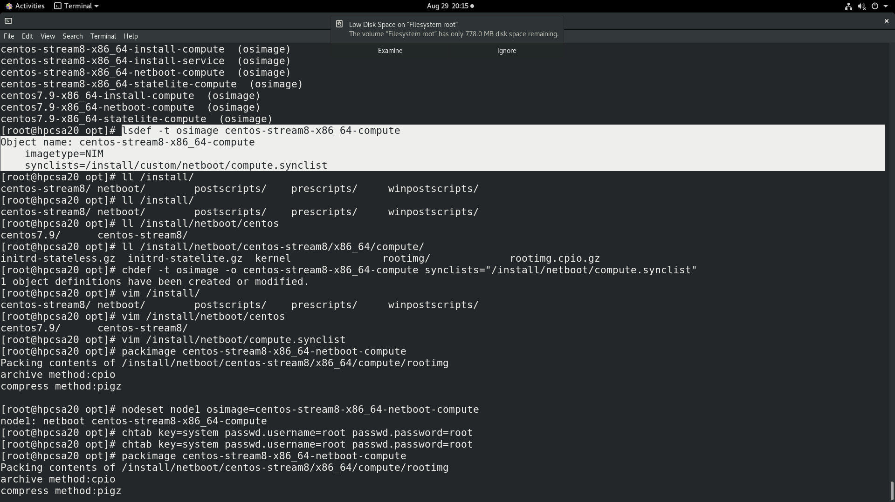

**SYNCRONIZING THE USER CONFIGURATIONS WITH THE NODE DEFINATION FOR EASY ACCESS TO THE NODE**

