Module 3 – Git & Jenkins Assignment 2

1. Project Creation – Maven Web Application
- CREATE MAVEN WEB APPLICATION
mvn archetype:generate -DgroupId=com.sanders -DartifactId=SandersWebApp -DarchetypeArtifactId=maven-archetype-webapp -DinteractiveMode=false
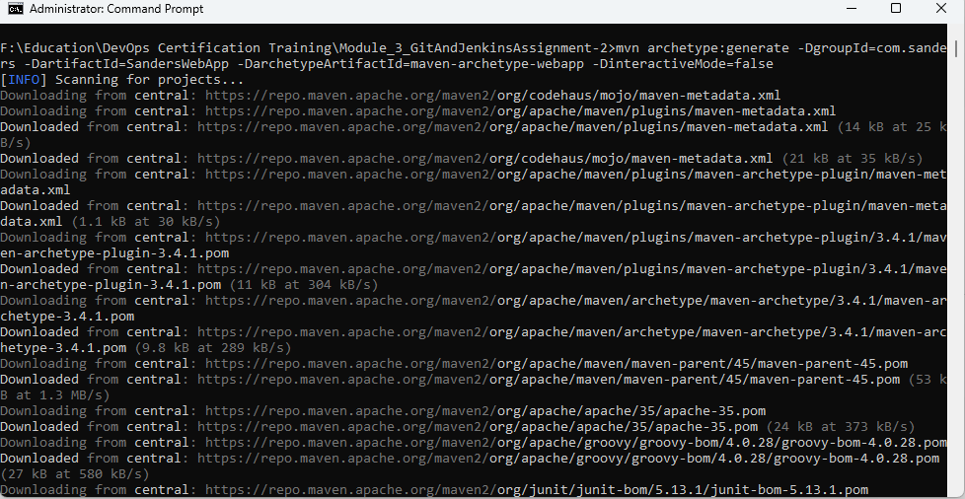
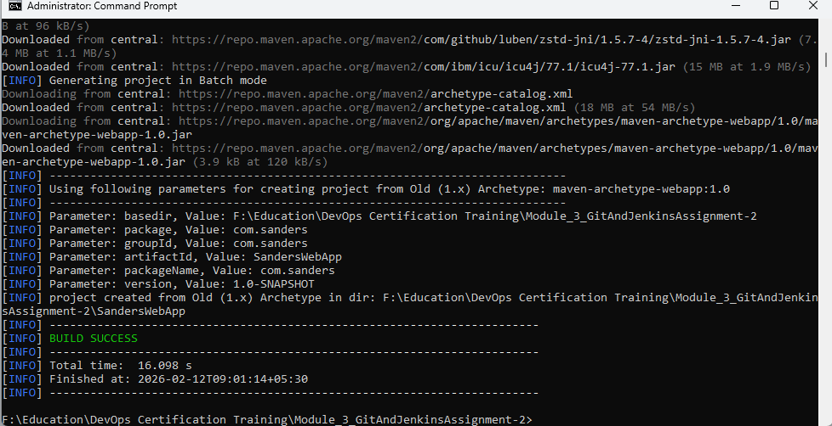

2. Git Repository Setup
- Initialize Local Repository
git init
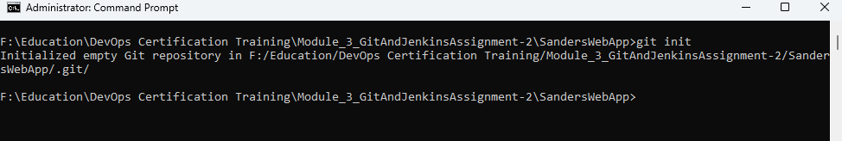

- Add Remote Repository
git remote add origin https://github.com/chaudharytamar/Module_3_GitAndJenkins_Assignment-2.git
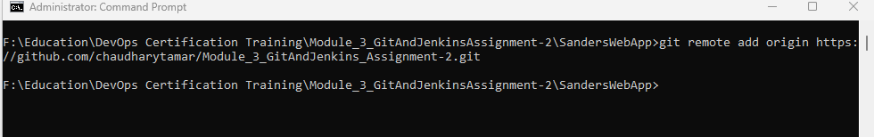

- Add Files
git add .

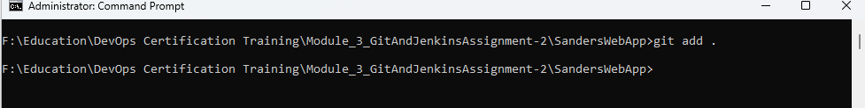

- Commit
git commit -m "Initial commit"
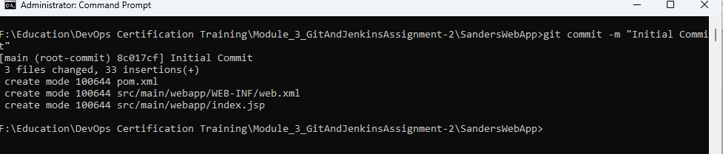

- Push to GitHub
git push origin main
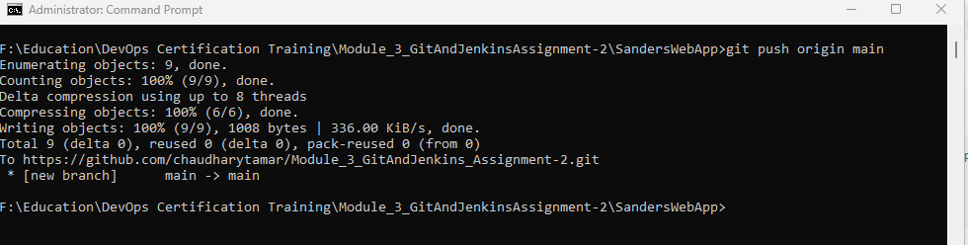

3. Jenkins Jobs Configuration

Job 1 – Compile_Job
- CREATE JENKINS JOBS
JOB 1: Compile
Step 1: Open Jenkins
Open browser:
http://localhost:7070
Login with your Jenkins credentials.
Step 2: Create New Item
- Click “New Item”
- Enter project name: Compile_Job
- Select Freestyle Project
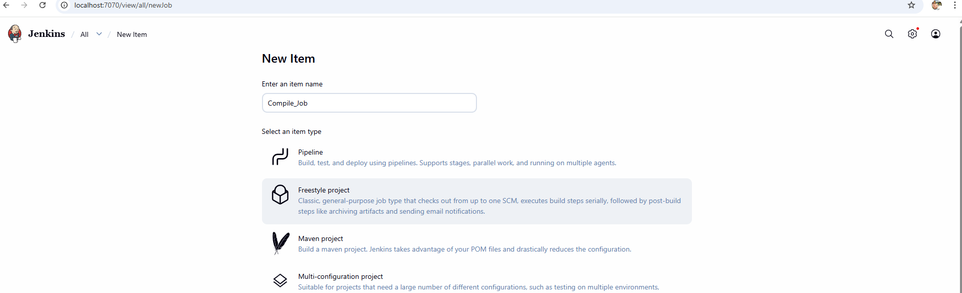
- Click OK

Step 3: Configure Source Code Management (Git)
Scroll to Source Code Management

Select:
Git

Enter:
- Repository URL
- https://github.com/chaudharytamar/Module_3_GitAndJenkins_Assignment-2.git

Branch:
*/main

Step 4: Add Build Step
Scroll to Build
Click:
Add build step → Invoke top-level Maven targets

Maven Version:
Select installed Maven

Goals:
clean compile

Step 5: Save Project
Click Save
Step 8: Build the Project
Click:
Build Now

- Code Review (Using Checkstyle)
Test Locally
mvn clean verify

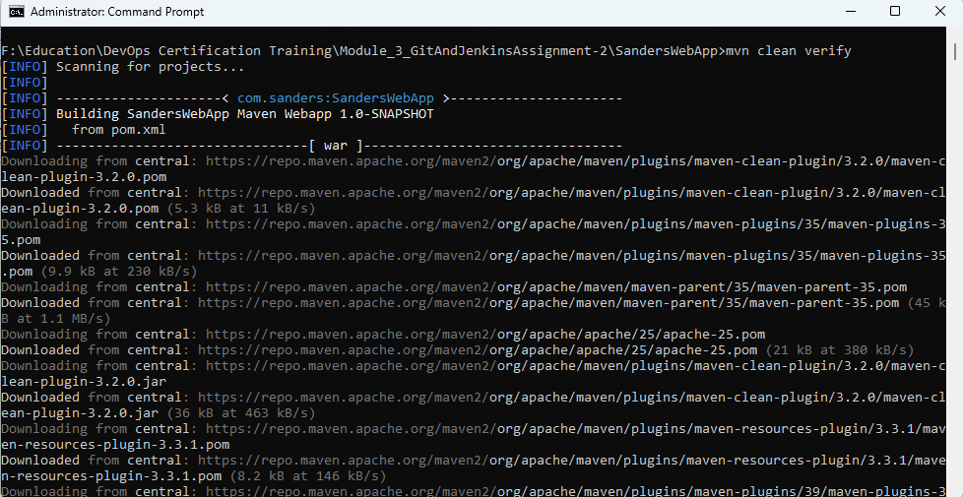

Job 2 – Code Review (Warnings NG)
- Code_Review Job
- STEP 1 — Install Warnings Next Generation Plugins
Under Build → Add: Invoke top-level Maven targets
Goals: clean verify
Code Review Pipeline Script
pipeline {
agent any

tools {
maven 'Maven3'
jdk 'JDK25'
}

stages {

stage('Checkout') {
steps {
git branch: 'main',
url: 'https://github.com/chaudharytamar/Module_3_GitAndJenkins_Assignment-2.git'
}
}

stage('Build & Static Analysis') {
steps {
bat 'mvn clean verify'
}
}

stage('Code Review - Warnings NG') {
steps {
recordIssues(
tools: [
checkStyle(pattern: '**/target/checkstyle-result.xml'),
pmdParser(pattern: '**/target/pmd.xml')
],
qualityGates: [
[threshold: 5, type: 'TOTAL', unstable: true],
[threshold: 15, type: 'TOTAL', failure: true]
],
enabledForFailure: true
)
}
}

stage('Archive WAR') {
steps {
archiveArtifacts artifacts: 'target/*.war'
}
}
}
}

- Result of Code Review

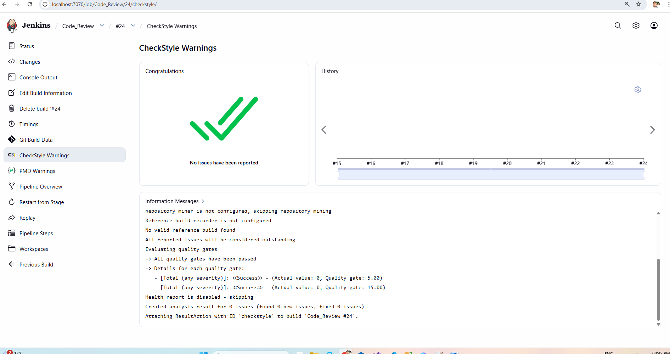

Job 3 – UnitTest_Job

- UnitTest_Job
Create Sample Test Class
F:\Education\DevOps Certification Training\Module_3_GitAndJenkinsAssignment-2\SandersWebApp\src\test\java\com\sanders

package com.sanders;
import org.junit.Test;
import static org.junit.Assert.*;
public class AppTest {

@Test
public void testAddition() {
int sum = 5 + 3;
assertEquals(8, sum);
}
}

- Commit and push to GitHub.
- Create Unit Test Job in Jenkins

Select: Freestyle Project

UnitTest_Job

Click OK.

Configure Source Code

Source Code Management

Select: Git
Enter your GitHub Repository URL: https://github.com/chaudharytamar/Module_3_GitAndJenkins_Assignment-2.git
Branch:
*/main

Configure Build Step
Scroll to Build Section
Click:
Add Build Step → Invoke top-level Maven targets
In Goals section write:
clean test

Configure Test Report Publishing

Post-build Actions
Click:
Add Post-build Action → Publish JUnit test result report
In Test Report XMLs field enter:
target/surefire-reports/*.xml

Save and Build
Click:
Save → Build Now

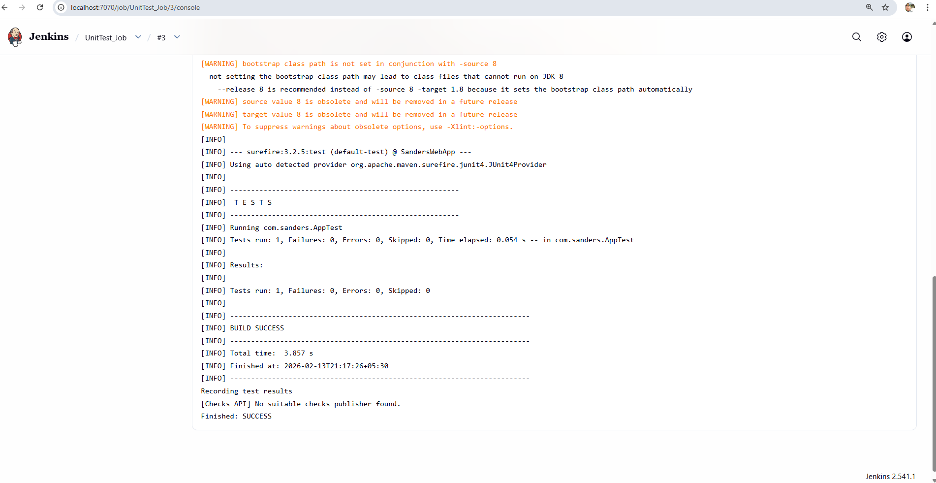

Job 4 – Package_Job

- PHASE 1:
- VERIFY MAVEN PROJECT CONFIGURATION
- Ensure Project is WAR Packaging
<packaging>war</packaging>
- Configure maven-war-plugin

<build>
<finalName>SandersWebApp</finalName>

<plugins>
<plugin>
<groupId>org.apache.maven.plugins</groupId>
<artifactId>maven-war-plugin</artifactId>
<version>3.4.0</version>
</plugin>
</plugins>
</build>

- Commit & push changes to GitHub.
- PHASE 2: CREATE JOB 4 IN JENKINS
- Create New Job
Jenkins Dashboard → New Item
Select: Freestyle Project
Name: Package_Job
Click OK.
- Configure Source Code
Source Code Management

- Select Git
- Enter Repository URL
- Add credentials (if private repo)
- Branch:

*/main
- Add Build Step
Scroll to Build Section
Click: Add Build Step → Invoke top-level Maven targets
Enter Goals: clean package
- PHASE 3: ARCHIVE WAR FILE
Scroll to: Post-build Actions
Click: Add Post-build Action → Archive the artifacts
Files to archive: target/*.war
- PHASE 4: SAVE & BUILD
Click: Save → Build Now

- Output ob Job
Started by user Manvendra Singh

Running as SYSTEM
Building in workspace C:\ProgramData\Jenkins\.jenkins\workspace\Package_Job
The recommended git tool is: NONE
No credentials specified
Cloning the remote Git repository
Cloning repository https://github.com/chaudharytamar/Module_3_GitAndJenkins_Assignment-2.git
> git.exe init C:\ProgramData\Jenkins\.jenkins\workspace\Package_Job # timeout=10
Fetching upstream changes from https://github.com/chaudharytamar/Module_3_GitAndJenkins_Assignment-2.git
> git.exe --version # timeout=10
> git --version # 'git version 2.50.1.windows.1'
> git.exe fetch --tags --force --progress -- https://github.com/chaudharytamar/Module_3_GitAndJenkins_Assignment-2.git +refs/heads/*:refs/remotes/origin/* # timeout=10
> git.exe config remote.origin.url https://github.com/chaudharytamar/Module_3_GitAndJenkins_Assignment-2.git # timeout=10
> git.exe config --add remote.origin.fetch +refs/heads/*:refs/remotes/origin/* # timeout=10
Avoid second fetch
> git.exe rev-parse "refs/remotes/origin/main^{commit}" # timeout=10
Checking out Revision a493f42814844afda2deb5292b7f9a1abab8fc58 (refs/remotes/origin/main)
> git.exe config core.sparsecheckout # timeout=10
> git.exe checkout -f a493f42814844afda2deb5292b7f9a1abab8fc58 # timeout=10
Commit message: "add maven war pulgin in pom"
First time build. Skipping changelog.
[Package_Job] $ cmd.exe /C "mvn clean package && exit %%ERRORLEVEL%%"
[INFO] Scanning for projects...
[INFO]
[INFO] ---------------------< com.sanders:SandersWebApp >----------------------
[INFO] Building SandersWebApp Maven Webapp 1.0-SNAPSHOT
[INFO] from pom.xml
[INFO] --------------------------------[ war ]---------------------------------
[INFO]
[INFO] --- clean:3.2.0:clean (default-clean) @ SandersWebApp ---
[INFO] Deleting C:\ProgramData\Jenkins\.jenkins\workspace\Package_Job\target
[INFO]
[INFO] --- resources:3.3.1:resources (default-resources) @ SandersWebApp ---
[WARNING] Using platform encoding (UTF-8 actually) to copy filtered resources, i.e. build is platform dependent!
[INFO] skip non existing resourceDirectory C:\ProgramData\Jenkins\.jenkins\workspace\Package_Job\src\main\resources
[INFO]
[INFO] --- compiler:3.13.0:compile (default-compile) @ SandersWebApp ---
[INFO] No sources to compile
[INFO]
[INFO] --- resources:3.3.1:testResources (default-testResources) @ SandersWebApp ---
[WARNING] Using platform encoding (UTF-8 actually) to copy filtered resources, i.e. build is platform dependent!
[INFO] skip non existing resourceDirectory C:\ProgramData\Jenkins\.jenkins\workspace\Package_Job\src\test\resources
[INFO]
[INFO] --- compiler:3.13.0:testCompile (default-testCompile) @ SandersWebApp ---
[INFO] Recompiling the module because of changed source code.
[WARNING] File encoding has not been set, using platform encoding UTF-8, i.e. build is platform dependent!
[INFO] Compiling 1 source file with javac [debug target 1.8] to target\test-classes
[WARNING] bootstrap class path is not set in conjunction with -source 8
not setting the bootstrap class path may lead to class files that cannot run on JDK 8
--release 8 is recommended instead of -source 8 -target 1.8 because it sets the bootstrap class path automatically
[WARNING] source value 8 is obsolete and will be removed in a future release
[WARNING] target value 8 is obsolete and will be removed in a future release
[WARNING] To suppress warnings about obsolete options, use -Xlint:-options.
[INFO]
[INFO] --- surefire:3.2.5:test (default-test) @ SandersWebApp ---
[INFO] Using auto detected provider org.apache.maven.surefire.junit4.JUnit4Provider
[INFO]
[INFO] -------------------------------------------------------
[INFO] T E S T S
[INFO] -------------------------------------------------------
[INFO] Running com.sanders.AppTest
[INFO] Tests run: 1, Failures: 0, Errors: 0, Skipped: 0, Time elapsed: 0.050 s -- in com.sanders.AppTest
[INFO]
[INFO] Results:
[INFO]
[INFO] Tests run: 1, Failures: 0, Errors: 0, Skipped: 0
[INFO]
[INFO]
[INFO] --- war:3.4.0:war (default-war) @ SandersWebApp ---
[INFO] Packaging webapp
[INFO] Assembling webapp [SandersWebApp] in [C:\ProgramData\Jenkins\.jenkins\workspace\Package_Job\target\SandersWebApp]
[INFO] Processing war project
[INFO] Copying webapp resources [C:\ProgramData\Jenkins\.jenkins\workspace\Package_Job\src\main\webapp]
[INFO] Building war: C:\ProgramData\Jenkins\.jenkins\workspace\Package_Job\target\SandersWebApp.war
[INFO] ------------------------------------------------------------------------
[INFO] BUILD SUCCESS
[INFO] ------------------------------------------------------------------------
[INFO] Total time: 9.900 s
[INFO] Finished at: 2026-02-14T10:13:50+05:30
[INFO] ------------------------------------------------------------------------
Archiving artifacts
Finished: SUCCESS

- PHASE 5: VERIFY BUILD SUCCESS
Click build number → Console Output
[INFO] Building war:
C:\ProgramData\Jenkins\.jenkins\workspace\Package_Job\target\SandersWebApp.war

BUILD SUCCESS
- PHASE 6: VERIFY WAR LOCATION
On Jenkins Server: C:\ProgramData\Jenkins\.jenkins\workspace\Package_Job\target\
- PHASE 7: VERIFY ARTIFACT IN JENKINS UI
Go to: Build → Artifacts
You can download it from here.
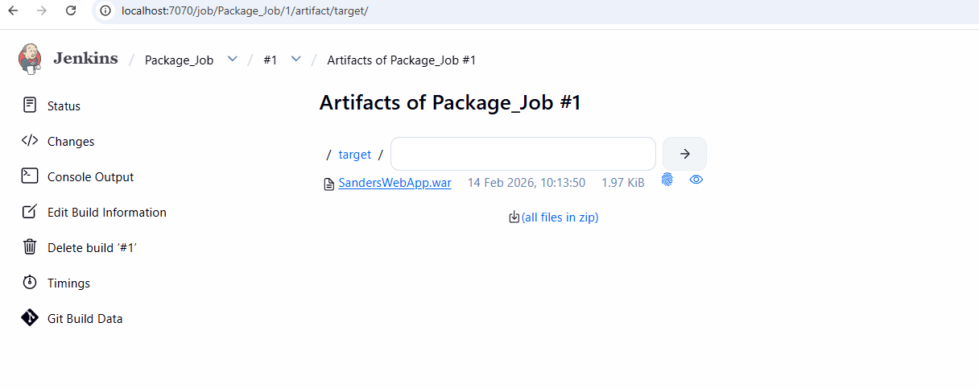

Job 5 – Deploy_Job
- PHASE 1: INSTALL & VERIFY TOMCAT
Install Tomcat
After installation, verify:
http://localhost:9090/
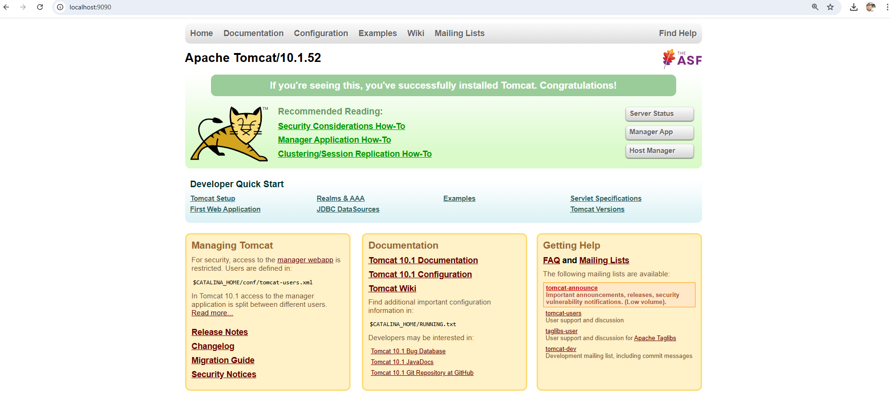

- PHASE 2: CONFIGURE TOMCAT USER FOR DEPLOYMENT
Open: C:\Program Files\Apache Software Foundation\Tomcat 10.1\conf
Add inside <tomcat-users>:
<role rolename="manager-gui"/>
<role rolename="manager-script"/>

<user username="admin"
password="admin123"
roles="manager-gui,manager-script"/>
Save file.
Restart Tomcat:
net stop Tomcat10
net start Tomcat10
- PHASE 3: INSTALL JENKINS DEPLOY PLUGIN
Go to: Manage Jenkins → Plugins → Available Plugins
Install: Deploy to container Plugin
Restart Jenkins.
- PHASE 4: CREATE DEPLOY JOB IN JENKINS
Create New Job: Jenkins Dashboard → New Item
Select: Freestyle Project
Name: Deploy_Job
Click OK.
- Add Build Trigger (Connect with Package Job)
Scroll to: Build Triggers
Select: Build after other projects are built
Enter: Package_Job
- PHASE 5: CONFIGURE DEPLOY STEP
Scroll to: Post-build Actions
Click: Deploy war/ear to a container

- PHASE 6: BUILD DEPLOY JOB
Click: Build Now
- PHASE 7: VERIFY DEPLOYMENT
http://localhost:9090/SandersWebApp

