AppleBite Co. – CI/CD Implementation using Jenkins, Docker, Ansible & Puppet
Project Objective:
Implement a fully automated CI/CD pipeline triggered by GitHub master branch push. The pipeline provisions a test server, installs required software, builds a Docker image, deploys a PHP container, and promotes to production automatically.

Architecture Flow
Developer → GitHub (master push)
↓
Jenkins Master (Windows 11)
↓
Jenkins Slave (Test Server)
↓
Ansible installs Docker
↓
Docker builds PHP container
↓
Deploy to Test → Promote to Production

Step 1 – Jenkins Master Setup (Windows 11)
1. Verify Java Installation:
java -version
2. Start Jenkins Service:
net start jenkins
3. Install Required Plugins:
- Git Plugin
- Pipeline Plugin
- SSH Agent Plugin
- Ansible Plugin
- Post Build Task Plugin
- GitHub Integration Plugin

Step 2 – Jenkins Slave (Test Server) Setup
Install Required Software:
Syntax: winget install Git.Git
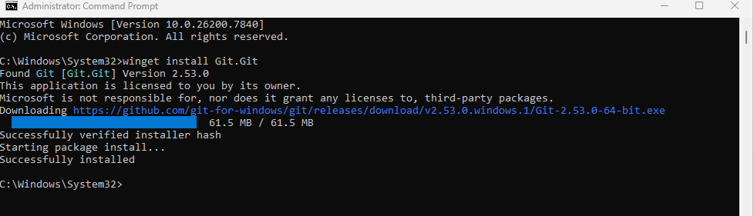
Syntax: winget install --id Python.Python.3.14 –e
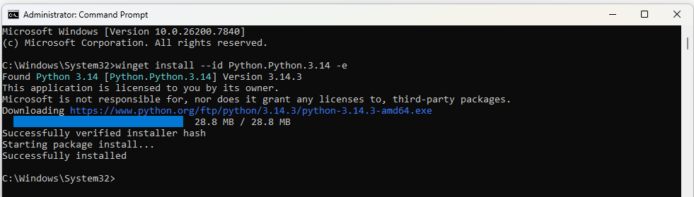
Install OpenSSH Server:
Syntax: Add-WindowsCapability -Online -Name OpenSSH.Server~~~~0.0.1.0
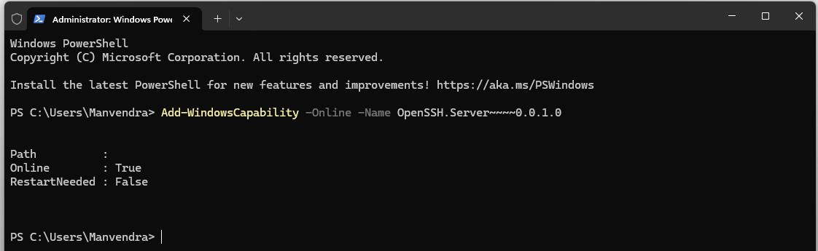
Start-Service sshd
Set-Service sshd -StartupType Automatic
Allow Firewall:
Syntax: netsh advfirewall firewall add rule name="OpenSSH" dir=in action=allow protocol=TCP localport=22
Verify SSH Service
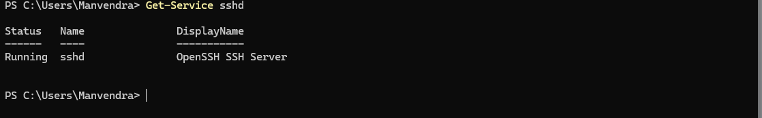

Step 3 – Add Slave Node in Jenkins
PART A – Prepare Jenkins Slave (Test Server)
Install Required Software on Slave
Open PowerShell as Administrator
Install Git
Syntax: winget install --id Git.Git –e

Install Java (Required for agent.jar)
winget install --id EclipseAdoptium.Temurin.17.JDK -e
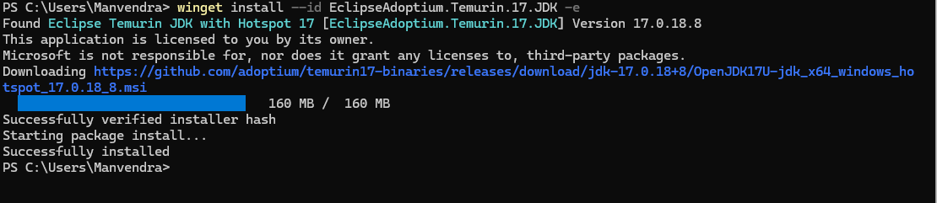

Create New Node in Jenkins Master
Login to Jenkins Master.
Navigate: Manage Jenkins → Nodes → New Node
Enter:
Node Name: Test_Server_1
Type: Select Permanent Agent
Click: OK
Configure Agent Details:
Fill the following fields carefully:
Basic Configuration
Field Value
# of executors 2 (or based on CPU cores)
Remote root directory C:\Jenkins_Agent
Labels test-server windows
Usage: Use this node as much as possible
Connect Agent to Master
Syntax: java -jar agent.jar -url http://192.168.80.1:7070/ -secret 37bf821973fb6d8e43224119476d641cc5cfb8c901d1b4191aec84069b467e21 -name "Test_Server_1"
Download agent.jar
http://MASTER-IP:7070/jnlpJars/agent.jar
Download and place in:
C:\Jenkins_Agent
Open Command Prompt in Agent Folder
Syntax: cd C:\Jenkins_Agent
Run command provided by Jenkins:
Syntax: java -jar agent.jar -url http://192.168.80.1:7070/ -secret 37bf821973fb6d8e43224119476d641cc5cfb8c901d1b4191aec84069b467e21 -name "Test_Server_1"
If successful, you will see:
INFO: Connected

Step 4 – GitHub Integration
Clone Repository:
Syntax: git clone https://github.com/edureka-devops/projCert.git
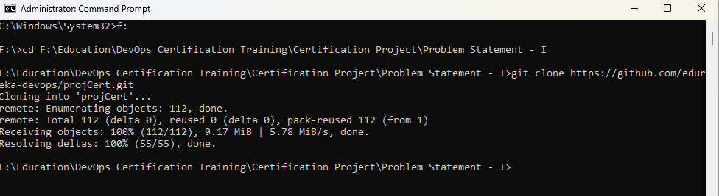
cd projCert
Create Dockerfile:
FROM devopsedu/webapp
COPY . /var/www/html/
EXPOSE 80

Build and Test:
Syntax: docker build -t applebite-app .
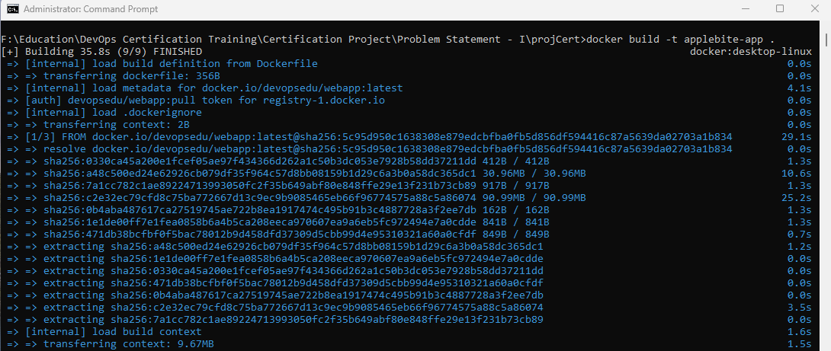
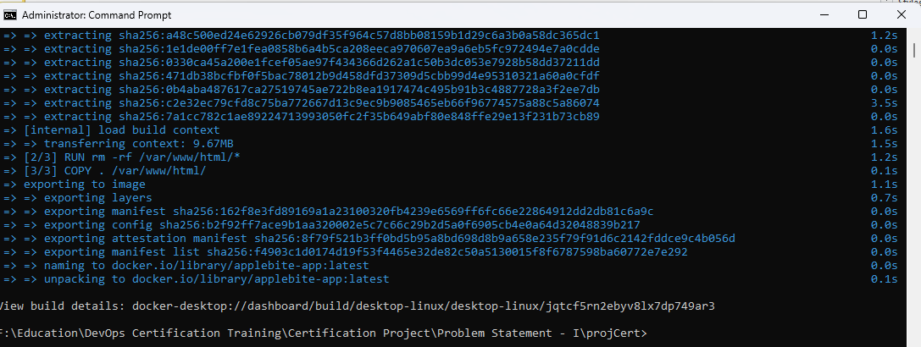
Syntax: docker run -d -p 8085:80 applebite-app
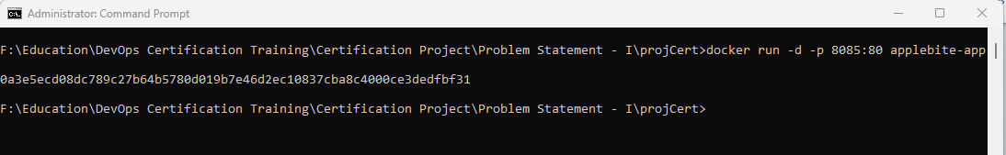

Test:
http://localhost:8085

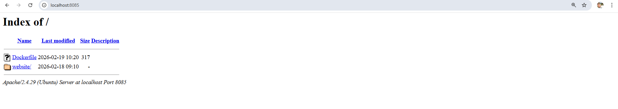

Commit and push:
Syntax: git add .
Syntax: git commit -m "Added Dockerfile"
Syntax: git push origin master
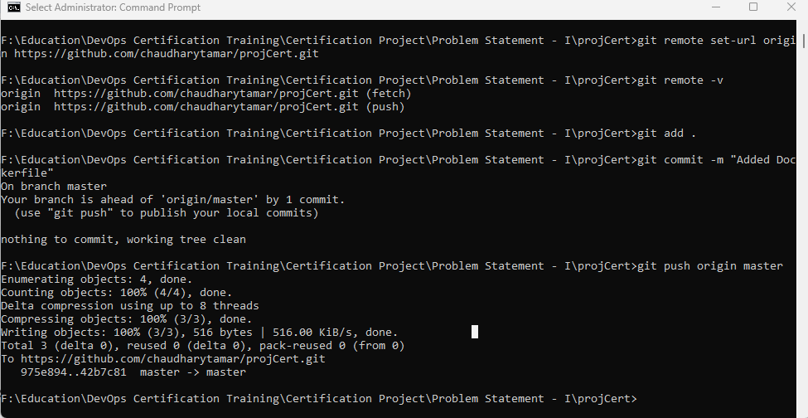

Step 5 – Job 1: Install Puppet Agent
Create Freestyle Job restricted to Test_Server.
Create Jenkins Job
Create New Item
Open Jenkins Dashboard
Click New Item
Enter name:
Install_Puppet_Agent
Select:
Freestyle Project
Click OK
Configure Job Settings
Restrict to Agent Node
Under:
General → Restrict where this project can be run
Enable checkbox and enter:
Test_Server_1
(Your connected Jenkins agent name)
This ensures installation runs on the slave machine, not the master.
Add Build Steps (Windows Agent)
If your agent is Windows, use:
Add Build Step → Execute Windows Batch Command
Paste:
echo Downloading Puppet Agent...
curl -L -o puppet-agent.msi https://downloads.puppet.com/windows/puppet7/puppet-agent-x64-latest.msi
echo Installing Puppet Agent...
msiexec /i puppet-agent.msi /qn
echo Verifying Installation...
"C:\Program Files\Puppet Labs\Puppet\bin\puppet.bat" --version

Configure Puppet Agent (Optional but Recommended)
If you are connecting to a Puppet Master:
Edit puppet.conf
Windows:
C:\ProgramData\PuppetLabs\puppet\etc\puppet.conf
Add:
[main]
server = <PUPPET_MASTER_IP>
environment = production

Start Puppet Service
Windows:
net start puppet
Build Command:

Build Now
- Click Build Now

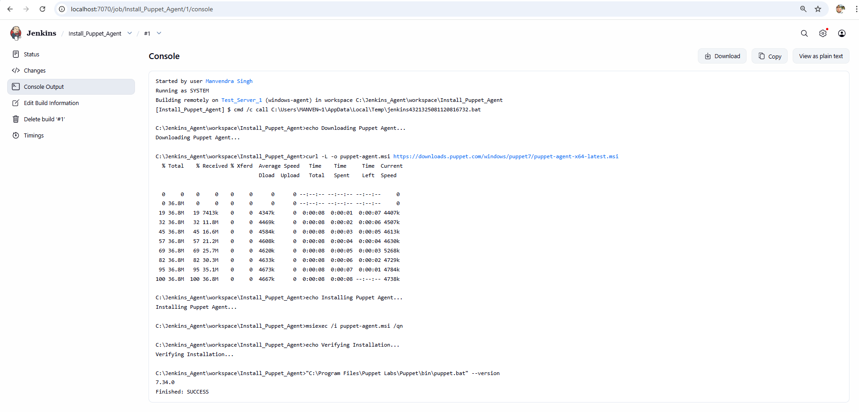

winget install Puppet.Puppet -e --silent
Verify:
puppet –version

Step 6 – Job 2: Install Docker using Ansible
Enable WSL & Virtual Machine Platform
PowerShell
Syntax: wsl –install
Enable WinRM
Syntax:
winrm quickconfig
Enable-PSRemoting -Force
Set-Item -Path WSMan:\localhost\Service\Auth\Basic -Value $true
Set-Item -Path WSMan:\localhost\Service\AllowUnencrypted -Value $true
Create inventory.ini:
[test]
SLAVE-IP ansible_user=USERNAME ansible_password=PASSWORD ansible_connection=ssh
Create install_docker.yml:
---
- hosts: test
tasks:
- name: Install Docker
win_shell: winget install Docker.DockerDesktop -e --silent

Create Inventory File
[testservers]
192.168.1.3

[testservers:vars]
ansible_user=ansibleuser
ansible_password=Password@123
ansible_connection=winrm
ansible_port=5985
ansible_winrm_transport=basic
ansible_winrm_server_cert_validation=ignore

Playbook
- name: Install Docker Desktop on Windows 11
hosts: testservers
gather_facts: no

tasks:

- name: Enable WSL feature
win_shell: dism.exe /online /enable-feature /featurename:Microsoft-Windows-Subsystem-Linux /all /norestart

- name: Enable Virtual Machine Platform
win_shell: dism.exe /online /enable-feature /featurename:VirtualMachinePlatform /all /norestart

- name: Set WSL2 as default
win_command: wsl --set-default-version 2

- name: Create Temp directory
win_file:
path: C:\Temp
state: directory

- name: Download Docker Desktop Installer
win_get_url:
url: https://desktop.docker.com/win/main/amd64/Docker%20Desktop%20Installer.exe
dest: C:\Temp\DockerDesktopInstaller.exe
Syntax: ansible-playbook -i inventory.ini install_docker_windows.yml
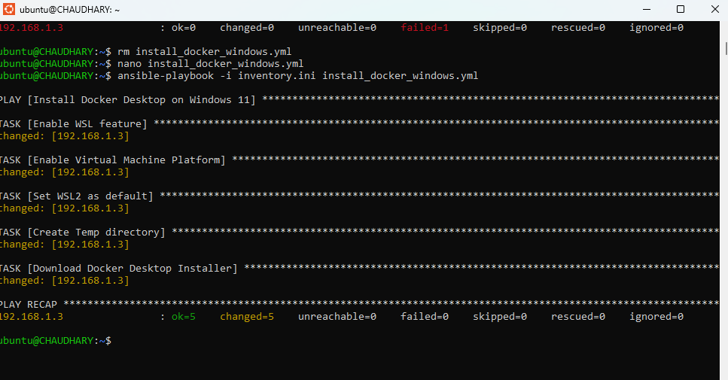

Step 7 – Job 3: Build & Deploy Container

FREESTYLE JOB (DETAILED EXPLANATION)

1. Create Job
Jenkins Dashboard → New Item
Name:
Build_And_Deploy_App

Select:
Freestyle Project

2. Restrict Job to Test Server
Under General:
Restrict where this project can be run
Enter:
Test_Server_1

3. Configure Git
Under Source Code Management:
Select Git
Repository:
https://github.com/chaudharytamar/projCert
Branch:
*/master

Add Build Step
echo ================================
echo 1. STOP OLD CONTAINER
echo ================================

docker stop applebite 2>nul
docker rm applebite 2>nul

echo ================================
echo 2. BUILD DOCKER IMAGE
echo ================================

docker build -t applebite-app .

IF %ERRORLEVEL% NEQ 0 (
echo Docker build failed
exit /b 1
)

echo ================================
echo 3. RUN NEW CONTAINER
echo ================================

docker run -d -p 8085:80 --name applebite applebite-app

IF %ERRORLEVEL% NEQ 0 (
echo Docker run failed
exit /b 1
)

echo ================================
echo DEPLOYMENT SUCCESSFUL
echo ================================

http://192.168.1.3:8085/
